Part 1: Multiple choice questions (10 questions – 10 points)
1. A monopoly is active in two markets with different price elasticities. What will happen?
a) the monopoly uses uniform pricing
b) the monopoly sets an equal price in both markets but unrelated to the size of the markets
c) the monopoly sets a higher price in the market where the elasticity is higher
d) the monopoly sets a higher price in the market where the elasticity is lower
2. an insurance companies sets different policies, some offer full repayment and some offer only partial repayment. Why does the insurance company act like this?
a) because it wants to solve moral hazard
b) because it wants to screen out the high-risk drivers
c) Because it wants to offer a choice to people with different risk adversity
d) None of the above
3. We face a market with a positive externality, which of the following statements is true?
a) The market will produce less compared to what’s socially optimal
b) We can resolve the inefficiency by charging money from who has created the externality
c) The market will produce not enough
d) None of the above
4. A company has a new project. It has now to invest 1 million dollars in R&D. However, the outcome of this project is still uncertain. There is a probability of 50% that a product will be developed. In the other case, no product will be developed; hence, no revenue can be earned. There is also a second problem, without advertising the company will also sell anything. Therefore a 2 million dollar advertisement campaign is considered. If the company chooses this option, a gross profit of marketing expenditure will be realized of 5 million dollars. Of course, if the company decides to leave the situation as is (so without doing the project); the net profit will be zero. The only question that remains is when we have to contract the advertising agency. IF the company decides to only do advertising AFTER the outcome of the R&D project is known, what’s the maximum price that this company is willing to pay for other costs?
a) 0.5 million
b) 1 million
c) 2 million
d)3 million
5. Consider the following game. There are two players, A and B. Each of the players has two options with 4 different outcomes. The players choose their strategy simultaneously, how many Nash equilibria are there in this game if we only consider pure strategies?
 | Player B
Player A |  | up | down
 | left | (4,6) | (3,7)
 | right | (7,3) | (6,4)

a) 0
b) 1
c) 2
d) 4
6.
7.
8.
9.
10.

Part 2: Qualitative questions
1. Consider the diagram below. The market we’re talking about is the market of shipping freight over the Atlantic. You may assume that this market is a competitive market. Curve a indicates the short run supply curve. Curve b represents the original demand curve. Suppose that market demand shifts down to curve c. What will be the consequences in the short and long run? Indicate what’s the difference between short and long run and use the diagram to show what the effects will be (if any) of considering long or short run. (6 points)
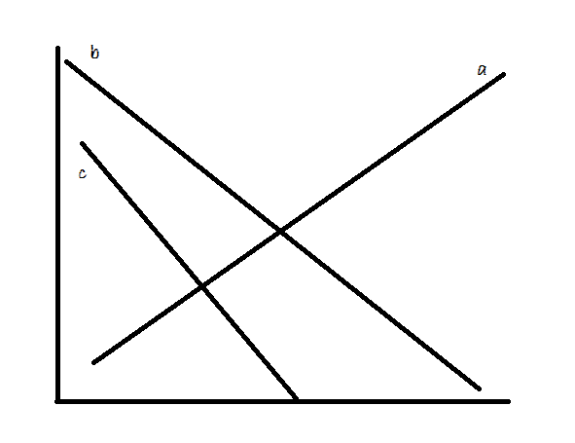

2. A monopoly has different possible pricing strategies. Explain the difference in outcome between a uniform price and complete price discrimination (CPD). (5 points)

Part 3: Quantitative questions
1. In a certain market two companies (A and B) have developed their own technology. The problem however is that the industry already has adopted a certain other technology. What should these two companies do regarding to the pay off matrix below? Assume that both players act simultaneously and that regardless of the choice of companies A and B, all other firms in the industry will keep using the ‘industry technology’. Providing a group of customers with a channel comes at a cost of zero dollars per channel. (5 points)
 | Company A
Company B |  | Own technology | Industry technology
 | Own technology | ( 5,5 ) | (4,3)
 | Industry technology | (3,4 ) | (3,3)

a) Is there a dominant strategy?

b) Is there a Nash equilibrium? Where?

c) What solution gives us the highest cumulative outcome for both firms?

d) If we allow A the act first, will we reach this optimal outcome (see question c)? Give some comment.

2. Bundling. A company provides two kinds of television channels. One is a High tech channel and the other is a wildlife channel. Assume that there are only two kinds of customers, namely geeks and regular people. In the table below, you’ll find what each type of customer is willing to pay for each channel. What is in your opinion the best solution? (8 points)
 | High Tech channel | Wildlife channel
geeks | 15 | 4
Regular people | 3 | 8

