13. Financial restructuring
1. FINANCIAL AND STRATEGIC VALUE CREATION
Value of firm
= Value of all equity financed firm
+ PV of tax shields (main component)
+ PV of other benefits of leverage (e.g. disciplinary effect)
+ PV of benefits of control change (e.g. access to new markets)
+ PV of benefits from M&As (e.g. eco of scale)
+ PV benefits from ∆ in strategy, policy, structure,…
- PV costs financial distress

2. LEVERAGED RECAPITALIZATIONS
Substantial of leverage ratio
= issue debt & pay back shareholders

Result 1: more tax deductible interest expenses
- Effect on BS
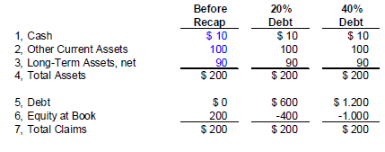
- Effect on taxes
  - Without debt
= T.OI
  - With debt
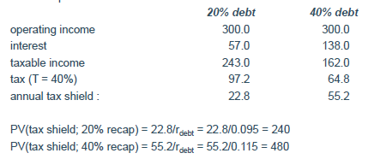
PV(tax shield) = (T.debt.r_{debt})/r_{debt}= T.debt
Perpetuity!
- Effect on firm value
= Modigliani-Miller
= Value levered firm = value unlevered firm + PV(tax shield)
- Effect on share P
  - Money raised by loans used to buy back & destroy shares
  - At which P can shares be bought?
New share P
= Market value eq/(previous # shares outstanding – shares repurchased)
  - Shares will be bought at P
P = market value equity/(previous # shares outstanding – debt amount/P)
  - # Shares repurchased
= debt/share P
- Effect on interest rate coverage (risk)
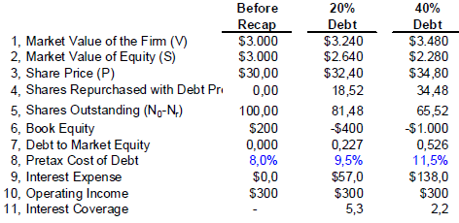
  - Interest coverage = OI/ interest expense
Total picture
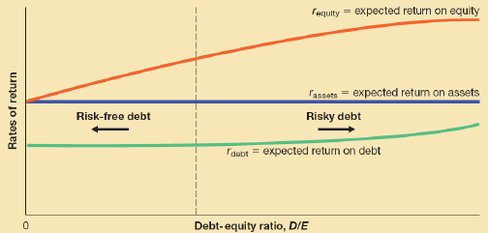

Result 2: ∆ ownership % of managers/insiders
2 Options
- Use loans to repurchase shares from non-insiders
= does come at cost: risk
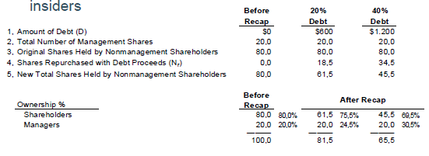

- Use loans to pay cash div to non-insiders & stock div to insiders
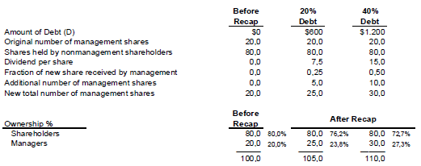
! Common-equity
= stub when financial recap results in decline of its market value to 25% or less of previous market value

Leveraged recaps
= Larger % eq replaced by debt
- Larger leverage effect upon company value
- Larger increase in managerial ownership (less free float)
- Large part of debt used for large cash dividend payment to non-management sh or used to repurchase shares (or combi)
- + Increase tax shield
- - story that firm tries to prevent takeover bid (defensive manoeuvre signal)
= more difficult to get majority as non-insider

Empirical studies
- Average increase of total debt/total value (from 20% to 70%)
- Managerial ownership increases (from 9%-24%)
- Market response
= depends on motivation (takeover bid story)
  - Proactive
= CAR + 30% for equity & + 5% for bonds
  - Defensive
= CAR mixed (+ and – values)
- Post-recap performance
  - Large # comp * financial distress due to high leverage
  - Increases sensitivity to fluctuations in industry and general economic circumstances
  - Success rate when recap part of general strategy to efficiency
= disciplining effect of debt
Leveraged recaps: financial crisis
= Leveraged recap act peaked during 2nd quarter 2007
- Recap bonds sold in structured products
(CLOs – Collateralized Loan Obligations)
- Due to fear of recession
= P(Default of recap companies)
- P of existing CLOs crash
= no interest in new instruments
- Risk premium of leveraged loans >11% above Libor in dec 2008
(London Interbank Offered Rate = lend & borrow from each other at that rate)
- Watch loan maturity wall!
= most companies starting now reach the wall in 2024
= need payoff or renew loan
- US takes more risk (loans) than EU
  - More leveraged loans in US than EU, despite fact that EU economy is larger
  - Crashes hard, but picks up faster
  - If all goes well, really growth

! Recap
= borrow money & replace equity
- Leverage, ownership & tax shield rise
- Risk rises
- Other options
DCR

3. DUAL-CLASS STOCK RECAPITALIZATION (DCR)
= create new class of shares with different voting or CF rights
Examples
- Class A: 1-share-1-vote
= high CF rights (high div yield)
- Class B
= low div yield, multiple voting rights
= not everywhere legal

3.1 Post DCR
- Insiders control 55-65% voting rights
- Insiders own just 25% CF rights
- Family control strengthed (entrench position against takeovers & replacement)

Rationale
- Increased power of management/ insiders allows focus on LT performance
(Can’t just say you do it for power)
= don’t need to show good results every quarter
- Poorly performing management more difficult to replace
= entrenchment (entrench their position against takeover so they won’t be replaced)

Market reaction
- Positive in pre-announcement period
- 0 at announcement
Shares with multiple voting ratings are worth more in case of takeover bid (get higher payout)

Entrenchment paradox
= existing non-management sh need to approve DCR, even though they know it will become more difficult to fire management & will receive less money in takeover deal
Give confidence to outsiders to give up control
- Transfer of CF rights from insiders to outsiders
(give option to exchange common stock for shares with limited voting rights but higher div)
- Insiders typically already hold large % voting rights pre-DCR (43%)
& are willing to sacrifice some current div income for prospect of larger, LT capital gains
- Increase in external management supervision

3.2 Exchange offers
= security holders get opp to exchange securities for ≠ type
- Value new > value old security
- Offer limited in scope (max # to exchange) & time (1 month, sometimes extended)
- Sometimes conditional upon success
- Market response + in leverage , FCF and signal given about undervaluation of share & future increases in CF
- Response to distressed exchanges
= * lower leverage to avoid bankruptcy
= signal of weakness to market
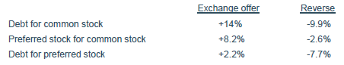

3.3 Financial distress
= company lacks res to meet all obligations (can lead to default)
= liquidation value firm’s assets < total value of creditor claims

Solutions: financial restructuring
- Informal
I.e. debt renegotiation in mutual agreement with creditors, asset sale,…
- Formal
I.e. voluntary liquidation, formal reorganization, bankruptcy,…
3.3 Bankruptcy
Single chapter systems
= liquidation only
- Liquidate distressed companies to max payoff to creditors
- Management/sh lose control
= court appointed receiver: curator
- Priority of claims
  - 1st pay back legal fees x expenses of bankruptcy
  - 2nd wages due workers
  - 3rd taxes due
  - 4th open for general claims
    - Mortgage holders receive total amount of proceeds of sale of property (unless more than they paid, rest is for general claims as well)

Dual chapter systems
= reorganization (US ch.11 gerechtelijk akkoord/WCO) + liquidation (US Ch. 7: faillissement)
- System needs to distinguish/filter btw companies with P(survival) & unviable companies which should be liquidated immediately
- In theory
= based on differences in company value ‘dead’ and ‘alive’
= going concern value
- Reorganization
  - Debtor-in-possession
= management keeps control, but is supervised by court
  - Company protected from creditors for duration of procedure
  - In practice
= severe filtering problems, ° potential abuse of system
  - Might * betting the ranch (see later)
- US Ch.11
= often used as strategy to stall time in order to find suitable buyer for company’s assets

4. COSTS OF FINANCIAL DISTRESS
- Direct costs of bankruptcy
  - Court fees
  - Fees for legal & financial consultants
  - ± 3% company value for large, quoted companies
much higher for SMEs
- Indirect costs
  - Loss of supplier & customer confidence
  - Loss of employees
  - Increase in loan rates
  - Selling assets at low P (fire sale)
- Agency costs
  - Costs resulting from ≠ in interests of sh/managers/creditors
  - Bankruptcy
= ° priority rules
= sh receive residual value, creditors paid first
  - Financial distress
= likely that sh/managers may take decisions which are sub-optimal for company value
    - Launching high-risk projects, even though NPV < 0
= P(success) minimal, but potential payoff huge
= betting the ranch
    - Ignore projects with low risk & NPV > 0
- Bankruptcy law design
= deviate from absolute priority rule (APR)
- Rational creditors
= know sub-optimal behavior can occur
  - Only willing to lend money to distressed companies If risks are sufficiently compensated
= high interest rates
  - Costs of sub-optimal behavior transferred to company & sh
    - Avoid costs by limiting P(financial distress)
    - Limit leverage ratio
  - Market value of debt financed company
= market value of all-equity financed comp + PV(tax shield) – PV (costs financial distress)
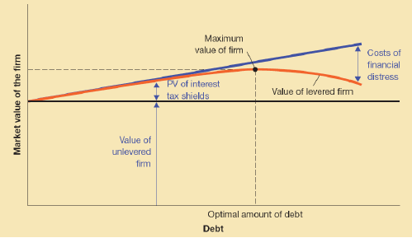

4.1 Costs of financial distress: Cross-industry
= Loss of assets value due to fire sales NOT equally severe in all industries
- Some fixed assets
= sold at relatively good prices
- Specialized equipment more difficult to liquidate
- Non-tangible assets (e.g. R&D)
= often impossible to turn into cash
  - Can explain ≠ leverage ratios across industries
- Leveraged recaps & ultra-high leverage strategies
= traditionally most popular in mature, low-tech industries
  - High-tech industry
= have high economic risk
= want to keep financial risk low
= low debt ratio

4.2 Costs of financial distress: cross-country
= Severity of financial distress costs depends on efficiency of country’s insolvency system
- High leverage strategies more attractive in countries with efficient insolvency system
= Higher P(saving distressed company) is higher ex ante max level of leverage
- Measures of efficiency
  - Recovery rate for creditors
  - Length of procedure
  - Cost of procedure
  - Company saved as going concern,…

World bank methodology
= compare value as going-concern to value of liquidation
If going-concern > liquidation: reorganise
Depending on efficiency of insolvency system will the going concern be >/< than liquidation
- General efficiency is low
  - Especially in poorer countries
(lower-middle income countries average)
  - Especially in countries with French civil law systems
French < German law countries < Common law < Nordic law

5. LIQUIDATIONS
Voluntary liquidation
= value individual assets > value going concern
- Wealth creation for sh
- + CAR (+5 to + 15%)
- P(voluntary) with % management shareholdings
  - Trade-off benefits control (management) vs. value of equity holdings (Sh)
= agency problem becomes smaller when more management holdings

Takeover bust-up
= buy company & sell assets
= external ∆ ownership
= CAR target +, CAR bidder not significant

