16. Going private & LBOs

Going private

= quoted (Public) company stops listing on stock exchange  
= delisting ↔ IPO

= Offer to buy all publicly held shares (free float)

**Potential source of finance**

= increase leverage & repurchase shares

* Leveraged buyout (LBO)
* Management buyout (MBO)  
  = for smaller companies & divisions  
  = crucial role for existing (incumbent) management  
  = takeover led by new managers (Management buy-in MBI)
* Long term goal  
  = take company back to stock exchange at higher P

1. LBO vs. MBO vs. LEVERAGED RECAP

1.1 LBO vs. Leveraged recap

**Leveraged buyout**  
= issuing debt to buy company’s stock or pay dividends, initiated by outside party

**Leveraged recapitalization**  
= when initiated by company itself for internal reasons



1.2 LBO deal structure

Shell company  
= created only for transaction

**LBO/MBO example: Wavell corporation**

* Stable CF, low leverage ratio
* Parent dissatisfied
  + Low growth opp
  + Activity non-core to group
* Management negotiated takeover P of $2 mln
  + Assumes they can generate sufficient CF to repay loans
  + Make **bank loan repayment schedule**
    - Loan
    - Interest rate
    - Payments
      * Annuity factor PVAF(t,r%) = [1-1/(1+r)t]/r
      * Payment = loan/PVAF(t,r%)  
        = consists of both interest & principal payment!
  + **Make Pro-forma CF statement**  
    ! Because you take large risk: need to show bs assumptions are realistic e.g. stable EBIT
    - EBIT – interest – taxes + depreciation – Principal repaid = addition to cash
  + **Cash reserves** always +   
    = NI + depreciation – debt repayment + previous cash balance
  + **Profits retained**= previous equity + NI  
    = value of equity increases
  + **Make pro-forma BS**  
    = cash + other current assets + property + net plant & equipment   
    = total assets   
    = debt + equity
  + **Managers get rest of equity value after buy back shares**= Value equityt - #shares*guaranteed returnt
  + **Expected return managers**= (Rest of equity/#shares)1/t - 1
  + **° Debt free company that can return to stock exchange (SIPO)**

**🡪** Risk especially high in 1st years following LBO

Peak LBO = later bc as time passes, uncertainty rises

2. VALUATOIN OF LBO COMPANIES

2.1 Discounted Cash Flow (DCF) method

= using WACC as discount factor  
= not convenient as debt ratio ∆ through time  
🡪 WACC ≠ contstant

2.2 Capital Cash Flow (CCF) method

1. Compute FCF of 100% equity financed company
2. Compute interest tax shield
3. CCF  
   = FCF + tax shield
4. Discount at expected return on assets (asset return = ka)  
   ka = Rf + ßa x (RM – Rf)  
   where ßa = asset beta (beta of 100% equity financed company)
5. Leads to same results as appropriately modified version of DCF or adjusted Present Value methods

**Projected operating relationships**  
= operational efficiency

* NOI = net operating income = EBIT
* NOPAT = net operating profit after taxes = (1-tax).NOI
* FCF corrections  
  = ∆ working capital, extra capital expenditures, ∆ other assets  
  = assumption driven
* FCF = NOPAT + depr - ∆ working capital – capital exp – change other assets net
* Interest expenses can be determined based on debt repayment schedule (given)

Rev 5000, growth 8% first 5y, 3% after, tax 40%, 2000 book debt, 100m shares

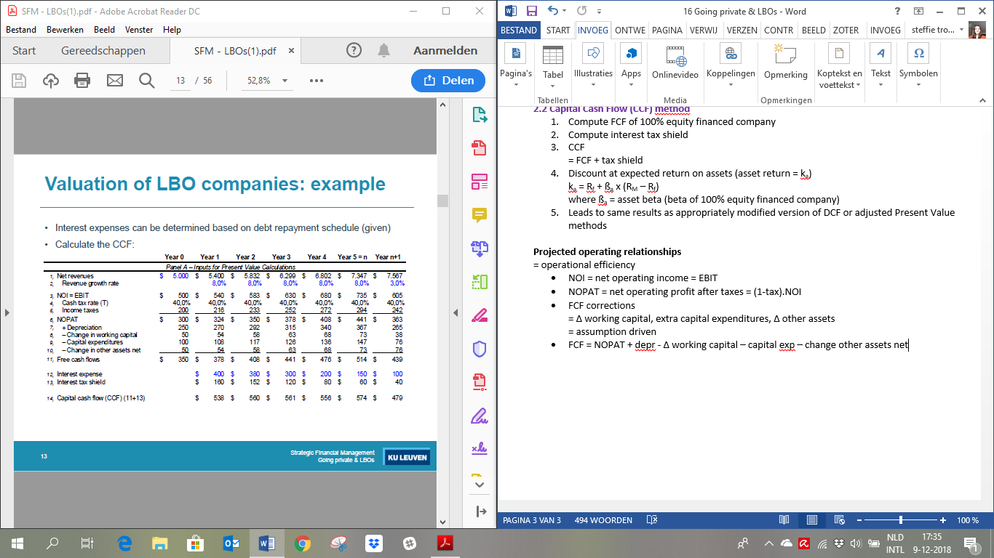

* Terminal value = CCFn+1/(Ka-g)  
  ! Solution extremely sensitive to assumed growth value (g)
* Operating value (V)  
  = PV (CF y1-y5) + PV(Terminal value)
* Value equity = V – value D
* Intrinsic share P   
  = value equity/# shares

2.3 LBO value creation

* Financial  
  =raises leverage ratio & tax shield
* Operational  
  = increases efficiency (profit margins) & sales growth
* Every assumption affect company value  
  = sensitivity analysis
* ! Whatever the number, should still be > current share P  
  🡪 Do transaction for a reason

2.4 Valuation multiples

= reference points for comparison of valuation across companies & deals

1. Operating value/ rev0  (cf. P/sales)
2. Operating value/NOI0 (cf. P/E)
3. Operating value/EBITDA0 (cf. P/E)
   1. EBTIDA = earnings before interest, taxes, depr & amortization

3. LBO STAGES

1st stage

= planning & fund raising

* Financing
  + 10% cash from investor group
  + 50-60% bank loans, balance from senior x junior subordinated debt
* Management incentives  
  = stock price-based incentives (options, etc.)

2nd stage

= firm taken private

* Stock-purchase (buy outstanding shares)  
  or asset-purchase (buy assets and form new privately held corporation)
* New owners usually sell off parts of acquired firm to reduce debt

3rd stage

= attempt to increase CF

* Cut operating C & spending
* When possible: delay capital expenditures
* Try new M to revenues

4th stage

= reverse LBOs increase liquidity

* Investor group may take improved company public again through public equity offering  
  (Second initial public offering – SIPO)
* Investors reaching SIPO realized 268.4% annual return on LBO investment

Attractive LBO targets

1. Typical target industries
   1. Basic, non-regulated industry  
      = stable earnings, predictable/low financial requirements  
      e.g. retail, textiles, food, apparel, soft drinks (half of all LBOs)
   2. High-tech industry less appropriate  
      = more risk, no track record, fewer assets, high P/Es
2. Target firm characteristics
   1. Capable management  
      = willing to bet personal wealth on success
   2. Strong market position within industry
   3. Liquid balance sheet   
      with undervalued assets

4. EXIT STRATEGIES

= Private equity investors need to recover their investment  
(± 5y after deal)

1. Sell other company in industry  
   = strategic buyer
2. Secondary buyout (SBO)  
   = sell it to other buyout firm
3. (Secondary) IPO  
   = take company (back) to stock exchange
4. Bankruptcy
5. MBO
6. Other

4.1 Empirical studies

**‘80s samples**

* Announcement effect  
  = usually +20% AR
* Premium paid on top of stock P during (1-2) month(s) before deal
  + Premium increases with # bidding parties (average from 55% to 69% with ≥ 3)
* Leverage increases (D/E ratio)
* Divisional MBOs
  + Average divison sold represents 16.6% of parent’s market value
  + Small + announcement effect
* High-leveraged LBOs
  + LBO makes EBITDA/interest ratio drop
  + Almost 1/3 of high-leveraged deal leads to financial distress
* Divestments market response
  + + if healthy company
  + – if distressed

**More recent**

* Premium ±30% (lower than in 80s)
* Post-buyout debt to capital 70.5 (lower than 80s)
* 15% IPO, 16% sold, 10% 2nd LBO, 12% bankrupt, 47% still private/unkown

5. VALUE CREATION IN LBOs

5.1 Positive value creation

1. **Tax advantages**  
   = increased deductability of interest payments, accelerated depreciation,…
   1. Larger potential adv, larger premium
   2. Substantial part of bid premium can be recovered through tax adv
2. **Management incentives & agency costs**= LBO/MBO increases managerial ownership & concentration of ownership
   1. Better alignment of interest of managers & sh  
      = more incentives for management to spend effort, lower agency costs
   2. Less asymmetric info problems
   3. Less FCF problems (thanks to higher leverage))
   4. Empirical evidence  
      = almost all LBO companies have extensive management incentive plans & higher premiums paid for companies with higher P(FCF problems)
3. **Advantages of being private company**
   1. Focus on LT goals
   2. Frees up management time
   3. Reduces communication needs

5.2 Expropriation

1. Wealth transfer from debt to equity  
   = from bondholders/preferred stock holders to sh
   1. Massive leverage, value of existing debt instruments, despite existence of covenants
   2. Empirical evidence  
      = losses for bondholders statistically significant but quite small compared to gains of sh
2. Wealth transfer from employees to sh  
   = limited evidence, sometimes LBO ° employment
3. Wealth transfer from tax payers to sh  
   = deductability is compensated by capital gains tax paid by selling sh in LBO and SIPO deals  
   = more tax paid after leverage is reduced
4. Asymmetric information  
   = transfer from outsiders to insiders  
   = insiders more info about true company value  
   = premium too low (underpricing)!

5.3 Post buyout

Is there actual LT value creation?

* Compare LBO and SIPO  
  = + rate of return, correlated with ownership share of management
* Comparison with S&P  
  = median excess return 26.1% higher in LBO  
  = similar to premium earned by prebuyout sh  
  = excess return relates to ∆ OI, not to potential tax benefits
* Performance  
  = Before SIPO: rise, after little decline (average still rise)  
  = evidence of info asymmetries, management will ° SIPO in exceptional y
* CAR first 3 years +   
  = most of gains due to firms taken over
* Firms outperform industries in 4y following SIPO
  + of leverage loosened cash constraints
  + Capital expenditures

! Evidence post-deal performance = mixed  
🡪 Depending on what you look at, can look very + or very –

6. LBO ACTIVITY

= Correlated with merger waves (M&A activities)   
🡪 Large bubble in ’06, ‘07

6.1 LBO waves

**1. Early 90s**   
= sharp decline # buyouts

* Too many playesr  
  = competition drives up bid P & higher P(default) (winner’s curse)
* Recession/lower eco growth  
  ° bankruptcies
* LBOs go out of business   
  = have attracted too much debt they cannot repay

**2. Rest of 90s**  
= recovery in buyout market ~ strong eco growth  
! No return to 80s level

**3. Buyout boom (2003-2007)**  
= driven by private equity funds (KKR, Blackstone Group)

* **Private equity funds**  
  = (quasi-) equity investments I non-quoted companies with high growth potential
  + High risk, high req return
  + Traditionally limited to early stages of comp life cycle & hih tech industries  
    
  + Problem 1 PE industry  
    = traditional venture capital model: historic returns on early stage investments low   
    = Internal Rate of Return 5-10% for European PE funds (higher for top quartile)
  + Problem 2  
    = huge inflow of funds  
    = more funds available, not necessarily more good ideas
    - Solution  
      = shift towards late stages (high historic returns, large deal sizes)
    - Consequence  
      = shift from I in high tech to traditional industries
* **Buyout boom: valuations & leverage**  
  = Due to strong competition on buyout markets: ° ever increasing valuations  
  = ever increasing post-LBO leverage ratios  
  🡪 Rise in debt/EBITDA ratios  
  🡪 EU: P just as high, just less firms willing to take risk (US more risk-taking)  
    
  e.g. Blackstone/Hilton: largest hotel buyout in history & largest deal for Blackstone  
  🡪 Does not do divestitures, but funds the whole transaction by using mortgages on the real estate

**4. Buyout bust (mid 2007)**  
= start financial crisis

* Dramatic slowdown of inflow of funds into PE industry
  + Value & volume of European PE backed buyouts fell
* Market for CLO instruments of buyout loans collapses   
  = exposure gets stuck in large merchant banks
* Due to spill-over of crisis to “real” economy
  + High leverage ratios make LBO companies vulnerable to ∆ in bs cycle
  + Default rates LBO companies increase (1% ’07 to >4% ’08 to >10% ’09)
  + “Paper” loss in CLO’s vs “real” loss

e.g. Blackstone & Hilton break-up: tripling investment, most profitable PE deal ever

7. LBO: LOWER RISK?

Nowadays  
= LBOs exist again, but comp take lower risks (industry has learned)

e.g. Debt-to-EBITDA Dell 2x-3x

🡪 Still highly levered deals, increased pressure from regulators  
e.g. Heinz at 6x-9x EBITDA