18. Share repurchases
1. REPURCHASES & PAYOUT POLICY
1.1 Payout to shareholders
- Cash dividend
= common dividend (cf. leveraged recap)
- Stock dividends
= cf. spin-offs & carve-outs
- Share repurchases
= buybacks
= cash offer made by company for outstanding shares of their own common stock
  - Importance in US since 80s/90s & more recently in Europe as well
  - 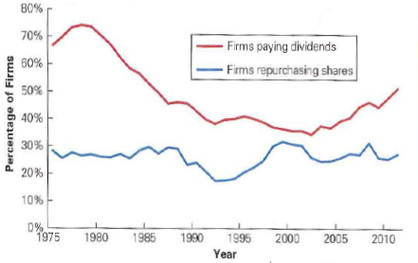
  - Value share repurchases/Total payouts (1975-2010)

1.2 Repurchases vs LBO/Recap
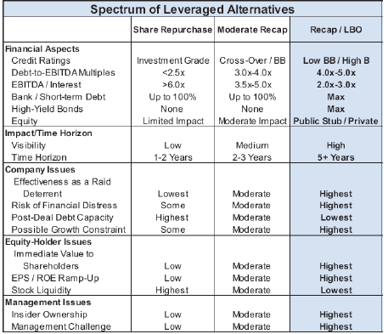

1.3 Repurchase motives
Cf. recaps & LBOs
- Adjust capital structure (leverage ratio )
- Increase insider/management ownership
= reduce agency costs
- Takeover defense
- Signal of good governance
= payout excess cash to sh
- Signal of undervaluation
= market valuation of future profits or CF too low
- Part of wider financial restructuring plan
- Neutralize impacts of employee stock option plans
- Alternative for cash dividends
  - Flexibility
  - Tax advantages
2. TYPES OF SHARE REPURCHASES
2.1 Fixed-price tender (FPT) offers
= company makes offer for predetermined # shares at fixed P during certain t
= higher than market price (±20%)

Stock repurchase model (formularium)
Assumptions
- Efficient markets
- No asymmetric info
- Perfect competition (Investors are Ptakers)
- Wealth max investors,..

Model
Value of sh after expiration = value shares before announcement – value repurchased + change in sh wealth associated with repurchase offer
P_{E}N_{E} = P₀N₀ – P_{T}(N₀-N_{E}) + W

With P_{E} = P after repurchase, P₀ before, P_{t} = FPT offer price
N_{E} = # shares after repurchase, N₀ before
W = FPT value creation

& $\frac{W}{{ N}_{0}P_{0}}=F_{P}\frac{(P_{T}-P_{0})}{P_{0}}+\left(1-F_{p}\right).\frac{(P_{E}-P_{0})}{P_{0}}$
= rate of return repurchase offer = RoR received by tendering sh weighted by % shares repurchased + RoR non-tendering* %nontendering

With F_{p} = fraction of shares repurchased = (N₀-N_{E})/N₀

Value creation
= split btw selling (tendering) & non-selling (non-tendering) sh
=%shares repurchased.premium + %remaining.AAR

Value creation drivers
- Higher leverage ratios (tax shield)
- Signalling undervaluation effect
= post-buyback earnings will be higher than pre-buyback expectations
- Repurchases are sometimes related to other efficiency increasing operations
e.g. divestitures
- Average post-buyback share price is about 10% higher than the pre-buyback price
2.2. Dutch auction repurchases (DAR)
= Offer to buy # shares within certain P range & let sellers determine the P at which they are willing to sell (reservation price)
- Reservation P differs from buyer to buyer
- V(r)=a+br (r = #shares)
  - Determines new price
  - Profit for selling shareholders 0.5(P_{new}-P_{old}).200
- Clearing P
= price paid, same for all selling shareholders
- Average premiums in DAR < FPTs
- Can be takeover defence
= remove all sh which are willing to sell for relatively small premium

Value creation
- Smaller than for FPT
- Oversubscription
= If larger #sh wish to take offer (supply shares > demand)
= if reservation P < lower-range P terms (or ° by lumpiness of bidding schedules)
  - Prorationing: very small wealth effects
- If managers/insiders stake
= larger wealth effects

2.3 Transferable put rights (TPR)
= issue put rights for # shares you wish to repurchase
e.g. in 20% repurchase, each sh receives 1 TPR per 5 shares held
- Put option gives right to sell share at fixed P
= strike P > current stock P
- TPRs tradable on stock exchange

Advantages
↔ DAR
- Market identifies 20% of sh willing to sell without having to collect offers & without having to determine equilibrium P
- No mismatch in supply & demand of shares
- SH with high reservation P, not interested in exercising TPR & will sell
- SH with low reservation P, willing to pay extra to buy more TPRs than received
  - TPR value = strike price – reservation price
- Can be takeover defence
  - Insiders will sell TPR to outsiders who will use it

2.4 Open market repurchases (OMR)
= company announces that it will repurchase certain # shares on open market (Stock exchange)
- No fixed P, no fixed period (several weeks to months)
- By far most commonly used method (90% of all purchases)
- Amount of shares repurchased relatively small (5% on average)
↔ FPT, DAR, TPR (15-20%)
- Often part of LT repurchase program

2.5 Event studies
- Average pre-event CAR –
- Announcement CAR +
  - Smaller effect for OMR than other types
  - Effect 90s < effect 70s & 80s
- Event studies ‘90s
  - Cause of decreasing CARs
= repurchases more & more to neutralize employee stock option (ESO) plans instead of as signal of undervaluation
    - Exercising ESOs * new shares & * dilution
    - Neutralize dilution effect through share repurchases
  - Cause of repurchase growth
= Countering ESOs (> undervaluation)
    - Companies start repurchasing as soon as becomes likely that ESOs will be exercised

3. Undervaluation model: Rappaport’s model (1998)
= share repurchases interesting as undervaluation increases
= If company’s shares are undervalued & if stock is repurchased near undervalued P, firm will earn rate of return > market-required cost of equity
- Buy-back P < intrinsic value
= return on buy-back > req return on equity
  - 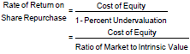
- Repurchase only makes sense if NO superior alternative investment opportunities
  - E.g. 2 alternatives
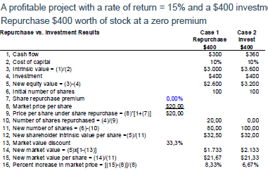
- If premium paid = increase in share P caused by investment project
= indifferent between investment and buyback
- Conclusion
  - Repurchases more attractive if undervaluation , premium and return on available investment projects

4. REPURCHASES VS. DIVIDENDS
= Are repurchases substitute for common annual div payments?
4.1 Advantages repurchase
- Exceptional type of payout
  - Div payment strong signal for company’s LT profit outlook
  - Reducing div strong – impact on sh P
- Taxation
  - Historical tax rates: 40% div, 20% capital gains tax (on profits from repurchases)
  - Tax timing
= sh can choose whether or not to sell sh & can therefore choose to pay capital gains taxes in that particular year, if div are not optimal
  - BE: source tax (RV) on div 30%, tax repurchases de facto 0%
  - Systematic repurchase of shares instead of div NOT allowed
  - US tax reform: 15% both types

4.2 Empirical evidence
= Importance of repurchases vs. Div partly explained by ∆ listed company characteristics
- Shift towards firms that don’t pay div
  - Higher rate of investment, R&D,…
- 25 large div payers accounted for 55.5% of div
- Div & repurchases
= different functions for different economical segments
  - Large, mature firms: * div
  - Small, growing firms: repurchases to offset option grants
- 2005: #firms paying div ≈ #firms repurchasing

4.3 Motives of div vs. repurchase choice
- Dividends
  - - consequences to reducing payout
  - Consistency with historic payout policy
  - Attract retail investors to purchase our stock
- Repurchases
  - Availability of good investment opp to pursue
  - M&A strategy
  - Market P of stock (stock good investment tov value)
  - Make decisions after I plans are determined

If people pay-out capital for 1st time: more often only share repurchases

Alternative use of div funds
- Pay down debt
- Repurchase shares
- M&A
- Invest more
- Retain as cash
- …

5. BUYBACK BOOM
2004Q4-…
Cf. buyout boom
= strong growth in share repurchases
- Corporate profits never higher
- Interest rates low
= substituting equity by debt is cheap
- Shareholder activism

Financial crisis
- Industry-specific drop in repurchases in 2007
e.g. Energy, information technology,…
- General drop in repurchases 2008-2009
e.g. materials, telecommunication services, utilities

Mid 2015 – mid 2016
= return of mega buybacks in US
= Europe buybacks stay low

2017/2018
= more conservative payout policy

