19. Takeover defenses
= How can companies protect themselves against hostile takeovers
Preventive defences & after a bid defences
1. HOSTILE TAKEOVERS
- Preliminary talks
  - Early in M&A process
  - Btw management/board of directors of bidder & target about bidder’s intentions
(P, restructuring plans, etc.)
- Friendly takeover
= when corporations agree on general principles & bid can be launched with target’s approval
- No agreement
  - Drop the deal
  - Hostile takeover
= try to acquire majority of shares (and votes) without support of target’s management and board of directors

Hostile takeovers
= More difficult, take more time & more expensive than friendly takeovers
Historically: not frequently used

Since 2000
- Increase in importance
- Increase cross-border takeovers thanks to lower regulatory restrictions
- Availability of funding through PE & hedge funds
- Reduction in takeover defense mechanisms due to sh activism in the US

2. DEFENSE MECHANISMS
2.1 Indirect strategies
= Companies looking for targets focus on key characteristics
E.g. low performance, low growth, excess cash, low stock price,…

Increase efficiency to reduce prob of becoming target
- Get rid of loss generating activities
e.g. spin-offs, carve-outs
- Sell excess real estate (asset sales)
- Increase leverage (recaps)
- Payout excess cash (div, share repurchases)

Strategy hexagon
= try to implement all possible ways to create value yourself
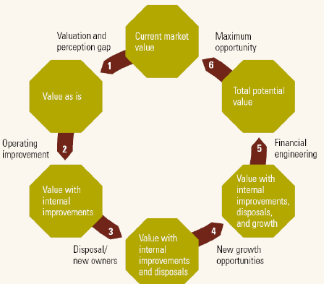

2.2 Preventive strategies
= Shark repellents/ porcupine provisions
= Make acquisition of majority of voting rights as difficult & expensive as possible tos care off potential bidders
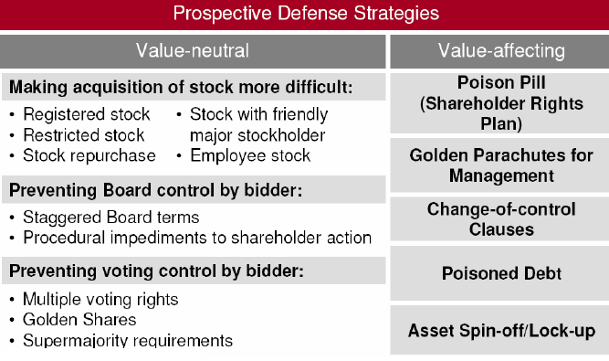

General sh policy
= Max % of shares held by “loyal” parties
- Family
- Friendly corporations & holdings
- Employees (via employee stock option plans)

2.2.1 Shareholder rights
= legally allowed provisions differ from country to country
- Supermajority clause
= all decisions about control ∆ require at least 2/3 of votes
= potentially with board-out and/or fair-price amendment
  - Board-out
= provides board with power to determine when x if supermajority provisions will be in effect
  - Fair-price amendment
= supermajority provisions with board-out clause x additional clause waiving the supermajority requirement if a fair price is paid for all purchased shares
- Preferred stock or stock with multiple voting rights
cf. Dual class stock recap
- Golden shares
= shares with right of veto over control changes
e.g. held by government in former public companies

2.2.2 Board of directors
= can dismantle takeover defences
= make it difficult for bidder to ∆ composition of board

- Staggered board
= election of members spread out through time
e.g. each year only 1/3 of members of board can be re-elected, bidder needs at least 2y to get majority
- Dead hand provision
= only those board members having voted to install a defense mechanism allowed to vote about deactivating it
= prevents a bidder from achieving control of target’s board and then removing pill
E.g. redeem a poison pill

2.2.3 Restructuring
= Make sure that divisions most attractive to bidders are difficult to control/sell
- Spin-offs
- Asset lock-ups
= give options to friendly parties that will allow them to buy specific assets at a predetermined P in case of hostile takeover bid
2.2.4 HR management
= Make sure bidder will have to pay very high layoff costs
- Gold/platinum parachute
= top management can leave with predetermined compensation package if the controlling owner of company ∆
≠ golden handshake
- Tin parachute
= all senior staff/ employees can leave with predetermined compensation package if controlling owner of company ∆
e.g. 12 months wage (even when leaving voluntarily)
- Parachute effects
  - Alignment hypothesis
= managers more willing to support beneficial takeovers (+)
  - Wealth transfer hypothesis
= potential future gains from takeover shifted towards managers (-)
  - Signalling effect
= increase likelihood of takeover
Advantage
= regulated by labor law & allowed in some countries where other defences are illegal
Disadvantage
= very difficult/impossible to remove, also makes friendly takeovers more difficult to succeed

2.2.5 Financial instruments
= Creation of securities carrying special rights exercisable by a triggering event, making it more costly to acquire the firm
- Poison pill
= flip-in pill
= option clause activated in case of hostile takeover bid & that allows to issue a large amount of new shares & sell them at very low P to friendly parties
= provide for a bargain purchase of target’s shares at some trigger point
  - Increases insider ownership
  - Makes it much more difficult for the bidder to get a majority
  - Cost: strong dilution for existing shareholders
- Flip-over pill
= issue rights that allow shareholders to buy bidder shares at a low P
= provide for a bargain purchase of bidder’s shares at some trigger point
= subsidized purchases
- Poison put
= option clause that is activated in case of hostile takeover bid x that allows bond holders to sell their obnds back to company for payback at 100% of nominal value
= protects against risk of takeover-related deterioration of target bonds, at same time placing large cash demand on new owner & thus raising costs of acquisition
- Macaroni clause
= extreme version of the poison put
= bonds have to be repaid far above nominal value

Rationale for poison puts (Cook & Easterwood 1994)
- Entrenchment hypothesis
= pus make firms less attractive as takeover targets
- Bondholder protection hypothesis
= Protecting bondholder value against leverage increases post-deal
- Mutual interest hypothesis
= both managers & bondholders sought to prevent hostile debt takeovers
Negative stock P reaction, + effect on P existing debt
2.3 Ad-hoc strategies
= after bid has been made, often too late to install regular takeover defenses
Need rapid response
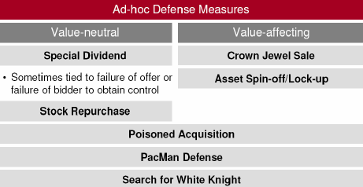

2.3.1 Lawsuits
= Try to prove that takeover would be bad for anti-trust reasons, that there is fraud/disinformation spread by bidder
- Low P(Success)
- Stall for time to organize real defense
  - E.g. for installing poison pill
= Morning after poison pill

2.3.2 Just say no
= management & BoD refuse all cooperation
- Hard to keep up, because management & board are under obligation to max shareholder value
- “Bear hug” strategy by bidder
= make offer at very high premium so that rejection becomes impossible

2.3.3 Standstill agreement
= after negotiations bidder agrees not to buy extra shares for given period of time
e.g. in exchange for seat on board

2.3.4 Pay superdividend
= get rid of excess cash
= can be financed by selling assets the bidder is most interested in (Crown jewels sale)

2.3.5 Share repurchase
= get rid of excess cash + reduces free float, making it more difficult for the bidder to buy a majority of shares on the open market
2.3.6 Whitemail
= issue a large amount of new shares on the open market at low P
- Reduces stake bidder has already bought & makes more difficult to gain majority
- Severe dilution
2.3.6 Greenmail
= buy back shares bidder has already bought at very high premium
“here is some money, now go away”
- Very expensive solution
= announcement effects negative, but dependent upon deal (Negative AR to sh)
  - e.g. standstill agreement
= voluntary contract in which stockholder who is bought out agrees not to make further investments in target company during specified time period (e.g. 10y)
- In some cases not allowed by company bylaws
= antigreenmail amendments

2.3.7 People pill
= management and senior staff threatens to resign if takeover succeeds

2.3.8 Pac man defense
= target launches counter-offer on bidder
e.g. Rio Tinto & BHP Billiton
- P(success) low
= bidder usually much larger & better prepared

2.3.9 Scorched earth policy
= extreme crown jewel sales & activation of expensive defense mechanisms which make a takeover unattractive

Drawback
= activating all defense mechanism can lead to a severe weakening of company & even bankruptcy
= suicide pill
Less destructive: look for external help

2.3.10 External help
- White Squire
= friendly company buys shares to undermine hostile bidder’s (Black Knight) offer
Not acquiring control of target
- White Knight
= company that wants to make a friendly takeover bid to counter the Black Knight’s bid
Problems
  - Finding potential friendly bidder fast enough
  - WK offer often less well-prepared than BK because lack of time
  - WK has to offer higher premium than BK: * bidding war
  - Compensation for risk that friendly offer fails
= break fee paid by target company requesting help
  - * Yellow Knight
= if P(deal failure) becomes too high, the WK may withdraw
- Risk
= WS/WK ∆ sides and joins hostile bidder
= Lady Macbeth strategy
- Gray Knight
= 2nd hostile bidder that tries to take adv of battle btw target & first hostile bidder
= less frequent

WKs often fail to block hostile bidder, but do create extra value (get P per share up)

2.4 Takeover defences in US and Europe
= Different defenses bc of ≠ legal frameworks and ≠ in role of BoD
- US
  - Focus of bidder on gaining control of Board
  - Board has relatively wide array of defences
  - E.g. BASF/Engelhard
    - First E * poison pill & board rejects BASF offer
    - BAF nominates candidates to staggered board
    - E * stock repurchases
    - BASF increases offered pps, but still rejected, after extra increase accepted
- Europe
  - Power of Board more limited
  - Board limited in defense options
  - Focus of bidder on convincing stockholder directly
  - E.g. Mittal/Arcelor
    - Offer rejected
    - Arcelor * defense: increased regular div, * special div,* asset lock-up
    - Increase offer, A * WK Severstal
    - Arcelor pays break fee to Severstal & gets taken over

EU Takeover bids directive (2004/25/EG)
= regulatory pressure to NOT increase defensive measures/barriers to transfer of capital/res/employees
You can defend yourself, but in a normal way (e.g. no poison pills)

General principles
= improve transition of ownership, protect minority sh, improve transparency, reduce takeover defense mechanisms

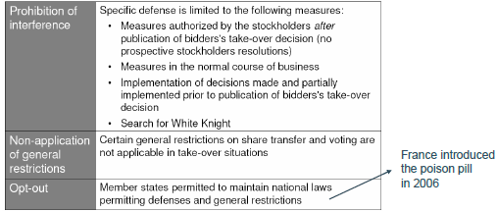

- Opt-out has led to low implementation of key parts of directive
- Board neutrality rule (Art. 9)
= during bid period, board of target must obtain prior authorization from general assembly of sh before taking action which might result in frustration of bid
  - Implemented by 19 member states (13 with exceptions)
- Breakthrough rule (Art. 11)
= neutralizes pre-bid defenses during takeover by making certain restrictions (e.g. share transfer/ voting restrictions) inoperable during takeover period & allows successful bidder to remove incumbent board of target &modify articles of association
  - Implemented by 3
3. DO TAKEOVER DEFENSES WORK?
= Empirical evidence about effectiveness of many preventive strategies mixed
- Strongest defense
= combi of poison pill x staggered boards, doubles P(failure) hostile bid
  - Target remaining independent
= lower stock return than companies taken over by BK or WK
- Effect on shareholder value
  - Positive effect
= if management thinks extra defenses are necessary, P(takeover bid) is high
  - Negative effect
= if takeover defenses work, P(takeover premium) decreases
  - Mixed evidence
    - Announcement effects often not significant
    - Slight tendency towards negative response
= especially in more recent studies
- Effectiveness & stock P impact
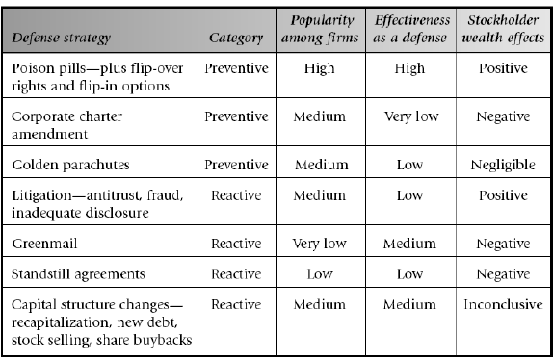
  - Effectiveness
= Most individual defenses have -, but often small impact on takeover likelihood
= effects often difficult to separate

US shift towards softer strategies
= after major stock market scandals
- More attention good corporate governance
- Sh activism
= sh more active when * concerned about managerial actions to create impediments to the market for corporate control
- Shift towards less extreme defense mechanisms
  - Way less poison pills
  - Less staggered boards
  - Proxy fights were lower, nowadays back up
    - Activist sh try to get seat on board to influence policy
= strengthen governance, reduce power of management & reduce defenses
= power of attorney given from small sh to others so they can use votes
  - Less extreme: activist campaign objectives
    - M&A, board changes, business strategy
(Not often strategy changes, but frequently part of end result)
    - Growing importance in Europe
Poison pill as entrenchment tool allowing incompetent management to protect itself against bidder that could create more value for sh
Lower defenses = more hostile takeovers

