Economics of innovation

- model with inverse demand P = 100 - Q and c(0) = 30 (10 points)
  - Calculate equilibrium quantity and monopoly profit
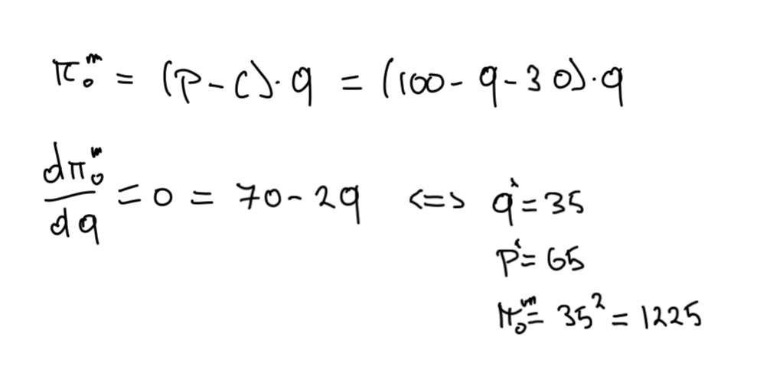
  - Calculate equilibrium quantity and monopoly profit (and profit gain) if innovate and c(1) = 20
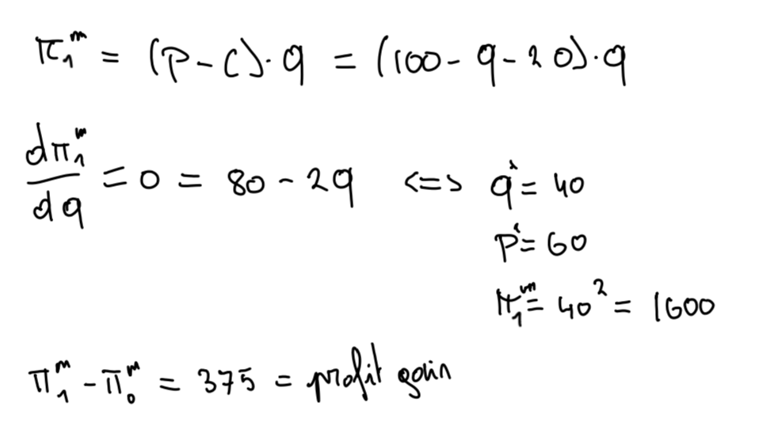
  - Calculate equilibrium quantity and profit under perfect competition (same c(0) = 30)
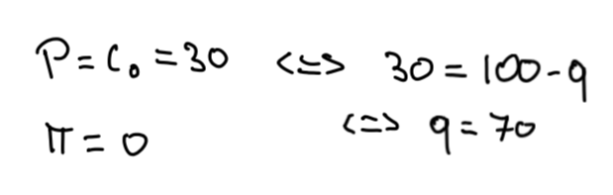
  - Calculate equilibrium quantity and profit (and profit gain) if a company innovates (non-drastic) and c(1) = 20
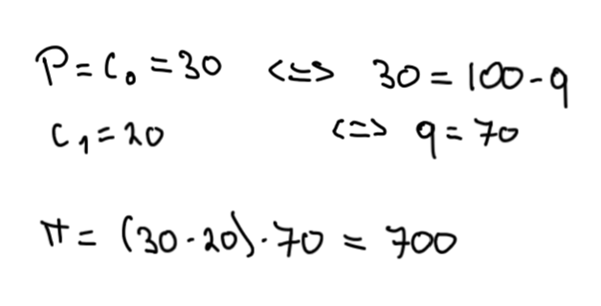
  - Compare the profit gains and discuss, why are they different under the different market situations
replacement effect
- Patent race model (10 points)
  - Give the payoff matrix, given a probability p and explain
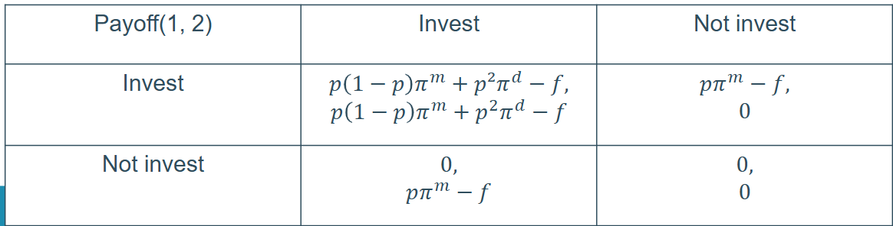
  - Explain wasteful R&D, how when and why it happens. How should a policy maker take this into account?
Rant about how it’s not socially optimal but that policy makers should ignore
this since it’s more a theoretical phenomenon (we always welcome more
R&D)
- Explain how tax credits and allowing collaboration work and how and when a policy maker should use these tools (10 points)
-> lecture 9
- One guest lecture was about international R&D (10 points)
  - explain ‘home-base-exploiting innovation sites’ and ‘home-base-augmenting innovation sites’
  - What are the reasons a firm would establish either sites
- Explain dynamic and static efficiency, what should a welfare maximizing policy maker to to create the optimal patent (10 points)
-> lecture 6

