1. Introduction

1. SCHUMPETER’S HYPOTHESES
Joseph Schumpeter (1883 – 1950)
= First who systematically thought about innovation within econ analysis
Innovation
= doing things differently
vb. New commodities, new sources of supply of materials, reorganizing industry (* monopoly)
! Innovation ≠ invention (scientific novelty)
! Inventor (produces ideas) ≠ entrepreneur (gets things done)

2 Famous hypotheses
Schumpeter’s Mark I: MAIN hypotheses
= Hypothesis of creative destruction
- Industries mostly large-nr oligopolies
- Entrepreneur essential to innovation (19th century)
Put new method into practice, later settles down as manager/owner
Intuition of life-cycle model of person
- NEW (small) firms create innovation
- Large firms: old x inflexible
(eventually replaced by entrepreneur who does things differently x better)
- Existing firms go bankrupt because of innovative new firms

Schumpeter’s Mark 2
= Hypothesis of innovative older firms
- Early 20th century: industry mostly concentrated market structures
- Development now sophisticated x costly (only profitable on large scale)
- Few can afford (5% of discoveries make the market)
- SMALL companies cannot innovate (cope with all the failures)
- BUT technology so entrepreneurs stay successful

Schumpeter’s theory
= 3 market failures: externalities, indivisibilities x uncertainty
Large firms
- Able to spread (fixed) costs of R&D over larger sales base
- Exploit economies of scale
- Diversified: more chance unexpected discovery (serendipity)
vb. Post-it
- Advantages in raising financing
- Advantages in hiring skilled people
Concentrated supply-side market structure favors innovation (oligopolistic)

General
= Incentives to innovate (mostly money) play important role for technological progress
= Policy makers high interest in fostering incentives to innovate

2. NATURE OF INNOVATION x R&D
Investment in innovation
- Investment in period t
- Expected profits in periods t + x
- BUT: Investment in RxD is different
  - Hardly recouped (high sunk cost)
  - Incomplete appropriability of returns
  - Risky (uncertainty project outcome/ returns)
  - High probability no returns at all
  - Coslty to finance externally – reliance on internal funds
  - If internal funds not available + external too expensive: R&D constrained

Definitions of innovations
What is innovation?
= “ultimate result of creative process RxD”
= RxD may lead to invention x if invention is commercialized, this is innovation

Product vs process innovation (in Industrial Organization Theory)
Product innovation
= generation, introduction x diffusion of new product (production process unchanged)

Process innovation
= generation, introduction x diffusion of new production process (products unchanged)
(mostly lower MC)

Article Belleflamme/Peitz
= product innovation nothing but extreme case of process innovation
= New product already existed, simply too expensive to produce
So required process innovation to make new product available

Drastic vs. non-drastic process innovation
Drastic (major) process innovation
= reduces cost to such extent that innovator can behave as monopolist (no competition)
New monopoly P (new MC) < Former P (= old MC)

Non-drastic (minor) proc inno
= Rivals can still compete on market
P^{m}(C_{new}) > C_{old}

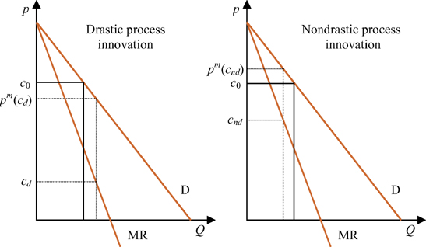
Other types of innovation
- Organizational Innovation
= New business practices for organizing procedures
= New methods of organizing work responsibilities/ decision maing/ external relations
- Marketing Innovation
= Implementation of new marketing method
(significant changes in product design/ placement/ promotion/ pricing)
- Design innovation

2. Market structure & incentives to innovate

1. MARKET STRUCTURE X INNOVATION
Incentives to innovate
- Process innovation increases profitability
- Drastic innovation creates monopoly
- How much to invest? Depends on market structure

2. ARROW MODEL (1962): process innovation
= Which market structure is best to innovate?
- Some investor developed new procedure that MC
- Monopolist = willing to pay the amount of extra profit
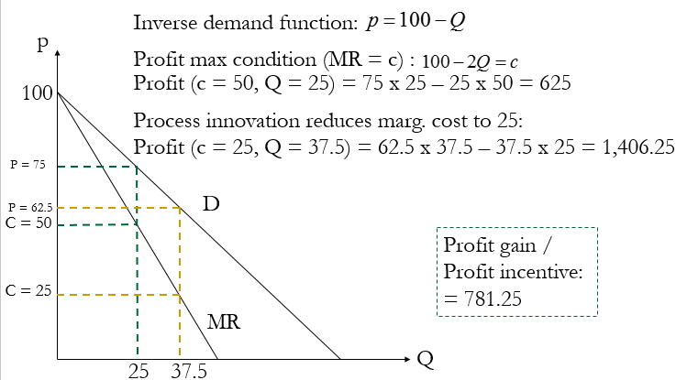
- Firm in perfectly competitive market
= willing to pay ∆ in MC (Since it’s the only one with lower MC, set’s price right below other MC x * profits)
Innovation yields greater profit in perfectly competitive industry than in monopoly situation

Replacement effect (Tirole 1988) monopoly
= replaces own profits with slightly higher ones (↔ competitive firm: creates profit for 1st time)
- Drastic innovation
Incentives to innovate comp firm: π^{M}
Incentives to innovate monopoly: π^{M}₁ – π^{M}₀
- Social value > Value for competitive firm (fails to appropriately increase CS)
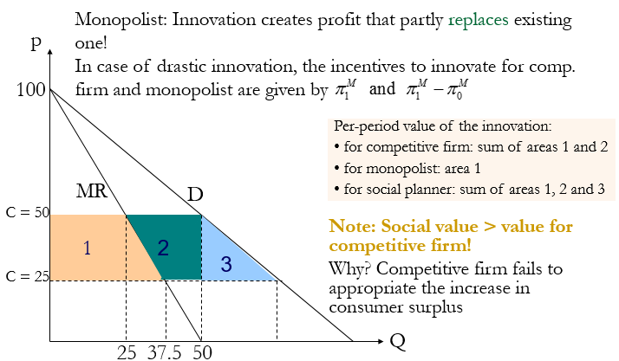

! Underlying assumptions
- No financing constraints
- Innovation external to the firm
- Firm that bids more gets innovation with certainty
- No entry

3. PRODUCT INNOVATION
= difficult analysis due to
- Profits caused by differentiation (even in comp. industry)
- Monopolist gets change to price-discriminate
- Replacement effect reduced by consumers that buy old goods

Non-drastic innovation
= competitive firm still face lower replacement effect than monopolist, larger incentives to innovate
! Monopolist may be able to sell more units (=bigger incentive)

Drastic innovation
= new product makes old one obsolete
= greater incentives to innovate if competition in old product is intense

