3. Strategic interactions between firms
Vb. Monopoly threatened by entry (* duopoly)

Market structure x innovation
Vb. Article Belleflamme/Peitz + Looking for Mr. Schumpeter (168-172)

1. GILBERT/ NEWBERY’S AUCTION MODEL
(Belleflamme/Peitz 18.2.1)
- 1 Incumbent (monopolist)
- Process innovation for sale
- Monopoly position threatened when outsiders bids for innovation
= challenger
Who bids/ invests most?

Result
= Under certain circumstances: monopolist greater incentives than competitive firm if invention is non-drastic
! ↔ Arrow result

Framework of Gilbert/ Newbery
- Monopolist wins
= keeps earning monopoly profits
- Monopolist loses
= competitor enters markets (*duopoly)
Monopolist incentive to bid more than rival = difference in profit 1 vs. 2
Bid more with non-drastic innovation
Bid exactly same with drastic innovation (since firm 2 would become monopolist when winning)
Explains persistence of monopolies

Efficiency effect
= Fear of losing monopoly position provides the incumbent with stronger incentive
- Monopolist has incentive to stay monopolist
- Higher incentives incumbent if firms’ products are close substitutes
- Incumbent can mimic choices of duopolists
- Monopoly position prolonged through innovation

Monopolist threatened by entry = willing to pay more for minor innovation than potential entrant who can produce close substitute to monopolist’s product

Formal exposition
- Incumbent x entrant can acquire innovation (lower MC)
- Entrant can enter profitably only with innovation
- C1 = MC with innovation, C0 = MC without
- Incumbent gets innovation: entrant stays out
  - Incumbent profit = π_{m}(c1)
  - Entrant’s profit = 0
- Entrant gets innovation: entrant enters with MC = c1
  - Incumbent’s profit: π_{d}(c0,c1)
  - Entrant’s profit: π_{d}(c1,c0)

Monopoly threatened by entry
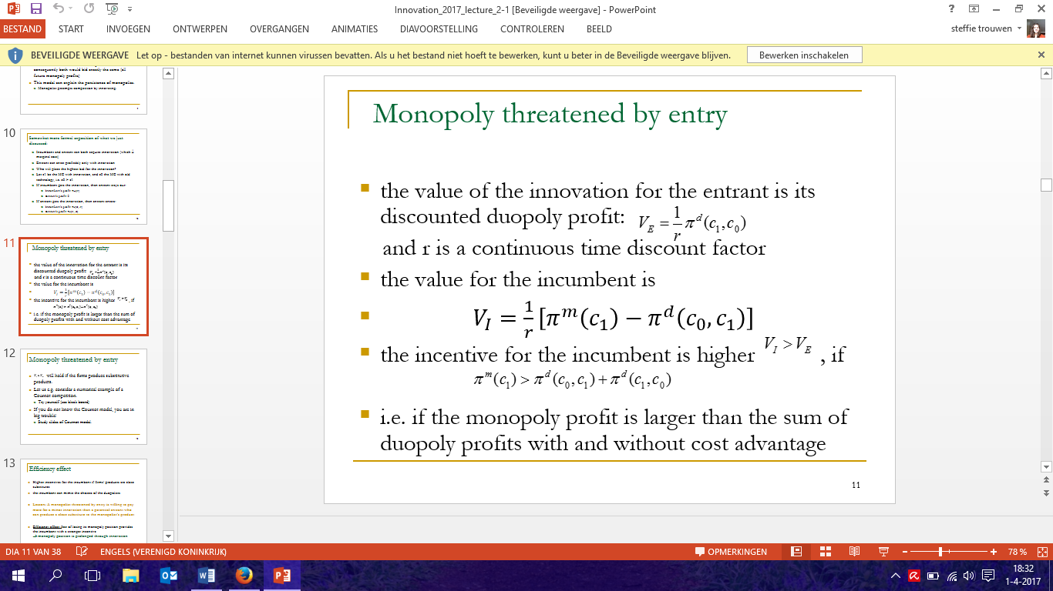
Value inno for entrant
= discounted duopoly profits : V_{E} =
Value inno for incumbent
= V_{I} = monopoly profit (C1) – duopoly profits (C0, entrant C1)
=
Incentive incumbent higher if V_{I} > V_{E}
=
V_{I} > V_{E} : holds if firms have substitutive products

! Numerical example Cournot competition
- Homogeneous good
- 2 identical firms in same market
- Entry not possible
- Firm 1 observes output other firm x sets Q to maximize own profit
Q₁* = (a-c)/3b = Q₂*
Key assumptions Gilbert/Newbery
- Firm bids most wins patent with certainty
Without this assumption * patent race model Reinganum (1983)
- Patent provides perfect protection against future competition
- Entrant that wins patent cannot bargain with incumbent for exclusive rights to technology (No licensing)

(definitions in empirical test)
Incumbent
= firm that innovates in order to keep/ enlarge its market share
Challenger
= potential entrant as a firm stating in the survey that the goal of its innovation activity is to enter the market

