Topic 3. R&D cooperation

1. R&D COOPERATION
= with x without public encouragement widespread
for instance in high-tech industries

Vb. 1970’s Japan
= collaboration mbt R&D allowed
Goal = increase competitiveness in semicond industry: worked!

1. Motives for collaboration
- Internalising knowledge spillovers within the consortium
- Greater efficiency of R&D
- Greater amount of financial resources available
- Sourcing of complementary know-how
- Elimination of wasteful duplication in efforts
- Larger x more risky projects may become feasible

2. Cooperation between
- Horizontally related competing firms
- Horizontally related non-competing firms
- Within x across industries
- Vertically related firms (customers x suppliers)
- Universities x Public Research Centers

Contract/ equity based
Differ according to objective of joint R&D undertaking

3. Questions
- Does cooperation increase or reduce R&D
Reduce f.ex. learn a lot that we had otherwise invested in ourselves (avoid duplication)
- Results in terms of patents with/without cooperation
- Should firms be allowed to coordinate their decisions at R&D stage?

4. Innovative environment
- Ideas common knowledge
- R&D investments result immediately x fors ure into an innovation
- R&D inv = form strategic commitment
- R&D leads to spillovers which benefit other firms
- Firms may cooperate on R&D decisions to internalize spillovers

2. THEORETICAL MODEL ON KNOWLEDGE SPILLOVERS X R&D COLLABORATION
D’apremont/ Jacquemin (1988) in AER
- 2 firms compete à la cournot
- 2nd stage of game
- First stage: choose to invest in R&D (reduce mc) x how much
- Spillovers present

Compare 2 situations
- Firms behave completely non-cooperative
- Firms allowed to cooperate on R&D, still compete on product market

What happens to total R&D in economy x equilibrium profits x output

2. The model
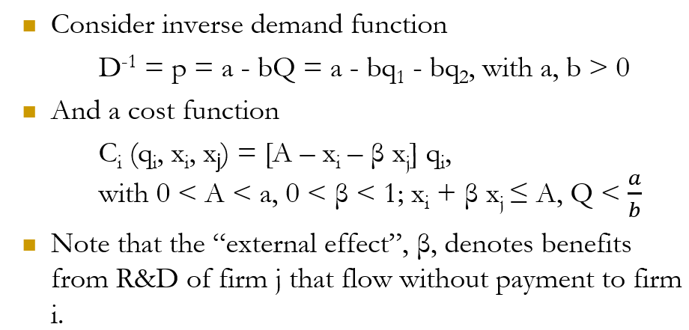

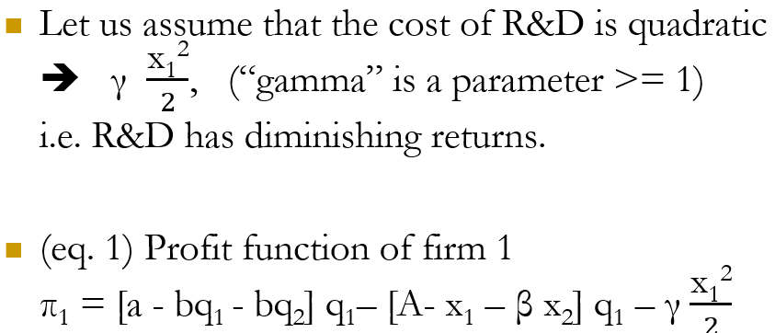
1. Non-cooperative behavior
- To get FOC: neem afgeleide profit mbt q
- Symmetrische firms dus q₁* = q₂*
- Best responses berekenen
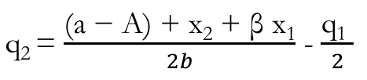
- q₁ en q₂ gebruiken om niveau R&D te boordelen (first stage of game)
q₁ (q₂) in evenwicht profit 1 (2) x afleiden mbt x₁ (x₂) en = 0
- Bereken Q* = q₁* + q₂*
Dit vgl we met Q in cooperative behavior

2. Cooperation allowed
! Only difference in 1st stage where they choose R&D
Optimise joint profits wrt R&D
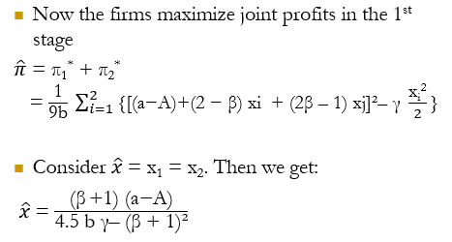
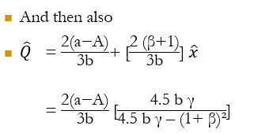

3. Conclusions
- If firms can collaborate on R&D
= internalize external effects through joint decision
- X* compared with ^x
= for large spillovers (ß > 0.5), R&D increases when firms cooperate
(^X >x*)
- No spillovers: output x R&D higher without collaboration
- Also in that case: higher industry output means lower consumer prices (higher CS)

4. Examples of model equilibrium with numbers
= choose random nr for parameters a, A, b, ɣ, ß

3. Summary
R&D activities with spillovers create 2 externalities
- R&D affects overall industry profits
  - Externality with level of spillovers
  - Ignored when firms choose R&D separately
  - Internalized when chosen cooperatively
- R&D affects a firm’s competitive advantage w.r.t. its rival
  - Externality with level op spillovers
  - Present when firms choose R&D separately!
  - Internalizezd when chosen cooperatively

4. A government initiated collaboration
Sematech
- US response on Japanese R&D coll (many years later)
- Initiated subsidies program
- All firms kept own R&D lab (50% government subs)
- Successful, but reduced total R&D spending!
= in contrast with theoretical modell…

5. Flemish data on R&D collaboration
40% collaborates in some way for R&D

Collaboration models
31% vertical partners (suppliers x customers)
29% science (university, PRC)
12% horizontal partners (competitors)

Agreements between firms that contribute to techn progress may be permitted under EU competition law!

Block exemption
Block exemption for R&D cooperation if
- Combined market shares < 25%
- No contractual restriction on independent R&D
- No restrictions on use of jointly generated knowledge
- Threat to break up R&D collab could be part of punishment strategy that creates incentives for firms to restrict output
If block exemption does not apply, may still be permitted by European Commission (exemptions)
Sometimes with extra limits

What if firms extend cooperation to product market?
= R&D coop x info sharing not necessarily permitted! (even less encouraged)
- Public policy trade-off market power (because collusion x abuse market power) |
x efficiency (R&D coop)
- Not clear how trade-off balances out
! Antitrust authorities must make sure cooperation is limited to R&D activities

