TOPIC 1 : R&D INNOVATION AND MARKET STRUCTURE

- INTRODUCTION

- Schumpeter’s Hypotheses

Schumpeterian Competition
- Shumpeter : innovation as ‘doing things differently’
- Examples :
  - Introduction of new products
  - New ways of producing old products
  - Opening up of new markets for new products, sources of materials
  - Reorganizing an industry by making a monopoly

- Invention Innovation
  - Invention : involving scientific novelty
  - Innovation : might or might not be related to invention
- Inventor Entrepreneur
  - Inventor : produces ideas
  - Entrepreneur : gets things done which may, but not need, to embody anything that is scientifically new

Schumpeter’ main hypotheses
- Schumpeter’s view changed over time

- Schumpeter’s Mark I
  - Context : industries were characterized by large-numbers oligopolies of early industrialization
  - Entrepreneur was central to innovation
    - Put into practice a novel method of production into a new firm
    - Then took a owner-management position
    - If successful => get old and conservative in the process
    - => life-cycle model of a person
  - It is the NEW and small firm that innovates
  - As the firm becomes old and large => becomes inflexible => new entrepreneur with new firm
  - = CREATIVE DESTRUCTION

- Schumpeter’s Mark II
  - Context : industry is characterized by concentrated market structures
  - Big businesses were creating standard of life instead of keeping it down
  - Most of cheap and simple inventions have been made
    - Development is now sophisticated and costly
    - It must be on sufficient scale to be successful

Schumpeter’s theory
- 3 market failures
  - Externalities
  - Indivisibilities
  - Uncertainty
- Large firms
  - Spread costs of R&D over a larger sales base
  - Exploit economies of scale and scope in R&D
  - More likely to exploit an unexpected discovery
    - = SERENDIPITY
  - Spread risk involved in R&D by undertaking many projects at same time
  - Advantages in raising financing for R&D
  - Advantages in hiring skilled people
- Conclusion
  - Concentrated supply-side market structure favors innovation
    - Competitive oligopoly

Discussion of Schumpeter
- No ambiguous truth to be found about his ideas
- ‘incentives to innovate’ play an important role for technological progress
  - Incentives : money and expected profits from investment
  - Economists are still debating these incentives structures
  - Policy makers have a high interest in fostering incentives to innovate

- Types of innovation
Nature of innovation and R&D
- Investment in innovation is characterized by
  - Investment in period t
  - Expected profits in period t+x
- Investment in R&D and innovation is different from other types of investment
  - Hardly be recouped (=terugverdiend) as it is characterized by high sunk costs
  - Incomplete appropriability of returns
  - Risky
  - High probability of no returns at all
    - Low inside collateral value
    - High adjustment costs
    - Asymmetric information
  - Costly to finance externally , reliance on internal funds

What is innovation?
- Typically seen as an ultimate result of a creative process
- R&D may lead to an invention
- When an invention is commercialized : innovation

Product vs. process innovation
- Product innovation
  - Generation, introduction and diffusion of a new product
  - With production process being unchanged
- Process innovation
  - Generation, introduction and diffusion of a new production process
  - With products being unchanged

- Basic theories mainly focus on process innovation
  - Often represented by a reduction in marginal cost
- Belleflamme/peitz:
  - Product innovation is nothing but an extreme case of a process innovation
  - The new product already existed but was simply too expensive to produce; so it took process innovation to make the new product available

Drastic vs. non-drastic process innovation
- Drastic = major
  - Reduces cost to such an extent that innovator can behave as monopolist without being constraint by competition in the industry
- Non-drastic = minor
  - Rivals can still compete on market
  - Price drop isn’t big enough to be able to put price under c0

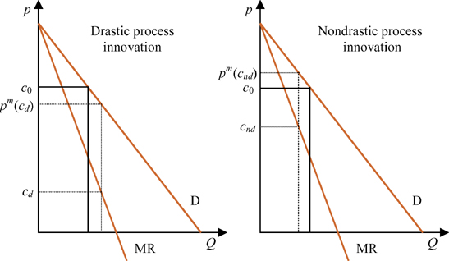

Other types of innovation
- Organizational innovation
  - New business practices for organizing procedures
  - New methods of organizing work responsibilities and decision making
  - New methods of organizing external relations
- Marketing innovation
  - Changes in product design or packaging, product placement, promotion or pricing
- Design innovation
- MARKET STRUCTURE AND INCENTIVES TO INNOVATE

- Incentives to innovate
- Process innovation increases profitability
- Drastic innovation may create a monopoly
- How much investment? Depends on market structure

- Arrow model

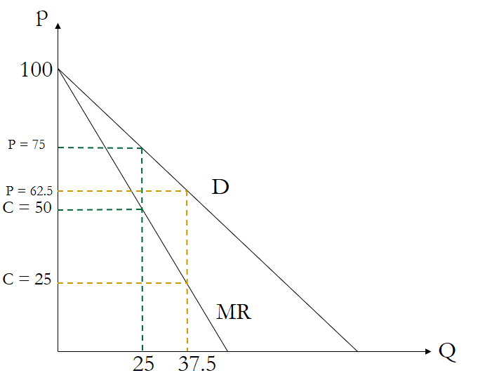

- Inventor has developed a new procedure for production of a good
  - Reduces constant MC
- Market equilibrium?
  - Monopoly profits = $p*Q- C_{0}*Q$
  - Maximize : dprofits/dQ
    - (Monopoly profits afleiden en = 0)
- Graphical
  - $C_{0}$ and MR : intersection => find Q*
  - Q* and D : intersection => find P*
- Gain by innovation
  - $P_{0}-P_{i}$

- Competitive situation
  - First : zero profit
  - Second : big profit => serve entire market (price slightly less than previous)

- a competitive firm places a larger value on a minor process innovation than a monopoly does
- the profit incentive to innovate may follow an inverse U-shape as the number of firms in the industry increases
- oligopoly has highest incentives

- Replacement effect

- Innovation gives greater profit for perfectly competitive industry than monopoly
- Higher incentives for competitive firms to invest in R&D
- Competitive firm willing to pay more than monopolist => replacement effect
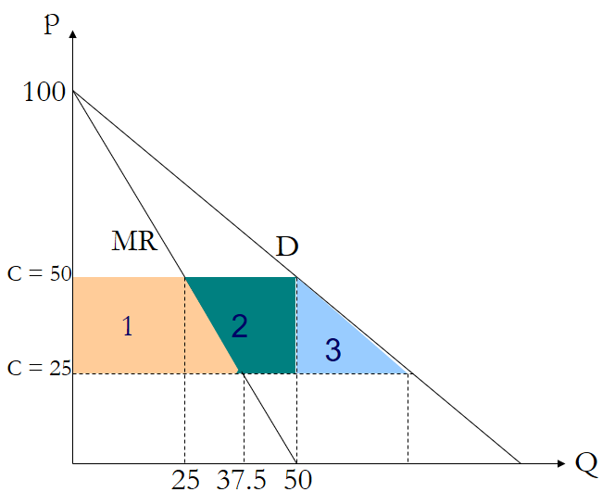

- Graphical
  - Value of innovation
    - Competitive firm : area 1 + 2
    - Monopolist : area 1
    - Social planner : area 1 + 2 + 3
  - Social value > value for competitive firm
    - Competitive firm fails to appropriate the increase in consumer surplus

- Underlying assumptions
  - No financing constraints
  - Innovation is external to the firm
  - Firm that bids more gets innovation with certainty
  - No entry

- Product innovation

- Non-drastic innovation
  - Competitive firm may still face a lower replacement effect than a monopolist
  - Monopolist may be able to sell more units and have larger incentives to innovate
- Drastic innovation
  - Competitor may have greater incentives to innovate if competition in the old product is intense

- GILBERT AND NEWBERY

- Auction model

- Monopolist and somebody (=challenger) has a process innovation for sale
- Auction model : the one who bids most wins the prize

Results : non-drastic
- Monopolist has a greater incentive than a competitive firm to bid for the patent if the invention is non-drastic
  - Arrow result

- If the monopolist wins
  - It remains monopolist and earns monopoly profits
- If the monopolist loses
  - Competitor enters market => duopoly with old vs new technology
- Monopolist’s incentive to invest is difference between these 2 scenarios

Efficiency effect
- Monopolist has an incentive to stay monopolist
- Higher incentives for the incumbent if firm’s products are close substitutes

Results : drastic
- The old monopolist or the entrant will be the new monopolist
- They would bid exactly the same = all future monopoly profits

Calculations
- Value of innovation for entrant = discounted duopoly profit =
  - Rr = continuous time discount factor
- Value of innovation for incumbent =
$V_{I}=\frac{1}{r}\left[π^{m}\left(c_{1}\right)-π^{d}\left(c_{0},c_{1}\right)\right]$

- Incentive of incumbent is higher if :
  - => if the monopoly profit is larger than the sum of duopoly profits with and without cost advantage

  - Will hold if the firms produce substitutive products

- a monopolist threatened by entry is willing to pay more for a minor innovation than a potential entrant who can produce a close substitute to the monopolist’s product

Assumptions
- Firm that bids most wins the patent with certainty
  - If not : patent race model
- Patent provides perfect protection against future competition
- Entrant that wins patent cannot bargain with the incumbent for exclusive rights to technology (no licensing)

- PATENT RACE MODEL (Reinganum)

- Addition of time and uncertainty
- Patent race => be the first to come up with an innovation

Firms decide about
- Intensity of investment
- Timing of investment

Combined influence of
- Replacement effect
  - Monopoly power = disincentive for R&D for incumbent
- Efficiency effect
  - Threat of entry = incentive for R&D for incumbent

Result of Gilbert/Newbery disappears when
- R&D follows a discovery process and in every period there is only a certain chance to win the patent
- Innovation is drastic

Result of Arrow’s replacement effect disappears
- If risk of entrant’s innovation is low, monopolist has lower incentive to invest as it only benefits incrementally from the innovation
  - New profits – old profits
- If the entrant is likely to succeed, the monopolist will invest at most the same if the innovation is drastic, but never more

- results depend critically on assumptions made
- it remains an empirical question who has the higher incentives to innovate

- Empirical research

- JOSH LERNER : An empirical exploration of a technology race

Set-up
- ‘who innovates more? The leader or the follower?
- He collected data from the disk drive industry
- Innovation focuses on how to get more memory storage capacity per inch²

Does his empirical test reflect the models well?
- Models are about incumbent firms and firms that might challenge these firm’s market position
- The ‘challenger’ is a firm that potentially innovates in order to enter the industry (is not yet active in this market)

- Josh : looks at firms that are already active in industry
  - Leader vs follower story
  - Innovation could be interpreted as incremental

- CZARNITZKI AND KRAFT : an empirical test of the asymmetric models on innovative activity : who invests more into R&D, the incumbent or the challenger?

Identification of firms
- Incumbent = firm that innovates in order to keep or enlarge its market share
- Challenger = firm stating in the survey that the goal of its innovation activity was to enter new markets

Results
- We study R&D intensity instead of actual innovation (as Josh Lerner did)
- We find evidence in favor of patent race model instead of Gilbert-Newbery model
  - Incumbents invest less into R&D than challengers

- CZARNITZKI AND KRAFT : which firms buy licenses? Market positions and license expenditures

Instead of R&D investment, we use license expenditure as dependent variable
- Firms buy inventions from others
- They know what they get for their investment
  - R&D : here we do not know what we get for investment

Results
- By changing dependent variable the results turn around
  - Incumbents invest more
- Gilbert-Newbery considered an auction
  - If you win the bid, you know what you get with certainty
- License expenditure reflect this better than R&D investment

