TOPIC 4

- KNOWLEDGE AS A PRIVATE GOOD

- Characteristics of knowledge

Knowledge is public good
- Non rival
  - The use by one person does not preclude the use by someone else
- Non excludable
  - It is not possible to exclude anyone from using it
- No additional cost for additional user

Private good
- Production is costly
- Additional good imposes a cost for its producer and buyer

- Demand and Supply for private good

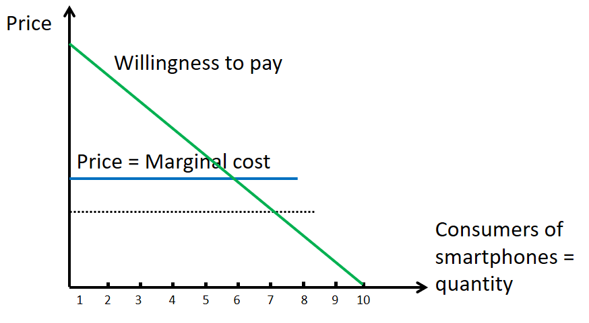

- Demand and Supply for public good
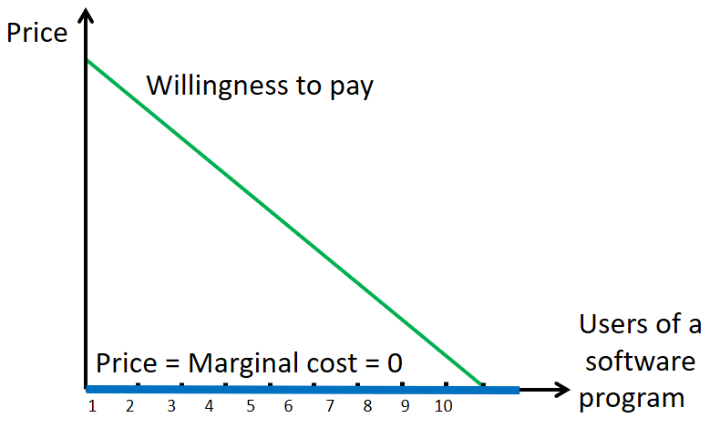

- UNDERINVESTMENT IN KNOWLEDGE

- Problems

Public goods
- Efficient competitive price for a public good = 0
- This will not cover the cost of developing the software program
- Original inventor has incurred costs, but is not rewarded
  - Underinvestment in knowledge
  - Software will not be developed and no one will profit

Private goods
- It has both development and simple production costs
- The use of technology by producers does not imply any cost
  - Smartphones can be supplied at MC of production by anyone
- Original inventor will nog be rewarded for his development
  - Can only charge the MC
  - incentive to develop new technologies is low

- Intellectual property rights as solution

- What are IPR?

- The rights give to persons over the creations of their minds
  - Usually give the creator an exclusive right over use of creation for certain time
- Social purpose :
  - Provide protection for results of investment in innovation
  - Giving the incentive and means to finance R&D activities
- Facilitate the transfer of technology in the form of foreign direct investment, joint ventures and licensing

- IPR make developer a monopolist

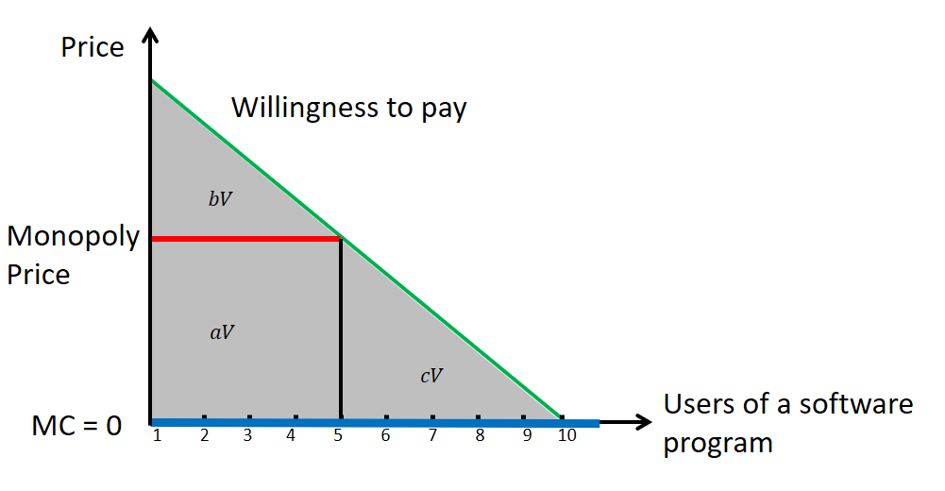

- IPR make inventor monopolist

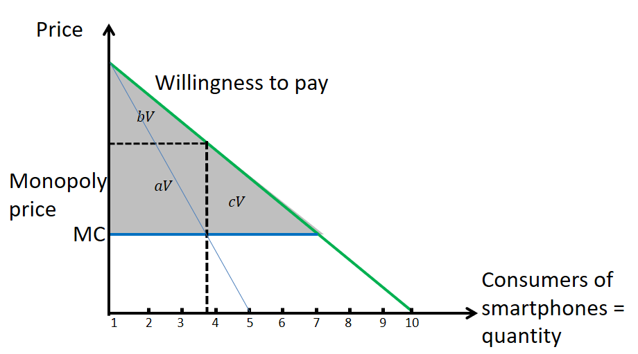

- Effect of IPR

 | Consumer surplus | Producer surplus | Deadweight loss
Competitive setting | $$aV+bV+cV=V$$ | $$0$$ | $$0$$
Monopoly setting | $$bV$$ | $$aV$$ | $$cV$$
Impact of monopoly pricing | $$-$$ | + | +

- Consumer surplus reduces
- Producer surplus increases
  - Monopolist can make profits
  - inventor can pay its development costs
- Overall welfare reduces
  - Because there is now a deadweight loss => major shortcoming of IPR

- Ex-ante justification of IPR
  - Incentive mechanisms needed to induce inventions
- Ex-post defect
  - Deadweight loss
  - Not all users are willing to pay more than MC

- Overview of IPR
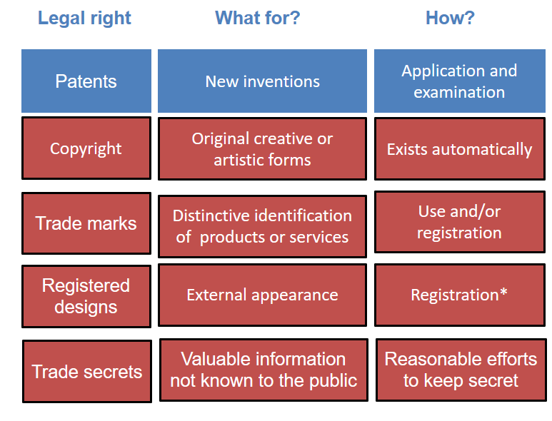

- Introduction to patents

- Rights from patents

- Prevent others from making, using, offering for sale, selling or importing infringing products
  - In the country where the patent was granded
- Sell these rights or conclude licensing contracts and generate licensing revenues
- For up to 20 years
- The patent does not grant the right to use the invention

- What can be patented?

- Any inventions in all fields of technology
- Provided that they are
  - New
    - New at the date of filing the patent application
    - New if it does not form part of the ‘state of the art’
      - State of the art = everything made available to the public
    - No public disclosure of an invention before filing the patent application
  - Involve an inventive step
  - Have an industrial application

- What cannot be patented?

- Discoveries , scientific theories and mathematical methods
- Aesthetic creations
- Schemes, rules and methods for performing mental acts, games, doing business, …
- Presentations of information
- Computer programs
  - Unless it causes a further technical effect going beyond the normal physical interaction between the program and the computer
- Inventions whose commercial exploitation would be against morale
- Plant or animal varieties
- Medical information for treatments

- What rights does a patent offer?

- Right to prevent third parties from commercially exploiting an invention without authorization
- Not a right to use
- Right to assign or transfer ownership and conclude licensing contracts

- Who is entitle to apply for and obtain a patent

- Any natural or legal person or anybody equivalent to a legal person
- Joint applicants
- Must designate the inventor
- If applicant is employee
  - It is in the name of firm

- What must be disclosed in a patent application?

- Detailed description of at least one way of carrying out the innovation
- Information that is sufficiently clear to a person ‘skilled in the art’
- Information is published in the patent document so that everyone can benefit from it
- Patent bargain = disclosure of the invention in exchange for patent protection
  - In exchange for patent protection and temporary monopoly, inventor is forced to publicly disclose his invention in order for others to build on it

- Can trade secrets be an alternative to patents?

- If the invention is a process, ‘trade secrets’ can be a viable alternative
- Problem :
  - Can leak out and then there is no protection
  - Once the invention has been disclosed, It cannot be patented

- Where can a patent application be filed?

- National patent offices
  - National patent valid only in that country
    - Non-nationals can apply too
  - 12 month right of priority for international applications
- European patent office = EPO
  - Equivalent to national patents in the countries for which it was granted
  - Applicant chooses the countries
  - Cost depends on the number of countries
- Patent cooperation treaty PCT
  - One application for 141 contracting states

- Patents from an economist’s point of view

- The legal monopoly

- Gives the owner the right to exclude others from using the innovation
- Legal monopoly to be the only user of invention
  - Monopoly generates a deadweight loss
  - Distortion of free market

- Technology spillovers

- Patents are intended to provide the inventor protection from technology spillovers
  - Spillovers are only bad for inventor
  - Consumers and imitators profit from spillovers
- Patents still allow some spillovers
- Patents contain patentable and non-patentable knowledge that is free to use
  - Inventors get new ideas from reading existing patents
- cumulativeness of knowledge

- Patent length

- After expiration of the patent everyone can use it freely
- Consumers point of view
  - Patent life to be short
  - Want to move to low prices with many firms providing the product
- Inventors point of view
  - Patent life to be long

- Empirical evidence on the use of patents as protection mechanism

- Importance of patents is often overestimated
  - Better : lead time and secrecy
- Reasons to patent
  - Prevention from copying, blocking others from patenting, use in negotiations, …
- Reasons not to patent
  - Inventing around is easy, demonstrating novelty is difficult

- Alternatives to IPR

- Prizes
- Research funding
- Procurement
- Secrecy

- Nordhaus model

- Choosing the optimal patent length

- Patent protects an innovation for a limited time
- The longer patent life => the higher value of the profits to the innovator and the higher his incentives to innovate
  - But : the larger the deadweight loss for the consumer
- Trade-off between increasing incentives and increasing deadweight loss

Discounted time
- Discounted time from present until the expiration of the patent at time τ
$T= \int_{0}^{τ}{e^{-rτ}}dt=\frac{1}{r}\left(1-e^{-rτ}\right)$
  - τ ≥ 0
  - r = discount rate
  - ordinary : 0 ≤ τ ≤ ∞
  - Discounted Time :
    - From T = 0 (corresponds to τ = 0)
    - To T = $\frac{1}{r}$ (corresponds to τ = ∞)

Nordhaus model
- Model in which only one inventor can produce an invention that lowers average and MC of production of a consumer good
- No uncertainty
- Perfectly competitive market, no firm makes profits, initially all goods are sold at MC $c_{0}=p_{0}$
- Demand for the good each period is linear
$Q=A-bP$
  - A > 0
  - b > 0
- Initial and average MC of producing the consumer good is $c_{0}$
- Research resources are denoted by R and cost s per unit
  - They are all spend in t = 0
- Present value of research cost = Rs
  - No need to discount as all is spent in t = 0
- Research leads to a cost reduction from $c_{0}$ to $c_{1}$
- Cost reduction increases with the amount of research, but with diminishing returns
$c_{0}$-${ c}_{1}=R^{α}$
  - 0 < α < 1

- Graphical

Without cost-reducing innovation

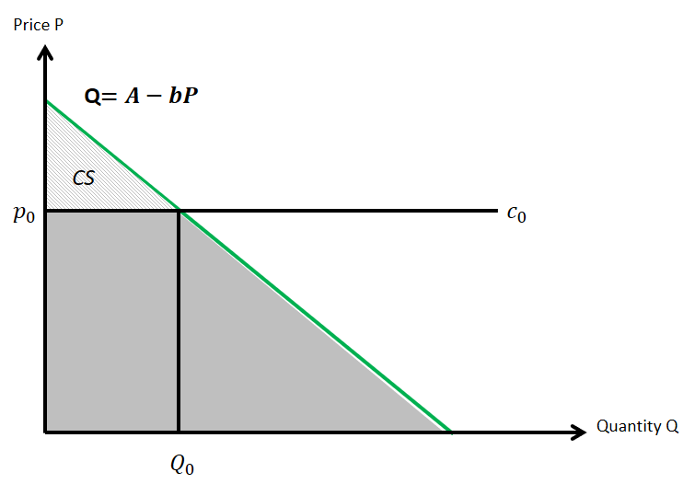

- Cost: $c_{0}$
- Price: $p_{0}$
- Quantity: $Q_{0}$
- Producers make zero profits

With cost-reducing unpatented innovation

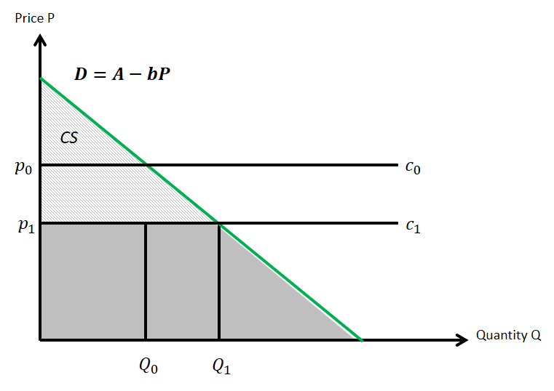

- Cost after innovation: $c_{1}$
- Price after innovation: $p_{1}$
- Quantity after innovation : $Q_{1}$
- Producers make zero profits

With cost-reducing patented innovation

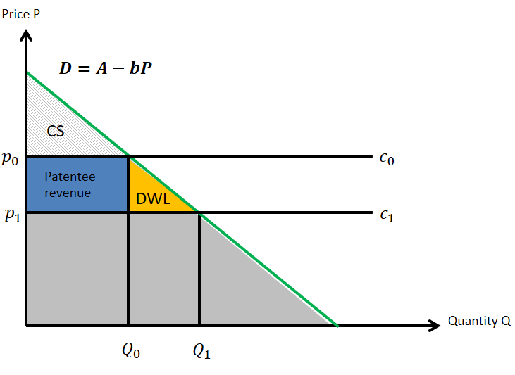

- Patentee charges royalty rate $c_{0}-c_{1}$
- Producers have a cost of $c_{1}+(c_{0}-c_{1}$) $=c_{0}$
- Price after innovation: ${ p}_{0}$
- Quantity after innovation : $Q_{0}$
- Producers still make zero profits
- Patentee obtains a per period revenue: ${ (c}_{0}-c_{1})Q_{0}$
- Deadweight loss per period: ${0.5(Q}_{1}-Q_{0}{)(c}_{o}-c_{1}$)

- Goal

2 components of overall welfare
- Surplus until expiration of patent at point T, patentee monopoly rent from licensing revenues

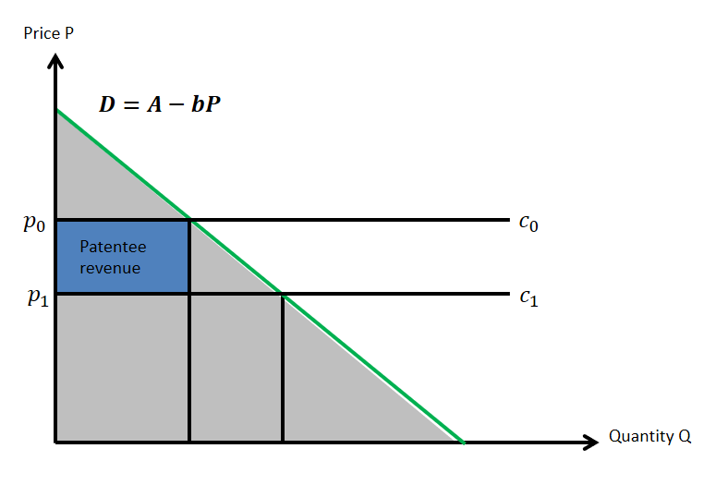

- Surplus after expiration of patent at point T, consumer surplus after expiration of the patent

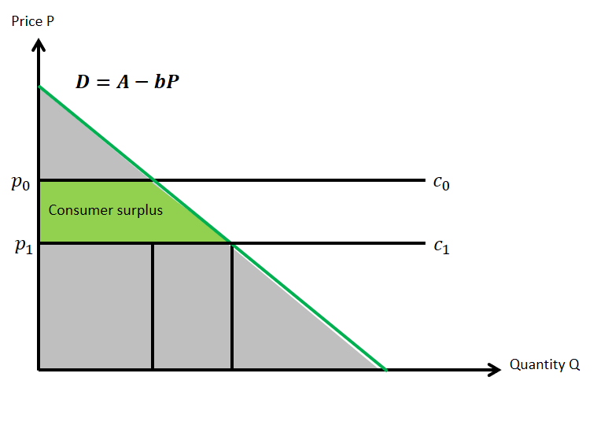
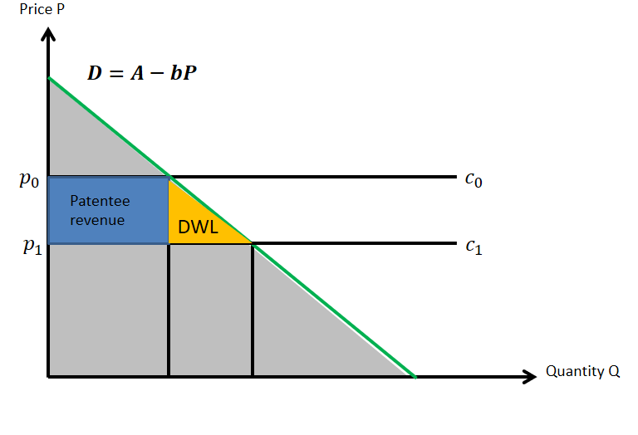

- Simplifications

Normalization of slope of demand function
- By setting P₀ = Q₀ = 1

- Price elasticity of demand
  - = $(-\frac{b\left(P_{1}-P_{0}\right)}{P_{1}-P_{0}}\frac{P_{0}}{Q_{0}}=-b$

- Cost reduction
  - = $c_{0}-c_{1}=B$

- Patentees revenue flow per period
  - $\left(c_{0}-c_{1}\right)Q_{0}=R^{a}Q_{0}=B$

- Patentee profit present value
  - = $R^{a}Q_{0}T-sR=BT-sR$
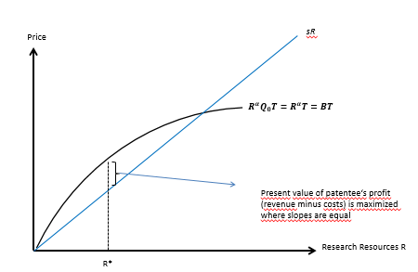

- Overall discounted surplus after expiration of patent at time T
  - $=\left(B+0.5 b B^{2}\right)\left(\frac{1}{r}-T\right)$

- Welfare maximizing patent length T
  - $W=BT-sR+\left(B+0.5bB^{2}\right)\left(\frac{1}{r}-T\right)$

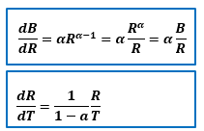

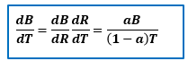

- Maximizing overall welfare

- Optimal patent life:
$τ=-\frac{1}{r}ln⁡(1-\frac{a\left(1+bB\right)}{0.5bB\left(1+a\right)+a}$

- Conclusions
  - A higher price elasticity of demand reduces optimal patent life
    - Because it increases deadweight loss for consumers
  - A lower degree of diminishing returns of research expenditures ( increase of a ) leads to a longer optimal patent life
    - A higher a reduces the resources R spent to get to a certain cost reduction
    - Lower resources R spent by the invertor increase welfare
  - A higher cost reduction reduces optimal patent life
    - Profit increases linearly with the size of the cost reduction, but welfare loss increases quadratically

- Conclusions of Nordhaus model

- Policymakers have to balance the deadweight loss to the consumers during patent life against the monopoly gains by the patent inventor
- The longer patent life , the higher the value of the profits to the innovator , the higher his incentives to innovate
- But the longer patent life, the larger the deadweight loss for the consumer

- Limitations of Nordhaus model

- Different characteristics of the market lead to different optimal patent duration
- But : how to determine optimal patent life in the real world?
  - Impossible

- Model considers a single innovation by a single firm
- No uncertainty
- No competition for the innovation
- But , if ideas are not scarce several firms can do research on a topic and duplication of innovation may occur
- Apart from patent length also the breadth of a patent matters
  - How easy is it to invent around and use substitutes?

