TOPIC 5

- INTRODUCTION

- Innovators learn from their predecessors
  - Without prior insights innovation might not happen
- Difficult to compensate developers of basic technologies
  - Commercial value usually resides in products that are developed much later
- If ‘founders of ideas’ earn some profit, it is mostly due to licensing fees from later developers
  - This requires that later products infringe patents

- HOW SHOULD PROFIT BE DIVIDED BETWEEN SUCCESSIVE INVENTORS?

- Innovators must not only collectively earn enough profit to cover joint cost
- Profits must be divided that it creates the right incentives at each stage of the innovation process
- Among other feature, each innovator must be able to cover the own costs
- Current IP system is a blunt instrument for this delicate problem

- CASE 1 : Basic vs. Applied research

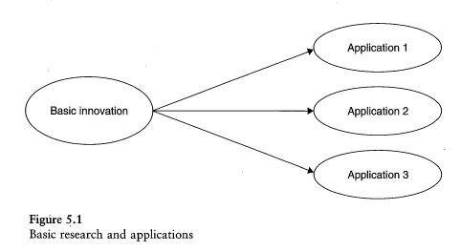

- Licensing : instrument for passing profits from applications to basic inventor
- If division of profit is insensitive to division of cost, the incentive system will nog work very well

1st innovator
- Social value = x ((1/r) – f*T)
  - x = per-period value to end users
  - r = discount rate
  - f = fraction of value lost as deadweight loss during patent life
  - c1 = invention cost
- Patent owner’s profits = x*π*T
  - π = fraction
- => if 1ste innovation is purely basic science => x = 0

2nd innovator
- Social value = (x + y) ((1/r) – f*T)
  - y = per-period increment to market value of new product = sum of all future discounted profits
  - c2 = development cost
- Total profit = (x + y) * π * T

Social value of 1st innovation should reflect option for the 2nd
x((1/r) – f T) – c1 + max[0, y((1/r) – fT) – c2]

Goals of patent system
- Ensure investment into 2nd innovation whenever y * ((1/r) – f*T) > c2
- Transfer enough surplus to 1st innovator
- Consider 1st innovation is pure science, i.e. x = 0.
  - There would be no value without 2nd innovation
  - 1st innovation would never exist if inventor could not benefit from 2nd

- Terms of licensing : 2 ingredients

Threat points
- For each firm, the threat point is expected profit it can guarantee itself when it leaves the bargaining table

Bargaining surplus
- Amount by which the 2 firms will be richer in total if they actually make a licence deal

- Cases

Ex-ante license : make deal before 2nd invests c2
- If 0.5y πT – c2 > 0

No ex-ante, no investment by firm 2
- 0.5y πT – c2 < 0

No ex-ante license, firm 2 invests, ex-post license
- They would bargain and threat point is profit if no license deal is made

- Profits are
x πT + 0.5y πT – c1
and 0.5y πT – c2

No ex-ante license, firm 2 invests, no ex-post license

- Consclusions

- Being constrained to resolve blocking patents might put 2nd generation of products in jeopardy
  - 2nd innovator knows that it may have to pay license fees
  - 2nd innovator will not invest unless the value of the innovation >> costs
  - Resolving blocking patents ex-ante can expand the circumstances in which 2nd product is developed
- To ensure that costs of both innovators are covered, patent life T might have to be longer than if same innovator had developed both innovations
- Society’s interest might be aligned with 1st innovators interest
  - 2nd innovation is never in jeopardy if ex-ante licenses can be made
  - From society’s perspectivy, one would need to insure that 1st innovator can cover costs
    - This could be achieved if the 1st could make a take-it-or-leave-it license offer to 2nd innovator and thus collect all net profit on 2nd
    - Beneficial for society, as 2nd innovation is not going to happen without 1st.
    - Unlikely

- Remarks

- Research exemption on 1st innovation is beneficial for its owner
  - 2nd innovation can be developed without a license but cannot commercialize
  - Improves 1st bargaining position as bargaining occurs after investment of 2nd
- Division of cost is not sensitive to innovators’ relative cost. If c2 increases, the 1st innovator has to offer more generous license terms
  - Not vice versa
  - As 1st ‘s costs are already sunk when 2nd enters the game
  - Increasing T will help
- Current patent legislation does not address these issues
  - T is same for all patents
  - Research exemptions exist for universities but not for firms

- CASE 2 : Research tools

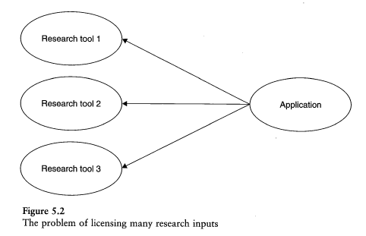

- Suppose : 2nd innovation requires input from several 1st generation innovations
- Combined price of multiple research tools can be so high => 2nd generation user is excluded
- Can be explained by Cournot model-type: assume products (here research tools) are complements
- Combined price means the owners of research tools form a cartel. Then each provider has an incentive to deviate from collusive price.
- Possible solution: Patent Pools
  - Owners of patents put there patents into a pool, and registered users pay a fixed license fee to everybody = Cartel with contract

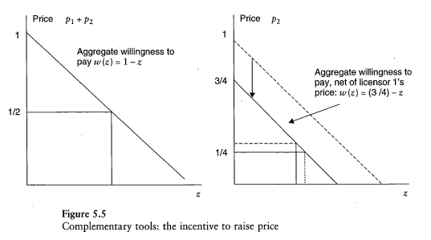

- Aggregate willingness-to-pay curve
  - = demand curve for both research tools together
- z users : sorted by willingness to pay
- Licensors form monopoly and charge monopoly price
  - (MC = 0 here) p = ½ each provider gets p1=p2=¼.
- Right panel shows:
  - Licensor 2 has incentive to deviate from that price it would increase profits
- take licensors 1 choice as given, and subtract price of ¼ from licensor 2’s demand curve.
  - If licensor 2 would serve less users, profits would increase
  - Max is at MRR = MCC = 0
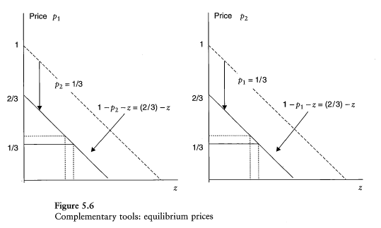

- Licensor 1 would react to the p-change of licensor 2 and also choose profit-optimal price
  - When they price separately, equilibrium p1=p2=1/3
  - Thus total price for user p1+p2 = 2/3 > ½
  - Both could actually increase profits by charging jointly ½ each.

Extra
- Cursus : 5.4 and 5.5 and 5.7

- CASE 3 : Quality ladders

- The more frequently a patent is cited in subsequent patent applications, the more social (and thus also private) value it might have

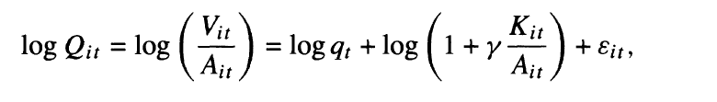
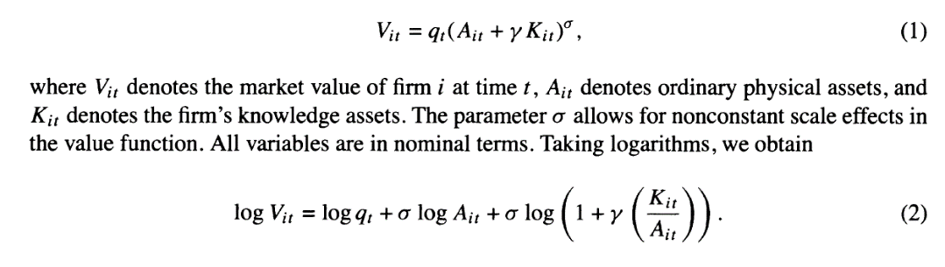
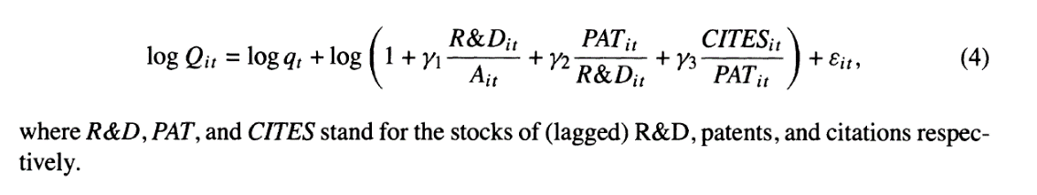

- Hall, Jaffe and Trajtenberg
  - Used patent citations
  - Showed that those patents that are referred to more often in subsequent inventions are more valuable
- Czarnitzki/Hussinger/Leten (2011, working paper) go one step further:
  - The European Patent Office classifies patent references
  - Some are cited because they describe the state-of-the-art
  - Others are cited because the insights made there do actually challenge the inventive-step of the new patent applications

