TOPIC 2 : Financial constraints and subsidies

- BACKGROUND : Why is innovation important?

- Important to understand the underlying economic attributes of technological change
  - = change in goods and services and the means by which they are produced
- Central to technological change are innovation and its diffusion
  - Diffusion : knowledge spillovers to other actors in the economy

- R&D => invention => innovation => technological change => growth

- R&D and innovation are of foremost importance to
  - Labor productivity
  - Competitiveness of innovators
  - Economic growth
- R&D and innovation are a priority area at the EU level

- NATURE OF R&D AND INNOVATION AND EXTERNAL EFFECTS

Knowledge production
- Primary output of innovative activities is knowledge of how to make new goods and services

- Uncertainty
  - Technological uncertainty :
    - how to make new things
  - Commercial uncertainty :
    - how to make new things adopted by consumers

- Indivisibility
  - High fixed costs of establishing one economic unit for the production of knowledge
  - Low marginal costs of providing knowledge
  - Knowledge can be used multiple times => costs of transmitting the knowledge
  - => economies of scale
    - AV decreases with increasing production

- Public goods characteristics
  - Non-rival
    - Can be used simultaneously by an unlimited number of consumers
  - Only partially excludable
    - Difficult to prevent others from using the knowledge

- Positive externalities
  - When a firm investing in R&D cannot take fully into account the positive effects of its R&D investments beyond its profits
  - Some people get benefits from knowledge that they do not pay for
  - social returns from innovations > private returns
- Forms of externalitites
  - R&D knowledge may spill over to other firms
  - Cumulative invention
    - Innovation of a firm may enable other firms to build on the firm’s innovation to make further innovations
    - Original inventor may keep only a small part of the generated social value
  - Consumer surplus
    - When selling the output of R&D, the innovator cannot fully capture the value of its innovation to all users
  - Negative externalities
    - Environmental damage
    - Duplication of R&D costs in case of business stealing

  - all positive externalities >> negative effects
  - economic growth

- APPROPRIABILITY AND ABSORPTIVE CAPACITY

- Appropriability

Spillovers
- Input spillovers and output spillovers
  - Private return on R&D < social return
  - Input spillovers
    - When R&D efforts of one firm help rivals reach their own research goals
  - Output spillovers
    - When first-discoverers are not able to collect all of the economic profit generated by their innovation
- Schumpeter
  - Fundamental innovation would trigger a follow-on cycle of incremental innovation
- Copycat innovation
  - Range from pure imitation to making use of information
- Follow-on firms
  - Carry out their own R&D more rapidly
  - Avoid dead-end research
  - Reduces risk of failure
  - Save time and cost
- Incomplete appropriability of returns to R&D : one reason for under-investment in innovation
- Patent production is one way to increase appropriability
- Arrow :
  - No amount of legal protection can make a thoroughly appropriable commodity of something zo intangible as information
- Other ways to help appropriability
  - Increasing cost of others for using information
Informal ways of appropriability
- Secrecy
  - Non-disclosure of knowledge
  - It reduces spillovers => increases imitation costs
  - More effective for process innovations than for product innovations
  - Good solution for early-state inventions
- Lead time
  - Time required to go from initial concept to market introduction
  - Short lead time can lead to important competitive advantage
- Continuous innovation, learning-curve effects
  - Innovating more quickly than rivals do
  - When competitor has imitated an innovation, company has already released another onto the market
- Complexity
  - More difficult to replicate
  - Outsiders lack tacit knowledge
- Marketing, sales and service efforts

IP protection and spillovers
- In reality it is not clear that patent rights are important appropriability mechanism
- Informal ways more common in practice

Spillovers : consequences
- Spillovers are beneficial from social point of view
  - Incoming spillovers increase productivity of R&D
  - Spillovers improve situation for customers as prices decrease and product choice increases
- To absorb spillovers, firms must have some absorptive capacity
- Complexity and specificity of information/knowledge requires absorptive capacity

- Absorptive capacity

- R&D generates innovation
- R&D develops firms ability to identify, assimilate and exploit knowledge from its environment necessary to productively absorb spillovers

- the prospect to benefit more from spillovers increases incentives for R&D that builds-up absorptive capacity

- If knowledge is tacit => appropriability of returns from innovation is not limited by the free flow of information
- Information ≠ knowledge
  - Everyone can see or read information
  - Knowledge is not easily absorbed
spillovers may not necessarily reduce R&D, but can also create incentives as firms invest
in R&D in order to increase their absorptive capacity

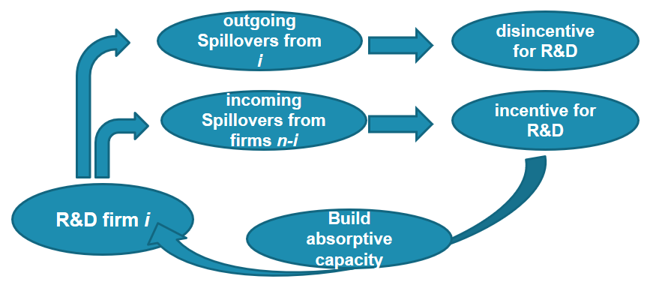

- Maximize the benefits from the external knowledge, incoming spillovers
- Minimize the negative effects from the spillovers generated for imitators, outgoing spillovers

- Empirical evidence on spillovers

Czarnitzki/Kraft
- Firms that are in industries where knowledge is more difficult to appropriate (outgoing spillovers are above median), profits are reduced even more than increased by incoming spillovers
- In these industries, the average mark-up level of firms is lower due to high spillover effects

Cappelli et al.
- Use of different variables
- Spillovers from different sources have different benefits

- MARKET FAILURES RELATED TO INNOVATION

2 main market failures
- Limited appropriability
  - Public good properties
  - Externalities
- Financing constraints
  - Asymmetric information
  - Uncertainty

- Market economy may fail to provide adequate incentives for firms to engage in innovation
- Firms underinvest into innovation from a social point of view

Limited appropriability
- Inventing firm cannot appropriate all the benefits of its knowledge-creation activities because of positive externalities
  - Inventing firm bears all the costs
  - Reduces incentives to engage in R&D
  - From a social point of view there may be insufficient allocation of resources to R&D
social returns from innovations > private returns

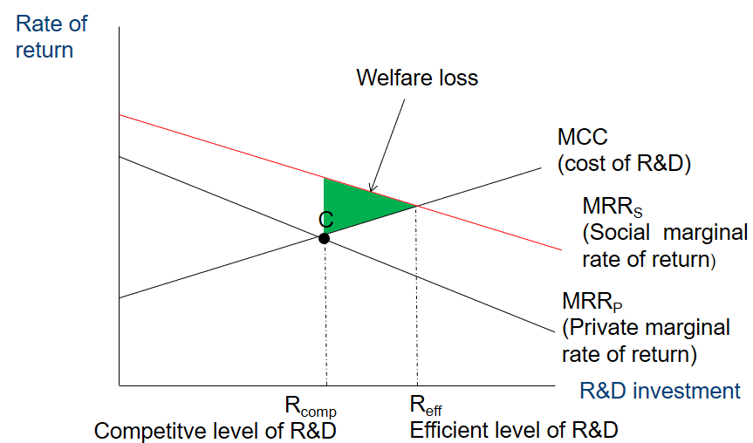

- Externalities and the related limited appropriability create a dilemma
  - Policy should enhance incentives for the socially efficient production of knowledge
    - Increase appropriability (ex ante)
  - Policy should encourage incentives for the socially efficient diffusion of knowledge
    - Increase spillovers (ex post)
    - Produced knowledge should be free of charge except for transmission costs

how to increase incentives without reducing social return?

- FINANCING CONSTRAINTS

Market failure
- Innovation is usually the result of investment by private profit seeking firms
  - Such investment includes R&D, human capital or generation and processing of knowledge
  - Investments in knowledge pays off, but we don’t know which projects are successful
  - Information problem => uncertainty and asymmetric information

Investment in innovation by firms
- Investment in R&D and innovation is different from other types of investment
  - Uncertainty of project outcome
    - Technological uncertainty, uncertainty of returns, market uncertainty, regulatory uncertainty
  - High probability of no returns at all
  - Long time horizon
  - Investment in skills and training
    - creation of knowledge is usually embodied in the firms employees
  - Low collateral value / intangible assets are created

Why insufficient financing?
- Capital market imperfections
  - External cost of capital for innovation > cost of capital investment due to
    - Asymmetric information
    - Uncertainty of returns
    - Low inside collateral value
- Importance of internal sources of financing for innovation as c_{internal} < c_{external}
  - Firms foremost use internal financing but
    - cash is limited
    - new equity limited / costly / not wanted

consequences of restricted financing
- Innovation projects may render unprofitable due to higher costs of capital
- From a society’s point of view :
  - Sub-optimal investment in innovation
- Justification for government intervention :
  - Usually in the form of subsidies or tax credits
- Policy makers’ interest :
  - Identify potentially constrained firms to design optimal policy instruments to alleviate welfare-reducing underinvestment

Ideal test for financial constraints
- Give firms additional cash exogenously
- Observe whether they pass it on to shareholders or use it for investment or R&D
  - If they choose the second, firm must have had unexploited investment opportunities that were not profitable using more costly external finance

- Unrealistic in reality
- Experimental setting

Simple model
- Each period : firm I has a set of ideas for innovation
  - ${IC}_{i}$ = Innovative Capability = ability to generate and pursue new innovation ideas
  - Ranking of expected rate of return in descending order
  - Expected rate of return = Expected benefits – implementation costs
- ${MRR}_{i}$ = Marginal rate of return
  - MRR_{i} = f (I_{i} , IC_{i} , X_{i})
  - $I_{i}$ = Innovation Expenditure
  - $X_{i}$ = other firm and industry characteristics
- ${MCC}_{i}$ = Marginal cost of capital
  - Profit maximizing firm invests in innovation until MCC = MRR
  - Varies with the size of the investment
  - Reflects the opportunity costs of investing funds in innovation
  - Depends on expected returns to other uses of available funds
    - R^{e,o} = tangible or financial assets
    - IF_{i} = internal funds
  - Increases with the total amount borrowed
  - Firms draw first on IF before external financing
    - MCC_{i} = f (I_{i}, R^{e,o}_{i} , IF_{i}, W_{i})

- Imperfect capital markets
  - Costs of external capital are assumed to be higher than those of internal funds as lenders require a risk premium for instance due to information asymmetries
- Marginal capital costs are also affected by firm characteristics
  - Wi = creditworthiness

- I*_{i} = optimal investment in innovation
  - I* = h (IC_{i} , R^{e,o}_{i} , IF_{i,} X_{i}, W_{i})

- Examples

Unconstrained firms : A and B
- B has higher innovation capacity
- Imperfect capital markets : c_{ext} > c_{int}
  - We would expect no additional innovation projects
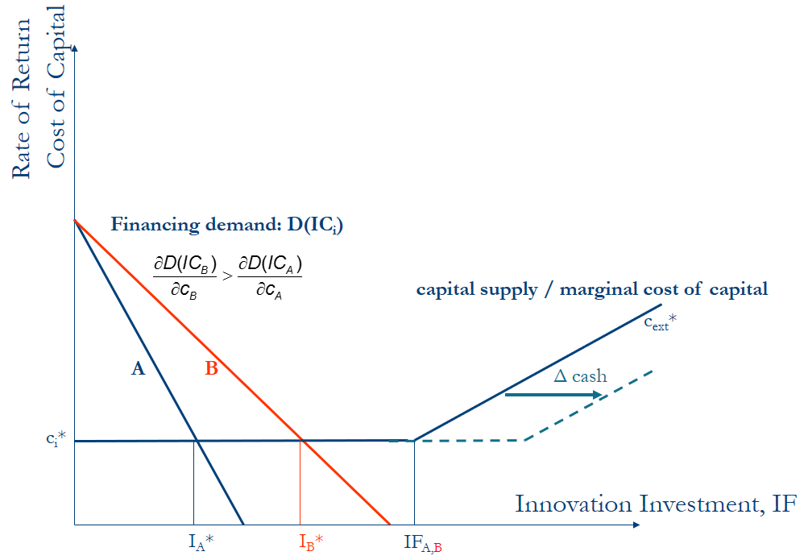

A unconstrained, B constrained
- A and B with same internal funds (IF)
- A and B with different innovation capacity (IC)

- We see a positive effect for B, not for A

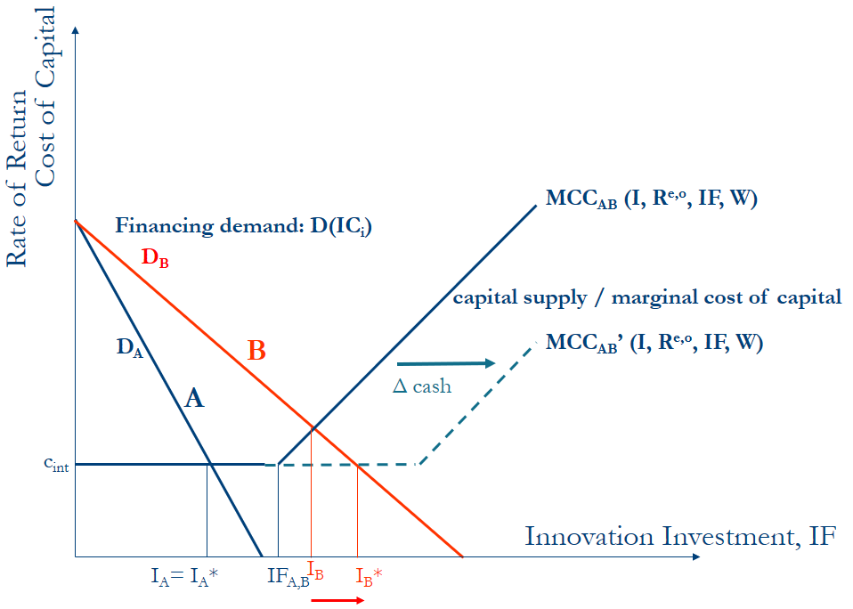

Constrained firms : A and B
- A and B have same internal funds (IF)
- A and B have different innovation capacity (IC)

- We expect a positive effect for both A and B
- We expect a stronger effect for B due to higher innovation capacity

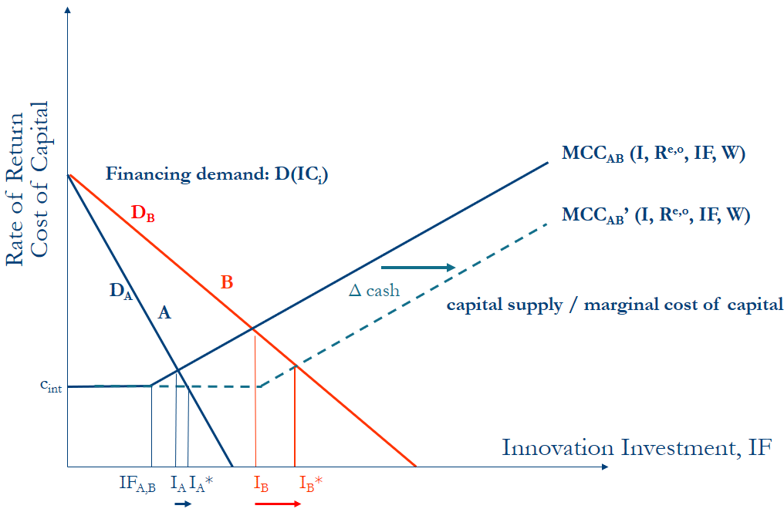

Constrained firms : A and B
- Same innovation capacity
- A has lower internal funds than B

- We expect a positive effect for both A and B
- We expect a stronger effect for A due to lower IF
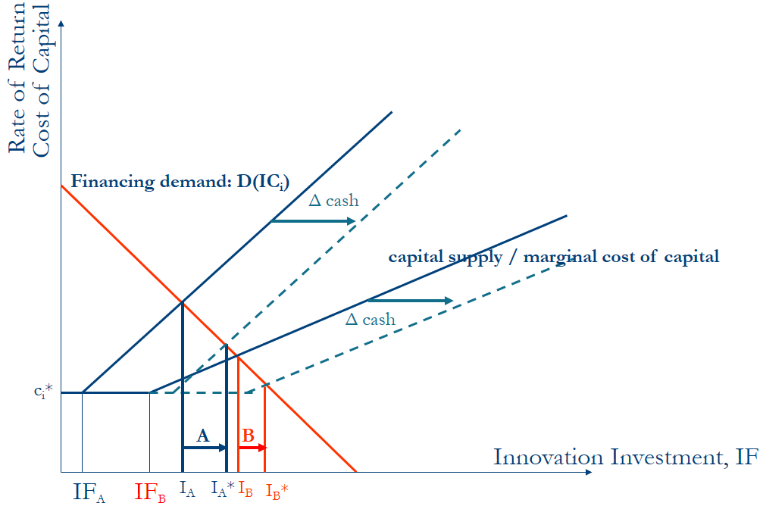

Constrained firms : A and B
- If the gap between c_{ext} > c_{int} is larger, the effect of additional cash is higher, but always more so for firms with higher innovation capacity
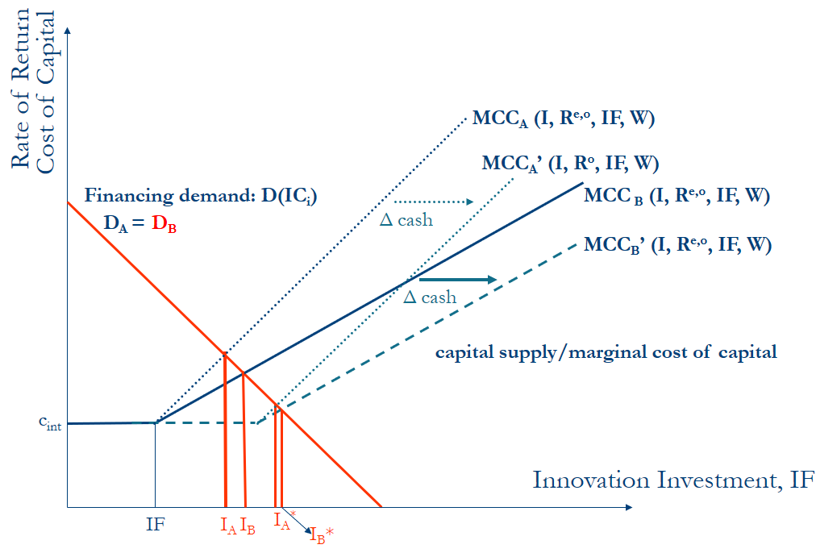

- Summary of insights

- Financial constraints depend not only on availability of internal funds, but are driven by innovation capacity by increasing resource requirements
  - Firms with low internal funds are not necessarily constrained
  - Firms with higher innovation capacity are more likely to have unexploited innovation projects, independent of their financial background
  - No such pattern for the decision to invest in physical capital
  - Observe constraints for financially sound firms with high innovation capacity implying that they have to put some of their ideas on the shelf
  - Firms with low innovation capacity choose other options to use the additional cash
- Firms with high innovation capacity, but low internal funds are most likely to be constrained => small, young and knowledge intensive

- Heterogeneity

Routine R&D vs. cutting edge R&D
- Routine R&D
  - Imitation or variation
  - Strengthen product lines
  - Only new to product portfolio but not new to market
  - Lower resource requirements
  - Returns sooner and better predictable
  - Lower default risk
  - Returns from initial products as source for financing
- Cutting edge R&D => constrained
  - Radical innovation
  - Market novelties
  - Involves basic research
  - Resources intensive
  - Highly uncertain in terms of default and expected returns
  - Secrecy issues

Research vs. Development
- Research => Constrained
  - Uncertainty of project outcome
  - Higher probability of no returns at all
  - Far from the market
  - Knowledge creation often tacit
  - Usually no tangible assets
- Development
  - Based on previous success in Research
  - Higher probability of returns
  - Patentable results
  - Closer to market
  - Yielding returns sooner

- Conclusions

- Financing gap is found => innovation may be hampered by a lack of financing opportunities
- Not all firms are affected to the same extent
  - Smaller firms suffer more from financial constraints
  - Younger firms may also suffer more
    - They have no established banking relationships
- Firms pursuing cutting-edge R&D strategies are more likely to be subject to financial constraints in the credit market
  - More radical innovation is hampered, slower technological progress
  - Characteristics usually attributed to R&D, are more applicable to R than to D
  - R investment is more sensitive to the firms’ financial liquidity
- Targeted innovation policy may have strongest effects
- Results have strong implications in banking-dominated financial systems
- Consequences for market structure

- If particularly small and young firms are concerned with the most severe constraints, technological progress has to rely mainly on large and established firms
- This may aggravate barriers for market entry in both technology and product markets for new firms and may thereby strengthen market power of established firms
- It seems worthwile to assess the effectiveness of existing schemes in terms of addressing the intended targeted group and the firm’s cost of participating in such schemes

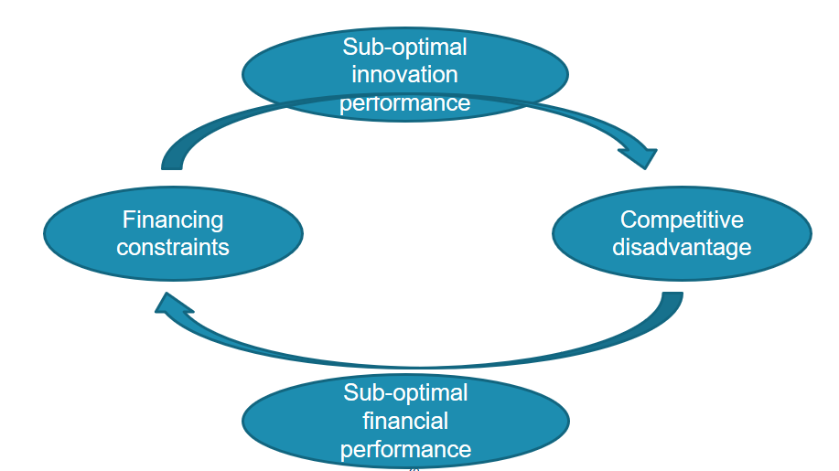

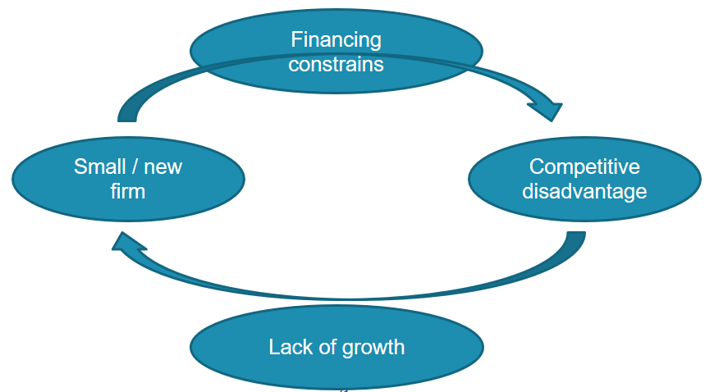

- Cutting-edge R&D
  - One of the driving forces of technological progress
  - Yield higher social returns than routine R&D projects
- Industrial Research activities
- Intangible assets
  - Are not reflected in the firms’ balance sheets, financial statement-based estimations of firm value and creditworthiness
  - Penalize firms that invest in R&D

- What can policy do?

Most important tools used by industrialized countries
- Intellectual property rights
- Direct R&D subsidies
- Tax reliefs to reduce cost of R&D
- Anti-trust exemptions for R&D collaboration
- Public production and procurement
- Loans with low interest rates for financially constraint firms

- R&D SUBSIDIES

- Basic idea of R&D subsidies

- Reduce the cost incurred by companies for undertaking R&D
- Reduce possible financing constraints
- Increase firm’s incentive to engage in R&D activities
- Without reducing knowledge diffusion ex post

Direct subsidies and limited appropriability

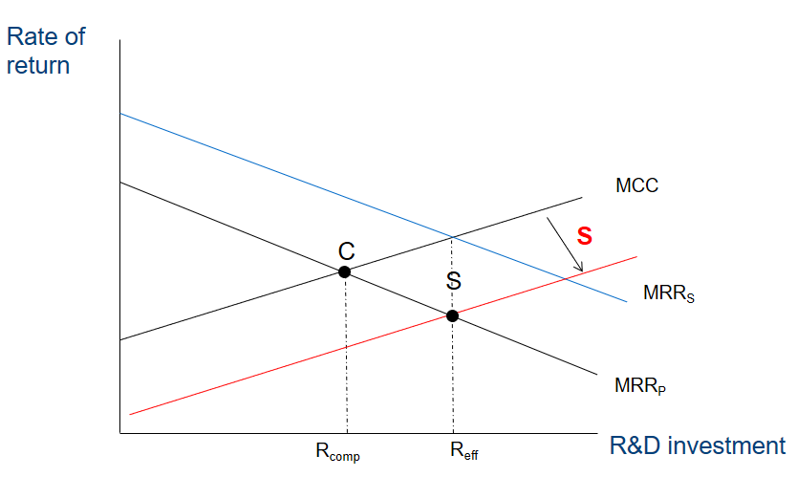

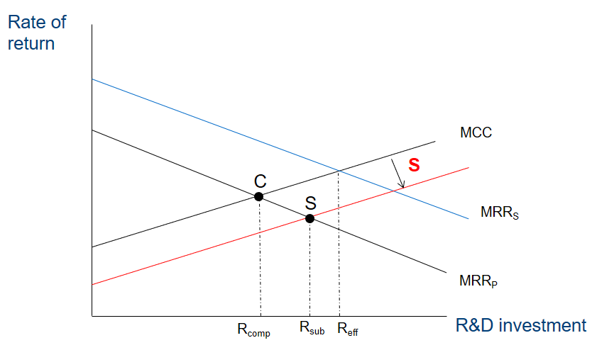

Direct subsidies and financing constraints

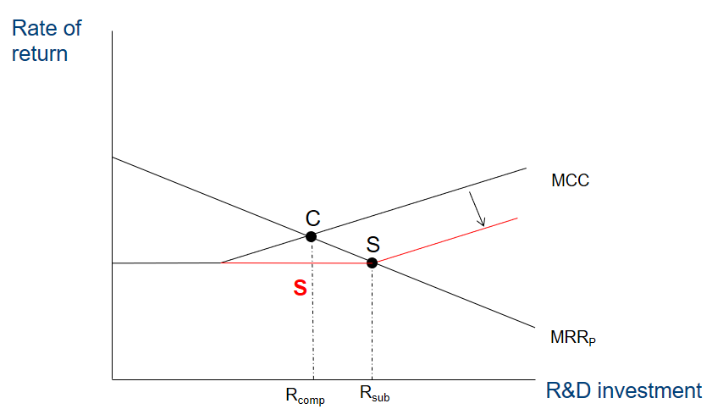

- Problems related to R&D subsides

Efficiency of intervention
- Efficiency of government intervention : 2 issues
  - Can an appropriate policy instrument be designed?
  - Can this instrument be efficiently implemented?
- Objective of public funding of private R&D
  - Provide incentives for firms to launch innovation projects that are beneficial from social point of view but which firms would not launch on their own

Subsidies
- Subsidies are a selective tool => choose the right projects
- Costly to society
  - Funded by taxing society
  - Selection of projects : cost to apply and cost to select project
  - Risk of misuse of subsidies
  - If projects are chosen to be subsidized that would have been also pursued in the absence of the subsidy, the subsidy may crowd out private investments

Right projects
- Projects that generate the highest benefit for society
- Projects that firms could not have financed without a subsidy
- Informational problems
  - Are public employees capable of making right decisions?
  - Public servants have limited information
- Incentive problems
  - Are they willing to make the right decision?
  - Corruption?

- Evaluating R&D subsidies

Comparison group
- Comparing firms at a different point in time is difficult

Problems with comparison group
- Firms who receive a subsidy are different from those who did not receive a subsidy
- Differences between the groups : 2 factors :
  - Pre-existing differences = selection bias
  - Impact of the subsidy

Solutions
- Techniques to control for the selection bias
- Design and experiment
- Selection bias disappears when the treatment (receiving a subsidy) and control group (not receiving a subsidy) are selected randomly

- R&D subsidies in Flanders

- IWT = subsidy allocation agency
- In general, to reduce potential misuse of the subsidy by recipients, subsidies to the industry constitute only a share of the project costs
  - The subsidy rate is higher for projects that have a higher inherent technological / commercial risk
  - The subsidy is higher for SMEs and collaborative projects

