Distinctive brand cues and memory for product consumption experiences

Introduction
Brand image = the role of brand names and other aspects as cues that signal product attributes, benefits, affect or overall quality
- Do brand cues facilitate recall or inference of previous experiences and previously learned brand associations?
- Learning from direct experiences VS advertising
- Discrimination learning
- Sequential VS simultaneous experiences
- Effect of delay between consumptions

Conceptual background and hypotheses
Associations between brands:
- Differentiated (vs similar) brand names should yield higher accuracy in memory-based quality judgments
- Differentiated (vs similar) packaging shapes and colors should yield higher accuracy in memory-based quality judgments
Forgetting and recalling the wrong targets over time:
- Differentiated (vs similar) brand names should produce a slower decline in accuracy in memory-based quality judgments

Study 1: role of differentiation in brand names
- Overview: at Time-1 and Time-2 (phone)
  - Easy learning, alphabet names condition (control)
  - Difficult learning, alphabet names condition
  - Difficult learning, similar names condition
  - Difficult learning, differentiated names condition
- Predictions
- Method: subjects, stimuli (tropical fruit juice), brand name manipulation, procedure (easy vs difficult learning), dependent measures
- Results:
  - Time-1: easy learning, alphabet names condition
  - Time-2: difficult learning, differentiated names condition
- Discussion: rule out of possible inferences

Study 2: role of differentiation in packaging attributes
- Overview: only Time-1
  - No visual differentiation (control)
  - Color differentiation condition
  - Shape differentiation condition
- Predictions
- Method: see Study 1, only Time-1
- Results:
  - Differentiated colors significantly better than control
  - Differentiated shapes marginal improvement compared to control
- Discussion: even when brand names are highly similar, differentiation in shapes/colors can enhance accuracy in memory-based quality judgments

Study 3: can differentiation facilitate learning even when product prices provide potentially misleading cues
Consumers may rely on price to infer product quality. Combinations of cues vs single cue (study 1/2).
- Overview: at Time-1 and Time-2 (at lab)
  - Easy learning: similar brand names/packaging, price information (control)
  - Difficult learning: similar brand names/packaging, no price information
  - Difficult learning: similar brand names/packaging, price information
  - Difficult learning: differentiated brand names/packaging, price information
- Predictions
- Method: subjects, stimuli (orange juice), brand name and packaging manipulations and pretests, procedure (see study 1)
- Results:
  - Time-1:
    - easy learning quite accurate
    - accuracy significantly higher among differentiated (vs similar)
  - Time-2: differentiated performed better
- Discussion: distinctive brand names improve accuracy and discrimination in quality judgments even when price cues are deceptive and there is simultaneous differentiation in multiple cues. Deceptive price cues: differentiated helped restore accuracy and discrimination to approximately the levels without price information.

General discussion
Current (vs prior) research, e.g.: real world consumption situation:
- Some (vs minimal) intrinsic differences among products
- Sequential (vs simultaneous) product exposure
- Significant (vs insignificant) delays between product exposure and quality judgments

Memory-based judgments in consumer decision-making
- Will only make inferences on the basis of extrinsic cues if they cannot directly retrieve intrinsic quality attributes
- Cue-based inference process is more effortful than pure guessing but less effortful than retrieval from memory
- Extrinsic cues: for some serve as a basis for quality inferences, for other as memory pegs

Managing brand equity
- Benefit differentiation: brand name linked to unique consumer benefits
- Differentiation in extrinsic brand cues: brand recognition, need for symbolic associations and learn/accurately remember a product’s intrinsic quality (=> especially positive for high-quality brands)

Trademark dilution: public policy and legal implications
- Association of high-quality brand experiences with low-quality copycats (and vice versa)
  - Remark: not the same as mistake identity of a brand
- Importance of legislation to counter this

Limitations and future research
- Separate semantic and non-semantic effects: semantic differentiation has been proven to be most important
- Joint influence of brand cue differentiation with other marketing variables (e.g. advertising)

Consumer learning and brand equity
Brand names vs attribute cues in prediction of product outcome: when/why do people treat products with identical attributes but different brand names differently?
- Blocking: learning of one predictive cue can block the learning of subsequently encountered predictive cues (redundant), explanations:
  - Associative theories: no additional learning once perfect prediction is achieved
  - Normative causal-reasoning: first cue unconfounded with any other cue, second cue occurs only in the presence of the first cue

Experiment 1: effect of preexposure to a predictive cue on learning of subsequent predictive cues
- Method:
  - Design and subjects:
    - Predictive feature: brand name (Brand) vs intrinsic attribute (Attribute)
    - Redundant feature: intrinsic attribute
  - Stimuli
    - Brand/control condition
    - Brand/experimental condition
    - Attribute/control condition
    - Attribute/experimental condition
  - Procedure
    - Phase 1: Only predictive feature (only experimental)
    - Phase 2: Predictive and redundant feature (experimental + control)
  - Measures
- Results:
  - Strong blocking effect on redundant feature and positive effect of preexposure
  - Use of mean feature effect (MFE)
  - Experimental: effect of redundant feature equally small for brand/attribute
  - Control: higher weight on attribute (more causal)
- Discussion

General discussion
- Counters some theories
- Porcess:
  - Parallel associative updating
    - Additivity
    - Error reduction
    - Predictive attributes compete for equity
  - Sequental hypothesis testing
- Future research
  - Distinguish between associative and hypothesis testing
  - Generalizability of blocking
  - Forward looking and backward looking processes
- Conclusion

Recall and consumer consideration sets: influencing choice without altering brand evaluations
Changes in a brand’s accessibility may affect the probability of retrieval, consideration and choice. Combines possibility of changes in the choice set and memory-based choice.
The consideration set = set of brands brought to mind on a particular choice occasion:
- Brand-consideration stage: retrieval (= activation of info stored in long-term memory) depends on:
  - Strength of activation of brand node
  - Strength of association between brand node and other active nodes
  - Availability of retrieval cues focus here: brand prime
- Brand-evaluation stage: depends on brand’s value on attributes considered important for choice

Retrieval from a product category
Hierarchical category structure: choice of product i in subcategory I given prime j: P(i|j)=P(I|j)*P(i|I) => both direct (i=j) and indirect (i & j element of I) effect
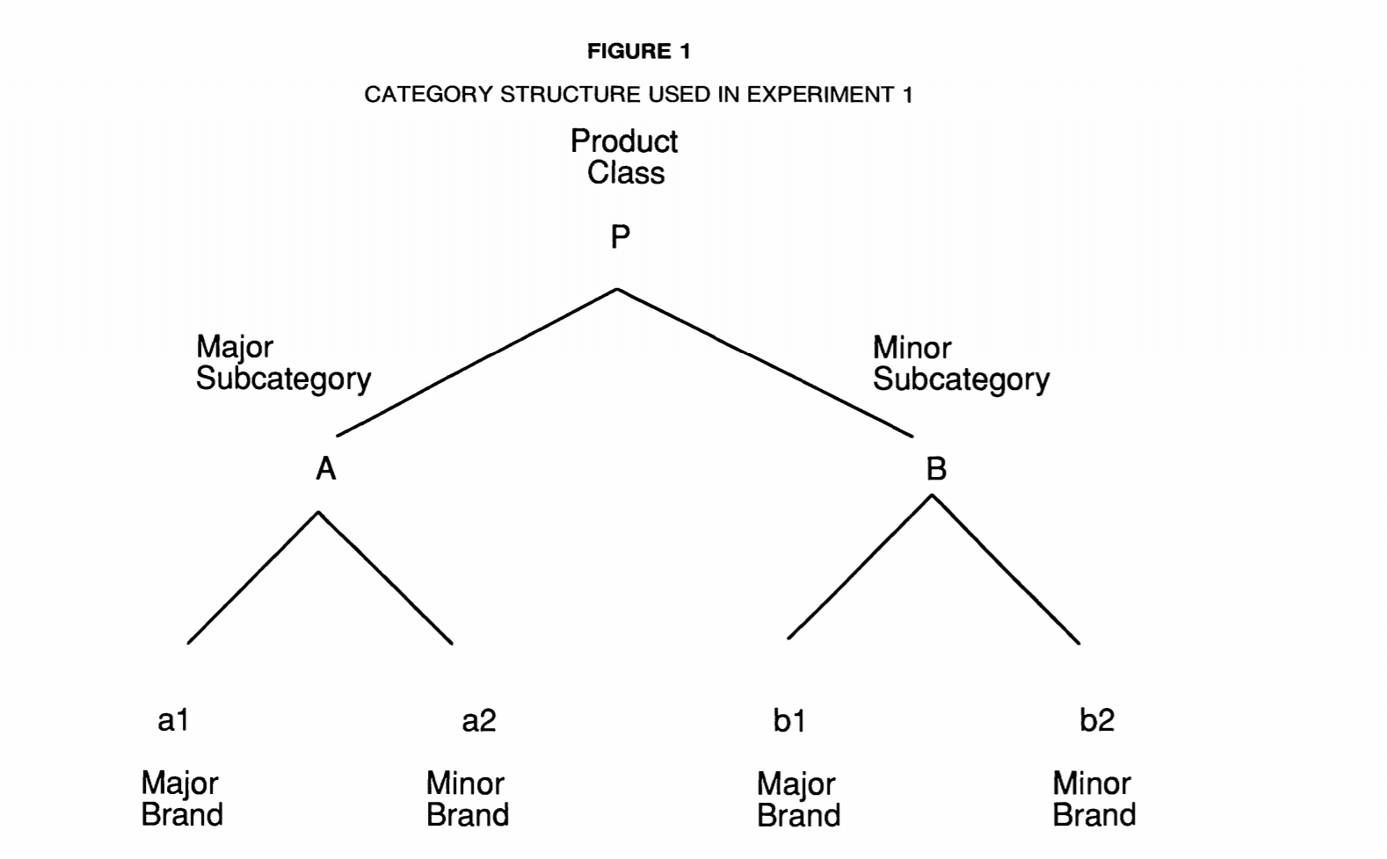

Hypothesis development
- Retrieval + Direct effect: priming of brand will directly increase likelihood of retrieval of brand (smallest for most accessible brands in most accessible categories (a1))
- Retrieval + Indirect effect: priming of brand will indirectly increase likelihood of retrieval of other brands in same category (highest for most accessible brands in inaccessible categories (b1))
- Choice: effects of priming on retrieval will carry over to increase likelihood of choice only for better-liked brands
- Evaluation: no effect

Experiment 1
- Subjects
- Design
  - Brand prime factor: a1, a2, b1, b2, no (control)
  - Brand factor: a1, a2, b1, b2
- Stimulus selection: list familiar brands and cluster
  - Brand usage rate and liking were used for accessibility
  - Three product categories with three subcategories => 12 brand primes
- Procedure:
  - Priming (not for control group): statements including target brands
  - Choice, consideration and recall: indicate brand choice, list consideration set, recall other brands in product class
  - Intentions: receive list of brands and rate choice likelihood
- Dependent measures
- Results: in line with hypotheses
  - No prime, direct prime and indirect prime level = score when no/current/competitive brand is primed
  - Category structure and evaluations prior to priming: retrieval / intention scores in no prime group revealed accessible / preferred brands
  - Brand retrieval: direct a2, b1 and b2 >< indirect b1
  - Brand choice and consideration: b1
  - Intentions: no effect
- Discussion
  - Limitations: no choice set presented, tasks in predetermined order, scale used

General discussion
- Limitations
- Implications and future research

Emotional brand attachment and brand personality: the relative importance of the actual and the ideal self
Self-congruence = fit between brand’s personality/image and consumer’s self: actual or ideal self? depends on context (more specifically: product involvement, self-esteem and public self-consciousness)

Conceptual framework
Definitions of: brand personality, self-concept, actual self, ideal self, emotional brand attachment, product involvement, self-esteem and public self-consciousness

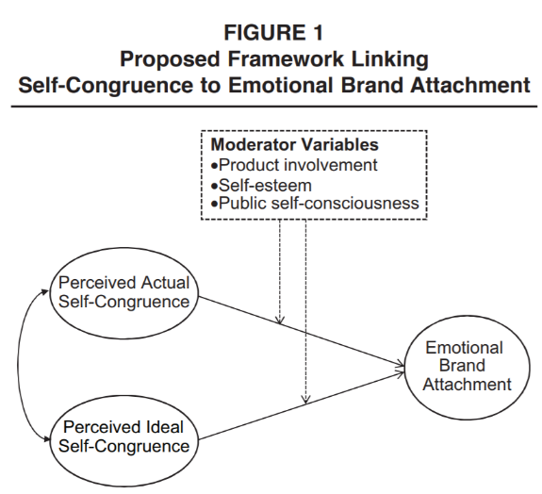

Hypotheses
- Main effects:
  - Actual self-congruence has a positive effect on emotional brand attachment ( cognitive-consistency, self-expansion and self-verification)
  - Ideal self-congruence has a positive effect on emotional brand attachment ( self-enhancement) was not proven!!
- Relative effect: actual self-congruence has a stronger effect on emotional brand attachment than ideal self-congruence ( construal level theory)
- Moderating effects:
  - Product involvement
    - Strengthens the relationship between actual self-congruence and emotional brand attachment ( self-verification)
    - Weakens the relationship between ideal self-congruence and emotional brand attachment ( self-enhancement)
  - Self esteem
    - Strengthens the relationship between actual self-congruence and emotional brand attachment ( self-verification)
    - Weakens the relationship between ideal self-congruence and emotional brand attachment ( self-enhancement)
  - Public self-consciousness
    - Strengthens the relationship between actual self-congruence and emotional brand attachment ( self-expression)
    - Weakens the relationship between ideal self-congruence and emotional brand attachment ( /)

Method
- Data collection and sample: online questionnaire with minimum familiarity score
- Measures: score for actual self-congruence, ideal self-congruence, emotional brand attachment, product involvement, self-esteem and public self-consciousness using all kind of scales

Results
See hypotheses: only positive effect of ideal self-congruence was not significant (H2 not supported by the data) became significant when low scores on moderators

Discussion
- Academic implications and further research
  - Link with concept of authenticity
  - Supports construal-level theory arguments
  - Non-significant effect of ideal self-congruence: might be explained by coexistence of positive and negative effects Social comparison theory
  - Moderating variables: different types of self-congruence calls for a more targeted approach to branding
  - Further research: other moderating effects, differences in brand’s personality dimensions, attainability of ideal selves
  - Limitation: no evidence regarding nature of process
- Managerial implications:
  - Incorporation consumers’ selves into branding considerations
  - Focusing on authentic branding
  - Reconsidering aspirational branding
  - Individualizing branding efforts

When identity marketing backfires: consumer agency in identity expression
Identity marketing = fit between brands and target identities rewards but also risks: can backfire due to consumers’ need for agency (choice) in addition to their drive for self-definition/expression

Identity marketing
Identity is a motivator of behavior what identity-marketing message will consumer respond to?

The current research: identity expression and agency
- Identity-referencing message = simply mention the target
- Identity-defining message = suggests identity depends on specific action/purchase

Study 1: do managers prefer explicit identity marketing?
- Managers evaluate advertising to green consumers
- Three potential messages: identity-defining, identity-referencing and nonidentity (control)
- Indicate choice / likelihood of purchase / message explicitness: identity-defining > identity-referencing > nonidentity

Study 2: explicit identity marketing backfires with consumers
- 3 (message type: nonidentity vs identity-referencing vs identity-defining) x 2 (identity salience: target (= green consumer) vs neutral)
- Activate target: visualize role as a friend to the environment
- Purchase of likelihood:
  - Identity-referencing: increased likelihood
  - Identity-defining: decreased likelihood + counterproductive (lower than neutral)
- Linked with agency (similar results)
- Alternative explanation: narrower identity category rejected

Study 3: uncertain consumers seek identity definition
- 2 (identity certainty: uncertain vs certain) x 2 (message type: identity-referencing vs identity defining)
- Manipulate identity certainty of parents: describe uncertain/certain moment
- Advertisement of sunscreen
- Likelihood of purchase:
  - Certain parents: identity-defining reduces likelihood
  - Uncertain parents: identity-defining increases likelihood
- Mediation by agency: indirect effects only for certain parents

Study 4: individual need for agency moderates response
- 2 (message type: identity-referencing vs identity-defining) x individual reactance (measured)
- Advertisement of sports channel
- Likelihood of purchasing
- Reactance scale to measure individual differences in the need for agency
  - High reactance: identity-defining reduces likelihood
  - Low reactance: no effect
- Alternative explanations: persuasion knowledge, depth of processing, message familiarity rejected

Study 5: agency in identity expression is distinct from choice
- Restoring consumers’ sense of agency through external means (self-design process)
- 2 (message type: identity-referencing vs identity-defining) x 2 (choice process: standard choice vs self-desing) x 2 (choice set size: small vs large)
- Customizable sustainable streetwear for green consumers
  - Standard choice: choose the product you prefer (from list)
  - Self-design: design the product you prefer (customized)
- Likelihood of purchase:
  - Standard choice: identity-defining reduces likelihood
  - Self-design: -
- Agency: higher for self-design
- No effect of choice set size
- Alternative explanations rejected

General discussion
- Theoretical and substantive implications: link with previous research
- Limitations and future directions:
  - Does seeking to improve self-image reflects identity uncertainty?
  - Limits to substitutability of sources of agency (see no effect of choice set size)
  - Other identity-marketing techniques besides communications (e.g. hard-sell tactics or promotional incentives)
  - Other means of reinstating perceived agency besides self-design
  - Effects varying for particular content of brand and consumer identities
  - Drive to maintain agency

Brand tourists: how non-core users enhance the brand image by eliciting pride
Trade-off in managing symbolic/exclusive brands: investors’ clamor for sales growth by extending the customer base vs customers’ demand for exclusivity (risk of brand dilution)
- Core vs non-core users
  - Brand immigrants: claim to be part of the in-group of core users negative effect
  - Brand tourists: buy the non-core branded products but do not claim any in-group membership positive ‘brand tourism effect’

Theoretical framework
Symbolic value of brands and brand extension: consumers buy products to express identity.
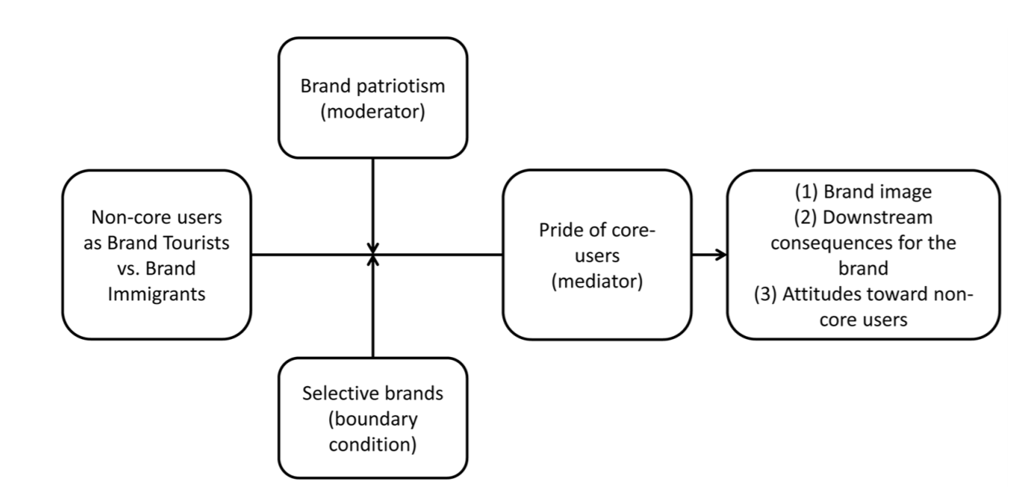
Hypotheses:
- Non-core users of selective brand will have positive effect when they are perceived as brand tourists rather than brand immigrants
- Positive effect will be mediated by core users’ pride (brand tourists will increase pride)
- Positive effect will be moderated by core users’ brand patriotism
- Positive effect will be stronger for brands perceived as selective

Study 1: the effect of depicting non-core users as brand tourists
Summer school courses offered by Harvard University without admission process
- Brand immigrants: on résumé Brand tourists: not on résumé
- Measures: brand image, downstream consequences (donations), attitudes toward non-core users positive for brand tourists

Study 2: the brand tourism effect and willingness to spread positive word of mouth
Lomography cameras and smart phone app
- Brand immigrants: not very apparent difference Brand tourists: clear difference control: no mention
- Measures: downstream consequences (word of mouth, future intentions) positive for brand tourists

Study 3: non-core users as brand tourists in the domain of luxury fashion brands
Prada collectors’ paper shopping bag to anyone entering store
- Brand immigrants: Lucy feels a member Brand tourists: Lucy does not feel member <-> control: no mention of feeling
- Measures: brand image, attitudes toward non-core users, feeling of pride + mediation analyses positive for brand tourists

Study 4: the moderating role of brand patriotism
Though Mudder nonparticipants can pay to attend events
- Brand immigrants Brand tourists control via testimonials
- Measures: brand image, attitudes toward non-core users, brand patriotism + moderator analyses positive for brand tourists / for higher level of brand patriotism

Study 5: selectiveness of the brand as a moderator of the brand tourism effect
Core product is course, non-core product is book about the course
- 2 (Selective course: limited number of students Non-selective course: for everyone) x 2 (Brand immigrants: book is good replacement for course Brand tourists: book gives taste)
- Measures: brand image, feeling of pride (dominant driver), feeling of anger (not as predicting as pride) positive for brand tourists / for selective

Study 6: the brand tourism effect and signals of membership
Selective sports club where members receive a distinctive accessory with club’s logo
- Brand immigrants: everyone receives accessory who comes to gym Brand tourists: everyone can come to gym but do not receive accessory
- Measures: brand image, feeling of pride (three measures), feeling of anger positive for brand tourists

General discussion
- Directions for future research:
  - Brand extensions in different product categories: high- versus low-fit brand extensions, categories may be viewed as more or less likely to be appropriated by new customers
  - Response to emigrants: extent classification of brand users with category who deliberately decides to leave brand
  - Response to counterfeits: fake products
  - Similarity between profile core user and non-core user
  - Balance needs of core users with prospective customers
  - Primary drivers to belong to brand community: status display VS functionality
  - Alternative explanation: perceived honesty of brand tourists vs brand immigrants not explained by our findings
- Managerial implications:
  - Minimizing the negative effects of brand immigration
    - Manage perception of non-core users and ability to claim membership
    - Actively limit outsiders’ access
    - Increase perceived separation between core products and extensions
    - Creating a perception of more deserving (e.g.: migrants in military)
  - Leveraging brand tourism
    - Display statistics (of Facebook, Twitter, etc.)
    - Create tourist destinations

Brand buzz in the echoverse
Echoverse = entire communication environment in which a brand/firm operates with actors contributing and being influenced by each other’s actions megaphone effect: actors can attract attention, influencing individual echoverse components

Conceptual framework + findings
3 actors (firm, media and marketplace), 5 sources, 11 components
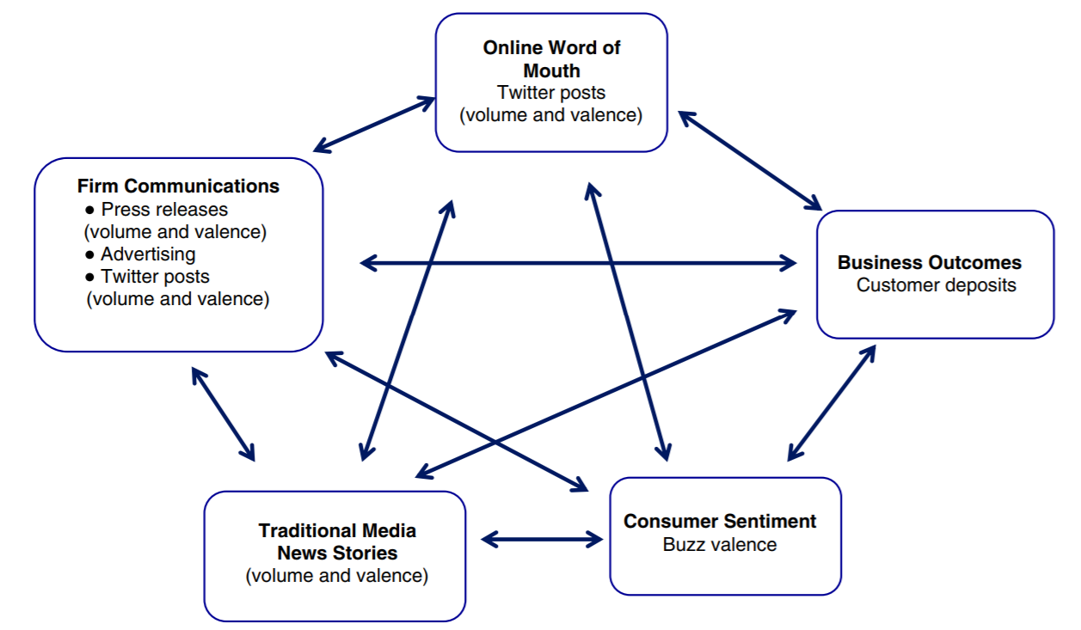
- What is the strength of the echoverse? To what extent do communications from each source affect the other sources?
- What is the nature of the echoverse? What is the direction of impact between components (positive negative)?
  - Increased use of social media
  - Adverting bypasses the echoverse
- Are there asymmetries in the echoverse? Is the direction of influence between some sources more one-way than to-way? yes
- How has the echoverse changed over time? As social media has grown, have relationships between sources changed over time, with some becoming more significant and some less?
  - Impact of online WOM
  - Negativity spiral
- How do the response dynamics to the various communications components in the echoverse differ across companies? Do some firms experience stronger responses to their use of certain communications components than others?

Discussion
- Theoretical contributions
  - Framework + feedback loops
  - Negativity spiral
  - Social identity theory
  - Role of advertising
- Managerial contributions
  - Factors outside firms’ control:
    - Negative news has stronger impact than positive news
    - Online WOM more influential consumer sentiment less predictive
  - Factors under firms’ control:
    - Online WOM marketing
    - Personalized ( broadcast)
    - Press releases
    - Advertising
- Limitations and future research
  - One industry investigated: financial services
  - Specific data used for components
  - Broad measures
  - Changing environment new insights emerging
  - Interaction of competitors’ echoverses
  - Metric used

The impact of brand credibility on consumer price sensitivity
- Brand credibility = credibility of the product position information contained in a brand (brand as a signal)
  - Depends on brand’s willingness and ability to offer what it promises (trustworthiness and expertise)
  - Cumulative effect of the credibility of all previous marketing actions taken by the brand = reputation
  - Incentive for sellers who invest heavily in their brands to provide truthful product position information
  - Brand credibility should increase expected utility by
    - Increasing perceived quality and/or raising expected quality
    - Decreasing perceived risk and information costs
  - Increase differentiation among brands
- Price sensitivity = weight attached to price in a consumer valuation of a product’s overall attractiveness or utility
- Consumer uncertainty = due to imperfect and asymmetric information
  - More sensitive to uncertainty: uncertainty reduces price sensitivity = price-seeking behaviour less sensitive to uncertainty: uncertainty increases price sensitivity = price-aversion affected by product category specific factors
- Four product categories, varying in
  - Degree of imperfect observability
    - Length of consumption history consumers need to perfectly evaluate product attributes or significantly reduce uncertainty
    - Extent of product and brand knowledge consumers can acquire purely from search activities
  - Level of involvement
  - Consumer heterogeneity

The brand relationship spectrum: the key to the brand architecture challenge
Brand architecture: manages brand teams, deals with relationships and structures powerful brand architecture tool = brand relationship spectrum:
- House of brands = involves an independent set of stand-alone brands, each maximizing the impact on a market
  - - : sacrifices economies of scale, synergies, brand leverage
  - + : clearly position, freedom, dominate niche segments
  - Shadow endorser = not connected visibly to the endorsed brand, but many consumers know about the link
- Endorsed brands = still independent but are also endorsed by another (usually organizational) brand
  - Token endorser = master brand involved in several product-market contexts, which is substantially less dominant than the endorsed brand
  - Linked name = name with common elements creates a family of brands with an implicit or implied endorser (e.g.: Big Mac)
- Subbrands = connected to a master or parent brand, augment or modify the associations of the master brand (primary frame of reference subbrand add associations)
  - +/- : potential to affect the associations of the master brand
  - Subbrand as a co-driver: both master brand and subbrand have major driver roles
- Branded house = master brand has dominant driver role across multiple offering, subbrand solely descriptor (little or no driver role)
  - Should be the default brand architecture option
  - - : lot of eggs in one basket, limit targeting groups
  - + : enhances clarity, synergy and leverage
  - Same brands but with different identities
Selecting the right position in the brand relationship spectrum: ask four key questions downward/upward movement on the brand separation spectrum toward branded house/house of brands (perspective of a new brand)
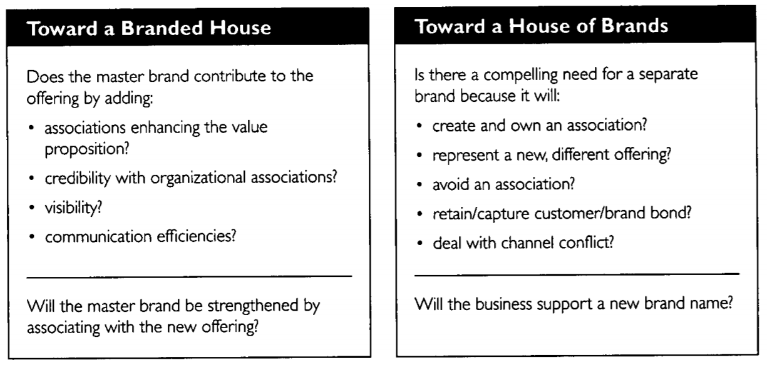

What makes brands elastic? The influence of brand concept and styles of thinking on brand extension evaluation
- Elastic = able to launch extensions into distant product categories
- Characteristics of parent branch:
  - Prestige brands = abstract brand concepts more elastic
  - Functional brands less elastic
- Consumer styles of thinking: influenced by culture
  - Holistic thinking = attention to relationships
  - Analytical thinking = focus on specific attributes
- Hypotheses:
  - Brand elasticity is jointly determined by parent brand concept and consumers’ style of thinking
    - H1: functional brands: holistic thinker will evaluate distant brand extensions more favourably prestige brands: evaluate similarly
    - Study 1A + 1B (same study, different product):
      - 2 (style of thinking: analytic VS holistic) x 2 (parent brand concept: prestige VS functional)
      - Style of thinking identified using analytic-holistic thinking scale
  - Examine styles of thinking as a situational variable
    - H2: functional brands: situations that encourage holistic thinking will evaluate distant brand extensions more favourably prestige brands: evaluate similarly
    - Study 2:
      - Style of thinking prime: think analytically/holistically by asking participants to circle non-relational/relational pronouns
      - Same as study 1
  - How can firms encourage holistic thinking in more realistic settings?
    - H3: direct brand: holistic thinkers will evaluate more favourably subbrand: evaluate similarly
    - Study 3:
      - 2 (style of thinking: analytical VS holistic) x 2 (brand architecture: direct brand VS subbrand)
    - H4: no information: holistic thinkers will evaluate more favourably elaborational communication: evaluate similarly
    - Study 4:
      - 2 (style of thinking: analytical VS holistic) x 2 (communication type: no information VS elaborational)
      - Style of thinking prime: scene: finding embedded figures (analytical) describing the scene (holistical)
  - Providing additional information depends on a customer’s personality
    - H5: analytical/holistic thinkers provide more favourable evaluations in the analytical/holistic frame
    - Study 5:
      - 2 (style of thinking: analytical VS holistic) x 2 (frame: analytical VS holistic)
      - Frame: viewed advertising with holistic (using adjectives) versus analytical (using verbs) frame
      - Matching the message frame to styles of thinking more favourable perceptions of message quality more favourable extension evaluations
- General discussion
  - Conceptual contribution
  - Managerial implications:
    - Brands can be stretched more for holistic thinkers trait of certain ethnic groups / geographic areas / …
    - Challenges of extending brands can be overcome with existing strategies
    - Importance of thinking about brand concepts when positioning and building brands (functional VS prestige)

The asymmetric effects of extending brands to lower and higher quality
Robust line extension asymmetry in which higher-quality extensions improve overall brand perception and evaluation more than lower-quality extensions damage them (sometimes no effect) consistent across:
- Product classes (study 1)
- Real and fictitious brands (study 1)
- A priori brand liking and familiarity
- Brands with austere and personable images (study 2)
- Brands of low to moderate prestige (study 3)
- Consumer regulatory focus (study 2)
contributing psychological processes: vary across consumers!
- Quality associations: higher quality > lower quality
- Variety effects: positive for higher/lower
- Opponent processes: lower quality extensions produce both negative quality associations effects and offsetting positive variety effects => in total neutral effect
- Perceived extension relevance to brand evaluation (best-of-brand processing): brand’s highest-quality version signals brand capability lower no change
General discussion: asymmetry supports leveraging brands across quality tiers, however be cautious!

Revenue premium as an outcome measure of brand equity
Brand equity = the marketing effects or outcomes that accrue to a product with its brand name compared with those that would accrue if the same product did not have the brand name approximated by private label / low share product

Conceptual background
- Why measure brand equity
  - Guide marketing strategy and tactical decisions
  - Asses extendibility of a brand
  - Evaluate effectiveness of marketing decisions
  - Track brand’s health
  - Assign financial value to brand
- Desiderata for ideal measure 1 measure cannot satisfy all
- Existing measures of brand equity
  - Focus on assessing consumer-based sources: customer mind-set
  - Focus on outcomes / net benefits of a firm:
    - Product-market outcomes middle ground
    - Financial market outcomes

The revenue premium measure
- Theoretical basis
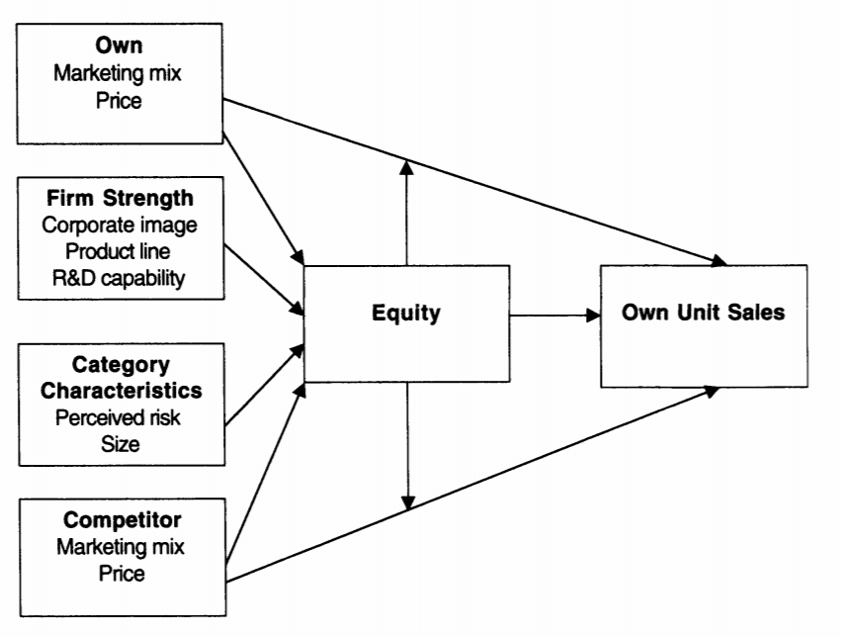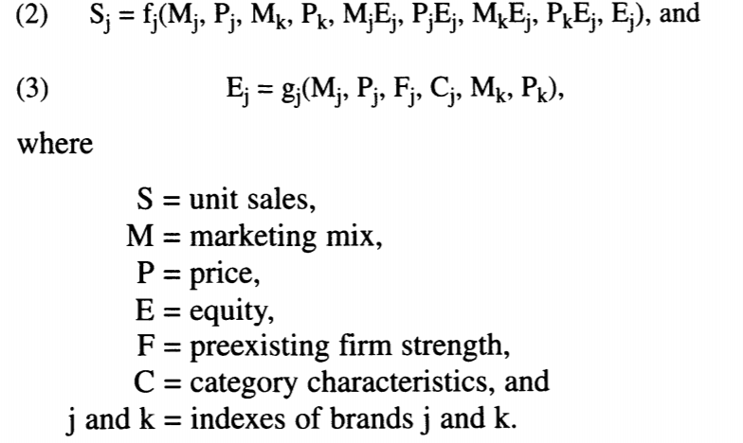
- Advantages and limitations

Assessing the validity of brand equity measures + data analysis
- Stability over time
- Correlation with other measures
- Correlation with marketing activities
- Empirical analysis: local data set and national data set

Conclusion
- Implications for managers
- Implications for researchers

Subtle signals of inconspicuous consumption
- H1: while everyone should be able to make reasonable correct inferences about explicitly marked goods, subtle signals are more likely to be misperceived
  - Pilot study: asked to estimate cost of two subtly marked low vs high end bags fashion students saw the difference
- H2: preferences for signal explicitness vary based on cultural capital, such that insiders (i.e. people with domain-specific interest and knowledge) are more likely to prefer subtle signals
H3: preferences for subtly marked goods are mediated by desires for distinction from the mainstream
  - Study 1: 2 (chooser type: regular vs insider) x 2 (explicitness: control vs subtle) insiders preferred subtle + cared more about being differentiated from mainstream
- H4: high-cultural capital individuals’ relative preference for subtle signals are stronger in
  - product domains that are identity relevant
    - Study 2: (chooser type: regular vs insider) x 2 (domain identity relevance: low vs high) less identity-relevant domains showed no difference between chooser types
  - public (vs. private) consumption situations
    - Study 3: number of goals
      - Role of public vs private consumption
      - Subtlety in other ways
      - Broader population
      - Fashion knowledge participants had different preferences in public/private

General discussion
- In some cases one group may actually behave similarly to another in order to avoid imitation by a third group
- Signal costs affect signal fidelity/reliability + increase likelihood that signals persist
- Impact of technological changes

Signaling status with luxury goods: the role of brand prominence
Categorization based on wealth and need for status:
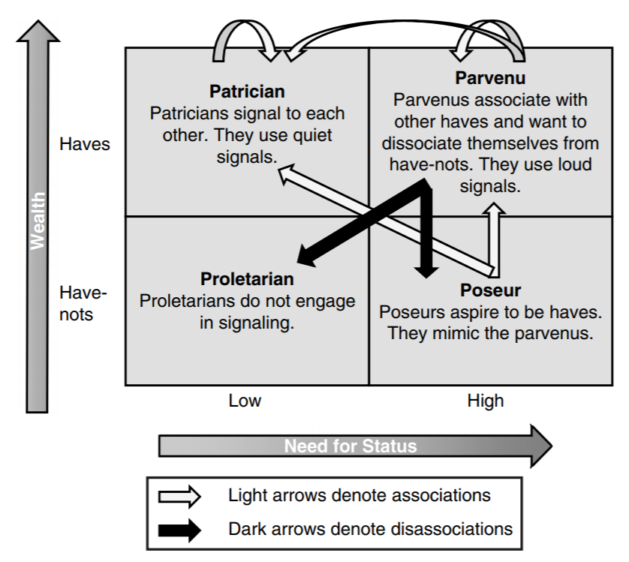
- Study 1: relationship between brand prominence and price:
  - Based on data of web sites luxury bags: charge more for quieter bags
- Study 2: brand prominence and counterfeit goods:
  - Based on data of web sites luxury bags + data on counterfeit bags: counterfeits choose to copy louder bags
- Study 3: recognizing subtle brand cues
  - Segmentation based on demographics of geographic areas
  - 2 (class: patricians vs nonpatricians) x 2 (brand prominence: loud vs quiet) x 2 (identification: brand names provided vs brand names not provided)
  - Patricians were able to correctly rank prices with and without brand names nonpatricians ranked prominent bags higher without names vs correctly with names
- Study 4: associative/dissociative motives and brand prominence
  - Segmentation based on demographics of geographic areas
  - Associative and dissociative motives see figure
  - Patricians least likely to buy loud bags
  - Poseurs more likely to buy counterfeit bags

General discussion
- Managerial implications
  - Need to develop (and communicate) a griffe
  - Don’t over-popularize brand will lose its value
  - Advertise to everybody
  - Reassess traditional pyramid approach
- Limitations and further research
  - Counterfeit data from Asia
  - Based on offer, not sales
  - How can firms using only loud branding affect status by introducing quieter goods

Let your banner wave? Antecedents and performance implications of retailers’ private-label branding strategies
Premium private label tiers: top end of the market, quality equal to national brands = base case Economy private label tiers: bottom-of-the-market = compared relatively to premium PL
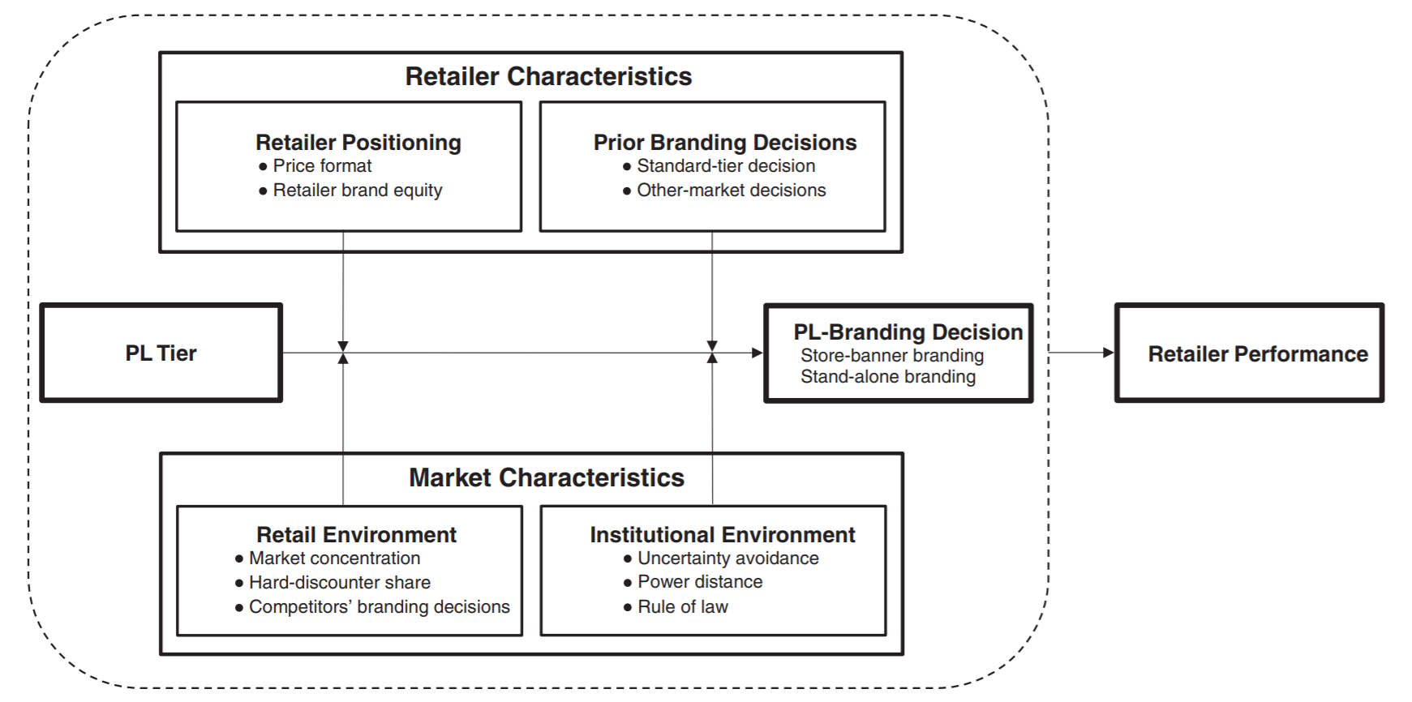
- Retailer positioning
  - Price format
    - Hi-lo strategy = focus on image rather than price
use store-banner: important indicator of PL quality + PL works as silent salesman
weaker for economy: cue-inconsistency
Everyday low price = similar low price every day, limited service
  - Retailer brand equity
    - High equity retailer
use store-banner: signal in uncertainty, lowers perceived risk, losses for retailer high when claim is false
weaker for economy: less uncertainty about positioning of product
Low equity retailer
- Prior branding decisions
  - Standard-tier decision:
    - If already uses store-banner branding
use store-banner: success speaks for itself
weaker for economy: potential sales shift, economy is less profitable
  - Other-market decision
    - If already uses store-banner branding
use store-banner: within retailer transfer of knowledge
weaker for economy
- Retail environment
  - Market concentration
    - Lower concentration = higher degree of competition
use store-banner: stand out in market by using unique premium PLs
weaker for economy: no big differentiating role
  - Hard-discounter share
    - High share = more hard-discounter (have PL-dominated assortments with stand-alone brands)
use store-banner: mainstream retailers fight back by maximally differentiating themselves, using premium PLs
stronger for economy: specifically aimed at protecting bottom of market against hard discounters
  - Competitors’ branding decisions
    - More competitors use store-banner branding
use store-banner: uncertainty in new market leads to imitation
weaker for economy: uncertainty is much lower
- Institutional environment
  - Uncertainty avoidance
    - Uncertainty-avoidant countries
use store-banner: sign of quality reassurance, less risky than failing to respond to stakeholder interests
weaker for economy: lower risk for consumer
  - Power distance
    - Countries with high power distance = strongly motivated by status and affiliation norms
use stand-alone: disguise PLs to increase status
weaker for economy: more difficult to increase status
  - Rule of law
    - Strong rule of law = independent suppliers have less power
use store-banner: less risk that supplier will deviate from contract and thus less risk for negative spillovers
weaker for economy: less incentive for suppliers to deviate from contract since less room for profitability
- Performance implications of the PL-branding decision
  - Contingency theory: decision depends on its congruence with situational characteristics faced by firm right decision improves performance
weaker for economy: less significant number of drivers
  - Darwinian economics: observed behaviour will be near optimal
  - Conformity especially appealing in uncertain conditions

The effect of business-cycle fluctuations on private-label share: what has marketing conduct got to do with it?
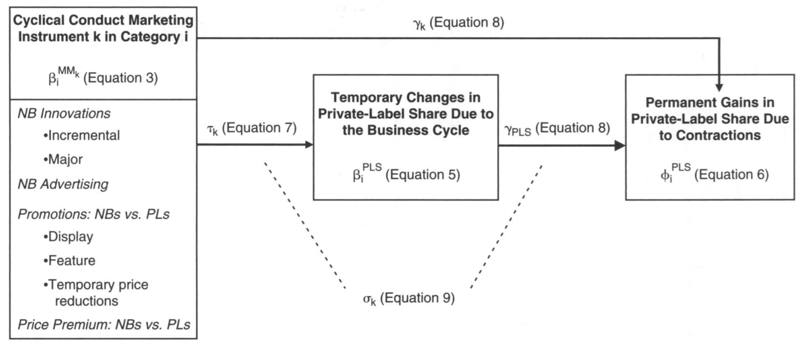
Questions:
- How do managers of national brands / private labels adjust their behaviour in response to economic up- and downswings? Procyclical / countercyclical adjustments (+ magnitude)?
- Do these adjustments contribute to temporary gains / losses in private-label share during contractions / expansions? If yes, which marketing instruments have greatest impact?
- Do these adjustments contribute to permanent gains in private-label share?
Discussion:
- Implications for national-brand manufacturers
- Implications for retailers
- Retailers’ observed practice of supporting their own labels in contractions
- National brand manufacturers also partially responsible
  - Opportunities to limit private-label growth have been missed
  - Reallocate some marketing investment from expansions to contractions requires multiyear perspective
  - Promotions have strongest temporary and permanent effect

The influence of a mere social presence in retail context
- Social impact theory until now: impact of interactive social presence
impact results from three social forces
  - Social size
  - Proximity
  - Importance (not discussed here)
- Now: impact of noninteractive social presence
  - Study 1: social size
    - H1: As the size of a noninteractive social presence increases, a consumer will be more likely to experience negative emotions and manage self-presentation behaviours
    - NO:
      - V-shaped pattern = more positive emotions when 1 person, than 0 or 3 explained by human motivation to belong?
      - Managed behaviours when social presence (size > 0), but no difference between 1 or 3
  - Study 2: proximity
    - H2: A consumer will experience more negative emotions and will be more likely to manage self-presentation behaviour when a close noninteractive social presence increases in size, but when the social presence is further away, social size will no longer matter
    - YES

