Business Analyse
Vraag 1
Process delivery lifecycle/software development lifecycle (dit thema/concept ieder jaar op examen)
- Incremental tackles highest priority first (antwoord D) (x7)
- Iterative (x2)

Vraag 2
Elicitation techniques
- workshops are a good technique to quickly resolve conflicting interests… (x13)

Vraag 3
APQF PCF (dit thema/concept ieder jaar op examen)
- APQF PCF is a industry neutral with hierarchy; category, process, activities (x11)

Vraag 4
Heuristic process redesign (dit thema/concept ieder jaar op examen)
- resequencing (x1)
- generalist-specialist (x7)
- incremental improvement (x1)
- task elimination (optie c) (x6)

Vraag 5
Decision tables, unique vs. any, incomplete and subsumption (dit thema/concept ieder jaar op examen)
- any hit… (antwoordmogelijkheid A) : (x11)

Vraag 6
Calculate Petri Net trace fitness (dit thema/concept ieder jaar op examen)
- Fitness = ⅖ (x12)

Vraag 7
Rootcause analysis frameworks
- Fishbone categorizes using 6M’s… (antwoord D) (x14)

Vraag 8
Types of requirements, functional vs. non-functional (dit thema/concept ieder jaar op examen)
- non functional requirement (x11)
- functional requirement
- business requirement
- Transition requirement

Vraag 9
MoSCoW and KANO framework linked, what is true
- attractive leads to satisfaction when included (x12)

Vraag 10
Declare trace (dit thema/concept ieder jaar op examen)
- Trace 1: CCC
- Trace waar B 2 keer komt zonder A er tussen. CABCBAB (x12)

Vraag 11
Calculate the probability X of the very last branch so the total cycle time is 181 minutes (dit thema/concept ieder jaar op examen)
Afbeelding niet noodzakelijk correct gereconstrueerd
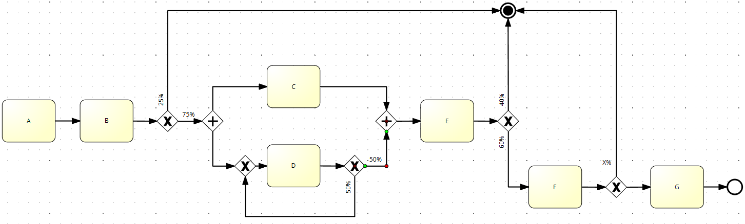

A | B | C | D | E | F | G
10 | 15 | 40 | 24 | 52 | 100 | 100

- 0%
- 20% (x12)
- 65%
- 79%(2x)

Vraag 12
Business Capability model and business Canvas model
- focuses on the ‘what’ and the ‘how’? (optie A) (x1)
- BCM is a replacement for BMC…

Vraag 13
Artificial negative events, false positives vs. false negatives (dit thema/concept ieder jaar op examen)
- Log 2 has more negative events than log 3 (x9)

Vraag 14
Semantic and syntactic correctness/completeness (dit thema/concept ieder jaar op examen)
- semantically correct (2x)
- BPMN model niet correct (x1)

Vraag 15
BPMN parentprocess/subprocess + terminate event, general model language understanding
- 120 days timer…. (antwoordmogelijkheid B) (x7)

Vraag 16
Statements about Petri Nets places/transitions/blank transition
- Not a workflow net because you can’t reach B from G (x3)
- Meer tasks dan places (x7) (deze was juist, heb net les herbekeken en zegt 1à keer dat invisible task een transitie is)
- It can reach from p0 to P6 (x1)

Vraag 17
Livelock, deadlock, lack of synchronization (dit thema/concept ieder jaar op examen)
Afbeelding niet noodzakelijk correct gereconstrueerd
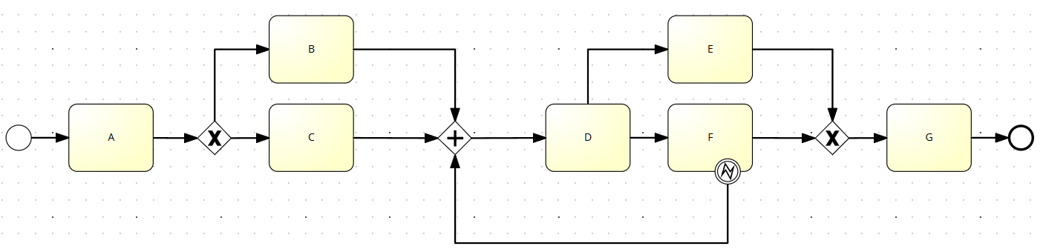
- There is a lack of synchronization and a deadlock (x13)
- livelock and deadlock (x1)

Vraag 18
Business process management systems (BPMS) (dit thema/concept ieder jaar op examen)
- they should be eliminated in transformation from conceptual to be to executable (x4)
- exceptions should be explicitly mentioned (x9)

Vraag 19
Stakeholder analysis frameworks, which answer is false
- SH matrix excludes stakeholders with low interest and low power (x14)
- Onion diagram uitgelegd

Vraag 20
Overfitting vs. underfitting vs. non-fitting (dit thema/concept ieder jaar op examen)
- A is overfitting (x13)

