FBE EXAM
D0M09A Economics Aspects of European Integration

Prof. Filip Abraham
22/01/2017

Instructions for students

- Please write your identification info (student name, nr) on every page!
- Maximum duration: 2 h 15 min (from official starting hour of the exam)
- Exam type: written, open book
- Only the following auxiliary materials are allowed:
- Pen
- Slides
- Textbook
- Lecture notes
- Own class notes
- Articles related to the course
- One dictionary

- Students are allowed to use their own pen, but should only use the paper provided by the university.
- Please, check that your exam bundle contains 2 questions. Immediately ask the surveyor for another bundle if this is not the case. Please do not detach any pages from this bundle.
- The weight of each question in the total exam grade and time allocation is indicated in the exam
- Be concise in your answers.
- Graphs are only needed when explicitly mentioned in the question.
- Mobile telephones and electronic devices should be handed to the invigilators who will keep them for you until the end of the exam. All material such as jackets, backpacks, books and own paper should be left at the back or the front of examination room.
- For any irregularity of a student, all articles in the irregularities-section of the exam regulations apply.

Good Luck!

Question 1: The One Belt, One Road initiative (1h15min)

One of the most influential Chinese initiatives in the domain of market integration is the One Belt, One Road (OBOR) initiative. As mentioned in class, the idea is to establish a direct and fast connection by road and by sea between China and Europe in order to improve market access and achieve closer economic “Eurasian” cooperation (see picture below). The Chinese government is massively investing in the infrastructure of the participating countries in Asia and Europe. It is awarding lucrative contracts to Chinese and European companies that get involved in the infrastructure projects.
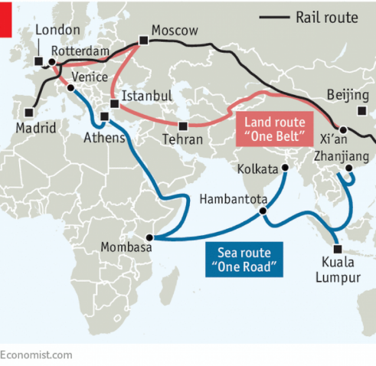

Which of the five freedoms would be affected by the One Belt, One Road Initiative? Explain how.

Using the graphical framework of market integration, developed in class, analyze the impact of the One Belt, One Road initiative on Europe, China and the US.

One of the concerns in Europe is that OBOR will benefit some regions/ countries in Europe but harm others. Based on theories of comparative advantage, regional clustering/agglomeration and metropolitan hubs, do you believe this will be the case?

In pursuing global trade and investment relations, strategic interests matter. Is it in the strategic interest of the EU to participate or should the EU follow another global trade and investment approach with respect to China? Use in your answer the analysis of trade and investment relations developed in class.

Suggested answers to the question

Ad 1. If the One Belt, One Road (OBOR) initiative is successful in reducing the transportation time between China and Europe, we can expect that the mobility of goods (exports and imports) will benefit leading to more international trade between the countries involved in OBOR.

The mobility of capital will be affected because Chinese financial capital transfers will be needed to finance the infrastructure projects in Europe and other OBOR countries. The mobility of capital may also increase due to higher mobility of European and Chinese firms when they engage in foreign direct investment to establish themselves in OBOR countries. This may for instance happen when Chinese and European companies optimize their value chains along the OBOR routes.

The mobility of labor may also be influenced if Chinese workers are used to work in infrastructure projects outside their home country or European expats are managing projects related to the OBOR initiative.

Ad 2: We consider a sector that builds infrastructure and where public contracts matter a lot. In those activities barriers between countries are often substantial. The first graph shows the situation before the OBOR. We assume distances between China and the EU are larger than between the EU and the US.

OBOR reduces the distances between China and the EU considerably while maintaining the distances with respect to the US (we assume that Trump does not retaliate against OBOR). This is shown in the second graph. We get the effects discussed in class when moving from a segmented to a semi-global solution (see course notes). The mobility of goods between China and the EU will increase. Interestingly, this will also be the case for the mobility of firms when EU firms will

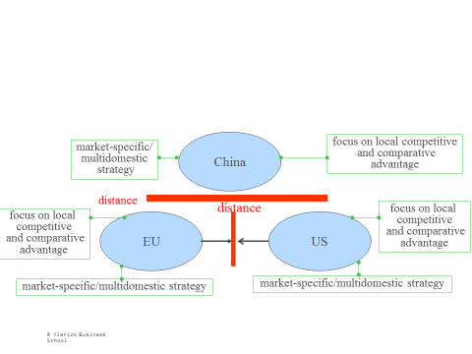

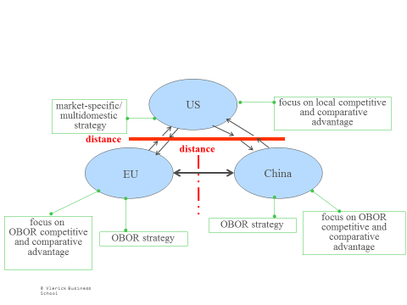

obtain contracts to build infrastructure in China or in other countries along the OBOR routes. Similarly, Chinese investors may want to invest in European infrastructure (e.g. Chinese firms buying the port of Athens). All of this means that the pattern or cross-border export flows between the EU and China will be augmented by cross-border foreign direct investment flows. This is meant by OBOR strategies in the second graph.

Note furthermore that the US companies may suffer as a result of OBOR. This will be the case if the closer contacts between the EU and China will lead to infrastructure contracts going to Chinese and EU firms at the expense of US competitors.

Ad 3. The question is based to the class discussion on location, economic geography and regional policy. Information is found in chapter 4 of the lecture notes, in the slide set on regional policy and location, and possibly, in the article from The Economist on the losers of globalization that was discussed in class.

The answer of the question is similar to the discussion on the Krugman hypothesis on European integration which states that market integration may widen regional differences in the EU. In this case, the question is whether closer integration with China will have an unequal impact on European countries and regions.

When one looks at theories of comparative advantage, the key slide is:

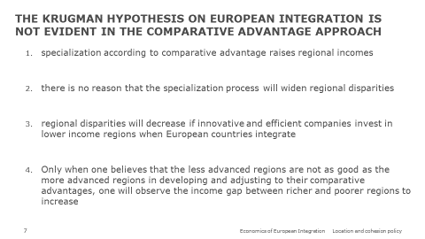

Translating to OBOR, it may very well be that integration with China leads to a specialization according to comparative advantage, raising all or most countries/regions and not only those that are located around the OBOR routes. That is the optimistic view.

The alternative, more pessimistic view is that OBOR will systematically benefit some regions or countries while harming others. This will be the case in the regional agglomeration approach if the conditions in the next slide are satisfied.

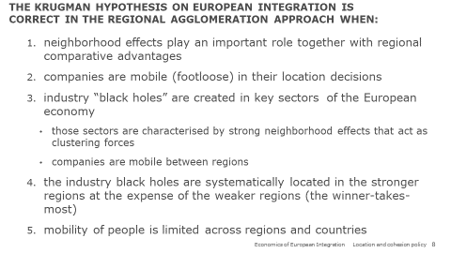

It may also happening in theories that emphasize the link between global integration and urbanization in metropolitan hubs (see next slide)

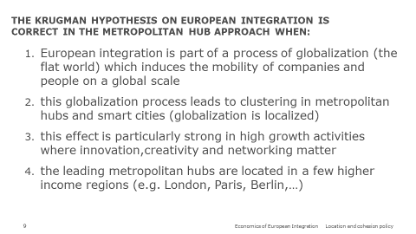

In their answer students may or may not refer (i) to the empirical evidence for the various theories that are found in the slide set or/and (ii) to the article from The Economist.

Ad 4. This question is based on the discussion on global trade and investment relations (see lecture notes chapter 7 and the slides on global trade and investment).

The strategic objective of China is to strengthen its position as a global player and promote the interests of Chinese firms and investors. Geopolitically speaking, it aims at weakening the transatlantic relations between the US and the EU by creating stronger “Eurasian” economic links between Europe, China and the other countries along the OBOR routes.

For Europe OBOR has advantages and disadvantages. One advantage is that EU firms may obtain OBOR-related contracts and may perhaps get a better access to the Chinese market. Another advantage is that a better relation with China may make Europe less dependent on the unpredictable US strategy under the Trump administration. The disadvantage is that Chinese firms may become even stronger competitors than they already are. Likewise, the Chinese government may replace European by Chinese companies once that technology transfers has taken place in OBOR-related public contracts.

The European alternatives for OBOR are double. On the one hand, Europe may go for a minilateral strategy and conclude a major free trade agreement with China, focusing on sectors that matter for Europe while protecting European interests. The other strategy is to become more protectionist with respect to China, making it more difficult for China to buy European companies and/or sell their products in European markets.

Question 2: Brexit: The Chequers plan (40 min)

Just before the summer the British government announced the so-called Chequers plan about Brexit.

- One element of the plan is that the UK and the EU would sign a free trade agreement on the mobility of goods but not on the mobility of services. Are you surprised? Does this make sense? What are the advantages and disadvantages of this proposal for the UK and the EU?
- Another key issue concerns the right of the UK to negotiate its own trade agreements with non-EU countries. Under which conditions do you think the EU could agree with this UK demand?
- As the negotiations are in a deadlock, it becomes more and more likely that the UK may leave the EU in March 2019 without a trade and investment deal. Suppose you are the CEO of a large multinational food company operating in the UK and the EU. How would you prepare for such no-deal scenario?

Question 3: Competition Policy towards China (35 min, 25% of the grade)

Chinese companies are increasingly buying European companies, acquiring key technologies and getting access to the EU domestic markets. This is controversial. Does the analysis of (i) global trade and investment relations and (ii) competition policy provide any insights on how to deal with this?

Question 4: 20 Years of the euro: where is the party? (45 min)

On January 1,2019 the euro will celebrate its 20th anniversary. Unless the mood improves in the next couple of months, there is not much of a party atmosphere.
- What do you think are the big challenges of the euro-zone?
- Are you optimistic about the future of the euro-zone? Explain.
- Suppose that the euro-zone would collapse. What would happen?

Question 2: The renewed optimism about European Integration
(1 Hour, grade 9/20)

One fundamental theme in this year’s course was the renewed optimism in the EU, leading to a new steps in the process of European integration.

Competition policy is an area where this renewed confidence is apparent, symbolized by the tough attitude of EU Commissioner Margrethe Vestager. In class we discussed the case of Google’s dominant position in online search and shopping services. We simulated this case by one group of students representing the European Commission as a prosecutor, one group defending Google, and one group taking the role of the European Court of Justice which made a final judgement on this case.
Do you agree with the judgement on this case taken by the group that represented the European Court of Justice? What were the arguments made in the class discussion that were the most convincing to you?

Banking union is a key part of the creation of an Economic and Monetary Union. Based on the guest lecture by Florian Brandt, do you see progress in the realization of a banking union that would justify the renewed optimism about European integration.

The social dimension is an important ingredient of realizing a sustainable Economic and Monetary Union. Based on the guest lecture by Frank Vandenbroucke, do you see progress in the realization of a social union that would justify the renewed optimism about European integration.

