FBE EXAM
D0R16A Marketing Strategy Modeling

Prof. Lien Lamey & Dr. Kristina Melis
27/01/2017

Instructions for students

- Please write your identification info (student name, number) on every page!
- Maximum duration: 3h (from official starting hour of the exam)
- Exam type: written, closed book
- Only the following auxiliary materials are allowed:
- pen
- Students are allowed to use their own pen, but should only use the paper provided by the university. Other papers, notebooks, ... are not allowed.
- Mobile telephones and electronic devices should be handed to the invigilators who will keep them for you until the end of the exam. All material such as jackets, backpacks, books and own paper should be left at the back or the front of examination room.
- For any irregularity of a student, all articles in the irregularities-section of the exam regulations apply.
- Please, check that your exam bundle contains 3 questions with subquestions and 8 pages. Immediately ask the surveyor for another bundle if this is not the case. Please do not detach any pages from this bundle.
- You can use the back of the pages as scrap paper.
- Only the answers written on the front of the pages will be read. Cross out your scrap text that doesn't need to be corrected.

Marks
Question 1 | Question 2 | Question 3
/4 | /8 | /8

Question 1 – Customer Value & Firm Value

Imagine the following scenario:

In March 2015 a Dutch company launched a new social media platform – PinMedia, where subscribers can rent online movies and TV sitcoms via the PinMedia website. Information on the number of subscribers/customers at a monthly basis, starting from March 2015 up to December 2016, is publicly available.
Pin Media

How can you derive a proxy of the value of this customer driven company PinMedia based on the information provided in Figure 1?

- Please give the formula to compute firm value of PinMedia?
- What are the inputs you need to derive a proxy of the firm value of PinMedia?
- One of the inputs is the number of acquired customers each month: Which type of model do you need to derive these forecasts based on the data provided in Figure 1?

Question 2 – Marketing Strategy in Turbulent Times

Imagine the following scenario:

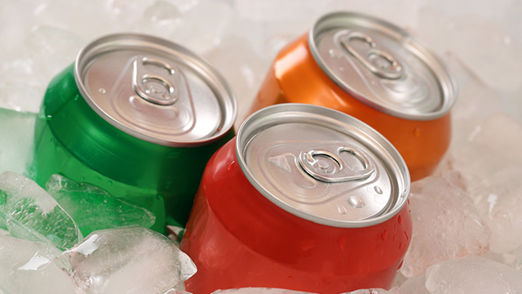
The firm SODA produces the well-known soft drink brand Six-up. Under the Six-up flag, SODA offers a broad set of varieties: different flavours (e.g. cola, orange, lemon,…) and different package sizes (33cl, 0.5l, 1l, …). You can buy these Six-up drinks in almost every supermarket in Belgium (such as Carrefour, Delhaize, Colruyt, Spar,…).

Recently, the Belgian economy is turning sour. According to the latest reports, the Belgian economy is in an economic contraction. Despite these hard economic times, the firm SODA really wants to protect the market share of its Six-up brand in the soft drink category and even wants to improve its position in the market.

- Which competitor should Six-up fear the most during these hard economic times? And why? Which factors explain the increased popularity of this competitor during hard economic times?

- Should Six-up spend its limited marketing budget on price decreases or advertising support during these hard economic times? Please motive your answer carefully.

- How can you derive the (temporary) relationship between the market share of Six-up and the business cycle over time? What are the two methodological steps?

Question 3: Omni-channel Marketing Strategy

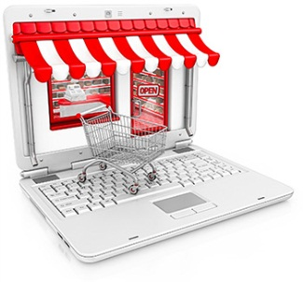
A multi-channel supermarket chain FRESHMARKET wants to predict purchase conversion rates using within-site activity. You are the analysist of Freshmarket and are asked to develop a model to predict a website purchase conversion (i.e., the likelihood of placing a purchase order) based on the sequential tasks that a website visitor goes through when visiting the website.

A website visitor can take the following steps:
- Start at homepage
- Login or register (if it’s a first-time visitor)
- Choose product(s) from one or several categories and place them in shopping cart
- Use list of favorites
- Choose pick-up point
- Choose timeslot of pick-up
- Request loyalty card (not necessary)
- Look at overview of order (service cost is visible now)
- Add remarks on order (e.g., ripe or unripe bananas)
- Confirm order
- Payment at pick-up point
- Define the Nominal User Tasks (NUTS) that you plan to use in your model and come up with good variables derived from within-site activity which can influence each of the NUTs (Hint: Not all listed tasks should be considered as separate NUTs. There is a maximum of 4 NUTs)

- Specify your model (show the equation of the likelihood of purchase and the utility on which this likelihood depends) and give the underlying assumptions of this model. (Hint: Take into account the NUTs you have identified in 3.a.)

- The variables used and their importance in a purchase conversion model depends on the product category or sector.
- What is the difference with predicting the likelihood of purchase using within-site activity of a car company compared to a supermarket?
- Which of the variables identified in 3.a. are expected to weigh more or less in a purchase conversion model compared to that of a car company and why?

Good luck!

