2. Culture and segmentation

1. WHAT IS CULTURE
= Integrated system of learned behaviour patterns (before 10y) that are distinguishing characteristics of member of a given society
- Value framework shared by people in a social group
- NOT always national borders
  - Within-country differences (e.g. Be)
  - Cross-national similarities (e.g. southern Austria & north Italy)
- Every person is encultured
- Passed down from 1 generation to other
- Acculturation (adapting to other culture) can be very difficult

Language
= word & tone used to convey message (not only verbal)
= necessary condition for learning culture
Important for global marketer
e.g. translation errors

Religion
= understand differences btw religions & divisions within religions
e.g. Christian vs protestant (money attitude)

Values
= enduring belief that one mode of conduct/ end-state of existence is preferable to an opposite mode of conduct/end-state of existence
- Value system
= learned organization of principles & rules to help choose btw alternatives, resolve conflicts & make decisions
- Values prioritized & taught <10y

2. CULTURAL DIMENSIONS
1. Hofstede’s 4 original cultural dimensions
- Power distance
= extent to which individuals are willing to accept inequality in society
e.g. Are employees afraid to disagree with manager?
  - High score
= more willing to accept ≠ in wealth & influence
    - Expectation that some individuals have > power than others in which upward mobility is very limited
    - Latin America, Japan & Arab nations
    - Asia
= hierarchy rituals (greeting, business cards)
= relevance of status symbols (global & luxury brands)
  - Low score
= inequality not easily accepted
= argue for more equitable distribution/ form of decision-making
e.g. Scandinavian & Germanic speaking countries
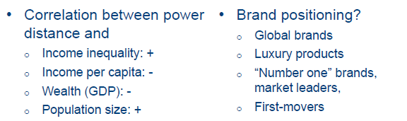
- Individualism vs Collectivism
= Extent to which people in society are focused on individual achievements and accomplishments as opposed to the overall success of the group to which they belong
  - Individualism
= Personal success highly valued
= People rewarded for initiative & ability to act independently
E.g. USA, Western Europe
    - Individual benefits, personal success, concern for privacy
  - Collectivism
= oriented towards teamwork and success of the group
= ability to work as team member and contribute to its success is highly valued
e.g. Latin American cultures, China
    - Ads focus on in-group benefits (e.g. Cheers beer) 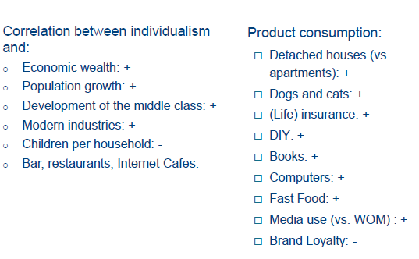
- Uncertainty avoidance
= Extent to which individuals in a society expect to be guided by formal rules & regulations
e.g. Company rules should not be broken.
  - High score
    - Expect structure, don’t like risk & ambiguity
    - Seek out plans & policies to guide action
    - Unikely to exhibit high-risk behaviour (e.g. entrepreneurial)
    - Be, Greece, Japan (mouth masks), Poland, Portugal, Russia
  - Low score
    - Initiative & risk taking behaviour
    - Less tolerant of bureaucratic policies & procedures
    - Embrace situations in which payoff & consequences not known in advance
    - UK, Sweden
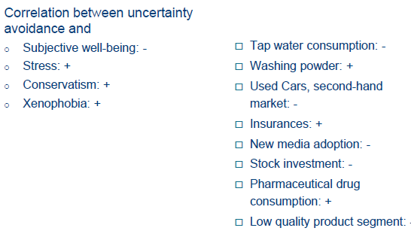
- Masculinity vs. Femininity
= extent to which a society tends to emphasize x reward ‘masculine’ values such as competition, success and performance as opposed to ‘feminine’ values such as nurturing and caring for others
  - Masculinity
    - People value competitiveness, assertiveness, ambition & the accumulation of wealth x material possessions
    - e.g. Japan, US & UK (moderate)
  - Femininity
    - People value relationships, friendly atmosphere, security (of employment) and quality of life & are more nurturing
    - E.g. Sweden, Norway
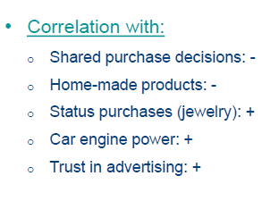

2 New dimensions
= LT vs ST orientation & indulgence vs restrained
- Long-term orientation
  - LT
    - Thrift, perseverance, sense of shame, status importance are valued more
    - LT horizon in investment decisions
    - E.g. Eastern nations, China
  - Short-term orientation
    - ST gratifications valued more & rapid solutions to solve existing issues are preferred
    - Quarterly profit expectations
    - Less developed nations
  - + correlation of LT orientation with economic growth
- Indulgence
= extent to which a society allows relatively free gratification of basic x natural human desires related to enjoying life x having fun
  - Indulgent
    - Focus more on individual happiness and well-being
    - Importance of leisure time, friends
    - Greater freedom x personal control
    - Following impulses is good
    - Mexico, Nigeria, US
  - Restrained
    - Not lot of importance to happiness, freedom, leisure
    - Gratification needs to be regulated b strict norms
    - Perception of helplessness x what happens in one’s life is beyond his/her control
    - Life is hard, duty, not freedom
    - France, Japan, Germany
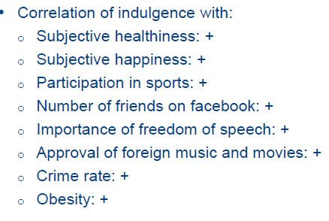

Limitations of Hofstede’s values
- Country averages vs individual scores
  - Ignorance o existence of subcultures
- Data accuracy
  - Limited to one company
  - Questionnaires
  - Several biases present (conformity to group in collective cultures)
- Timeliness of the data
  - Dynamics due to internal x external influences
  - By nature, quite stable over time

Schwartz’s human values
= tries to measure universal values that are recognised throughout all major cultures
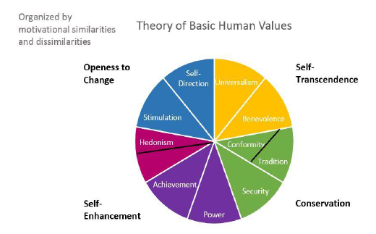

- Self-transcendence
= transcending the human state, spiritually
- Conservation
= ethical use & protection of values
- Self-enhancement
= motivated to make yourself feel good x maintain self-esteem
- Openness to change

High and low-context cultures (Hall 1976)
High-context
= communication is important (how message is delivered x by who)
= importance of nonverbal elements, behavioural codes
E.g. Chile, Mexico, Japan

Low-context culture
= direct messages, most information is explicitly given
= context provides less meaning
e.g. US, India, China, Russia, Australia, Germany, Scandinavia

Importance of context culture
= new product launches (negative evaluation not expressed in Japan)
= employee feedback (not given in Middle East)

3. MARKETING IMPLICATIONS OF CULTURE
Divergence or convergence?
De mooij en Hofstede 2002

Study impact of culture on consumption
- Does globalization lead to convergence? Homogenous consumer wants x needs
- Still lot of divergence!
= many consumption differences btw countries

Private label consumption
(usually cheaper & believed to be less qualitative)
= higher in
- Individualistic countries
  - Collectivistic place more importance on using brands as status symbols
- Countries with ST orientation
= less brand loyal

Luxury articles and masculinity
= culture very important
= masculinity, more luxury articles (expensive things more popular, more status)

Steenkamp et al. 1999
Impact of personal x cultural values on innovativeness
Include both individual values (Schwartz) & cultural values (Hofstede) & link with innovation

Framework: Consumer innovativeness (DV) =Personal values (IV) & National cultural dimensions (IV2)
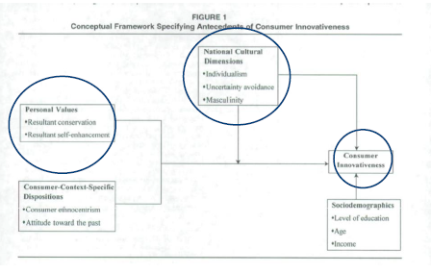

- Conservation (vs openness to change)
= decreases innovativeness
- Self-enhancement (vs self-transcendence)
= no effect on innovativeness (although expected +)
- Individualism
= increases innovativeness (more own initiative, not the group)
- Uncertainty avoidance
= decreases innovativeness (avoid risky behaviour)
- Masculinity
= increases innovativeness (material goods)

4. INTERNATIONAL SEGMENTATION
Why segment?
= to deal with structure of heterogeneity in consumer needs and wants across borders
= better matching products to customers
Homogenous clusters of consumers are likely to exhibit similar responses to marketing efforts
= reduced costs of marketing
= focus on best segments

Segmentation
- Minimize within-cluster distance
- Maximize between cluster distances

1. Segmentation level
Macro: country segments
- Clusters of (multiple or single) countries that follow national borders
- Multi-domestic strategy
= each country separate segment
  - Distinct mm-strategy and positioning at national level
- Conditioning
= high within-country homogeneity
- Advantages
  - Accessible segments
  - Cost effective through centralization of activities
  - Easy to implement, no coordination required

Micro: consumer segments
- Clusters of consumers that can cross/transcend national borders or that exist within particular country
- Pan-regional or global strategies
- Condition
= low within-country homogeneity
- Advantages
  - Global integration
  - Economies of scale & scope
  - BUT less cost efficient from logistics perspective
  - Proper adaptation

Bijmont et al (2004)
Country segment (macro)
= tried to find countries with more or less the same dimensions
Found 7 segments
Consumer segments
Found 14 consumer profiles

Linked consumer & country segments & calculated chance that a certain consumer group belonged to certain country
= easy to target
Included role of demographics
2. Segmentation base
= set of characteristics that is used to assign consumers to segments
= requirements of good segments
- Identifiability
= should be able to distinguish segments
- Substantiality
= large enough
- Accessibility
= can they be reached with promotional activity?
- Stability
= are segments stable over time?
- Actionability
= Good basis for formulation of effective marketing strategies
- Responsiveness
= Respond homogeneously to Mefforts targeted at them

General bases
= independent of domain in question
- Observable
  - Geographic regions (Middle East, Oceania) or trade blocks (EU, Nafta)
  - Socio-demographic (population size, age, education, language, infant mortality, life expectancy
  - Economic: level of development, infrastructure, GDP (per capita)
- Unobservable
  - Cultural: Hofstede, Schwartz values
  - Lifestyles: VALS (value attitude lifestyle)

Domain-specific bases
Types:
- Product diffusion patterns
- Means-end chains, benefits sought
- Usage: heavy vs. light
- Financial product ownership
- Brand loyalty

Combi of multiple criteria or 2-stage segmentation can be used

3. Segmentation methods
Aim = maximize within-segment homogeinity, max cross-segment heterogeneity
= priori segmentation
Post-hoc methods: cluster analysis, factor analysis, finity mixture model, decision trees analysis

5. INTERNATIONAL TARGETING AND POSITIONING
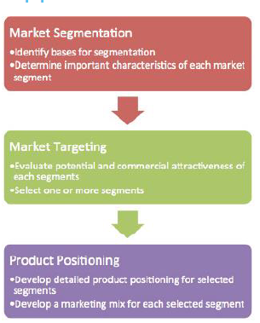
STP approach

Targeting
= decide on which segments to target
Criteria
- Size
- Difference
- Money
= anticipated profits must exceed costs of additional marketing plans x other changes
- Accessible
- Focus on different benefits

Positioning
= act of designing the company’s offer x image so that it occupies distinct x valued place in the target customer’s mind

Who is the target group, who are the competitors, what are my points of difference?


