3. International entry
Internationalization as source of growth
Ansoff’s growth matrix
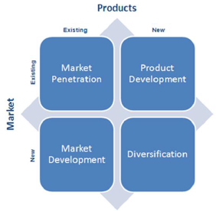

Firm internationalization
- Proactive
= take advantage of opportunities outside geographic boundaries
  - Product appeal to consumers across world
  - Managerial urge
  - Achieve greater profitability through eco of scale
- Reactive
  - Declining/ mature home markets
  - Counter competitive threat
  - Overproduction
- Born global

1. MARKET SELECTION
Country selection & process
- Impossible to operate in all countries simultaneously
- Not all countries profitable
- Financial consequences of poor selection
- Importance of (physic) distance
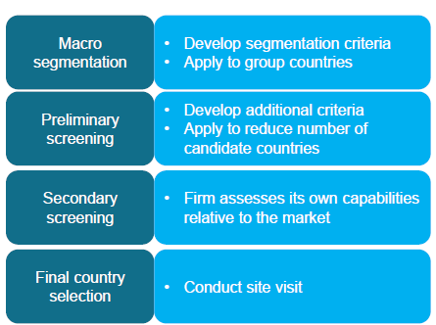

1. Macro segmentation
Develop segmentation criteria & apply to group countries
= screen large # countries
= actionable and measurable criteria
= Homogeneous within x heterogeneous between

2. Preliminary screening
Develop additional criteria & apply to reduce # candidate countries

Drivers of market potential
Country specific, country&product specific & product specific variables
Influence sales potential
For preliminary screening only country & country x product specific
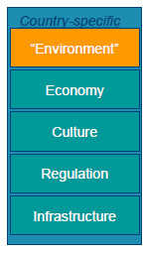
Country-specific drivers of market potential
Environment
- Political environment
Risky countries: Angola, Congo, Colombia, Haiti
  - General instability
e.g. revolution, terrorism
  - Expropriation
e.g. nationalization (Coca-cola)
  - Operations
e.g. import restrictions, local regulations
  - Finance
e.g. exchange rates, taxes
- Physical & geographic environment
e.g. Climate
- Demographic characteristics
Market size
e.g. population size, rate of growth, age structure

Economy
- Consumer demand
= disposable income per capita or household revenue, purchase power, income inequalities,.
- Distribution channels, media
- Future potential
e.g. emerging markets
- GDP + impacts performance
- Economic distance – impacts performance

Culture
E.g. openness to other cultures, materialism, importance of the norm, ethnocentrism
= culture affects many consumer-related dimensions: brand image, consumer innovativeness
- Religion
e.g. financial interests, meat consumption
- Cultural hostility and boycotts
e.g. US foreign policy

Cultural distance is - related to foreign market entry decisions
Regulations
- Import-export regulations
  - Tariff barriers
  - Non-tariff barriers
= specific limitations on trade, customs and administrative entry procedures, standards, government participation in trade (export subsidies)
- Price regulations
- Marketing effort regulations
- Depends on industry!!!
E.g. Belgium fully regulated, US no regulations in pharma

Infrastructure
- Physical transportation structure, retail distribution network, communication network, mass media,…
- Level of development
- Electricity availability
- Internet access
- Supplier and supporting industries present in local market
Country & product-specific
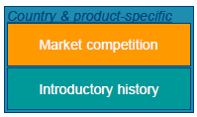
Market competition
- Competitive analysis
= Porter’s 5 Forces (opportunities & threats)
- Domestic x foreign competition
- # competitors (-)
- Variability in market shares among competitors (+)
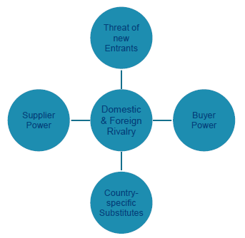
- Competitive attack
= entering a market to weaken competitors
  - Attack competitor’s cash-generating home market
  - Precede a competitor’s entry
= pioneer advantages
  - Risk: costly x dangerous
Introductory history
- Learning effect
- Spillover effects btw countries
- Near-market knowledge
- Leading markets
  - Learn from highly demanding customers and strong competitions
  - Not always the largest markets
US for PC, Japan for camera,…

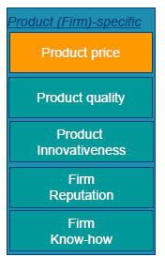
3. Secondary screening
Firm assesses its own capabilities relative to the market
Product (firm) – specific

Product price
- Match with the country characteristics
e.g. income
- Local competitors’ price
- Accounting for import tariffs
- Profitability analysis

Product quality
- Match with the country characteristics
- Match with the positioning of the company
- Perceived quality
  - Quality-price ratio
  - Country dependence

Product innovativeness
- Perceived innovativeness
- Differentiation compared to available alternatives
- Importance depends on country
  - Risk-avoidant nations vs. risk-seeking nations

Firm reputation
= country-of-origin effect
= country = brand equity (german cars, Italian clothes,..)
Can ∆ over time

Firm know-how
- Patents
- Knowledge of the market (other products) or similar markets (near-market knowledge)
- Management skills
- Ability to adapt to the local conditions
- Interest of a strategic partnership/alliance

4. Country selection process
= final country selections: conduct site visit
Site visit
- Meet channel intermediaries
- Assess local competitors
- Speak to government regulators

2. MODE OF ENTRY
Institutional arrangements firms employ to enter foreign markets
- Key determinant of success of internationalization
- Depends on internationalization objectives

Depends on control, costs, risk, commitment & profit potential

6 ways to enter
1. Exporting
= manufacturing products in one country & selling in one or more foreign countries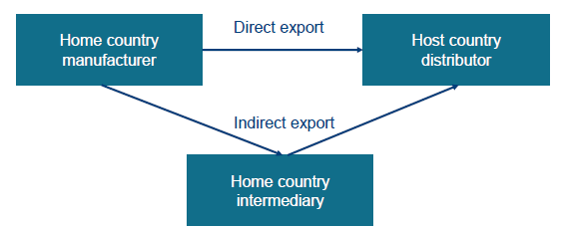
+ | -
Knowledge of foreign market not needed | Least profitable mode of entry
Internationalization with minimal risk | No control on positioning product in foreign country
Least costly mode of entry | Little opportunity to learn the foreign country

Importance of intermediaries
Market intelligence, customer relationships & aware of regulations

2. Licensing
= firm (licensor) grants right to use its intellectual property to antoher firm (licensee) in exchange for financial compensation (royalty).

Intellectual property
- Patents
- Trademarks
- Copyright materials
- Business models

Licensor
- Inexpensive way to internationalize
- No market knowledge needed
- Useful in circumventing protectionist policies
- No opportunity to learn from foreign business
- Danger of sharing technological know-how

Licensee
- No investment in R&D
- Speed of entry
- Technological support
- Danger of being used for old technologies

3. Franchising
= One company (franchisor) grants another (franchisee) the right to use its business model in a specified jurisdiction over a defined time period in exchange for financial compensation (management fee).

Franchisee duplicates business operation in foreign country
Store design, market research, products, trademarks
Direct vs indirect (via master franchisee)

4. Joint ventures and strategic alliances
= exchange or share parts of value chain
= work together to achieve mutually beneficial objectives
= joint ventures capital is brought into new venture

5. Foreign sales subsidiary
= establishing (only) a sales presence in country
= recruit x train local salesforce
! Subsidiary has total control of sales function

- Greater control of sales function
- Close relationships with channel members
- Feedback from foreign customers
- Deeper level of commitment to a country, better relationship with government
- Costs of training, compensation and office x support services

6. Foreign direct investment (FDI)
= investment of financial capital in a foreign jurisdiction to acquire new asseets or to expand the company’s stake in assets.
= greenfield expansion
= LT commitment to foreign country, investments in plants, equipment, real estate, infrastructure,…

- Market-related reasons
  - Seek new markets
  - Expand market share
  - Follow a large customer
- Circumvent protectionism
- Navigating regulations and establish relationships with politicians and bureaucrats, government incentives
- Make use of country-of-origin effects: “Made in…”
- Cost-related factors:
  - Lower labour costs
  - Cheap natural resources

7. Reshoring
e.g. Apple

3. TIMING AND ORDER OF ENTRY
1. Waterfall strategy
- Gradual, stepwise entry into various markets
- Usually preferred
- Pro’s Lower risk, consolidate on existing resources x gradual learning
- Con: rather slow

2. Sprinkler strategy
- Several markets are entered simultaneously
(withing a limited period of time)
- Growing trend
- Pro’s: quick, generate first-mover advantage
- Con’s: financially demanding x risky
Entry timings x size in transition economies
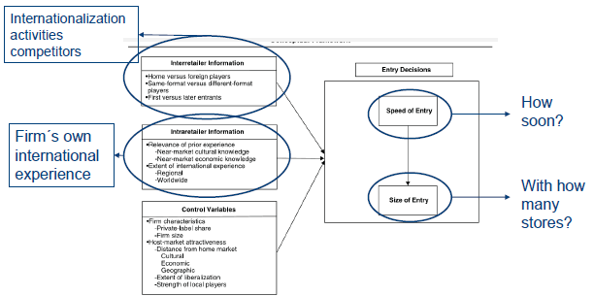
1. Intraretailer information
- Relevance of prior experience
  - Near-market cultural knowledge
    - Cultural distance btw potential markets x markets in which firm is active
    - Based on 4 Hofstede dimensions
  - Near-market economic knowledge
    - Economic distance btw potential market x markets in which firm is active
    - Based on 4 eco indicators
- Extent of international experience
  - Regional international experience
    - Presence in # countries in region
  - Worldwide international experience
    - Presence in # countries worldwide
Proof:
- Relevance of international experience
  - Near-market cultural knowledge has + effect
= more international experience sooner enter market
  - Near market economic knowledge + effect
= more knowledge Sooner entry
    - But only significant when size similar to size market already experienced!
- Extent of international experience
  - Regional experience + effect
  - Worldwide experience + effect

2. Interretailer information
- Home versus foreign players
  - Home rivals more influence/ more informative than foreign rivals
    - Info easier to obtain
    - More relevant
- Same-format versus different-format players
  - Influence same format > Different format
    - More informative
  - Influence different format > same format
    - Less competitive retaliation
- First versus later entrants
  - Pioneer’s entry stronger signal about potential

Proof: interretailer info
- Home based
  - Home based players + effect
  - Home based² – effect
Allow nonlinear effect
  - Inverted U! ∩
    - Increasing effect for smaller nr of players
= If # home based players is small & # home based players rises, speed of entry
    - Decreasing effect for large nr of players
= If # home based players is big & # rises, speed of entry

- Foreign players
  - Foreign players + effect
  - Foreign players² – effect
  - Inverted U!
    - Increasing effect for smaller # foreign players
    - Decreasing effect for larger # foreign players
- Same format players
  - Same-format players + effect
  - Same-format players² – effect
  - Inverted U!
  - Pioneer effect of first same-format player
- Different-format players
= linear effect
= # of different-format players rises, speed of entry rises
Order of entry: pioneer advantage
First-mover advantages
- Customer-based advantages
  - Attract risk-averse consumers
e.g. you look like the safest player if later entrant come. They know you best.
  - Create the industry standard
  - Consumer lock-in
e.g. by making it hard to switch, you keep the customers you gained at beginning
- Producer-based advantages
= barriers to entry
  - Eco of scale x learning
  - Technological leadership
  - Secure scarce supplies

Empirical generalization wrt order of entry
For mature consumer x industrial goods
- - relationship between order of market entry x market share
= The higher your nr of entry, the lower you ms
- Theory predicts a diminishing marginal impact for market share of later entrants
= 2nd entrant lower than 1st, 3rd lower than 2nd,…
- Early entrant market share slowly declines over time

First-mover disadvantages
- Free-riding of later entrants
= acquire same technology at lower cost
- Competitor may enter with superior (newer) technology
- Shifts in consumer needs may provide opportunities
- Incumbent inertia prevents pioneer from doing necessary investments

Emperical findings
= No absolute pioneer advantage
= 47% of pioneers that started left market after some time, they have only 10% of market share & only 11% are still market leaders

4. ALLOCATING RESOURCES DURING ENTRY
- Uniform strategy
= equal distribution of Mefforts among markets
- Support-the-strong strategy
= distribution of marketing efforts proportionally to the # of adopters in markets
May miss business opportunities in new markets
- Support-the-weak strategy
= distribution of Mefforts prop. To the # remaining market potential
May slow down penetration in main markets

Emperical findings
- In presenece of moderate entry costs
= disperse Mefforts (= uniform/support-the-weak) tend to perform better ito net present value of # adopters
- In presence of high entry costs
= Support-the-strong strategy more profitable

Effect of entry decisions in the long run
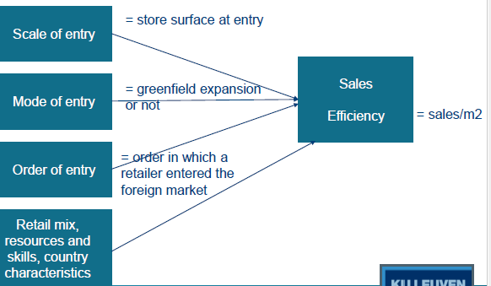

- The bigger the scale of entry, the larger the sales & efficiency
- If mode of entry is greenfield, larger sales & efficiency
- If order of entry rises (later in market), less sales & less efficient in LT
= evidence pioneer advantage

