4. International pricing x advertising

1. BASICS OF GLOBAL PRICING
Cost-plus formula
P = all costs + extra mark-up
Costs
- Full-cost pricing method
= manufacturing costs + administrative + R&D + transport + selling + …
- Variable-cost pricing
= only incremental cost of bringing product to market
= EXCL fixed costs, only direct costs!
= anticipated eco of scale by increasing production to new markets (introduce product)
= very low P (not enough to cover all costs), should be corrected after some time
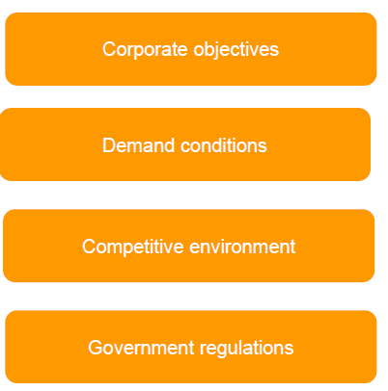
Factors that influence global prices
1. Corporate objectives
= Global P strategy should be consistent with overall obj.
e.g. Objective to become market leader, low-cost leader, …
4 Pricing strategies (zie deel 2)
2. Demand conditions
Market response to price
Psensitivity/ elasticity
= % change in sales when P changes 1%
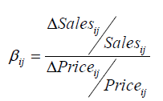
Demand side factor
= customers reactions determine part of Pstrategy

- Unit elasticity
=-1
= 1% increase in P makes 1% increase in Q
- Elastic demand
<-1
= % decrease in P < % increase in sales
- Inelastic demand
> -1
= % decrease in P > % increase in sales
- Elasticity to brand I’s price in country j (B_{ij}) estimated
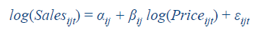

Psensitivity as determinant of P strategies
- Higher Psensitivity, more aggressive Pstrategy should be
- Segment markets based on customers’ reactions to P
  - Lower P to Psensitive customers

Segmenting based on Pelasticity
- Extract higher P from customers with higher WTP for tailored service
- Customization
How do service attributes explain differences in WTP
  - Bolton x Myers 2005
    - B2B: system support services
    - Calculate Pelasticity for each customer
%∆ # contracts/ %∆ P paid
    - Separate measures for low-support x high support
    - Germany: inelastic: P lowering not a good idea since you won’t gain much
Korea: elastic: Positive Pelasticity: higher P = higher Q = P as sign of quality
    - H1: Service Q (reliability, responsiveness, assurance) , Psens
= correct: If more reliable, if more responsive x if more assurance, Psens
! The more negative Pelasticity, the more Psensitive
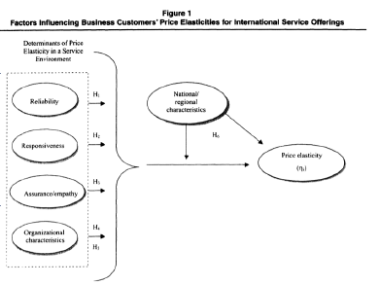
3. Competitive environment
= competition also influences P you can set

Price corridors
= solution to compromise btw maintaining Pdifferentials x charging uniform P across all countries
= difference btw min x max P reach max 20-25% without triggering major problems

Interfirm strategic interactions
= supply side determinant of Pstrategies
= within-market interactions
- Competitive reactions wrt price on local market
- Cooperative strategy
= competitors agree on P x maintain relatively higher P
- Competitive or aggressive strategy
= firms react aggressively to Pdecrease made by competitor
Higher external pressure, lower P, more incentive for cooperative behaviour
Usually more aggressive in home countries x cooperative in host

= across-market interactions
- Administration of Pfunction at firm level (global vs local managers)
- Order of entry
- Threat of aggressive/competitive pricing in 1 market on reprisal on other market
From larger to smaller
Competing in >1 market often cooperation x softer competition
4. Government regulations
Collusion/Pfixing in most countries forbidden & Pcontrols in some countries (maxP venezuela)

2. GLOBAL PRICING STRATEGIES
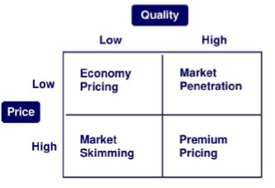
4 price strategies
1. Market skimming
- 1st High P, later lower P
- Highest level profits in SR
- Attract early adopters x less-P sensitive consumers 1st, later more Psensitive x fight off competitors
- Good for new, innovative products with high demand (iPhone)
- Max contribution margins
2. Penetration pricing
= enter with extremely lw P to capture large share of market
- Large pool of Psens consumers
- Control production x distribution costs
- Eco of scale necessary
- Max market share
- Can be LT strategy as competitors will be deferred
E.g. Walmart
3. Economy pricing
= Low P for low-cost goods
- No-frills products
- Attract Pconscious consumers
- Min cost of advertising x production
- Production scale must be large enough to be sustainable
E.g. Aldi

4. Premium pricing
= P higher than competitors
- P indicator of quality
- Unique goods/services/ strong brand with unique value
- Other marketing instruments in line with premium positioning
e.g. Organic products

Global pricing coordination
Globalization: greater awareness to foreign prices, greater access to other markets
e.g. buy online, consumer tourism

3 approaches
- Polycentric
= subsidiaries decide own prices
- Geocentric
= standardized basis + local markup (depending on local context ~ trading blocks)
- Ethnocentric
= totally standardized price for standardized products

! Importance of price in international positioning
Local vs. international image is not necessary the same (e.g. Burberry)

3. MANAGEMENT OF FOREIGN EXCHANGE RISKS
Role of exchange rates
= affect firm (ST) revenues x decisions
- No managerial decisions
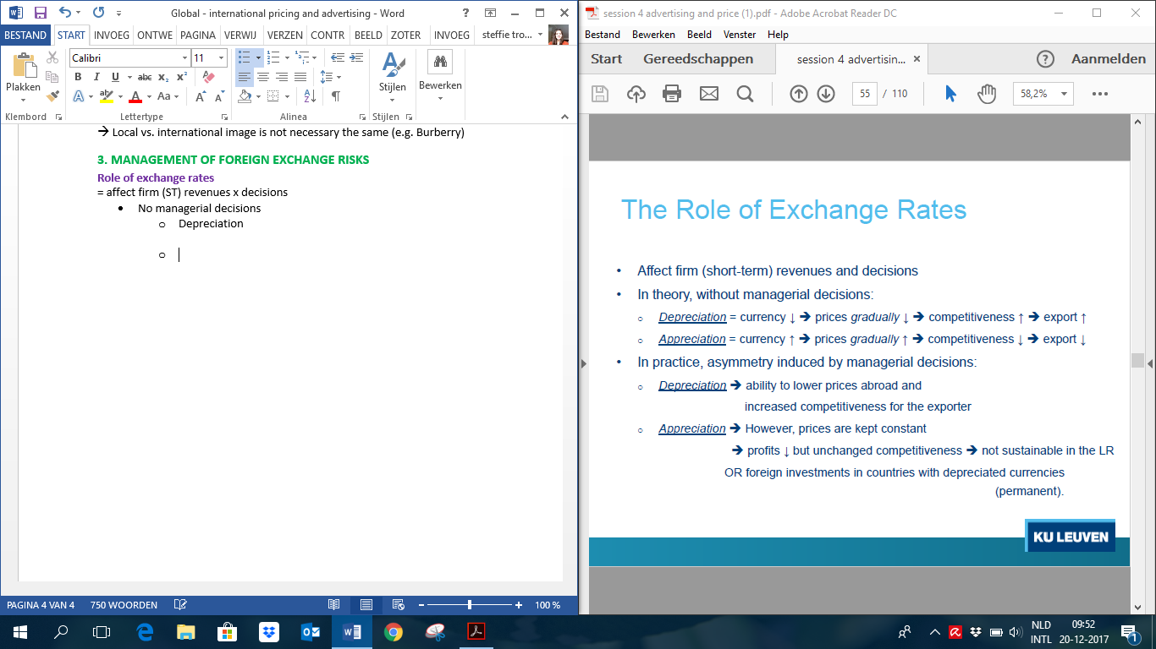
  - Depreciation
=
  - Appreciation
=
- Managerial decisions induce asymmetry
  - Depreciation
= ability to reduce P abroad x increase competitiveness for exporter
  - Appreciation
= P kept constant to keep competitiveness but profits decrease
= Not sustainable in LR
OR foreign investments in countries with depreciated currencies!

Role of hedging
= insurance against ST losses due to currency fluctuations
= forward contracts
- Sale or purchase specified amount of foreign currency at fixed exchange rate for delivery on future date
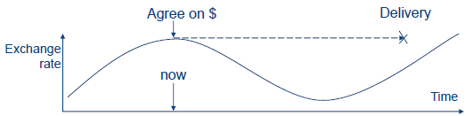

Role of Transfer Price
= P paid for goods shipped from headquarters to subsidiaries, incl duties x fees
= Can * internal arrangements, profits shifting, tax shifting, support competitiveness of subsidiary,…
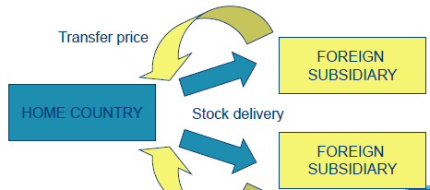
= in countries with high taxes: use high transfer P, so they do not have profits x don’t pay taxes.
= shift profit to low tax countries

4. GLOBAL ADVERTISING
Global advertising task
= trade off btw ethnocentric global x polycentric multi-domestic campaigns
= finding optimal balance btw
- Global coordination of campaigns, building of a consistent brand image x cost saving
- Adapted communication to cross-national differences
  - Media availability (internet access, cable TV)
  - Media effectiveness (movie theatres India)
  - Receptivity to ads x message construction (humour)
  - Regulations (comparative ads, ads < 12)
E.g. Duracell in EU vs in US (Energizer)

Types of global advertising strategies
- Identical ads
= language adaption only (no text, translation, subtitles)
- Prototype ads
= language/ visual adaptation to match local culture
= same story (script) x message but adapted creative perspective
e.g. slogan often not translated, different layouts/colours/…
- Pattern standardization
= uniform positioning theme + local execution x creativity
= most common

Conditions for global advertising
- Same brand image
- Same symbols’ interpretation (colors)
- Same preference ito product features/ attributes (look vs functionality)
- Same usage conditions
- Same media availability x effectiveness
- Uniform regulations


5. DEVELOPING A GLOBAL ADV STRATEGY
1. Target audience
Receiver of message
E.g. consumer, government officials, prospective investors, employees
2. Communication objective
Determine objectives of communication
e.g. Create awareness, communicate benefits, improve image
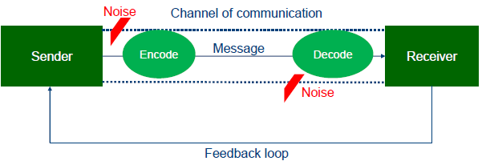

3. Budget considerations
Amount spend on adv is increasing every year
Scandinavia: most advertising together with US & Australia
Growth in adv biggest in Latin-America & Asia-Pacific (catch up on spending in West-EU)
Advertising as % of nominal GDP as barometer of general strength in advertising demand
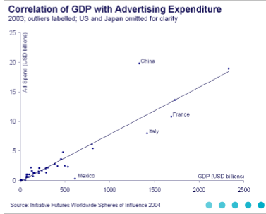
- Above normal spending: brazil, US, China
- Below normal: muslim countries (Indonesia), Mex, FR & IT

Most ad still via TV medium

Advertising and the Business Cycle: Deleersnyder et al 2009
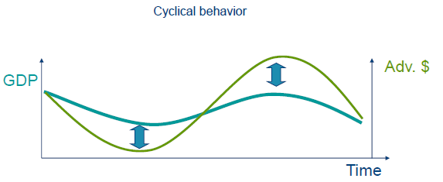

Cyclical behaviour of ad spending
- Cut ad costs when sales go down to maintain ST Profits
  - Especially where adv is seen as cost rather than an investment to build brand equity
  - Inverse link with LT orientation x power distance
(If more LT orientation/power less cutting costs)
- Herding behaviour
  - In culture that score high on risk avoidance x collectivism

Comovement elasticity indicates to which degree ad spending moves in the same direction as eco
Average: GDP rises 1%, adv rises 1.39%
- Long-term orientation
= less likely to cut costs when GDP decreases & - influence on comovement elasticity
- High power distance
= importance brands, so also – influence on comovement elast
- High uncertainty avoidance
= adv follows bc more + on comovement elasticity
- High collectivism
= no significant evidence that collectivitic countries adv follow bc more than individualistic
Budget approaches
- % of sales
- % of predicted (future) sales
- Competitive parity
- Objective x task method

4. Media strategy
- Media availability (electronic media)
- Nature of product (ads for children)
- Media habits
  - Outdoor
= large audience (Japan x South-Korea)
  - Cinema
= high theatre frequentation in Argentina x India
  - Print
= high literacy rate, limited commercial broadcasting in FR, GE, SW, UK
  - Radio
= not much in Europe x regulated
  - TV
= Not used to reading, attracted by audio-visual media (US, Asia, South-America)

5. Crafting the message
Culture is very important in sending message
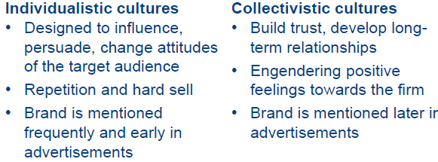
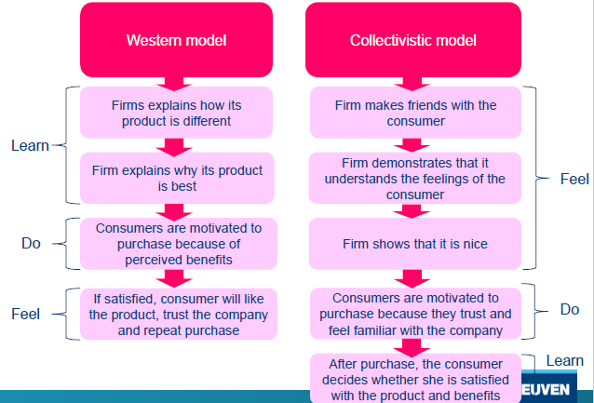

Humor in international advertising
Universal cognitive structure
= humor created by incongruity/contrast x potential resolution features to this incongruity
= enhances recall, evaluation x purchase intentions IF integrated with ad objectives x viewed as appropriate with the product category
People develop expectations based on category norms that are violated in the ad
Contrast includes (not) actual, (un)expected, (im)possible

! Culture-dependent
E.g. Colors very different in EU vs in Asian symbolism

6. Management of communication process
= very tricky in international campaign in 30 countries
Often use external experts

7. Measuring communication effectiveness
= via value chain
= If you create good campagin, influence customers mindset x will hopefully lead to more sales & more shareholder value


