1. Introduction to global marketing
= systematic planning, coordination and implementation of marketing activities in international markets

1. EVOLUTION OF GLOBAL MARKETING
Globalization
= increasing interdependence, integration & interaction among people, companies & governments of different nations around the world.
Lead to converging commonalities across globe

Drivers of globalization
1. Technological changes
= global connectivity
- Global telecommunication infrastructure
= information flows btw geographicallly distant locations
- ICT
e.g. internet, satellites, wireless telephone
= facilitates communication btw companies x consumers
- Web 2.0
= content websites created by users
Barriers remain!
Digital divine (niet iedereen internet/ telefoon)

2. Political arrangements & unification process
- Since WWII
= creation of supra-national political organizations (NATO, UN)
- International trade organizations x agreements to promote the trade of pxs
E.g. WTO, GATT, MERCOSUR, NAFTA
- Monetary unions
e.g. Euro zone

3. Technological and legal harmonization
= increase in #standards applied globally
e.g. Copyright laws x patents

4. Globalization of economy & trade
= increase in volume x variety of transactions across borders
Rise x success of multinational companies
Volume global trade x 20 since 1950
e.g. China biggest exporter, US biggest importer

5. Financial globalization
- Emergence of worldwide financial markets
- Better access to external financing for corporate, national x sub-national borrowers
- Free international capital flows
- Globalization of financial crises…

Marketing globalization
= rise of consumerist society around world (buying of material goods)
Started in US & spread across world
Consumerism

Evolution of global marketing


1. Domestic strategy
- Entering international markets by applying domestic strategies
- Ignoring country differences
- International sales as bonus
NOT successful
e.g. Kellogg’s

2. Separate strategies
- Importance of international differences
- M strat per country
- NO coordination of strategies across countries = no synergies/ cost savings!
Effective but expensive

Period of Kotler!
= early ‘70s
- Companies need to be customer driven instead of needs marketing magager
- Market segmentation, segment targeting & product positioning
- Marketing mix adaption

3. Integrated phase
- Recognize inefficiencies of separate strategies
- Look to exploit similarities
  - Same competitors in different countries
  - Global customers
- Standardization
- Global marketing: Levitt 1983

4. Global strategy with adjustments
- Unique customers no longer ignored
- Glocal marketing
= balance btw global marketing (standardization) and local marketing (adaptation)

Glocalization
= differentiated globalization
= standardize parts of marketing strategy (global e.g. product lines, brand name) & adapt another part of mm (e.g. assortment, promotions, advertising)

E.g. Mc Donald’s, Ford, Disney, Unilever

2. STANDARDIZATION VS ADAPTATION
Standardization perspective
= Levitt 1983
= Operating with relative constancy in ≠ countries as if the world is single entity
1 or several elements of mm (controllables)
Applies to markets with homogenous preferences

E.g. Apple, Stone Island, Idool

Benefits of standardization
- Economies of scale in production & marketing
- Consistency in dealing with customers
e.g. Hilton
- Global customers
= country-of-origin effect
= a product’s origin has large impact on product evaluation
e.g. L’occitane (franse savoir-vivre), German cars (reliable)
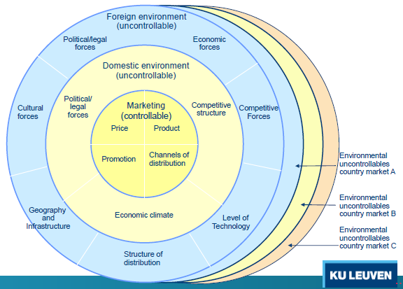

Product standardization
= Brand name, core product, modular design, adapted packaging

Service standardization
= core service (e.g. McDonalds), some adaption with local staff

Adaptation/localization perspective
= operate in ≠ countries for which the product and other mm elements are adapted
Relatively high cost
Production x distribution in ≠ countries
applied in multi-domestic markets with strong local preferences
e.g. Cola (Diet coke in America), Ikea, GM

Benefits of adaptation
- Better match to local needs x preferences
- Creates “uniqueness”
- Uses existing networks in country
- Avoid taxes x trade barriers if product is localized
- Shows commitment of company

Ozsomer x Simonin 2004: Standardization or adaptation?

Standardization & performance
Good to centralize product decisions
(product char, branding & packaging decisions)
Not good to centralize non-product decisions (pricing, sales force & sales promotion) 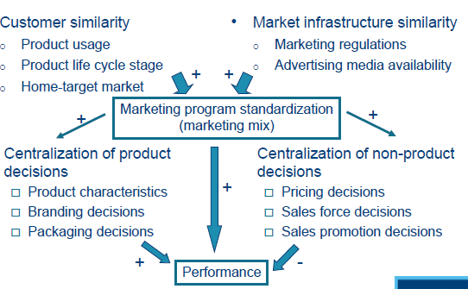

Lemmens et al. 2007: Standardization in Western Europe?
Single market with eco of scale & coordinated strategic moves?
Coherence btwn Consumer confidence index of different countries (ST vs LT)

Leading indicator of many purchase decisions
- Willingness to buy x expenditures for different goods
- Used for forecasting recession periods
- Linked to P sensitivity

Consumer confidence indicator
= useful segmentation info!
- Very little cohesion in ST horizon
= Price promotions
- Much more cohesion on LT horizon
= regular P∆, brand-building activities
= not dependent on geographical distance, but related to economic distance x cultural distance
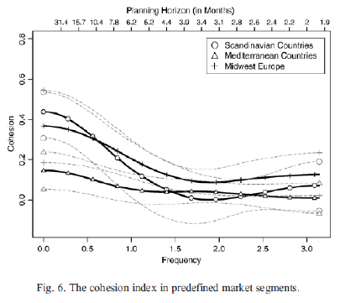

3. GLOBAL VS LOCAL BRANDS
Benefits of global brands
- Economies of scale
(building brand from scratch over & over costs a lot of money, e.g. Unilever)
e.g. Ikea
- Global visibility and reputation
= focus on 1 product category
= company name as brand name
E.g. nike
- Cross-country learning effects
- Global sourcing benefits
e.g. Indian call centers

Holt et al 2004: How do global brands influence consumer behaviour?
- Quality signal
= global brands perceived more qualitative
- Global myth
= symbols of cultural ideals
“citizen of the world”
- Social responsibility of global brands
e.g. Nestlé, McDonald’s
- No impact of American values!

Alden et al 2006: Who chooses global brands?
Global consumption orientation GCO
= Extent to which consumer expresses globalized, glocalized or localized prefrences

4 types of attitudinal responses
- Global orientation
- Local orientation
- Glocal orientation
- Lack of interest
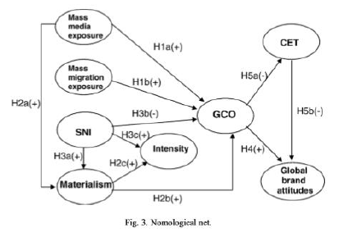
GCO influenced by
- Exposure to global cultural flows +
  - Mass media from different countries
  - International travel
= mass migration exposure
- Materialism +
  - Importance attached to possession
  - Possession creates pleasure x happiness
- Susceptibility to normal influence –
  - Importance attached to norms & opinions of others

GCO influences global brand attitudes & consumer ethnocentrism (CET, appropriateness of buying foreign products)

Steenkamp & de Jong 2010: attitude towards global vs local brands
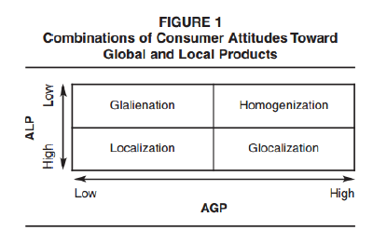
Glalienation: don’t like brands at all
Localization: local > global
Homogenization: global > local
Glocalization: global = local

e.g. Dutch Males = don’t like brands
Materialism creates glocalization
Emphasis on tradition & conformity = localization

