13. Strategy of international business

1. VALUE OF INTERNATIONALIZATION

Value drivers

Internationalization will help in all these aspects

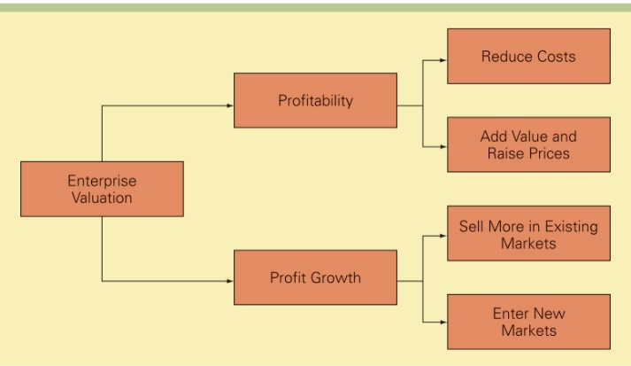

! Internationalization creates value when it fits the strategy!

2. ADDING value scorecard

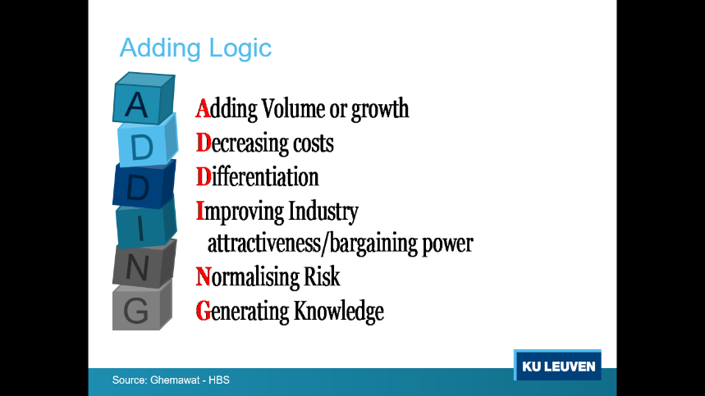= Given the competitive strategy: HOW does internationalization help to create extra strategic value?  
= 6 components of value creation

1. Adding volume or growth

* Examine effects of incremental volume on profit
* Probe level at which additional volume yields eco of scale/scope  
  (nationally, at the plant or customer level)

2. Decreasing costs

* Examine cost drivers
* How value chain (porter) can be spread across countries

3. Differentiation & willingness-to-pay

* Analyse market segments
* Value of global brand
* How cross-border (CAGE) heterogeneity in preferences affects WTP for products on offer

4. Improving industry attractiveness/ bargaining power

* Relevant market (concentration dynamics, rivalry)
* Competitor organization across countries
* Supplier organization
* Distributor organization
* International differences in industry profitability

5. Normalising risk

* Understand key sources of risk in your business
* Assess cross border operations on overall corporate risk
* Optimize risks, not neutralize

**Risks to manage**  
= volatility, not sure about

1. Political risk
2. Economic risk
3. Legal/contractual risk (IPrights)
4. Operational risk/exchange risk

6. Generating knowledge

* Generate & diffuse knowledge/cross borders – network advantages
* Acquire enhanced resources & capabilities
* Location-specificity vs mobility of knowledge

3. WHEN IT FITS THE STRATEGY

**Strategy**

= Choice of a competitive positioning (based on cost, differentiation & focus)

and fitting activity system (M. Porter)

= designing best activity fit for chosen company goals

*E.g. value curve*

= to be successful with all your aspects, find fitting activity system to deliver the value

= linking value curve with activity system

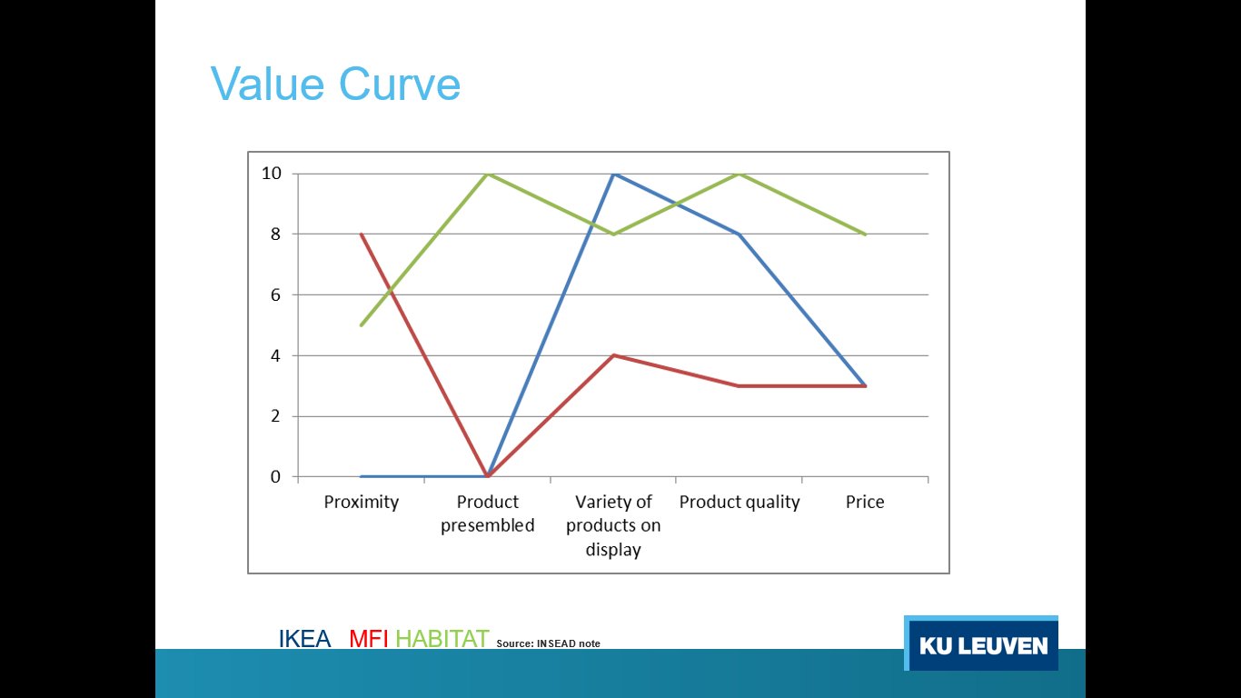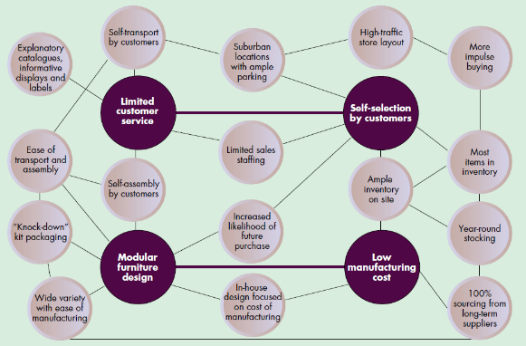

Business model canvas

= way to represent all elements of business model, how bs operates x creates value

= activity system translated in revenue & cost streams

🡪 Guides decision makers in aligning BM with external environment

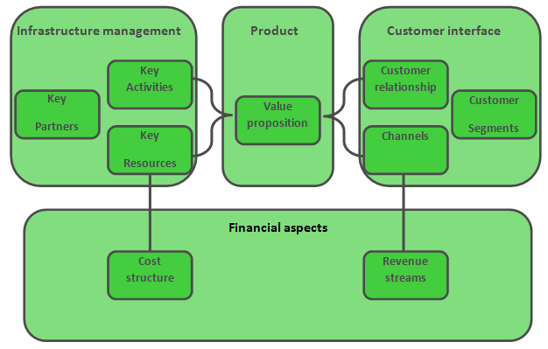

Infrastructure  
= generates all the costs

! Understand BM to survive

🡪 Internationalization should not jeopardize but reinforce BM

🡪 Adaptions for foreign countries possible, but aligned with global competitive positioning firm

4. PROFITABLE INTERNATIONAL GROWTH:

= Look for ADDING advantages that fit with & reinforce BM

**Avoid**

1. Risk to move too far from core business
2. Risk to jeopardize company BM
3. Risk of “liability of foreignness”   
   = competitive disadvantage vis-à-vis local firms

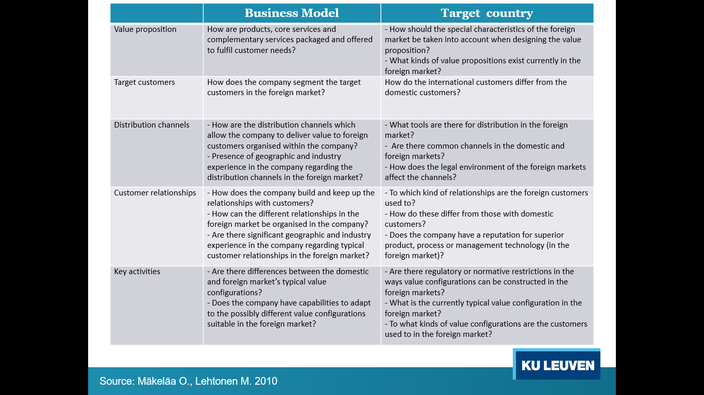  
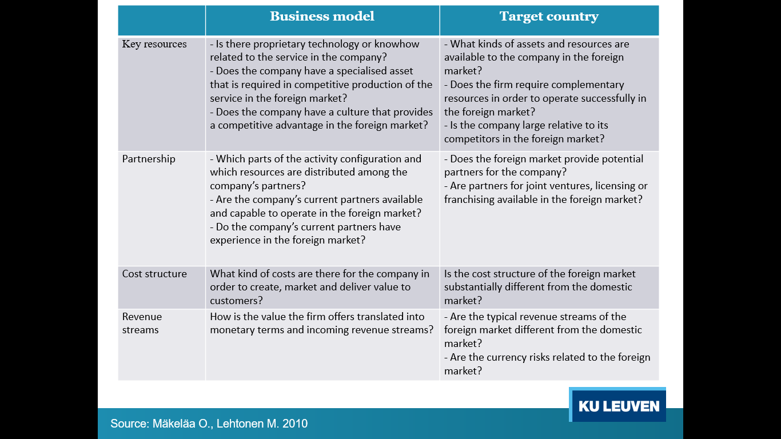

Profitable growth from expanding to foreign country

1. **Attractiveness factors**  
   = potential gains  
   = ADDING factors in relation to country conditions
2. **Compatibility factors**= BM elements in relation to country conditions

MATCH model

= technique to help achieve sustainable growth

* Diversification into new markets creates risk that firm loses focus & weakens its core competencies (costs often underestimated)

**First concern**

= consistency of foreign operations with chosen strategic positioning & underlying activity system

🡪 Use ADDING value Scorecard to consider strategic benefits from intern.

**Second**

= Check if basic elements of activity system would find difficulties in implantation/ ineffectiveness in country

🡪 Use BM compatibility

**Finally**

1. Normalize attractiveness & normalize compatibility (scale 0-1)
2. Mapping country’s attractiveness score against country’s Total Compatibility Height
3. * MATCH/ BM adapted attractiveness scores



5. TRIPLE A

**Strategies include**

1. Aggregation
2. Arbitrage  
   = looking for best condition for activities in value chain
3. Adaptation of model  
   = Look for ways to sell more without totally ∆ BM. Just adapting to foreign country

4 generic international strategies

= all consisting of the triple A elements  
= based on extension of BM  
= Choice of strategy depends on industry pressures for integration (global industries) vs local responsiveness (local industries)

1. **Global standardization strategy**  
   = increasing profitability x profit growth by reaping cost reductions that come from eco of scale, learning effects & location economies.  
   = strategic goal to pursue a low-cost strategy on global scale
   1. Strong pressures for cost reductions
   2. Demand for local responsiveness is minimal

**Global strategy Levers**

* + Major market participation
  + Product standardization
  + Activity concentration
  + Uniform marketing
  + Integrated competitive moves

1. **Localization strategy**  
   = increasing profitability by customizing firm’s gxs so that they provide good match to tastes/preferences in different national markets
   1. Substantial differences exist across nations with regard to consumer tastes and preferences
   2. Cost pressures not too intense
2. **Transnational strategy**  
   = simultaneously
   1. Achieve low costs through location eco, eco of scale & learning effects
   2. Differentiate product offering across geographic markets to account for local ∆
   3. Foster multidirectional flow of skills between different subsidiaries in firm’s global network of operations

Makes sense when

* + Cost pressures intense
  + Pressure local responsiveness intense

1. 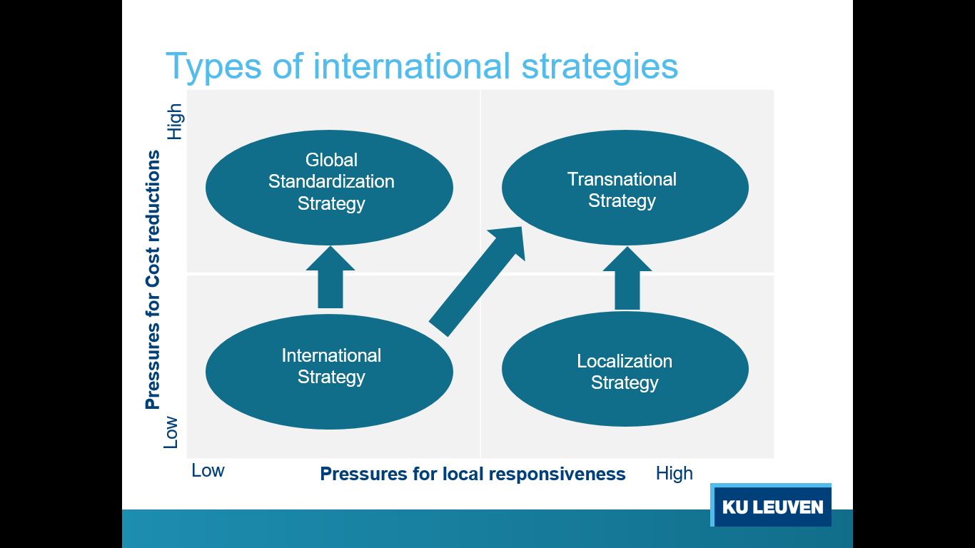**International extension strategy**  
   = taking products first produced for domestic market & then selling them internationally with only minimal local customization
   1. Cost pressures are low (because few competition)
   2. Low pressures for local responsiveness

! International & localization strategy become less viable  
when competitors emerge

6. LOCAL vs. GLOBAL INDUSTRIES

Local

= firms can sustain competitive advantages within boundaries of countries  
= easier for universal needs (bulk chemicals, steel, sugar, petroleum) BUT P main weapon, no differentiation so cost reductions very imortant

Competing in multilocal industries

1. Domestic firms within each country
2. Subsidiaries of multinational companies operating independently of each other in respective countries

Global

= Firms can sustain competitive advantage only if

1. They are present in key countries of world
2. They integrate and coordinate their activities across the world on a centralized manner

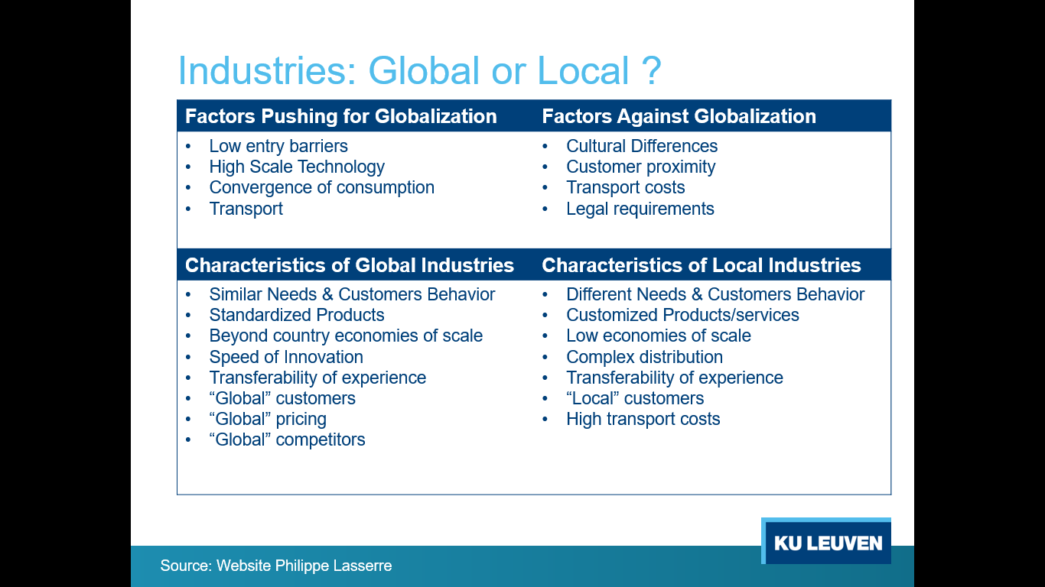

Industry context & within industries differences determine which strategy is best!

7. THE EVOLUTION OF STRATEGY

* International strategy may not be viable in LT
* Survive: shift to global standardization/ transnational strategy in advance of competitors
* Localization: gives competitive edge BUT when wanting to face aggressive competitors  
  🡪 Cost structure reductions necessary (* transnational strategy)

Leverage subsidiary skills

Managers should

* Recognize that valuable skills (which can be applied elsewhere) can arise anywhere in firm’s global network (not only in corporate center)
* Establish incentive system to encourage local employees to learn new skills
* * process for identifying when valuable new skills have been created in a subsidiary