1. Understanding competition
Marketing strategy
= functional strategy aimed at customer value creation, market orientation, segmentation, targeting x positioning
Decisions when selling products on markets
Strategic Marketing decisions
= long term holistic decisions concerning future directions for organization
- Impact over LT
- Made at higher level in organization
- Irreversible or difficult reversible
- Result in distinguishable competitive advantage
- Made in context of other strategic decisions

↔ tactical marketing decisions
= ST (annual/quarterly) decisions to execute strategic directions within the firm

Performance Is always evaluated RELATIVE to competitors
Firm’s success depends on the degree to which its managers’ decisions satisfy selected consumers’ needs and preferences better than competing firms do
Consider all products that satisfy same needs! (not same technology)

1. IDENTIFY COMPETITORS
= A good strategist has to think like the competitor

How DO managers identify their competitors?
- Attributes of competing firms
= supply-based approach
= how similar ito technology/products offered/strategy/…
- Attributes of customers
= demand-based approach
= customer attitudes x behaviours (who they think are your competitors)

Competition NOT always symmetric
= (objective) asymmetry exists
= degree to which one firm competes with another is not the same as the degree to which the second firm competes with the first
Effect of ∆ are ≠ for each firm
(small firm decisions not noticed by big, big decisions are definitely noticed by small)

Identifying competitors?
Direct competitors
= Serve the same customer needs using the same resources

Indirect competitors
= serve the same customer needs but with different resources

Potential competitors
= have ability to satisfy similar customer needs
= firms for whom various barriers to entry are low/ easily surmountable
- Technology
= possession of necessary techno to operate in market (patent activity)
- Reputation & image
= use firm reputation in one product area to leverage its entry into another
= brand extension (e.g. Clairol haircolor/hairdryer)

Defining the “market”?
=potential customers sharing particular need/want who might be willing & able to engage in exchange to satisfy that need or want.

Similar customer needs define a market, NOT a similar product
e.g. car by taxi companies or car as transportation option

How SHOULD managers identify their competitors/their market?
Market definition
- Purchase or Use-Behavior approaches
  - Cross-elasticity of demand
competitor >0, substitutes < 0
= % ∆ in Qx / % ∆ in Py
  - Similarities in behaviour
=substitution in use
  - Brand switching
= only when product regularly bought (FMCG)
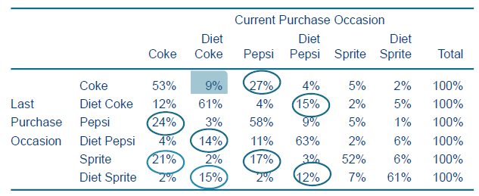
- Customer-Perception or Judgmental Approaches
  - Decision-sequence analysis
= Decision trees not so easily made
= The higher in the decision sequence, the less you compete with eachother
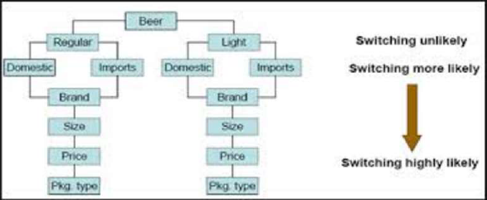
  - Perceptual mapping
= visual representation (2D) about how consumers perceive brands/products on $≠$ characteristics
= group of analysis techniques that represent brands in multidimensional space.
    - Interpoint distance reflects degree of substitution
    - Dimensions of product reflect product features underlying the competitive market structure. M can ∆ perception
    - If you move to ideal point on map, you’ll sell more
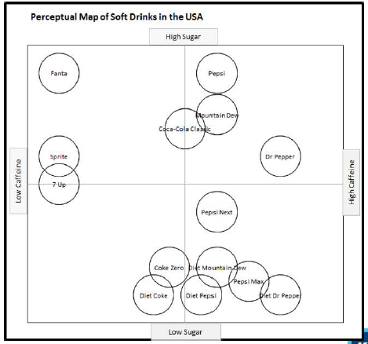
  - Customer judgments of substitutability

2. MODELLING COMPETITION: MARKET SHARE ATTRACTION MODELS
Market shares
= command attention of product/brand managers as key indices for measuring performance of product/brand in marketplace
BUT
productmanager not interested in forecasting ms but in forecasting ∆ in sales volume of firm’s product corresponding to ∆ in mm variables

Profits =(P-unit cost)*volume sales – costs (M etc)

Analyzing brand sales
Direct approach
Brand sales = f(marketing var, environmental var,…)
e.g. Scan*Pro model
- Quantify effect of promotional P reductions, feature advertising (in leaflet) & in-store displays on brand sales at store level
- Own & cross price/promotion effects
= if competitor promotes their product, + influence on your sales too!
(in a store in certain week)
= - voor promovoerder

Indirect approach
Brand sales = category sales x market share
& market share = f(marketing variables,…)

Q_{it} = Q_{t} * m_{it} (my sales = total sales * my market share)

Advantages
- Distinction between ∆ caused by ∆ in market size & ∆ in relative position of brand
- Factors causing expansion/contraction of entire market don’t have to be included in MS model
- Reduction of # explanatory var & risk of multicollinearity
Insights: elasticity decomposition
Let Q_{i} = Q*m_{i}
Then for any variable X_{ki}:
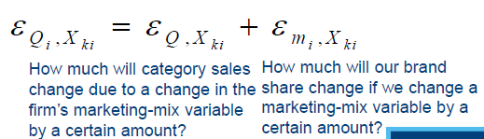
If x%, my sales will go up by e%

- If industry sales elasticities near zero
= highly competitive market (lower E, size of market fixed so you steel from competitors)
- Share elasticity NOT stable over time
= higher market share, lower Em, effect M lower if high marketshare
= if you had almost no advertising & increase it, E much higher & big help
Depends on level of market share & on level of MMvar

Share elasticities
Price Advertising
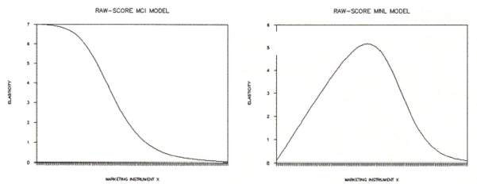

Impact of level P/M highest

If already tons of M, more will not help much

Market share analysis
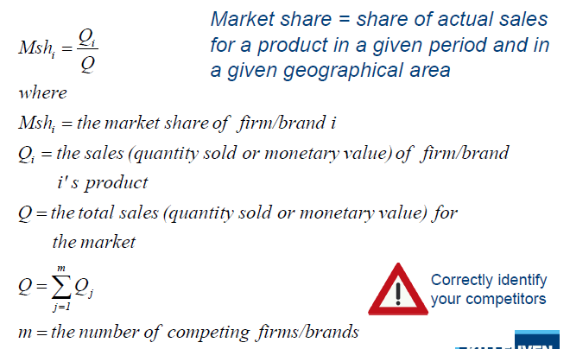

Market share attraction model
- Main determinant of market shares is the attraction (A_{i}) which consumers feel toward each alternative brand i
- Attractiveness of brand I determined by Meffort (P, advertising, product features)
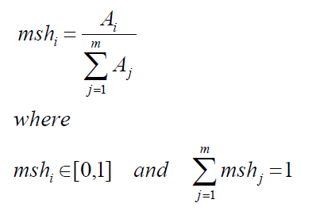
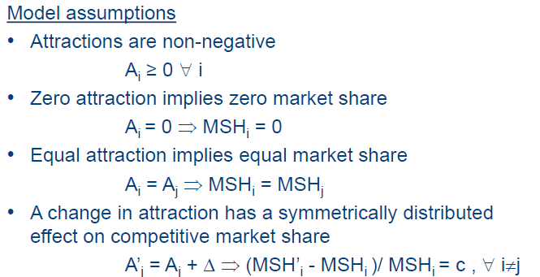
Attraction model: specification
M_{it} = A_{it} / $\sum_{c}^{C}{A}$_{ct} A_{it} = attraction of brand i in period t
C = nr of considered brands

Inclusion of explanatory variables MCI & MNL attraction models

Multiplicative Competitive Interaction (MCI) attraction model
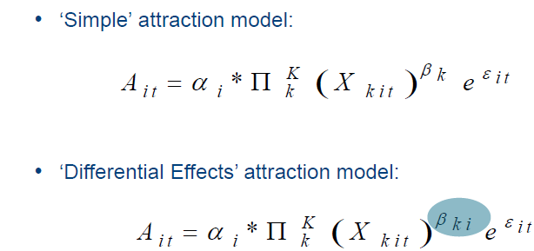

Multinomial Logit (MNL) Attraction Model
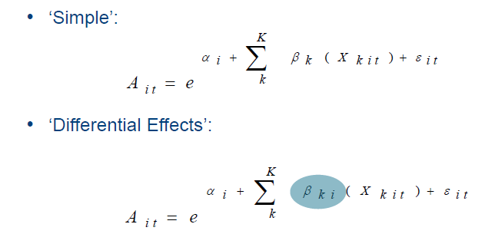

Share elasticities
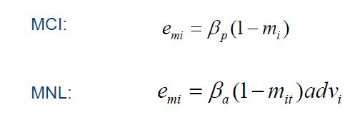
Higher m, lower effect

Higher m, lower effect but also depends on level of Adv!

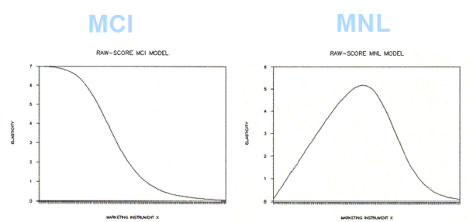
Transformation necessary to estimate yourselves

3. MODELING COMPETITIVE REACTIONS
What questions to ask when considering P∆
- Cost
- Look at consumers
- Components of the competitors!
  - Past/current competitor behaviour
  - Expected future competitor behaviour
  - Expected future competitor reaction
Taken into account by very small % of managers
Hard to measure, irresolvable uncertainty, high costs to measure

2 Strategic errors (Day & Reibstein 1997)
- Failure to anticipate competitors’ moves (ACTIONS)
- Failure to recognize potential interactions over time (REACTIONS)
Major error by only focussing on past/current behaviour

Strategic competitive reasoning
= assessment & consideration of competitors that serves as an input into the firm’s decision making
- Description of competitor
- Prediction of comp actions
- Prediction of comp reactions

Most common response to competitors is NO response
! Underperception of competitive reactions lowers performance

Factors driving competitor reactions
- Awareness of the competitive attack
- Motivation to react
- Ability to react (sometimes, small firm not enough resources/money/done research)

Competitive reactions
- Purchase behaviour predicted from estimated demand functions
- Competitive reactions anticipated by estimated reaction functions
(how ∆ in instrument one brand depend on ∆ in one/more instruments from other brands)

1. LNB-models
Regular demand model: Qi = Q*mi & E_{Qi,Xki} = E _{Q ,Xki} + E_{mi , Xki}
Nothing about competitor reactions

Customer & competitive reaction functions
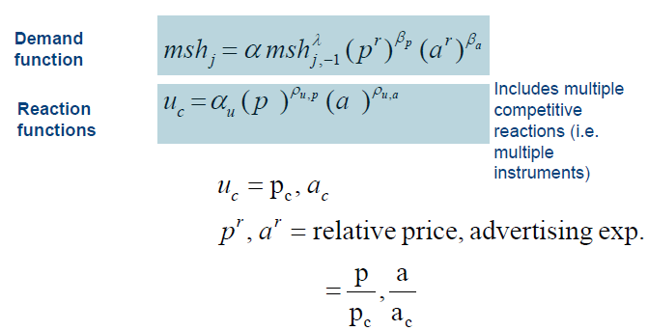
Total market share effect (advertising)
Indirect effect from competitor reactions included: change in A competitor = change in own MS
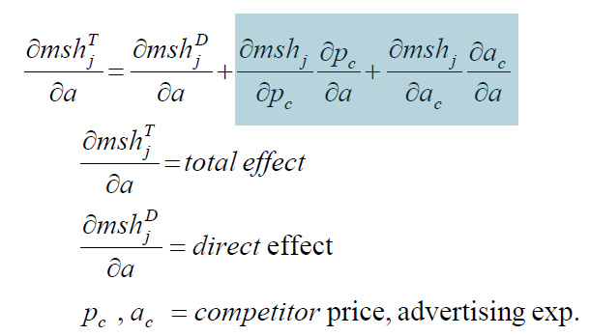

Total market share elasticity (advertising)
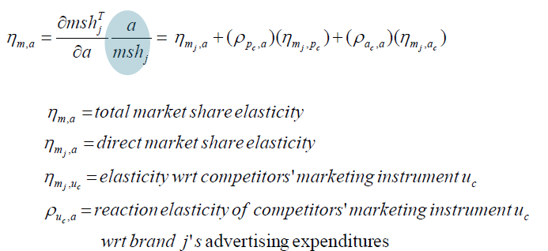

Limitations of LNB model
- Leader Follower: follower reacts to leader, not other way around
- Follower: aggregate of other firms
- No dynamic effects (no past influences, only reacts on current actions)
- Aggregated data (monthly, bimonthly,…)
- No distinction between manufacturer & retailer reactions (also influence on P)

Extended LNB model
Also includes: Price promotions & non-price promotions
(sampling, premiums, features, bonus packs & refunds)

Very complicated
Ptoday/Pprevious = competitive price actions + lagged endogenous variables + own & competitive
non-price promo actions

2. VARX models
Takes impact Maction into account, but also demand function! (not in LNB)
Dynamic, autoregressive, response & reaction functions
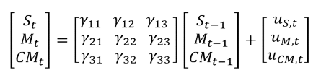
St = sales of my product t
Mt = marketing of my product t
CMt = competitive marketing actions
Estimates all 3 simultaneously & all influence each other

Impulse Response function
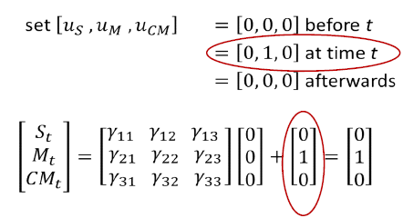
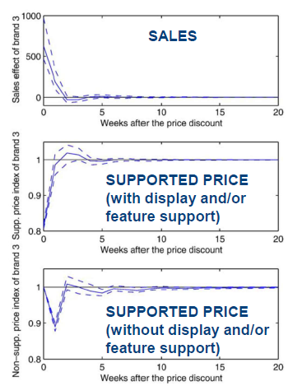
Ook op t+1 en t+2 kunnen
Responses to Price discounts VARX model
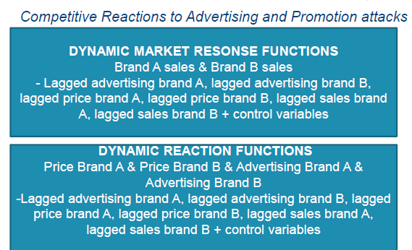

3. Game-theoretic models
= study of rational behavior in situations in which your choices affect others & their choices you
(so-called games)
- Knowing game-theory doesn’t guarantee winning
- Framework for thinking about strategic interaction
Game theory
= interactive decision theory
- Decisions
= take world as given & make best choice yourself
- Games
= Best decision depends on what other do & what they do may depend on what they think you do

4. COMPETITIVE REACTIONS: INSIGHTS
Factors driving competitive reactions
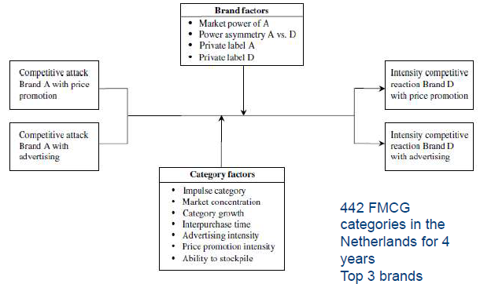
A = attacker
D = defender, does he react or not?

Price promotion & advertising reactivity
= stronger when
- Attacker more powerful
- Relative power structure in the dyad favors defenders
- Category is less concentrated
- Interpurchase time is higher

Price promotion reactivity
= stronger in categories that involve more impulsive buying

Advertising reactivity
= lower
- In growing categories
- For storable products
- In categories with lower advertising intensity

Type of competitive reaction
- Passive (no reaction)
= most common
- Accommodating behaviour
= simple (1 instrument) & short-run reactions
- Retaliatory behaviour
= price reaction against price attack
X% spoiled arms
= x/y when x, # reaction elasticity > 0 & y, # own elasticity < 0

- No reaction to promotion attack good?
= absence of reaction corresponds primarily to absence of harmful cross-sales effects (82%) so good.
  - Only 12% missed opportunities
  - Only 50% reacts
- No reaction to advertising attack good?
  - 80% doesn’t react
  - <1% missed opportunities
  - ! If you do react to Apromo 76% spoiled arms
- Retaliatory behaviour towards promotion attack good?
  - 37% spoiled arms
= they react to attack & it doesn’t boost sales (losing money)
! Cross-elasticity attack = net resulting cross sales effect

Instrument x strenght
Simple/multiple, same/different + over/underreaction
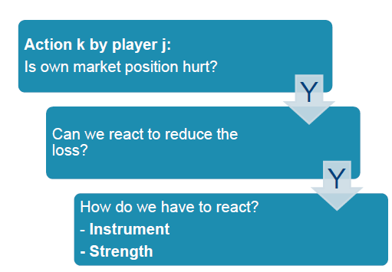

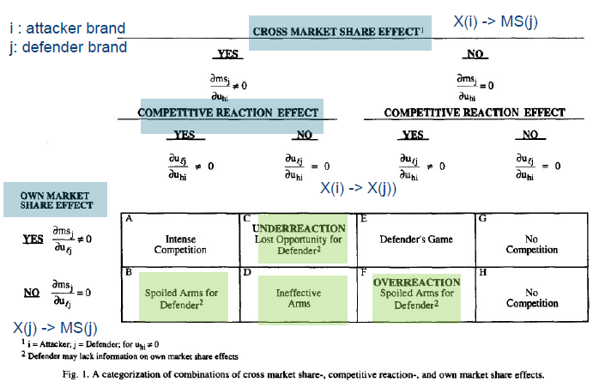
Own MS effect
= if your decision (react or not) influences your MS

Competitive reaction effect
= if you decide to react or not

Ineffective arms
= not able to react

Spoiled arms
= you react but there is no ∆ in MS

If all 3 effects + :
intense competition

