7. MODELLING CLV: CUSTOMER RETENTION
Customer retention
= probability of a customer being ‘alive’ or repeat buying from a firm
Contractual & non-contractual setting

Models
= logit model, hazard model, (probability model), Markov model & (computer science model)

1. Logit model
- Need to know more than WHO will churn
- Need to know WHEN change occurred (customer to non-customer)
Observe set of customers for period of time (record when events occur)
Model that quantifies risk of churn, depending on time-varying covariates

2. Hazard model
= duration model
= model time to failure or time to event
Able to account for censoring
Access relationship btw covariates and survival time

! Ongoing relationships are right-censored
= Also takes consumers in account that are still here
= T (time event occurs) > end time of study

Hazard function
= conditional (time specific) failure rate
= imminent failure risk/ instantaneous rate of failure, given survival until now
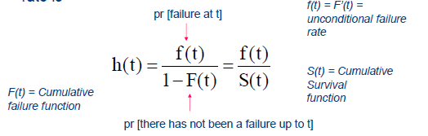
= time & situation dependend!

Proportional hazards
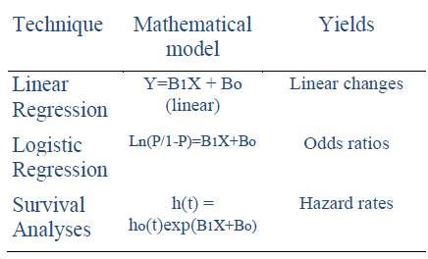
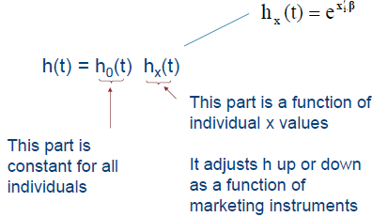

3. Markov model
= customers switch among competitors
Always a share (↔ lost for good)
Switching matrix
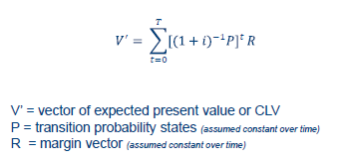

8. CLV modelling: ACQUISITION & RETENTION
= Best to model simultaneously
e.g. Low price = probability acquisition rises, but retention decreases

9 . CLV modelling: CUSTOMER EXPANSION
= margin generated by each customer at each time period
E.g. Regression-based models of margins
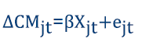 Change in customer margin (CM) for customer j at time t

Balance acquisition & retention resources to max customer profitability
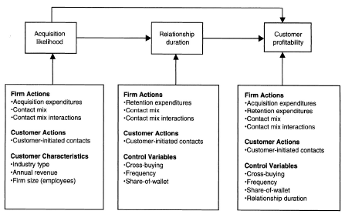

10. CLV & FIRM VALUE
Maximizing CLV
= maximizing long-run profitability x financial health of company

Firm value
= sum of life time value of all current & future customers
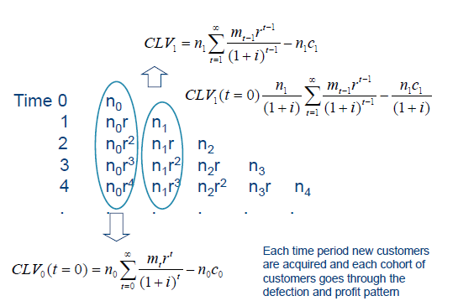

Value of customer base
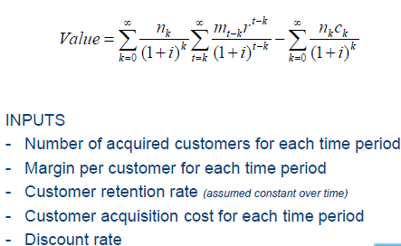

Gupta et al. 2004: valuing customers
- Customer-driven businesses & publicly reported quarterly customer data
- Difficult to evaluate using traditional financial methods (low earning, negative cf, …)
- High growth businesses ↔ stable businesses (classic methods such as cash flow)
- High growth = more difficult to predict future customers
= use diffusion model!

Customer value vs market value
= for 3/5 companies, CV provides good estimate of market value at one point in time
Customer value good proxy for firm value!

Managing customer value
= impact of acquisition cost, margins, discount rates on CV much lower than impact of retention rate!
1% improvement in X = 0.05/1/1% vs 5% when retention rate rises 1%!!!
Rust et al. 2004: using customer equity to focus marketing strategy
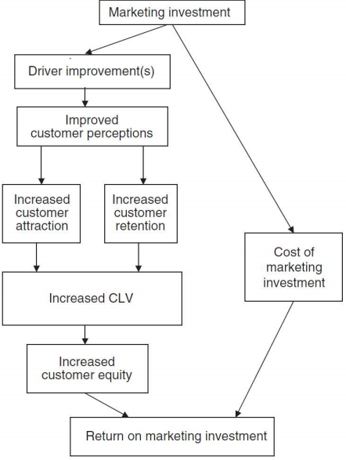
CE = $\sum_{i=1}^{l}{CLVi}$

Brand switching matrix
= always a share assumption
- Acquisition
= modelled by flow from other firms to focal fimr
- Retention
= modelled by diagonal element associated with focal firm
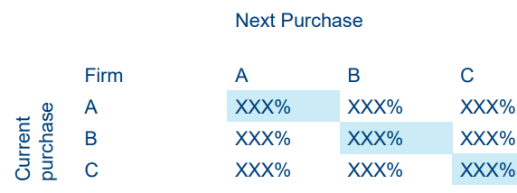

Individual level switching matrices
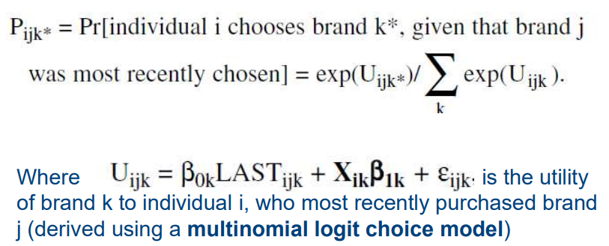

Utility if you bought product last period, if it has a high brand image,…
= more likely to buy next time

Calculation of CE
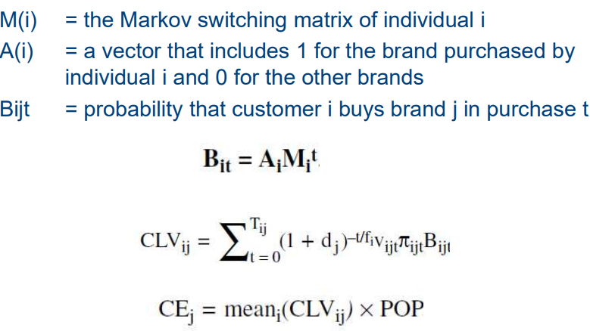

ROI
= return on investment
= if higher than cost of capital, good investment
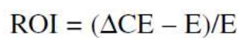

E = discounted expenditure stream in 1/more drivers
∆CE = improvement in customer equity that the expenditures produce

