TOPIC 4 : TELECOMMUNICATIONS INDUSTRY

Background

Convergence of telecom landscape in Belgium
- A brief history
  - Up to early 90s
    - One fixed copper line network operator for voice : Belgacom
    - Multiple local fixed cable operators for TV
  - Since mid-90s
    - 3 mobile operators
    - Fixed copper line operators also offer broadband, later TV
    - Local fixed cable operators become Telenet and also offer broadband and voice
  - Recent development
    - Fixed and mobile convergence (mergers)

- How does competition work
  - Inter-platform competition
    - Competition between networks
  - Intra-platform competition
    - Competition on a network
  - requires access to network
    - At interconnection or access price

Telecom history in the US
- AT&T monopoly until 70s

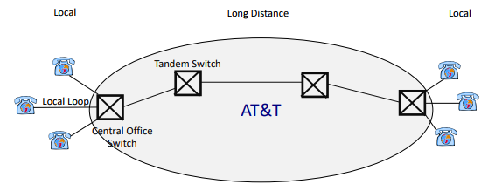

  - Monopoly for local calls
  - Monopoly for long distance calls

- Deregulation in the 80s
  - Reasons :
  - Economic thinking?
    - Only market forces, in a competitive environment secured by the rule of law, can be relied to secure a dynamic and efficient economy
  - Or technology?
    - Reduced costs of infrastructure
      - Due to radical developments in the electronic/ computer industry and digital economy
    - Increasing technological convergence between previously separated industries
      - Consumer electronics industry, telecom, media and entertainment
    - Appearance of substitutes to fixed-line communications
      - Cellular, Internet

- Break-up of AT&T
  - 1974 antitrust suit : US AT&T
    - Government alleged that AT&T monopolized the long distance service market
    - Had illegal exclusive relationship with Western Electric
    - Refused to interconnect with telecom competitors
    - Used various discriminatory practices that raised the costs of competitors
    - Abused regulatory process, provided incomplete information to regulators
  - Outcome
    - AT&T retained its long-distance network
      - But 7 Regional Bell Operating Companies (RBOCs) were broken away from it
    - RBOCs remained regulated monopolies providing local telecommunication services, which were not allowed to provide long distance service

  - In local markets, the RBOCs are still monopolies
  - In the long-distance market, AT&T faces competition
  - RBOCs cannot provide long distance service that originates in its local area to avoid price discrimination against competitors and vertical price squeeze
  - LECs provide ‘originated access’ to long distance companies and are essential bottleneck inputs for long distance service

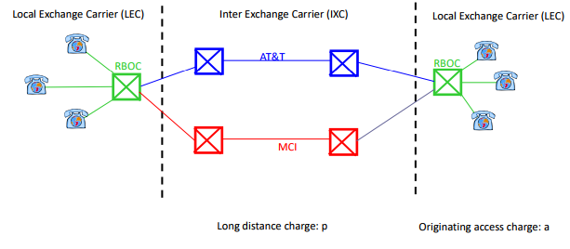
- Post-breakup years
  - Competition in long-distance has been a great success
    - the market share of AT&T fell from almost 100% to <45% in 2000
  - Prices of long distance phone calls have decreased dramatically
    - The average revenue per minute of AT&T’s switched services has been reduced by 62%
  - AT&T was declared non-dominant in the long-distance market in 1995

Reforms in the EU
- Until the end of 70s
  - All countries had local monopolies, typically owned by the government
- In the 80s
  - Increasing sentiment towards telecommunications deregulation drawing on positive US experience
- In 1996
  - The Commission issued Directive, which required all Member States to have completely liberalized telecommunications market in 1998

Key goals and trade-offs
- Productive efficiency
  - The cost-minimizing mix of inputs to obtain a given output level
  - Across firms : avoid duplication of fixed infrastructure costs

- Static or allocative efficiency
  - The welfare-maximizing output level
  - Violated if p > MC

- Dynamic efficiency
  - Welfare maximizing investment over time
  - Trade-off : promise sufficient profits to promote investment

Natural monopoly and retail price regulation

Natural Monopoly
- Definition
  - A natural monopoly exists when two or more firms cannot be profitable in the market
- This is more likely the case when
  - Market size is small
  - Economies of scale are large
  - Competition would be tough and result in p ≈ MC

- In Telecom, a natural monopoly is often referred to as an essential facility or bottleneck
  - Even if competition would be possible downstream, firms rely on an essential input upstream

- Remark
  - Essential facilities are not always absolute
  - Sometimes by-pass is possible, which mitigates the essential facility problem

Economies of scale
- Definition
  - There are economies of scale if total costs increase less than proportionally with output or equivalently if average total costs decrease in output

- The minimum efficient scale = MES
  - The level of output beyond which average costs no longer decrease

- Commonly used cost function with economies of scale
  - C(q) = F + c*q

- Sources of economies of scale
  - General : administrative and marketing costs, purchasing power towards suppliers, specialization of managers, …
  - Specially important in telecom : investment in infrastructure

Examples of natural monopolies
- Competition may not be a viable alternative
  - direct regulation of the monopolist may be needed

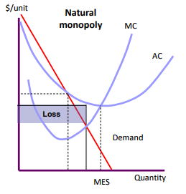

- Examples
  - Telecom
  - Trains
  - Airports

Natural monopoly : no regulation
- An unregulated monopoly
  - Chooses price or output to maximize profits

- First order condition MR = MC Lerner index
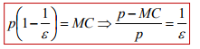

  - Market power is inversely proportional to the price elasticity of industry demand
  - Market power results in monopoly deadweight loss

Monopoly deadweight loss

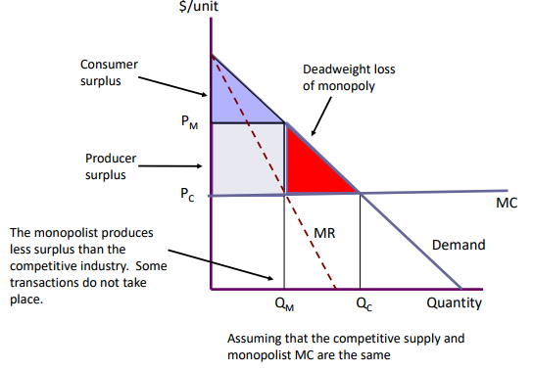

Natural monopoly : regulation
- Suppose a monopolist with cost function
  - C(q) = F + cq

- No regulation : monopolist sets monopoly price, which implies
  - Variable profit
    - π = $q_{M}(p_{M}$ – c)
  - Total profit
    - π – F

- MC regulation : force monopolist to set p = MC
  - This achieves allocative efficiency at quantity $q_{R}$
  - But monopolist makes a total loss of -F

- MC regulation + subsidy : give the monopolist a subsidy of F
  - But this requires tax increase, which leads to its own type of inefficiency

- AC regulation : force p = AC
  - Monopolist then makes zero total profits

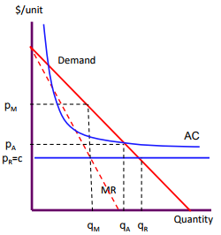
- The options are conflicting
  - Ideally we want MC pricing, no subsidy, full service and quality service
  - impossible in the case of natural monopoly

  - Efficiency can refer to 3 parts
    - Productive
    - Allocative
    - Dynamic
these may involve trade-offs

- Government involvement is necessary
  - Either through provision of services by state-owned monopoly or regulation
  - Choice between
    - Imperfect markets
    - Imperfect government intervention

- Specific types of regulation, roughly ‘implementing’ AC-regulation
  - Rate of return regulation
  - Price caps and Ramsey pricing

Rate of return regulation
- Aim
  - Reasonable price to customers and fair rate of return on capital to the firm

- Comines a company’s costs and allowed rate of return to develop a revenue requirement, which becomes the target revenue for setting prices
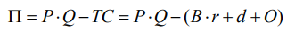
  - B = rate base
    - Amount of capital or assets the firm dedicates to providing its regulated services
  - r = allowed rate of return
    - Cost to finance firm’s rate base
  - d = annual depreciation expense of capital assets
  - O = operating expenses, which are the costs of material, labor, …

- The regulator limits the rate of return to r* which is the fair return on investment in capital
  - = cost of capital which determines RR
  - almost equivalent to AC pricing
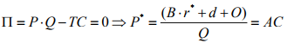
- Operating costs are always covered
  - no incentives for cost reduction = Cost-plus inefficiency
- Dynamic inefficiency
  - Since profits are fixed under ROR regulation, regulated firms have little incentive to adopt cost-saving innovations or to introduce new products
- Difficulties in measuring economic ROR with accounting data

Price cap regulation
- In the 80s
  - Many natural monopolies were privatized and price-cap = PC regulation was adopted in some countries as an alternative to ROR regulation
  - Ex : electricity generation and distribution, natural gas, water, telecommunications…

- Allowed price change = Change in Consumer Price Index (CPI) – X
  - X factor reflects productivity growth

- Lower governance costs
  - Less resources are used to operate the regulatory system
- Less vulnerable to cost-plus inefficiency
- But regulated firms may shirk on quality when price cannot be increased
  - Higher price per unit of quality

Ramsey pricing
- Relevant with more than 1 product

- Suppose there are 2 user types with inverse demands $p_{1}(q)$ and $p_{2}$(q)
- The objective is to maximize social welfare subject to the firm breaking even where per unit prices, which differ by type, can be charged
  - In the absence of fixed costs, the social planner would set the same price for both consumers at the MC levels

  - With fixed costs, but only 1 user type, the social planner sets price = AC

Interconnection and access regulation

Monopoly : interconnection or access
- Up to now
  - We considered how to regulate downstream prices of a vertically integrated monopoly
- In most network industries
  - Only the upstream level is a natural monopoly
  - Other levels can support competition
- It then makes sense to allow competition downstream or further upstream
  - Downstream : retail services to consumers
  - Upstream : investment in long-distance infrastructure
  - monopolist owns an essential facility/ essential input, to which competitors interconnect
- This might allow for deregulation of retail prices, but will require regulation of access or interconnection prices

Structure of various network industries

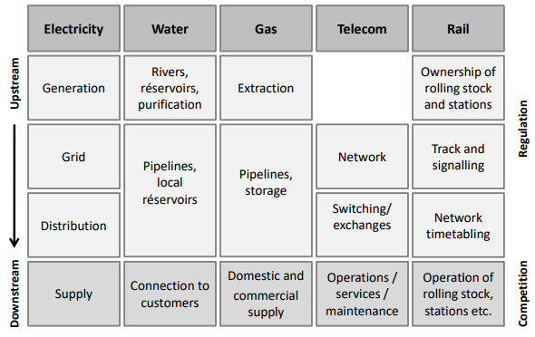

Access or interconnection
- One way access

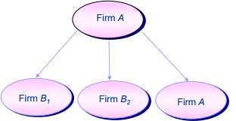

- Two way access
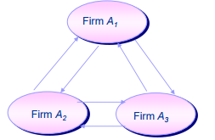

- Essential facilities
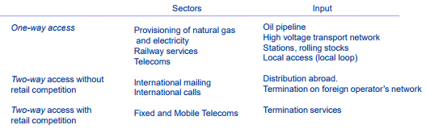

Access or interconnection in telecom : contracts
- Definition
  - The physical connection of separate networks to allow users of those networks to communicate with each other

- 2 types of access contracts
  - Call termination and call origination
    - A firm pays another firm for actual usage
    - They pay to originate or terminate calls to customers on another network
    - contracts with ‘access price per minute of usage’
  - Leasing network elements or local loop unbundling
    - A firm leases some part of another network for a period, independent of actual usage
    - contracts with ‘access price per month’
    - Gives more flexibility in providing services and more investment opportunities

One-way access
- One service provider must obtain inputs from another provider in order to offer services to its customer
- The carrier supplying the inputs may or may not compete with the firm purchasing the inputs

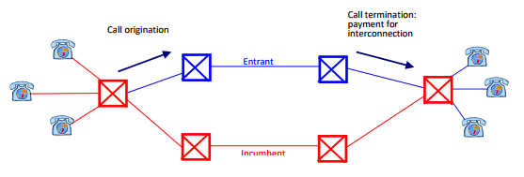

- The incumbent controls the local loop
  - payment for one-way interconnection is always from the interconnecting operator to the interconnection provider = local exchange carrier

Why regulate one-way access? Risk of foreclosure
- Monopolist controls the essential facility or essential input
  - Ex : local telecom network, railway tracks, electricity distribution, …
- Competition in other segments which require the essential facility
  - Ex : long distance calls, railway operations, electricity generation, …

- If the monopolist is also active in the competitive segment, it may try to limit the competition and preserve its market power in the following ways
  - Refuse to interconnect
  - Chare very high access price for the essential facility to ‘squeeze’ competitors
  - Sabotage entry by providing a lower quality interconnection service
- foreclosure of competition
  - Owner of essential facility may monopolize complementary segments and consumers pay monopoly price anyway

- Solution
  - Break-up
    - Force the upstream firm to divest its interests in the downstream market
    - two-way access
    - It may reduce efficiency
  - Regulation access prices
    - Wholesale/ interconnection prices

Foreclosure through a margin squeeze

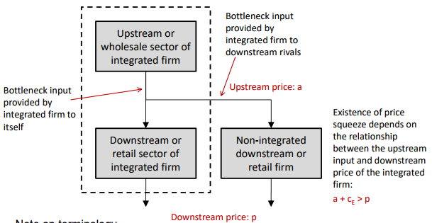

- Terminology
  - Upstream price = wholesale price = access price = termination price = …
  - Downstream price = retail price

One-way access regulation
- A regulatory alternative to break-up or divestiture is to allow the upstream firm to compete downstream but prevent it from discriminating against downstream competitors
- Access price
  - The price paid by downstream firms for access to the essential facility

- 2 kinds of regulation
  - Cost-based regulation through Long-Run Incremental Cost = LRIC
    - Access price based on physical cost of providing access
  - Efficient Component Pricing Rule = ECPR
    - Access price also includes opportunity cost of foregoing profits from selling access
- Among regulators, there is a consensus that cost-based regulation of access is most likely to lead to desirable outcomes
  - But measuring cost is challenging

- If the interconnection price is set too low
  - Inefficient competitors may enter the market
  - Competitors may not invest sufficiently
    - Prefer simple re-selling instead of developing innovative new product offerings
    - Incumbent operator may not invest in quality of the network
- If the interconnection price is set too high
  - Efficient competitors may be deterred
  - Because of pass-through, consumers will pay more than they need to

Access Regulation : Long-Run Incremental Cost (LRIC)
- Definition
  - Cost difference when not providing access assuming that the facility provides the other services at the same levels as before but can re-optimize its operation
    - In the long run
    - ≈ long-run marginal cost

- Approaches in practice
  - Top down
    - Start from firm’s accounting costs
    - Separate the assets and costs into service groups
    - Then add the extra costs associated with interconnection
    - estimate of LRIC
  - Bottom up
    - Model an efficient network based on a simplification of network design
    - Favored by many regulators
      - They reduce reliance on information provided by incumbent
  - Benchmarking
    - Compare access charges across countries
    - Regulate according to an ideal and comparable benchmark country
    - Be preferred as an interim method to small regulators
      - Who do not have sophisticated cost models

Access regulation : LRIC in practice

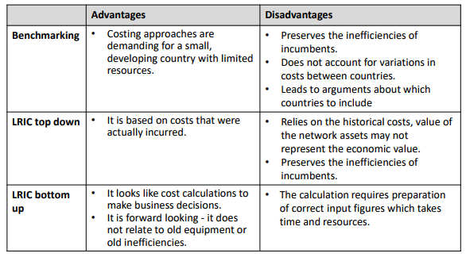

One-way access regulation : Efficient Component Pricing Rule (ECPR)
- Suppose the following
  - $c_{0}$ = incumbent’s upstream cost of providing access
  - $c_{I}$ = incumbent’s downstream retail cost
  - $c_{E}$ = entrant’s downstream retail cost
  - $p_{I}$ = incumbent’s retail price
  - $p_{E}$ = entrant’s retail price
  - a = access or interconnection charge

- Cost-based access regulation
  - a = $c_{0}$

- Efficient Component Pricing Rule (ECPR) = Margin Rule
  - a = $c_{0}+{(p}_{I}-c_{0}-c_{I})=p_{I}-c_{I}$

- Armstrong uses different notation
  - $c_{2}$ instead of $c_{0}$
  - $c_{1}$ instead of $c_{0}+c_{I}$
    - $c_{1}$ is overall upstream + downstream costs

- ECPR originally proposed by Baumol
  - If a component of a product is offered by a single supplier who also competes with others in offering the remaining product component, the single-supplier component’s price should cover its incremental cost plus the opportunity cost incurred when a rival supplies the final product
  - That is, the access price offered to an independent downstream firm cannot be higher than the difference between the final price set by the incumbent and its marginal cost at the downstream stage

- ECPR guarantees the following margin for the entrant E
  - $m_{E}=p_{E}-\left(c_{E}+a\right)=\left(p_{E}-p_{I}\right)+(c_{I}-c_{E})$

- If E were to set a competitive price with respect to the rival $(p_{E}=p_{I})$
- Then E gets positive margins if and only if $c_{E}<c_{I}$

- ECPR ensures that E can enter on I’s network if and only if E is more efficient than I

- ECPR is optimal under the following assumptions
  - Monopoly’s and the entrant’s goods are perfect substitutes
    - Otherwise entry by a less efficient entrant may be desirable
  - The regulator observes the monopoly’s MC on the competitive market
  - The entrant has no monopoly power
    - Otherwise, the choice of $p_{I}$ not only determines the access price, but also constrains the entrant’s monopoly power
  - The technologies exhibit constant returns to scale
    - Fixed entry costs would create difficulties with the ECPR rule
  - The benchmark pricing rule = MC pricing

- Otherwise, we can develop more sophisticated access pricing rules
  - Ex : Ramsey prices

- Under these assumptions, ECPR is optimal and gives the right signal for entrants to enter
- Otherwise it needs extension Armstrong extends the rule to
  - ${a=c}_{0}+δ(p-c_{0}-c_{I})$
    - δ = displacement ratio = extent to which I can be replaced by E
    - δ = 1 : I and E are perfect substitutes
      - No possibility of input substitution
      - No bypass
    - δ = 0 : I and E are independent, no substitutes
      - Back in cost-based regulation, because there is no opportunity cost for the incumbent in providing access

- To derive the extended ECPR in the simplest case, assume
  - I and E offer differentiated retail services
  - E is perfectly competitive
    - $p_{E}=c_{E}+a$

- Total welfare
  - ${W\left(a\right)=v(p}_{I},p_{E})+\left(a-c_{0}\right)x\left(p_{I},p_{E}\right)+\left(p_{I}-c_{0}-c_{I}\right)x(p_{I},p_{E})$
    - = consumer surplus + I’s access profits + I’s retail profits

  - We know that
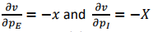

  - Substitute $p_{E}=c_{E}+a$ in W(a)

- Optimal access price satisfies FOC with respect to a
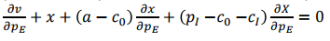

Two-way access : competitive bottlenecks
- Two or more carriers must connect their networks so that customers of one carrier can call customers served by the other carriers and

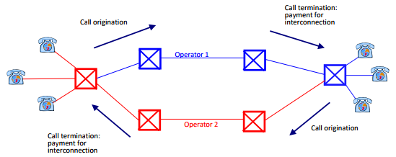

- Examples
  - Mobile telecom, fixed to mobile interconnections, international calls

- Each operator has its customers
  - Some calls are on-net
  - Some are off-net
    - Off-net needs interconnection agreements

- Access need is reciprocal
  - Foreclosure risk reduced

Why regulate two-way access? Risk of collusion
- Competitive bottlenecks
  - Call termination : once users choose their provider, that provider will have monopoly power with respect to the initiators of incoming calls
  - Even vigorous competition among operators will not cure the inbound monopoly problem
- Calling Party Pays = CPP
  - A wants to call B B’s network sets an access charge for call termination which is paid by network A
- Externality
  - This price is not taken into account by B when it chooses network
  - Monopoly power in setting termination charges
- This is an issue for all network operators independently form the market share
  - Termination is a bottleneck to reach a particular customer

Summary
- One-way access
  - Foreclosure (essential facility) doctrine calls for regulation of access charges
  - Use access regulation to enable (efficient) entry

- Two-way access
  - Competitive bottlenecks ‘collusive’ nature of access charges for linear pricing structures
  - Less a concern for more sophisticated pricing
  - Allow for (symmetric) reciprocal negotiations between operators
  - Regulation of termination rates may result in ‘waterbed effect’

Empirical evidence on intra-platform and inter-platform competition

Broadband industry : introducing competition
- History
  - During the 90s
    - Companies already had relatively fast Internet, while residential households had low speed Internet (narrowband), through dial-in on fixed copper line network
  - From 2000
    - Households receive high speed internet (broadband), either from fixed copper line network (ADSL) or from cable or other means
  - Since 2010
    - High speed internet also through mobile networks

- Objective of regulation
  - Remove legal and economic entry barriers that protect monopolies from competition

- Methods of introducing competition
  - Inter-platform competition
    - ADSL cable fibre wireless ….
  - Facility-based intra-platform competition (full bundling)
    - Entrants lease bare unbundled local loop elements and investments in own equipment
    - Full LLU shared access with incumbent
  - Service-based intra-platform competition
    - Entrants are merely reseller and therefore incur few investments themselves
      - Unbundling of incumbent’s network elements
    - Entrants can not easily differentiate themselves from incumbent through better quality

- For intra-platform competition
  - Regulation of interconnection is important
- For inter-platform competition
  - Competition policy matters

Broadband industry : inter-platform competition
- Inter-platform competition is strongest form of competition
  - Greater variety and coverage of services
  - Higher quality of services
    - Incumbent faces competitive pressure to upgrade its own network
    - Competitors are not constrained by existing old infrastructure
  - Lower prices

- With sufficient inter-platform competition, no regulation of retail and wholesale access prices is required

- Only feasible if fixed investment costs to build infrastructure and reach final consumers are sufficiently low
Broadband industry : intra-platform competition
- Intra-platform competition is a weaker form of competition
  - They are appropriate as a ‘second-best’ if the costs for setting up competing platforms are too high
  - But they require a form of wholesale access price regulation
    - Mostly cost-based
    - ECPR not common in Europe
  - Full local loop unbundling may achieve stronger benefits than bitstream access through lower prices and/ or increased investment
  - Bitstream access
    - Involves the risk of discouraging investment by the incumbent
      - Free-riding problem since it is forced to share its network investment
    - It is therefore more seen as a stepping stone towards deeper forms of competition

Broadband industry : ladder of investment
- Refers to a regulatory approach which aims to reconcile the various forms of competition

  - Regulator sets a low access price to encourage service-based competition
  - Once entrants gain a consumer base and knowledge of the market, they can move up the Ladder of Investment and invest in own facilities, still leasing the incumbents network
  - At some further point the entrants may be sufficiently strong to build their own platform
  - The regulator increases the access price to encourage the entrants to climb up the next rungs

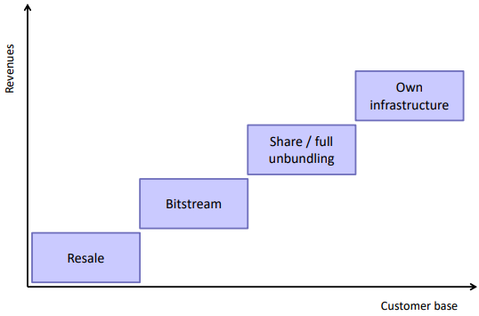

Broadband industry : LLU in the UK
- One incumbent, British Telecom (BT), owning copper line network
  - It originally only provided voice telephony
  - Since 2000 it upgraded its network to provide broadband internet through ADSL

- One cable operator, Virgin
  - This company originally only provided cable TV services
  - It also upgraded its network to provide broadband internet

- Due to the liberalization, BT faced the obligation to open its network
  - First only Bitstream access
  - Later full local loop unbundling (LLU)

- Empirical study of Nardotto, VAlletti and Verboven
  - Micro-data on LLU in the UK with information on broadband penetration for 5000+ local exchanges over 5 years
    - A local exchange is a switch covering a small geographic area in the UK
  - Information on quality via 1m speed test
  - Socio-demographics by local exchange

- First regression model
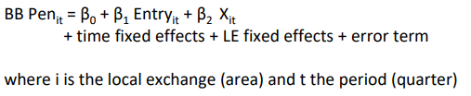

- Second regression model
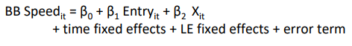

- LLU does not increase penetration
- LLU does increase quality

