3. Lean startup method: testing the business model hypotheses

1. RENT THE RUNWAY
- They learned a lot = goal of lean startup
- No jack-of-all trade = they weren’t generalists, so had to take extra classes for stuff
- Most actions are made to learn from!

Power of well-implemented customer discovery interviews & MVP tests
Product-market fit
! Business hypotheses can be found in the business model canvas

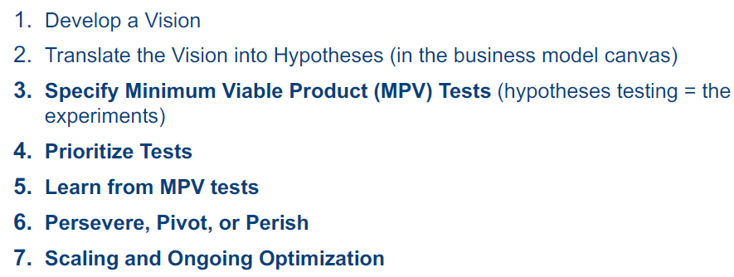
2. SPECIFY MVP TESTS
Leap-of-faith assumptions
Value hypothesis
= tests whether a product really delvers value to customers using it
Find volunteers who want to try product & retention rate

Growth hypotheses
= how customer will discover product
= rate at which product spreads among individuals

Questions:
- Do consumers recognize they have problem you can solve?
- If there was a solution, would they buy?
- Would they buy from you?
- Can you build a solution?

Validate Learning (VL)
- Learning
= unit of progress for startups (max learning/unit time & effort)
- VL
= process of demonstrating empirically that a team has discovered valuable truths about business prospects
= solving key uncertainty = progress!
- More concrete, accurate & faster than classical BP
- Antidote to the lethal failure problem
- Value is providing benefit to customers, anything else = waste
- “Validated”
= learning is backed up by empirical data collected from REAL customers via experiment

Experiment (test)
In practice
Learn what they really want, not what they say they want (faster horse)
Experiment > market research because you LEARN more (x spend less bc interaction is cheaper)
- More accurate data about customer demand
(real vs hypothetical)
- Interaction with real (nt potential) customers to learn needs
- Surprise effect (unexpected behaviors)
In theory
- Startup: every action is experiment (designed to achieve VL)
- True experiment
= start with clear hypothesis & test empirically (scientific)
- Startup experimentation
= guided by vision
- In LS, experiment typically product (Minimum viable product)
- Experiments * negative result: still prove instructive & influence stragy

