The Rich vs King Dilemma

1. SEQUENCING OF FOUNDERS’ DILEMMAS
Case evan williams
- Blogger: control-oriented decisions (internally consistent)
  - Vs. value-creation oriented decisions
- Unhappy after case A: trapped in company where he is rich, but no king
(contrast with king motivation)
- Decision on type of venture pursued also influence the possibilities of rich vs king

Founder’s dilemmas
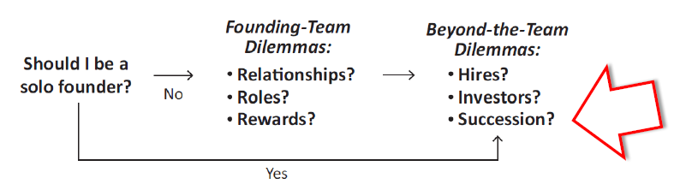

Evolution of hiring decisions as startup matures
- Cash compensation vs equity
  - Contingent compensation structure
= cash includes bonuses related to individual/ startup performance
  - Less equity compensation & more cash when more mature firm
- Rewards aligned to type of role (sales people)
- Low cash compensation difference founders vs employees
- Equity-stake differentials far greater

Only 48% of founders still CEO after 3rd round

Founder-CEO succession process
3 questions
- Should I be replaced?
- How do we make transition?
- How can I play LT role at company?

1. Decisions to replace
- Voluntary succession
- Fired for failure
- Fired for success
= paradox of entrepreneurial success
e.g. Wily
  - Product development
  - Fund raising
  - Being entrepreneur vs being small business manager
2. Searching for a successor
- Sources of successors
= mostly from outside
  - Founders prefer internal
  - VCs propose external superstar candidates from network
- Founder involvement
  - Can be good to smooth transition & bc founder knows startup best
  - Conflictual x can scare of high-quality candidates
- Successor dissimilarity
= larger the skills dissimilarity between professional CEO & founder, the smoother the succession process

Post-succession positions of replaced founder-CEOs
Triggers of change can be board or founder-CEO themselves
- Move to CTO or CSO
- Moved to other C-level position
- Moved to lower-level executive role
- Left the company immediately

After the succession
- Keeping founder?
  - High returns
= learn from founder & greater buy-in from the employees
  - High risk
= if control-motivated, the founder will contrast the new CEO
- Board’s role
= smooth the transition
  - Ex-ante professional investors (part of due diligence)
= try to assess whether founder-CEO will resist succession (rich vs king test) & might condition the investment to that possibility
  - Financial incentives to founder to smooth transition

2. OPPOSITE VIEW: WHY WE PREFER FOUNDER CEOs
= professional CEO are better at max product cycles while founder CEOs are better at finding product cycles
↔ Wasserman: prefer professional CEOs

3 ingredients
- Comprehensive knowledge
- Moral authority
- Total commitment to the LT

Motivations to be entrepreneur instead of employee of company
Entrepreneurs
- Autonomy
- Financial gain (men)
- Managing people (men)
- Power & influence
- Altruism (women)

Non-entrepreneurs
- Men
  - Prestige
  - Security
- Women
  - Recognition
  - Security

3. RICH VS KING DILEMMA
- Entrepreneurship is process by which individuals pursue opportunities without regards to the resources they currently control
- Resource constrained
  - Lack of res is reason behind liability of newness
  - Lack of res is reason behind founders’ dilemmas
- Attracting outside resources requires founders to give up valuable assets
  - Outside investors want something in exchange
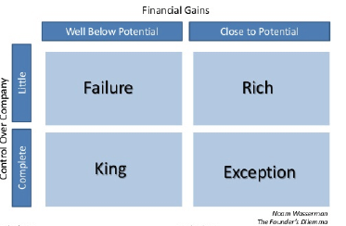

2 entrepreneurial motives consistently in tension with each other: control vs value creation
Difficult to grow both a valuable company & remain in control of it
E.g. apple is one of the few who did not make a choice!
Core dilemmas
= choice at every step between making money x managing their ventures
If not figured out which one most important: often * failure
(caused by senior management team!)

Trade-off
= value of founder’s equity stake depending on degree of control maintained

Consistent founder decisions?
= solo founders act different than team startups

- Hires
  - Solo founders hire more younger employees than team startups
  - Suggest solo founders favoured more inexpensive hires
- Investors
  - Solo founders
    - Twice as likely to use debt, which does not dilute his ownership as financing source
    - Raise 1st financing round later
    - Raise less capital in 1st round
- Chairman title
  - Solo founders more likely to retain both chairman & CEO titles
= ‘Double King” after 1st round of financing

Other choices affecting Rich vs King
- Preferred rate of startup growth
- Capital intensity
- Boundaries of firm

Other alternatives
- Second-tier resources
  - Adequate co-founders
  - Second-tier of investors/ smaller financing rounds
- Hybrid path towards rich & king entrepreneurial ideal
  - Start solo & small, later shift to wealth-oriented decisions to hit accelerator
    - By taking funding too early, risk losing ownership
  - Hardest decision
= when to give up some control to grow the company
  - Assess critical resources that are lacking & careful plan how to attract
  - King oriented founders avoid co-founders, but may use equity slices to attract best post-founding hires!
e.g. Lew Cirne, Wily
  - High risk of failure
= shifting strategies may cause major tensions

Better & Worse outcomes
Core founder’s view
= self-awareness
- No better outcomes, consistency is key
- Hard for unexperienced founders
  - No reflection on rich vs king motivations
  - No realize of growth stages & challenges & don’t know if they have skills to address this challenge

View of other involved stakeholders
= need to assess founder!
- Alignment btwn motivation founder with motivation co-founders, hires & investors
- Some VCs use rich vs king trade-off to judge whether invest in founder-led start-ups
- Term sheet negotiation with investors reflects King vs Rich orientation of founder
e.g. price/valuation vs board composition
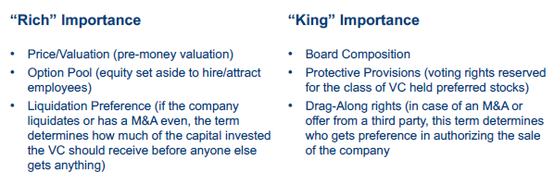

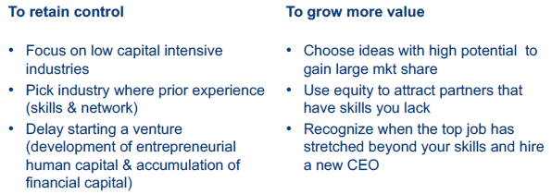

4. CONCLUSIONS
2 Key motivations: control vs value creation
= often mutually exclusive, leading to trade-off decisions
= regard people involved in venture! (co-founders, hires, investors, successors & ideas to pursue)

Decisions need to be internally consistent & consistent with founders’ own motivations

