Roles & rewards

1. UPDOWN
- Tradeoff negotiating early (3R’s: rewards, roles, relationship)
  - Pro
= No elephants in room (relationship)
= rewards for effort/commitment
= roles clearly defined
= costly to negotiate multiple times
= No quick decisions when talking to investor that wants to know CEO & se division
  - Contra
= No possibility to change when static agreement
= Relationship isn’t always clear in beginning of company
= Roles can change & rewards should change with it
- Timing of equity split may be advantageous for 1 co-founder but very disadvantageous for another within same team
- Craft equity-split arrangement that incorporates dynamic elements
= respond to changing interests, perspectives & environments
  - Set guidelines & milestones for how to split equity
  - Set vesting schedule
  - Set aside some equity to appoint later
  - Flexibility of contract
    - Known-knowns = standard provisions
    - Known-Unknowns = contingency provisions
    - Unknown-unkowns = trust

2. THE 3Rs MODEL
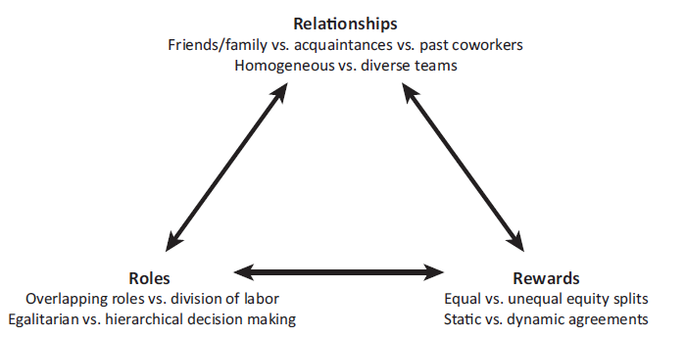
1. Roles
Distribution
= clear division of labour that is formalized in the titles
! Titles matter (symbolic significance that can translate into real authority)

Decision making process: executive titles
- Start-ups: top heaviness instead off pyramidal structure
- Title inflation: might have negative long term implications
- Hard to replace founder/ employee with senior title

Assigning top positions in startup
= level of commitment, human + social + financial capital, idea people

Overlapping roles vs division of labor
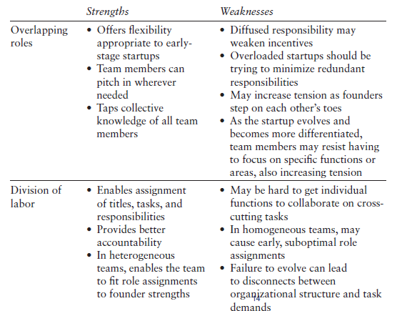
Decision making process
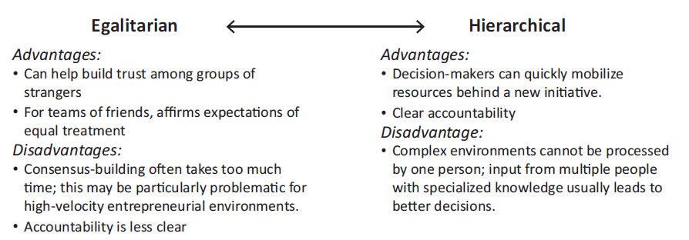

Balancing the best of Egualitarism & Hierarchy
2 steps: consensus + qualification
Rewards
Equity split
= equity ownership & other financial rewards (salary/benefits) allocated among founding team

When to split
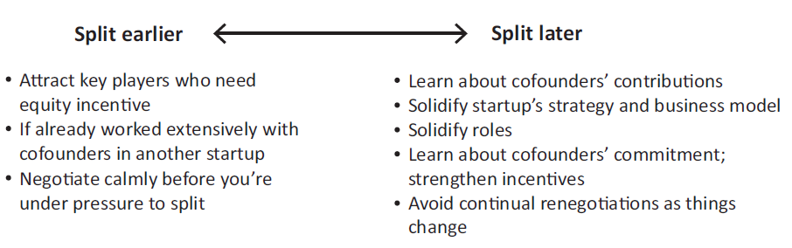
Criteria for equity split
- Past contributions to venture (idea premium 10-15%)
- Opportunity costs
= salary sacrificed to pursue start-up
- Future contributions
  - Hardest to evaluate, but most important
  - Background: serial premium 7-9% (when successful exit)
  - Commitment level (fulltime/ part-time)
  - Titles: CEO-premium (14-20%)
- Capital contributions
= not only tangible, also signal confidence in startup potential

Equal vs unequal equity splits
- Unlikely 2 exact equal contributions from 2 founders
- Practice: mostly equal split!
  - Outcome inequality aversion (psychological pain vs financial gains)
  - Avoids conflicts about ranking & boosts cohesion
- Downside
  - Some founders less productive (free riding/ incompetence)
  - What seemed fair turns out unfair (inefficient incentives)
  - Could create lack of hierarchy, leadership vacuum & voting deadlock
  - Inequity vs. inequality!

Formal vs informal split
Equal split: less time negotiating (60% less than 1 day)
- Signals lack of experience & preparation
- Lower valuation (VC discount)

Static vs dynamic equity splits
- Static equity
  - Huge mistake
  - Adverse events
  - ST view (tasks evolve)
  - Skills will remain valuable
  - Outweight past contributions
- Dynamic equity splits
  - Contingency provisions: worst/best/expected case scenario for split
  - Buyout terms
  - Vesting schedules
Protecting yourselves from cofounders: self-imposed vesting
Vesting
= most common type of dynamic equity agreement
= founders earn their equity stakes at certain times/milestones
! Leaving before requires relinquishing the unvested portion to the startup/ cofounders

2 types
- Time-based
= if slower, equity before expected contribution
- Milestone-based
= hard to specify ex-ante the milestones

Dynamic agreements avoid trade off splitting earlier vs later
= allows for attracting co-founder & keep motivation at same time

! Misalignments of 3Rs create tensions in team!

