Organizing for Entrepreneurship

Class 1: Introduction & “Marshmallow Case”
- Explain the relationship between the type of business opportunity and the cash need (+ related implications)
- Describe the concept “business model” and link it to examples
- About the Marshmellow Challenge:
- Define and describe the importance of prototyping
- Describe the role of prototyping related to starting up a venture
- Explain the importance of prototyping related to business model design.

1) Explain the relationship between the type of business opportunity and the cash need (+ related implications).
Different business opportunities have different profiles:
- Undefined Solution + Undefined Needs = Fantasy!
- Undefined Solution + Defined Needs = Market Pull Become BO
- Defined Solution + Undefined Needs = Technology Push Become BO
- Defined Solution + Defined Needs = Business Opportunities
The cash need depends on the burning rate of money related to the business opportunity (= it takes time to become profitable):
- Market pull: Reach break-even point relatively fast, low cash need
- Technology push: high cash need need to attract funding (VC or BA) to survive burning rate of money until break-even point is reached Exit oriented in tech-push (= investors need to gain)
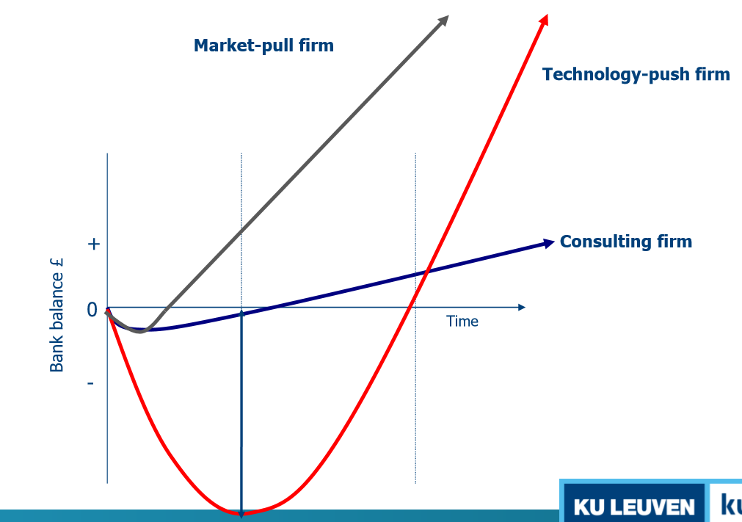
2) Describe the concept “business model” and link it to examples.
Business model = describes what a firm will do, and how, to build and capture wealth for stakeholders.
- How do we create value? (Value proposition)
- How do we deliver that value? (Key processes and resources)
- How do we capture that value? (Revenue generation, margin & exit)
3) Marshmallow Challenge. Iterate, experience, refine: make prototypes & test
3a) Define and describe the importance of prototyping.
The longer you wait towards the deadline to test your hypothesis/ assumptions, the more difficult it gets to iterate and the more cash is burned.
- You need to improve your study models = exploring alternatives quite early and often.
- Embrace lean start-up methodology & do tests: don’t get too attached to ideas in early stages.
- It’s not about improving/ refining your first idea, but about innovation (question the status quo & test alternatives)
3b) Describe the role of prototyping related to starting up a venture.
Business plan Going to the market = metaphor for “putting the marshmallow on top”
- Learn by doing, multiple iterations usually beats constraints
- We need to identify the assumptions in our (start-up) project (real customer needs, cost of the product, duration of the service) & test them early and often
3c) Explain the importance of prototyping related to business model design.
Prototyping = The process of building quick, cheap & rough study models to learn about the desirability, feasibility & viability of alternative solutions.
- Business model canvas: combination of Customer desirability (Do they want it?), Technical feasibility (Can we build it?) & Business viability (Sanity check)
- Innovation lies in the intersection area of these 3

Module 1: Building the start-up

Class 2: The lean start-up method
- Describe why early market engagement is important for startups, use the insights from the case boo.com to illustrate your answer
- Explain the product development approach of Netscape Navigator/Myo and link it to the LSU method
- Describe the 3 key principles of the LSU method & Compare the LSU method with traditional business planning
- Describe the different mechanisms to seek evidence and illustrate with examples
- Explain how the LSU method is related to the concept crossing the chasm and firm value creation over time

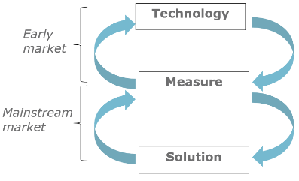
1) Describe why early market engagement is important for start-ups, use the insights from the case boo.com to illustrate your answer.
Crucial = conversation with innovators/ early adopters (early market):
By being in dialogue with early adopters, founders are able to learn a lot of important lessons about what the product needs to become to achieve mainstream success.

- Boo.com: no customer involvement in product development process + they launched the site for the first time when it was released as the end product lot of technological issues & customers didn’t like the “miss Boo” experience (= didn’t need/ want the product’s features).
2) Explain the product development approach of Netscape Navigator/Myo and link it to the LSU method.
Product development process: Use a sequence of beta-versions = rapid iterations of design-build-test User-centric development: sensing customer & market needs by broad internal & external testing. Use of prototypes postpones capital expenditure = possible to postpone dilution as long as possible
- From prototyping to the lean start-up (LSU) method:
Lean start-ups practice “agile development” = eliminates wasted time and resources by developing the product iteratively and incrementally create & test minimum viable products (MVPs).

3) Describe the 3 key principles of the LSU method & compare the LSU method with traditional business planning.
3 key principles of the Lean start-up:
- START: summarize hypotheses/ assumptions in business model canvas
- Customer development: assemble MVP to test these hypotheses use customer feedback to learn (= What learning do you seek?)
- Agile development approach based on BML-cycles (Build, Measure, Learn)
Test assumptions fast: Validated learning & constant feedback (iterate/ pivot if needed)
LEAN | TRADITIONAL
- Business model  - Hypothesis-driven  - Cyclic, customer-focused  - Operates on good-enough data | - Business plan  - Implementation-driven  - Linear, product-focused  - Operates on complete data
The lean start-up: experimentation, customer feedback & iterative design
Traditional business planning: elaborate planning, intuition & “big design up front” development
4) Describe the different mechanisms to seek evidence and illustrate with examples.
- Analogs/ antilogs: evidence of something that has worked/ failed elsewhere, transported to another context (cfr. Influencers used to sell products WORKS!)
- Interviews: separated problem & solution interviews with open questions listen & try not to sell!
- Experiments: test “Minimum Viable Product” with “early adopters” plan your experiments & track what you learn
- Test different versions of a product with customers = use prototyping techniques
- Paper & pencil = rough sketch of concept (and interaction in text)
- Mock up = Scaled prototype/ 3-dimensional illustration
5) Explain how the LSU method is related to the concept crossing the chasm and firm value creation over time.
Firm value will rise after every successful iteration/ pivot of the product development
- Increase firm value very fast
= Firm value
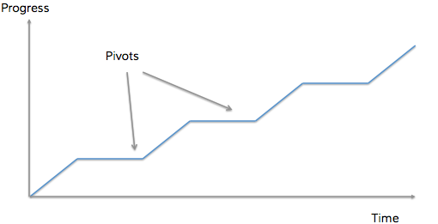

Class 3: Business model design
- Define and dimensionalize business model (innovation).
- Describe the business model canvas and the 9 building blocks.
- Describe the different starting points and related points of attention.
- Discuss the business model patterns of Nespresso and Apple, and link it with other examples.
1) Define and dimensionalize business model (innovation).
- Defining Business model = the architecture of (functional relation among) a firm’s mechanisms (Value proposition, customer segments, value chain, revenue capture mechanisms) for creating, delivering, and capturing value.
- Defining Business model innovation = designed, novel, and nontrivial changes to the key elements of a firm’s business model and/or the architecture linking these elements.
- Dimensionalization: different BMI typologies have difference in scope & degree of novelty:
- Evolutionary BMI = occurs naturally, fine-tuning process (modular & new to firm)
- Adaptive BMI = adaptation in response to changes in external environment (architectural & new to firm)
- Focussed BMI = management actively engage in modular changes to disrupt market competition (new to industry) $→$ ex. targeting a new customer segment, ignored by competition, keeping other components intact.
- Complex BMI = management actively engage in architectural changes to disrupt market competition (new to industry) $→$ ex. from bricks-and-mortar to online platforms
!! Companies today need to be ambidextrous exploitation (execution) & exploration (innovation)
2) Describe the business model canvas and the 9 building blocks.
Business model canvas = used to visualize and assess an existing BM or to create an entirely new BM.
- Value proposition = describes the bundle of products and services that create value for a specific customer segment.
- Customer segments = the different groups of people or organisations your organisation aims to help with getting a job done.
- Channels = outlines the customer touch points through which an organisation interacts with each of its customer segments to communicate and deliver a value proposition.
- Customer relationships = describes how an organization gets, keeps and grows each customer segment and what type of relationships it entertains with each of them.
- Revenue streams = represents the type of revenues an organisation generates from each customer segment for a specific value proposition.
- Key resources = describes the most important assets required to make a business model work.
- Key activities = describes the most important things a company must perform to make its business model work.
- Key partnerships = outlines the network of suppliers and partners that make the business model work.
- Cost structure = describes all costs incurred to operate a business model.
3) Describe the different starting points and related points of attention.
Use Build-Measure-Learn cycle:
- Market pull = find a solution for a given problem (jobs, pains, gains)
- Technology push = find a problem you can solve with your solution (invention, innovation, technology)

4) Discuss the business model patterns of Nespresso and Apple, and link it with other examples.
1. They empower the product through the business model (not focus on product innovation alone)
2. They invented a new business model (not simply copied from competitors)
3. They had to take some risk and experiment (could not prove in advance that the model would work)
Note: The right business model can be the difference between success & failure for the same product!
Use Business Model Canvas to evaluate BMs (How much at risk are you from being disrupted? How could you shift your BM from what it is to another, stronger model?)
- Cfr. Nespresso: lock-in customers through Nespresso pods
- Cfr. Apple: lock-in customers through Apple’s iOS & apps
- Cfr. Hilti: lock-in customers through service based model of online fleet management system

Class 4: Organizing the start-up
- Explain why business model always work on paper but often fail in the real world, and link it with examples
- Explain the difference between a business model and strategy, illustrate with an example (cfr Ryanair)
- Explain why a value chain analysis is important for start-ups, use the insights from the case Candid Condom to illustrate your answer
- Use the example of Groupon to discuss the concept “value network”

1) Explain why business models always work on paper, but often fail in the real world, and link it with examples.
A business model is based on assumptions (hypotheses) following “backwards looking” research. This assumptions often don’t hold in a rapidly changing business environment (cfr. Mobile internet case: from technology provider B2B to product provider B2C)
- In order to tackle these issues, you need to talk to lots of stakeholders, also after launching and scaling the solution!
2) Explain the difference between a business model and strategy, illustrate with an example (cfr. Ryanair)
- Business model = The way the firm operates and how it creates, delivers and captures value
- business model design = made of concrete choices (strategy) and the consequences of these choices) difficult to change
- Business model = reflection of realized strategy as it represents the execution of the plan
- Strategy = A contingent plan of action to achieve (a) particular goal(s)
- Plan of which business models to adopt
- !! Every organisation has a business plan BUT not every organization has a strategy !!
- Tactics = The steps used to compete in the market
- Competitive choices enabled by each business model relatively easy to change
3) Explain why a value chain analysis is important for start-ups, use the insights form the case Candid Condom to illustrate your answer
VAC analysis allows you to think ahead about your competitive position, the opportunities and challenges you may encounter with other players and the probable consequences for your BM.
- In order to reach your customer, you will need to attract and negotiate with those players in the value chain who control any value-added or complementary assets that you do not have.
- Look at the different stages of the Value Chain and analyse: Who the players in the VAC are, Where the value is created/ captured and where the power is, What you can do yourself (<> where do you need partners for) & If there are any problems and how you could cure them.
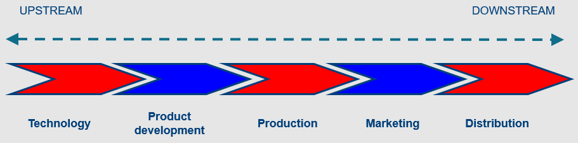
4) Use the example of Groupon to discuss the concept “value network”
Value network = graphical representation of how the different players interact with each other
- The players: company (offers product/ service), partners (other stakeholders), client (B2B or B2C, receives product/service and gives something in return)
- The flow from company to client: product, service, experience & reputation (really valuable!)
- The flow from client to company: money, less money, attention & exposure
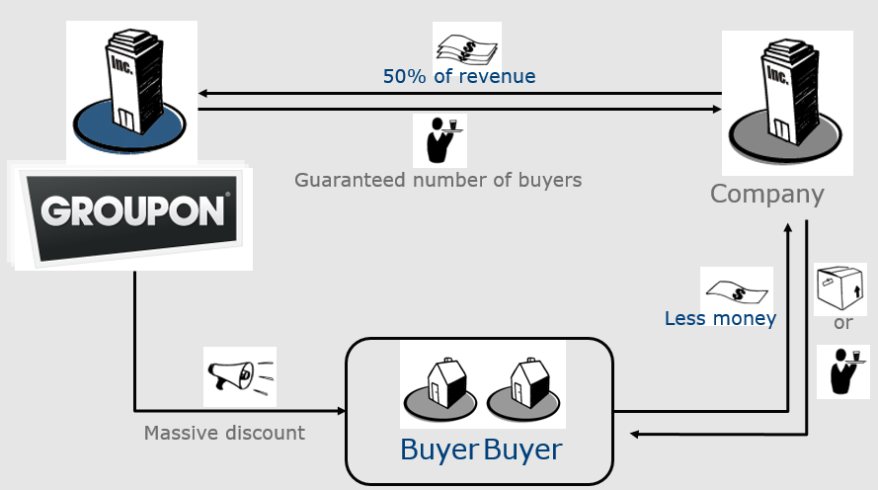

Class 5: Assembling the Founding team (entrepreneurial teams)
- Discuss the advantages/disadvantages of going solo and founding team
- If the startup operates in a turbulent environment, would you advise going solo or establishing a team? Explain your advice
- Discuss how you can use the 3Rs model to assess the founding team
- Discuss how you will chose your team members and what are the adv/disadv of including friends and family in the founding team
- Discuss the relationship between team turnover and start-up performance
- Discuss how team composition is different depending on whether you adopt short term or long term planning and what does this mean in practical terms.

1) Discuss the advantages/ disadvantages of going solo and founding a team.
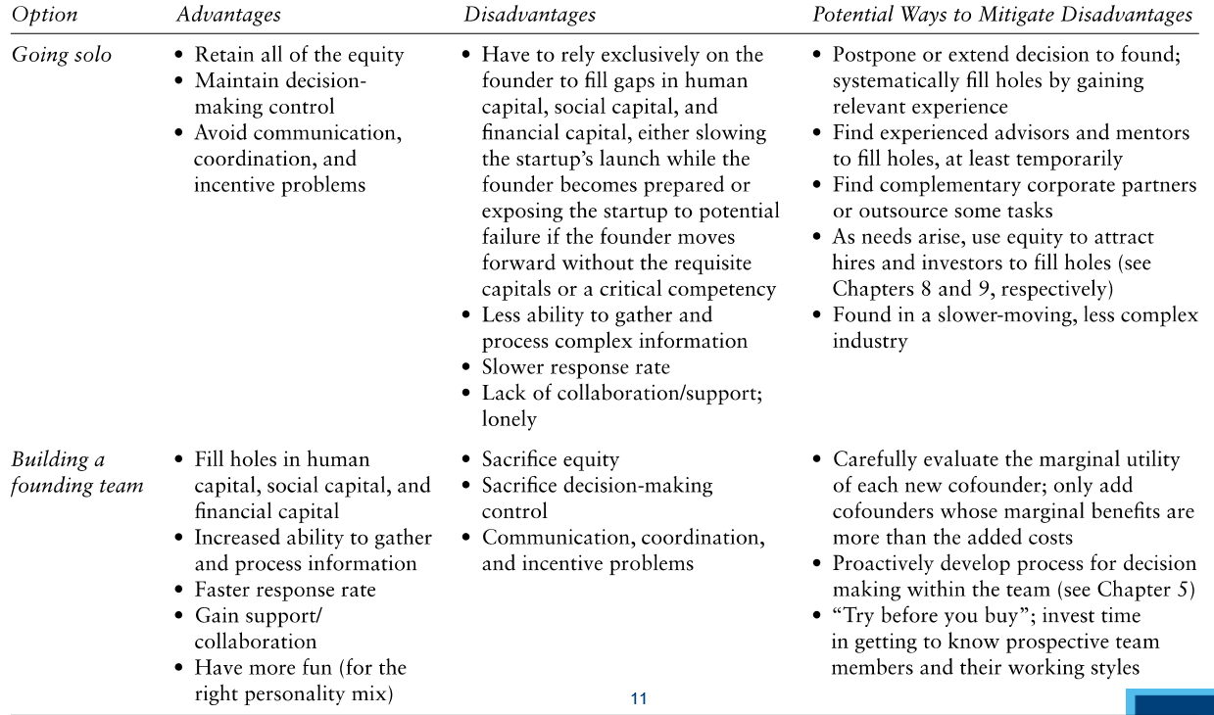
2) If the start-up operates in a turbulent environment, would you advise going solo or establishing a team? Explain your advice.
It is better to build a founding team when the business is in a fast-moving industry, especially if there are first-mover advantages or network effects.
- Larger teams are better at solving problems in a complex and turbulent environment:
They can absorb, recall & process more info, correct more errors in inference and analysis, consider more potential solutions and bring a broader range of perspective to bear on the problem.
3) Discuss how you can use the 3Rs model to assess the founding team.
Team tensions are determined by the 3 Rs, use these to assess the founding team:
- Relationships: Homo- vs heterogeneous teams / with whom to found / playing with fire gap
- Roles: Division of labour, positions, skills / Decision making process
- Rewards: Splitting the pie / compensation
4) Discuss how you will chose your team members and what are the advantages/ disadvantages of including friends and family in the founding team.
Chose team members out of: Direct contacts (family & friends), indirect contact or network (mutual acquaintances) or impersonal search process (strangers)
- Note: Teams with past co-workers = most stable & social relationships (F&F) = most unstable
- Most ventures start with friends and family in founding team because of same factors of homogeneity and because they offer emotional support BUT
The stability of the founding team is affected by: damage if the social relationship blows up & because of avoiding Elephants in the Room (avoid discussion of sensitive issues)
5) Discuss the relationship between team turnover and start-up performance.
High turnover of team members generates mixed results:
- High turnover can create communication difficulties, trust barrier
+ High turnover could be beneficial for adaptation and learning potential & change
dominant effect is context dependent:
- Stable conditions: continuation of members is beneficial
- Turbulent environment: learning through change is a necessity
6) Discuss how team composition is different depending on whether you adopt short term or long term planning and what does this mean in practical terms.
Homogeneous (ST of stable environments) vs heterogeneous teams (LT or turbulent environments):
- Homogeneous teams: non-diversified founding team facilitates communication, commonalities promote efficient implementation and fast action BUT this may cause LT problems because of overlapping human capital. Pursue exploitation strategy (trust and cooperation)
- Heterogeneous teams: founding teams with different backgrounds generate larger and more diverse skillsets which affects strategic creativity. Heterogeneous groups are more adaptable due to diversity in skills and network. Pursue exploration strategy (firm adapting & learning)

Module 2: From building to accelerating

Class 6: Growth trajectories

Class 6a: Preparing for and Evaluating the Challenges of Growth
- Describe how firms can properly prepare for growth.
- Describe the most important factors for firms to focus on during each stage of growth.
- Describe the managerial capacity problem.
- Discuss the challenges for growth imposed by adverse selection and moral hazard.
- Discuss the day-to-day challenges of growing a firm.

1) Describe how firms can properly prepare for growth.
Establish growth-related plans in order to anticipate at growing too fast
- Manage growth by understanding the stages of growth, along with the unique opportunities and challenges that each stage entails.
2) Describe the most important factors for firms to focus on during each stage of growth.
- Introduction (start-up phase) determine core strengths and capabilities, make sure the initial product/ service is right (work very hands-on, “in the business”)
- Early growth (increasing sales) start working “on the business” rather than “in the business” & increase formalization (heightened complexity)
Product innovation

Process innovation
- Continuous growth need for structure and formalization $↑$, decide whether owner & current management team have the experience & ability to take the business further
- Maturity (growth slows) focused on managing efficiently than developing new products look for partnering opportunities (/ acquisition/ licensing) to breathe new life into firm Develop “next generation” of products if growth not achieved through existing product mix
- Decline NOT INEVITABLE: depends on strength of leadership & ability to adapt over time (= reshuffle business you can reinvent yourself)
3) Describe the managerial capacity problem.
Managerial capacity problem = bottleneck that arises when a firm’s managerial resources are insufficient to take advantage of its new product opportunities.
- Because firm can’t quickly increase its managerial services (expensive to hire & takes time for new hires to be socialized in corporate culture and acquire firm-specific skills)
Managerial services = administer the routine functions of the firm and facilitate the successful execution of new opportunities.
4) Discuss the challenges for growth imposed by adverse selection and moral hazard.
- Adverse selection = As # of employees a frim needs rises, it becomes increasingly difficult for the firm to find the right employees.
- Moral hazard = New hires in a firm typically do not have the same ownership incentives as the original founders, so they may not be as motivated as the founders to put in long hours and may even try to avoid hard work.

5) Discuss the day-to-day challenges of growing a firm.
- Cash flow management: firm requires increasing amount of cash as it grows CFIMITYM
- Price stability: if growth at the expense of competitor’s market share price war
- Quality control: issues when firm not able to increase its resources to handle the extra work
- Capital constraints (ever-present problem)

Class 6b: Strategies for Frim Growth
- Explain the difference between “internal growth strategies” and “external growth strategies”.
- Explain what an “international new venture” is and describe its importance.
- Explain “licensing” and “franchising”.
- Explain “joint ventures” and describe the difference with “mergers and acquisitions”.

1) Explain the difference between “internal growth strategies” and “external growth strategies”.
- Internal growth strategies: involve efforts taken within the firm itself
- New product development, international expansion
- Encourage entrepreneurship inside company = intrapreneurship (NPD)
- External growth strategies: establishing relationships with third parties
- Mergers & acquisitions, strategic alliances & joint ventures, licensing/ franchising
2a) Explain what an “international new venture” is and describe its importance.
International new ventures (“born globals”) = businesses that seek to derive significant competitive advantage selling products or services in multiple countries.
- Foreign market entry strategies: exporting (direct/ indirect), licensing/ franchising, Joint venture, Wholly owned subsidiary, Turnkey project
2b) Explain what an “New Product Development” is and describe its importance.
New Product Development = the creation and sales of new products (or services) as a means of increasing firm revenues and profitability.
- In many fast-paced industries, NPD is a competitive necessity (find niche and fill it)
3) Explain “licensing” and “franchising”.
- Licensing = granting permission by one company to another company to use a specific form of its intellectual property under clearly defined conditions.
- Franchising = granting permission by one company to another to duplicate its business in another location.
4) Explain “joint ventures” and describe the difference with “mergers and acquisitions”.
- Joint venture = an entity created when two or more firms pool a portion of their resources to create a separate, jointly owned organization (mostly to gain access to a foreign market).
- Merger = the pooling of interests to combine two or more firms into one.
Acquisition = the outright purchase of one firm by another.
Difference: The companies within a joint-venture keep existing on their own <> (on of) the companies in an M&A do not exist on its own anymore afterwards.

Class 6c: Modelling Growth Trajectories

Modelling Growth Trajectories: S-curves
- Growth patterns of cumulative sales of new products against time = similar to S-shape curve

The Bass Model
- Model for the timing of initial purchase of new products
- Disentangles innovators from imitators regarding to the initial adoption of innovation
  - Innovators = people who are eager to be first in buying the product, without being pressured by growth of adoption process Influenced by external influencers.
  - Imitators = individuals who buy the product only after being influenced by initial buyers Influenced in the timing of adoption by the pressure of the social system
- Basic assumption: The probability that an individual purchase will be made at time t, given that no purchase has yet been made, is a linear function of the number of previous buyers:
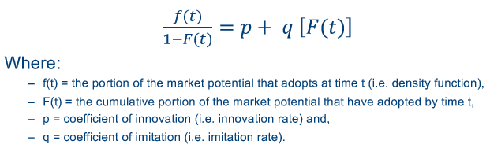
f(t) = p [1 – F(t)] + q [F(t)] [1 – F(t)]
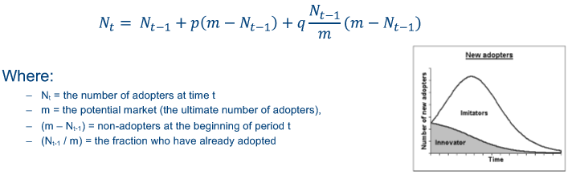

Parameter estimation techniques
“Parameter estimation (of m, p & q) for diffusion models is primarily of historical interest: by the time sufficient observations have developed for reliable estimation, it is too late to use the estimates for forecasting purposes.”

Results
Ex-ante “forecasting” the diffusion of new products/ technologies by means of quantitative models is problematic
- Model growth of new technologies BUT align this with good figures (= what it actually is today, not only what it could be).

Class 7: Sources of funding
- Describe Internal and External sources of funding for startups
- Discuss the relationship between the Stage of Venture Development and the funding of startups
- Discuss the two main sources of external funding for startups (Business Angels and Venture Capital firms)
- Who/what are they and what drives them to invest in startups?
- Advantages/disadvantages
- Describe the life cycle of a Venture Capital fund and evaluate the chances to get VC funding for a startup.
- Explain the funding gap in the context of entrepreneurial finance

1) Describe Internal and External sources of funding for start-ups.
- Internal sources: Personal means (own cash) or Cash Flow
- External sources: Bank loans (but banks don’t like risks), 3F (Friends, Family & Fools), Business Angels & Venture capital
2) Discuss the relationship between the Stage of Venture Development and the funding of start-ups.
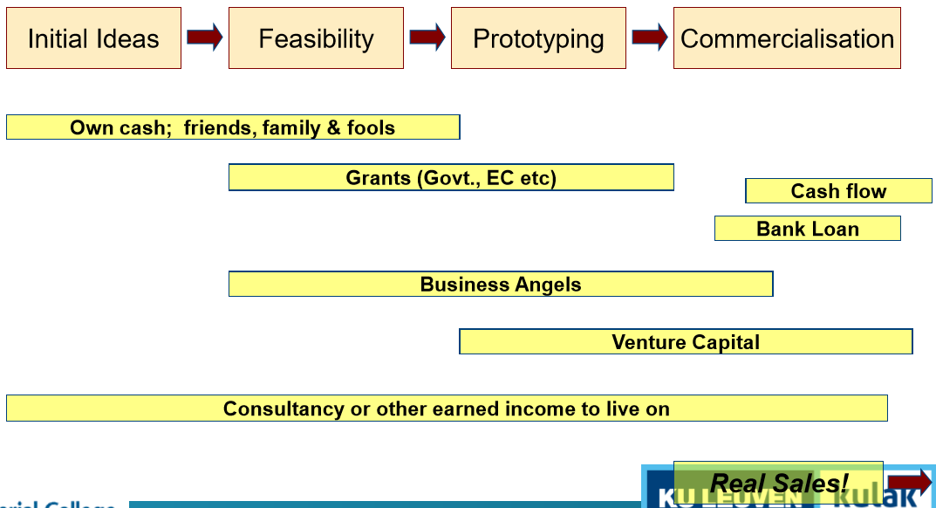
Note: Life cycle of venture and funding raise capital through series of funding phases (rounds)
- Initial round should raise capital needed BUT when high burn rate of cash, then another round of financing required (as business develops, share price $↑$ because company value should $↑$)
- If company not able to meet benchmarks investors will only further invest if share price $↓$ = Down-Round
3) Discuss the two main sources of external funding for start-ups.
- Business Angels: Investing their own money, generally invest $50 – 100 K
- Venture Capital Firms: Investing funds of outside limited partners, generally have $100 – 500 Mio in capital under management (invest $2 – 10 Mio in venture)
4) Who/ What are they and what drives them to invest in start-ups?
- Business Angels: Wealthy investors, individuals who invest their own capital in new ventures, often experienced entrepreneurs.
- Objectives: fun (personal interest) & return (interested in equity growth, fin. return 30-35%)
- Venture Capital Firms: Intermediaries who invest outside equity from professionally managed pools of money (VF Fund) in a portfolio of entrepreneurial ventures.
- Objectives: interested in growth & increasing the value of the venture when making investments
5) Advantages/ disadvantages:
- Business Angels:
PROs  - familiar with the sector  - invest in early stage (at moment that VCs are reluctant)  - generally light reporting requirements | CONs  - informal relationship (consider themselves part of the entrepreneurial team) only invest if there’s a “match” with the entrepr.  - Entrepreneur needs to accept BA’s (hands-on) involvement
- Venture Capital Firms:
PROs  - large VC fund will keep 1/3 as backup cash to reinvest in businesses in need | CONs  - highly involved with portfolio companies  - expect regular reporting from entrepreneur  - always look for an exit (planned beforehand)

6) Describe the life cycle of a Venture Capital fund and evaluate the chances to get VC funding for a start-up.
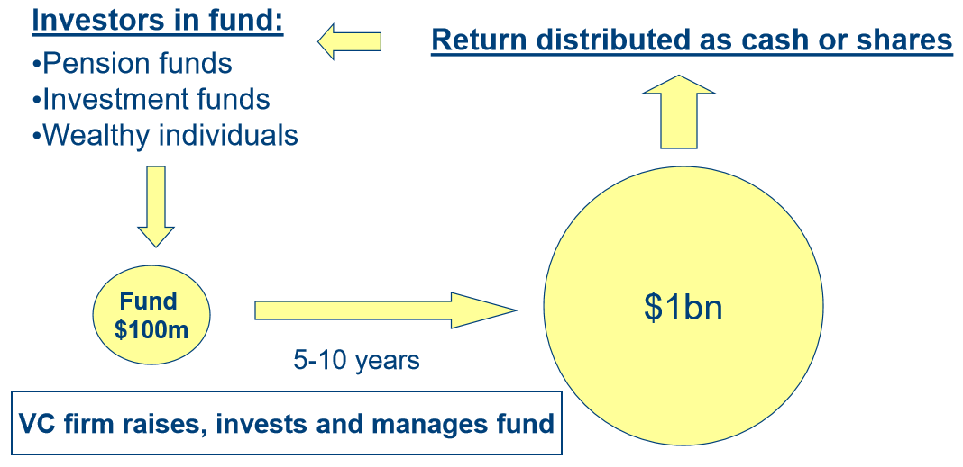
- Chances of receiving VC funding are low Only invest in 3-5 business out of 100
7) Explain the funding gap in the context of entrepreneurial finance.
Funding gap: The ability of small firms to access finance is hindered by persistent market failure (information asymmetry) for new businesses.
- Adverse selection: entrepreneurs possess more information about their own abilities and the prospects of their venture than the provider of finance may misrepresent this information.
- Moral hazard: one party to a transaction cannot observe relevant actions taken by the other party that might influence the outcome of the investment.
Policy intervention needed Loan Guarantee Schemes and/ or Support equity funding

Class 8: Exit decision (IPO versus Trade sale)
- Describe the different valuation methods for start-ups, which one would you prefer to use? Explain why.
- Explain why start-ups often have difficulties to achieve their forecasts, use insights from the case Internet Securities in your answer
- Discuss why start-ups typically raise more cash from investors than strictly needed, use insights from the case Internet Securities in your answer
- What are the advantages/disadvantages of IPO versus Trade sale for entrepreneurs

1) Describe the different valuation methods for start-ups, which one would you prefer to use and why?
- Net Present Value (NPV) Valuation: $value= \sum_{t=1}^{n}{\frac{{FCF}_{t}}{{(1+WACC)}^{t}}+\frac{{FCF}_{n}(1+g)}{{\left(1+WACC\right)}^{n}(WACC-g)}}$
- Discounted Cash Flow (DCF) = projected CFs discounted to today
- Multiples Valuation: Based on how similar assets are currently priced in the market (~ comparables)
- Valuation of similar, publicly listed firms Calculate multiples: Earnings multiples (P/E) or Sales multiples (P/S) Multiply P/S multiple with own company sales
Chose for Multiples valuation method, because NPV method is only as reliable as the CF projections. Start-ups usually aren’t that good at forecasting (cfr Internet Securities case) so NVP will not be reliable.
2) Explain why start-ups often have difficulties to achieve their forecasts, use insights from the case Internet Securities in your answer.
Start-ups often have difficulties in forecasting their revenues because they operate in a turbulent and uncertain environment, where the burn-rate of cash is difficult to predict. It is often very difficult to estimate what effect funding (increase in resources) will lead to.
3) Discuss why start-ups typically raise more cash from investors than strictly needed, use insights from the case Internet Securities in your answer.
VCs are brutal! When ventures are in need of cash, their bargaining power decreases drastically. The further away in the future your out of cash point is, the stronger your bargaining power will be.
4) What are the advantages/ disadvantages of IPO versus Trade sale for entrepreneurs
- IPO (initial public offering) = when a company sells part of its equity to the public and becomes listed on an exchange
Advantages | Disadvantages
- Opportunity for growth  - Increased visibility  - Greater returns (value $↑$)  - CEO independent | - Significant time and money (hard, long and costly process)  - Ongoing disclosure  - Reliance on market conditions (become publicly listed)

- Trade sale = involves giving full control of the company to a secondary buyer, who typically is a larger player in the same sector as the start-up
Advantages | Disadvantages
- Resources & capability leveraging (strategic advantage: more assets combined with attest of acquirers)  - High liquidity | - Loss of control (become part of a larger group)  - (downsizing)

5) Explain what Term sheets are and what could be negotiated in this.
Acquirers (and VCs) are tough negotiators BUT entrepreneurs have the right to protect their interests in the deal!
- A term sheet is a nonbinding agreement setting forth the basic terms and conditions under which an investment will be made.
- Valuation of the company, amount of investment, the percentage stake sought, voting rights, liquidation preference, anti-dilutive provisions, and investor commitment are some of the key terms that should be spelled out in the term sheet.
Term sheet discussion:
- IPO demand right (type of registration right)
Internet Securities: “The IPO demand right would allow large shareholders a future option to retrieve ISI back out of Euromoney and take it public”
- Founders only able to exercise this right under certain conditions (negotiate these)
- Earn-out scheme
Internet Securities: “G.M. is owner of 808,000 common shares in ISI. The formulas below describe how he can sell to Euromoney the shares that remain after his initial sale up to 14% outlined above.”
- Negotiate earn-out scheme

