International business strategy
  - What determines the international success and failure of firms?
IBS means effectively and efficiently matching an MNE’s internal strengths (relative to competitors) with the opportunities and challenges found in geographically dispersed environments that cross international borders. Such matching is a precondition to creating value and satisfying stakeholder goals (most important: shareholders, customers, employees), both domestically and internationally.
(MNE: firm with economic operations in at least 2 countries)

1: Conceptual foundations of IBS
How do you measure size? market cap, employees, annual (worldwide) revenues, turnover, …
eg. Largest annual worldwide sales: Walmart (VW 7th place, Apple 12th place)
eg. Most profit: Saudi Aramco (Apple 2nd place; 6th in first list)
eg. Most assets: China National Petroleum (very capital intensive) (VW 3rd place; 4th in first list)
eg. Most employees: Walmart – by far the largest (China National Petroleum 2nd place)
eg. Market capitalization (American list): Apple (Microsoft, Amazon, Alphabet, Tesla, Facebook, Alibaba)
Walmart first in 2 categories but knew troubles in certain countries = not always successful!

Conceptual framework Verbeke
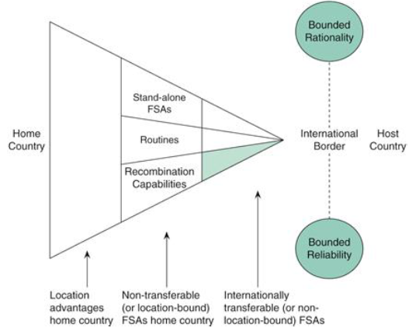
Triangle shape: on the broad base of the location advantages (LAs) of its home country (left) it builds a smaller subset of FSAs (firm specific advantages) that are location-bound (middle), and then a still smaller subset that are non-location bound (right). Bounded rationality and reliability influence the ability of these NLB FSAs to be transferred across the international border to the host country.
- Non-location bound FSAs
(= internationally transferable)
- Location bound FSAs
- Location advantages
- Value creation through recombination
- Complementary resources of external actors (not explicitly shown in figure)
- Bounded rationality
- Bounded reliability
First 3 (FSAs and LA) as a set = distinct resource base available to the firm, critical to achieving success in the marketplace firm = bundle of resources under common governance
- Physical resources (natural resources, buildings, plant equipment, …)
- Financial resources (access to equity and loan capital)
- Human resources (individuals and teams; have both entrepreneurial and operational (or efficiency-related) skills)
- Upstream knowledge (sourcing knowledge, product- and process-related knowledge)
- Downstream knowledge (= critical to the interface with customers; related to marketing, sales, distribution, and after-sales service activities)
- Administrative (governance-related) knowledge (regarding functioning of organizational structure, culture, and systems)
- Reputational resources (brand names, good reputation for honest business dealings, …)
Routines: distinct ability to further combine these resources in unique ways (valued by stakeholders)
= stable patterns of decisions and actions that coordinate the productive use of resources, and thereby generate value (domestically or international).
Combination ability expressed in routines = higher-order FSA, because routines are more complex (also more flexible and durable) than an FSA derived from distinct but stand-alone resources harder for rivals to imitate or otherwise acquire.

1: Non-location bound FSAs
NLB FSAs = corporate strengths that are technically transferrable to foreign countries AND can be profitably exploited there ! not necessarily ALL foreign countries = strengths relative to rival firms
Can be transferred abroad in two ways: (send to foreign plant)
- embedded in final products (export the products with the FSAs in them)
- as intermediate outputs (transfer FSAs separately from products) eg. know-how
In general: NLB FSAs tend to have a limited geographical scope
- most firms from Fortune’s Global 500 realize most of their sales in their home country (if their NLB FSA exploitable worldwide mature firms should realize similar share of sales in each main world region)
- Study by Rugman & Verbeke: out of 365 firms from Fortune’s Global 500: !data from 2004, now more in ↙
- 9 firms: 20-50% of sales in each Triad region = global firms (eg. Coca-Cola, LVHM, Philips)
- 25 firms: 20-50% of sales in two Triad regions = bi-regional firms (eg. Nissan, Unilever, McDonald’s)
- > 300 firms: realize most sales in 1 Triad regions, usually home region = home-region oriented firms
- Suggests that NLB FSAs are often region bound – especially downstream ones
Explanation: institutional differences within a region are often smaller than those between regions
- formal rules: laws and regulations; informal rules: norms, values, habits (culture)
- due to regional integration agreements (eg. EU, EFTA, NAFTA, MERCOSUR, ASEAN, …)
 |  | Part of the value chain
 |  | Upstream | Downstream
FSA | NLB | Unique product technology, procurement (bargaining) power, R&D, patents, design | Global brand reputation, store layout, digital tools, technical skills, logistics, distribution system, customer service
 | LB | Access to natural resources (+license to abstract it), locally-embedded R&D team, labor costs, tax, human capital (for R&D) | Market knowledge + targeted marketing (cultural differences – local customer preferences), local distribution network
eg. Global brand reputation: used to be Coca Cola for a long time, now tech companies (Apple, Amazon, Microsoft, Google, Samsung, …)
Are needed to offset the liability of foreignness = the additional cost of doing business abroad
! also exists for individuals (eg attraction information in Japan only in Japanese or cheaper price for locals compared to tourists)

2: Location bound FSAs
Cannot be transferred abroad OR can be transferred but have little/no value there
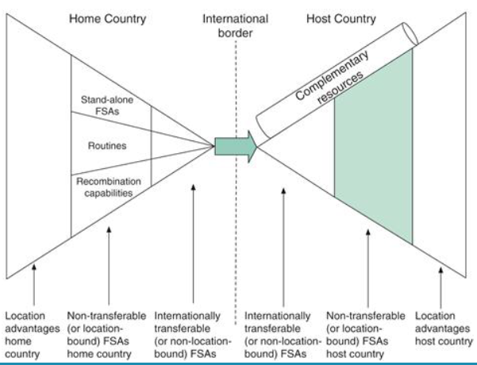
eg. Stores at favorable locations OR local market knowledge (different for every country, so not useful to transfer it to other countries)
Green shape: the creation of new LB FSAs in the host country is very important

3: Location advantages
Pertains to geographical areas
(↔ FSAs are related to specific firms)
LAs = characteristics of a geographic area that provide benefits to firms operating there (can be countries, states, agglomerations (= clusters), or supranational regions)
eg. property rights regime (patents, trademarks, …) can truly support a firm’s FSAs (you have nothing with a patent or brand is it is not protected in certain countries)
The existence of LAs abroad may motivate firms to undertake “foreign direct investment” (FDI) (because access to these LAs often requires local presence)

Foreign direct investment
FDI = investment that causes a firm to have a significant ownership stake in (and thus partial (or full) control over) a foreign business entity (“foreign subsidiary”)
= greenfield investment (new entity created) or acquisition (take-over)
firm becomes a multinational enterprise (MNE)
≠ foreign portfolio investment – no desire for control, investment in tiny ownership stake
≠ contractual expansion modes – direct & indirect exporting, outsourcing, licensing & franchising

Motivations for FDIs
1: natural resource seeking (relevant LAs: oil, gas, minerals, land, …)
2: market seeking (relevant LA: customer presence) – having customers in more countries may entail risk reduction
3: strategic resource seeking (relevant LA: presence of strong technological, managerial, or reputational resources – some of which may be obtainable through acquisitions, whereas others may require local learning or local hiring)
4: efficiency seeking (relevant LAs: cheap labor, low taxes, customer closeness, avoidance of import tariffs, possibilities for economies of scale, …)

When to choose FDI over contractual foreign expansion
OLI paradigm = firm is better of with FDI when 3 advantages are present at the same time
O: ownership advantage = firm needs to have 1 or more internationally transferrable strengths in the activity concerned – to offset the liability of foreignness/outsidership (≈ NLB FSAs)
L: location advantage = locating the activity abroad needs to be more attractive than locating it at home
– for instance because of lower wages, export costs, or benefits associated with local presence
I: internationalization advantage = performing the activity internally needs to be more attractive than having it performed by an external, contractual partner (most complex ‘letter’)
- exists when an internationally transferrable strength is largely ‘tacit’ and thus difficult to transfer to an external partner
- or when it is ‘codified’ and thus easy to transfer externally, but prone to misuse by the partner
the simultaneous presence of OLI advantages explains why MNEs exist
eg. Pizza Hut: I-advantage: franchising mouse infestation – they didn’t care (= abuse by external partner) destroyed the brand reputation!
FDI would have been better (in tourist location: no incentive to maintain the quality in a franchise)
some MNEs: not always all OLIs at the same time needed, eg. Apple: they don’t use FDI for everything

Archetypes of administrative heritage
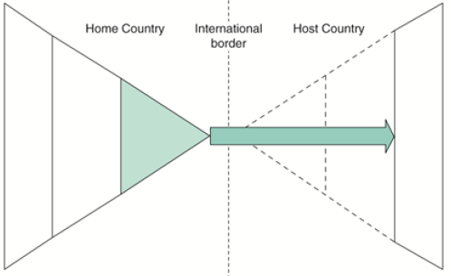
4 types of internationally active firms, based on first 3 factors of Verbeke (NLB FSA, LB FSA, and LA)

Centralized exporter
Transfers its NLB FSAs abroad embedded in its (finished) products (to the LAs of host countries)
eg. NEC, motion picture studios, Rolex (for watches: Swiss = quality – knowledge spillovers located closely together), Gazprom, many SMEs
(some remain it deliberately, to exploit high image)

International projector
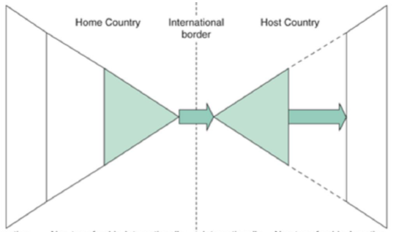
Transfers its NLB FSAs abroad separately (not embedded in products) (eg. expatriots to implement knowledge)
eg. Ford, Disney (Disneyland), most international franchises, IKEA, Spotify
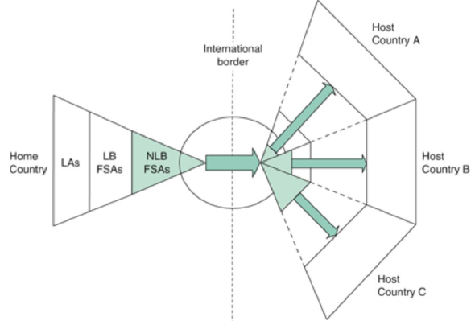
eg. Disney: some local adaptation to preferences, but same building blocks in all theme parks - Shanghai: Main Street has been replaced by Mickey Avenue to reduce the feel of Americana, while attractions include the Chinese-style Wandering Moon tea house, a Chinese Zodiac-themed garden, and a Tarzan musical featuring Chinese acrobats.

International coordinator
Transfers different NLB FSAs to different countries – depending on LAs in the host countries (what does the host have to offer, eg: R&D to countries with ‘smart high skilled people’)
+ has an FSA in logistics (circle on figure) = international vertical supply chain
eg. BP, Logitech, pharmaceutical firms, Apple (R&D: US, manufacturing: China, …), Airbus
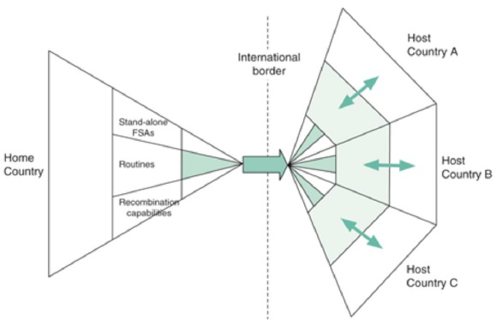
!! Risk: supply chain disruption (eg. Brexit: has impact on business with and within UK; eg. Covid: lockdown disrupts global supply chain)

Multi-centered MNE
Transfers only key routines and invests to develop LB FSAs in the host countries to be locally responsive (good knowledge about LAs is needed!)
eg. Philips (pre-1960), Lafarge, construction and food companies, AB-Inbev (some big names like Stella, but a lot of local, small brands from tiny breweries)
In-class assignment: American and Chinese tech giants
American: international projector (FANG = Facebook, Amazon, Netflix, Google)
Chinese: multi-centered MNE (BAT = Baidu, Alibaba, Tencent)
See hand-written notes

4: Value creation through recombination
So far: focus on stand-alone FSAs, may be eventually imitated!
Sustained competitive advantage requires higher-order FSAs:
- Routines: reflect a firm’s ability to combine its existing resources into coherent bundles
- Recombination capability: reflets a firm’s learning ability = the firm’s ability to combine its existing resources with newly accessed resources in innovative ways
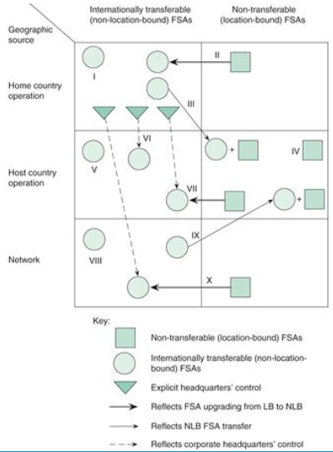
Recombination requires: entrepreneurial skills (creative and smart personnel), slack (unused) human resources (employees that have time to think, eg. Google: 20%-rule), the replacement of some resources in the initial resource bundle (with new, better resources)
10 FSA development patterns: reflects recombination capability of the firm (pattern 1: no recombination!)

5: Complementary resources of external actors
Often needed to fill ‘resource gap’
Can be obtained through “cooperative entry modes”
- International alliances (chapter 12) – very broad range of options
  - With technology providers, licensees/franchisees, local distributors, joint venture partners, …
- Cross-border mergers and acquisitions (chapter 13) (more intense, 2 becomes 1, high integration)
Will be relied upon when:
- Internal development is too costly or infeasible
- External actors are able and willing to provide the resources

6: Bounded rationality
Reflects “scarcity of mind” – managers typically face information problems when making decisions
- Information incompleteness: pieces of information may be unavailable or withheld by lower-level employees
- Information overload: limited processing capacity – may lead managers to make decisions based on heuristics (simple rules) eg. Choose alternative that is ‘good enough’ (instead of searching best option)
= human trait, happens to everyone, not only managers – eg. video search the 21 differences (Cluedo), million different options of soap types in the supermarket

7: Bounded reliability
Reflects “scarcity of effort to make good on open-ended promises” – internal and external actors do not always put into practice their expressed intentions
- Opportunistic behavior: intentionally making false promises or breaking promises (or withholding information as strategic decision information incompleteness (bounded rationality)
- Benevolent preference reversal: making a promise in good faith and breaking it without bad intentions (by accident, don’t mean to be bad)
‘Good governance’ needed to limit occurrence of bounded reliability
eg. monitoring, giving incentives (eg. performance-based payment), involve them in strategic decision making instead of just imposing them
bad examples: bounded reliability gone out of hand: Nick Leeson (Barings Bank), Wirecard
CASE 1.1 Honda
- Archetype (before producing in US): centralized exporter (produced cars in Japan + exported them to other countries)
- Main upstream (NLB) FSAs (when deciding to start producing in US): product technology (superior engine design) – more tacit knowledge, easier to transfer; process technology (sophisticated manufacturing processes) = more complex; supplier network (LB FSA) + supplier management and upgrading skills, bargaining power over domestic suppliers (largely LB FSA)
- Main downstream FSAs (when deciding to start producing in US): market knowledge (Japanese market = LB FSA), brand reputation
- Main benefits from switching from export to local production is US: tariff avoidance (competitive edge), avoiding transportation costs (rising oil prices), get rid of exchange rate risk (no risk when purchases and sales in same currency), more responsive (closer to customers) + learn more about them (preferences), benefit for US economy: greenfield investment = new firm = new jobs created (way to improve image)
- Strategic actions to successfully transfer upstream FSAs to US: transfer new Us employees to Japan to learn the manufacturing practices + send domestic Japanese experts to US plant; hired US employees that were passionate about cars + not worked for US car manufacturers (other work ethics/culture). Send team of specialists to American suppliers to help them upgrade their activities (meet Honda’s high-quality standards), only small US suppliers and suppliers of motor parts (not the big suppliers that already supply big American car manufacturers) – because they probably more open to upgrade by Honda
- LB FSAs needed to become successful in US: local supplier network, market knowledge (local preference), insight in workers in American manufacturing (used to decide: let’s not use ex-employees)
- FSA-development pattern: pattern III (add LB FSAs to its NLB FSA bundle (recombination))
Pattern III = “think global, act local!”

2: The critical role of FSAs

Prahalad & Hamel (1990): Core Competence
M-form = multi-divisional form (popular in US after WOII) – for companies active in multiple industries
each division responsible for group of products SBU (= strategic business unit) for each specific product
(firm > divisions > SBUs) vs. Core Competence-based view (clearly visible in Japan)
 | M-form | Core Competence (= CC)
SBUs are | Autonomous | Interdependent
Strategy formulation | By the SBUs = decentralized | Centralized (strategic architecture developed by HQ for firm as a whole)
HQ allocates | Financial capital (take money/profits from successful SBUs and give it to other SBUs that need it to be successful | Human capital (key employees should be rotated between SBUs – they are the competence carriers, embody the CCs)
CCs = the collective learning in the organization, especially how to coordinate diverse production skills and integrate multiple streams of technologies
= routines and recombination capabilities (learning + innovation)
= higher-order FSA (» Verbeke) need to sustain a competitive advantage in the long run
Characteristics:
- Difficult to imitate
- Give access to a wide variety of markets
- Add significant value to end products
Additional condition Verbeke: loss strongly harms the firm’s performance
CASE 2.2 IKEA
- Core competence: routine: combining all practices into a coherent business model (high quality for low cost = cost-leadership practice) + recombination: improved practices over time (learning)
- Main practices: in-house product design ( lower production cost), showroom design (circular store + open warehouse), low-cost international suppliers, plat packaging, store location (near central warehouses/distribution points lower transport costs), …
- international expansion path (Uppsala): first neighbouring countries (Scandinavia), then further away (Germanic countries, Anglo-Saxon, …) – further away = bigger distance, but still rich/well-developed
- international expansion path (FSA development pattern): first pattern 1 (copy paste Swedish business model in foreign locations), then pattern 3 (also develop LB FSAs in the foreign markets) eg. Local adaptations to the preferences (in US, China, Eastern Europe) – local knowledge = LB FSA
- forms of local adaptation: product redesign (adaptations), store adaptation, services adaptation, location of the stores, purchasing (sourcing of resources, local suppliers in remote countries)
- most adaptations at the same time: US (3) and China (4): most there, because very big markets (worldwide largest potential customer base). High potential investment in local adaptation pays off!!
IKEA: focus on mistakes to learn for the future learning culture is very important!!
death original owner: will not have effect on core competence, because by now, the culture is strong enough that his involvement is no longer an absolute requirement
eg. Dyson (British firm): innovation/design/air/motors CC = successfully combine and recombine technologies in the sphere of air circulation (+ electric motors) with design (and high quality)
- electric cars: does not make sense (too different)
- new ventilation system for Covid: developed in 10 days!! = much more related to product portfolio (core)
think carefully about applying CC to new product!!
eg. Datwyler (Swiss firm, produces seals for Nespresso cups): they define their CCs on the website
CC not just academic concept!!
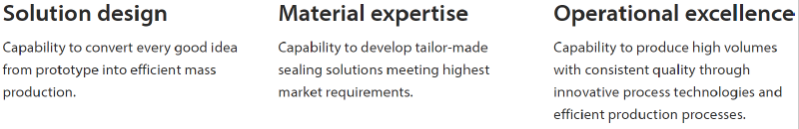

Prahalad & Hamel – complementary perspectives
US: SBU-approach vs. Japan: CC-approach
- confirmed by Egelhoff (for semi-conductor industry)
- US MNEs: focus on short-term profitability through product differentiation and frequent repositioning
- Japanese MNEs: focus on long-term performance through continuous improvement of process technology for standardized products (KAIZEN) high product quality at low cost
US approach may be more appropriate in industries characterized by fundamental technological change and the related commercial breakthroughs and early profits. In such industries, it is not the finetuning of strategy implementation through a focus on process technology that counts, but rather the correct anticipation of the future dominant industry standard, as well as rapid profit building by attracting buyers to customized niches (» Verbeke)
US firms: tend to be more agile = important in dynamic industries (Japanese careful incremental approach doesn’t work well) – important to act quickly + attract customers in early stage

Japan Inc: many Japanese firms have fallen behind in recent years; causes:
- Institutional system that stimulates lifetime employment, resulting in:
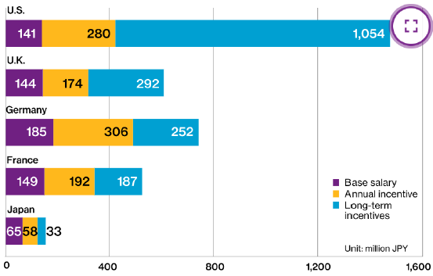
  - Limited (corporate) entrepreneurship
  - Excessive labor costs (zombie workers)
- System has become liability now that many industries have become more dynamic + international competition has intensified
- Deficiencies in corporate governance
  - Promotions based on seniority rather than quality
  - CEO pay is low and based less on performance (see figure, but over the years increase of incentives compared to base salary)
  - Uncritical board with few outside directors
- Many cross-shareholdings, preventing takeovers of poorly performing firms
Last years: boards open up to overseas executives, open up to foreign direct investors, overhaul of M&A rules, big investments possible, …

CCs in international context
CCs ≈ higher order NLB FSAs can be copy pasted to foreign countries
= international projector = pattern 1
CC = recombination capability (but transfer is only copy paste the competence without recombination)

Prahalad & Hamel: weaknesses
* Two questionable assumptions:
- Home-country LAs are irrelevant for the development of CCs
- CCs are always NLB
* The reallocation of ‘competence carriers’ may harm rather than reinforce a firm’s CCs
- it causes such carriers to become separated from their local colleagues and from local external actors
! co-location is often crucial for innovation (environment influences CC)
eg. Mahindra Aerospace: engineers in glass office in center of factory – diffuse know-how (advice/feedback)
» Complementary perspective Bartmess &Cerny
* Overlook that foreign subsidiaries may also develop CCs
* A centralized approach to the development of CCs may result in bounded rationality and reliability problems (information overload + selective information provision by SBU managers)
* Streamlining operations to develop and exploit CCs is often harmful in the case of downstream activities (because it hinders local responsiveness)

3: The nature of home-country LAs

Diamond model Porter
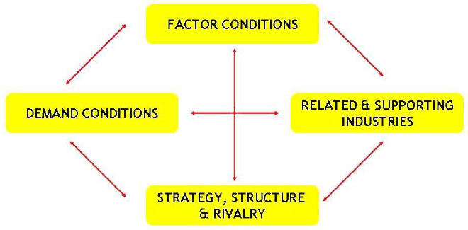
International success of an industry, based in a certain country, depends on 4 domestic conditions (individually and jointly influence how innovative firms will be – more favorable = more innovative industry + more international success)
If actors co-located in cluster contributes to innovation
eg. Silicon Valley – US tech industry (all HQ in San Francisco)

Factor conditions
The availability of production factors in a national economy
- Created production factors (have been actively developed within an economy, based on investments by the government and private parties) eg. skilled labor, knowledge, infrastructure
- Natural production factors (available without investments) eg. low-skilled labor, natural resources
!! too much can make domestic firms become lazy – if unfavorable stimulates firms to search for innovative solutions (eg. Japan: JIT because little storage capacity)
!! Especially created factors are crucial to an industry’s international competitive success (best if they are tailored to the specific industry instead of general investment)

Demand conditions
A large customer base encourages firms to be innovative cutting edge products (or business models) that are appealing to customers worldwide
eg. Aldi & Lidl: developed a low-cost business model + achieved international success with it (came up with this model because German consumers are very demanding in terms of retail prices – keen on bargains)

Strategy, structure, & rivalry
Strategies and structures are to some degree culture specific (eg. US (short-term oriented, more open to radically different ideas, less hierarchical) vs. Japanese/Korean firms)
National aspects of strategy and structure promote the success of specific national industries (eg. Japanese, Korean and German firms: substantial international success in the ‘white goods’ industry – disciplined precision manufacturing + continuous small improvements in product quality = needed in this industry)
Domestic rivalry promotes the “survival of the fittest” – pressurizes the need to innovate (Quote Uber CEO:
“It’s a really powerful thing for a company to compete. It makes you fierce about serving your customer.”)

Related and supporting industries
Domestic suppliers and domestic producers of related products
If related and supporting firms are highly competitive, their innovations will likely also benefit firms in the focal industry (eg. Through knowledge transfers)

Verbeke’s reinterpretation of the diamond model
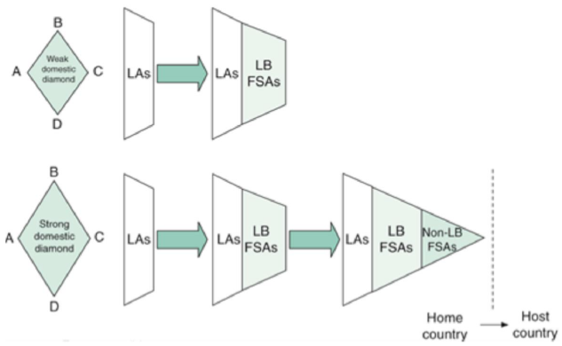
Upper: weak/unfavorable diamond conditions firms will not be able to develop NLB FSAs (which are needed to overcome the liability of foreignness for international expansion); they are able to grow domestically, but it will be hard/impossible to succeed internationally
Lower: strong/favorable diamond conditions build NLB FSAs through innovation (enabled by strong diamond conditions)
- Diamond conditions can be seen as LAs
Follows FSA development pattern II (LB FSAs become NLB FSAs through innovation)
In-class assignment: Indian IT consulting industry – international success (+ recently less)
- Diamond conditions: factor – skilled (cheap) labor (well-educated IT programmers) + decent IT infrastructure
- Diamond conditions: demand – domestic demand from the former parent firms + strong foreign demand from developed countries (western MNEs)
!! Porter: only focus on domestic markets (demand)
- Diamond conditions: related & supporting industries – Big 5 now part of enormous ecosystem
- Diamond conditions: strategy, structure & rivalry – internal rivalry between Big 5 (forces firms to innovate, to beat their rivals)
- Condition (+ therefore industry) less favorable: Western MNEs perform IT more in-house in their Indian subsidiaries no longer need to use Indian consulting firms = change in demand condition (foreign) – also because of Covid
+ technological advances decrease in need of Western MNEs to use Indian IT firms (eg. cloud services Microsoft)

Porter: key weakness
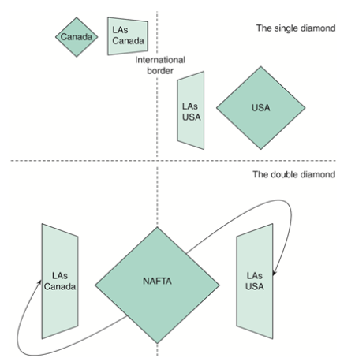
* Assumes that firms are bound to the domestic diamond conditions they face
!! reality: firms can gain access to favorable diamond
conditions in other countries – through international
expansion (FDIs) (thanks to globalized world ≈
article is outdated)
eg. Canadian exports to the Us, facilitated by NAFTA; upper figure: Canada: small diamond;
lower figure: NAFTA = leveling the playing field, creating one big diamond for US and Canada
eg. International new ventures (Kuemmerle) = born globals = entrepreneurial firms that, from their inception, seek to derive significant competitive advantage from the use of resources and the sale of outputs in multiple countries – internationally active since day 1 – tap into foreign LAs from the outset (eg. Airbnb, Logitech, …)

Prahalad & Hamel CC vs. Porter diamond model
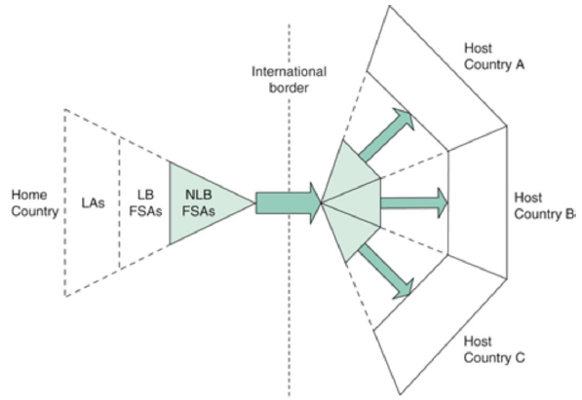
- Drivers of innovations: internal competences vs. home-country LAs (= external)
(CC does not take LAs into account = dotted lines in graph)
- FSA development pattern: I vs. II
- Level of analysis: individual firm vs. national industries
Verbeke: firm-level diamond [not the key part of chapter 3]
middle: competitive performance – 4 conditions (same as Porter) with (Local-State-National-Foreign global) and (SWOT)

4: The problem with host country LAs

Globalization
= process leading to greater interdependence and mutual awareness among economic, political, and social units in the world, and among actors in general = international connectedness
Main causes: innovations in transport and ICT (easier, cheaper, faster) + liberalization (trend in most countries, lowered barriers)

Globalization: evidence
eg. DHL Global Connectedness index (2001-2020): expected score: dip in 2020 due to Covid (lockdowns)
most connected countries: small, developed countries (more connected to their counterparts in other countries) (top 10: the Netherlands, Singapore, Belgium, United Arab Emirates, Ireland, Switzerland, Luxembourg, UK, Denmark & Malta) big countries like Us (37) and China (70) are much less connected
- World is far less globalized than many people think – most flows are domestic rather than international (!! Managers also overestimate globalization, eg. portfolio investments, …)

- Four pillars of global connectedness: trade, capital (big plunge financial crisis), information (i.e. internet), people (tourism, migration, business travel, … big dip due to Covid)
- exports: steep increase since after WOII
- FDI stocks (% of GDP) value: steep increase since 1990’s)
- changes in national investment policies: much more liberalization (76%) than restrictions/regulation (24%)
- Global supply chain: Covid-2003 in China – very small impact on world - - - Covid-19 in China: worldwide impact because China now important part of the global economy (because increase of globalization)

Globalization: consequences
Barriers are eliminated convergence of (product) preferences ≈ Flat World ≈ McDonaldization
World = global village without borders distance is not important anymore
(Multiple books: The death of distance; The world is flat (Thomas Friedman); The borderless world; The global village; the McDonaldization of Society; …)

Ghemawat
Globalization = globaloney (Why the world is not flat… yet)
At best: semi-globalization
Has consequences on firms that want to expand
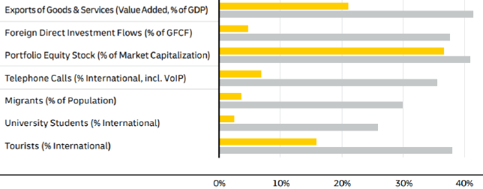
International trade (exports of goods & services), capital (FDI flows, portfolio equity stock), information (international phone calls), and people (migrants, exchange students, tourists) flow are much smaller (yellow) than managers presume them to be (grey)

- They overestimate globalization, and underestimate the difficulties of expanding abroad
(preferences are not completely converged – still large cultural (and other) differences)
! They need to look at the costs, risks, challenges, …
DISTANCE STILL MATTERS!!!

CAGE-framework

Cultural distance
Pertains to differences in social norms and preferences, religious beliefs, and language
Most relevant to branded consumer goods
Requires adaptations in branding strategy, product appearance, and product content (eg. taste)
» Complementary perspective Schmitt & Pan
Indicator of cultural distance: differences in countries’ scores on Hofstede’s dimensions of culture:
power distance (low score = strive for equal distribution of power + justification), individualism (vs. collectivism – in Asian countries), masculinity (care more about prestige, competitive more stress + suicides (eg. Japan) vs. femininity – work to live, not live to work), uncertainty avoidance (rules and procedures to avoid risks), long-term orientation (high in Asia), indulgence (free to pursue interests, follow your heart vs. laws on how to behave (social norms) often in Asian countries)
Indicator of cultural distance: Dow’s measures of religious and linguistic distance

Administrative distance
Pertains to differences in national institutions such as laws (formal), political systems, and corruption
Can be low(er) because of regional integration agreements and colonial ties (history)
Most relevant to politically sensitive industries (eg. oil & gas) – sometimes firms labelled as politically sensitive to protect the home economy against outsiders (eg. food retailer in France “important for food safety”)
Indicator of administrative distance: differences in countries’ scores on the Worldwide Governance Indicators (WGI) by the Worldbank: voice & accountability, political stability & absence of violence, government effectiveness, regulatory quality, rule of law, control of corruption

Geographic distance
Includes physical remoteness between countries
- but also sharing a border, cross-country transport, ICT infrastructure, time zones
Most relevant to: ‘low value-to-weight’ goods (eg. cement), perishable goods (eg. food, flowers), technology-intensive services (eg. customer support needed, sometimes hard over a distance)

Economic distance
Pertains to differences in economic development, such as nature and quantity of demand, purchasing power, infrastructure quality, labor force composition, ethical standards, …
Centralized exporter + international projector: prefer to minimize it (offer standardized products – easier with small distance = less differences)
International coordinator: aims to exploit the distance with arbitrage
Indicator of economic distance: differences in countries’ GDP/capita (bigger difference = bigger distance)
Indicator of economic distance: Dow’s measures of differences in industrial development and education

Verbeke’s reinterpretation
CAGE distance: makes it harder for a firm to access host-country LAs, since they:
- Diminish a firm’s stock of NLB FSAs (greater distance = weaker transferability and exploitation potential of NLB FSAs ≈ smaller NLB FSA triangles)
- Necessitate greater investments in LB FSAs (greater distance = higher investments required ≈ larger LB FSA trapezoids)
Close to home: maybe possible to transfer some NLB FSAs, further away: less able to rely on domestically developed assets
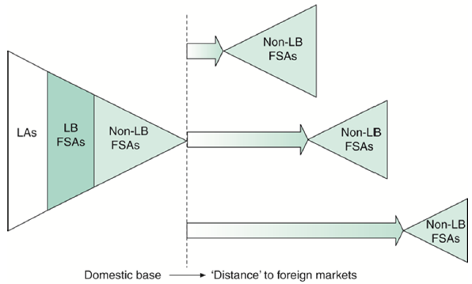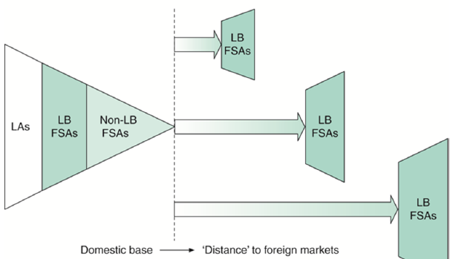

Strategic implications distance
Distance ↗ chance that firms perform poorly + exit (because less NLB FSAs to rely on, need to invest more to gain LB FSAs)
Distance firms more inclined to use cooperative entry modes – to obtain the required LB FSAs + to limit exit costs
Distance ↘ firm’s inclination to enter a country influencing their location choices – especially when they have little international experience (stick to the stuff you know)

Uppsala internationalization process model
Barkema, Bell & Pennings (1996)
Internationalizing firms tend to enter close countries first and use the experience they gain there to enter more distant countries later experience lowers the perceived risks and costs associated with distance
Within a foreign country firms tend to move from low commitment operating modes to higher commitment ones (based on what they learned from the low commitment)
- Irregular exports exports through sales agents sales subsidiary production subsidiary
- Licensing joint venture wholly-owned subsidiary
CASE 4.2 Walmart
Largest MNE (annual worldwide revenue + number of employees) – but not successful everywhere
Germany: not able to transfer FSAs (Japan, Korea, Brazil, …)
- FSAs in the US (underlying factors): (a) logistical skills & technologies, (b) bargaining power (towards suppliers) because they are a big player + size based (buy in very big quantities), (c) corporate culture: stimulate employees to offer superior service + formal policies = fostering high service standards; (brand reputation)
- Transferable to Germany: (a) barely (technology a little), (b) no/barely (maybe some products from existing international suppliers) but too small to gain power (and grow fast), (c) barely: cultural and administrative differences (it is technically transferable, but is lost its value = LB FSA)
- CAGE distance: cultural = corporate culture not transferable (different customer preferences) – also bargaining power (less straightforward, taste preferences need to source locally) – also logistic (moving for the job is not done in Germany – very normal in US)
- CAGE distance: administrative = bargaining power (zoning laws – big shops not allowed in city center)
- CAGE distance: geographic = need for local suppliers – low bargaining power
- LB FSAs needed in Germany: local market knowledge – problems because of distance:
cultural: consolidation resignation of managers with local market knowledge
geographic: UK CEO trying to run the German Walmart from London

Added psychic distance
» Complementary perspective by Hutzschenreuter, Kleindienst & Lange (2014)
CAGE distances = added psychic distance stimuli
- Added = idea that internationalizing firms add distance to their country portfolio
- psychic distance stimuli (PDS) = idea that CAGE distance indicators influence managers’ perceptions of the distance to a country
! indicators do not explain managerial perceptions of distance perfectly
eg. China is distant from Belgium according to CAGE distance indicators, but a Belgian manager with extensive work experience in China may perceive the distance to China to be small
! personal experience also important
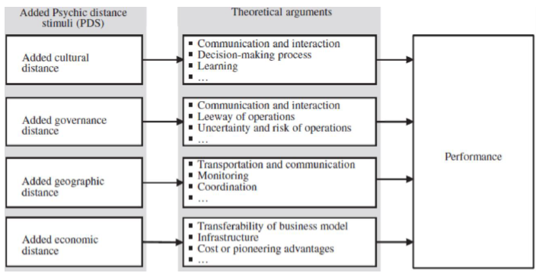

Thought-provoking questions
1: is it really the distance from the home country that determines the challenges associated with a foreign entry? (Ghemawat) – or is it the distance from the closest host country? (Hutzschenreuter et al)
eg. Belgian firm with subsidiaries through EU + China – distance to overcome when entering Vietnam?
= distance between China and Vietnam – much of knowledge required to become successful in Vietnam can be sourced from Chinese subsidiary
6 American MNEs – founded in US, but now in Canada (Burger King), UK (Coca-Cola Enterprise, Liberty Global), Ireland (Pfizer), Cayman Islands (Herbalife), the Netherlands (Mylan)
2: what is an MNEs home country? Country where it is registered? Where its head office is based? Where it was founded? Where most operations are based?
! can be very hard to determine (especially when lot of mergers/acquisitions/…) – no clear connect to 1 specific country
- the stateless MNE (no clear home country)

5: Combining FSAs and LAs in a multinational network

Bartlett & Ghoshal’s typology of MNEs (Harzing, 2000)
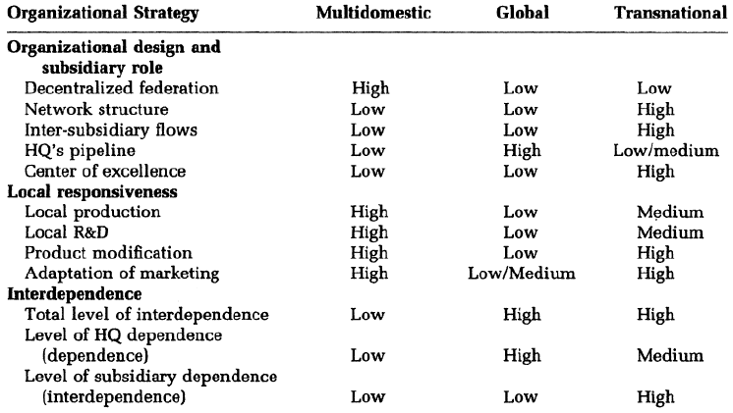
(Decentralized federation = subsidiaries are autonomous)
(Pipelines = just sell what HQ gives you ≈ sales outlet) (Centre of excellence = good in 1 specific thing)
Multidomestic = combing low integration with high responsiveness
Relatively high percentage of autonomous subsidiaries
Global = combining high integration with low responsiveness
Many subsidiaries are receptive
Transnational = combining high integration with high responsiveness
Active subsidiaries are most likely

Multi-centered MNE = multidomestic MNE (exactly same according to prof)
Develop LB FSAs abroad – to be locally responsive Only transfer key routines – only financial control

Centralized exporter = global MNE (high level of similarity)
Pipelines of HQ, HQ decides on everything low local responsiveness

International projector ≠global MNE (on some factors)
Create facility in every country (clone domestic operations) = local production/R&D (NOT in global MNE)

International coordinator ≈ transnational MNE
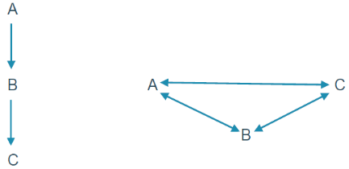
Unique features: high subsidiary interdependence + high inter-subsidiary flows
(with specialist subsidiaries = center of excellence)
Differences:
- I.C. = mainly economies of scale – no local responsiveness (transnational has a bit of local adaptation)
- network structures: transnational (previous page - right) = high, more complex, real network vs. I.C. (left) = not really network, vertical value chain

Subsidiary roles
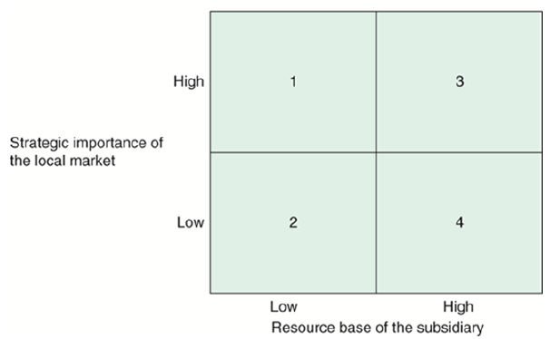
Model by Bartlett & Ghoshal (1986): 4 possible roles for individual foreign subsidiaries
Role depends on: A) level of strategic importance of the local market (LAs, eg. knowledge spillovers from clusters)
B) resource base of the subsidiary (do they have FSAs? Share if they are NLB!)
A) plays key role in long-term competitiveness
1 = black hole: located in a strategically important market, but low resource base
- often used to monitor local technological developments, market trends, and competitors
- eg. US carmakers’ Japanese subsidiaries (they have a bad image in Japan)
- undesirable status, which should be upgraded through additional investments and/or strategic alliances
2 = implementer: located in a strategically unimportant market and low resource base = most common role
- performed by subsidiaries that are sales pipelines or manufacturing clones (mega factories)
- important role: without implementers, MNEs cannot generate economies of scale and scope (and thus no above-average profits)
- eg. many subsidiaries in smaller economies, Xerox’s JV with Fuji (HQ’s perception – see ch1)
3 = strategic leader: located in a strategically important market and high resource base
- often developed through FSA development pattern VI (HQ based in home country gives permission to subsidiary in host country to develop NLB FSAs)
- eg. Xerox’s JV with Fuji (actually), ING Spain (developed model for standardizing processes in European online banks – developed in Madrid, for Czech, Austria, France & Italy)
4 = contributor: located in a strategically unimportant market, but high resource base
- often developed through FSA development pattern V (develop FSAs more independently in host country + can be later recognized by HQ + spread to other subsidiaries)
- eg. Geely Sweden (acquired Volvo), Haagen-Dazs Argentina
3 & 4: centers of excellence – sources of FSAs for other units
Multidomestic & global MNE: all subsidiaries have the same role
Transnational MNE: every subsidiary has a different role – based on what they are good at
Use model to give every subsidiary a role + create network

Integration-responsiveness framework
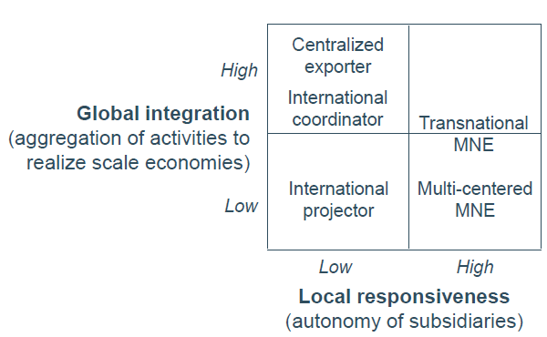
C.E. = global multi-centered = multidomestic
Global vs. I.C.: main difference: degree of integration /coordination/internationalization of value chain (global = most activities at home vs. I.C. = activities more spread)
Transnational: tries to be upper right, but most of the time somewhere in the middle (medium integration) – some economies of scale, but they don’t try to maximize it
I.P.: just replication, no integration + same products everywhere

Two common strategies for MNE management
UN model: all foreign subsidiaries are treated alike
- multi-centered MNEs: all subsidiaries are stand-alone units
- C.E. & I.P.: all subsidiaries are dependent on HQ
HQ hierarchy syndrome: subsidiaries are subordinate and supposed to focus on their own localities
Advice Bartlett & Ghoshal: assign differentiated roles to subsidiaries (see model)

Verbeke’s reinterpretation
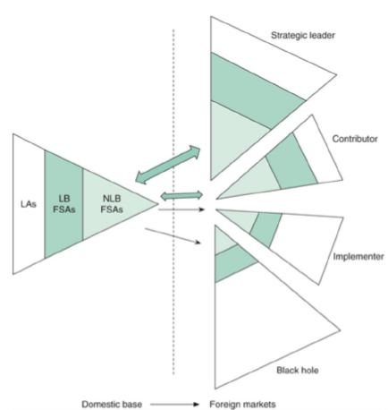
Large triangle = high LA (important market)
Strong FSAs = double arrow (exchange)

Limitations according to Verbeke
No distinction between upstream and downstream activities
(appelen en peren vergelijken)
eg. Honda case:
production + sales (range of activities)
- US subsidiary different roles (both good resources FSAs)
Upstream: contributor (US car industry not important for input) (figure A)
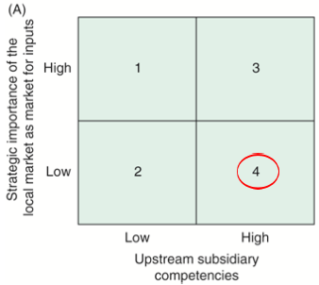
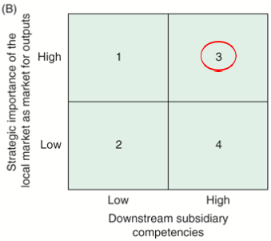
Downstream: strategic leader (important market – largest car market in the world)
(figure B)
CASE 5.1 Nestlé
- Initially: multi-centered/multidomestic MNE
- New type: transnational MNE (features: started integration, both upstream and downstream; still locally responsive; change in structure to network structure)
- Subsidiary roles: Purina PetCare US = strategic leader – Germany = implementer (or black hole – because objectively important market)
- Difference Nestlé & theoretical model: upstream/downstream distinction; top management decides on roles with model – Nestlé: clusters to enable knowledge sharing (structure for FSA transfer)
eg. Unilever: multidomestic (variety and risk spreading) transnational (balancing GI/LR) neo-global (maximizing efficiency) ≈ international coordinator (highly specialist units with single activity in global value chain) (see slides 23-24 from 11/03/2021)

12: Entry mode dynamics: Strategic alliance partners
Longer term international arrangements between 2 or more organizations that have agreed to pool some of their resources to accomplish certain goals while remaining at least partially independent
- Equity alliances (= mutual share ownership)
  - Equity JVs (= set up new legal equity, with co-ownership; eg TNK-BP, SAIC-GM)
  - Cross-shareholdings (= no new business created, just buy shares from each other; eg Nissan-Renault-Mitsubishi + Japanese government and French state) (common in Japan)
- Purely contractual alliances (= no ownership, just a contract; eg Google-Samsung)
Often fail because of conflicts
Interconnected ownership (like cross-shareholding): often complex network, prone to conflicts
Types of contractual alliances (long term agreements): lot of options throughout whole value chain (eg outsourcing, contract R&D/design/manufacturing/logistics, (in/out)licensing, franchising, …)

Hamel et al. (1989)
Focus: alliances between international rivals should be seen as learning race (= learn from your rival as fast as possible, and let your rival learn as little as possible from you)
Alliances between Western and Asian rivals: learning race often won by Asian firms
- Because Asian firms: often bring tacit routines that are hard to copy (hard to copy knowledge)
- Because western firms: generally bring in stand-alone, codifies FSAs that are easy to appropriate
- eg: Asian original equipment manufacturers (OEMs)
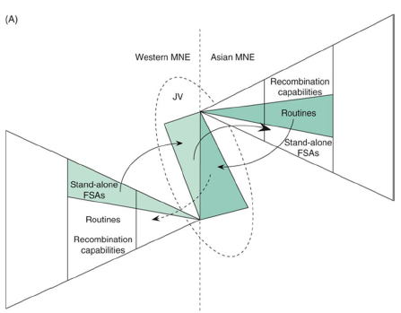
Figure: thin arrows (pointing to JV) = Western MNE contributes FSAs, Asian gives routines; thick arrow to right and dotted arrow = more of the JV’s contribution to knowledge can be captured by Asian compared to Western
Second figure: LB and NLB FSAs of Asian MNE have grown due to absorption of its partner’s stand-alone FSAs, while Western stand-alone FSAs have shrunk in relative terms due to dissipation of knowledge base to Asian MNE
End result = Western firm more dependent on fully skilled partner (≈ bounded reliability)
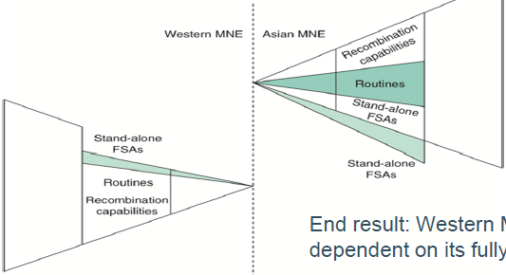
Current relevance learning race: restrictions in China to force strong companies in JVs to strengthen the Chinese companies (become self-sufficient and be competitive)

Caveat in learning race model Hamel et al.
Alliance partners do not always want to absorb each other’s FSAs
- sometimes just want to bundle = cooperative specialization (to create new, innovative things)
eg Run-DMC ft. Aerosmith, Valeant – Walgreens (deal to sell some of their medicines through the Walgreens pharmacies), Ben & Jerry’s – Netflix

Anderson & Jap (2005)
Focus: alliances in general
Besides asymmetrical learning, asymmetrical alliance-specific investments dependence
dependence bounded reliability inter-partner conflicts!
eg manufacturer-distributor relationship where 1 of partners needs to make a highly specific investment
Safeguards to avoid dependence, bounded reliability (opportunistic behaviour), and conflicts (= dark side):
- swapping hostages – symmetrical alliance-specific investments
- attention to (and investment in) alternative partners
- regular re-evaluation of the alliance relationship
- continued focus on profitability rather than volume
- setting and reassessing common goals
- avoid vicious cycles of suspicion and the resulting build-up of bounded reliability

Kale & Anand (2006)
Focus: equity JV between market-seeking MNEs and local firms in emerging economies
- often happens when wholly-owned-subsidiary (WOS) are legally prohibited
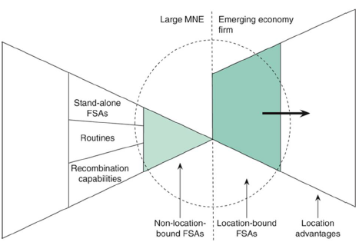
Partner contribution:
* MNE: NLB FSAs such as technology, management skills, financial capital
* local firm: LB FSAs such as governmental ties, market knowledge, distribution channels, local brands
Figure: dotted circle = JV; alliance can profit from the combined FSA bundles, and they allow accessing and benefiting from the much sought after LAs in the host country (bold arrow)
Figure next page: move from 2 to 1 when learned enough
In-class assignment: Starbucks – Tata Joint Venture
- insights Kale & Anand (2006) on international JVs in India (similarities): Starbucks NLB FSAs (toasting techniques, brand name) combined with Tata LB FSAs (market knowledge, local coffee beans + roasting, distribution chains, good locations) and LAs from India (big market for coffee, many customers); regulations: Starbucks couldn’t enter on its own – foreign ownership; privately owned partner: good idea, enables MNE to learn from the partner in the short run (relationship harder with state-owned)
- ways in which Starbucks-Tata JV fared differently from article (differences): K&A: MNE turns JV into WOS when they learned enough (vs. S&T: Tata is still valuable partner), which is possible now, because restrictions are less strict; K&A: conflicts/learning race dissolvement of JV (vs. S&T: not treated as learning race, strong trust foundation (evident from sharing of roasting secrets) = opposite of learning race view!)
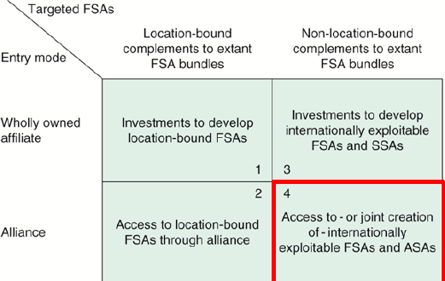
SSA = subsidiary specific advantage
ASA = alliance specific advantage
Cell 4: alliances involving only NLB FSAs – ideal outcome = learn from each other + create new FSAs
new FSAs can be special, from the specific alliance (ASAs) = NLB FSA but deeply embedded in the alliance, it is not just for 1 firm members can use it (exploit globally), but only within alliance
eg SkyTeam, Fuji-Xerox (1962-2019): developed special innovative capability (multiple employees in both companies mutual dependence reduces incentive to leave the alliance => stable relationship)
Cell 3: develop new FSAs on their own, through subsidiaries ~ centre of excellence (SSAs)
Alliances involving only NLB FSAs: both foreign MNE and emerging economy MNE contribute NLB FSAs to the alliance in the emerging economy as equal partners possible new NLB FSAs by learning (absorption existing knowledge of partner + new knowledge creation from alliance activity (red circle))
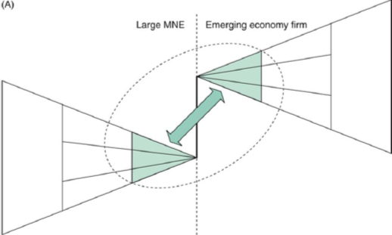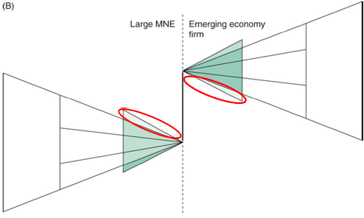
CASE 12.1 Danone & Wahaha
- Wahaha: needed money (financial resources), technological insights (and managerial techniques)
- Danone: needed market knowledge, managerial resources (they didn’t have managers who wanted to move to China W managed the JVs), brand reputation (W-brands well known in China), ties to local government officials (and possibly distribution channels, not in this case text)
- Learning asymmetry: D was too passive, did not learn from W; W did learn, not really from D, more independently from managing the JVs by themselves
- Change in bargaining power: W became stronger, they learned + got support from Chinese government didn’t need money from D anymore
In beginning: power more equally spread, mutual dependence (I need money, you need knowledge); D still dependent on W after several years, but W less dependent (used money to grow)
- other entry modes: greenfield investment: no, they lacked market knowledge (tried & failed earlier); full acquisition: government wouldn’t allow that (W/brands from W partly state-owned)
Uppsala model: when little knowledge – best low commitment mode
- what should D do differently: should have been more involved (to learn + monitor) – looked at is as portfolio investment not good to learn! + contract needs to be clear

13: Entry mode dynamics: Mergers and acquisitions
acquisition: firm A buys firm B, either fully or partly (eg AB Inbev (BE) SABMiller (GB) – second biggest M&A ever!!, Bayer (DE) Monsanto (US))
merger: firms A and B merge into a new entity C, much less common, are sometimes disguised acquisitions (firms not equal size, clear dominant firm) (eg Peugeot-Fiat Chrysler, Air France – KLM)
Largest cross-border M&As: Vodafone AirTouch PLC (GB) + Mannesmann AG (DE) – more than $200 billion, Royal Dutch Petroleum Co (NL) + shell Transport & Trading Co (GB)
2 common beliefs among top executives have made cross-border M&As very popular:
- globalization causes consolidation within industries, forcing firms to undertake M&As in order to survive (to avoid being acquired themselves or going bankrupt)
- M&As yield synergies and this create value

Ghemawat & Ghadar (2000)
They argue that those beliefs are often incorrect!!
- In many industries: consolidation levels have not increased over time
- A) many M&As do not have synergy potential because they are the result of management biases: top line obsession (empire building, focus on size), stock price exploitation, grooved thinking, herd behaviour (imitation) M&A waves, personal commitments, trust in interested parties
B) when M&As do have synergy potential – potential often not realized due to integration problems; in M: problems in melding (combining) partners’ routines and recombination capabilities (R&R.C.s)
in A: imposition of an acquirer’s R&R.C.s on the required firms – causing latter to lose its own R&R.C.s
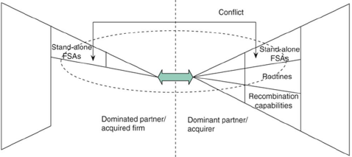
End result 2a (management biases) and 2b (integration problems) = >50% of all cross-border M&As fail (most destroy share-holder value instead of creating it)
Figure: frequent outcome acquisition integrations (FSAs from acquired firm shrink to accommodate the R&R.C.s from the acquirer (dominant firm))

Options for potential acquirers
* Grant autonomy to the acquired firm to maintain its R&R.C.s = especially important if acquisition is driven by strategic resource seeking motive (eg Geely Volvo in Sweden)
* Learn how to integrate acquired firms – by developing a recombination capability in this area (post-acquisition integration) (eg Cisco, CEMEX)
* Don’t do it!! – just choose a different strategy
↘ 7 alternative strategies (by Ghemawat & Ghadar):
pick up the scraps (spin-offs and divestments of mega M&As of other firms), stay home (improve locally), keep your eye on the ball (improve competitive position by developing and exploiting key FSAs), make friends (strategic alliances, see below), appeal to the referee (slow mega M&As of others by calling on regulators to review antitrust implications), stalk your target (first see if others are successful when no/little first-mover advantage), sell out (if consolidation is economically justified)
- strategic alliances: (often less internal resistance) preferred over M&As when:
  - Some of the target’s resources are not needed
  - These ‘unwanted’ resources are difficult to dispose of (eg. outdated technology/machines, …)
  - M/A would upset the target’s employees and thus cause huge integration challenges
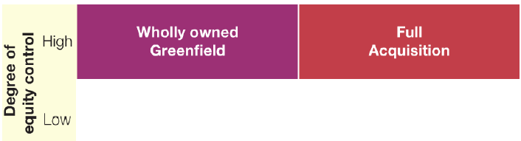
  - M/A is politically sensitive
- missing option: greenfield investment
FDI-based expansion modes
In-class assignment: strategy consultant for internationalizing firm – greenfield investment (GI) or acquisition (A) of WOS Strategic factors to base decision on:
- GI: need to bring all required FSAs yourself (need for complementary FSAs) – especially important for multi-centered MNE: want local knowledge (LB FSAs) to make local adaptations possible = A preferred over GI
- available time (need for speed): GI may take years to complete vs. A = quicker entry into market possible – important if market grows quickly to ensure market share
- amount of concentration in the market: GI = new player in the market = additional competition possible price wars (additional supply/capacity)
- strong recombination capabilities (core competence) – not explained by prof
- autonomy you plan to give to foreign subsidiary (needs to be high when A) + chance of cultural clash between yourself & potential acquisition (post-integration challenges)
- legal constraints: GI sometimes not allowed/blocked by local authorities
- importance of copying NLB FSAs abroad - can be hard to achieve with A (because changes needed for integration, eg. to structure)
- sentimental barriers: public/politicians don’t agree to A (want to protect their ‘crown jewels’)
- government incentives for GI (eg subsidies, cheaper loans, …) because GIs create jobs in the country
- availability suitable take-over targets that meet your requirements/quality needs

14: The role of emerging economies
20 largest recipients of FDI: US, China*, Hong Kong*, Singapore*, Netherlands, UK, Brazil*, Australia, Spain, India*, Canada, France, Mexico*, Germany, Italy, Indonesia*, Israel, Vietnam*, Korea*, Russia*
(* = developing and transition economies)

Emerging economies
4 strategic motivations for FDI in emerging economy: efficiency (eg low labor cost), natural resource (some upcoming economies are rich in naturel resources, eg Brazil, Indonesia), strategic resource (frugal innovations (= geared to consumers with low(er) purchasing power) + learn about them), and market seeking (countries with big population, eg China, India)
Traditional definition: relatively poor countries that exhibit rapid economic growth and pro-market reform (= institutional changes)
!! criteria don’t always apply (eg Russia: not really growing – South Korea: not really poor – China: not much institutional improvement)

Khanna et al. (2005)
Emerging economies = countries with institutional voids (= unfavorable)
- countries where specialized intermediaries (eg interim bureaus) are absent or substandard + pro-market institutions underdeveloped
- location disadvantages
Foreign MNE: should uncover these voids + give priority to them in selecting a foreign investment location (rather than focus only on size and growth rate of a market) AVOID VOIDS!!
Identify voids: MNE executives should analyze 5 areas of a country’s institutional context – not all countries have voids in the same areas
1: political and social context: are there many ‘checks & balances’ within the country, such as democratic governance, rule of law, NGOs, independent media, and trust among citizens? (Richer country more trust (high positive correlation!), most emerging economies less trust, some exceptions like China (due to communism?))
eg China: many voids vs. India: small voids
2: openness of the economy: how open is it to FDI, people, and products?
eg North Korea: closed vs. South Korea: small void
3: product markets: how well developed is the market for the MNE’s products, both technologically and legally (eg IP protection), and what is the quality and quantity of suppliers, logistics providers, retail chains, and market research firms? How feasible to start selling?
eg China: IP protection mediocre, large retail chains vs. India: good IP protection, few retail chains
4: labor market: how well developed is the schooling and hiring system, notably the quality of education, and the quality and quantity of educational rating agencies and recruiting agencies?
eg India: excels in technical schooling vs. Vietnam: underdeveloped
5: capital market: what is the quality of banking services, investor protection, accounting standards, bankruptcy proceedings, and credit rating agencies?
eg Brazil: pretty well developed vs. Indonesia: far less developed (large voids)
3 options after identifying voids:
- adapt the business model while retaining its core to adjust to existing voids – especially marketing adaptation (Arnold & Quelch, 1998) ≠ selling stripped-down version of products (Letelier et al., 2003) eg. Dell in China (same products, but sold in different way: not directly via internet but through local intermediates (independent, physical distributors) with high trust from Chinese consumers)
eg. IKEA: strong business model but certain adaptations (developed LB FSAs to address certain institutional voids in emerging economies)
- change the institutional context – only possible for large (powerful) MNEs!!
eg. Suzuki: entered India through JV with Maruti upgraded local supplies to reduce the void
- stay away – when the required investments in LB FSAs are too high, the voids too extensive
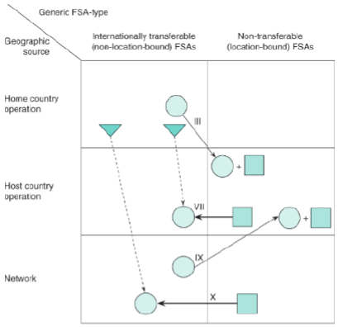
eg. Home Depot
first option (adaptation) = combining extant NLB FSAs with new LB FSAs = pattern III & IX (IX = III but NLB FSAs origin from existing foreign subsidiaries instead of home country)
the new LB FSAs may be upgraded into NLB ones and shared across emerging economies = pattern VII & X (VII: FSAs developed in 1 EE, X: FSAs developed in group of EEs)
eg. Unilever’s Indian subsidiary: early entrant in EE, transferred NLB FSAs from the UK & Netherlands to India + adjusted business model to EE conditions (India: poor infrastructure) invested in LB FSAs: came up with new distribution approach: hired women from rural villages as sales agents + adapted products to local circumstances (poor people whole bottle too expensive sell single-use portions (for special occasions, …). Later: transferred that LB FSA (local knowledge, how to reach rural/poor customers) to other EEs (hygiene is important everywhere)
first 2 options: often amount to ‘filling’ the institutional voids: either
- internally (adapting the business model such that ‘missing’ intermediary functions are introduced – perform tasks themselves)
- externally (by changing the institutional context)
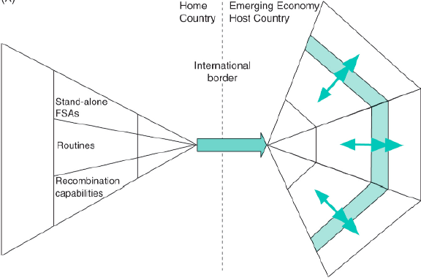
eg. firms that filled institutional voids: GM in China, L’Oréal in India, Tata motors in India (home-country firm that filled the void!!)
Institutional spill-over effect: by filling voids, the conditions in EEs may increase
Visualization: LAs in EEs increase (green/blue line), the conditions get better, the voids get smaller can attract new investors (cycle)
In-class assignment: Facebook in Asia Pacific
- voids in pol & soc context (restrictions on free speech), product markets (lack of internet access for consumers + income: mostly from selling digital ads = not well-developed in EEs)
- reaction option to pol & soc void: stayed away from China; tried to change the context (very tentatively) ≈ not always given in to censoring requests + pushed back (resisted the pressure of the government)
- reaction option to product market void: internet access - changed the context = invested in IT infrastructure; income ads – changed the business model = new service: payment services
(adapted the product portfolio to avoid the digital ads voids)

15: Emerging economy MNE
Countries in the Fortune Global 500: US (121), China (119), Japan (52), France (31), Germany (29), UK (17), South Korea (16), Switzerland (14), Canada (13), Netherlands (11), Taiwan (10), Spain (9), Brazil (8), Australia (7), India, Italy (6), Ireland (4), Russia, Mexico, Singapore (3), Saudi-Arabia (2), Austria (1), Belgium, Denmark, Finland, Indonesia, Luxembourg, Malaysia, Norway, Poland, Sweden, Thailand, Turkey, UAE
(> 50% from G7 – 165 from E20)
Largest non-financial EMNEs
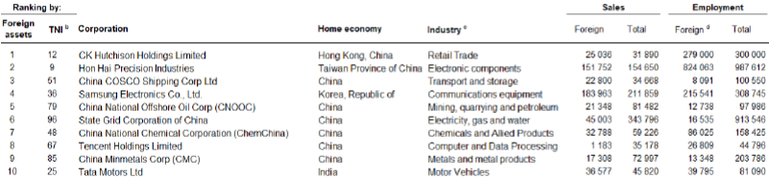
20th place: Hyundai Motor Company

Ghemawat & Hout (2008)
Many EMNEs: initially specialized in low-cost, large-scale manufacturing in home country
- often acting as original equipment manufacturers (OEMs ≈ contract manufacturers) for developed-economy MNEs (DMNEs)
but gradually becoming full-fledged MNEs – in part because their home markets have been invaded by DMNEs with FSAs in product technology and marketing (so they need to become competitive)
When DMNEs enter EMNE’s home country, the EMNE has 4 possible strategic responses:
- continue to specialize in domestic manufacturing (eg. Intran: manufacturing in Mexico)
- expand manufacturing activities to lower-cost countries in response to rising labor costs (eg. Foxconn (assembles products for Apple = Hon Hai in list above), Pegatron: from Taiwan, production in China too expensive – move to Indonesia + Vietnam)
- gain FSAs in product development & marketing = ‘upgrading’; often only feasible through international alliances or M&A (eg. Samsung, Geely, Haier, Huawei) + start offering ‘good-enough’ products (good enough quality for lower price)
- specialize in narrow segments of the value chain + develop the FSAs required for success in these segments (eg. Bharti Airtel (Indian telecom firm): focused on developing FSAs in customer care + government relations)
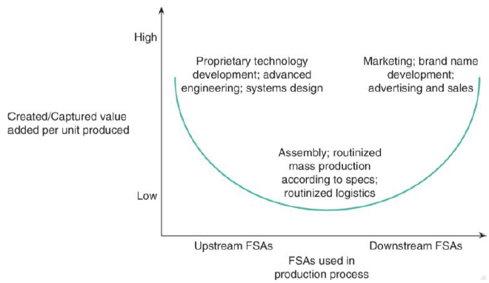
figure: FSA upgrading by EMNEs – lot of EMNEs start at the bottom of the smiley curve (in the middle) – over time upgrade upstream and/or downstream (whether they can really capture the added value of upgrading depends on their bargaining power towards customers?)

top 15 R&D investors among top 100 MNEs from developing and transition economies – invested most aggressively in developing upstream FSAs (first 4 = tech industry; most from China): Huawei, …, Samsung Electronics Co Ltd, Tencent Holding Ltd, China Mobile Ltd, …, Lenovo Group Ltd

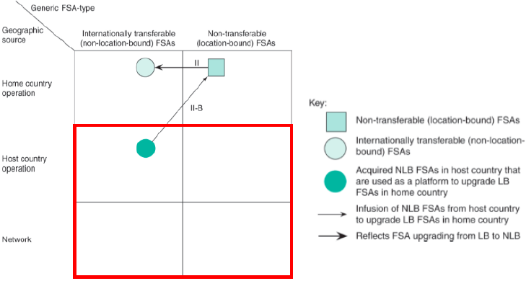
(EMNEs often lack skills necessary to develop FSAs through other patterns)

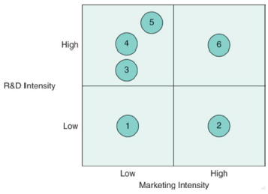

Tsai & Eisingerich (2010)
Types of EMNEs in the international arena (marketing = downstream FSAs; R&D = upstream)
1: regional exporters/importers – sell in and source from nearby EEs (eg. Hanwha, Hyosung – South Korea)
2: global exporters/importers – specialize in global supply chain management (eg. Li & Fung – Hong Kong)
3: technology fast followers – OEMs or original design manufacturers (ODMs) (eg. Foxcon – Taiwan, Hyundai Mobis – South Korea)
4: technology leaders – highly-advanced OEMs (eg. TSMC – Taiwan, Hynix – South Korea)
5: global market niche player – sell their own high-tech products in niche markets (eg. Asus – Taiwan)
6: multinational challengers – directly compete with DMNEs (eg. Samsung, Alibaba, Tencent)
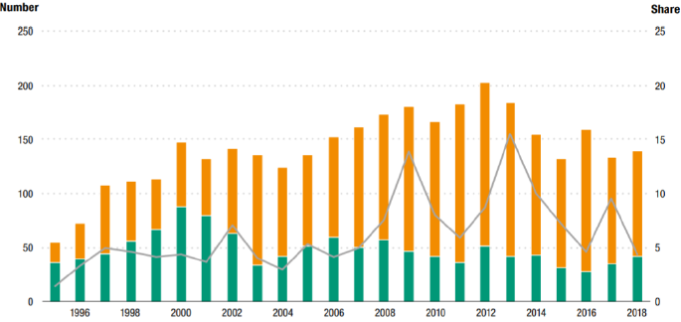
EMNEs: often state-owned (>50% of SO-MNEs are from EEs; first 6 on the list of top publicly traded state-owned firms, 7 = Volkswagen; 20 of 25 from EE)
Figure: cross-border acquisitions by majority-owned SO-MNEs, number and share of total value by home region (1995-2018) – green = developed economies – orange = developing and transition economies – curve = combined share of value of total cross-border deals
Worldwide: concerns among western policy makers about (SO) EMNEs
- fear of one-way technology flow
- backlash over deals for corporate jewels
- fear about loss of engineering knowhow and expertise
- move to protect interests against predatory China (screening as alert mechanism for foreign investments)
- more US scrutiny of Chinese deals in food sector (food safety)
- US panel calls for ban on acquisitions by China state firms
- more scrutiny on Chinese and other foreign investments
-…

Cuervo-Cazurra (2018)
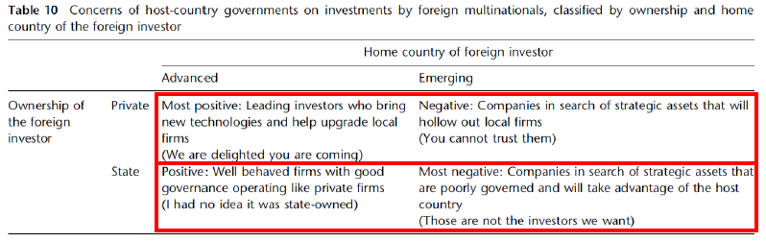
Host-country governments usually more negative about inward FDI from EEs
Host-country governments often even more negative about inward FDI from EEs when investing firm is SO
Table: economic, political, and psychological approach to host-country government concerns on investments and their policy response (exclude, monitor, control)

Guest lecture
Corporate location & fdi
In theory, practice and theory align. In practice, they don’t.

FDI – state & trends
Nike, Apple (US company, production in China), Hyundai, Corona (Mexican beer, bought by Stella Artois), NMBS (Bombardier: Canadian company, produces in Bruges) FDI in lot of daily uses
Graphs: Mature economies (western Europe) suffered more than Eastern Europe -- not always true
European job creation by foreign companies R&D (more west), manufacturing (almost same), and logistics & distribution (more west)

Corporate location: Why
Why companies engage in FDI: OLI – paradigm (Dunning)
Theory: Market seeking, natural resource seeking, efficiencies seeking, strategic resource seeking
Actually: making money (because our sources now might dry up, because shareholders need us to grow, they breath down our neck) FOLLOW THE MONEY

Corporate location: How
How companies locate
Perception influencers (dialogue with industry, business travel, articles, investment agency, online sources, word of mouth, rankings/surveys, personal travel, social media)
↘ class: follow your friends is not always a good idea (speaker: what seems a proven location will not go wrong) make it work, no matter the circumstances
!! sometimes you need to make dangerous decisions
!be innovative in your location strategy (don’t always follow the masses)
Who assists? Perception (site selection consultant, real estate broker, other, lawyer, in-house site selection team – they don’t always have the experience or skills to do the job) vs. reality (in-house teams, site selection consultant, others, real estate broker, lawyer, accountant)
The structured process: looks like throwing darts at a map, but really it is structured:
Frame – screen – assess – due diligence – negotiate – implement (from big cluster to 1 single element)
(timeline fits into bigger picture (2-5): ready product/service concept – engineering/layout – site search – contracting – construction – testing – start operations)
In reality: often like Vikings (first two steps or so (initial homework) and then immediately go to implementation (okay, now just do it!) – they will adapt when necessary) = Viking strategy (Scandinavian companies often do this)
Link with Uppsala model: just enter market and gain experimental knowledge – get your feed wet, learn by doing, …
e.g. US: abundance of data – site selection harder because much information – EU less risk averted – can do attitude – way and where they search is different
The bigger picture & timing considerations: months till actual start of operations (greenfield investments – all start from scratch)
Factors impacting timing = very company specific: size, ecological impacts (e.g. airbags company – safety, you don’t want such plant next to a residential area), technology, location, experience/blue prints, …, nature, company culture, search area
M&A is faster than greenfield investment (faster money, I want, I buy – greenfield takes much longer) but also look at integration time
PMI: post-merger integration (takes a long time)
Long term sustainable revenue: not always faster through M&A because long time needed afterwards
Location criteria are: company specific, country specific, technology specific, project specific, all of these
and the answer is: Uncle Ben’s: finding a wet land
Mars: we want female labor (males are to strong handed, not delicate enough)
Whiskas: we want potable water
project specific – but all made by same company

Corporate location: Times of turmoil
Situation: everyone has problems (we all think we have it the worst) – what is bugging you at night?
we don’t care what you do, you just have to be respectful for humankind
a lot of things create turmoil
Location & FDI implications: hold-hold-hold! (Put investments on hold, we will survive this), de-risking, reduced war chests, cost-cutting, resilience/growth for some
Pandemic-triggered re-shoring (many predicted this to happen – lot of hype around it)
Nearshoring – not reshoring; acceleration of existing at best; work not jobs; faulty ecosystems; long-term
Reshoring: works not always – not possible to go back to the way it was (most masks made in China, because they have all the knowledge/materials/… - no one here will do it for that price under such circumstances)

FDI attraction

Playing field
The landscape: what do governments (or public administration) do to attract foreign investments?
Very fast, competitive, powerful business - number of IPAs (investment promotion agency) x10 in 20 years
FDI promotion - core tasks: investment attraction, image building, aftercare, investment climate improvement
! also: outward investment promotion, export promotion, incentives administration, SEZ/IP administration

What really matters
Investment promotors: human factor important (network, trust, …)
Take-aways:
- theory is essential to grasp the practice
- FDI impacts your daily life in many, many ways
- The OI-paradigm is ultimately explained by the quest for money/corporate sustainability
- ±50% of location decisions are made by in-house teams, not always through a structured approach
- Company & project factors determine location drivers + eventual set of location criteria
- Timing through project implementation is determined by many factors, can range from 6 months to 6 years
- Current times of turmoil (will) importantly impact FDI, but business will find ways to deal with new realities
- FDI attraction is dauting task, and in the end a people’s business

Triad regions = 3 regions in the world = North America, EU, Asia Pacific
eg. Free trade for firms within EU
eg. Belgium vs. Netherlands: B>N on power distance, masculinity, uncertainty avoidance, and long-term orientation; N>B on individualism and indulgence Belgium and the Netherlands share a border but still big differences!!

