Les 1. Service marketing

1. WHAT SERVICE IS & IS NOT
2 models to define services
IHIP model
= classification of products vs service
- Intangibility
  - Physically
= services not heard, seen, tasted,… before purchase
  - Mentally
= hard to define x not easy to understand
- Heterogeneity
  - Unique products x processes: services ~ who, when, where & how delivery of service
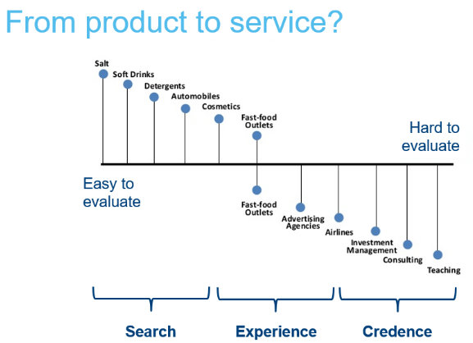
- Inseparability
  - Simultaneous production x consumption
- Perishability
  - Services cannot be stored for later use

Credence: almost impossible to evaluate what a good teacher is

IHIP model outdated?
- Tangible change might be the goal of a service (haircut), easy to imagine
- Strong customer heterogeneity, but technology * standardized services (standardized processes)
- Can be separated!
e.g. Car repair, internet banking,…
- Not always perishable (recording a lecture)

Service marketing mix
= 4 traditional P’s + 3 service-specific P’s
! Traditional mm = little customization
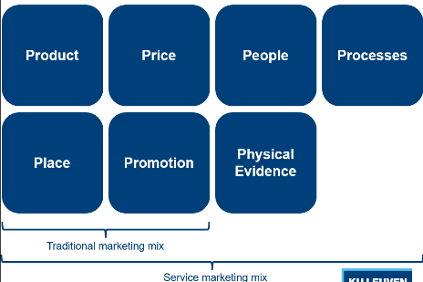
Physical evidence: vb. Problems attributes (beamer)

! If basic views on marketing no long valid?
Take marketing service as business logic & use services to get advantages

Traditional Goods-Dominant Logic (GDL)
- Goal of economic activities
= create x distribute output
- Goods enriched with value during manufacturing process (embedded value)
- Profit max by producing x distributing efficiently (value-in-exchange)
e.g. standardization,…
- Increase of value by * add-ons
(because else product loses value over time)
Problems with a GDL
- Goods NOT reason we buy them, need is!
- Customer = passive recipient of value
- Organizations don’t own products, only possess knowledge/skills to produce

Transitioning to a Service-Dominant Logic (SDL)
- Service
= application of competences for someone/something else
- Knowledge x skills embedded in use of goods
(i.e. value-in-use, weinig gebruik, weinig value)
Organizations serve as value facilitators
- Consumer resources need to be integrated with organisation’s resources
(cocreation of value)
  - Operand resources: physical x natural goods
  - Operant resources: knowledge x skills
= most important for services

SDL’s foundational premises
- Service
= fundamental basis of exchange
  - People exchange to acquire benefits of specialized competences/services (operant resources)
- Indirect exchange (standardized skills) masks basis of exchange
(skills-for-skills/ services-for-services)
- Goods
= distribution mechanisms for service provision
  - tangible products as embodied knowledge/ activities
- Operant resources
= fundamental source of strategic benefit
= 1st customers often competitors who want to copy
- All economies = service economies (exchanging operant resources)
- Value is cocreated by multiple actors, incl beneficiary (customer creates value)
- Actors cannot deliver value but can participate in creation x offering of value propositions
= Enterprise can only make value propositions
- Service-centered view inherently beneficiary oriented x relational
  - E.g. teacher starting point: students
- All social x eco actors are resource integrators
- Value always uniquely x phenomenologically determined by beneficiary
- Value cocreation coordinated through actorgenerated institutions/ institutional arrangements

Times are changing
- Focus shifting away from tangibles
x toward intangibles (E.g. Skills, information x knowledge)
- Toward interactivity x connectivity x ongoing relationships
- From producer to consumer
- From thing exchanged to process of exchange
SCD logic has potential to replace traditional goods-centered paradigm.

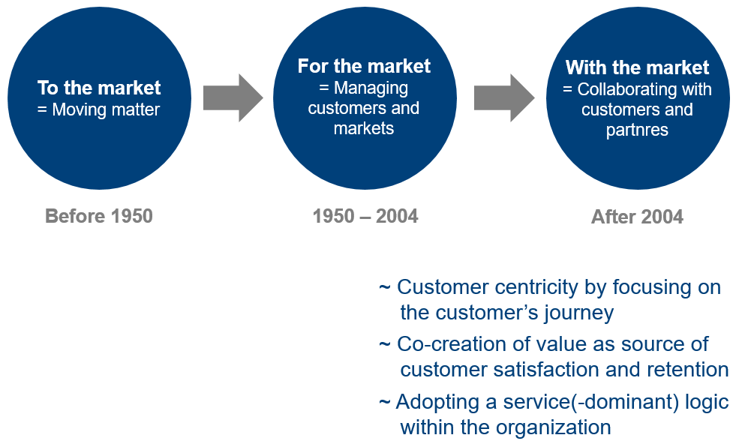

2. SERVICE AS A SOURCE OF COMPETITIVE ADVANTAGE
4 Sources of service as competitive advantage
Price perspective
= low P competitive advantage while offering service
e.g. Walmart/ Ryanair
Core product perspective
! Core product is not actual tangible product
= benefit of product makes it valuable
core competences
= bundles of skills x technologies (not physical assets)
= if product can offer you high benefits, * competitive advantage
e.g. EXKI, Watson
Image perspective
= enhance value of your product by adding an image
e.g. celebrities in perfume add
Service perspective
= By delivering service (not standard for your product, extra), * competitive advantage
e.g. callcenters Xerox
= not necessary for printer/document company but big advantage nowadays since * information company (printer company Document company info company)
e.g.2. IBM
= 80% of IBM business is consulting (they don’t even sell laptops anymore)
e.g.3. UBER
= delivers more than just taxi service & is very successful (it’s easy, you can give ratings, …)

3. CHARACTERISTICS OF SERVICE MARKETING
6 characteristics that make service management difficult
- Customer perceived service quality drives profit (≠ actual quality)
- Decision making authority: decentralized
= close to customer-organization interface
front-line employees should be able to make decisions as well
- Org needs to be organized: resources dedicated to supporting frontline employees
- Focus on employee engagement
- Customer perceived sq should drive employee rewards
- For 5, customer perceived sq should be measured x monitored
Requires insights from multiple disciplines!
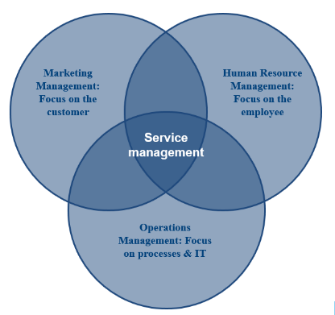
1. Managing the service encounter
= every time a customer comes into contact with you
= every time a critical moment of truth
- Service quality
- Servicescape design
= impact of physical environment in which a service takes place
- Customer experience management
- Service recovery
= action a service provider takes in response to service failure
= turn dissatisfied customers to loyal customers

2. Managing the organization
= service M is more complex than product M (service is subjective)
- Managing frontline employees
(employees are not always happy, shiny people)
- Service blueprinting
= operational planning tool that provides guidance on how a service will be provided
incl: physical evidence, staff actions, infrastructure needed

3. Using technology in the service encounter
Makes services even more complex

4. SERVICE QUALITY
= measure of how well service level delivered matches customer expectations
Conforming customers on consistent basis

Expectation – disconfirmation theory
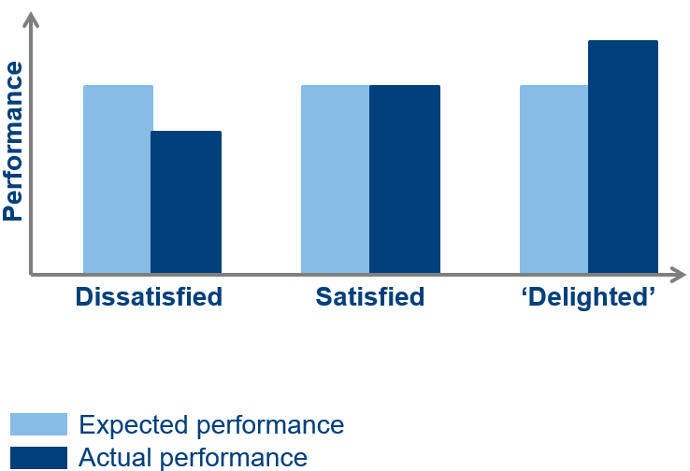
! People have different expectations

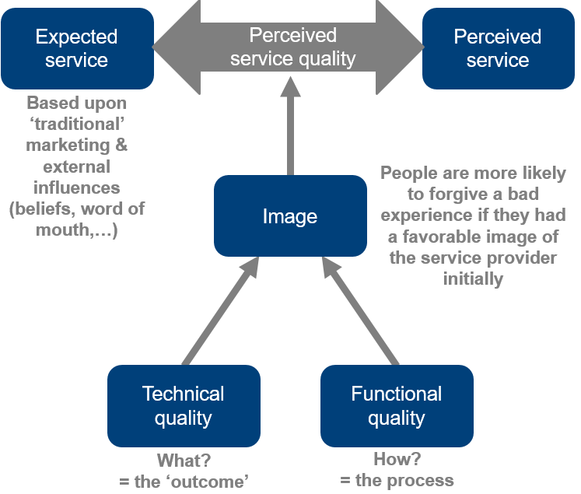

What are you getting x how are you getting it

Perceived service quality: SERVQUAL questionnaire
= most commonly used quality questionnaire
= needs to be adapted to settings

gives info about perceived service quality
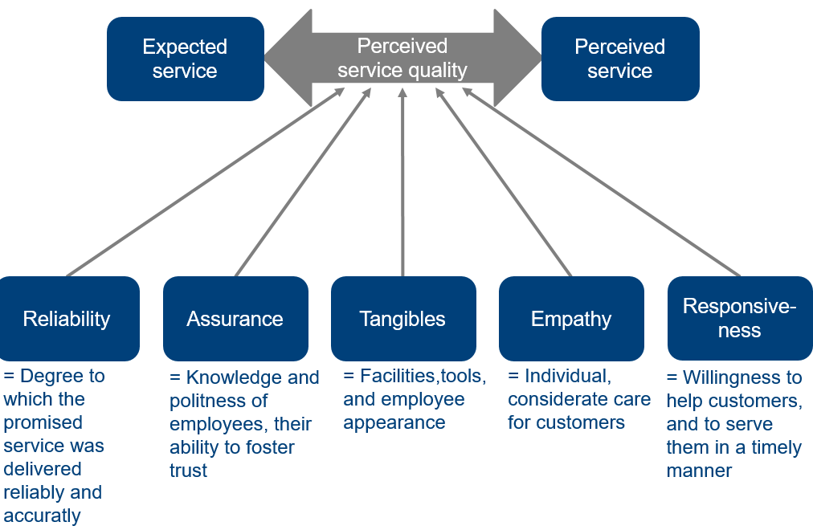

- Reliability
= the technical quality, the “what”
- Assurance, tangibility, empathy x responsiveness
= the “how”
= just as important!

EX: why P not listed as servqual aspect?
It is included indirectly!
P part of expectation
Pay a lot, expect perfect service (pay less, expect less upfront)
Expectations influence how you perceive the “how”

! Perceived servqual aspects affect customer satisfaction, behavioral intentions x actual behavior

