2. Managing service quality

1. MANAGING CUSTOMER DISSATISFACTION
Major sources of dissatisfaction
- HOW
employees are impolite/not responsive (40%)
- WHAT
the product isn’t what customer asked for (15%)
- What/How???
Service provider doesn’t provide a proper response to complaints (45%)

Often customer satisfaction isn’t evaluated, only other measures of service (call center)

Iceberg principle
= majority of dissatisfied customers don’t complain to the organization
Think they won’t be helped anyway (and they are right)
7% of companies has recovery procedures that lead to customer satisfaction

Problem: complainers want to be helped immediately & not via protocols & other employees

Justice is key
Distributive justice
= Compensations via coupon/redress/psychological compensations (apology)
= WHAT

+ Interactional justice
= Employees must make up
= via careful listening, empathy, provide explanations, empowerment & follow-up
= HOW people are being treated
+ procedural justice
= Via procedures: fast answers, involvement of customers in process & if unacceptable complaint: motivation why rejected

Which compensation is needed?
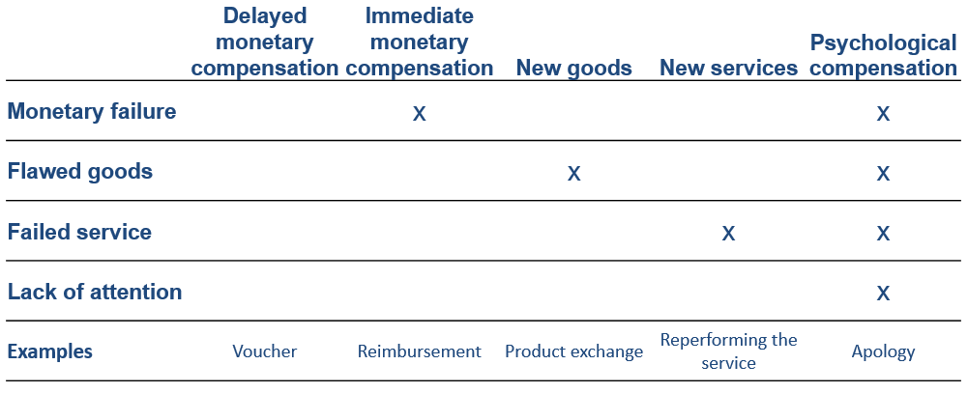

Reactions to satisfactory service recovery
Higher likelihood of repurchase, more w.o.m., better image, faster repurchase,…
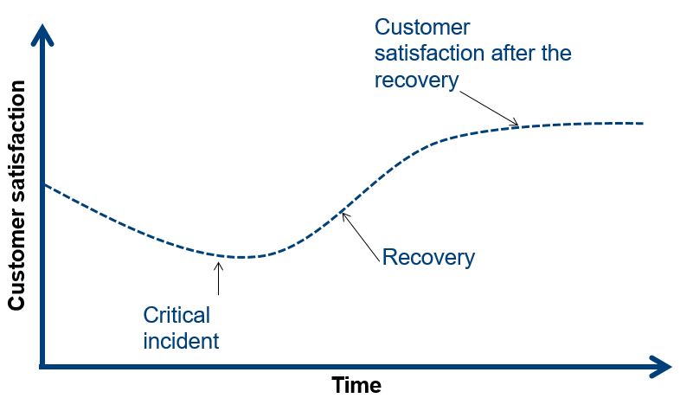

Customer satisfaction after satisfactory recovery HIGHER than before!

2. THE GAPS MODEL OF SERVICE QUALITY
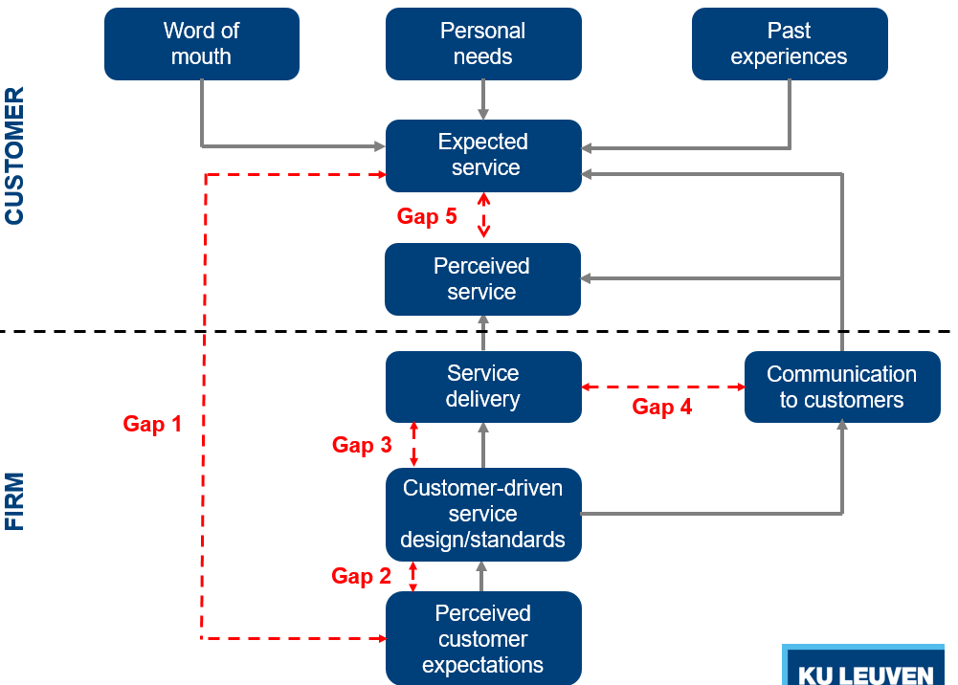

Gap 1.
Discrepancy between expected service & managerial perceptions about these expectations
= gap between what you want & what we think you want
- Insufficient/ incorrect market research
e.g. no analysis of service qualtity
- Too little bottom-up communication
E.g. no contact with customers/ employees
- Stronger focus on customer acquisition than retention
= transactional vs relationship marketing
- No consideration of customer complaints

Gap 2.
Discrepancy manger-perceived expectations & service design
- Bad/abstract service design
e.g. design not adapted to positioning
- Too little customer-centric standards
e.g. no formal processes to deliver servqual
- Bad servicescape design (environment)
e.g. poor maintenance, old-fashioned servicescape
Gap 3.
Discrepancy service design & actual service
- Poor HR management
e.g. poor recruitment & selection of employees, not enough support for employees
- Mistakes in matching supply & demand
e.g. insufficient yield management, wrong capacity management
- Problems with partners
channel conflicts about objectives, performances, costs,…

Gap 4.
Discrepancy actual service & communication about service
- No integrated Mcommunication
e.g. no interactive communication
- Poor management of consumer expectations
e.g. not training customers
- Promising too much in ads, sales,…
- Poor horizontal communication
across departments (sales, HR,…)
- Poor pricing
high price = high quality?

Gap 5.
Discrepancy perceived service & expected service
- Little understanding of customers’ zone of tolerance
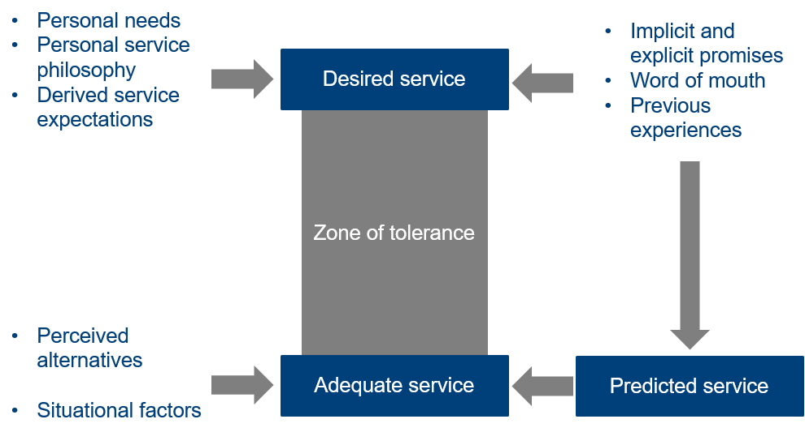
high P: expect a lot
lower P: more tolerated

3. SERVICE STANDARDIZATION
When standardizing: just make sure that production line is perfect
Possible because: predictable customer expectation, relatively fixed demand,…

Typically quality control metrics
= Tayloristic view
- Cycle time
- Yield
- Product returns
- Capacity
- # noncompliance events/year
- # unexpected maintenances
- …

Services are different!
- Customer expectations vary!
- Customers demand varies significantly
- Customers have different operand & operant resources
Yet standardization is possible in service! (upto certain point)

“service is the application of specialized competence (knowledge & skills) through deeds, processes & performances for the benefit of another entity or the entity itself”

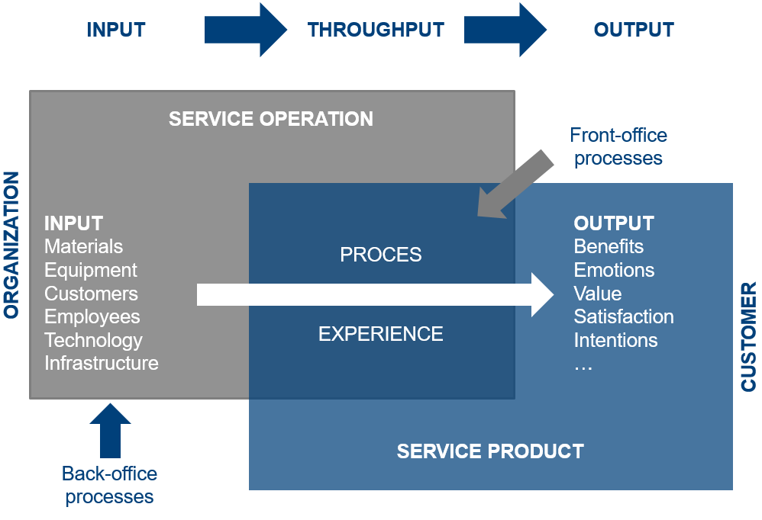
Supporting service encounter is crucial to deliver quality services

Service blueprints
= picture/map that portrays customer experience & service system, so that the different people involved in providing the service can understand it objectively, regardless of their roles or their individual point of view
= How a service needs to look/ be executed

Components
- Customer actions
= Different steps, choices, activities & interactions customer needs to go through to buy/experience x evaluate pxs
- Employee actions
= actions that are visible (front-office) & invisible (back-office) to customers
- Support services
= internal services/steps/interactions needed to let frontline employees perform service
- Physical evidence
= servicescape, required goods,…

4. MANAGING SERVICE EMPLOYEES
= employees play a critical role in service!!!

Employees
- Very visible in service encounter
= employee is the organization in customers eyes!
- Represent the organization
- Build relationships with customers
- Can generate sales while providing service
- Influence organizational productivity
The service-profit chain
= If you treat employees well, they will treat customers well too
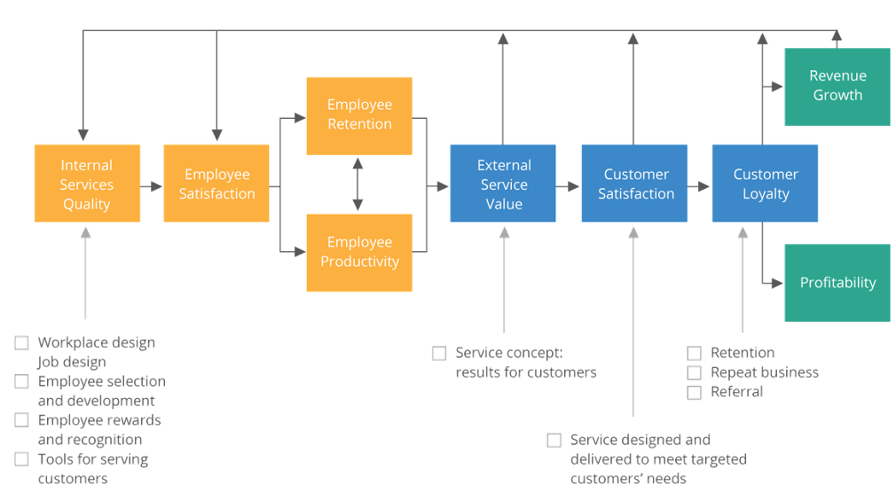
! But being a service employee is not always easy, they are boundary spanners

Conflicts
- Organization/client conflict
e.g. employee might want to help but isn’t allowed by organization (iPhone)
- Inter-client conflict
e.g. Customers smoke in non-smoking area
Expect employee to take action
- Person/role conflict
e.g. requested to smile all the time (even with rude customers)
Conflict btw what you are & what is expected from you
  - Emotional labor
= When employees suppress their own feelings in order to conform to customer/management expectations
    - Surface acting
= When person has to fake emotions to meet certain social/work rules
= Problem of fake smiles (easy discovered) + burn-out
    - Deep acting
= Trying to feel a specific emotion that they are thinking about in their mind

Service talent cycle
= How to get HR in service firms right?
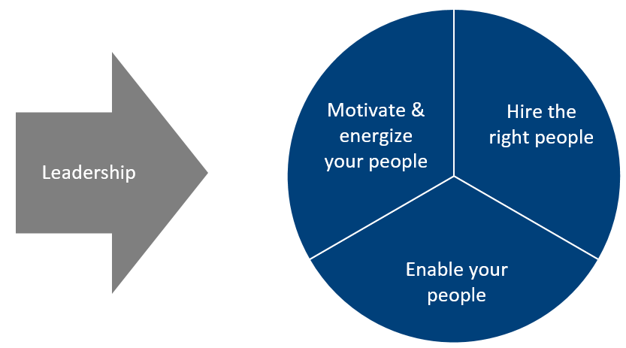
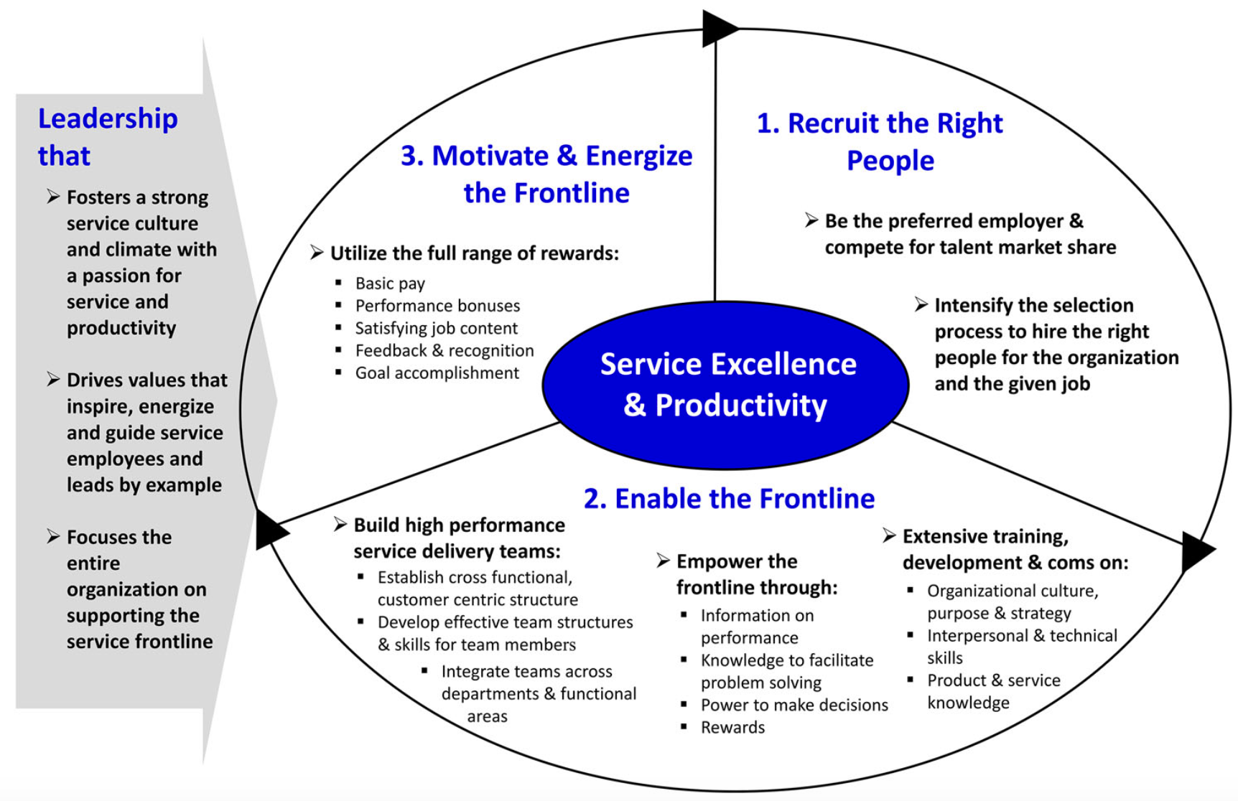
Step 1: Hire the “right” employee
- Invest in employer branding
  - Potential employers need to know you
  - Be attractive employer
  - Offer decent wage
Understand employee’s needs & develop attractive employer brand
- Select, select, select!
= find good fit
  - Frontline employees
= warm personality
    - Train to smile, but not to connect with others

Step 2: Enable frontline employees
- Empowerment
= process in which people get more ownership over events & situations that matter to them
- Proper skills & training should have authority to take decisions without consulting manager
- Offer training (job-related & personal training)

Step 3: engage employees
- Good job content (variety, autonomy,…)
- Feedback & recognition
- Set goals (realistic)

Step 4: Establish right culture
- Leadership
  - Transactional leadership
    - Focus on numbers & success
    - Team serves the leader
  - Transformational leadership
    - focus human aspects, creating safe environment
    - Leader serves team
  - Servant leadership
= combi of transactional & transformational leadership
= serving & guiding employees, taking into account organization’s goals x performance standards
- Service climate
  - Beliefs about organization’s emphasis on service quality throughout processes
  - Derived from employees experience
  - What types of behaviors are rewarded, supported, expected
  - Don’t forget that employees create customer satisfaction!!
- Involve entire organization
= talk to everybody & explain why customer experience is important



