3. Servicescape & digital transformation

1. THE SERVICESCAPE
= manmade, physical surroundings/ evidence
= environment in which service is delivered & in which firm x customer interact

- All aspects of physical facility + tangible aspects of communication
- Criteria to evaluate services
- Requirement for successful services
- Often used as positioning tool

1. Strategic roles of servicescape

1. Packaging
- Outward appearance of service
= impact service providor image
- Affects customer expectations

2. Facilitator
- Improve flow of service experience
- Might frustrate customers & employees if not designed well

3. Socializer
- Can help in socializations of employees & customers
  - Convey roles x expectations
  - For customers & employees/ employees only

4. Differentiator
- SC can create competitive advantage
- Serves as signal for market segments
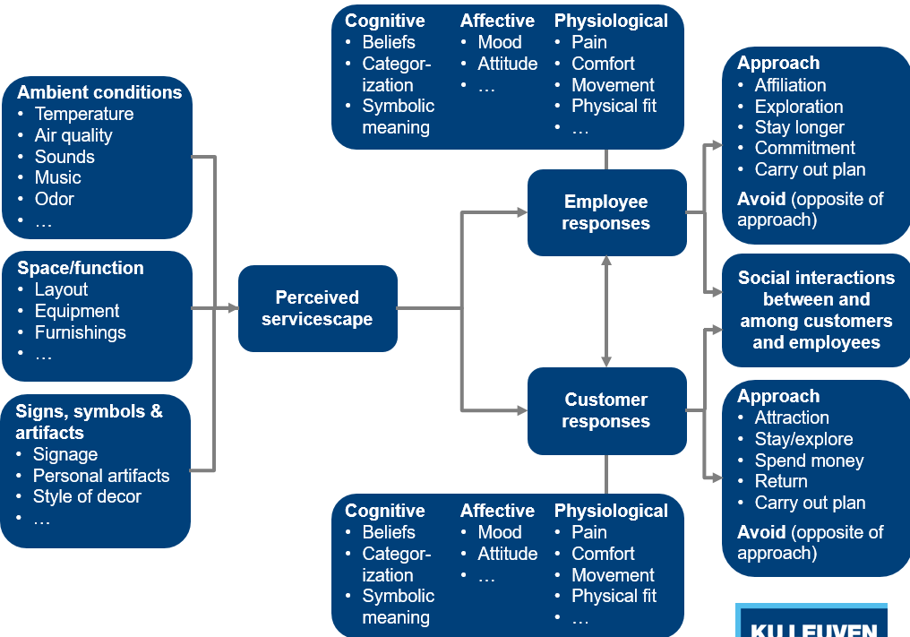
2. AMBIENT CONDITIONS
= design elements & details that jointly create desired service environment

- Sounds
  - Strong effect on customers (even if barely audible)
  - Fast temp & high volume: increase arousal levels
  - Adjust pace to match tempo music
- Scents
  - Ambient smell: pervades an environment
  - Used to obtain emotional, physiological & behavioral responses
  - Consistency is key (bakery, store,…)
- Lighting & color
  - Strong impact on consumers
    - Red: fast decision making
= good for low-involvement/ impulsive buying situations
    - Cool colors for high-involvement decisions
- Size & shape
= Spatial layout
  - S&S of furnishings, counters etc & how arranged
  - Create logical arrangement/ floorplan
  - Functionality is key
- Air quality & temperature
3. SIGNS, SYMBOLS & ARTIFACTS
= communicates image & helps customer find their way
= communicates service script (try to draw meaning from symbols etc)
! Challenge: design to guide customer through service delivery process
Unclear signals: * anxiety & uncertainty about how to process/obtain service
Small details make big difference

Hello Kitty + Eva Air
= success, make flying fun (tickets, lables, pillows, food)
= not success because liking hello kitty, just because it’s different
Affinity passenger & firm rises

2. DIGITAL TRANSFORMATION
! Technology has huge impact on consumers

1. Traditional service encounter
= rare
- Most services standardized/ info easy available
- High labour costs
- Highly personalized, creative services
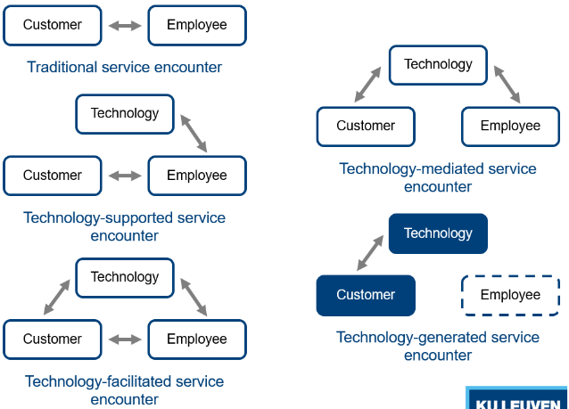
2. Technology supported
e.g. Supercomputer (when you die), supports the researchers

3. Technology-facilitated services
e.g. teacher gets help from ppt

4. Technology-mediated service encounter
= less x less face interaction, more x more via pc
e.g. online banking, call centers, robot surgery

5. Technology-generated service encounter
= employee no longer involved (self-check-in airport)
! Robot taxis, buttlers,…

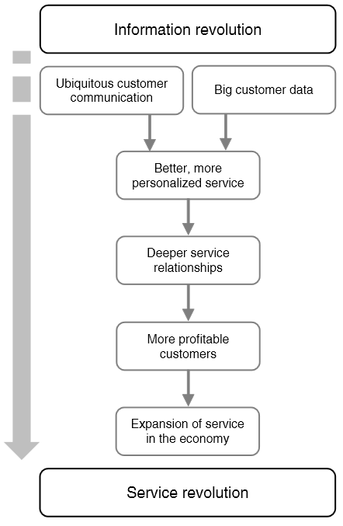
Is technology causing a service revolution?
= individual progress way better than standardization
* relationships

! e.g. financial segment: jobs decreasing
Artificial intelligence: smarter & faster than we
e.g. 3D printing avoids manufacturing & transport

Digital transformation is essentially a service revolution
- In line with service-dominant logic
  - Value arises not from technology itself but from services these technologies can deliver (what we can do with it)
- Path traditional service – technology-intensie service
  - In many industries
  - Drastic change in required skills labor force
more STEM (science, technology, engineering, mathematics)
- ! Assess whether digital transformation can make your company/industry obsolete

