Ethical reflections
ETHICAL DIMENSIONS
- Overuse of marketing for social ideas
  - May raise resistance to M overall
  - Costly manipulative
- Expert groups agree
= SM has ethical implications
  - Practitioners more tolerant x optimistic
    - Must be aware that public opinion may differ
= SM creates personal accountability
- Less endorsement for professional/ governmental regulations
  - Higher among researchers x social psychologists

! Who decides what’s good in SM?

NUDGE & THINK: TWO STRATEGIES FOR CHANGING CIVIC BEHAVIOR
How should policy change behavior?
- Law & incentives offer background
  - Limited scope
  - Costly
  - Rule may go unnoticed, feel external/inappropriate
- 2 big streams
  - Nudge
= policy maker designs choice environments to stimulate right choice
    - Evidence-based
= build on actual decision processes x strengths x weaknesses
    - Feedback
= clear x immediate
    - Captures x steers attention
    - Leverages social learning mechanisms
  - Think
= policy maker facilitates democratic debate & stimulates citizens to think, talk x act
    - Assumption
= legitimacy of political dm rests on public deliberation btw free x equal citizens
    - Focus on emergence x shaping of preferences
    - Moralizing capacity public debate
      - Extreme POV don’t get chance, perspective taking * cooperation & tolerance, Shaping arguments, publicly exchanging vision shapes preferences
    - Challenge new democracy
    - Success in Brazil & Canada
! Essential
= perceive impact (motivation) + safe x & respectful environment where people can talk freely
People actually think deep & take perspective
Decisions are supported

Comparing nudge & think
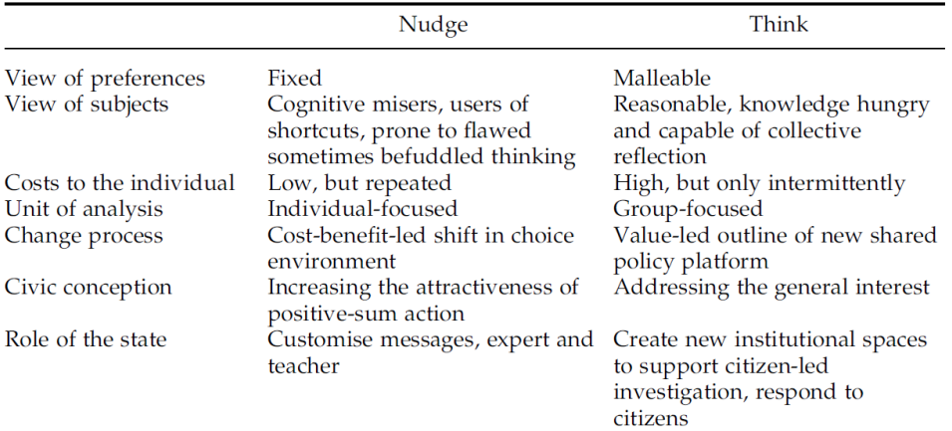

(Dis)advantages

+ nudge
Builds on actual dm processes, low cost, wide applicability
- nudge
Not fundamental, outcome modest, piecemeal

+ Think
Potential to dig deep x create real reforms
- think
Time consuming, vulnerable to manipulation (requires fair x supportive environment x willingness to act)

Connections
- Nudge may trigger thinking
- Both solutions to bounded rationality
- Authors
= learn from each other, when which strategy is useful

3. ETHICAL CHALLENGES IN SM
1. Ends of social marketing
= who decides desired outcome
- Nature of social problems
  - What is essential?
  - Well-being vs ‘good’ of people
  - Targeted individuals don’t always acknowledge problem (culturally determined)
  - Targeted unable/unwilling to expend resources to solve
  - Problems diverse
e.g. Change4life
= reduces responsibility government & delegates responsibility to individuals
= if they maintain their behavior, it’s their problem & fastfood continues to sell
- Individual & social well-being
  - Commercial M
= consumers’ wants x needs primary
    - Potential for misleading market exchanges
  - SM cannot use this info
= welfare exchange, not about providing goods to make people happy
= creating circumstances that foster well-being

How to solve?
- Subjective analysis?
- Collective support
= political elite decides
= paternalism, could be abused
- Pragmatic solutions
  - Address widely accepted issues only
but not always sufficient (eg birth control)
  - SM merely execute
= conflicts of interests: content & process are related

2. Analysis of social problems
= SM turns collective moral problems into individual M problems

Marketing vs moral rationale
- M acknowledges bounded rationality
= useful for problems under individual control x main impact on individual
e.g. drug abuse
! Not for others like poor education system, vaccination,…
- Moral can be reasoning used as persuasion tool (not morality per se)
- Genuine morality (discussion) is not area of social marketers

Individual versus whole
- Individual problems x solutions take place in context with ethical ramifications
  - Effectiveness requires background
  - Selection of means towards end provides ethical problems in itself
Who to target first, which subproblems

3. Subjects of social problems
= SM turns political participation into paternalism

- Demand doesn’t come from customers
  - Financial exchange with assigners (not customers)
  - Customers no balancing power (asymmetric power relation)
  - Determination of just P not under competitive influence
- Privatization
  - Social marketers are not under direct democratic control
  - Targeted customers don’t have voice
(even if there is a channel for info collection)

Dealing with the 3 challenges
- Transparency
= about ends x means & who hired SM x pays them
- Rights of targets of behavioral change should be acknowledged x organized
e.g. exit x free participation
- High standards required
! More than for commercial M to avoid undermining democratic values
- Ethical justification x democratic control required

