1. What is social marketing?

1. INTRODUCTION
Social marketing
= applying marketing technology to foster ‘desirable’ behavior

4 steps
- Identify problematic behavior
- Understand the problematic behavior
- Design a strategy to change the behavior
- Evaluate the effect of the strategy

Evidence-based social marketing strategies

2. EXAMPLES, HISTORY & CONTEMPORARY PERSPECTIVE
1. What is marketing: Kotler x Zaltman
Core
= exchange process btw ≥ 2 parties

Marketing management
= Management of exchange, attending to product, price, promotin x place
M has professionalized (research, formal strategies,…)

Old view
= selling products (sales orientation)
= creating products x services, changing needs & wants, sell

In practice
= a blend of finding out needs & selling (marketing orientation)
= applied behavioral science

1. Early phase: social advertising
= one-way communication of message
e.g. it is better to marry & have children at a later age, ‘housewives stop travelling by 4’

2. From social advertising to social marketing
- Focus on communication (promotion)
= spread of ideas, often referring to collective good
- Knowledge is not enough.
Implementation is the goal
- Definition
“design, implementation & control of programs calculated to influence the acceptability of social ideas and involving considerations of product planning, pricing, communication, distribution and marketing research”
Bridging gap btw knowledge x attitude on the one hand & behavior on the other hand
How to make social campaigns work
Limits of changing behavior via mass communication
Lazarfeld x Merton’s analysis
= 3 conditions for effective mass media
- Monopolization
= absence of counterpropaganda is required
= but alternative views are around and compete for people’s mind
! Also applies to business M
- Canalization
= Need for supportive attitudinal basis for the feelings that the social communicators are striving to shape
e.g. tooth paste seller doesn’t need to create new behavior pattern but just adjust brand choice
! Social x business marketing sometimes also needs to create novel attitudes (pc)
- Supplementation
= Need for follow-up close to consumer (face-to-face contacts)
Wiebe (1951)
= identified 5 prerequisites for social campaigns to work
- Force
= triggering underlying motivation
- Direction
= how and where to consummate their motivation
- Mechanism
= details of the ‘where’
= existence of an agency that enables person to translate motive into action
- Adequacy and compatibility
= quality of the ‘where’
= ability x effectiveness of agency in performing its task
- Distance
= the effort x cost required to consummate the motivation in relation to the reward
The four P’s
= modern perspective social marketing (Kotler)
1. Product
= what you want the citizens to acquire (sell)
- Behavior, values, beliefs, attitude
- Sell (convince the audience) vs buy (be convinced)
Aim of behavioral change
Often multiple products needed to reach that goal
e.g. educational campaign, courses, insurance rewards, fiscal benefits, …

2. Promotion
= creating awareness, familiarity & desire
More than advertising
- Personal selling
= any paid form of nonpersonal presentation x promotion
e.g. red cross calendar selling on road
- Sales promotions
= any paid form of personal presentation x promotion
= incentives, materials, events, programs
e.g. Flemish Bob-campaign key hanger
- Publicity
= unpaid, unpersonal
e.g. remarkable events are covered by media, youtube,…
- Sales promotion
= Miscellaneous paid forms designed to stimulate audience interest x acceptance of product

3. Place
= providing ways to act (adequate x compatible distribution x response channels)
- Where to buy
- Early environmental social campaigns = failed here
e.g. no political candidate, no green products,…
- Need mechanisms to translate motivation into action

4. Price
= cost/benefit balance should be good
- Monetary cost
= obvious in donation, but also taxi after drinking,…
- Opportunity cost in time
e.g. slower by bike
- Psychological cost
e.g. effort (buying a bike x using it), Punishment (pain, giving up smoking), uncertainty
- Energy costs

People make compromise btw what you propose & what they do (small step in right direction)
Challenges in social M
- Defining the exchange
- Resistance against manipulation
- Social causes are deeper than superficial product preferences
- Social M is costly itself: is it justibiable?
- Time will tell! Problems still here today
2. Andreasen: Sharpening up the field
Establishment of social M
= society, educational programs, academic research
BUT concepts not clear
Effectiveness & acceptance may suffer from misapplication

Social M ≠ societal M
Societal
= all types of M that have positive effects for society
= business M that takes into account society’s LT benefit
= protect consumers from “dark side of market place”, not to influence customer
e.g. insurance company promoting seat belt: doesn’t want people to wear seatbelts but wants reduction in costs

Social
= when behavioral change is primary goal
= NOT restricted to acceptance of ideas alone (also DO something)

Sharper definition
Social M is adaptation of commercial M technologies to programs designed to influence voluntary behavior of target audiences to improve their personal welfare & that of society of which they are a part

Aims
- Keep practitioners focused on relevant outcomes
- Keep discipline well-identified & distinguished
- Keep discipline out of areas where they can only fail

Analyse of definition
- Influencing voluntary behavior
  - Changing ideas x attitudes = hulpmiddel
  - Attitude – behavior gap
    - Qualitatively: attitude ∆ may not affect behavior at all
    - Quantitatively: attitude ∆ may only partially affect behavior
  - More than education/ propaganda
= these 2 are only usefull if they lead to behavior change
= not always part of social M
(true education should actually come before the attitude change)
  - Focus on behavior
Calls for behavioral effectiveness monitoring
- Programs
  - More than campaigns (have a fixed termination point, programs don’t & can include multiple campaigns)
  - Less than organizations
- Beneficiary ≠ marketer
  - Individual e.g. promote breast self-examination
  - Society e.g. increase recycling
  - Both e.g. promote sticking to speed limit (save lives, reduce society’s health care costs)

Why is it marketing?
Social Mprogram managers
- Know their customers’ needs, wants x current behavior (evidence-based)
- Segment their markets based on needs
- Pretest the elements of their strategy
- Aware of decision process by their consumers
= incl. awareness of options, values, considering options as relevant, feeling competent to acquire options,….
- Aware of (in)direct competition
- Have 4P’s covered
Social advertising = only Promotion covered

3. Rothschild: Social marketing version 3
Embeds social M in broader framework of education x law

3 broad categories of social management
1. Education
- Provides info/knowledge/ new view on problem
- Does NOT provide rewards/ punishments (but may refer to them)
- Stands in isolation
≈ behavioral solutions, health communications, persuasion

2. Law
= thought of as targeting options that are desirable collectively but lack intrinsic motivation
- Hard
= Coercion (achieve behavior in nonvoluntary manner), punishments
- Soft
= affects probability of transactions
e.g. taxes, subsidies
- Requires authority x political act x monitoring system
- Can also be desirable individually (helmets motorcyclists)

3. Marketing
= provide immediate benefits in exchange for the desirable behavior

Vague boundaries
law can set the stage for social marketing (offer additional benefits)
- Punish extreme behaviors
- Subsidize incentive programs
Marketing provides incentives x informs public about them (adds choices)
Education informs x persuades within set of existing choices
Persuasion = part social M campaigns
Education x M similar in that both propose uncoerced, free choice behavior

Relevant concepts
1. Self-interest
= people act out of self-interest
Perception of benefits is crucial
- Education: future, society, fitting in (self-interest)
- Law: avoidance of punishments, monetary benefits (act in self-interest to not be punished)
- Marketing: offers immediate reward/ incentives (used for self-interest)

Business M
= meets a need/want & directly satisfying
↔ Social M’s target behavioral ∆: weakly supported by self-interest (problem)
e.g. people don’t exercise, smoke & drink to excess,…

2. Primary demand
= reflects selection of product category/ family of behaviors
∆ from 1 category to other requires more change
Most difficult
Often necessary for social M
e.g. primary demand: drinking but afterwards hating yourself for your primary demand of drinking

↔ Secondary (selective) demand
= product decision has been made
= reflects selection of brand/type

3. Exchange
Social M
Behavioral change managers overestimate their power: ‘bad deal’
Competition is apathy, low involvement, free choice, … ‘good deal’
e.g. choice of relaxing now & maybe having heart attack later vs exercising & eating with lower probability for heart attack (but not certain)
With public health x social issues: payback often vague, uncertain & in distant future
e.g. Free choice
- Libertarianism
= education is primary behavior management strategy
  - Negative externalities to collective x society (tragedy of the commons, overusage)
- Paternalism
= restriction, law is primary behavior management strategy
e.g. individual freedom heavily restricted to protect us
- Social dilemma’s
e.g. natural resources,… (prisoner’s dilemma)

Business M
= transaction immediate & clearly defined

Framework: Marketing, education & law
M consists of voluntary exchange btw 2 or more parties, in which each is trying to further its own perceived self-interest while recognizing the need to accommodate the perceived self-interest of the other to achieve its own ends.

- Motivation to act
= self-interest
  - M can increase motivation by offering a good deal
  - Education can slightly increase motivation by pointing out the benefits
  - Law can obviate motivation
- Opportunity
= mechanisms offered by the environment
= they might want to act but are unable to do so because there is no environmental mechanism at hand
  - M can provide opportunities
  - Education can increase awareness
  - Law can support creation
- Ability
= skills x proficiency to act/solve problems
e.g. breaking a habit
  - M can reward ability
  - Education can increase ability
  - Law can help to frustrate individuals (first step towards learning)
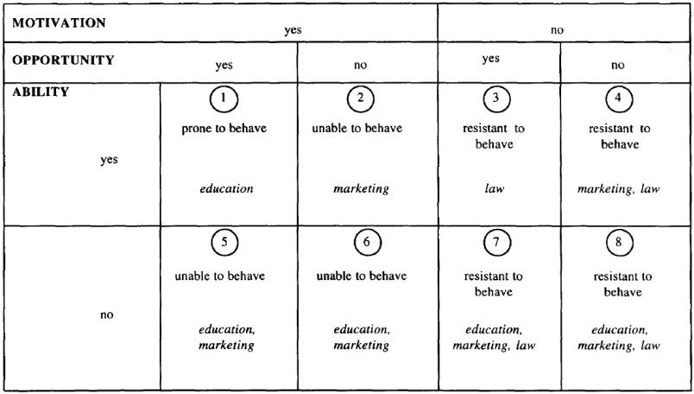

Characterization of the market: one or a few cells
- Education & M should be used when possible
- Motivation can emerge when opportunity & ability are established or made public

Uitgebreid voorbeeld zie pagina 32 artikel Carrots x Sticks
Characterization of target group/ segments
Mostly focus on 1/2 cells
! Underuse/overuse of education, M, law is problematic

Other factors influencing selection of education, Marketing or law
- Current usage as indicator of readiness to behave
= those behaving in a (non-) desired way are more prone (resistant) to adopt
e.g. addiction & habit strength
- Level of competition
= determines level of actions needed
  - Education when passive competition
  - Marketing when moderate competition
  - Law when heavy competition
- Network effects & developing a target of critical mass
= sometimes need for all individuals to change at same time
  - Social dilemma
= change incentive structure to discourage free-riding
  - Size of free-riding premium determines level of action needed
  - Sharing social benefits = * incentives
- Sharing community costs x benefits
= feeling of receiving a large share of community benefit: education will suffice
- Externalities
= negative ext determine need for behavior management
= low predicted externalities: education sufficient. Otherwise law
(never M when extreme externalities are present)
- Power of individuals vs society
= if power resides with the society: education & law
= If the power is more balanced, M is optimal
- Sense of community
= stronger communities (often negatively correlated with size), lower level of control
  - Homogeneous communities: manage behavior through education
  - Moderate homogeneous: Marketing
  - Least homogeneous: law to manage behaviour
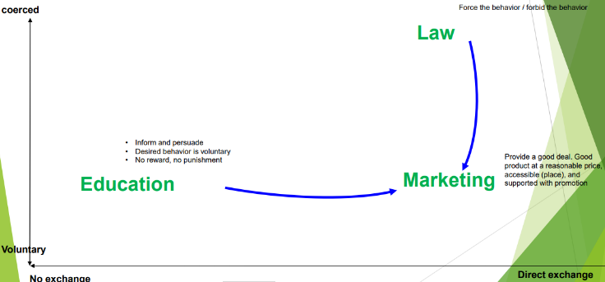

Conclusion
= social M is & should be M (exchange & more than social advertising)

Target specific zone of change
= where manager can offer benefit in exchange for individuals effort
= education can help to highlight this exchange
= law can help when no reasonable exchange can be offered or to provide support for an exchange

2. RELATED APPROACHES
1. Public health
= promotes x protects health of people & communities where they live, learn, work & play
= scientific discipline & domain of practice
- Topics
= vaccination of children, education about hazards of smoking,…
- Descriptive
= factors that affect health problems/ antecedents
- Interventionist
= methods to enhance desirable health outcomes
e.g. empirical studies (science) & organization in the field

Ecological approach
Health behavior determined by different levels of factors
- Individual (knowledge, attitudes, preferences)
- Immediate social level (friends, family)
- Organization (school, work)
- Community
- National/ supra-national level (policy

Inspired by biology (adaptive behavior in context) & community psychology (individual behavior is embedded in its social context)

4 principles
- Deep interaction btw person & setting
  - Mutual influence of persons x settings
  - Shared meaning of reality btw persons
  - Persons produce & use resources within limits
e.g. personal, social & communal including social norms
  - Setting is an open system
= influences on x from wider environment
  - Adaptive in 1 setting = setting dependent
- Constructionist
= meanings are constructed x are sociohistorically determined
- Collaborative research
= interventionists x researchers need to acknowledge the specificities of their setting to have success
- Ecological approach
= takes the social nature of individual decision making into account
Comparison with social M
Differences
- Public health more specific (health behavior)
- Less restricted ito window for actions
= more focus on education
- Product x exchange less prominent in public health
(with right availability, citizens should do it)
Similarities
- Shared focus on behavior
! Public Health more on knowledge x attitude & expect change to follow spontaneously
“if you inform them, they will do the right thing”
- Shared “consumer orientation”
= what do consumers want, what is their current behavior
- Similar methods, tools and aims

2. Behavioral economics
= playing with the architecture to ∆ behavior
= exploits regularities x biases in human decision making to influence people’s behavior
e.g. placing healthy foods first/ closer, footsteps towards garbage can, …
No informational campaign necessary!!
Freedom of choice preserved, preferences not touched, knowledge not changed!

Behavioral economics & nudging
Decision making via dual system
- Reflex system, effortful, slow
= goal oriented system, driven by values x intentions, requires cognitive capacity
- Impulsive system, effortless, quick (reflection)
= affective system, requires little/no cognitive engagement, being driven by immediate feelings x triggered by environment

Nudging exploits ‘low’ road (examples zie artikel)
- Choice architecture
e.g. power of default
- Physical design
e.g. distance, walking direction
- Social norm feedback
= can be explicit but also implicit (size of plate)
- Different from law/regulations
e.g. bans vs smart choice sets

e.g. fruit near cash register increased consumption, provide social norm info increases desirable consumption
! No studies about cost-effectiveness (depends on P of environmental ∆ x size of behavioral effect)

Side effects nudging
- May lead to biases
e.g. presence of celery reduced caloric estimation of hamburgers (* excess consumption)
- Effectiveness of nudges varies with segment
= P of cigarettes (better for low SES) vs packages pictures (better for high SES)
- Nudges could wear out/ produce reactance effects
e.g. default boxes in internet forms
! Role of awareness not so clear: do nudges still work when people are aware of the aim?
= pertains to acceptability x ethicality

Comparison social M
Differences
- Share idea of voluntariness x concept of ‘a good deal’ but the origins of good deal are different
  - Nudges: affective/ automatic/ incidental drivers
  - Social M: real economic incentives
- Nudges do NOT change preferences/ attitudes/ knowledge
= if environment changes, nudges may fade
- Nudges don’t even require appropriate knowledge or attitudes
Can they be designed such that they affect preferences? (later)
- Social M via high road, nudges via low road
- Price
= low effort to select desirable option (P of option lowers)
- Distribution
= desirable behavior is readily available
- No attention for promotion
(don’t realize what’s going on)
- Product not attended too, but can be defined as desirable option

In classic social M: no nudging since it doesn’t specify the good deal/ exchange

3. (Applied) Social Psychology
= * awareness of social norm
- Descriptive norms
= Norms can indicate what others DO
= standard from which people do not want to deviate
! People overestimate prevalence of undesirable behaviors among peers & use this estimation as a standard against which they compare their own behavior
= group pressure
e.g. 65% of 20-25Y olds own a smartphone
- Injunctive norms
= norms can indicate what other SHOULD DO
= what is commonly done/ approved within a culture
e.g. you should brush your teeth 2 a day

Potentially destructive effect descriptive norms
= Evidence about effective norms is mixed
Descriptive may reduce undesirable behavior of problematic target group but increase undesirable behavior of ‘good’ target group
e.g. if they see they use less energy than average, might use more
Can be cancelled by adding injunctive norm!

Study
- Energy consumption 300 hh & norm intervention
- Your consumption is x & average neighbourhood consumption = y
- Descriptive norm via emoticon
- Descriptive norms helped reduce overconsumption but may trigger good consumers to increase energy consumption
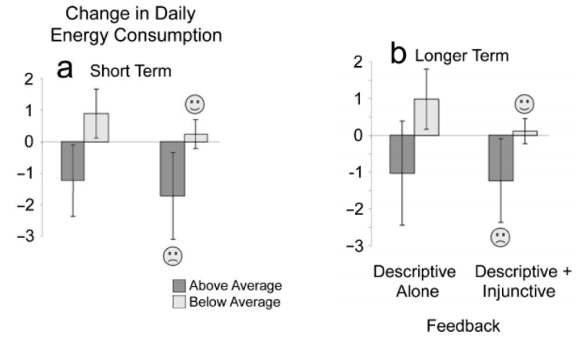
- Providing extra injunctive norm mitigates this perverse effect
Combine 2 norms = best

Alternative explanation: not necessarily same type of people
Boomerang effect

3. OVERAL CONCLUSION
= social M clearly related to public health, behavioral economics & applied social psychology

Different focus
- Social M = Mbased toolbox aimed at changing people’s behavior based on economic principles of “good deal”
- Public health focused on health x relies more heavily on knowledge x attitudes
- Nudging focuses more on low road to (temporary) behavioral change
- Applied social psychology provides bits x building blocks that can be used in practice

Resemblance btw public health x social M
= high resemblance, different histories but similar methods, tools x aims

Nudges x social psychological effects related to SM x PH?
- Promising tools used in PH x SM: integrate norm info in promotion & desirable option as default
- Complementary methods help PH x SM: provide low road support for high road changes
- Antagonistic methods can reduce each other’s effectiveness
e.g. law
= reactance, reducing interest in info, deteriorating attitude

Latter option not widely accepted but campaigns should be screened for possible back-fire effects

