Towards sustainable travel behaviour
Climate relevant behaviors (sustainable transportation)

FOUR WAYS OF ASKING WHY
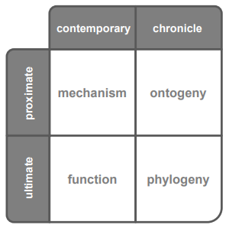
Explanations for behavior can be searched at ≠ levels of analysis

FACTS & FIGURES ABOUT TRAVEL BEHAVIOR
- Key capacity of all animals
- Key factor in human history
- Critically supported by technology
- Travel time is constant across time & space
  - Higher GDP/capita
= more travel
  - Road constructions continuously necessary
  - Road blocks

Travelling seems to be pretty crucial & constant part of our lives

Different behavioural parameters
- Activity choice
= what shall I do?
- Destination choice
= where shall I do it?
- Mode choice: How shall I get there?
- Departure time choice: when shall I go?

3. PROBLEMS & CHALLENGES
Road transport > 20% of man-made CO₂ emissions
The 1 behaviour with which you can save 5- pounds of CO₂ (vs eating no meat etc.)
- Direct emissions are NOT the only problem
- Technology won’t do the trick!
Reduction in consumption necessary
- Sustainable transportation requires reductions of car use

E-mobility
= most advertised solution
- Not so successful
  - Recharging costs, lack of infrastructure, nuclear waste, …
- Sustainable?
  - Nope, technology won’t do the trick
- Would you continue subsidizing electric cars
  - Shift to e-mobility doesn’t solve all problems
  - As much congestion with electric cars as without
- Can it save the climate
  - Nope, not on its own

4. EXPLAINING & CHANGING TRAVEL BEHAVIOR
= with good theoretical model, easier to ∆ behaviour
COGNITIVE APPROACHES
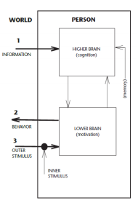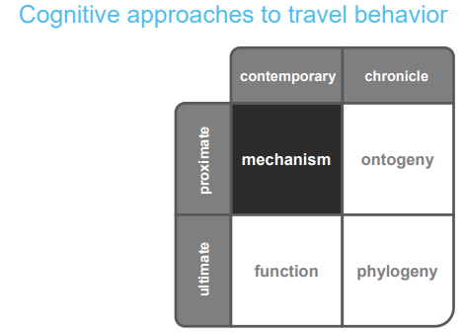

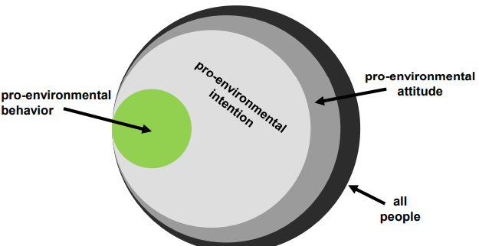
Theory of planned behavior (TPB)
= most popular cognitive approach
= x% of actual behaviour can be explained by TPB

! Problem: (attitude-)intention-behavior gap
! Contributor: habits
- Weak habits
= can easy be changed
- Strong habits
  - Automatized patterns of behavior
  - Not goal-oriented/deliberate
  - Associated with tunnel vision
- Benefitting from broken habits
  - Study: PT company promotion
    - Residential relocation * sensitive phase
= people motivated to search & try out new behavioral options
    - Add implementation intention: make instructions & write down
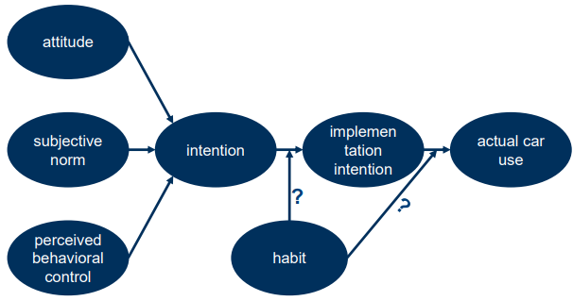
Problems of TPB (and other cognitive models)
- Arbitrary, intangible relationships
= you can always invent one more construct
- Triviality
= if something’s easy, it will correlate with intention to use
- Limited utility
= You don’t need TPB to know that making car use unpleasant will reduce car use
- Positive: very cheap & doesn’t hurt anybody

Conclusion
= cognitive models do not help us to reduce car use

BEHAVIORAL-ANALYTIC APPROACHES
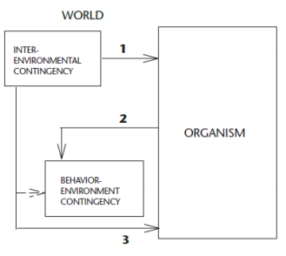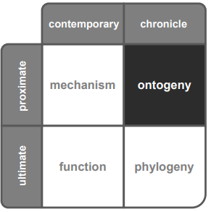

Classic marketing
= communicating contingencies
= Not only improving image of alternatives, also de-marketing the product itself
e.g. showing graph of gasoline consumption reduces use
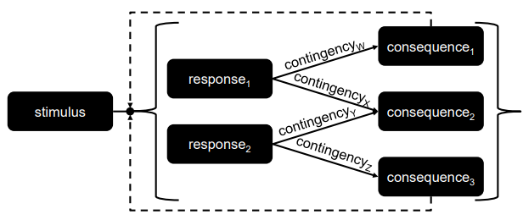

Changing contingencies: incentives
= Are they an effective tool to promote sustainable travel behavior?
Effects of manipulations NOT last long & returns to base level
Theoretically relevant, but largely untested incentive parameters
e.g. size, type, framing, temporal proximity, contingency, …

Conclusion
= changing behavior requires changing environmental contingencies

5. STUDYING TRAVEL BEHAVIOR IN LABORATORY
Incentives: introducing new contingencies
Hardly feasible in expensive & difficult-to-control field experiments
Use lab

Pro-Environmental Behavior Task (PEBT)
- Series of choices with ACTUAL consequences for individual & actual cons for environment
- Useful to study travel behavior?
= systematic laboratory research necessary to fine-tune car-use interventions!!
= more concern/attitude/… = more bike use

Research on sustainable travel behavior necessary!

