CSR: Corporate Social Responsibility
1. BIG BUSINESS ENGAGES IN ACTIVITIES THAT SUPPORT SOCIETY
= Support to causes that are in interest of society without obvious link with company
- Does not refer to sponsoring
e.g. beer brewers sponsoring music festivals
- Grey zone
= taking responsibility for impact own pxs & production
e.g. beer brewers getting involved in ‘smart drinking’ programs
Examples
- Very explicit CSR claims
  - AB Inbev: 2025 sustainability goals
  - Unilever: sustainable living on their homepages
- Less explicit CSR claims
  - BMW: smart cities
- Without easy detectable links
  - Jan de Nul

2. WHAT IS CORPORATE SOCIAL RESPONSIBILITY?
= Companies take into account their impact on society
- CSR as social, stakeholder & ethical obligation
Focus on motivation
- CSR as managerial process
Focus on process
e.g. monitoring environment, stakeholder issues & processes to take stakeholders into account
- CSR in marketing
= fragmented (per domain, stakeholders,…)

Stakeholder theory
CSR designated the duty, motivated by both instrumental x moral hazards, to meet or exceed stakeholder norms dictating desirable organization behaviors
- Nature of stakeholders
e.g. employees, customers, local community, managers,…
- Stakeholder norms
= norms about right x wrong by these stakeholders
  - Underlying hypernorms that all stakeholders share
    - General social contracts
e.g. adequate healthy x safety standards x info about these norms
  - Norms related to specific sth communities
  - Norms ≠ across sth communities
= group of individual sth that interact & have similar norms
- Stakeholders’ relative influence on decision making
= they want quality & price & within these constraints they want environmental benefits etc!
- Stakeholder issues
= Problem identifies by stakeholder community
  - Issues may vary widely
    - Ecological footprint (local communities, regulators, customers)
    - Respectful treatment employees (employees, customers, local community, media)
    - Legality (regulators)
    - Profit (sh, managers)
  - Stakeholders can influence companies decisions
    - Legalistic approach
    - Exit strategies (e.g. boycott)
    - Voice strategies (protest, consumer complaint)
- Stakeholder orientation
= extent to which company attends to sth demands, issues & norms
  - Generalization of ‘market orientation’ to all sth
  - Requires generation of sth intelligence
  - Dissemination of sth intelligence within company
  - Responsiveness to sth
= decision processes to address sth issues
- Stakeholder information generation
  - Employees
= regular discussions representatives, evaluation of employee satisfaction, data about employee injuries & absenteeism
  - Customers
= identification of & contact with customer advocates, discussion forums, data on complaints
  - Communities where firm operates
= identification of x consultation with community leaders to know about emerging issues, analysis of impact activities on environment, survey of firm reputation in community
- Stakeholder information dissemination
= info verspreiding
  - Employees
= internal communications, open-door policy to superiors, facilitation of informal meetings btw employees at all levels
  - Customers
= communicating nature of customer complaints across departments, results of customer research in product policies, circulation of info on emerging consumer trends
  - Communities where firm operates
= discussion forums, facilitating participation of employees into community affairs (giving lectures, …), granting price for best community initiative
- Stakeholder responsiveness
= programs to address sth issues
  - Employees
= employee health x safety programs, provision of day care, facilitating empl education
  - Customers
= product quality x safety improvement programs, programs to respond to customer complaints, facilities for handicapped
  - Communities
= Volunteerism programs, environmental protection programs, economic development programs

Propositions
- Power of sth community determines impact on company decisions
- Convergence of sth norms & denisity of network sth
= impact of norm on company decisions
- Centrality of focal organization impact of sth norms
  - Centrality of node denotes extent to which connections in network pass through that node
- Sth orientation & presence of norms defining responsibilities towards sth
= associated more + impact on sth issues
- Power of sth community
= sth orientation & presence of organizational norms
= Cooperative ability, norm convergence, density, less centrality of focal organization
All influence impact of company decision making on sth issues!
- + impact of org on sth issues & communication about issues by company
= sth identification with org
- Sth identification
= resources from that sth

CSR and social marketing (not in paper)
- In CSR: targeted ∆ is not main purpose of organization
↔ social M targets ∆
- In CSR: function may be part of overall M campaign
- Sth orientation draws company’s attention to real issues of sth
= company may adopt genuine goal to solve issue
! May align with SM aim to ∆ behavior
- BUT
  - Compare
    - CSR: focus on how much time/money given to an issue
    - SM: focus on how much issue is solved
  - CSR may be isolated from company
    - Could be original state
e.g. company sponsors non-profit org
    - Could be separation
e.g. CEO installs non-profit org
  - SM campaigns may benefit from collab with companies but remains vulnerable to conflict of interest perceptions

2. CORPORATE SOCIAL RESPONSIBILITY & SOCIAL MARKETING
Effect of CSR on customer donations to Corporate-supported non-profits
Is supporting org good for the company AND the beneficiary??

- Companies invest in CSR
  - Know-how, employee time, funding to ‘good causes’
  - General belief: helps company’s reputation & beneficiary (direct funding)
! Some beneficiaries are organizations involved in SM
- Focus on beneficiaries
= does beneficiary benefit beyond immediate monetary/time I from company’s CSR
= OR does it harm in LT?? (image spoiler)
e.g. Greenpeace sponsored by oil company
= good for oil companies reputation, maybe not so for Greenpeace

Process of identification
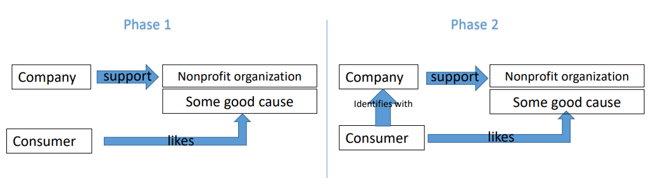
Liking of company = more than + attitude
Also purchasing products, supporting goals, w-o-m & defend against negative info
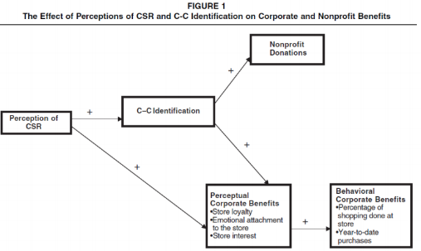
Hypotheses:

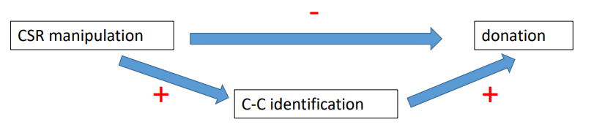
4 studies
= zie slides!
Opmerkelijk in 2e studie
Direct – impact of CSR manipulation on donations
Indirect + effect via CC identification
3e studie: misschien omdat je doneert aan ‘goed’ bedrijf, delegates responsibility of doing good
= consumers don’t feel like they need to donate themselves bc company already does it

Conclusions
- Engaging in CSR: benefits company & beneficiary
- Mediated by higher ID of customer with company
= motivated to support the supported organization
- Direct – effect, but seems to be supportive action of consumers who see company catching up on issue
- Cause should be aligned with dimension for which company engaging in CSR performed poorly
Effect of * cause aligned with poor track record additive to effect C-C id
- On top of expected effect that CSR increases support for cause via identification, negative CSR enhances support but only if CSR helps company (credible catch up for past lack)
- Limitations
  - Lack of control condition
  - Not sure what happens to non-customers of CSR-ing company
(assumption no effect)
- Overall conclusion
= non-profit benefits in direct & indirect way via consumer perceptions

3. OVERALL CONCLUSION
- CSR is not social marketing
- Aim to do something good for society
= benefitting one of company’s stakeholders
- Differs ito focal aim
- May be lined internally if success in CSR-cause becomes important aim for company
- May be “authenticized” if a company separates from its CSR cause

