Strategy process
1. FORMULATION & EXECUTION
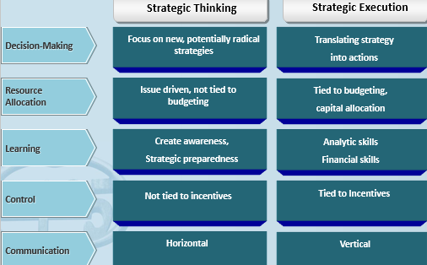
Strategy formulation & strategy implementation
If you execute a bad strategy very good, still not good
The management system
Translate strategy into actionable elements
- Develop the strategy
- Translate the strategy
- Plan operations (execute processes x initiatives)
- Monitor & learn
- Test & adapt the strategy
- Back to 1.

! The CEO matters
= significant effect of CEO∆ on investment policies, # acquisitions, R&D + advertising,….

2. CHALLENGES IN EXECUTION
1. Think about your network
= Who do you go to for advice

2. Biases in decision making

1. Overconfidence & overoptimism
= Overestimating skills tov others, taking credit for past outcomes, overestimate likelihood + events
e.g. in hospital after accident, drivers overestimate driving abilities
Counter:
- Test strategies
- Add 20-25% more downside to most pessimistic scenario
- Build more flexibility x options into strategy to allow company to scale up/ retrench as uncertainties are resolved (learn-to-burn rate)

2. Confirmation bias & Group Think
= Overweighting of evidence consistent with favoured belief/ failure to search impartially for evidence
= striving for consensus at cost of realistic appraisal of alternative courses of action

Counter:
- Create culture of challenge
- Strong checks x balances with independent review
- Challenger team
- “Pre-mortem” analysis

3. Loss aversion (prospect theory)
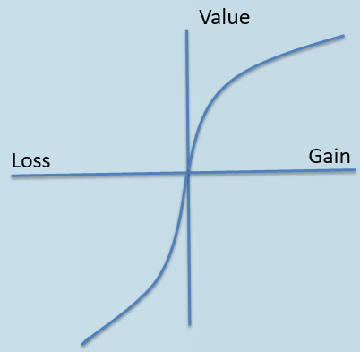
= tendency to feel losses more acutely than gains of same amount, * more risk averse than rational calculation would suggest

Counter:
- * stretch targets, impossible to achieve through ‘business as usual’
- Zero-based (clean-sheet) budgeting

4. Status quo bias & preference for even allocation
= preference for status quo in absence of pressure to ∆ it
= preference for even allocations

Counter:
- Adopt radical view of all portfolio decisions, view all businesses as ‘up for sale’
- Subject status quo to risk analysis as rigorous as any ∆ options

5. Sunk-cost fallacy
= Paying attention to historical costs that are not recoverable when considering future courses of action

Counter:
- Full rigor investment analysis to incremental investments
ONLY looking at incremental prospective costs x revenues
- Kill strategic experiments early if necessary
- Use “gated funding” for strategic I

