Value creation & value capturing

1. IS VALUE CREATED IN BUSINESS?
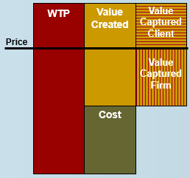
Willigness to pay?
= max someone is willing to pay, ≠ price!
Value created
= WTP - cost of providing gxs
Value captured
= splitted among customers & bs
! No sales, no captured value

Drivers of value creation
- What affects WTP?
  - Quality of service
e.g. how much more are you willing to pay for a Husky machine relative to a competitor
= based on calculations!
- What affects costs?
= the more you offer, the more costly

2. IS VALUE CAPTURED & SUSTAINED BY BUSINESS?
= relative to the capital invested

Drivers of capturing & measuring value
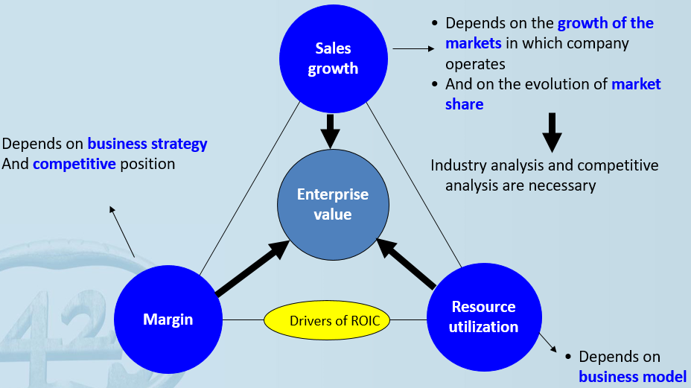
Incl elements of today & future

How much sales/ euro you invested in bs (all I)

Fundamental metrics for measuring & evaluating performance
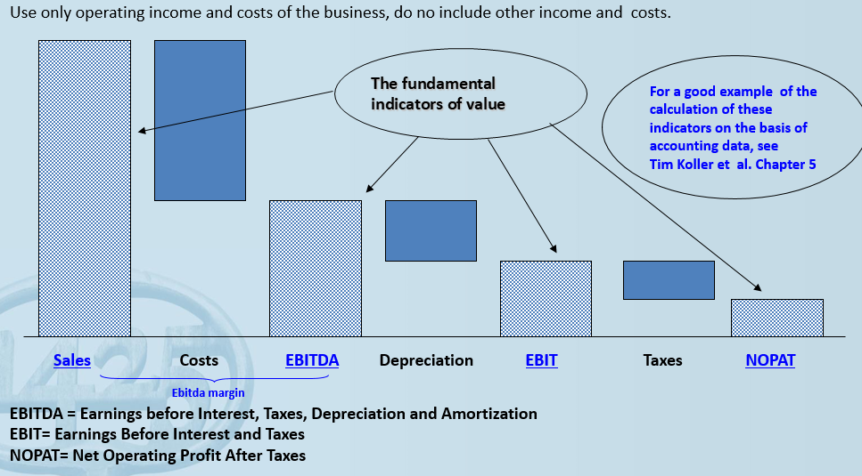

NOPAT – tasks advantage as consequence of debt financing = NOPLAT
- Interest charges in general reduce corporate taxes
- Advantage should be eliminated from results
- Elimination: * comparable over time x across firms when financial structures differ
- Focuses on strategic issues, nog financing issues

Calculate ROIC
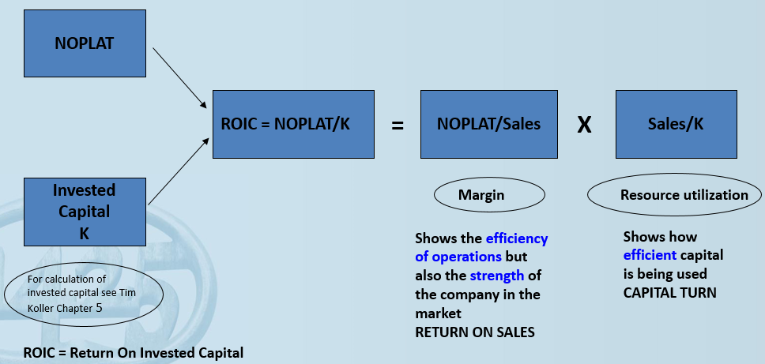

Invested capital
= cumulative amount bs has invested in core operations, primarily property, plant & equipment x working capital
= Fixed assets + inventories + trade receivables – current liabilities
= equity + non-current liabilities – cash

Economic profit/ economic value added
= most important
- Calculate WACC
= K_{e} . E/(E+D) + K_{d}. (1-t) . D/(E+D)
K = E+D
K_{e/d} = cost of equity/debt
- Calculate economic value added (EVA)
= NOPLAT – WACC.K
Only concentrating on highest ROIC doesn’t max EVA
All projects ROIC > WACC = generate EVA
Discontinuing projects with ROIC < WACC = generate EVA

Determining free cash flow
= NOPLAT – net investments
= NOPLAT – (gross investments – depreciation)
= NOPLAT – ((strategic I + replacement I + ∆ working capital) – depreciation)

Drivers of free cash flow
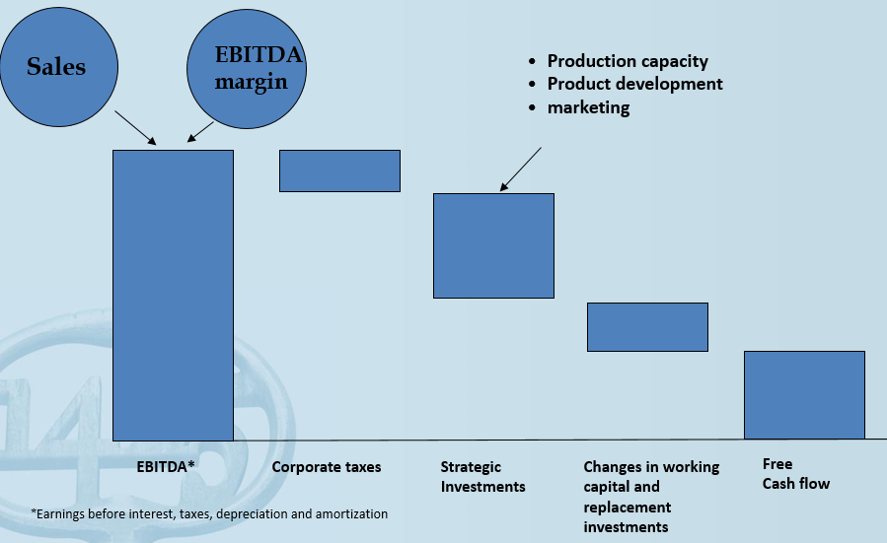

Enterprise value
= Sum discounted CF + discounted terminal value
= multiple of EBITDA
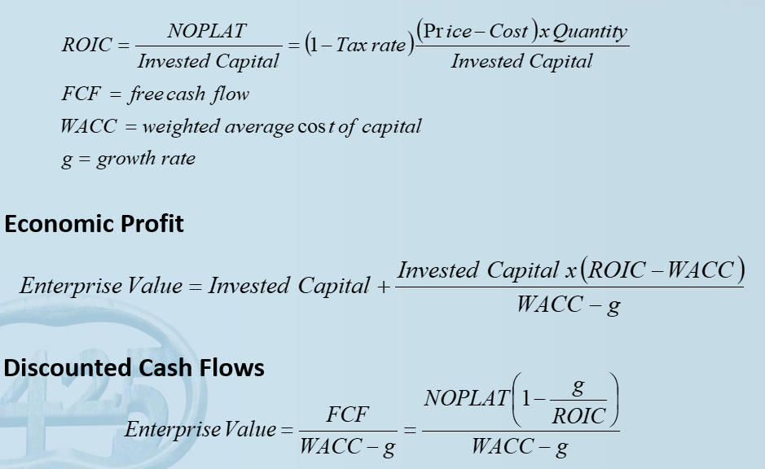
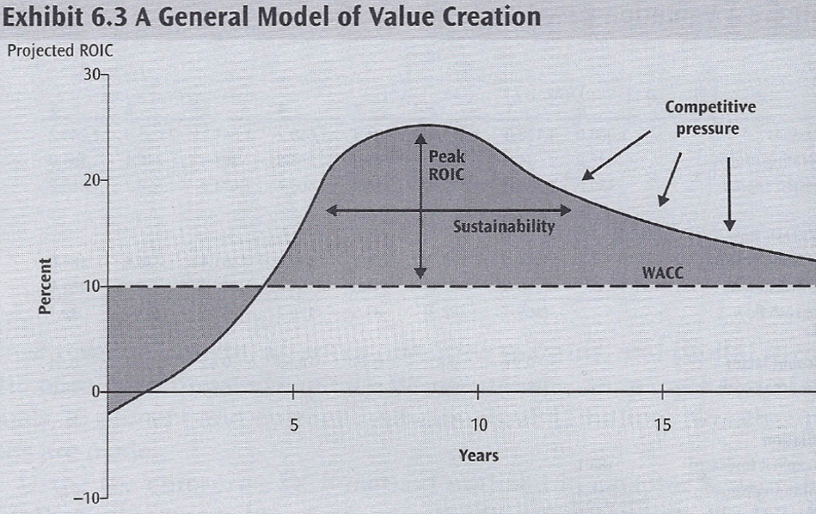
A strategy creates economic value…
= when enterprise vale > invested capital
= Sum discounted value eco profit > 0
- Several periods ROIC > WACC
  - Margins are larger
  - Use of capital more efficient
- Growth realized in activities where ROIC > WACC

Make sure creation eco profit/EVA sustained as long as possible

Performance differences btw companies
- Industry & environment
- Business cycle
- Competitive position (positioning)
= activities, how they are connected & creating value for customers
- Other unexplained

Importance of coherence & consistency!!!

