UML

Class: groups objects with similar characteristics
(abstraction of individual properties and focus on essential common properties)

Level 0: instances or object level (for class student: Henry, Calvin, Ana,..)
Level1: model/diagram level

Modelling: abstraction Level 0-> level 1
Validation of a model level 1->level 0 (=reasoning on an example)

Class:
- Template (object type)
“intent” = definition of class membership (ex. is a student if signed up)
(captures characteristics of objects in a class)

- “extent” of a class (which objects are in a class)

Class definition (=description of when an object is a member of that class)

Attributes:
Objects in a class are described by attributes(name, student number,…)
Each object has a value for an attribute(Calvin, Ana,….)
Each attribute has a data type(INTEGER, STRING,…)

Instance = a specific representation of an object

Association:
Relates classes and represents a collection of links between objects (of these classes)
Represents a type of link, with specific characteristics: (like optional or mandatory to have a link with other objects)
Minimum or maximum amount of objects we will find on the other side of the association. [min,max]
[0, *]
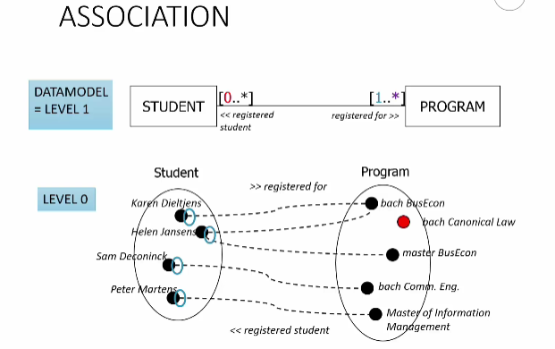
Student can be registered for min 1, max many programs :
An association can be written in 2 directions. These directions are called “roles” of the association.
Role from student to program is “registered for” (role name is put next to the destination class of the role)
Or role name in the middle,( role name is not mandatory)
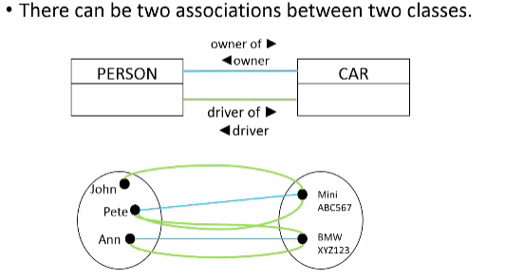
Unary association: connects a class to itself (ex. people are related to each other)
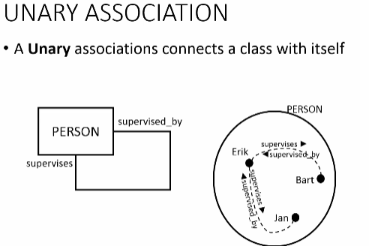
(Erik supervises Bart and Jan. Bart and Jan are supervised by Erik.)

Ternary association: 3-way association (when not possible to know exactly which used what)
(for supplier: look at all project product pairs to determine the general rule)
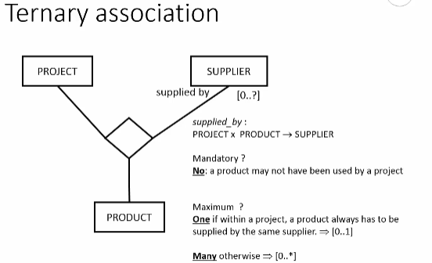
- So for this example, in order to determine what to write next to the "supplied by" role,
- we need to consider all project-product pairs, and see how many suppliers we find.
- The role will most likely not be mandatory: some products will not be used by all projects.
- For those pairs, we won't find any suppliers. So the minimum is 0.
- For the maximum, it depends on the rules. If within a project, a product always has
- to be supplied by the same supplier, then the maximum is one. If you can source a product
- from many suppliers within the context of a single project, it may be many.

Exercise Ternary associations
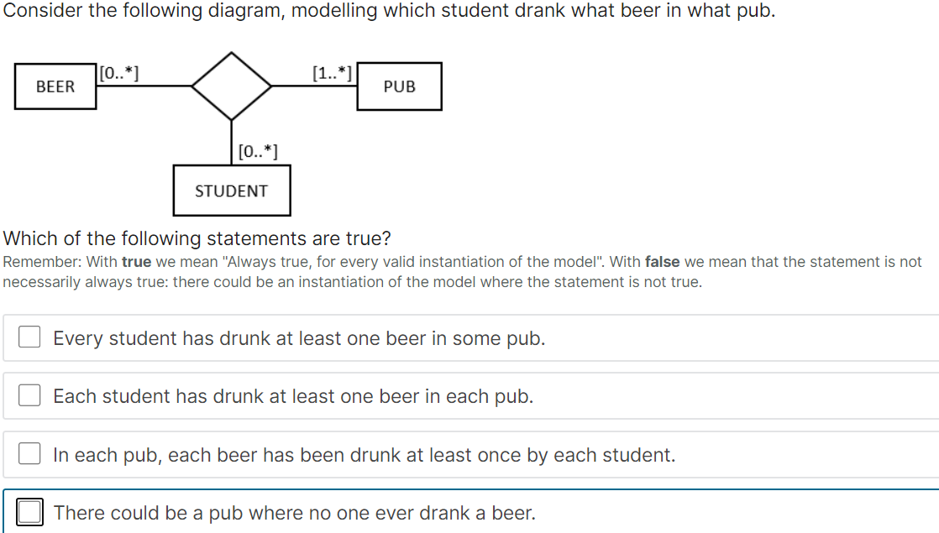

Generally, an optional mandatory association end does not induce any constraint. So, the interesting part to look at, is the mandatory constraint on the side of pub.
The mandatory constraint on the side of pub means that each possible combination of a student and a beer corresponds with at least one pub.

2 or more pairs could be in 1 pub, 1 pair could be in many pubs.
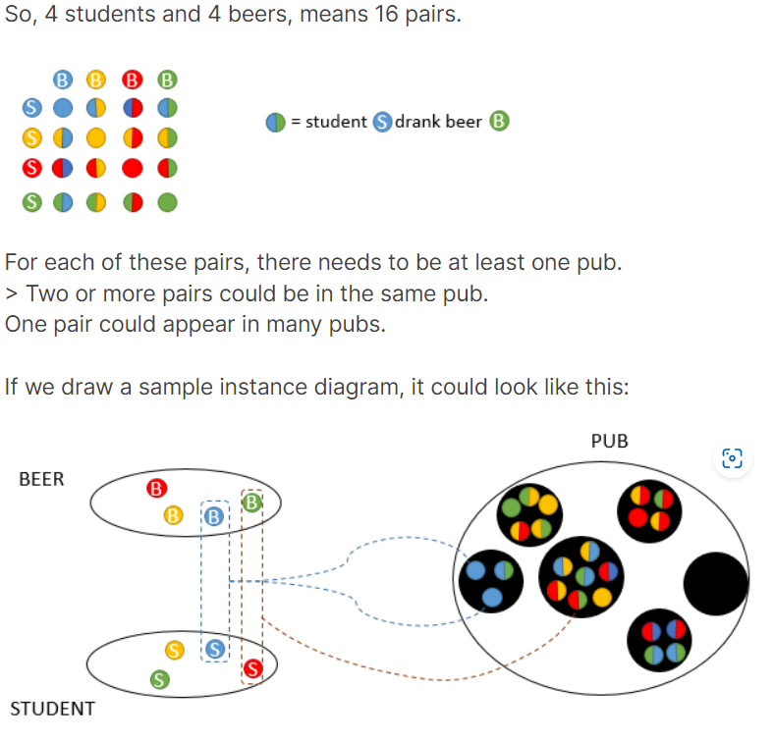
The minimum 1 on the side of pub means that for each pair of (student, beer) there is at least one pub.
On the other hand, for a pair (student, pub) it is not mandatory to have a beer. So, given a student, there could be pubs that this student didn't visit.
Likewise, for a pair (beer, pub) it is not mandatory to have a student. So, given a pub, there could be beers that have never been drunk in that pub. (a,b)

the mandatory constraint on the side of pub means that each possible combination of a student and a beer corresponds with at least one pub where the student has drunk that beer.
The other association ends are optional. So a (student, pub) pair doesn't need to always have a beer drunk by this student in that particular pub.
And similarly, a (pub, beer) pair will not always have a corresponding student who drunk this beer in that pub.

There are no students that never drunk beer.

Aggregation :
(some associations convey “part of” relations or composition) (ex. course is composed of a number of modules)
White diamond: shared aggregation
Black diamond: composite aggregation

Shared aggregation: parts can be shared across different wholes
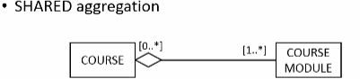
Course modules can be shared across different courses

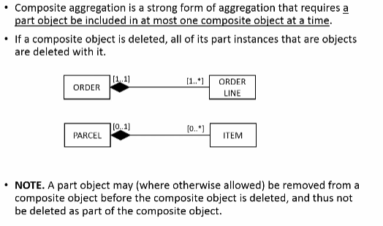
Composite aggregation: stronger form of ownership
Parts are owned by only 1 whole
The composite object has a responsibility for the existence and storage of the composed objects
A part object is to be included by at most 1 composite object at a time
If a composite object is deleted, all of its part instances are deleted with it.
Note: a part object may be removed from a composite object before the composite object is deleted (and thus part object not deleted)(allowed)

The diamond could be removed , no problem (is syntactic sugar)
(best to use conventional binary association with appropriate role names)

Implicit associations:
(Associations can be used to navigate from 1 object to the next along consecutive paths. This implies the presence of implicit associations between classes.)
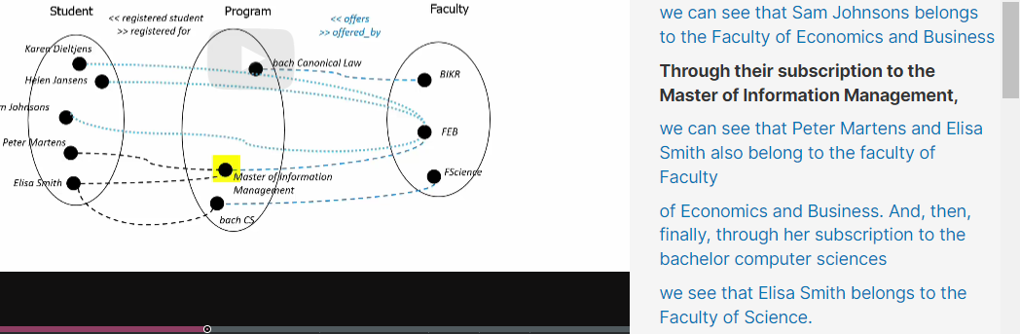

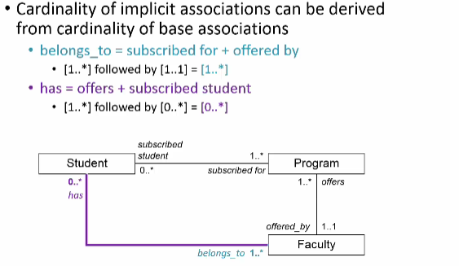

Parallel paths: do not ensure ending up with the same objects
When you have 2 paths to navigate from 1 class to the another, then the sets of paths will be different
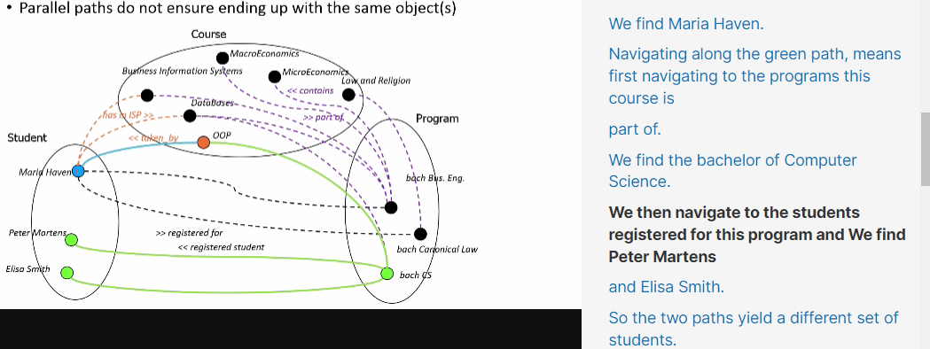

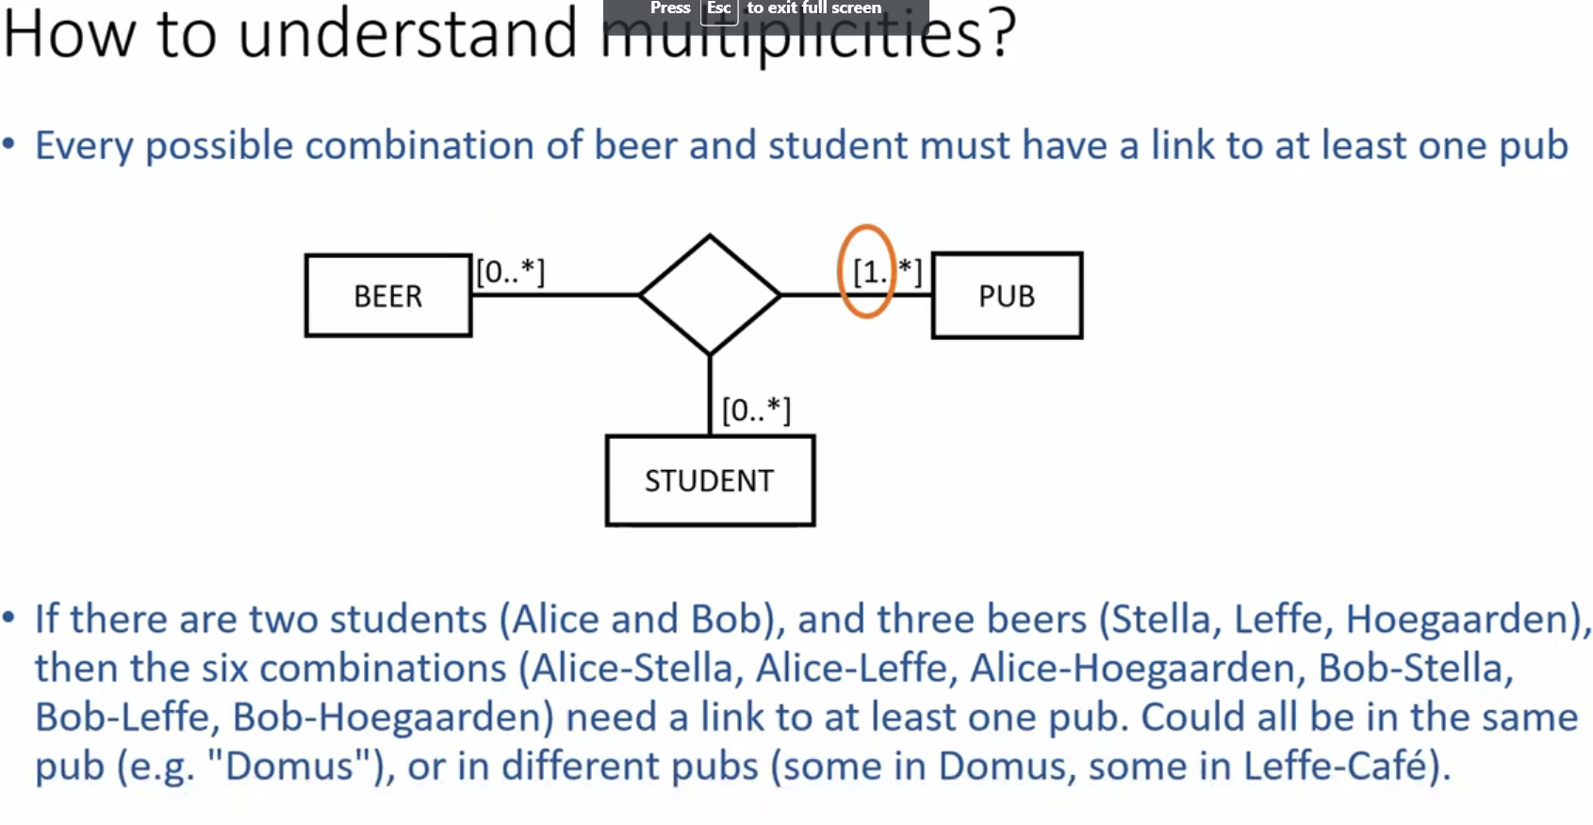

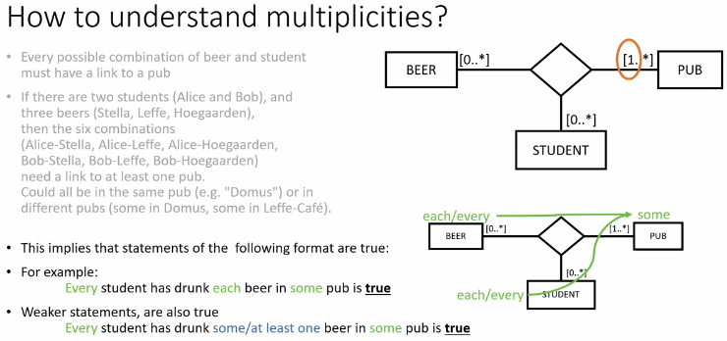
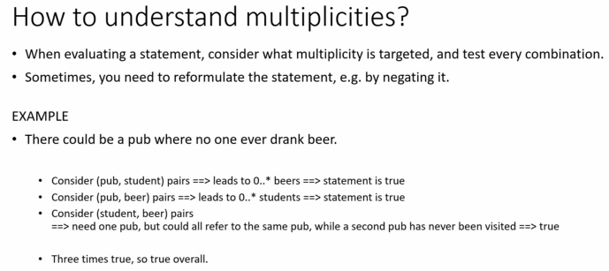
She will ask ternary associations



