Economics of Innovation & Intellectual Property

1. Introduction

History
- GDP, life expectancy and productivity all increased massively past 200y
- Rise started with industrial revolution
Technological change & innovation cause increase in productivity
Better productivity leads to economic growth

Innovation in Society
- Innovations generally benefits economic growth and thus society
- Key issue: firms invest less than is socially optimal in innovation
    - Society benefits more from innovation than the individual businesses
    - Hard to finance for small companies
Governments need to intervene
- Productivity growth is slowing again, even though we invest more in R&D than ever
- EU-goal: 3% of GDP must go to R&D, now about 2%

Innovation Definitions
- Knowledge
    - Codified: can be written down
    - Tacit: is embodied in individuals, can’t be transferred easily
- Technology
    - Production techniques used to design, make, package and deliver goods
    - Application of selected parts of knowledge
    - Combined with other inputs (energy, capital…) this determines productivity
- Invention
    - Idea resulting from a chance or systematic research
    - Inventions are knowledge
- Innovation
    - Turning an invention into an economically viable good
    - Innovation is a technology that solves a problem
    - Cannot happen without invention
- Diffusion
    - Process through which innovations become used by others
    - Source of societal welfare: reaping gains of better technology
    - Reaching individuals and groups external to the innovator
- Product innovation: new or significantly improved product
- Process innovation: cost reduction, quality increase…
- Marketing innovation: new marketing methods (design, packaging…)
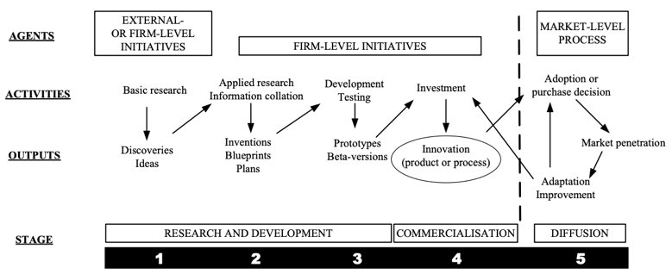
- Organisational innovation: new business practices for organising procedures
R&D
- Inventions mostly generated by R&D
- Substages
    - Basic research (10%)
      - Gain understanding without specific application in mind
    - Applied research (30%)
      - Solve a certain problem
      - Process in basic research allow more applied research
    - Development (50%)
      - Use (old) knowledge in new products & processes
- Who invests
    - Private sector
      - Intangible assets becoming more important for success
      - Try to protect innovations from benefiting competition
    - Public sector
      - Government provides incentives, infrastructure and compensation in areas where firms underinvest through policy

2. Micro-economics of Innovation

Simplifying Assumptions
- Goods are homogenous
- Perfect competition, firms compete on price
- Innovation = process innovation
    - Reduction of MC
    - Drastic: outcompetes others, innovator becomes monopolist
    - Non-drastic: innovator still constraint by competitive price

Drastic Process Innovation
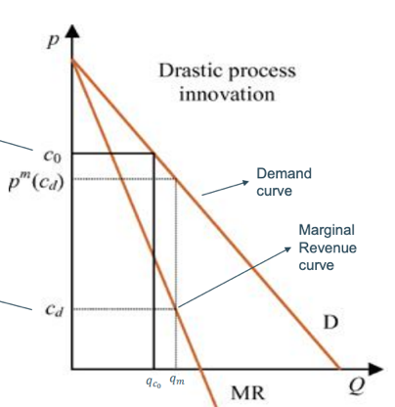
- Before innovation
    - MC = c₀
    - Competitive market: p = c₀
    - Profit: π = q_{c} * (p – c₀) = 0
- After innovation
    - MC lowers to c_{d} << c₀
    - Innovator can set price p_{m} < p
    - Other firms lose money with price at p_{m}
    - Innovator becomes monopolist
    - Profit: π_{m} = q_{m} * (p_{m} – c_{d})
    - Recall: price maximisation at Q where MR = MC

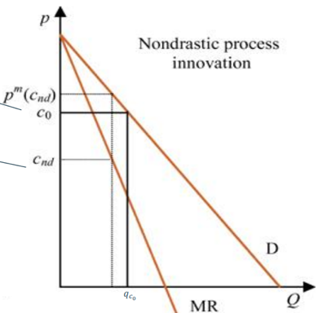
Non-drastic Process Innovation
- Before innovation (see above)
- After innovation
    - MC lowers to c_{nd} < c₀
    - Monopoly price p_{m} still higher than original p
    - Innovator keeps price at original level p
    - Innovator becomes monopolist
    - Profit: π_{m} = q_{c} * (p – c_{nd})

3. R&D, Innovation and Market Structure

Reasons for Innovation
- Joseph Schumpeter: first to link innovation and market structure
    - Schumpeter mark I:
‘Innovation happens because dominant firms are outcompeted by start-ups with better ideas. It is about the individual.’
    - Schumpeter mark II:
‘Innovation happens because dominant firms have a lot of resources to develop new inventions, and short-term monopolies guarantee returns. It is about large firms with a lot of market power.’
- Advantage of large firm innovation (Schumpeter mark II)
    - Externalities: firm with many products can better exploit innovation
    - Indivisibilities: with large fixed investments, large firms have more resources to exploit economies of scale and scope
    - Uncertainty: large firms have more resources to cope with risk
- Empirical facts about firm-size and R&D correlation
    - Probability of R&D increases with firm size, spending is proportionate
    - R&D productivity decreases per unit of spending as size increases
    - Small firms: more R&D in research phase & small development processes
    - Large firms
      - Specialize in larger developments
      - Buy considerable fraction of the research basis for next innovations
      - Still benefit despite lower avg. R&D productivity because of lower avg. cost of R&D
Arrow Model
- Assumptions
    - Homogenous product, no differentiation
    - Inverse demand of p = 100 – Q
    - Constant MC = c₀ = 50
    - Non-drastic innovation, no uncertainty, MC drops to c₁ (= 25) < c₀
- Question: what is profit incentive to innovate?
    - Equal to additional profit realized by the innovation
    - Can be seen as price to buy an innovation
    - Compare: monopolist, perfect competitive market and social planner
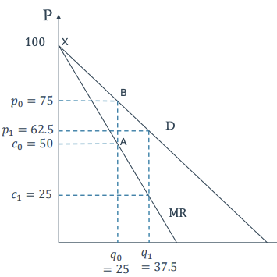
- Monopolist
    - Before innovation
      - Price p₀ = 75 (MC = MR)
      - Profit π₀ = q₀ * (p₀ – c₀) = 625
    - After innovation
      - Price p₁ = 62,5 (MC = MR)
      - Profit π₁ = q₁ * (p₁ – c₁) = 1406,25
π₁ - π₀ = 781,25
- Perfect competition
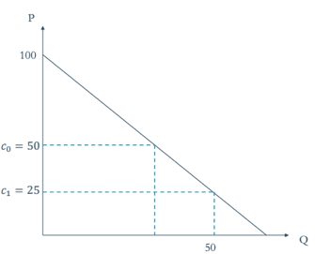
    - Before innovation
      - Price p₀ = 50 (= c₀)
      - Profit π₀ = q₀ * (p₀ – c₀) = 0
    - After innovation
      - Price p₁ = 50 (= c₀)
      - Profit π₁ = q₁ * (p₁ – c₁) = 1250
π₁ - π₀ = 1250
- Profit incentive higher in perfect competition since no-one makes profit without innovation
    - “What’s the point of focusing on making the product even better when the only company you can take business away from is yourself.” – Steve Jobs
    - ‘Replacement effect’
    - Only holds up for non-drastic innovation
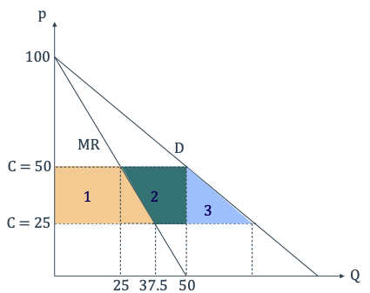
- Social planner
    - Tries to maximize social welfare, minimizes DWL
    - Consumer surplus that is unaccounted for: 3
    - Value of innovation
      - Monopolist: 1
      - Competitive firm: 1 + 2
      - Social value: 1 + 2 + 3

Product Innovation
- Less clear predictions
    - Account for product differentiation & price discrimination
    - Less replacement effect when older products still sold
- Non-drastic innovation
    - Competitive firm has lower replacement effect than monopolist
Higher incentive to innovate
    - Monopolist can sell more units and price discriminate
Higher incentive to innovate
- Drastic innovation
    - Makes old product obsolete
    - Competitor greater incentive if competition in old product gets intense

4. Innovation in Oligopolies

Basic Oligopoly
- Intermediate market structure with n firms
- Based on Cournot model
    - Two identical firms, both supply market
    - Entry not possible
    - Firm 1 observes output of other and sets quantity to maximize own profit
    - Fixed quantity for set period of time
    - Strategic interaction, ‘best response model’
- Incentive to innovate greatly affected by intensity of competition
Expectation: between monopoly and perfect competition; but NO

Basic Cournot Model
- Levels of output: q₁, q₂
- Market price linear: P(Q) = a – b(q₁ + q₂)
- Profit firm 1: π₁ = p(Q)q₁ – cq₁ = [a – b(q₁ + q₂)]q₁ – cq₁
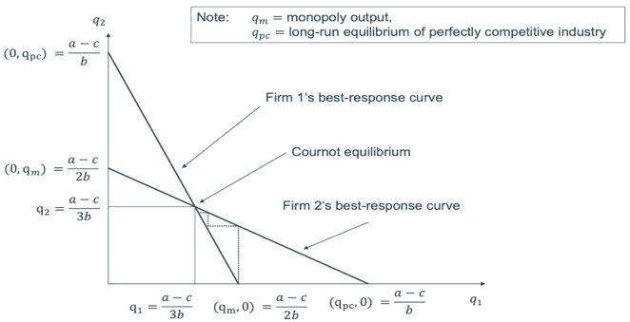
- Max. profit firm 1: a – 2bq₁ - bq₂ – c = 0
Reaction functions: q₁ = (a – c) / 2b – (1/2)q₂
q₂ = (a – c) / 2b – (1/2)q₁
Combined: q₁ = (a – c) / 3b
Back in profit function: π₁ = (a – c)² / 9b

N-firm Oligopoly
- Levels of output: q₁, q₂…, q_{n}
- Profit firm 1: π₁ = p(Q)q₁ – cq₁ = (a – b$\sum_{2}^{n}{q_{i}}$)q₁ – cq₁
- Max. profit firm 1: a – 2bq₁ – b$\sum_{2}^{n}{q_{i}}$ – c = 0
- Symmetry among firms: Q = N*q
Combined reaction: q₁ = (a – c) / (N + 1)b
Back in profit function: π_{i} = (a – (n – 1)c_{i})² / (n + 1)²b

Profit Incentive by Innovation
- Cournot duopoly with asymmetric costs for firm i
π_{i} = (a – 2c_{i} + c_{j}) / 9
- Before non-drastic innovation
    - c_{i} = c_{j} = c₀
    - π_{pre} = (a – c₀)² / 9 for both firms
- After non-drastic innovation of firm i
    - c₁ < c₀ for firm i
    - π_{post, i} = (a – 2c₁ + c₀)² / 9
- Profit incentive
    - PI = π_{post, I} – π_{pre} = … $= \frac{4}{9}(1+\frac{c_{0}-c_{1}}{a-c_{0}})(\frac{c_{0}-c_{1}}{a-c_{0}}){(a-c_{0})}^{2}$
    - Define $ψ=\frac{c_{0}-c_{1}}{a-c_{0}}$as relative size of innovation; 0 < $ψ<1$
PI = $\frac{4ψ}{9}(1+ψ){(a-c_{0})}^{2}$ ; larger innovation means higher PI
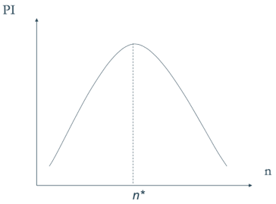
- N-firm oligopoly
    - Now depends on size n and $ψ$
    - Increase in n raises PI if $ψ$ is large enough
PI = $\frac{nψ}{{\left(n+1\right)}^{2}}(2+nψ){(a-c_{0})}^{2}$
    - Sign of PI(n + 1) – PI(n) depends on sign first term, positive when $ψ$ is over some threshold
- Empirical evidence inverted U-shape
    - Measure competition
      - Lerner index: proxy competition through price-cost margin
$L= \frac{p-c}{p}$
      - Herfindahl index: proxy competition through market concentration $H= \sum_{i=1}^{N}{s_{i}^{2}}$ with s_{i} as market share of firm i and N total firms

4. Innovation Models with Entry

Models with Entry
- Several firms have simultaneous innovation opportunity
    - Innovation as a competitive tool when thinking about entry
    - Other firms might innovate if you don’t

Gilbert & Newberry’s Action Model
- Innovation is certain
    - Highest bid wins patent with certainty
    - Patent provides perfect protection
    - No licensing
- Entrant and incumbent might acquire innovation
- Entrant can only enter profitably with innovation

- Who will place highest bid for innovation (= has highest profit incentive)
    - Incumbent gets innovation: entrant stays out, $π_{m,i}(c_{1})$
    - Entrant gets innovation: $π_{d, i}(c_{0}, { c}_{1})$, $π_{d,e}(c_{1}, { c}_{0})$
- If entrant gets innovation, both have duopoly profit
- G&N model takes time-discounting into account with factor r
    - $V_{e}= \frac{1}{r}π_{d,e}(c_{1}, { c}_{0})$
    - $V_{i}= \frac{1}{r}{(π_{m, i}\left(c_{1}\right)-π}_{d, i}\left(c_{0}, { c}_{1}\right))$
- If products are close substitutes, the incumbent has a higher incentive if the monopoly profit is larger than the sum of the duopoly profits with and without cost advantage
    - $V_{i}> V_{e}$ if ${π_{m, i}\left(c_{1}\right)>π}_{d, i}\left(c_{0}, { c}_{1}\right)+ π_{d,e}(c_{1}, { c}_{0})$
- Efficiency effect: threat of losing monopoly provides incumbent strong incentive to innovate
- Significantly differentiated product
    - Entry may increase size of market due to non-buyers buying or buying twice
    - Incumbent has less to lose, replacement effect smaller

Patent (or Technology) Race Model
- Add time and uncertainty to model
    - First mover advantage; first to file patent reaps its profits
    - Discovery time unpredictable but can be reduced with extra R&D spending
- Standard race: winning firm obtains patent, others lose R&D expenditures
- Asymmetric race
    - Incumbent firm tries to prevent rival filing patent, avoiding competition
    - Incumbent only cares about maintaining monopoly, not innovating
- Firms decide how much / when to invest in R&D
- Model set up
    - Two firms, each considers R&D expenditures of $f$
    - Probability of R&D success is p
- Model
    - If only one firm is successful p(1 – p), monopoly profits are earned
NPV = p(1 – p) $π_{m }$
    - If both are successful, duopoly profits are earned
NPV = p²$π_{d }$
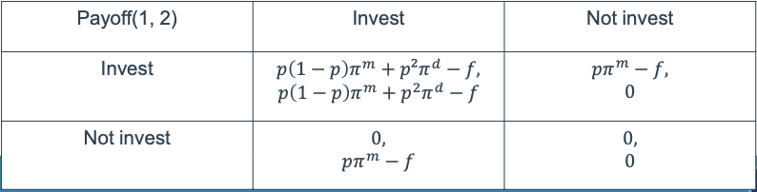

    - Nash equilibrium in (Invest, Invest)
      - Both firms invest if $f≤p\left(1-p\right)π_{m}+p^{2}π_{d}-p^{2}{(π_{m}-π}_{d})≡f_{2}^{pu}$
      - Thus $f_{2}^{pu}=f_{2}^{priv}-p^{2}{(π_{m}-π}_{d})$ if $π_{m}>π_{d}$ and $f_{2}^{pu}<f_{2}^{priv}$
      - Meaning as long as fixed cost of R&D $f_{2}^{pu}<f<f_{2}^{priv}$, both firms invest but aggregate profit would be higher with only one innovator
      - ‘Socially excessive R&D’ if f is between thresholds, overinvestment

- ‘Wasteful’ R&D
    - In reality does not really exist
    - Chance of doing unexpected discoveries along the way
    - Disclosed research helps future research
    - Social benefits go beyond simplification of aggregate profits
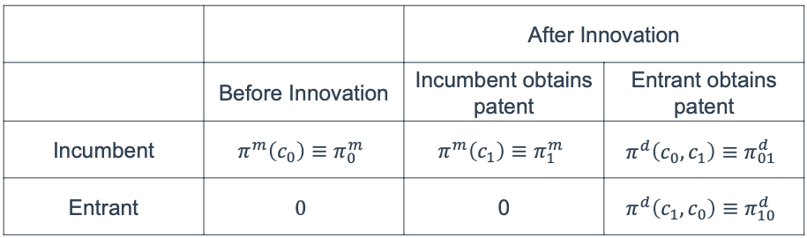
- Asymmetric race
- Equilibrium depends on balance of efficiency- and replacement effect
- Net effect is ambiguous, except for extremes
    - Minor innovation
      - Efficiency dominates, replacement not important
      - High R&D, discovery is early
    - Major innovation
      - Replacement dominates, efficiency disappears
      - If entrant discovers innovation, it becomes de facto monopolist
      - ‘Creative destruction’

5. Market Failures in Innovation: Appropriability

Types of Goods
- Private goods (ex. smartphone)
    - Technology is expensive to develop
    - The good has significant production cost
    - Competitive market: long run equilibrium at p = MC
- Public goods (ex. open-source software)
    - Only costs effort to produce
    - Everyone can use it without extra costs (MC = 0)
    - Competitive market: long run equilibrium at p = 0
    - Non-excludable: difficult to keep nonpayers from consuming
    - Non-rivalrous: use by one does not prevent use by others (at the same time)
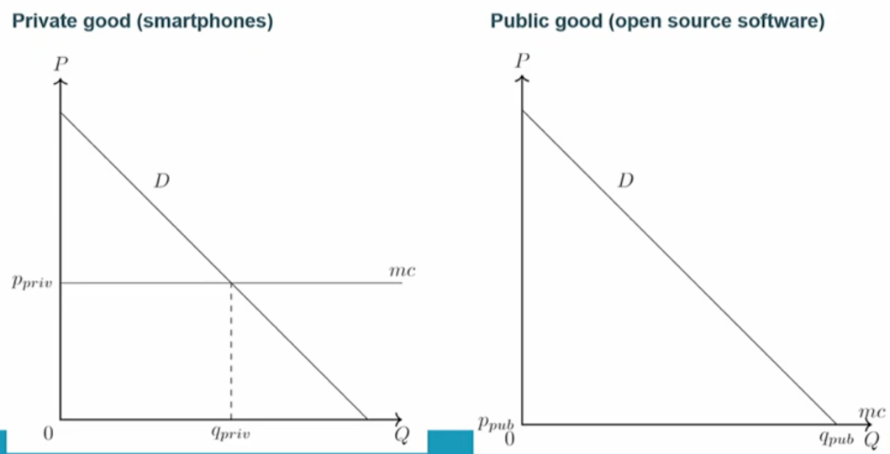
    - Negative externality: benefits ‘spill over’ to others, so full social return on investment is higher than private return

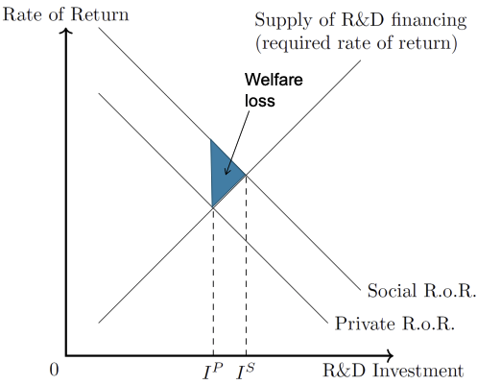
Appropriability
- Degree to which innovator captures return on investment
- Firms optimize spending decision based on private return and thus invest I^{P}, while the socially optimal level would be I^{S} due to positive externalities
Welfare loss
- Spillovers can come from inputs
    - Studying patents
    - Information leaks
    - Hiring ex-employees
- Spillovers from outputs:
    - Product imitation
    - Cumulative innovation
      - Later development can be more valuable than the original
      - Original inventor might only keep small part of social value
    - Consumer surplus
      - Producers can’t fully capture value of innovation to all users (except for specific circumstances like perfect price discrimination)
- Intellectual property does not fully solve appropriability
    - IP impact often unclear, many strategic uses of patents that are contraproductive (ex. thicketing, trolling…)
    - Ex. market share of drug does not drop firmly when patent expires
- Informal ways to protect IP are more important
    - Secrecy
      - Non-disclosure of knowledge, trade secrets
      - Reduces spillovers and increases imitation costs
      - Good solution for early state inventions
    - Lead time
      - Time required to go from concept to market introduction
      - Quicker = more competitive advantage
    - Continuous innovation to keep ahead of competitors
    - Time advantage
      - First mover advantage
      - Opportunity to set standard and shape preferences
      - Short time monopoly
    - Complexity
      - More difficult to replicate
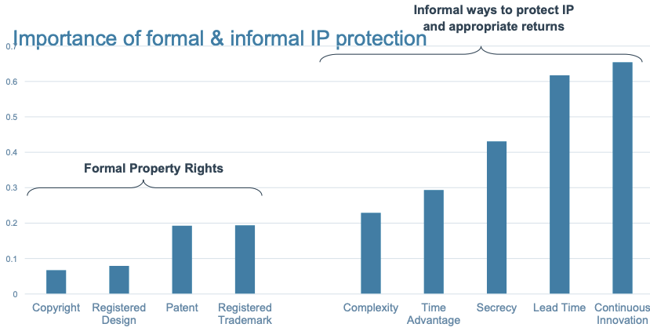
      - Use of tacit knowledge, hard to ‘steal’

- Positive side of spillovers (social view)
    - Receiving spillover increases productivity own R&D
    - Leads to higher competition

Modelling & Studying Spillover
- Decrease competitor’s MC due to own R&D investment
    - c_{i}(x_{i}, y_{i}) = c – x_{i} – βx_{j}
    - If firm i decreases MC by x, then this decreases competitor’s MC by βx
    - π_{i} = q_{i} (p_{i} – (c – x_{i} – βx_{j}))
- Czarnitzki & Kraft paper (CK)
    - Do firms with more incoming (outgoing) spillovers make more (less) profit
    - Study profit margin: profit / sales
    - Differentiate: competitors, customers, suppliers & research institutions
    - Incoming spillover defined as firm response
    - Outgoing spillover defined as industry avg of incoming spillovers
- Cappelli, Czarnitzki & Kraft paper (CCK)
    - Same study, but relates spillovers to its sources, as some might lead to own innovation more often (ex. spillover from universities)
    - Relates incoming spillovers from different sources to share of sales stemming from:
      - Market novelties: totally new products or services, mostly by spillover from research institutions & customers
      - Imitations: products new to firm’s portfolio but not new to market, mostly by spillover from competitors
- Jaffe, Trajtenberg & Henderson
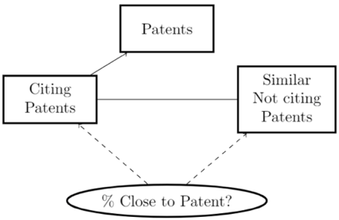
    - Geographic localization of knowledge spillovers
    - How localized are spillovers and how to overcome this
    - Traced knowledge flows through patents (they contain the location and citings to other patents, determining the scope of the patent)
Absorptive Capacity
- Ability to identify, assimilate & exploit knowledge
- Knowledge hard to appropriate (tacit & complex)
Firm needs own experience to recognize opportunities when it finds new information
- Build experience with R&D
    - Positive internal externality of R&D: investing now increases benefit from input spillovers in the future
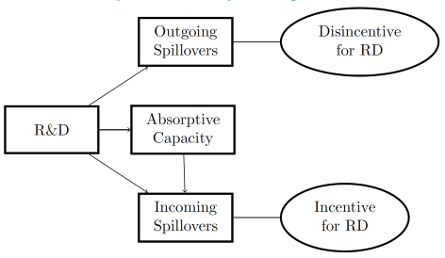
    - Limits appropriability problem: outgoing spillover reduce R&D incentives, but these are bounded by other firm’s ability to absorb knowledge
- In mathematical model we then get
c_{i}(x_{i}, y_{i}) = c – x_{i} – B(x_{j})x_{j} with 0 <= B(x_{j}) <= 1
- B(x_{j}) is capacity at which other firms can incorporate incoming spillover

6. Finance Constraints of Innovation

Financing Problem
- Investment in innovation is very uncertain, high risk
- Outcome can take long time to materialize
- Intangible output, appropriation is uncertain
- Investment can pay off the aggregate, but return on specific project highly uncertain
- Low inside collateral value (because intangible, mostly unrecoverable)
- Asymmetric information
    - Firm knows much more than investors
    - Firms can only partially be monitored
    - Moral hazard & adverse selection issues
- Most firms are cash constrained: can’t invest entire R&D themselves
- Need for VC, PE and good policy making

Model for Financing
- Demand for financing
    - Innovation comes from ideas, call this innovative capability (IC)
    - High-potential ideas executed first
      - For given expenditure I_{i} we can tell additional gain of investing more
      - Marginal rate of return (MRR) of the innovation investment
      - MRR varies by industry & firm characteristics
    - Downward sloping demand function for innovation financing
      - MRR_{i} = f(I_{i}, IC_{i}, X_{i})
- Supply for financing
    - Marginal cost of capital (MCC): return investors require
    - Investment (I)
      - More financing more expensive because of opportunity cost (other opportunities might have higher expected return (R))
      - Pecking order: cheapest funds first used
    - Internal funds (IF_{i}) are cheapest
    - Price external fundsing depends on creditworthiness and characteristics (W_{i})
    - Upward sloping supply of capital
      - MCC_{i} = g(I_{i}, R_{i}, IF_{i}, W_{i})
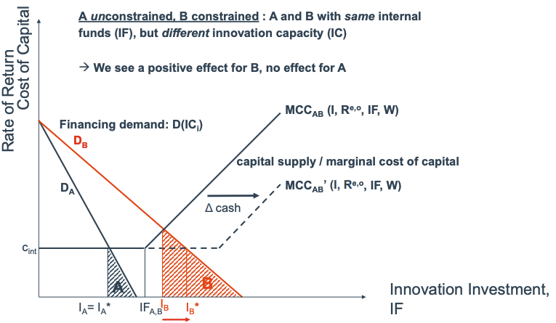
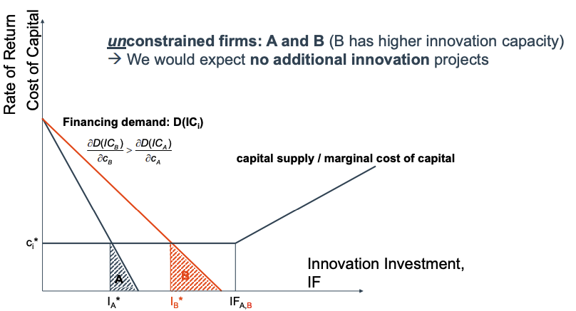
- Firms invest until marginal investment does not yield a positive return
MRR_{i} = MCC_{i}

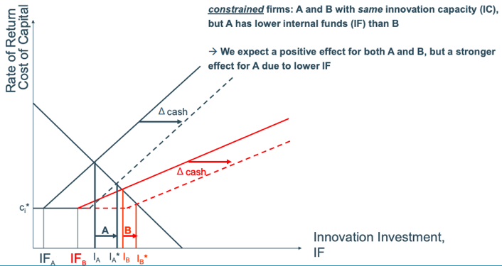
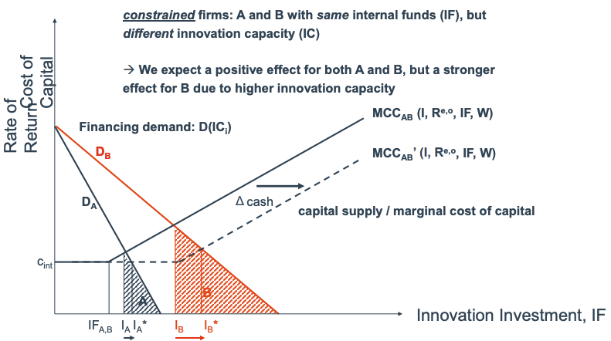

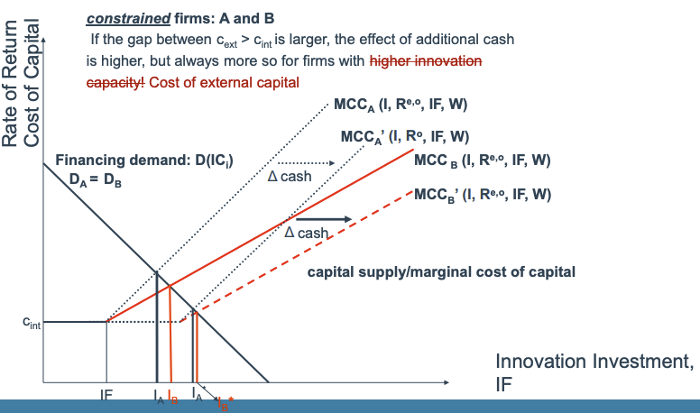

- Insights
    - Effect of additional finance depends if the firm is constrained
    - Financial constraints depend on IF & IC

7. R&D Cooperation

Cooperation in General
- Technology getting more complex difficult to keep everything in-house
- Cooperation is fastest way to acquire knowledge, removes inefficiencies
    - More resources available
    - No duplication
    - Internalizes spillovers
- Characteristics
    - Horizontal or vertical (forward or backward)
    - Within or across industries
    - Contract-based or equity-based
- Types
    - Strategic alliance
      - Contractual or informal
      - Short or long term (usually temporary)
      - Can include bilateral equity investment
    - Joint venture
      - Significant equity by both firms in new entity
      - Division of commitments & profits specified by contract
    - Licensing
      - Transfer of intellectual property right to other company
      - Can be exclusive or not, depends on price
      - Usually less expensive than developing own technology
      - Removes need to develop competing technology
    - Outsourcing
      - Other firms perform step in value chain
      - Contract manufacturing: scale but no long-term asset or labour commitments
      - Flexible, fast response time, low switching costs
      - Less earning opportunities, higher risk, transaction costs
    - Collective research organisations
      - Trade organisations, university centres, private operations…
      - Often through government or industry initiatives

D’Aspremont & Jacquemin Model
- Compare situation of cooperation and individual profit maximisation
- Assumptions
    - 2 firms, 2 stage game
    - Stage 1: invest in R&D
    - Stage 2: Cournot competition
    - Demand p = a – bq₁ – bq₂
    - Cost C_{i}(q_{i}, x_{i}, x_{j}) = A – x_{i} – βx_{j}
with 0 < β < 1 (spillover coefficient)
0 < A < a
x_{i} + βx_{j} $≤$ A
Q < $\frac{a}{b}$
    - Profit π_{i} = pq_{i} – C_{i}q_{i} – $\frac{1}{2}$γx_{i}²
- Solve through induction: find optimal output, use to find optimal R&D
    - Stage 2: get equation for both firms
      - Profit π₁ = pq₁ – C₁q₁ – $\frac{1}{2}$γx₁²
= $\left(a-bq_{1}-bq_{2}\right)q_{1}-\left(A- x_{1}-βx_{2}\right)q_{1}- γ\frac{x_{1}^{2}}{2}$
      - Maximise $q_{1}=\frac{\left(a-A\right)+x_{1}+βx_{2}}{2b}-\frac{q_{2}}{2}$
q₂ is symmetric
      - Substitute q₂ in expression of q₁
$q_{1}=\frac{\left(a-A\right)+x_{2}\left(2-β\right)+(2β-1)}{3b}$
    - Stage 1 non cooperative case: both firms optimize for their own π
      - Use equation from stage 2 to solve first stage
π₁ = $\frac{1}{9b}{[\left(a-A\right)+\left(2-β\right)x_{1}+\left(2β-1\right)x_{2}]}^{2}-γ\frac{x_{1}^{2}}{2}$
      - Max. x₁ = $\frac{(a-A)(2-β)}{4,5bγ-(2-β)(1+β)}$
      - Industry output Q = $\frac{2(a-A)}{3b}\frac{4,5bγ}{4,5bγ-(2-β)(1+β)}$
    - Stage 1 cooperative case
      - Use equation from stage 2 to solve first stage
      - Profit π = $\frac{1}{9b}{\sum_{i}^{2}{\{[\left(a-A\right)+\left(2-β\right)x_{1}+\left(2β-1\right)x_{j}]}}^{2}-γ\frac{x_{i}^{2}}{2}\}$
      - Max. x₁ = x₂ = $\frac{(a-A)(β+1)}{4,5bγ-({β+1)}^{2}}$
      - Q = $\frac{2(a-A)}{3b}\frac{4,5bγ}{4,5bγ-({1+β)}^{2}}$
- If spillover large enough: R&D is higher in cooperative case
- R&D cooperation also improves market performance as all firms compete on equal base
- Externalities from R&D spillover
    - Affects overall industry profits
      - Rises with level of spillover
      - Ignored when firms R&D separately
      - Internalized when firms cooperate on R&D
    - Affects competitive advantage
      - Decreases with level of spillover
      - Present when firms R&D separately
    - Absorptive capacity: induces larger R&D investment for similar spillover rate

R&D Collaboration as Policy
- Firms not allowed to collude but agreements that contribute to technological progress may be permitted in certain circumstances
    - Combined market share < 25%
    - No contractual restrictions on independent R&D
    - No restrictions on use of jointly generated knowledge
- Public policy trade-off between market power (collusion) and efficiency (cooperation)

8. Intellectual Property Rights

Forms of IP
- IP rights: rights given to person over creations of their mind
- Social purpose: to incentivize investments in R&D
- IP regime should also facilitate transfer of technology
- Focus of course: patent & copyright
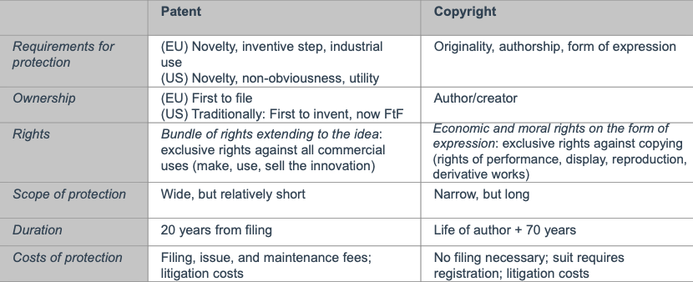
- Forms

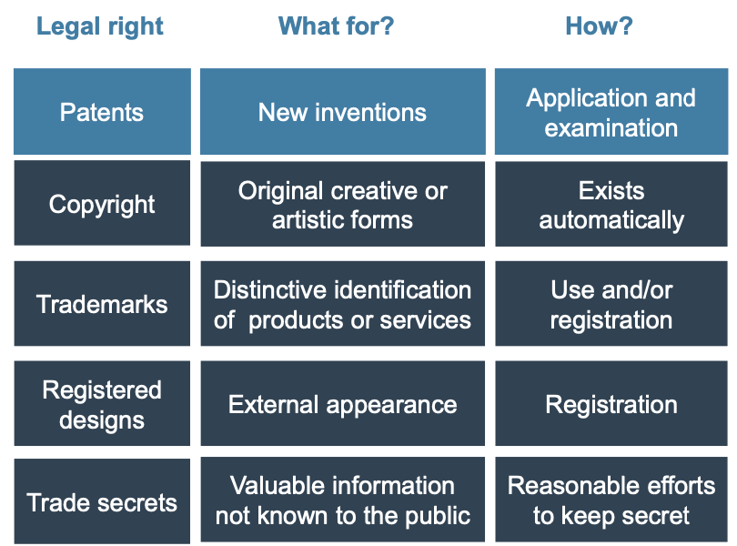
Patent
- Prevents from making, using, selling… products in country where patent was issued
- Sell rights for licensing revenue
- Up to 20 years
- Does not grant right to use invention but excludes others from using it
- What (as stated by European Patent Convention (EPC))?
    - New, not defined as state of the art
      - State of the art: everything made available to the public before filing date of the European patent application
    - Involve an inventive step: not obvious for an expert
    - Industrial application: can be produced for or applied to commercial setting
- What not?
    - Discoveries, scientific theories & mathematical methods
    - Aesthetic creations (see copyright)
    - Schemes, rules & methods for performing mental acts, playing games or doing business
    - Computer programs: includes software, but programs causing effects going beyond normal physical interaction between program and computer are patentable (grey zone)
    - Presentation of information
    - If commercial exploitation invention is contrary to public order/morality
    - Plants, animals or biological processes for the production of them
    - Methods for treatment of human/animal body by surgery or therapy and diagnostic methods practiced on the human or animal body
      - Not for products, substances or compositions
      - Manufacturing of protheses patentable, attachment procedure not
- Who
    - Any natural or legal person, inventor must be named
    - Can be multiple people
    - Right to European patent belongs to inventor or successor in title
      - Employee or the company? Depends on regional laws
      - Invention relevant to employee’s normal field of employment is generally owned by their employer
      - Inventor always has right to be named
- Application: filing
    - National patent
      - Only valid in specific country
      - Can expand into international application through right of priority
    - European patent at EPO (European Patent Office)
      - Equivalent to national patent in countries where it was granted
      - Costs depend on number of countries chosen
    - Patent Cooperation Treaty (PCT)
      - One application for 141 contracting states
      - Leads to multiple national examination procedures
      - No international patent, but can apply for multiple national patents at once
- Application: contents
    - Detailed description of at least one way of carrying out the invention
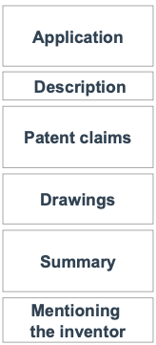
    - “Patent bargain” or “grand bargain” = disclosure of the invention in exchange for patent protection
    - Application
      - General info concerning applicant & invention
      - Definition of the application
      - Fees to be paid
    - Description: detailed info about invention, functions & uses
    - Patent claims
      - Attributes needed for realization of the invention
      - Comparison of claims in examination and during infringement claims (abstract formulation)
    - Drawings: designs with explanations, numbered components
    - Summary: name of invention, abstracts of technology and a drawing
    - Mentioning inventor: if inventor is not applicant
- Examination process
    - Formal examination
      - Correct documents
      - Analysis if technology is part of patent exclusions
    - Research
      - To which extend can it be protected
      - Needed to grant the patent
    - Examination
      - Criteria of patentability
      - Granted: opposition possible in first 9 months after grant
      - Declined: deficits listed in a document
    - Disclosure of patent application
      - After 18 months
      - Independent of the patent being granted or not
      - Everyone can find patent application and its technology
- Violation
    - Infringement lawsuit
      - Regular court
      - Patent office not responsible for this case
      - For duration of the trial the patent is considered valid
    - Claims
      - Injunctive relief
      - Right of information on extent of violation
      - Claim for indemnity on basis of lost profit & profit infringing party made or costs for a license

Opportunities | Threats
Control patent & invention | Disclosure of invention after 18 months
Exclude competition from patenting | Others can monitor innovation process
Create a legal monopoly | Application process is expensive
Signal capabilities to customers | Maintenance is expensive
Possible to communicate invention as it is now protected legally | Enforcing patent can be hard for smaller companies due to high legal costs

- Licensing
    - Price
      - Royalty per unit of output
      - Fixed fee over time
    - Terms
      - License to any fee or exclusivity
      - Auction off limited number of licenses
    - Increases diffusion of knowledge, socially beneficial
    - Increase private incentives to innovate?
      - Depends on relation licensor and licensee
      - License as additional profit source
      - Negative effect on direct competitors
      - Cumulative innovation complicates subject

Patent Economics
- Promotes dynamic efficiency, corrects underproduction problem in R&D but then others cannot use the knowledge at 0 MC anymore which can lead to underutilization (static efficiency)
- Legal protection makes invention excludable to solve underproduction problem
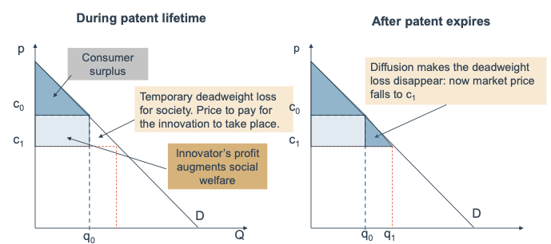
- Only lasts limited amount of time to solve underutilization problem
- Trade-off between dynamic and static efficiency: improve technological progress or maximize total surplus
- WTO TRIPS agreement defines
    - Patent length: how long do rights last
    - Patent breadth: what is the minimum to be considered “new”
    - Trade-Related aspects of Intellectual Property Rights

Patent Length
- Innovator revenue
    - Monopoly profits up to time T: π^{m}
    - Competitive profits in perpetuity: $\overline{π}$ < π^{m}
    - Discounted value of innovation
$$P\left(T\right)= \int_{0}^{T}{e^{-rt}π^{m} dt+ \int_{T}^{∞}{e^{-rt}\overline{π} dt}}$$
with income stream of amount x at interest rate r
- Innovator cost
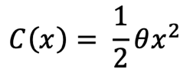
    - Assume convex cost function
    - θ = efficiency of existing technology, lower means more efficient
    - x = innovation success probability

- Maximization for the innovator
$$xP\left(T\right)-C\left(x\right)= xP\left(T\right)-\frac{1}{2}θx^{2}$$

$$\frac{d}{dx}xP\left(T\right)-\frac{1}{2}θx^{2}=0$$

$$x^{*}\left(T\right)= \frac{P\left(T\right)}{θ}$$
- Social return:
    - W = sum of consumer surplus & industry profits
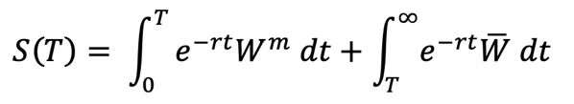
    - DWL: W^{m} < $\overline{W}$

- Social maximization
$$\max{S(T)}-C\left(x\right)=\max{x^{*}\left(T\right) S\left(T\right)}-\frac{1}{2}θ{(x^{*}(T))}^{2}$$

$$\frac{∂x^{*}\left(T\right)}{∂T}S\left(T\right)= x^{*}(T)(θ\frac{∂x^{*}\left(T\right)}{∂T}-\frac{∂S\left(T\right)}{∂T})$$

    - Left hand side: marginal dynamic gain
      - Increase in patent length increases incentive
      - Yielding benefit to the degree that social welfare is increases
    - Right hand side: marginal static loss, higher length means
      - Increased cost due to higher R&D investment
      - Decreased consumer surplus for longer patent length
Conclusion: optimal patent length is always finite

Patent Breadth
- Dimension to limit excessive monopoly power
- Studied in 2 types of innovative environments
    - Horizontal competition
      - Product space: how similar can product be without infringement
      - Technology space: how costly is finding non-infringing substitute
    - Cumulative innovation: innovation may be supplanted by improved product
- Broader patent means: excludes more substitutes, more costly to make replacement
- Breadth measured by parameter $b∈[0,1]$
    - Profits: π(b) with π(1) = π^{m} and π(0) = $\overline{π}$
    - Welfare: W(b) with W(1) = W^{m} and W(0) = $\overline{W}$
    - As with patent length π’(b) > 0 and W’(b) < 0 opposite effects
    - Write private & social returns as
$$P\left(T,b\right)= \int_{0}^{T}{e^{-rt}π^{m}(b) dt+ \int_{T}^{∞}{e^{-rt}\overline{π} dt}}$$

$$S\left(T,b\right)= \int_{0}^{T}{e^{-rt}W^{m}(b) dt+ \int_{T}^{∞}{e^{-rt}\overline{W} dt}}$$
    - Innovators F.O.C. then becomes
$$x^{*}\left(T,b\right)= \frac{P\left(T,b\right)}{θ}$$
- Find optimal mix between length & breadth, anticipating the innovator’s optimal conduct
    - Maximize S with respect to T and b with x fixed at some level
    - Approach by reformulating social value of innovation as a function of only breadth: S(T(b), b)
    - Now differentiate with respect to breadth yields:
$$\frac{dS(T\left(b\right),b)}{db}= \frac{∂S}{∂T}\frac{dT}{db}+\frac{∂S}{∂b}= -\frac{∂S}{∂T}\frac{\frac{∂P}{∂b}}{\frac{∂P}{∂T}}+\frac{∂S}{∂b}$$
    - Sign of the expression determines optimal patent policy
      - If $\frac{dS}{db}>0$: increasing breadth is welfare enhancing
      - If $\frac{dS}{db}<0$: optimal patent is narrow and long
- Theory predicts that optimal patent policy is either narrow and long or broad and short
current one-size-fits-all legislation likely not optimal

Patenting Issues
- Surge in patenting past decades, why?
    - Shift in technology, more biotech and ICT where patenting is common
    - Patent portfolio effect: patents can be more valuable when aggregated
    - Increasing importance of strategic patenting
- Patent thickets
    - Webs of intellectual property rights that partly overlap
    - Innovators relying on patent have to license the entire web
      - Makes follow-on innovation harder
      - Competitors entangled in web
    - Used to protect “key” patents
- Sleeping patents
    - Patent large amounts of related processes but only use one
    - To block off potential rivals
    - To use them in the future
- Submarine patents
    - Patent that is filed but permanently (intentionally) delayed by filing amendments
    - Patent is never granted but also never published
    - Gives applicant claim that is currently useless but might become valuable
    - When someone else actually achieves the innovation, patent owner can claim the royalties
Can lead to harmful behaviour
- Non-Practicing Entities (NPE’s, patent trolls) attempt to obtain IP rights and use them to extract rents from the innovative firms

9. Cumulative Innovation

Intro
- Cumulative innovation when patents build on each other, incentive is for a chain of innovation and not for a single innovative product
- Keep in mind the potential of a follow-up innovation
- Not guaranteed that creator of first innovation in chain is compensated
    - Incentive to create basic technology might be lower because of this
    - Policy needs to distribute profits between successive inventors (but doesn’t)

- Three kinds of cumulativeness
    - Basic & applied research
      - One innovation with many applications
      - How will license assure incentive for initial innovator?
    - Research tools
      - One application needs many different prior technologies
      - How to avoid hold-up problems where last licensor can extract rent
    - Quality ladder
      - Many iterations, each improves on last one
      - Technology might not be relevant long enough to turn profit

Basic & Applied Research
- Basic technology leads to valuable applications but is not valuable directly
- Solve problem through licenses, passing profit to the innovator
- Profit division depends on the costs partners made
- Suppose 2 innovators invent sequentially
    - Development cost c₁ & c₂
    - Direct value to end users: x (basic tech) & y (application)
    - Without follow-on invention, invention 1 generates
      - Social value of $x*\left[\frac{1}{r}-fT\right]$
= Full value in perpetuity minus DWL while patent lasts
          - Discount rate: r
          - Lifespan patent: T
          - Fraction of value lost as DWL: f
      - Innovator profit of $x*π*T-c_{1}$
          - $π∈[0, 1]$ depending on nature invention
          - Can be 0 if invention has no direct value
    - With a follow-on innovation
      - If products are consolidated (ex. through licensing agreement)
          - Social value of $(x+y)(\frac{1}{r}-fT)$
          - Total profit $\left(x+y\right)πT-c_{1}-c_{2}$
- Patent system should have two goals
    - If second innovation increases welfare it should be developed
$$y\left(\frac{1}{r}-fT\right)>c_{2}$$
    - First innovator should receive enough surplus to invest
$$x*π*T>c_{1}$$
- License can be agreed before or after second innovation, can be granted or not:
- Ex-ante license: make deal before second investment
    - Payoff firm 1 $=\left(πTx+\frac{1}{2}πTy\right)-c_{1}$
    - Payoff firm 2 $=\frac{1}{2}πTy-c_{2}$
or
    - Payoff firm 1 $=\left(πTx+\frac{1}{2}πTy\right)-c_{1}-{\frac{1}{2}c}_{2}$
    - Payoff firm 2 $=\frac{1}{2}(πTy-c_{2})$
- No ex-ante license, no investment by firm 2
    - Payoff firm 1 $= πTx-c_{1}$

- No ex-ante license, firm 2 invests, ex-post license
    - Payoff firm 1 = $\left(πTx+\frac{1}{2}πTy\right)-c_{1}$
    - Payoff firm 2 $=\frac{1}{2}πTy-c_{2}$
- No ex-ante license, firm 2 invests, no ex-post license
    - Payoff firm 1 $=πTy-c_{1}$
    - Payoff firm 2 $={-c}_{2}$
- In cases 1 and 3 the firms will have to bargain
    - Threat points: what each gets from deal
    - Surplus: amount by which they will be richer by bargaining, assume surplus split is 50-50
- Division of cost is not sensitive to innovators’ relative cost
    - If c₂ increases, the first innovator has to offer better license terms
    - If c₁ increases nothing happens because cost is already sunk when 2 decides
- Conclusion
    - Society’s interest is aligned with interest firm 1, if they can make profit innovation will take place
    - Bargaining power between firms 1 & 2 will decide second innovation
    - Firm 2 has zero risk, if innovation 2 is not profitable they just don’t innovate
    - Improve bargaining power firm 1 with a research exemption
      - 2nd firm can use 1st innovation to develop something new without a license but cannot commercialize it without a license
      - Position firm 1 stronger now as firm 2 also has sunk costs
    - Patent lifetime T might have to be long to ensure recovery of costs

Research Tools
- A downstream innovation requires input from several previous innovations
- Often licensed anonymously or at single price (combined price can be high)
- Patent pools
    - Organizations that own full set of patent rights and license them to others
    - Risk of collusion (cartel formation)
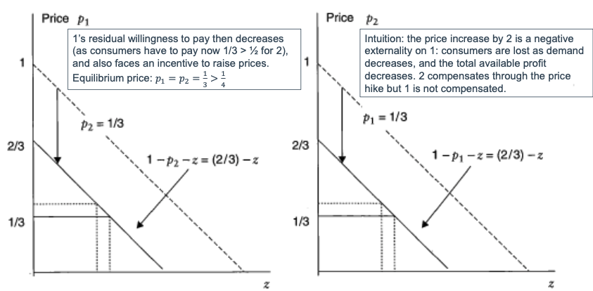
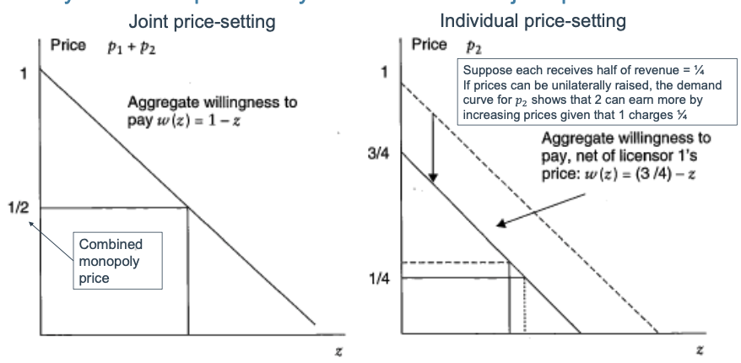
- Complementary tools have lower joint price
Quality Ladders
- Series of products that improve on each other
- Disclosure of invention shares knowledge, easier to do next improvement
- Effective patent life (time incumbent can reap rewards) can be shorter than actual life
- Model
    - Rate of improvement is Δ per year
    - Only highest quality product is sold at price p = Δ
    - Increasing quality with Δ improves all future products with same amount, next product innovates from x + Δ, with x being previous level
    - Social value of innovation is NPV of perpetual quality increase: Δ / r with discount rate r
    - Net private value is increased value minus development: Δ – c with c development cost
In many cases: Δ/r > Δ – c
market failure where many investments for which Δ/r > c are not made
- Solution (hard to implement)
    - Leading breadth: broad patent, gives rights to k future improvements
    - Private revenue then becomes k*Δ, and k*Δ > c
    - Alternative: larger inventive step?
      - Option 1: enter market, don’t patent improvement (doesn’t make sense, will be quickly imitated)
      - Option 2: wait for other idea to arrive and patent then (not socially desirable, slows down innovation)
- Market for technologies
    - Trade in IPR through sale and licensing
    - Creating functional MfT is hard
      - EU Innovative Union: effort to create unified European market
      - Technology hard to evaluate so hard to price

Value of Patents
- Mostly worth much less than development cost of the invention
- Maintain patent if renewal cost is lower than expected profit from the protection
Use difference to estimate distribution of patent values
- Griliches reduced-form approach: firm’s market value (V) is sum of physical assets (A) and knowledge assets (K)
    - q = market premium over replacement cost of capital (assume 1)
    - γ = shadow price of knowledge assets, how much capital A is equivalent in market value to a unit of K
    - $V_{it}=q_{t}{(A_{it}+γK_{it})}^{σ}$
- Estimate book value of R&D by realting market value to book value and regress it on R&D
    - $\ln{V_{it}=\ln{q_{t}+σ\ln{A_{it}+σ\ln{γ(\frac{K_{it}}{A_{it}})}}}}$
$\ln{Q_{it}≅\ln{q_{t}+γ\frac{K_{it}}{A_{it}}}}$

10. Innovation Policy Tools

Intro
- Government tools to shift rate & direction of innovation
    - Reduce costs: tax credits, subsidies, favourable labour market policies…
    - Increase expected revenues: changing antitrust policy, patent system…

- Additionality: policy can trigger R&D that wouldn’t have taken place otherwise
    - If not, policy is crowding out private investments (replacing)
    - Hard to evaluate
    - Policy needs to constitute to a net benefit in welfare
- Policy usually just solves ex-ante or ex-post issue, ex.
    - IPR are designed to provide incentive to innovate (ex-ante)
    - IPR hurt diffusion of technology in the short run (ex-post)
- Support of SMEs
    - OECD countries have generous tax credits for SMEs
    - Policies can try to build networks (co-location, science parks…)
    - SMEs more constrained, respond better to policy changes
    - May inhibit growth of SMEs
Tax
- Tax credits: fiscal incentives for R&D such as lower taxes on R&D expenses
- Evidence of effectiveness
    - Studies tend to use self-reported R&D expenditures, may just reflect re-labeling of other expenses instead of true R&D costs
    - Solution: use different metrics such as increase in patent filing
- Relocation of research: R&D departments in countries with good fiscal regimes
- Patent boxes
    - They apply a lower tax rate to revenue linked to patents
    - Raises risk of tax competition within Europe
    - High-value patents are relocated to places with best boxes
    - No evidence of higher R&D expenditures in countries with patent box
- Tax credits vs. patent boxes
    - Credits: targets input (spending)
    - Boxes: targets output (revenue)

Subsidies
- Used to help out specific types of R&D
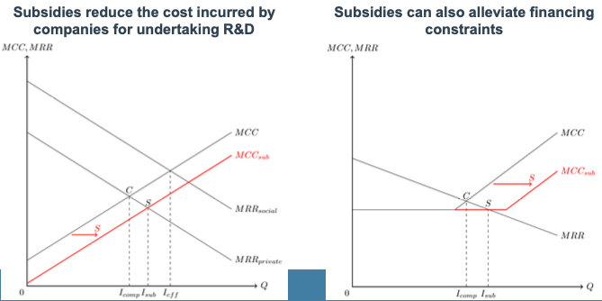
- Reduce the cost by financing part of a project

- Highly effective and precise, but lots of information is needed, hard to monitor
- Inefficiencies
    - Information issue
    - Misuse or imperfect allocation of funds
    - Cost of agencies that make selection and allocate the funds
    - Time consuming for both parties
- Hard to evaluate effectivity because only promising projects get funded, can’t compare to non-promising projects with no funding
- Conclusion (Flanders)
    - Increases employment (10%) and share of R&D employment (3%)
    - Increases total R&D spending
    - Mostly for small enterprises

Labour Market Policies
- Huge effect on if and how firms can innovate
- Immigration policy
    - Challenge: identify immigrant inventors (ethnic & survey data)
    - Different types of working visas

- Non-compete agreements
    - Employment contract in which employee pledges not to work for competing firm for x amount of time after end of contract
    - Reduces spin-outs
    - Encourages firms to invest in its people

