Chapter 1 – The Origins of Strategy

Why investigate the history of strategy?
- Defining & redefining strategy has been an ongoing endeavor, so it is the logic place to start
- Allows to define patterns in different strategies, which run throughout the book
- In path-dependency theory, you have to understand the history to fully understand the present

For long, strategy was limited to military actions and war
first industrial revolution (1700-1800): no strategy yet, as companies didn’t think they could significantly alter the market environment (‘invisible hand’, was out of their control)
second industrial revolution: technological improvement (railroads etc) gave rise to economies of scale & scope, and the new strategical vertically integrated firm emerged that, over time, was able to alter the environment it was present in
WWII & new quantitative techniques started the topic of strategical research; the learning curve which was discovered in 1930’s gained importance in the war too
the concept of distinctive competences came out of the military too

This all led to belief that, by conscious planning, a company could positively influence the existing market forces.

While there were some early articles published on strategy, most of the development started in courses of prominent business schools in the 50s and 60s
gave rise to the SWOT analysis; Ansoff’s product/mission matrix; and the further concept of distinctive competences, what makes a company stand out, even more important at the long – term level as long-term investments usually mean more risk (both very important concepts in 1960s)
when a company’s opportunities seem to outrun its current distinctive competences, they have to show a willingness to gamble that they can build the latter one up to the desired level
- Failure of companies was often blamed on them focusing too much on their current distinctive competences; and not adapting to changing environments

In 1960s, business environment became more complex, and academics stayed focused on a case-by-case method; so companies set up their own planning departments and hired the newly emerging consulting firms, like Boston Consulting Group and its experience curve
their version of the learning curve, but in a quantified way: doubling of production leads to a total cost decline of 20%
Another ‘powerful oversimplification’ of them was the growth-share matrix, giving rise to the first portfolio planning and diversification to get more market share
  - Keep a balance between cash cows and stars; allocate some cash to question marks; and sell off dogs

strategic business units were similarly developed by McKinsey in cooperation with General Electric, bringing the nine-block matrix as well as the profit impact of market strategies (PIMS)
  - Forced strategic thinking to be less aggregate and closer to the production level
portfolio planning even further popularized when crises of ’73 and ’79 forced companies to think about and discard parts of their businesses
Crises also questioned traditional learning curve, due to excess capacity and high inflation; as an intense cost-minimizing strategy reduces your ability to innovate and deal with innovations of competitors
- Also criticized for treating cost reduction as automatic rather than managed

eventually, portfolio planning came under attack as well. SBU recommendations were often sensitive to which planning techniques are used; and the recommendations based on historical data was problematic, as was the assumption that capital was the scarce source to focus on
- Often left companies that implemented it vulnerable to competitor’s actions
- Focus on quantitative analysis of portfolio planning was also criticized for being detached from business, and focused on short-term cost reductions rather than long term competitiveness

Porter – What is Strategy?

Positioning is too static, according to new strategy theories. Copying is easy, and any competitive advantage is temporary in today’s rapidly changing environment
Only a half truth. Some industries are like this and companies investing to become leaner can be good; but this hypercompetition is also a self-inflicted wound and leads to mutually destructive competition.

big problem is lack of distinction between operational efficiency and strategy
- Both are necessary for a superior position, but work in different ways
One can only outperform rivals by offering the same for less, or more for the same price; meaning cost reductions, differentiation, or both.
- Key concept is all activities that are going to decide the above
Operational effectiveness means performing similar activities better than competitors, by better utilizing inputs
strategic positioning means performing different activities, or similar activities different

differences in operational effectiveness (get more out of inputs; eliminate waste; better management) are very common, and decide the differences in profitability between firms
productivity frontier: sum of all best practices at a given time; moving closer to it means improving as a firm. Frontier is constantly evolving as well, as new technology emerges
firms have to be constantly evolving and learning to this changing frontier
the closer you get to the frontier, the easier you can improve on multiple facets at the same time, like lower costs and improve differentiation; it is no longer a tradeoff
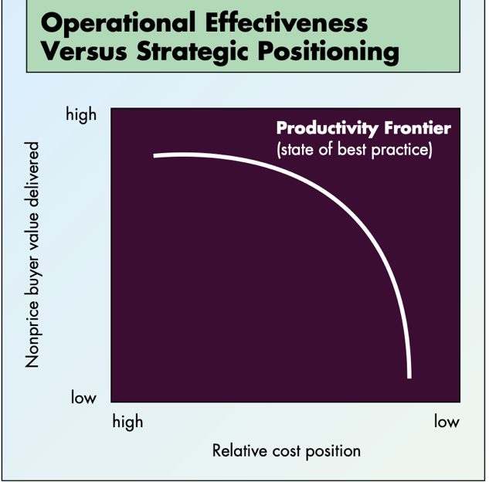
constant improvement in operational effectiveness is necessary for superior profitability, but not enough for long term survival
usually bc of rapidly changing best practices and quick imitation

effectiveness competition moves the frontier to the right, setting the bar higher for everyone, leading to absolute improvement in OE, but this doesn’t lead to any relative improvement for anyone as they don’t capture the value they create

secondly why OE isn’t enough: eventually, all companies will look the same, becoming a race down a path no one can win, becoming self-destructive

Competitive strategy is deliberately choosing to a different set of activities to offer unique a value mix. Often defined in terms of customers (like, ‘airline serves price-sensitive travelers’), but is really about performing different activities or doing activities differently
Southwest: doesn’t offer meals, assigned seats, baggage transfers,… giving their unique positioning, that no one could beat them to on their flight routes
- It is the tailored set of activities that turn a marketing ploy into a strategic positioning

Strategic positioning comes from 3 overlapping sources:
- Variety- based positioning: producing a certain subset of an industry’s products. Optimal when you can best produce this using distinctive sets of activities. Like Jiffy lube only offering lube, bringing faster service and lower costs
- Need-based positioning: satisfying nearly all needs of one customer group. Like Ikea that meets all needs of its customer group, not just one.
- Access-based positioning: segmenting customers that are accessible in different ways. While their needs aren’t so different from other customers, the best set of activities to reach them is. Carmike only offers cinemas in small towns, which is possible by their lean and standardized services.

strategy is the creation of a unique and valuable positioning, involving a different set of activities. If there was only one best position, there would be no need for strategy
- Just the unique positioning isn’t enough for success: imitation is unavoidable. Competition can reposition itself to be the ‘superior competitor’, or can ‘straddle’, matching the benefits of the successful position while still maintaining it own position
But a strategic position isn’t sustainable unless you have tradeoffs with other positions with activities it is incompatible with
- Continental lite: wanted to imitate southwest, but still maintained its other regular line, eventually leads to inefficiencies
tradeoffs create the need for choice and protect against repositioners and straddlers purposefully limiting what a company offers, like fancy soap only in drug stores, protected from imitation
3 reasons for tradeoffs:
- Inconsistencies in image or reputation: when you start delivering something else than usual, customer can start getting confused and undermine its reputation, a cheap soap brand can’t start imitating the fancy soap
- Activities themselves: different positions require different sets of activities. Ikea could never satisfy high end customers with its current layout
- Because activities are overdesigned or underdesigned for their use, destroying value
continental paid the price of tradeoffs between activities as they lost on the low cost, the two could not be combined

the lack of tradeoffs, being able to improve on both cost and differentiation, is only possible when you start far out of the frontier or if the frontier shifts to the right. On the frontier, where you have all the best practices implemented, there is a real tradeoff

what is strategy? Strategy is also making tradeoffs in competing, and thus choosing what not to do. Without them, there would be no need for choice and no need for strategy

OE is about excellence in individual activities; strategy is about combining activities
every activity is equally important in this, complementing each other, and creating a fit that locks out competitors that is as strong as its strongest link
some fits are company generic, but strategy-specific fits create the most value as it enhances a position’s uniqueness and amplifies tradeoffs. Plus, they force OE, as one bad activity will rot all the rest

3 non-exclusive types of fit:
- Simple consistency: aligning each activity with its strategy. Makes sure that competitive advantages don’t cancel each other out and makes it single-minded
- Reinforcing activities: like fancy soaps in fancy hotels, reinforcing the sales
- Optimization of effort: complete activity coordination and information exchange to minimize wasted effort
competitive advantage grows out of the entire system of activities. The fit enhances that. Thus it is wrong to focus only on ‘core competences’ and ‘key activities’ in strategy

fit is also important for sustainability of strategy: it is much harder to identify, replicate, and imitate a system of interlocking value enhancing activities than just one core activity
just imitating a few of the fitting activities doesn’t work, like Continental Lite

strategic positions should be on the long-term, as consistency reinforces the fit and frequently changing position is costly for the company

What is strategy? Strategy is the creation of a fit between each activity to create and reinforce a positioning

while external threats (competition, technology) are important, most bad strategy decisions come from within; with management not focusing on long term strategy or blindly imitating everything competitors do; thinking ‘customer focus’ means serving every single customer; or thinking that making tradeoffs limits the imaginary growth they want to get
focus should be on deepening your position, not broadening it for an ‘easy’ growth
  - Globalization can offer this deepening that isn’t possible domestically

the job of the highest leader is to guide the company to one strict strategy and maintaining it, to say ‘no’ and achieve those tradeoffs, and clearly distinguish between operational excellence and strategy. OE needs to be continually improved, but so does strategic positioning

Collis & Rukstad – Can You Say What Strategy Is?

very few executives can consistently say in 35 words what their strategy is; or they’re surprised when the long strategy documents coming out of their meetings are never well implemented
they forget to have a short, clear strategy statement that everyone involved knows and aligns to, otherwise you will have chaos in all of your departments

Porter’s article did not answer the question ‘how to describe a strategy?’
when you have a clear definition of this, it ill be easier to formulate your strategy; and to implement it as you can easily communicate and internalize it

3 elements for good strategy that executives have to be crystal clear about: objective, scope and advantage
1. Definition of the ends you want to achieve, how else would you attain it?
Should include not only an end goal but also a time frame
2. The part of the landscape the firm will operate in, and the boundaries to what it will offer
3. Competitive advantage is the essence of strategy, saying how you will do the above differently or better
- Internal and external component: how your activities will be aligned to deliver the unique value, and why the targeted customer should choose your product
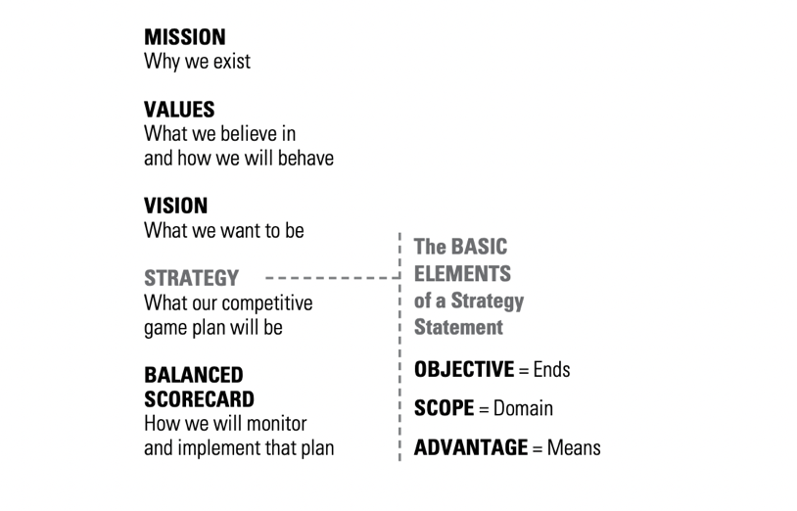
each of these requires tradeoffs, which distinguish companies strategically

strategy should be the single objective driving the company the next 5 years, not the mission statement (stating the underlying motivations for being in business) or firm values or vision (an indeterminate future goal). These 3 are often shared by many industries, while strategic objectives should be unique

strategic objective should be specific, measurable and time bound. Not (shareholder value’, but what you believe the main driver behind shareholder value will be (growth, becoming marker leader,…)
choosing and changing the objective can have a large impact on the firm

Scope has 3 dimensions: customer or offering; location; and vertical integration. They define hqt managers should(n’t) focus on, and can vary in relevance per firm
Not exactly detailed, does encourage experimentation with scope, but clearly defines what manager should focus on

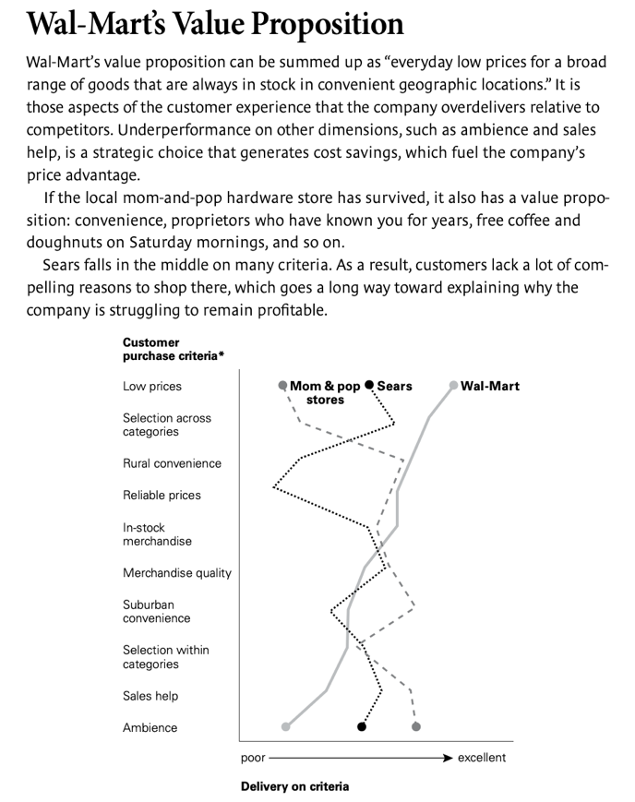
advantage is the most important element. Clarity about what makes the firm distinctive helps employees in successfully executing the strategy. Consists of 2 parts:
statement of customer value proposition: why should they buy your product? Value map can help with defining this against your rivals (= consistent decisions & activity-system map from Porter)

How to define strategy? Develop the strategy after investigating the landscape, but also investigate those of competitors and how they might change in the future. Rigorous investigating of resources and capabilities.
all to find that sweet spot between capabilities and what customers want that your competitors can’t match

should involve all levels of employees, in the best wording to be as clear to everyone as possible, with a value proposition chart and activity – system chart attached

Brandenburger & Stuart – Value Based Business Strategy

What exactly is value in a business context? following porter, they say the vertical value chain creates value as a whole (forcing companies to think more externally), depending on characteristics of suppliers (who are often treated as mere cost cuts), firms, & buyers
Which player then captures this value? relies on ‘added value’, value created by all players in chain minus value created by all players but your own
in certain cases, this added value forms the upper bound to the captured value
necessary, but not sufficient condition is thus to have positive added value, created by having a favourable asymmetry with your competitors

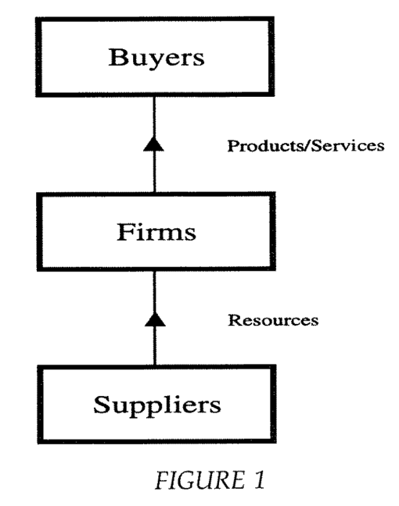
the value created by a vertical chain of players is defined as follows: value created = willingness-to-pay (of the buyer) – opportunity costs (of the supplier)

Willingness-to-pay: the tipping point where customers won’t prefer the quantity of product over the money
easy for eg. Industries with calculated operational savings from your product; harder for household products

Opportunity costs: the tipping point where supplier won’t prefer the given money over keeping its products
eg potential employees: their opportunity costs will be highest alternative wage they can secure

Nor mention of price yet: this is outcome of bargaining between firm & buyer & supplier. But in setting two above, it is expected that all parties have access to all other already set prices in market
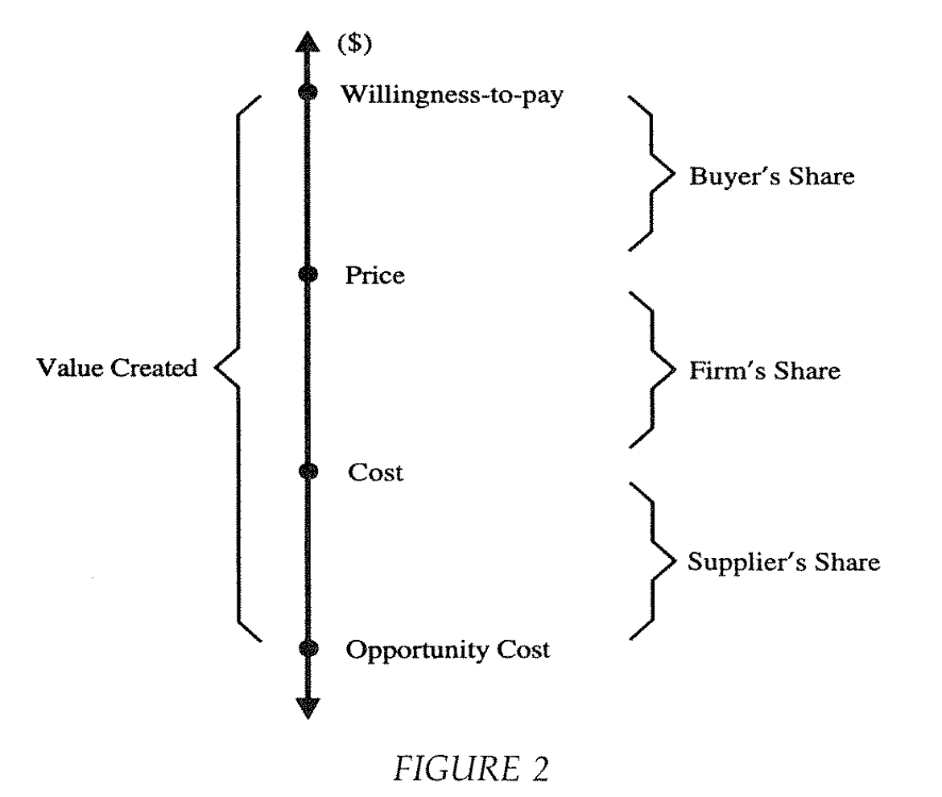
Who captures the value created? result of bargaining between players.
simple value chain

What with multiple players and competitors? Then WTP of premium product would depend on WTP of standard product, and you’re unable to separate value creation and capture
separate ‘inside’ and ‘outside’ the game -> define WTP similarly as above, only the money couldn’t have been spent on the standard product as this is in the game ; same for opportunity costs

Example 1: game with 2 suppliers, 2 firms, 1 customer. Each supplier has opportunity cost of 10, WTP’s are 100 and 150 for the firms. Opportunity cost is 10, of course. Only 1 WTP can be chosen, as customer will interact with only one firm. 150 is WTP chosen, as that leads to the largest pie value created = 150 – 10 = 140; always equating to largest slice.

Who then captures value with more players? Again due to bargaining, but many-on-many instead of one-on-one, as competitors try to on-up each other
in equilibrium, each player’s captured value can be no greater than their ‘added value’, equal to value created by all players in chain – value created by all players but your own
places upper bound on value captured; if it would be higher for one player, the other players would have missed out on a very favourable deal they could have made
Following example 1: added value of each player is 0, same for firm 1. Second firm has added value of 50; buyer has added value of 140. Assuming all players are competitive; outcome will be 0 captured value for suppliers and firm 1; between 0 and 50 for firm 2; between 90 and 150 for the buyer.

builds on ‘unrestricted bargaining’ assumption, that all players identify all and the best deals
added value approach doesn’t offer one set outcome; what that will be depends on how tough each player is in bargaining
except when sum of added value of each player equals value created; then it is one outcome

How can a firm capture value through added value? 2 steps: 1 benchmark situation; and generating positive added value from there
Benchmark situation: firm has large number of identical competitors (same WTP and opportunity costs). Don’t expect any added value in this scenario, so 0 added value

Example 2: 4 supplier, 3 firms, 2 buyers. Opportunity cost of 10; WTP of 100. Value created = (100 – 10) * 2 = 180. Added value of suppliers is 0. Each buyer’s added value is 90. Firms then have added value of 0. (sum of all added values is always overall value created).

Firms can have positive added value if they are ‘different’ from their competitors

Example 3: 4 suppliers, 3 firms, 2 buyers. Opportunity cost of 10; WTP of 100 for first and second firm, and 150 for third firm. Value created is (150 – 10) + (100 – 10) = 230. Added value of suppliers is 0, same for first and second firm. Third firm has added value of 50; each buyer added value of 90.

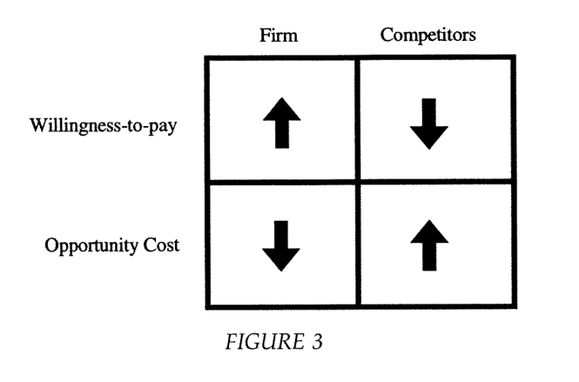
asymmetry arises because the firm could raise the WTP for its product; or because the WTP for the competing product dropped
can also exist in opportunity costs, because firms find a way to lower opportunity costs of its suppliers, or because other suppliers end up with higher opportunity costs
these 4 routes to added value are ‘value based strategies’

Top left box: differentiation strategy, raising WTP for your product
Bottom left box: lowering opportunity costs of suppliers of your firm, by e.g., reducing the cost of suppliers to do business with you, or nonsalary benefits competitors can’t match
Top right box: lowering WTP of competitor’s product, e.g., bad-mouthing or switching costs for buyers, like retraining costs for them, so they’ll stick with them
Bottom right box: raising opportunity costs of suppliers providing services to other firms, e.g. influencing suppliers’ perception of competitors; switching costs for suppliers

Discussion
size of pie was determined under assumption of ‘maximal flow’ possible; this follows from unrestricted bargaining assumption: you keep luring buyers & suppliers away when you can offer a better deal, until you hit the limit of maximal flow
means processes of value creation and appropriation are actually entwined
unrestricted bargaining isn’t always possible due to frictions in the market, if so, in these situations some players can capture more value than their added value e.g., new market entrants have asymmetries with established players leading to 0 added value for them (unless they succeed, e.g., through ‘judo economics’ where they target such a small part of the market the larger player just concedes; this only works if there is thus such friction in the market)

‘outside’ the game: alternative products available for customers, and alternative uses of resources for suppliers
this boundary generally does not matter, if players are deemed inside or outside

often shareholder value maximization is main objective, here value appropriation maximization is objective, which one is correct? depends on perspective you take
in a sense, dividends can be seen as the opportunity cost of shareholders’ capital

Koller – Fundamental Principles of Value Creation

Fred the hardware store:
ROIC: after-tax profits divided by capital invested in working capital and PPE – 18%
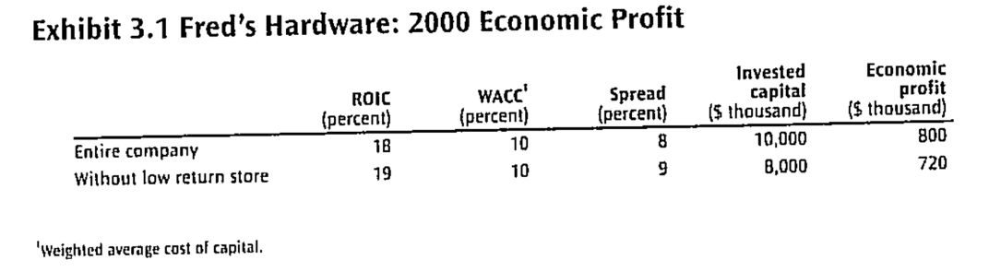
WACC: what he would get if invested money elsewhere – 10%
1 store was making only 14% ROIC, should he close it to raise the average ROIC? – no, it’s about the combination of ROIC and amount of capital invested expressed as economic profit, not ROIC itself
economic profit: spread between ROIC and cost of capital, multiplied by invested capital
should maximize economic profit over long term, not ROIC!
firms with fast growing operational profit aren’t necessarily better, as this growth is pushed by large capital injections, lowering ROIC & economic profit

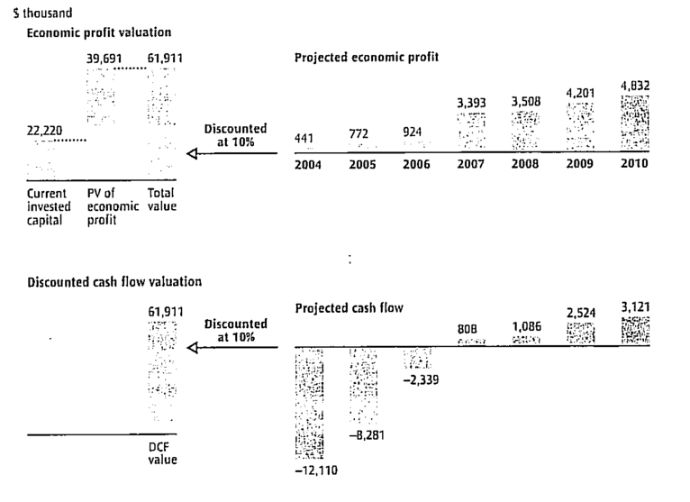
what with new expansion that would lower economic profit the first few years, to then increase? calculated with DCF, or discounted economic profit + invested capital today, which will amount to the same result!

Fred goes public: all the above was strategy for the real market: choose strategies that maximize future cash flow or future economic profit. When going public, you must simultaneously deal with the real market, and outside investors and analysts.
these investors buy and sell share based on what they think their intrinsic value is: based on what they expect the firm to generate in the future, not on what it has already done or the assets it has (share price also calculated through DCF)
fred has intrinsic value of 20 per share now, but only invested capital of 7 per share; meaning investors are willing to pay an upfront premium of 13. If firm continues exactly as forecasted, investors will generate 10% return; if better/worse, more/less than 10%
investor return is driven by performance relative to expectations
must manage both real market return (which drives intrinsic value of firm) and stock market expectations at the same time!
too low expectations (and too low share price): risk for hostile takeovers
too high expectations (and too high share price): dissatisfaction & share price drop

fred expands to garden and furniture stores: can’t just focus on backwards looking financial metrics for each division, as this doesn’t tell which value is created for the future

5 important lessons fred learnt:
- In the real market, you create value by earning a return on your invested capital greater than the opportunity cost of capital
- The more you can invest at returns above the cost of capital, the more value you create (growth will create more value as long as the return on capital exceeds cost of capital)
- Select strategies that maximize the present value or expected cash flows or economic profit (which will give same answer)
- Value of firm shares in stock market is based on the market’s expectations of future performance (which can deviate from intrinsic value if the market is less than fully informed about the firm’ true prospects)
- After initial price is set, the returns shareholders earn depend more on changes in expectations about future firm performance than the actual current performance. If you earn less than expected, stock prices will drop!

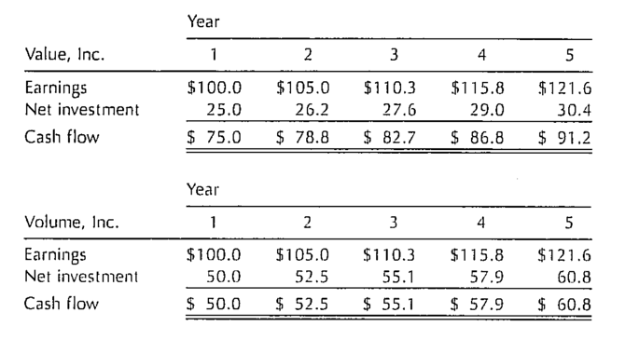
Discounted Cash Flow.
both firms have same earnings, but this can be misleading! Value inc. needs less investment to achieve the same growth in profit, so is more valuable
can calculate firm value with DCF formula, giving 1500 and 1000 each. Similarly calculate earnings multiples: 15 and 10 each.
dangers of valuing with multiples: Value inc. multiple multiplied with Volume inc. earnings would greatly overestimate Volume inc.
DCF accounts for difference in value by factoring In capital spending and other cash flows necessary to generate earnings
but, cash flow projections don’t say anything about the firm’s competitive position, how it compares to competitors,… plus, short-term projections are bad measurements of performance and easily manipulable

what matters is two drivers behind cash flow (and subsequently value as well):
rate at which company can grow its revenues and profits
its return on invested capital, relative to cost of capital
firm earning more profit per dollar invested will be worth more; so will a company that is growing faster than slower competitors with same return on invested capital

ROIC and growth drive cash flow:
growth rate = return on new invested capital * investment rate
growth drives cash flow and value. As long as return on new invested capital is higher than cost of capital used to discount; higher growth will generate higher value
makes sense for investors to accept lower cash flows in early years when growing, if they are made up later on

When to do what?
already high ROIC: increasing growth creates more value than further increasing ROIC
Low ROIC: increasing ROIC creates most value
return exactly same as WACC: additional growth neither creates nor destroys value (investors won’t invest in growth as they will get the exact same return somewhere else)
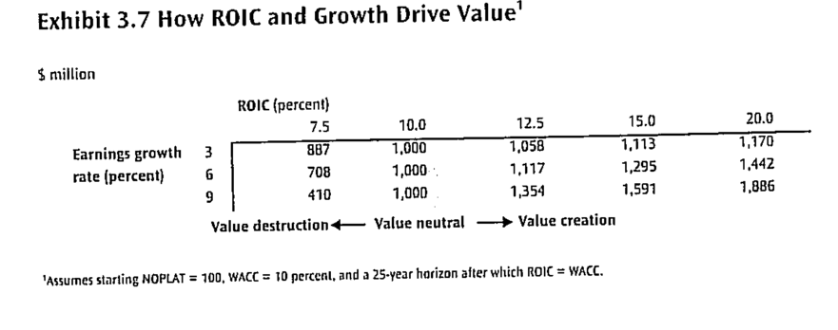
return on new invested capital less than WACC: additional growth will destroy value (investors are better off investing somewhere else)

Some terminology:
NOPLAT: net operating profits less adjusted taxes: profits generated by company’s core activities, minus income taxes on company’s core activities
Invested capital: cumulative amount company invests in its core operations- PPE, working capital, …
Net investment: Increase in invested capital from one year to the next
Free cash flow: cash flow generated by core operations after deducting investments in new capital (FCF = NOPLAT – Net investment)
ROIC: return each company earns on each dollar invested in the business (ROIC = NOPLAT / Invested capital)
Investment rate: portion of NOPLAT invested back into the business (IR = Net investment / NOPLAT)
WACC: rate of return investors expect from the company
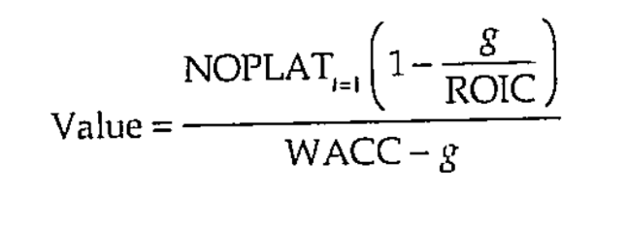
Growth: rate at which NOPLAT and CF grows each year

Now, without having to discount each year’s forecast:
(giving same result as discounting each cash flow)
relates to all fundamental drivers of corporate value: growth, ROIC, and cost of capital
but not very practical, as it is very restrictive: assumes constant growth rate, ROIC,…

same result can be achieved working with economic profit, where the value of a company is the amount of capital invested plus the present value of the value created each year
more real, as you wouldn’t measure a firm’s yearly performance in cash flows
Economic profit = invested capital * (ROIC – WACC)
= NOPLAT – (Invested capital * WACC)

Then value of a company = Invested capital + present value of projected economic profit
(So, if it would return exactly its WACC, it would just be worth what was initially invested)

ROIC and growth also drive multiples: e.g. earnings multiples, not only driven by growth!
industry multiples are not great to rely on, but have endured because they’re simple, and don’t require large, unknown forecasts about the future

Koller – Frameworks for valuation

company’s value is driven by 1) ability to earn ROIC higher than WACC, and 2) ability to grow. High returns and growth result in high cash flows, and thus drives value.
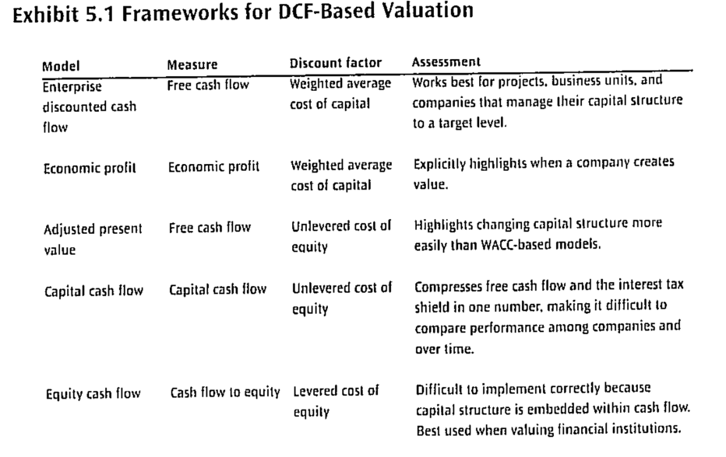
2 valuation methods: Discounted cash flow (relies solely on flow of cash in and out, not accounting earnings) and discounted economic profit (shows if company is earning its cost of capital in each year) => both give identical results

MM: value of firm’s economic assets must equal value of the claims against those assets
thus, 2 ways to value firm’s equity: value the entire operation and subtract all non-equity financial claims; or value equity cash flows directly
Should yield same results; but equity cash flow method is difficult in practice
also easier to value separate business units and projects with first method

DCF = operating assets (=discounted FCF) + non-operation assets – nonfinancial claims

FCF = cash flow generated by operations, minus any reinvestment
available to all investors and thus independent of leverage
thus, WACC need to be used to discount, to represent risk for all investors
(use of fixed WACC implicitly assumes capital structure stays at some target; if this would change in the future, adjusted present value should be used)
(Exhibit 5.5 & 5.6 ROIC & FCF calculation)

forecast FCF start with forecast NOPLAT and invested capital, then calculated from there
continuing value at end calculated with perpetuity formula similar like the one above
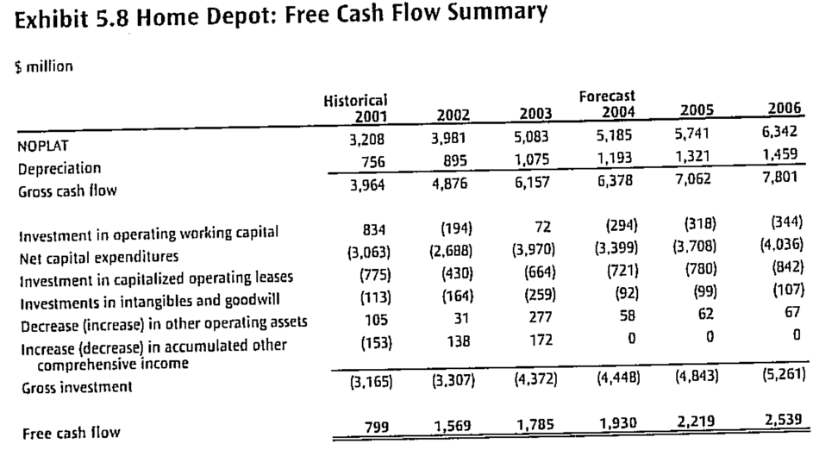
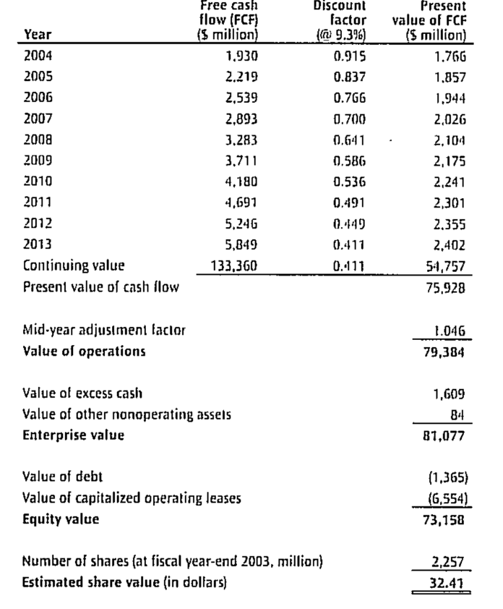

nonoperating assets: cash and marketable securities; and illiquid investment, like nonconsolidated subsidiaries

nonequity claims: debt, leases, retirement plans,…

DCF: based on cash in & out flows; simple, but doesn’t say much about firm performance
economic profit: highlights how and when company creates value

Economic profit = invested capital * (ROIC – WACC) = NOPLAT – (Invested capital * WACC)
(can be negative if you don’t earn you cost of capital)
substituting everything in value formula from chapter 3 eventually gives:
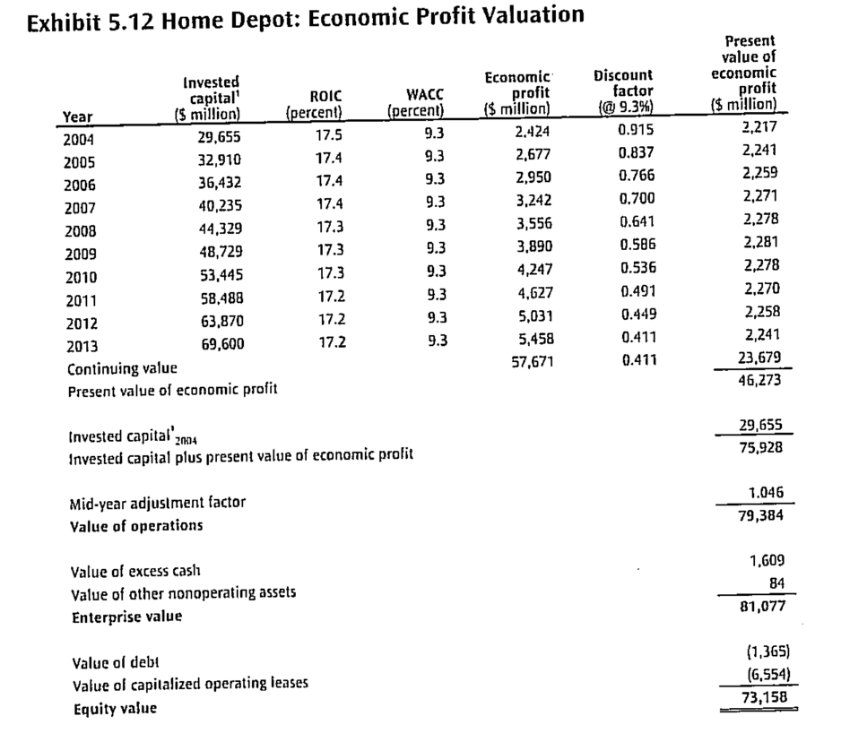
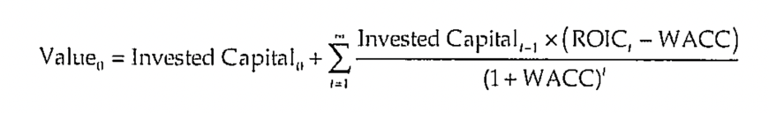

economic profit measure clearly shows effect of 2 key value drivers on firm value; DCF didn’t, there FCF could even continue to grow while ROIC dropped

plus, you can clearly compare a firm’s operation value with its invested capital

adjusted present value model: using constant WACC in valuation assumes company works with target debt-to-value ratios for its capital structure. But as cash flows significantly improve, so do the debt levels usually as well
then, constant WACC would overestimate the tax shields
APV separates operational value into sum of enterprise value if it were all equity financed; and PV of the tax shields (follows directly from MM; leverage does matter, as risk will increase with higher leverage)
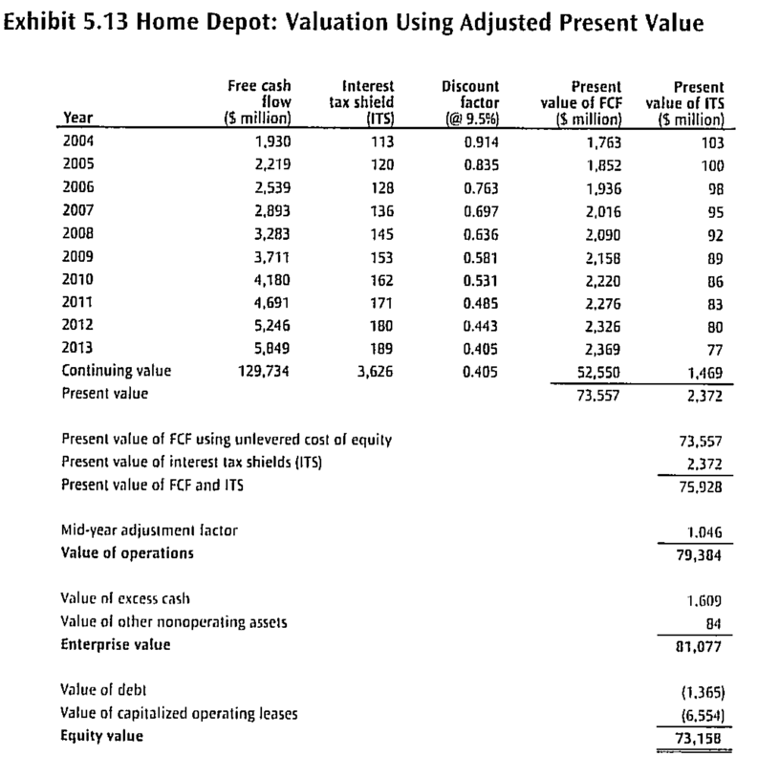
APV = discount FCF with unlevered cost of equity + value created by use of debt

(same here as above as we assume constant target ratio for home depot)

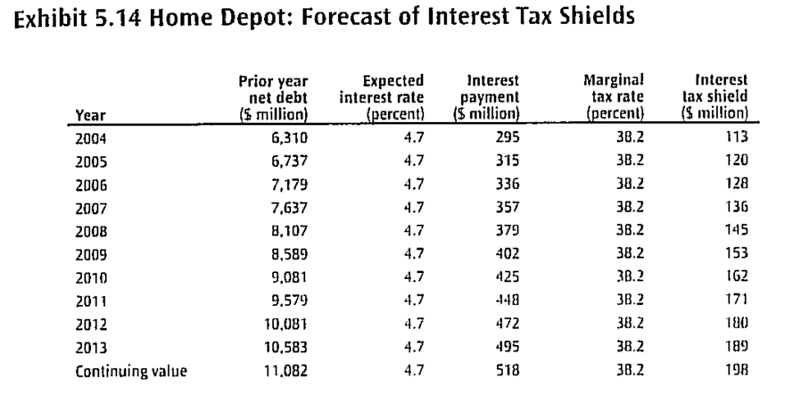
(P. 12-13: derivation of unlevered cost of equity)

Capital cash flow model: when company actively uses target-to-value level for its capital structure; both FCF and tax shield is discounted at unlevered cost of equity. Can thus combine the 2 into one capital cash flow:
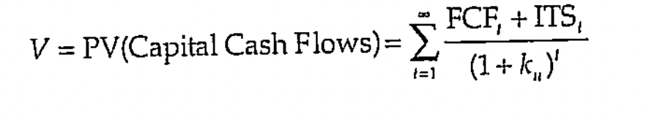
but separate FCF discounting is preferable, as this offers a much cleaner metric

cash flow to equity valuation model: discounts cash flows to equity directly with cost of equity, instead of indirectly by subtracting nonfinancial claims from enterprise value
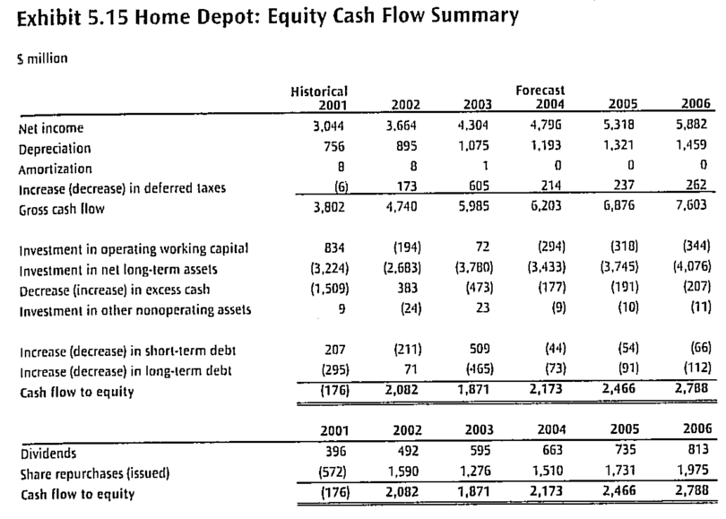
difficult model to implement when debt-to-value will change over time; and hard to value individual business units

2 other variations: using real instead of nominal FCFs; and using pre-tax cash flows

2 alternatives to DCF: multiples and real option pricing

Koller – Thinking about Return on Invested Capital and Growth

in long trial of DCF, can be easy to lose track of what’s really important: ROIC and growth. Further details & forecast items can cloud what actually drives the value
focusing on these can help you see if the forecasts really fit with the firm and the industry
exhibit 6.1 shows realistic DCF calculation with only 3 projections
all extra line item should only be added when they increase the accuracy of the key value drivers

simple key value driver model from chapter 3 only works with stable, mature companies
but is overly restrictive for growing companies, as their ROIC is likely to change
general ROIC evolution: value depends on peaks of your ROIC, and how long you can hold on to this (sustainability)
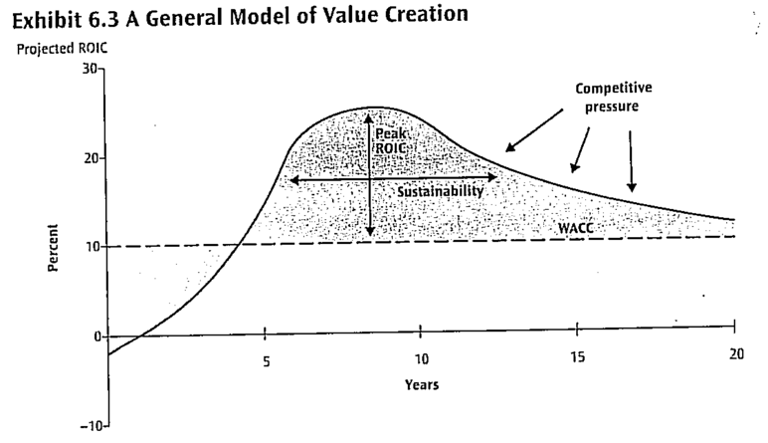
eventually, it can’t resist competition, ROIC nears the WACC, and enterprise value will equal BV of invested capital
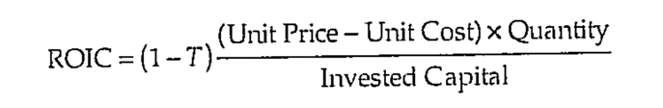
where is your source of value creation? Is it the higher price? Is it the lower cost? Is it more products sold per invested dollar? To justify any high future ROIC, you must have at least one competitive advantage
price premium: when you sell a differentiated product, so you are the price setter. E.g. Coca Cola, because of its brand loyalty
cost competitiveness: selling at a lower price than competitors. E.g. Walmart
capital efficiency: selling more products per dollar investment offers competitive advantage even when profits are low. E.g. southwest always has its planes in the air. This difference can be traced back to the corporate strategy southwest has chosen

just one of 3 above is not enough; a firm has to sustain this as well. A company has to avoid competition from easily duplicating it, or new firms from entering, else its ROIC peak will be short-lived
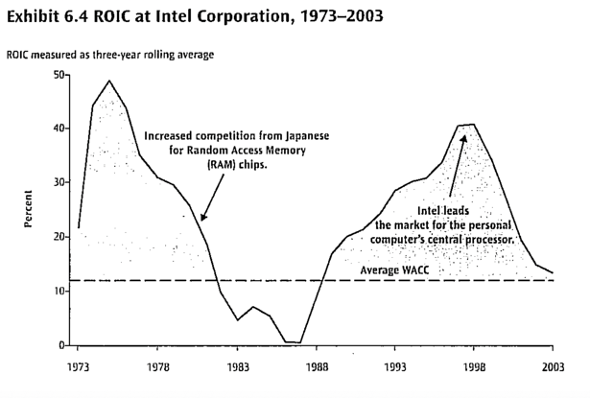
e.g. self-service kiosk in airports: doesn’t show increase in ROIC, because all airlines have access to this technology

if you generate high return above your WACC, you will attract new competitors. Challenge is to protect yourself, or always switch to other trends (Intel) or markets (J&J)
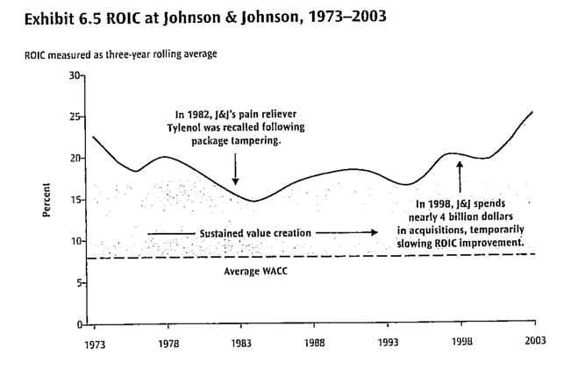

What if you don’t have positive spreads? You have to ask yourself
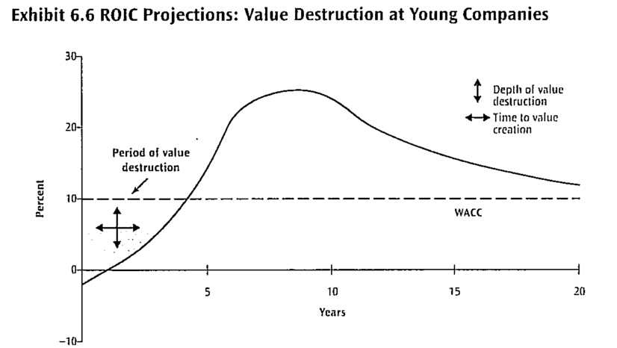
- When will we start generating value, and
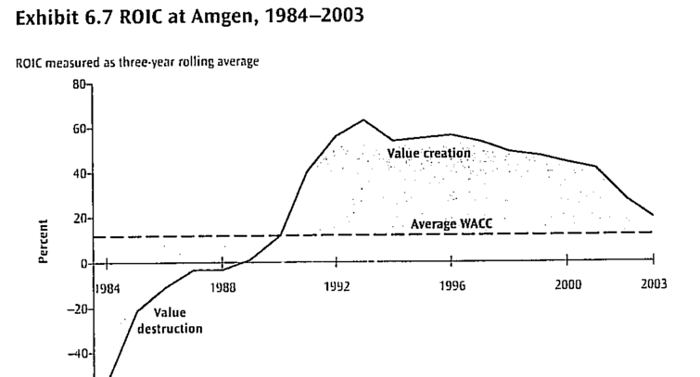
- How large will the initial investment or loss be?

Empirics of ROIC:
median ROIC is 9%, but very high differences between companies, growth and industries. Companies with sustainable advantages, like patents, earned higher ROIC than others. ROIC does regress to the median, but stays persistent (when 20% in ’94, half still 20% in `04)
stayed consistent over 40 years, with only slight increase, mainly pushed by large companies with high entry barrier industries. However, this is not observed when measured with goodwill included.

median ROIC consistently increases as revenue growth increase, regardless of revenue size. But, strong growth does NOT cause strong performance, as this is unlikely to be sustainable
why the positive correlation? 1) underlying factors cause both high growth and ROIC, like high entry barriers where demand can’t be satisfied. But if demand would drop, so would ROIC (so not sustainable). 2) companies with high ROIC have more incentives & opportunity to grow, by e.g. starting and accepting new projects
revenue size doesn’t have an impact on ROIC, often because of inefficiencies that overpower possible economies of scale

how fast does competition push down the high ROIC? Most companies with high returns fall over next 15 years; companies with low returns rise over next 15 years.
but, highest companies don’t fall as much. Conservative valuation technique to assume ROIC regresses to WACC in perpetuity is thus not as applicable to high performing firms.
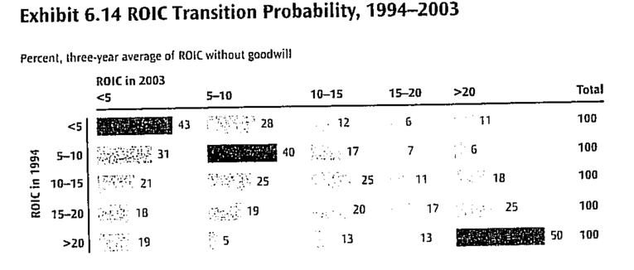
probability of increasing/decreasing ROIC

growth creates value only when additional return is above WACC. In today’s competitive environment, it becomes increasingly pushed, but also difficult to find projects and grow
median growth was 6.3% (relatively high compared to GDP, can be bc of stock-listed companies, increased specialization & outsourcing, etc) and fluctuates more than ROIC. Very high growth rates also decay very quickly, whereas ROIC was more persistent. Extremely large companies struggle to grow further. Large differences across industries as well.

why is high growth so hard to maintain? Large growth also attracts high competition. Similarly, the larger you get, the lesser you grow (growing at 20% at 1 million is much easier than at 2 billion). Plus, even the best products eventually track market growth.

Ghemawat & Collis – Mapping the Business Landscape

industry matters: 10-20% of variability in profit comes from the industry they’re active in
economic margin varies systematically across industries, making it difficult for managers in some industries to lift their company to the top
business landscape (broader than industry): three-dimensional representation of which industries you can compete in, the profitability of this industry, and how you can compete
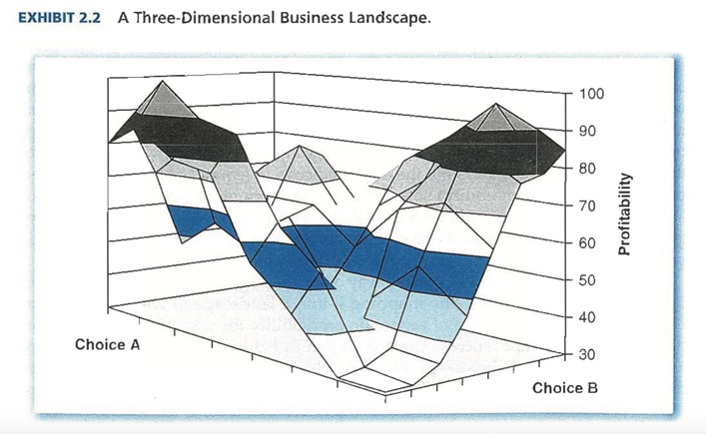
challenge is to lead business to a higher point on the landscape

traditional supply-demand curves didn’t have much impact on strategy development until ‘70s, when downwards shift in demand forced managers to think more about the cost side in the supply curve
but is limited, as it assumes you don’t have any market power as a firm and assumes unrealistic homogeneity amongst customers

history of mix of economy and supply-demand analysis: eventually led to rise of industrial organization, mapping the differences in profit between industries
impact on strategy was small as most economists focused on public rather than private police, until Porter started explicitly focusing on strategy (and his 5 forces that influence average industry profitability framework)
generalized the supply-demand analysis of individual markets in several ways
- Relaxed assumption of both large numbers of competition and homogeneity
- On vertical axis: shifted focus from 2-link chain (suppliers & buyers) to 3-link chain (suppliers, buyers & rivals)
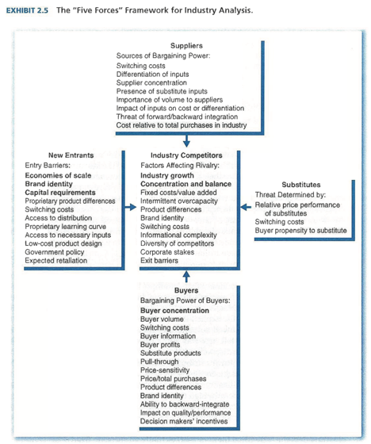
- On horizontal axis, it accounted for both direct rivals as well as potential entrants
focus on private policy, emphasis on extended competition, and ease of use made this framework highly popular

FORCE 1: degree of rivalry
represents how the value created in an industry dissipates to direct competition
depends on number and size of competitors (larger rivals usually can’t easily gain additional market share) e.g. airlines: lack of one major player means when one airline raises prices, the others quickly follow
also depends on general industry conditions: high fixed costs, excess capacity, slow growth, lack of product differentiation all increase degree of rivalry. E.g. all of these are attributed to low profitability in airline industry
also behavioral determinants: if competitors are diverse, face high exit barriers, or have high strategic value to their position in the industry, they will likely become more aggressive

FORCE 2: threat of entry
key concept is entry barriers, which prevent competitors from joining industries where profit is above zero -> large investments, reputations you need to build up,…
e.g. two strategic groups: research pharmaceutical and generic manufacturing pharmaceuticals. First one is more profitable, due to higher entry barriers

FORCE 3: threat of substitutes
depends on relative price-to-performance ratios of different types of products or services customers can use to satisfy their need. Similarly depends on switching costs for customers when switching to different product
substitution curve follows S-shape: starts slow with few trendsetters, then other customers quickly follow, then slows down as all cost effective substitution has occurred
e.g. cars, busses,.. for short distance travel. Not just exactly similar products.

FORCE 4: buyer power
one of two vertical forces. Influences appropriation of the value created by an industry. More buyer power allows buyers to squeeze margins by forcing them to reduce prices or increase services offered
more power when only a few customers, very large order sizes, well informed customers, few switching costs,… but important to distinguish between potential and used power
dependent on behavior: e.g. pharmaceutics, patients often can’t choose to not buy the drugs, or afford to have the substitute fail

FORCE 5: supplier power
mirror of buyer power. Depends on size and concentration of suppliers, the degree of differentiation of the inputs, and switching costs for the firm
e.g. airlines: struggle with very strong labor unions

buyer & supplier power is not only competition; also has strong cooperative component to it that managements can’t lose sight of
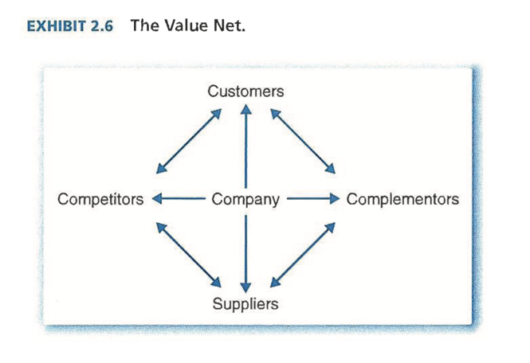
framework later generalized often, e.g. the value net framework which highlights critical role complementors play, the opposite of competitors (6th force!). They increase WTP and decrease supplier prices. E.g. doctors for pharmaceuticals, or Microsoft and Intel
while they both create the pie, they likewise compete with each other for a slice of that pie. Bargaining power of complementors depends on relative concentration, relative supplier/buyer switching costs, relative complementor to your competitor switching costs, ease of complementors invading other competitors, growth rate of the whole pie.
but not argument to limit their power; they are usually needed for excellence

so far, landscape templates discussed (supply/demand, porter, value net) focused on bringing in new players. Do we need to add more? Maybe, e.g. nonmarket players like the government. But main takeaway is that there is no all-purpose framework to analyze landscapes.

Process of mapping business landscapes. How can managers link the above to strategy? Shouldn’t be used to see if you’re above or below economic sea-level, as most managers know this. Instead, is used for understanding this variation. Six step process:
- Gathering information. A lot of public information available, but needs filtering
- Drawing the boundaries. Industry definition: which part of the landscape to focus on. General purpose industry classifications can help (when reworked), so can ‘inside out’, starting with your own market and slightly expanding from there, including substitutes and complements (Horizontal Scope). Vertical & geographical scope focusses on which supplier/buyer chain to consider and the physical locations
- Identifying groups of players. Competitors, new entrants, substitutes, complements, buyers & suppliers, and any other necessary. Need to be consistently categorized, and distinguishing within can be handy to see differences in bargaining power
- Understanding group-level bargaining power. Not focusing one everyone, but only those groups with the most favorable conditions, keeps the analysis manageable
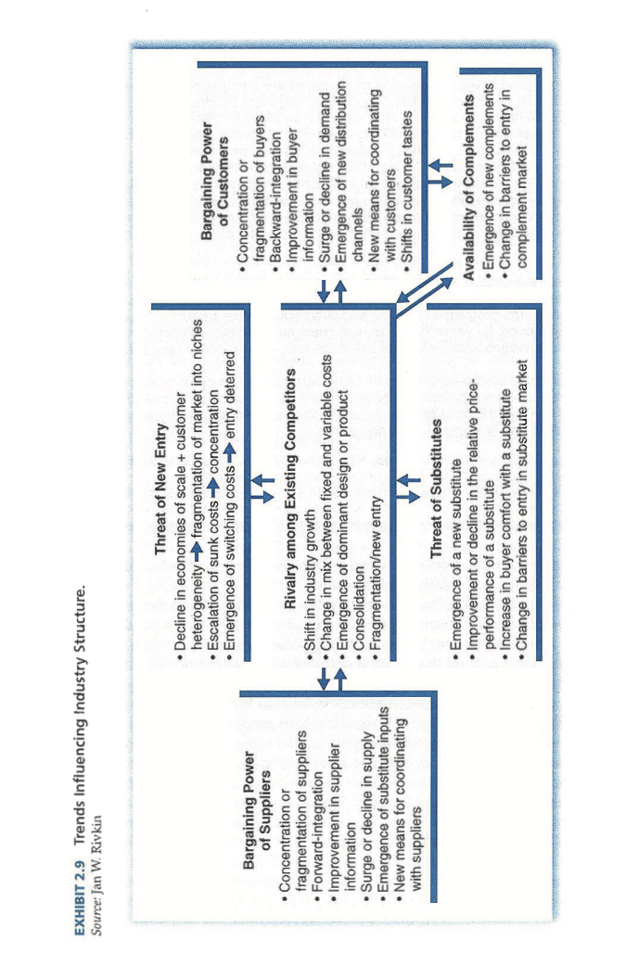
- Thinking dynamically. Thinking about how the landscape will change in the future is the most important, as failure to anticipate change can be disastrous. Useful to think about different time horizons, economy wide business cycles and sensitivity to that, and your distinct industry cycle. Also lessening effect of short-lived cycles.
- Responding to/shaping the business landscape. Use the above knowledge to form strategic action.

Porter – The 5 competitive forces that shape strategy

competition is often only seen as direct rivals, which is too narrow: there are 5 forces to keep in mind when talking about strategy, and when understanding industry competition and profitability. When forces are intense (like airlines, hotels) almost no company earns attractive returns. If not (like software, soft drinks), may companies can be profitable
industry structure is what drives competition & profitability, not whether it is emerging or mature, high tech or not, regulated or not,…
while many things can influence profitability in the short run (eg business cycles), the 5 competitive forces and industry structure shape the medium and long term industry profitability
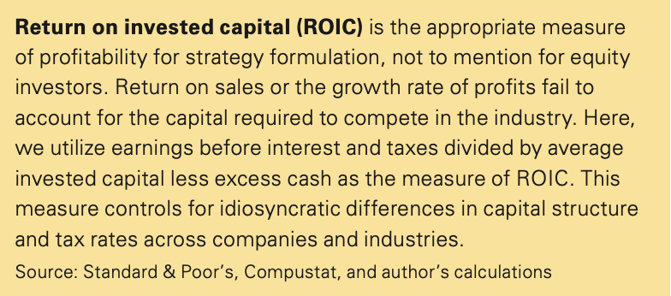
5 forces reveal the root of industry’s profitability and offers framework for anticipating and influencing competition (and thus profitability) over time and is essential for strategic positioning

which forces are strongest depends on industry. Eg. Airbus/Boeing have fierce rivalry and high airline bargaining power, but very low threat of entry. The strongest forces are most determinant for profitability of industry, but are not always as obvious

Threat of entry. New entrants put pressure on prices, costs, and investments needed to compete. Definitely when diversifying, like very established Apple with Apple music.
puts a cap on industry profitability bc incumbents must hold their prices or keep investing to keep barriers up when threat is high (-> not bc of actual entry)
7 major entry barriers:
- Supply-side economies of scale: producing at higher volumes lowers costs. Forces potential entrants to immediately start at high volume. Exists in all parts of the chain
- Demand side economies of scale. Network effects. Buyer’s WTP increases with number of buyers that also choose the company. E.g. Ebay
- Customer switching costs. The larger the costs, the harder to get customers.
- Capital requirements. Large investments needed, definitely when non-recoverable.
- Incumbency advantages independent of size. Any cost or quality advantage the incumbent has to deter, like technology, suppliers, brands, experience,…
- Unequal access to distribution channels. When retail/wholesale is limited to enter
- Restrictive government policy. Can hinder or aid entry, or amplify other barriers.

possible retaliation to entrants by incumbent also plays a role in deterring. Risk is higher when they’ve done so previously, they have plenty resources to do so, etc.

Power of suppliers. Can reduce profitability by increasing costs, reducing quality, etc. E.g. Microsoft reduced profitability of PC industry with high price of software.
supplier group is powerful if it is more concentrated than industry it sells to (like Microsoft); suppliers don’t depend heavily on that industry for survival; firms face supplier switching costs; suppliers offer differentiated products; there is no good substitute; supplier credibly threatens to move forward in value chain.

Power of buyer. Can capture more value by demanding lower prices, more quality, and playing industry players against each other, reducing profitability.
have power when they have negotiating power. Have this when they’re highly price sensitive; there are only a few buyers or very large volumes purchased (def. important in industries with high fixed costs); industry has undifferentiated products; low buyer switching costs; can credibly threaten to move backward into supply chain.

applies to customers and b2b. also to intermediate customers, but their power increases when they can also influence buying decisions of other customers downstream, e.g. jewelry retailers. Can be fixed by directly influencing the end user to choose your component

Threat of substitutes. When industry doesn’t distance itself from substitute through prices, marketing, etc. , they put a cap on the price and reduce profitability and growth potential. Can be direct, like email to express mail, but also in different parts of the chain, like software sold to travel agents gets threatened by online travel websites.
even not purchasing, purchasing a used product, or doing it yourself are substitutes

threat of a substitute is high if: offers attractive price-performance trade off to industry’s product (§the better the relative value, the more it reduce profit); buyer’s cost of switching to substitute is low.
substitutes can also be good for your industry: e.g. plastic as low cost substitute for aluminum in car manufacturing

Rivalry among existing competitors. Degree with which it drives profitability down depends on intensity of rivalry and basis of rivalry.
intensity is greatest when competitor are numerous or equal in size and power; industry growth is low; exit barriers are high; rivals are highly committed and want to be the best; lack of familiarity between firms means they can’t read each other well
when firms compete on same basis, or dimension, rivalry is most intense and detrimental, as it leads to zero-sum game
most destructive when solely focused on price competition, as it transfers industry profit directly to the customers and easily leads to quick retaliation rounds
other bases, like brand image, features, etc. are less detrimental, as improvements usually support higher prices as well and improve value relative to substitutes

Industry structure – represented by 5 forces – determines how value created is divided amongst every player: how much is retained by companies vs. bargained away to customers and suppliers, how much is limited by substitutes, and constrained by possible entrants
Some pitfalls when thinking the following factors represent the underlying structures:
- Industry growth: not always = to attractive industry for all. Can put suppliers into great bargaining position, attracts many new entrants,…
- Technology & innovation: don’t make industry attractive or unattractive in itself.
- Government: not distinctly good or bad. Must analyze effect on all 5 forces.
- Complementary products & services: when value of 2 combined is greater than 2 in isolation. Like government, must be analyzed individually, but porter says it isn’t a sixth force as the effect isn’t necessarily good or bad. They only influence profitability by influencing the other 5 forces.

What with changes in industry structure? Each of the five forces can have internal or external changes, leading to an increase or reduction of industry profitability
e.g. patents expiring may trigger threat of new entrants; small hardware stores being replaced by things like home depot can increase (retail) buyer power; airlines increased supplier power when bargaining with travel agents for commissions in internet era; advances in technology improves value of substitutes; maturing firms that start to converge may increase their rivalry, or because of M&A’s (can also stop rivals), technology changes,…

5 forces explain why an industry and its profitability is what it is, revealing its most significant aspects of the competitive environment. Only then can you incorporate industry structure into your strategy, 1) positioning the company to better deal with the competitive forces, 2) anticipating and exploiting shifts in the forces, 3) shaping the balance of forces to form a more beneficial industry structure for your company (which the others benefit of too) (but can be dangerous in the long run when changing it in a bad way).

also hold the key to defining which industry a firm is operable in. without a clear definition, a strategy is worthless

Ghemawat & Rivkin – Creating competitive advantage

being better than your competition is key to strategy. Having a competitive advantage means being able to drive a bigger wedge between WTP and costs than competitors can.
second dimension in ‘profitability grid’: while industry differences are important, differences within an industry also play a large role (e.g. best airlines create value; while worst pharmaceuticals have horribly negative spreads)
within-industry accounts for 40% of profitability variation, and only 20%. between industries (but not an argument for ignoring between industry differences, still a big chunk of variability, and more persistent than in-industry variation)

How was/is competitive position analyzed?

competitive cost analysis. Gained popularity in ‘60s when experience curve was starting to get accepted. 2 big changes happened in 1970s:
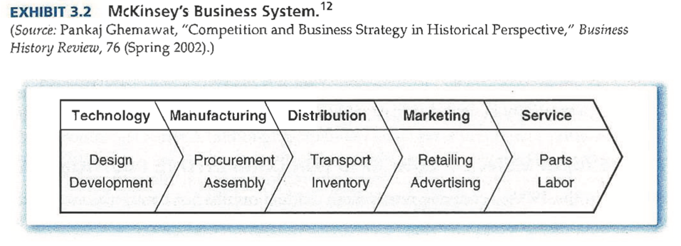
- More focus on disaggregating businesses and costs of/across individual activities (gave rise to activity analysis exhibit 3.2, as side-branch of portfolio analysis). Fixed the issue of SBU’s having often overlapping cost structures
- New cost drivers (not just experience scale effects anymore).
Differentiation analysis. After analyzing costs, greater focus was put on the customers. The idea that low costs and low prices was all customers wanted started to change.
the price premium or reduction of other costs through differentiation became a new way of defining the competitive context
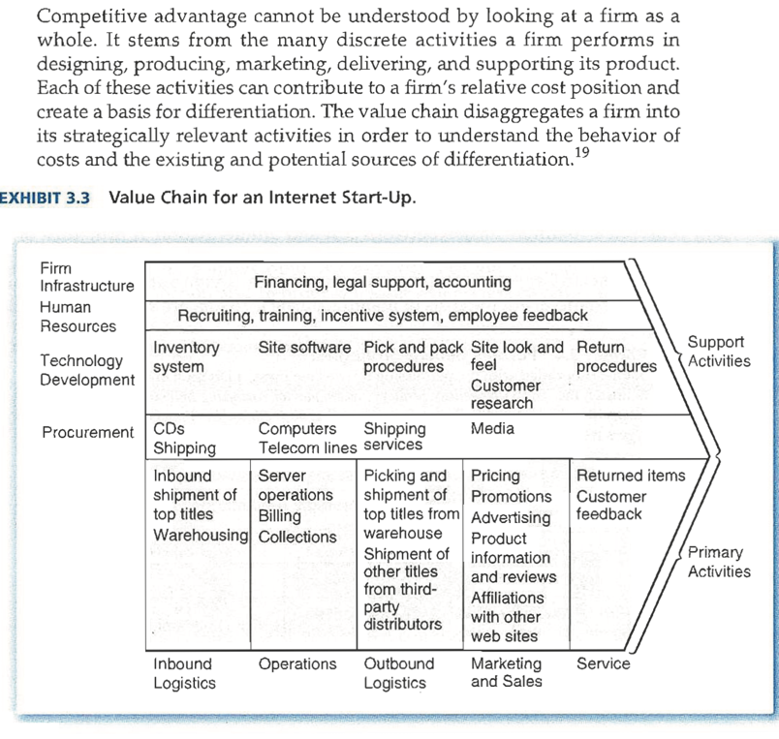
Porter’s competitive advantage suggested analyzing both costs and differentiation through his value chain, which explicitly repackages activities in four categories and thinks about links between them in following way: (value chain for internet startup selling physical music)
further integration of cost and differentiation also split up customers into groups

people like porter argued in most industries you had to choose between low cost or differentiation as a strategy (his generic strategies). Focus strategies could mix the two together, and can work depending on specific industry structures
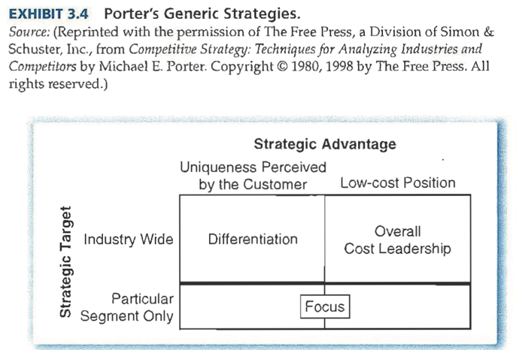
this usual tension between cost and differentiation represents the trade off most firms have to make when choosing strategy
but the tension is not absolute and got a lot of critique. E.g. Japanese companies can offer high quality for low costs. (= dual competitive advantages), or Zara who sits in the intermediate clothing market
most strategists have therefore stepped away from generic strategies, saying you must consider both WTP and cost together. The optimal position is then when you get the largest wedge between the two. But, you usually can’t have both low costs and high price premiums at the same time
- Choice, or TRADEOFF that sits on a spectrum, instead of choosing between two generic strategies
- E.g. Southwest offers no-frills services, which keeps them profitable, but also lowers the WTP for them but positioning works for them
- Cirque du Soleil excludes many high-cost elements (like animals) from circus, but still alludes to many people who have high WTP for their shows

Brandenburger & Stuart changed the scene by introducing the concept of added value in a vertical (supplier – firm – buyer) chain
demand side: differentiation leads to WTP
supply side: opportunity costs, lowest they would go to give up their services
total value created is WTP – opportunity costs. The distinct division of who then captures what is usually indeterminate, but the added value does form an upper bound in most cases, = maximum value created by all players – maximum value created by all players but that one
Is upper bound when unrestricted bargaining happens, as everyone would just keep bargaining until they get the best deals
example: two sweetener companies, one newly entered. They had high initial costs, learning costs, etc. and weren’t in a good position. Eventually, the big winners were coca cola and Pepsi, as they extracted much lower prices form the stablished player, because its added value dropped when the new firm entered
basically, when not quantifiable, added value I the question: if one link were to disappear, would someone miss it?
unattractive industries usually have lower added values for players, unless one player was able to competitively position itself and drive a bigger wedge between cost & WTP

How to link the above to strategic planning and action to raise WTP or lower cost without sacrificing the other?
through dumb luck, but also by breaking down the firm into day-to-day activities and analyzing how they contribute to the two components, which enables managers to see why they do or don’t have added value and where they can improve it. Often started through activity analysis, or porter’s value chain. Then, 3 steps follow:

Step 1: using activities to analyze relative costs. Analyze your own activities’ costs, then compare with your competitors to see where you do better/worse. Then, identify your cost drivers for each activity, e.g. hostess could reduce outbound logistics by focusing more on local markets, reducing the amount of delivery stops that were necessary. Urban deliveries were also more expensive than suburban ones. More preservatives reduced costs. Etc.
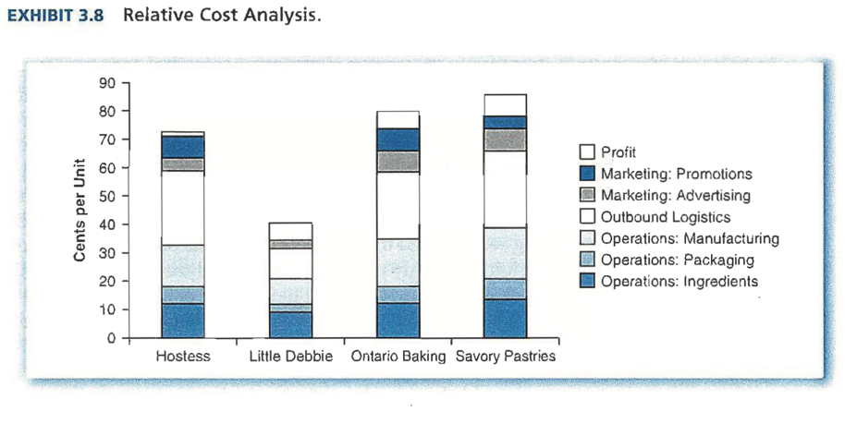
cost drivers are essential because they allow you to estimate out their preservative use, urban deliveries, delivery stops,…
found Little Debbie was ahead of them in many of these aspects!
important to focus on activities, not just overall costs. Ontario & Savory have similar cot positions, but are made up of very different cost drivers

Step 2: using activities to analyze relative willingness to pay. Differences in activities lead to differences in WTP, and hopefully better profitability. Can come from any activity: product design, delivery and sales, after-sales services, complementary goods, advertising,…
but WTP is very hard to measure, often use simplified measures. You have to question, who buys the cakes? What do they want? What are they willing to pay for? How does the firm fulfill this?

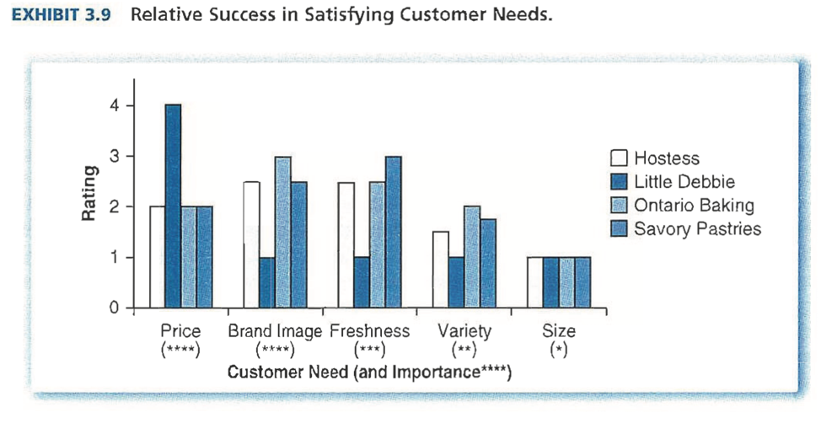
analysis of snack cake market – hostess is not superior on any of the customer’s needs

Horizontal differentiation: looking for different products (fantasy books vs. schoolbooks). Vertical differentiation: looking for a different product (hardback vs. paperback fantasy) and have different WTP for each book type
identifying WTP becomes harder when these two occur in market segment

Step 3: exploring different strategic options and making choices. The search to widen the wedge between the two above. What drives each competitor? (e.g. could hostess improve savory’s freshness even further, getting more premiums?) How will competition react? (will little Debbie launch a price war against hostess?)

Finally, the firm that had been split up into activities must be put together again, with a consistent and coherent plan. All decisions have interaction with each other – making the rugged 3D business landscape from chapter 1. This means you might have to alter several activities all at once to reach the higher peak, and that there might be more than one way to reach it. Plus, it always pertains to a choice, between one peak and the other.

Collis & Montgomery – Competing on resources (brings together porters external 5 forces and view of internal focused-on-capabilities thinking)

10 years ago, every large company had a strategy team. Now, with the turbulence and rapid pace the market is changing with, strategy has been pushed to the side, as business unit managers complain it is too static and slow to keep up with the current market.
corporate is also doubting it: many great divisions from their growth/share matrices actually turned out to be value-destroying
many new strategists had to change it up, and turned inwards. But, much of strategists caused a lot of confusion amongst managers. New framework emerging clears this up, focusing on combination of external & internal resources that drive company’s position in a dynamic competitive environment. (= Resource-based View of the Firm, RBV)

RBV sees companies as unique combinations of (in)tangible assets and capabilities. These determine how effectively a company runs its functional activities. They can be physical (e.g. telephone wires owned), intangible (e.g. brands, know-how), organizational (e.g. Japanese lean manufacturing). Firm with most appropriate configuration for business and strategy is most successfully positioned.

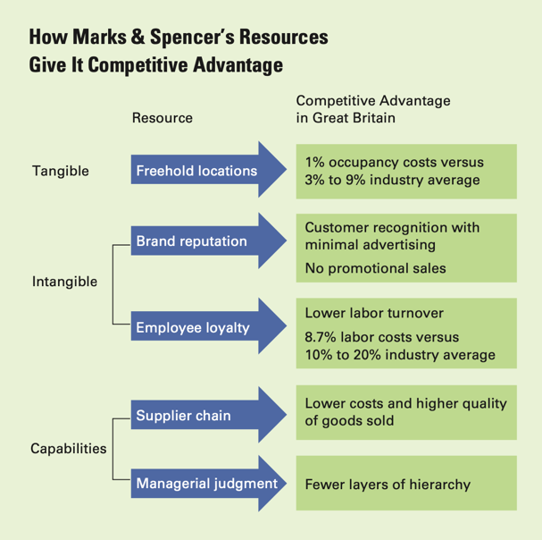
competitive advantage is thus the developing and owning of a (range of) resources that makes you perform better or cheaper than your competitors.
what is a competitively valuable resource? -> depends on an interplay with market forces, as not everything will be valuable in each industry and time.
links firm’s internal resources to external forces!

But identification isn’t always easy. Has to pass several tests before building strategies around it:
- Is it hard to copy? If so, it limits competition and makes value more sustainable. Inimitability isn’t forever, but building strategies around resources that will stand ground for a while will be more valuable. (inimitability based on physical, path-dependent, causal ambiguity, economic entry deterrence reasons)
- How quickly will the resource depreciate? The longer lasting, the more valuable and the more sustainable.
- Who captures the value the resource creates? Not always the company, even though they own it. Depends on the bargaining between suppliers, firm, buyers,…
- Can this unique resource easily be trumped by another resource? -> porter’s substitute force.
- Whose resource is really better? You have to evaluate your resources relative to your competitors’. Core competences can’t just be a feelgood exercise, but a harsh external assessment. Disaggregation of activities can help make this clearer.

tests determine how market forces determine value of the resources, making you look both inward and outward at the same time.
But, most firms have no, or only few, good resources, rest are all mediocre/bad
even so, the good resource must be embedded in other resources and activities that will distinguish the company’ s position in the market
Can’t remain static either: resource isn’t forever, you have to deal with the pressures of competition and continually invest and upgrade for the next round of changing resources
important to see. In companies with a divisional structure, investing in strategic resources is often treated as much less important than maintaining divisional profit
job of corporate to guard the ‘crown jewels”!
but you have to keep the contextual dynamics in mind, and the external forces of the industry when determining what to invest in
also upgrading: moving beyond what the company also can, to hold off the decay of value that’s almost inevitable. Done through new resources (eg new brand name), alternative resources (eg multimedia for AT&T), alternative industry (segments)
@ often done in stages, slowly upgrading and spreading over time
also leveraging resources: to markets you are already active in, and possibly new ones. You have to constantly revalue your scope, and think, ‘where can we extend our resource to? If we even can, perhaps it is market-specific?”

RBV explains why corporate diversification has such a bad track record. 3 common errors when leveraging resources: 1) overestimating the transferability of the resource, 2) overestimating your ability to compete in highly profitable industries, along with high entry barriers (which are, in fact, resource barriers), 3) assuming generic resource, like lean manufacturing will leverage in other markets regardless of dynamics.
gain when diversifying is nonetheless high: e.g. Disney, with its leveraging of resources to hotels, merchandise,…

(what happened to BCG’s growth/share matrix? Came in ’73, when lost companies finally had something simple to focus on strategically again. But, it only addresses cash, not the relationships between all activities in the firm, which is the core of firm value and good strategy. Eventually, it stopped working.)

Ghemawat – Sustaining superior performance

sustainability in the face of imitation. Are there barriers to imitation that already exist or that you can put up? If not, how fast will the value it creates erode because of imitation?
managers often overestimate the sustainability and underestimate the speed with which the top-return will converge to the industry average again. But still important to stretch that interim added value as much as possible!

classifying threats to sustainability is best done in industry-level differences and within-industry level differences. Research suggests differences due to industry differences are more sustainable in the long term than those due to advantages over competition. This chapter focusses on the last, though.

to sustain within industry differences, you need commitment to durable, specialized resources – “sticky resources”. This is why the deregulation of airlines in 70’s didn’t lead to a smoothing of airline profitability: there are hub resources, customer loyalty,… (=sticky!).
southwest also so successful because of their specific resources they have
chapter 3 said, to value fixed inputs, it was easier to look at firm activities for analysis
here, when looking at determinants of sustainability, you have to explicitly look at resources that are fixed on the short term.
2 concepts: added or scarcity value of resource (linked to competition), and appropriability (linked to bargaining, how much does the firm capture?)
have to overlap at the same time to be a good sticky resource for the firm

laid out in tetra-threat framework:
- Imitation: superior resource is no longer scarce.
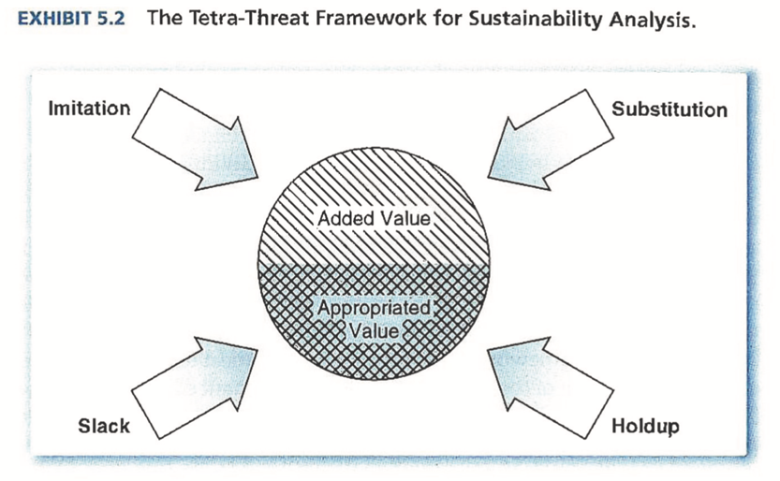
- Substitution: superior resource is substituted, reducing its sustainability. More indirect threat to sustainability than direct imitation
- Holdup: threat of (more) appropriation of sustainable added value by e.g. complements that work together to create value
- Slack: internal threat to appropriation, being the persistent tendency to dissipate potential economic surplus.

Framework might seem similar to Porter’s 5 forces at first. But it’ different. E.g. the pharmaceutical industry: from Porter’s view, you could analyze why the whole industry profitability is so high: differentiation, rapid growth, etc. But what about within industry differences, the big blockbuster drugs that aren’t imitated? This is due to patents etc., rooted in internal underlying resources.
similarly, the resource based threat of substitution is much broader than Porter’s.

Threat of imitation.
not always bad. Can lend credibility to your product, e.g. when network externalities are needed
but, imitation of scarce resources is usually bad for added value.
very important in pharmaceutical industry that’s protected by patents: both during the patents, when sightly tweaked molecule by competitor’s might pass by the patents, but definitely after they expire, when cheap manufacturers move in and take their market share
Some non-mutually exclusive barriers you can put up against this:
- Private information. To the extent you can hide information from competitors, you can hold off imitation.
- Switching costs/relationships. Severity of imitation can be blunted, by signing enforceable contracts, or creating switching costs or superior relationships with suppliers or buyers. E.g. pharmaceuticals with doctors, giving them gifts etc.
- Size economies. Possible advantage of being large. Scale economies (being big in an industry); Learning curves (advantages over time); scope economies (being big across industries). Implementing them could deter competition, like the large sales force needed for pharmaceuticals.
- Threats of retaliation. Must be backed up by ability (having competitive advantage and resources) and willingness to retaliate, otherwise it’s quite empty.
- Imitation lags. Imitation typically takes time. Can even influence this, by e.g. lengthening your patents one way or another to deter generic drugs longer
- Upgrading. Continuously upgrading your own added value to deter imitation, meaning a growing wedge between WTP and costs over time, and large commitments to resources. E.g. pharmaceuticals that keep bringing out new blockbuster drugs.
in a ‘fast-cycled’ industry, upgrading needs to be near continuous
In any case you have to see, is it easier for the first mover to have that advantage and build a better, more coherent set of activities? Otherwise, there is no point in deterring imitation.
Resources & capabilities?
resource based view tends to focus on exploiting the resources the firms has gathered In the past – e.g. patents of blockbuster drugs for pharmaceuticals. But, this focus on the past isn’t enough. You also have to make commitments to new future resources, through R&D, manufacturing improvements etc. So linking past resources to the present and future capabilities.
capabilities are firm-specific opportunities, making them perform activities better or make commitments better than competitors. Are much slower to develop, and evolve through many different decisions over time, like Toyota’s lean manufacturing (instead of resources, which are usually one big decision).

Threat of substitution.
in terms of resource substitution, not product substitution like chapter 2.
substitution reduces added value by displacing scarce resources instead of duplicating them.
supply side substitution: technological change, changes in input price or availability, deregulation (like airline industry)
demand side substitution: shifts in customer preferences, unmet needs, changes in customer mix

e.g. Amazon and Barnes & Noble: rise of amazon threatened to displace many resources of Barnes & Noble, like their massive stores and their employees. There were many things they could have done in response:
1) not responding. If you don’t have resources, don’t think the threat is large, …
2) migrate/harvest. Redeploying resources in areas that aren’t as sensitive to substitution /start milking resources instead of building or maintaining them.
3) Defending. Start increasing your WTP or decreasing costs; or impairing that of competition
4) Straddling. Establishing a foothold in both camps; both online and physical, for example
5) Switching. Entire shift to the substitute. Sometimes no alternative, but it is dangerous.
6) Recombining. While switching would be going to a model that already exists, this would mean recombining elements to make a new strategy.
7) Leapfrogging. Trying to outsubstitute the substitute by developing something even better.

Above two threatened the added value of firms. The following two threaten the ability to capture that value of firms.

Threat of holdup.
diverts added value to buyers, suppliers, complements. This is distinctly decided by the actions that other players take. Based on resource or other dependence. Some solutions:
- Contracting. Enforces long-term relations, but fully comprehensive contract are impossible, so doesn’t fully reduce risk of holdup
- Integrating. Vertically integrating suppliers. Can be inflexible, and needs coordination
- Increasing bargaining power. Being hard to get, tough negotiations, short contracts to limit supplier bargaining power (5 forces thus have something to do with holdup!)
- Mutual dependence. Can only work when each partner gets enough of the profit stream created when working together, so no opportunistic behavior happens.
- Developing trust. Easier in some countries/industries than others.
Threat of slack.
internal threat to capturing value. Gap between the value actually appropriated and amount potentially available.
reflects persistent suboptimization by a company. Relatively easy to define, but hard to measure. Plus, some slack, like a lot of regional offices, might be necessary to attract clients.
relationship with slack as a threat and success of firms: firms without prior or current success are likely to have much room to suboptimize. If you have a large free cash flow, you have more to needlessly burn as well. Some solutions:
- Generating information. Benchmarking, etc. to understand everything that goes on
- Monitoring. Catch inappropriate behavior before too much damage is done.
- Performance incentives. Works best if behavior is tightly connected to efficiency
- Shaping norms. Creating intrinsic motivations for the right behavior.
- Bonding resources. Less cash flows means less slack, so more debt piling might keep managers in check. But obviously not great for other reasons.
- Changing governance/mobilizing for change. Forcing change from the top down.
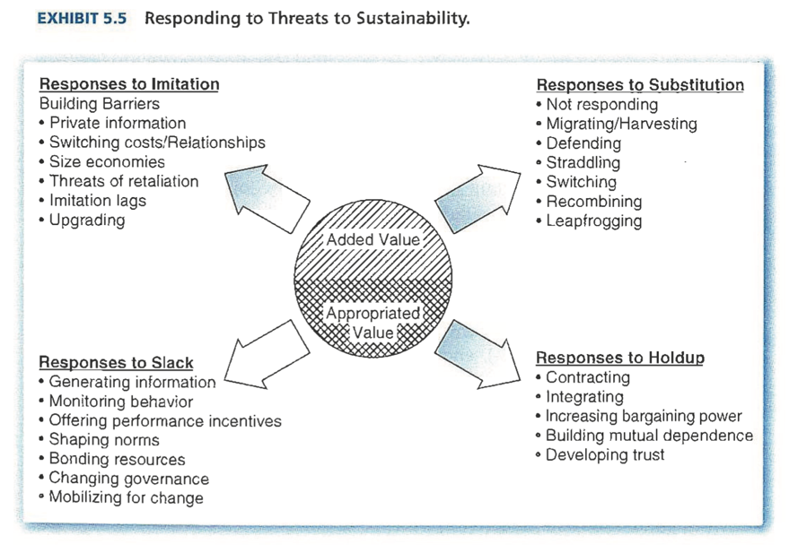

Final pages: Walmart case study.

Mckinsey – Have you tested your strategy lately?

ten tests to test the strength of your strategy (that is, the outcome of the strategy development process). Much more detailed than, e.g. porter, but sometimes it’s necessary to pinpoint exactly what’s wrong. And now more important than ever: financial crisis forced companies to face the issues and trade offs they put off, and shorter, decentralized planning cycles call for common sets of tests.

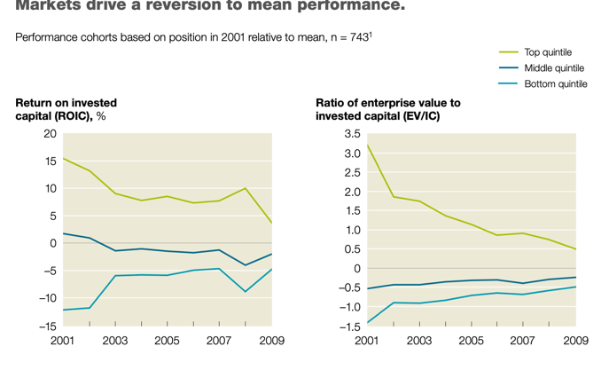
Test 1: will your strategy beat the market?
always a heap of players – suppliers, buyers etc. – that pull the value created to them. It’s a continuous market process, that eventually reduces you captured value to zero.
unless you can beat the market! By having an imperfection (= competitive advantage) that slows down this market process where everyone reverses to the mean performance.
as a firm, you have to ask yourself, are you truly beating the market, or “just playing along” in the market?

Test 2: does your strategy tap a true source of advantage?
know your competitive advantage, and you’ve answered the question of why you make money. Competitive advantage can stem from 2 kinds of scarcity:
- Positional advantages. Structurally attractive markets that form high walls for new entrants.
- Special capabilities. A scarce resource whose possession confers unique benefits. You’ve got “privileged, tradeable assets”, like patents or mines; and “distinctive competences”, things you can do particularly well. Often companies think they have a lot of capabilities, but this might just be due to size, luck, etc. You have to test your capabilities vigorously before pinning your strategic hopes on it.

the putting together of all resources & capabilities will create the most value, and will be the hardest to copy.

Test 3: is your strategy granular about where to compete?
beating the market begs the question: which market? Dividing your business units differently can lead to dramatically different results and resource allocations.
what’s the correct granularity? 5 units? 50 units?
about 80% of revenue growth variance is decided by where you compete, so shifting your focus to the ‘where’ is very important, but often forgotten.

Test 4: Does your strategy put you ahead of trends?
can’t put too much weight on the continuation of the status quo. Trends can happen quickly, like technology innovation, or very slowly, so slow you usually don’t see it coming, and then it’s too late to change your strategy and capture profit. Always check the trends.

Test 5: does your strategy rest on privileged insights?
data is easily available now. Your ‘informed strategy’ probably relies on data that competitors also have. Look for problems and gaps that others haven’t seen yet, with information (like customer insights, market research) that others don’t have.

Test 6: does your strategy embrace uncertainty?
strategy depends on unknown, uncertain future business environment. Four levels of uncertainty: 1) reasonably clear. 2) number of different outcomes, you can still prepare. 3) a range of probabilities that could happen. 4) total ambiguity, not even outcome distribution.
most companies assume they’re at level 1, and succumb because they’re really 4

Test 7: does your strategy balance commitment and flexibility?
usually, the greater your commitment (which is necessary for a strategic decision), the lower your flexibility, like a tradeoff. You need to make the correct one to be successful over time. You have to decide on where, how, and when to commit.
committing to some now, and other in the future, leaves some flexibility.

Test 8: is your strategy contaminated by bias?
such as overoptimism, anchoring (tying your valuations to some arbitrary anchor point), loss aversion, confirmation bias (overweighting information that validates your opinion), herding, champion bias (tying an idea’s merit to the person proposing it).
leads to 2 big inference problems: attribution error (false attribution of success to observed factors, thinking copying someone’s strategy will lead to the same results); and survivorship bias, skewing insights of what might cause a firm to fail.

Test 9: is there conviction to act on your strategy?
just one or two non-believers at the top can strangle a new strategy. You need to openly question your old system and make sure the whole team shares the belief of the new one.

Test 10: have you translated your strategy into an action plan?
clearly define where you are moving from and where you are moving to. Develop a detailed view of the shifts necessary to make the move

Collis – Why do so many strategies fail?

today’s climate is very volatile. Established players can lose everything when the next new thing come up; or hot new players can fail because they fail to generate steady profits.
these failures often happen because CEOs don’t realize they have to capture value, besides creating it; or neglect the sustainability of their strategy; or underestimate how quick customers’ taste changes or new technology emerges
leaders ignore the complete strategy landscape, or the interdependencies that happen. A few actions can be taken by CEOs to integrate everything:
- Identify opportunities. Know what’s happening in the world and what benefits you.
- Define the best way to tap a given opportunity. Define a business model to maximize the value of the potential opportunity, stating what you will do, which configuration of assets are needed, how the value created might be split amongst players pursuing it (scale economies/network effects that will benefit a few players? Do we need to be first?)
- Figure out how to capture the value generated in the near term. Design a strong competitive position in 3 factor model: What is the industry attractiveness? What will be your competitive positioning? (your unique value proposition to a customer group and the configuration of activities that can make you outperform competitors) How will other players interact, how sustainable is it?
- Realize value over time. Keep making incremental changes to how you do it as the external market changes.
- Build a foundation for long-term success. Which strategic choices, how you interact with competitors, which resources thus needed, etc. Not a linear process, more iterative of hypothesis, experimentation, learning, and action.

firms often focus too much on how to capture value, instead of new ways to create value and how activities and capabilities need to evolve over time.
partly due to frameworks like porter that focus on capturing value are successful in well-established stable industries and have become ingrained in strategy process
but this isn’t enough. You have to challenge yourself and look for the newest opportunities.
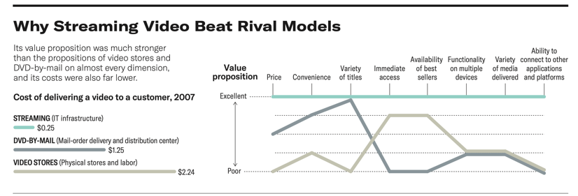
But you can’t jump on every single opportunity either, that would be pointless. You have to create a strategic approach to identifying the value-creating potential of new models. For example, why streaming video would replace rival models, like dvdmail or Blockbuster.

exploiting new opportunities also means facing more competition. Even Disney jumped on Netflix’s model. Seduced by the immediate success however, firms often jump to large investments that often don’t end up paying off, like WhatsApp that was bought by Facebook: it faces numerous imitators, and still doesn’t monetize any of its users.

E.g. Tesla, the most valuable car brand in the world, hasn’t delivered return on investment yet and it’s unclear if they ever will! 3 factor model from above should be applied to these as well:
the electric car industry of the future will just be the diesel industry of now. The barriers of entry are pretty low, and hundreds of firms are entering in the electric car business. Over time, the attractiveness of the electric industry will deteriorate further.
is its brand aura and performance edge a sustainable competitive advantage? Will soon be challenged by Porsche, BMW, etc. plus, it’s way behind on others production-wise, so cost effects will likely benefit competition in the future as well.
need for scale led Tesla to have 7 models now, but even more inefficiencies

the challenge is often not finding new business opportunities, but rather supporting and continuously improving the current competitive positions. Too many adjustments to the wrong opportunities can also neck a company.
a viable business model and distinctive competitive position doesn’t guarantee success in the long term. You have to balance agility and experimentation, and pre-set bounds to this; and keep investing in all needed capabilities. And of course, a strategy that supports this.
e.g. Edward Jones: it’s harder and harder for them to capture value with all the changes in the market, but they shouldn’t change its entire competitive position: their network of small brokers for conservative people is great, but incremental changes must be made to deal with the external market.

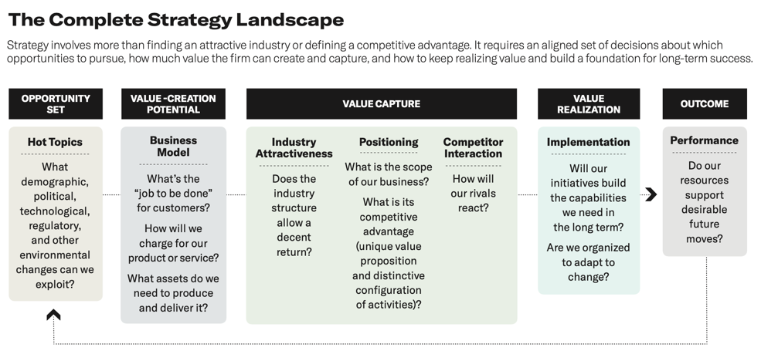
Hidden in this strategic landscape is a source of competitive advantage based on recognizing the interdependence of its element. Plus, everything must be integrated across the landscape.

Ghemawat & Rivkin – Choosing corporate scope

scope has several dimensions: horizontal (what industries do you compete in?), vertical (should you make your own inputs?) geographic (where do you compete?) horizontal in this chapter.
performance differences at corporate ownership level are much smaller than at business level or industry level, but you still can’t ignore corporate strategy.
short history: in ’70s and ‘80s the portfolio management from chapter 1, then value based management came up, focusing on financial performance of units and businesses, eventually taking over portfolio management techniques.
new development in 1990: core competence concept by Prahalad and Hamel, attacking the SBU way of thinking, stating they don’t focus on the firm and on integrating the competences they have, and that mangers should focus on a firm wide strategy and core competences instead.
got some critique, saying that finding your core competences is just a feel-good
exercise for firms -> must be a harsh, external benchmarking, not an internal assessment!
plus, core competences say you yield higher returns from diversifying to related industries than unrelated industries, but this can be successful, how is that explained?
mindless diversification to slightly related things thinking you can undoubtedly generate synergies is wrong though, and often very unsuccessful, like Sears to the financial industry. But it can be successful as well, like when Walmart went into food as well. How do you separate the two? 2 tests to see impact on individual business units:
- Better off test: does the combining of business units lead to the creation and capture of more value than if they were independent? What is the corporate added value?
- Better alternative test: is common ownership the best way to reap the benefits of coordinated action? What is the optimal value appropriation?
(maybe 3d test: best parent test: what would the best available parent achieve, not what would you achieve. But rather stringent, as you shouldn’t get rid of all businesses you’re not running absolutely optimally.)
these tests also avoid some forces that might drive managers to overexpansion:
- Overconfidence bias
- Focus on stretch goals and thinking bigger is better; panicking as mature businesses’ growth rates slow.
- Desire for top management to build an ‘empire’.

Better off test
to pass this test, horizontal differentiation must enable your business units to create and capture more value together than separate -> incremental value must offset cost of HQ, you must create corporate added value.
Why would this happen? Scope effects of course, but this is a little dodgy. Other reasons:
- Industry attractiveness: a) it can mitigate the impact of the five forces. Rivalry can be muted by meeting rivals in several other markets, thus fearing aggression. Denying firms complementary input can increase barriers to entry. Etc.
b) it can give the firm an opportunity to move out of a structurally poor industry. Nokia going from rubber to mobile phones in ‘90s.

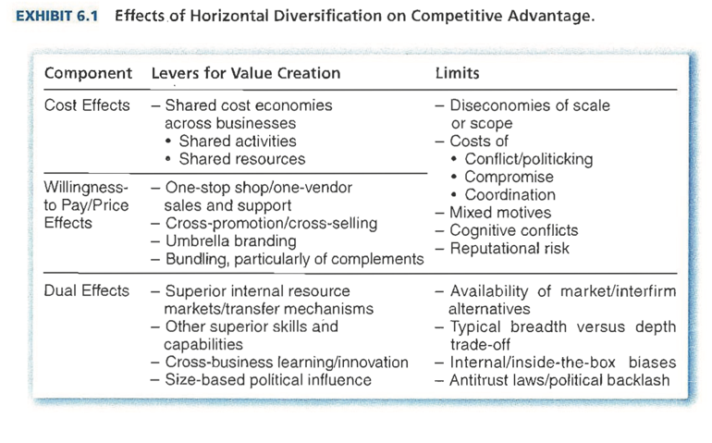
- Competitive advantage: improve your position within an industry. They can influence the wedge for business units between cost and WTP and thus create more value. Through reducing costs, or increasing WTP, or both.
- Shared cost economies. Through economies of scale, that must be carefully assessed. Can arise anywhere I the value chains of business units. Resources involved can be tangible and intangible. But becoming too large can becoming inefficient, and cause conflicts, etc.
- WTP/price effects. Typically come from 2 sources: 1) increased WTP for combined services: one-stop shops, cross promotion, umbrella branding, and 2) improvements in firm’s ability to price that extracts WTP: setting coordinated prices in different markets you’re active in, raising barriers to entry and thus raising prices,…
But, again some caps on this value creation: conflicts, now in terms of price penalties, issues managing because of fear of self-cannibalization when dealing with substitutes (like airlines setting up low-cost services, afraid of taking away customers from their regular service), threats to a firm’s message it sends to customers after expanding and other reputational risks.
- Dual effects. When you can’t cleanly separate cost effects from WTP effects
- Risk considerations. Often used by management to justify diversification, to reduce volatility in overall corporate performance. But, in finance theory, investors can easily diversify themselves. Argument does hold well in less developed markets.

Best alternative test.
this test realizes ownership isn’t necessarily the best basis for coordinating across units.
can a corporation that owns a business unit achieve its ends better than the same units coordinated in a different way? -> focusses on value appropriation, not just addition!
could Disney exploit its characters by licensing them to independent theme parks? Could Walmart have done so by licensing to independent supermarket owners?
- Transaction costs and ownership. Sometimes, it is better to contract out your excess capacity than to horizontally expand. E.g. Disney licensing its characters to McDonalds instead of opening its own fast food chain. Concept of transaction costs can help you make the decision which to bring outside the value chain:
relationship between any two business units is a set of transactions. The one with the lowest transaction costs, e.g. finding a trading partner; preventing opportunistic behavior (like threat of holdup)(depends on strength of contracts: if strong, can be better to not be owner); independence; is the most optimal.
- Models of corporate management. Test not only says what businesses should be managed; also how they should be managed. 3 ways that try to meet the test:
- Dominant-business corporations: a few dominant units, and several peripheric units around it. Meet the test by investing in a set of highly specialized coordinated resources that separately owned companies cannot match. E.g. Walmart. Focused on deeper sharing and coordination.
- Related-business corporation. More business units than a), and more autonomy and a distinct bottom line for each, but still distinct threads that bind the businesses together. Meet the test by one-time transfers of resources or ongoing sharing of resources/skills. Corporate has difficult task to coordinate all units together. E.g. Walt Disney, with its theme parks, movies, merchandise etc. Focused on broader sharing and coordination.
- Unrelated-business corporation. Many units with few relations between them. Satisfy the test by a strategy based on generic and unspecialized resources. E.g. US conglomerates’ tight financial and cash management to create value.
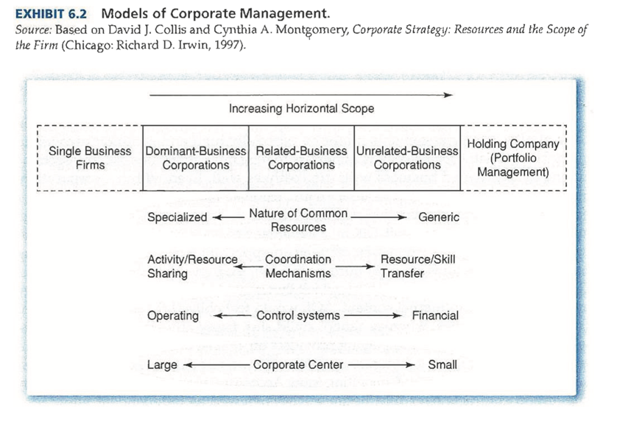

Final pages: application to AOL Time Warner merger. Many mergers always highlight ‘synergies’ to justify both the merger and the enormous costs and premiums, but most synergy arguments are highly flawed. Flaw are highlighted by 2 tests.

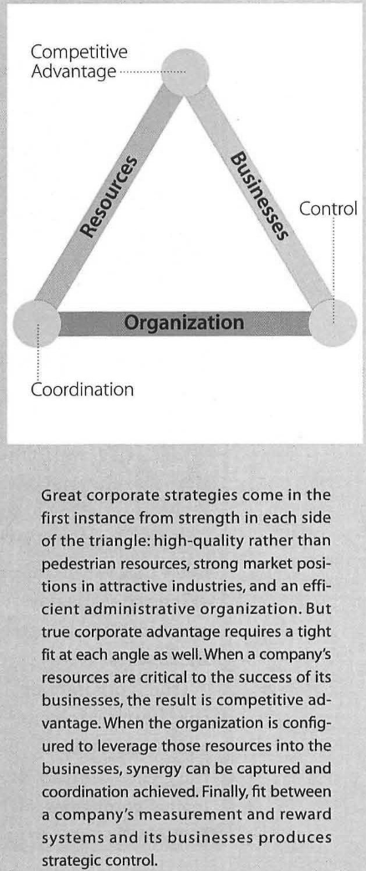
Collis & Montgomery – Creating corporate advantage

most businesses are just the sums of their parts. Most managers are good at understanding what it takes to get a competitive advantage at the business level, but not at creating corporate advantage.
biggest mistake is only focusing on one part of the triangle – resources, business or organization – and not on how they should all fit together.
a good corporate strategy is a carefully constructed system of interdependent parts. All of these elements are aligned with one another through the resources, that form the binding thread. They vary from highly general to highly specialized resources.
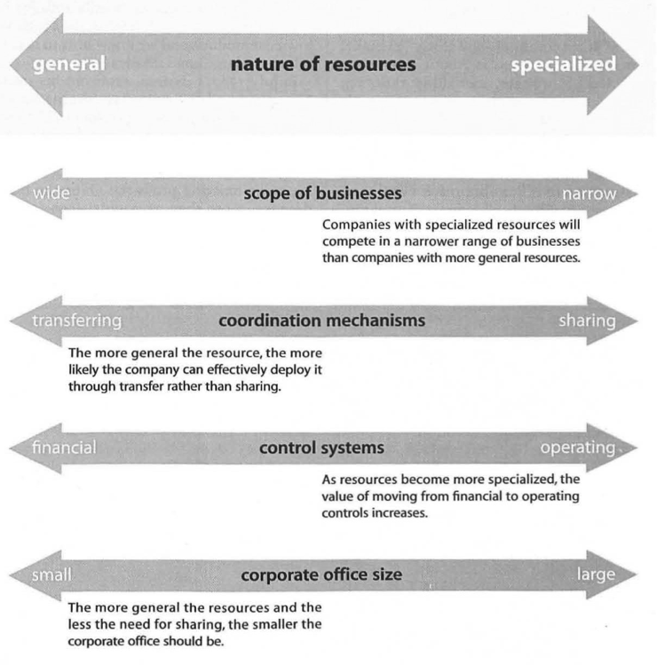

the set of resources it holds in the continuum decides which businesses the firm can be in and in which it can’t. Important to know, as most managers mistakenly enter businesses based on product similarities, not resource similarities. Plus, they create plain vanilla strategies with one HQ, instead of tailoring the organizational structure to the particular strategy. There is no one size fits all!
Example: Newell. Makes products from propane torches to office supplies. Yet it is far from a conglomerate! The relatedness between businesses comes from common resources they draw on: Newell’s relationship with retailers, high-volume manufacturing, service, etc.
Firm’s corporate capabilities enhance competitiveness of each business it owns!
need for fit between resources and businesses constraints set of viable businesses, but increase the likelihood of being successful.

the kind of coordination and control likewise plays a role to effectively deploy your resources. Newell achieves the benefits of coordination with low organizational costs. Newell transfers resources instead of outright sharing them, as this is not always optimal (overall, public goods, like brand names, lean manufacturing etc. are best shared, private goods, like sales forces, are best transferred. This needs less explicit coordination).
e.g. as much knowledge is embedded in management, they move managers around their business units; meet up with each other, etc. The only thing it shares is its large data management system.

effective control system also plays a role in corporate strategy. Without it, corporate quickly loses the ability to determine the strategy and influence independent businesses. You can choose from operational (manager’s decisions and actions) or financial (few objective measures, like ROI) control systems.
Newell’s is based on 30 operational criteria it deems important across all businesses and holds individual & operating managers accountable for performance
what are the most important lessons based on Newell? 1) corporate strategy is guided by a vision of how the company will create value as a whole. 2) corporate strategy is a system of interdependent parts, with success depending on how they all reinforce each other. 3) corporate strategy must be consistent with, and capitalize on, opportunities outside the business. 4) benefit of corporate membership must be greater than the cost.
resources are the unifying thread!!

Sharp corporations: sits at near end of specialized resources continuum. Most important specific resource for its competitive advantage across businesses is LCD technology. This, again, restricts the businesses sharp can operate in, because it knows it wouldn’t have a competitive advantage there without its technology. They have a large HQ staff, because they have to intricately coordinate all its shared technological activities.
sharp is divided in functional units instead of product units, so most activities (like R&D) are shared. To enforce coordination, their managers have to configurate everything.
control systems are based on how people behave, rather than short term financial goals.

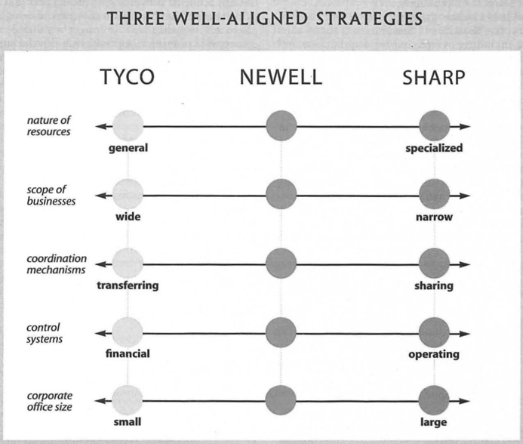
Tyco sits at near end of generalized resources continuum. They show that a carefully built up conglomerate can be successful. Because their resources are general, they can operate in many businesses, but its financial controls and governance structure still puts a cap on this. They’re organized in independent product groups.

what is clear is that there is no one size fits all strategy. Internal consistency, tailored to a firm’s resources and opportunities, is the most important. If you stick to this, you can create meaningful competitive advantage.
it can work as long as it passes following test: the company’s businesses must not be worth more to another owner.

Friedman – The social responsibility of business is to increase its profits

business men believe they are defending free enterprise when they claim that business is not ‘only’ concerned with profit but also with social ends; that they have a social conscience
pure and unadulterated socialism?
people have responsibilities, businesses really can’t have them. In this discourse, then it would be corporate executive to hold responsibilities.
corporate executives are employees of the owners of the firm, and have to reach the objectives set by these owners. Most often monetary, but can also be something other.
what does it mean when the executive, acting as the agent, is socially responsible? Is he then acting against the wishes of his employer? Isn’t he spending the money of shareholders, customers, employees when he increases costs, raises prices, etc. to serve this purpose?
isn’t he then imposing a tax and deciding where he spends this tax? Only a government can do this! They would then be civil agents, then they must be elected through a political process,… This justifies the link between ‘social responsibility’ and socialism: a political mechanism, not market mechanisms, are appropriate to allocate scarce resources.

will the shareholders and customers even accept that he is spending their money? The difficulties of social responsibility are shown – you can do good, but only at your own expense.
wouldn’t it be easier to go through a faster company solution than a slow political process? Then you are only attaining undemocratically what you can’t get democratically. This can’t be good – one man’s good is another man’s evil.

in practice, social responsibility is often the cloak for actions justified on other grounds. To get access to certain resources, to avoid extra costs when donating to charity as the firm instead of the individual shareholder,…
way to generate goodwill in the current anti-capitalism climate, while still only focusing on their own benefits
nothing but window dressing, that continues making capitalism and the making of profit look like something that is evil. “in a free society, and have said that in such a society, “there is one and only one social responsibility of business – to use it resources and engage in activities designed to increase its profits so long as it stays within the rules of the game, which is to say, engages in open and free competition without deception or fraud”. “
Porter & Kramer – Creating shared value: how to reinvent capitalism
Capitalism is under siege. Business is increasingly being seen as a major cause of social, environmental, and economic problems. Trust in businesses is falling rapidly. Main problem is businesses themselves, still stuck in an old way of value creation, optimizing short-term financial performance in a bubble. How else would they justify overlooking customers’ wellbeing, depleting viable natural resources, etc.?
governments have stepped in, institutionalizing the presumed tradeoff between economic efficiency and social progress.
purpose of companies must be redefined to create shared value, creating economic value while also creating value for society. Companies must reconnect business with society!

capitalism is an unparalleled vehicle to meet human needs, improve efficiency, etc. But a narrow conception of this prevents companies from reaching their full potential to meet broader societal challenges.

In neoclassical thinking, social improvement imposes a constraint on the corporation and eventually raise costs and reduce profits. This is also the thoughtpattern behind e.g. externalities like pollution and the taxes to make firms internalize them.
in this sense, firms’ strategies don’t include society, and societal problems are for governments and NGOs to fix. CSR is mainly just to improve reputation, anything else is just irresponsible use of shareholders’ money.

shared value concept recognizes that societal needs define markets, not just conventional economic needs. It also recognizes that social harms – wasted energy, accidents – are often internal costs too. Improving on this can benefit firms too.
it is not about personal values, nor about sharing value already created. It is about expanding the total pool of economic and social value. Not just paying farmers more in fairtrade, but about increasing their yield, efficiency, quality, etc.

a company and the health of the communities around it are closely intertwined. Standard capitalism doesn’t recognize this: there, everything that happens outside the firm is not in its scope (like arguments put forward by Friedman). Even when profits are generated, the communities don’t benefit from this

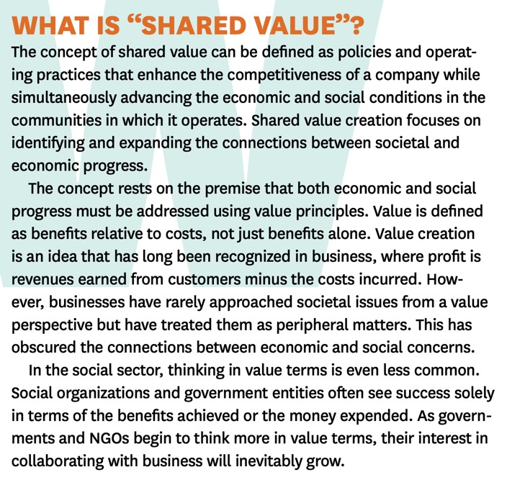
wasn’t always like this though. Only when other social institutions started taking over the ‘caring’ roles did companies start acting like this. Shorter investment cycles, vertical integration, etc. all drove economic efficiency forward, but companies missed fundamental opportunities for value creation.

companies can create economic value by creating societal value. 3 ways to do so:
- Reconceiving products and markets; 2) redefining productivity in the value chain; 3) building supportive industry clusters at the company’s locations.
they create a virtuous cycle of shared value, and it resets the boundaries of capitalism.
opens up many new needs in the market, gain efficiency, expand markets,…
different opportunities in emerging/developed markets, different industries,…

- Reconceiving products and markets.
too many companies have lost sight of the question: is our product good for our customers? What customers want is drastically changing! Companies are playing into this, and this opens up whole new ways for innovation and creates shared value.
kind of blurs the lines between for profit and non profit firms
too much focus on industry! Yes, it has a large impact on profitability, but they’re missing the impact of the broader business environment.
emerging markets, underdeveloped urban communities, etc. all offer new opportunities. Providing appropriate products to them increases social value, and profits at the same time, like e.g. vodafone’s payment system in Kenia.

The starting point for a company is identifying all societal needs and benefits that are/could be embodied in the firm’s products. These aren’t static, and evolve constantly.

- Redefining productivity in the value chain
company’s value chain is always impacted by societal issues that create economic costs. Opportunities then arise, to create shared value! So-called externalities actually do cause internal costs, even without imposed taxes and regulation.
few companies reap the full productivity benefits. But it is getting better and better.
it’s this deeper understanding of productivity and the fallacy of short-term cost reductions that give rise to new approaches.
Some examples where shared value is created by mutually enforcing the value chain:
- Energy use and logistics. Saving energy and shipping cuts costs, as well as emissions.
- Resource use. More efficient resource usage in water, raw materials, packaging, etc. Further enabled by improving technology.
- Procurement. Traditionally, you try to get as much bargaining power as you can as a firm to drive down prices. But, marginalized suppliers cannot remain productive. Improving on that improves productivity, quality, and efficiency, plus sustainability. Even outsourcing can create transaction costs and inefficiencies that trump the cost savings.
- Distribution. New business models create shared value. iTunes, Kindle,… drastically reduces paper & plastic usage.
- Employee productivity. Low wages, safety, health coverage,… reduces employee productivity, often more than the costs you would save.
- Location. Technology makes any location possible, so the cheaper the better? Hidden costs of highly dispersed and distant production might make companies move production closer to home. The most successful firms will be those with deeper roots in their communities, as they can create shared value.

- Enabling local cluster development.
the success of a firm is always affected by the supporting firms and infrastructure. ‘clusters’ – geographic concentrations of firms, suppliers etc. – greatly improves productivity and innovation. Like Silicon valley.
these also include broader societal institutions, like universities, trade associations, clean water, market transparency, …
deficiencies can also cause costs for the company. Poor education means higher training costs. Discrimination means less capable working people. As firms get more disconnected from their communities, they don’t see the costs that these cause. Building clusters to fill these gaps can thus create shared value!

Profit with a social purpose represents a higher form of capitalism: allowing society to advance and companies to grow at the same time, resulting in a prosperous cycle of company and community prosperity.
best opportunities will be those closely related to the firm’s business and area it is active in. This is the place they bring the most resources to bear.

shared value lens can be applied to every major company decision and activity. But creating it will require new forms of collaboration, especially those with cluster development
in any case, shared value doesn’t arise out of a sense of charity, like CSR, but out of a deeper understanding of economic value creation.

(side notes: above also counts for governments and nonprofits. Can’t look at social benefit as only that, to be reached at any costs, as an activist. They too should focus on shared value.
The right government regulation can encourage creating shared value. The wrong can even make the ‘traditional’ tradeoffs inevitable.)
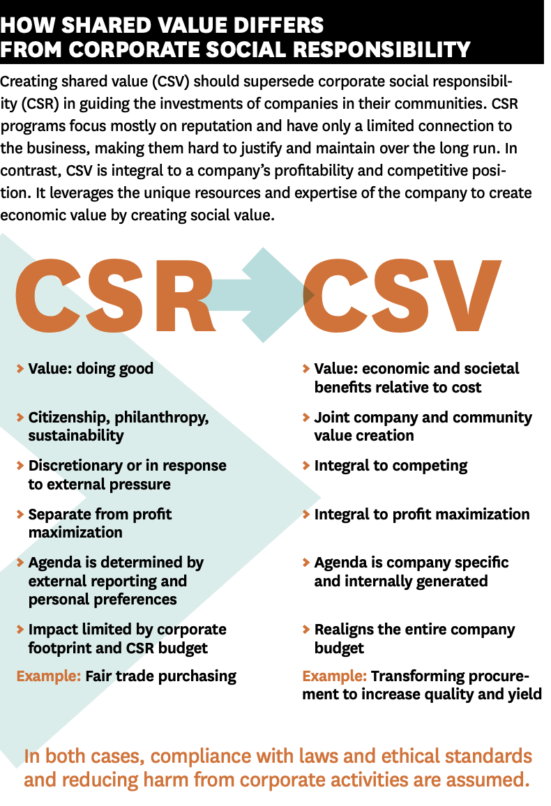
Kaplan & Norton – Mastering the management system
Too many companies fall to Gresham’s law: pushing discussions about bad operations at executive meeting at the forefront will inevitably drown out discussions about good strategy implementation. firm inevitably falls into a trap, of not meeting any operational targets but never talking about how to modify the strategy, which growth, which opportunities,…
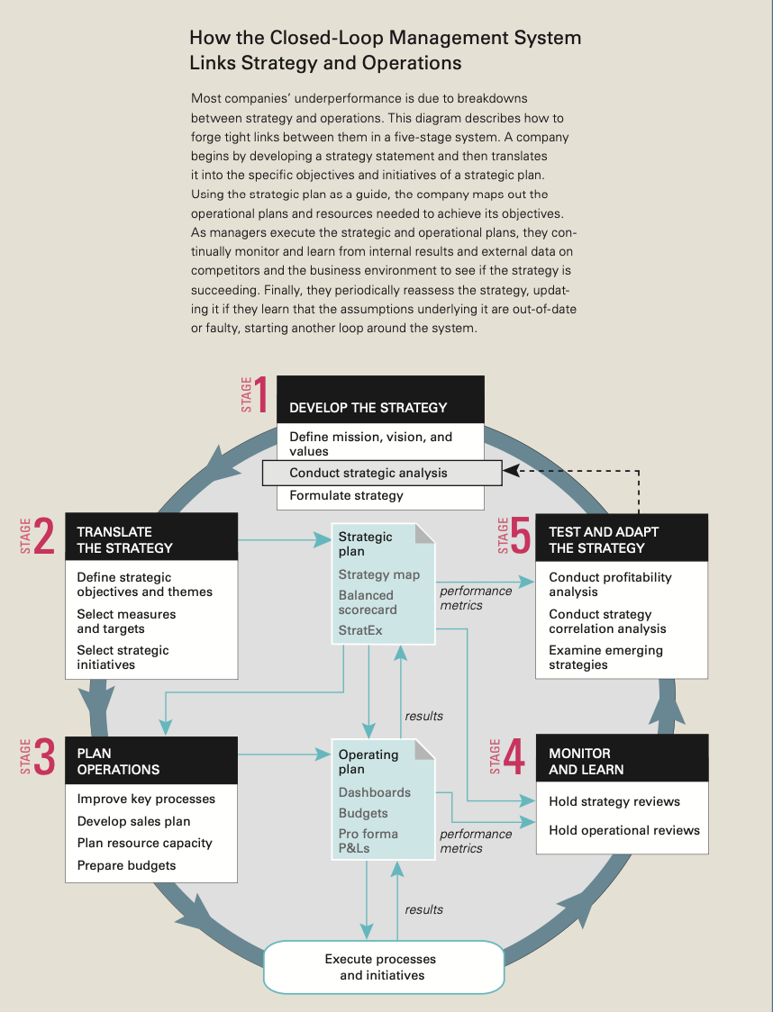
Breakdowns in a company’s management system (= integrated set of processes and tools that firm uses to develop its strategy, translate it into operational activities, and monitor and improve the effectiveness of both) are usually what causes its downfall, not lack of ability or effort. Failure to balance tension between strategy and operations is huge! closed loop management system can change this. system often breaks down right at the beginning already, when grand strategies can’t be translated to goals and targets for middle management, or link the objectives to tools that support operational improvement processes.
Stage 1: develop the strategy.
Management articulates strategy at (usually annual) meetings. If it’s an entirely new strategy, it might take a few days of meetings, to reexamine the current assumptions and environment and formulate the strategy. With CEO, executives, heads of business and regional units, senior functional staff. questions to ask: 1) What business are we in and why? Defining the mission, vision, and values (internal compass that guides actions). This puts executives in the right mindset for considering the other agenda points. 2) What are the key issues we face in our business? A strategic analysis of the company’s external and internal situation. External: analyzing the five forces, industry growth, macroeconomical environment, and the dynamics. Internal: assess the firm’s internal capabilities and performance. Through Porter’s value chain, or identifying the distinctive Rs & Cs that give the competitive advantage. Then, summarize the internal and external analysis in a SWOT analysis to assess their abilities to help or hinder the company. 3) How can we best compete? The strategy formulation itself, describing the strategy and how you’re going to achieve it. Which customers will we target, which value proposition will we give, which are the technology/organizational enablers,… Porter’s cost vs. differentiation strategy, resource based firm view,… all this step
Also SWOT
Startegy maps & balanced scorecards

Stage 2: translate the strategy
Translate the above in objectives and measures that can be clearly communicated. 2 things: Strategy map: visualizes the strategy as a chain of cause-and-effect relationships among strategic objectives. Links the objectives all the way down to the processes, the people, the organizational structure and the technology. but, all these many objectives can be difficult for managers to understand. Chopping it up into 'strategic themes’ can help with this.
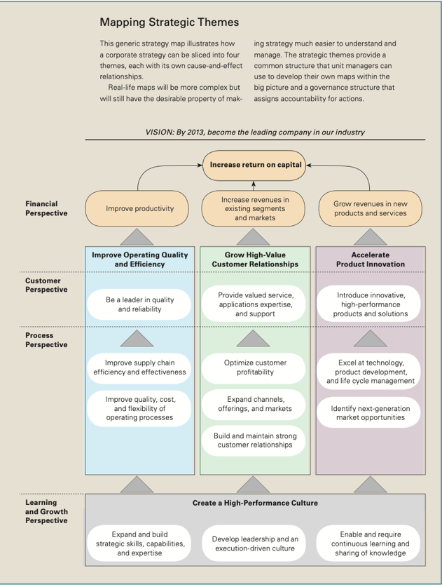
Balanced score card: of performance metrics and targets for each strategic objective. If you can’t measure it properly, you won’t improve on it either. Third step: identifying your strategic initiatives, your portfolio of resources you need for your strategic objectives. Designed to close a performance gap, like e.g. developing a customer loyalty program.
Step 3: Plan operations
Plan that lays out actions that will accomplish the objectives. 4 aspects: 1) Process improvements: improving on your already existing processes, and aligning them with your strategic priorities. With specific success factors for each process that employees can focus on. 2) Sales Plan. Breaking down your overall sales target, to then see what needs to change. 3) Resource capacity plan. What resources do you need to execute the strategy? For example, measure through time driven activity-based costing. 4) Dynamic operating and capital budgets. After previous 3 steps, financial implications for each resource is easily calculated from the sales and operating plans, and subsequently authorized.
Stage 4: monitor and learn
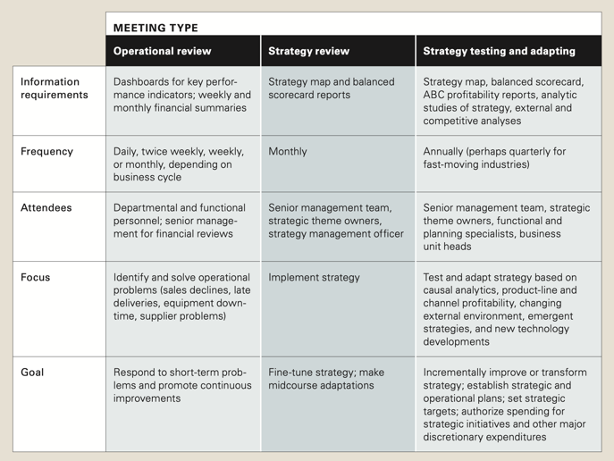
While implementing the strategic and operational plans, management must hold 2 types of meetings. 1) Management meetings reviewing the performance of operating departments and business functions. Reviewing operational dashboards, and fixing short term operational issues. 2) Strategy leadership meetings to review the progress of the strategy, balanced score card performance indicators, and any barriers to the strategy.
Stage 5: Test and adapt the strategy
(third type of meeting). When managers discover something wrong with the assumptions underlying the strategy, they need to rigorously reexamine and adapt it. 3 new inputs: 1) Cost and profitability reports. What are the economics of the current strategy? P&Ls of each product, customer, segment, etc. So you can see where the strategy failed or worked. 2) Statistical analyses, to estimate correlations among strategy performance numbers and investments (or those that were hoped for, but aren’t there). 3) Emerging strategies. Considering opportunities for new strategy proposals as well. Most good proposals come from within the organizations, from managers and employees. But executives should still think clearly about what to do and what not to do. Then, adapting the balanced score card and strategy map accordingly. This launches a new cycle again.

