Business Analysis
Summary of classes by Jochen De Weerdt, winter semester 2023
Pictures from slides by Jochen De Weerdt

1. Introduction to Business Analysis

What is Business Analysis
- “The practice of enabling change in an enterprise by defining needs and recommending solutions that deliver value to stakeholders”
- From business needs to feasible solutions (via technology)
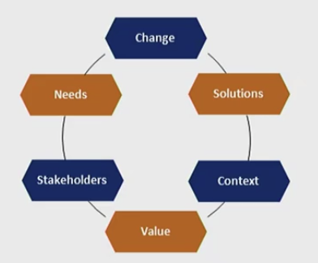
- Business Analysis Core Concept Model (BACCM)
- International Institute of Business Analysis (IIBA)
    - Institution shaping BA
    - Courses, books…
    - Sets standards in BA
- Business Analysis Body of Knowledge (BABOK)
    - By IIBA
    - Collection of concepts, activities… considered standard within the profession
    - Not a ‘how to’ but a renumeration of everything in BA
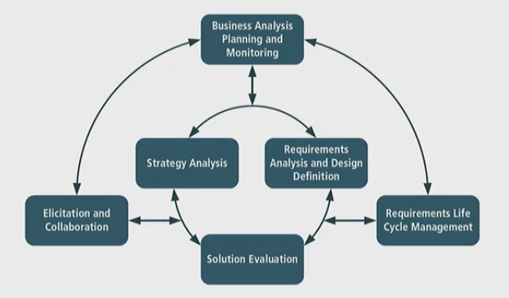
    - Knowledge areas:

What is a Business Analyst
- “A liaison among stakeholders in order to elicit, analyse, communicate and validate requirements for changes to business processes, policies and information systems
- Different types
    - IT business analyst
    - Systems analyst: technical
- Profile competencies
    - Problem solver, systems architect and planner
    - Facilitator: facilitate relations between stakeholders
    - Negotiator between stakeholders
2. Context Analysis

Business Strategy
- Strategy
    - Integrated set of actions aimed at increasing LT wellbeing & strength
    - Determination of basic LT goals
    - Adoption of courses of action
    - Allocation of resources necessary
    - LT direction of an organisation
    - 5Ps: plan, ploy, pattern, position & perspective
    - Importance: success through aligning execution with context of internal & external environment
- Businesses benefit from being aware/capable to apply knowledge in strategic context
    - Analyse & discuss strategic opportunities
    - Build credibility when discussing with stakeholders
    - Question appropriateness & alignment of decisions taken prior to changing initiative
    - Provide leadership/influence for delivery of strategically aligned change
- Strategic context: from current state to target state
What is the plan to get there: strategic mission or roadmap
- SWOT
    - Strengths & weaknesses: internal context analysis (VMOST, BSC…)
    - Opportunities & threats: external context analysis (5 forces, PESTLE)

External Context Analysis
- External perspective
    - Economic growth
    - Monetary policy
    - Regulations
    - Technological trends
Opportunities & threats
- PESTLE(E) analysis
    - Political: stability, government policy, taxes…
    - Economic: interest rates, exchange rates…
    - Sociological: age distribution, career attitudes…
    - Technological: automation, R&D activity…
    - Legal: employment laws, antitrust laws…
    - Environmental: climate, weather…
    - (Ethical: GDPR, innovation regulation…)
- Porter’s five forces
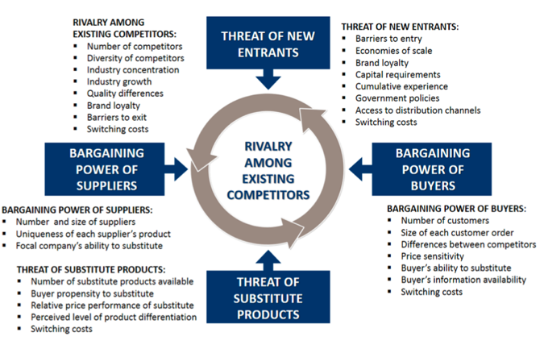
    - Porter’s model not useful in case of disruptive change
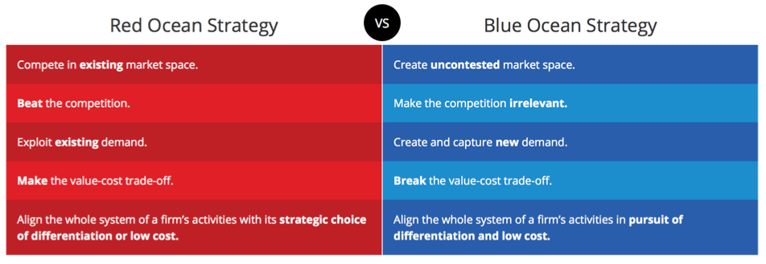
- Blue ocean vs. red ocean strategy

Internal Context Analysis
- Internal perspective
    - Organisational strategy
    - Business model
    - Capabilities & flaws
    - Organisational culture & structure
Strengths & weaknesses
- VMOST
    - Vision: defines target state
    - Mission: describes what firm does or will do
    - Objectives: what firm wants to achieve
    - Strategy: LT approach taken to achieve the vision, mission & objectives
    - Tactics: detailed means by which strategy will be executed
- Resource audit
    - Strengths & weaknesses per resource type
    - Can be applied to subunits too
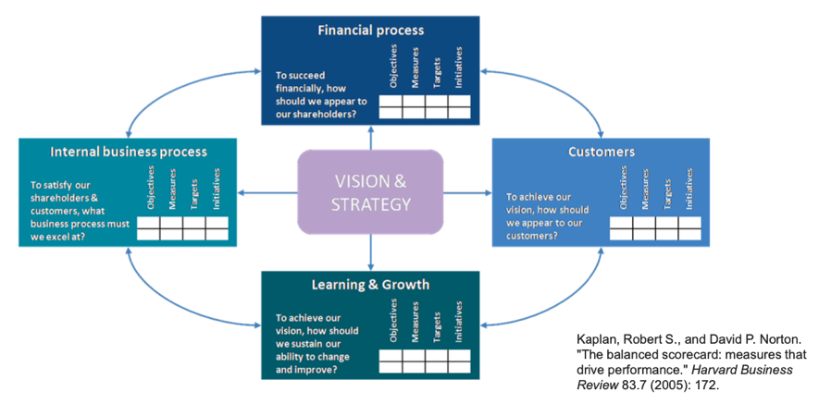
- Balanced scorecard (BSC)
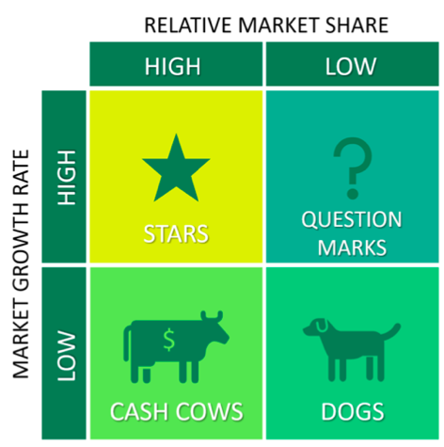
- Growth share matrix (BCG matrix / Boston box)
Strategy Execution
- Developing & executing strategy
    - Start from results of in-/external context analysis
    - Analysis of gap between current and target state
    - Key techniques
      - Business model canvas (BMC)
      - Business capability model (BCM)
- Business model canvas
- Customer segments & value propositions
    - Value proposition canvas
      - Who are most important customers
      - What value is proposed
      - Customer jobs: functional, social or emotional jobs
      - Customer pains: causes customer to be annoyed during job
      - Customer gains: required, expected, desired & unexpected gains
    - Products & services
      - Physical, intangible, digital or financial
      - Pain relievers: how does it alleviate customer pains
      - Gain creators: how does it create a gain
    - Customer segmentation to discover archetypes
    - Product-market fit between value proposition & needed product/service
    - Value can be produced by
      - Newness
      - Performance improvement
      - Customisation
      - Getting job done (trustworthiness)
      - Design, brand or status
      - Price & cost reduction
      - Risk reduction
      - Accessibility, convenience or usability improvement
- Channels & customer relationships
    - Customer journey mapping
    - Types of customer relationships
      - Personal assistance: bade on human interaction
      - Dedicated personal assistance: dedicated representative
      - Self-service: no direct contact
      - Automated service: self-service using automated processes
      - Communities: users help each other
      - Co-creation: create together with customer
- Key resources & activities: most importance assets and actions for a firm
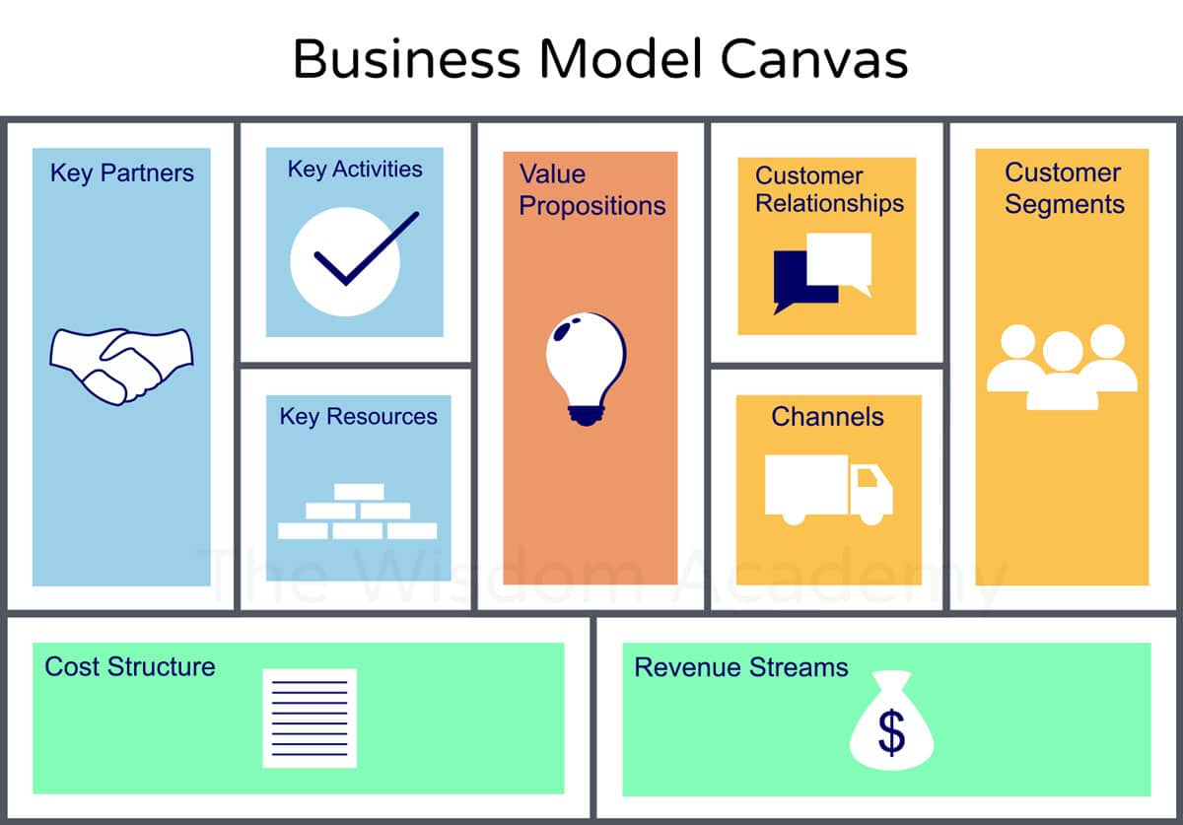
- Cost structure & revenue streams (profit = revenue – costs)
- Business capability model
    - Capability: abstract collection of resources, processes & technologies that enable an organisation to achieve a desired outcome
    - Modelling a capability
      - Performance gap
      - Impact gap
      - Risk
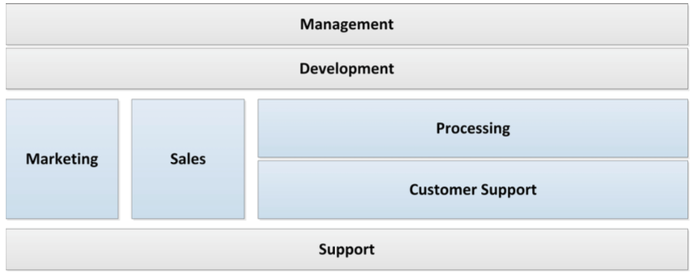
    - High level analysis, not done by business analysts

Enterprise Architecture (EA)
- An EA represents the core building blocks of the organisation and their interaction
- Business architecture
    - Blueprint that provides common understanding of the organisation
    - Used to align strategic objectives and tactical demands
- Types of architectures
    - Application architecture: portfolio of business applications
    - Data architecture: describes all date held by organisation
    - Infrastructure architecture: hardware, networks…
    - Compliance architecture: meet/manage compliance expectations
    - Security architecture: protect business from harm

3. Requirements Engineering

Requirement Types
- A requirement
    - Feature requested by a stakeholder
    - May form part of a solution
    - May be unstated, implied or derived from other requirements
    - Business analysis ensures that requirements are clear and understood
- Business requirements: high-level statement of goals, objectives…
- Stakeholder requirement
    - Needs of a class of stakeholders
    - Bridge between business & solution requirements
- Solution requirements
    - Describes characteristics of a solution
    - Developed and defined through requirement analysis
    - Divided into functional & non-functional requirements
    - Functional requirements describe
      - Behaviour & information the solution will manage
      - Capabilities the systems must perform

    - Non-functional requirements describe
      - Conditions that don’t relate to behaviour of the solution
      - Environmental conditions under which solution remains effective or qualities the system must have
      - Quality or supplementary requirements
- Transition requirements: capabilities needed to go from current to future state

Requirements Elicitation
- Crucial state of RE process: uncover, acquire & elaborate requirements
    - Different sources
      - Stakeholders
      - Documentation
      - Existing systems
- Different techniques
    - Qualitative
      - Gaining impressions & opinions
      - One-on-one interviews, meetings & observations
      - Scenarios
      - Prototyping
      - User role analysis and personas
    - Quantitative
      - Surveys & questionnaires
      - Document analysis

Requirements Analysis
- Objective: identify requirements that
    - Overlap
    - Are in conflict with other requirements
    - Are duplicates
    - Need to be separated into individual requirements (composite/complex)
- Defining requirements: examine requirements, filter them and build a well-formed set
    - Unravelling multiple requirements
    - Check for overlap and duplicates
    - Confirm relevance of requirement and evaluate feasibility
      - Technical, business & financial feasibility
    - Remove conflicts and confirm quality of expression
      - Clear, concise & consistent
      - Relevant, unambiguous & correct
      - Testable & traceable
- Prioritize requirements
    - Usually not feasible to satisfy all elicited requirements right away
    - Two common models
      - MoSCoW model
      - Kano model
- MoSCoW model
    - Must have
      - Delivering solution without this makes no sense to stakeholders
      - Delivering solution without this is illegal
      - Delivering without this is unsafe

    - Should have
      - Not absolutely necessary, but stakeholders will be unsatisfied
      - Important but not essential
      - Harmful to deliver without this but solution remains relevant
      - Solution can’t work without the requirement but temporary workaround is used to deal with the gap
    - Could have
      - Desirable but has moderate impact on stakeholder satisfaction
    - Would have
      - Interesting in the long run, but spending doesn’t justify expense
      - Would implement if there was enough time/money
- Kano model
    - Must be
      - What stakeholder takes for granted
      - Cost of entry to initiate the solution
    - One dimensional
      - Demanded from solution in order for it to be acceptable
    - Attractive
      - Satisfaction gets higher as implementation level increases
      - Would be appreciated but not necessary
    - Indifferent
      - Satisfaction won’t change if implemented or not
    - Reverse
      - Is not wanted in solution
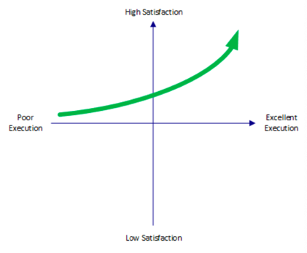
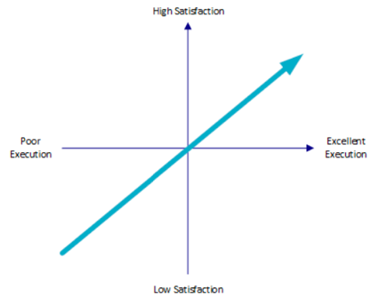
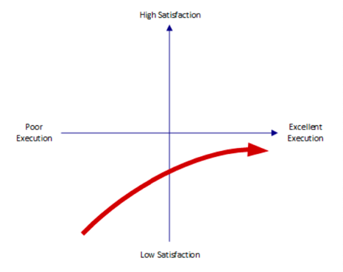
      - Satisfaction gets lower
Attractive
One dimensional
Must be

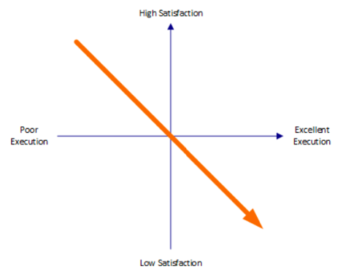
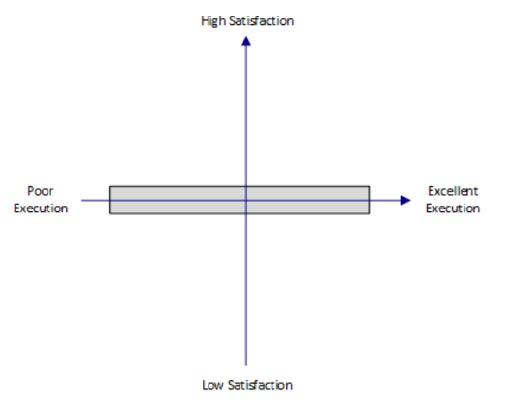
Reverse
Indifferent

Requirements Validation
- Definition
    - Show that the requirements define the system that the customer wants (quality gateway), conducted by external stakeholders
    - Justified by high cost of errors on requirements
Non-detection of requirement error cost > implementation error cost
      - Error amplified by all phases, becomes significant at release
    - Different from testing
      - Validation: check consistency with expectation
      - Testing: check compliance with requirement documents
- Formal vs. informal validation
    - Linear project approach: documented requirements are reviewed
    - Agile project approach: less formal, ongoing refinement until ready
- Criteria
    - Validity: do requirements reflect customer expectations
    - Consistency: conflicts, duplicates…
    - Completeness: is everything required by customer included
    - Realism: feasibility of requirements
    - Verifiability: can requirements be checked and tested
- Techniques
    - Requirements review: systematic manual analysis of requirements
      - Regular reviews f documentation during development
      - Customers & stakeholders involved reviews
      - Formal or informal
      - Communication between developers, customers and users
    - Prototyping: using executable preliminary model of solution to check in practice if requirements are correct
      - Create incomplete versions of solution under development
      - Prototype only simulates aspects of solution
    - Test-case: to verify testability
      - Test case is a set of test components
      - Each component describes entries, actions or events and expected response to determine whether function works

Requirements Documentation
- Importance
    - Enables communication
    - Basis for ensuring requirements consistency
    - Basis for validating what solution should provide
- Text based documentation
    - Requirements catalogue
      - Typical in linear projects
      - Simple, tabular format for defining requirements
    - User story
      - Defines features actors require of a system
      - Written from user perspective
      - 3Cs: card, conversation & confirmation
- Diagrammatic documentation
    - Use case model
    - Data model
    - Business process model
- Linear vs. agile
    - Linear: formal, reviewed and signed off
    - Agile: informal, outline, requirements evolve during development

Requirements Modelling
- Business/stakeholder requirement level
    - No real modelling
    - Relevant techniques: prototyping, customer journey mapping…
- Solution requirement level
    - Non-functional requirements: not really applicable
    - Functional requirements: focus of diagrammatic modelling techniques
      - Use case diagrams
      - BPMs
      - Data models
- Diagrammatic models: Unified Modelling Language (UML)
- Modelling business perspective
    - Visualizing actors who will engage system
    - Levels: context, business use case & system use case diagrams
    - UML use case diagrams are a standard notation
      - Actors: who interacts with system
      - Use case: something actor wants system to do
      - System boundary: box around all use cases
      - Associations: linking actors and use cases
      - <<include>>: link between use cases, allow reusing certain steps common for multiple use cases
      - <<exclude>>: link between use cases, for extension scenarios, steps that will be developed during later iteration
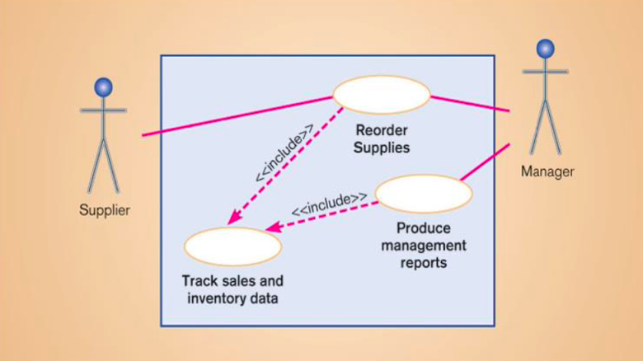
      - Ex. use case diagram
- Modelling data perspective
    - Shows how systems interacts with data (saving, deleting, generating…)
    - Two standard techniques
      - Entity relationship diagrams (ERDs)
      - UML class diagrams
- Modelling process perspective
    - BPMN
    - UML activity diagrams

Requirements Management
- Continues after end of project, as requirements may change
    - New stakeholders, environment changes
    - More user experience
- Types of requirements
    - Sustainable requirements: derived from core activities
    - Volatile requirements: change during development / when system in use
      - Mutable requirements: change due to environment
      - Emerging requirements: as understanding of systems develops
      - Consequential requirements: results from introduction of other computer system
      - Comparability requirements: depends on other systems or organisational processes
- Traceability
    - Relationship between requirements, their sources and system design
    - Source traceability links requirements to stakeholders
    - Requirements traceability links them to other dependant requirements in the solutions in order to assess how many other requirements will be affected by a change in solution (impact analysis)
    - Design traceability links requirements and design modules that implement them in the solution
    - Horizontal
      - Tracing requirement from inception to delivery
      - Backwards: what was source, who raised it
      - Forwards: track where it is developed & implemented
    - Vertical
      - Tracing requirement up/down requirement hierarchy
      - Alignment with general/technical requirements

4. Delivery of Solution & Project Management

Making the Business Case
- Business case presents and evaluates one or more courses of action that will address a problem or enable the organisation to grasp a business opportunity
- Supports decision making, persuade stakeholders to move forward
    - Stress benefits, not features
    - Sell benefits before discussing the costs
    - Ensure buyers understand the problem or opportunity
- When to produce business case
    - Immediately after preliminary investigation
    - Living document: ongoing review
    - Should pass certain decision gates about viability before proceeding
- Structure of business case
    - Introduction
    - Executive summary
    - Description of current situation
    - Options considered
      - Option description
      - Costs & benefits analysis
      - Impact & risk assessment
    - Recommendations
- Costs & benefits analysis
    - Tangible & intangible costs & benefits
    - Appraisal techniques
      - Payback (break-even)
      - Discounted cash flow (DCF) or net present value (NPV)
      - Internal rate of return (IRR)
- Solution cost
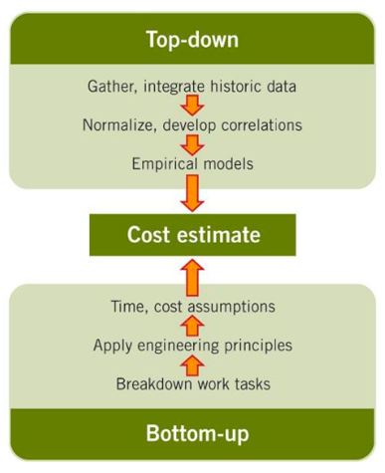
    - Top down vs. bottom up
    - Rough order magnitude (ROM)
      - Goal: provide stakeholders with rough idea of project’s costs
      - Accuracy usually -25% - +75%
    - PERT (three point) estimation
      - Subject matter experts propose 3 different estimates
      - Optimistic, pessimistic and most likely outcome
      - PERT: program evaluation and review technique
      - It overweighs the most likely outcome compared to others
- Impact & risk assessment
    - Estimate impact in different areas, examples:
      - Organisation structure
      - Working practices
      - Management style
    - Assess risk based on description + impact + probability + countermeasures + ownership
- Agile context of business cases
    - Steering away from large monolithic projects
    - Now more incremental approach
    - Initial case produced based on feasibility study
      - MoSCoW prioritisation to formulate options
      - Delivery of each release is opportunity to revisit the case
      - Reprioritize backlog according to changes in environment

Solution Development Approaches
- Delivery style
    - Numerous methods, standards & lifecycles may be used
    - Factors
      - Roles: key roles performed during project
      - Deliverables: artefacts delivered by team
      - Context: characteristics of business and project
      - Lifecycle: process adopted for development & implementation
- Context is given by
    - Culture & philosophy
    - Business context
    - Constraints
    - Prioritised business needs
    - Project drivers
- Delivery lifecycles
    - Software development lifecycles provide clear basis for conducting development projects
    - Sets out sequence of stages required to define and deploy IT system
    - Can be easily adapted to business change projects
- Main delivery lifecycles (SDLCs)
    - Waterfall lifecycle
      - Series of sequential stages
      - Each stage signed off before next one starts
      - Backwards facing arrows indicate need to check back
      - Strong basis for clear project management
      - Supports high quality solution delivery
      - High risk for project delays due to exhaustive quality focus
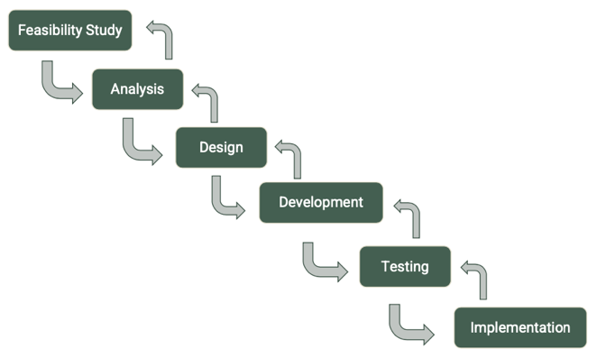
      - Does not enable adaption or change well

    - V-model
      - Variant of waterfall, similar benefits & drawbacks
      - Testing stages explicitly shown
      - Derivation & usage of test criteria made explicit at each stage
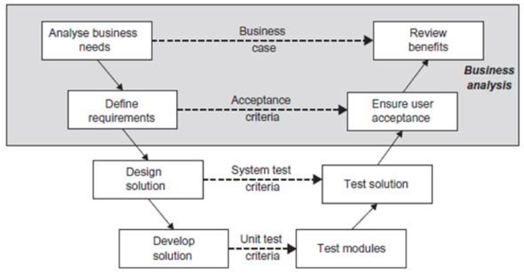
      - Business case used post-implementation to review success

    - Incremental lifecycle
      - Recognises difference in importance of certain requirements
      - A need remains to have a complete set of requirements and overall design at the start
      - Goal to develop and deliver solution in series of increments
      - High priority requirements first, lower ones deferred
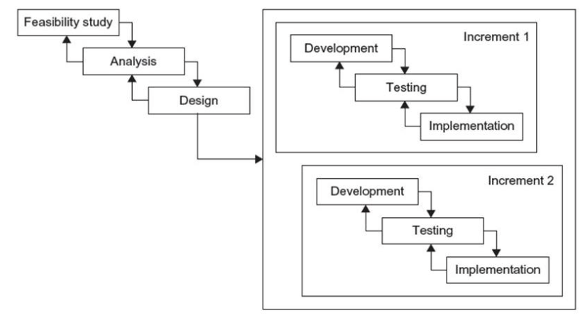
      - Total delivery cost likely higher than delivering in one release
      - High level analysis of solution should be future proofed
    - Iterative lifecycle
      - Spiral model: prototype based, introduces iteration concept
      - Basis for early agile approaches, including rapid application development (RAD)
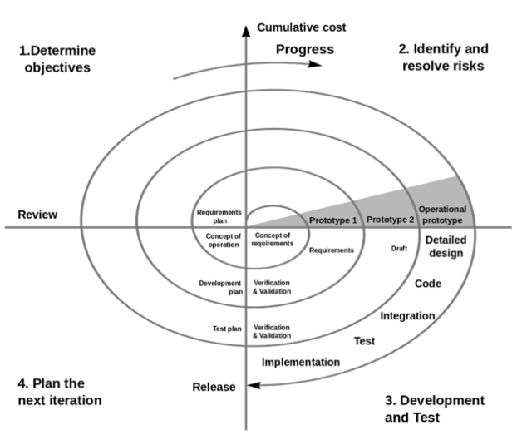
      - Newer agile approaches: DSDM, Scrum…
    - Agile principles
      - Main characteristics
          - Collaborative working
          - Prioritised requirements
          - Timeboxed iterations
          - Evolutionary development
          - Empowered teams
          - Incremental delivery
          - Continuous testing
          - Experiential learning
      - Methodologies: Scrum, Lean, Kanban, Crystal, XP, FDD & DSDM

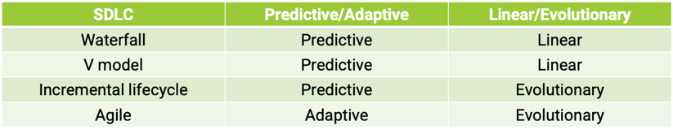
- Lifecycles summary
    - Agile approach popular nowadays
      - Cope with rapid pace of business change
      - Predictive techniques assume stakeholders know exactly what they want at outset of a project (problematic)
      - Fragmentation can be problem due to lack of overview
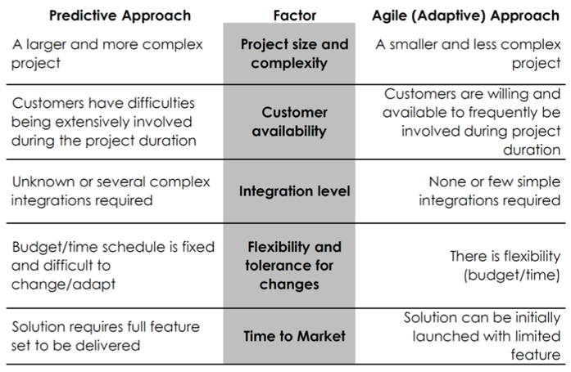
    - Selecting approach

Solution Testing
- Look back at strategy analysis: fit with solution
- Testing
    - Demonstrate system works as it should
    - Running system to find errors
    - Finding differences between desired results and real results
    - Measuring software quality
- Test levels
    - Unit/module testing (lowest level)
    - Integration testing (system as whole)
    - System testing (specific aspects)
      - Safety & performance tests
      - Volume tests
      - Stress test (extreme situations)
    - Acceptance testing (by the business)
- Testing lifecycle
    - Unit/module test: validate that each unit performs as designed
    - Integration test: check modules work together in combination
    - System tests: valuate compliance with specified requirements
    - Acceptance tests: evaluate compliance with business requirements and assess whether I’s acceptable for delivery
      - Internal acceptance performed by members of organisation
      - External acceptance by external members who made software
    - Integration testing
      - Bottom-up: empty control module calling module to be tested
      - Top-down: empty modules at lower level
      - Big-bang: after module testing, combine all and test system
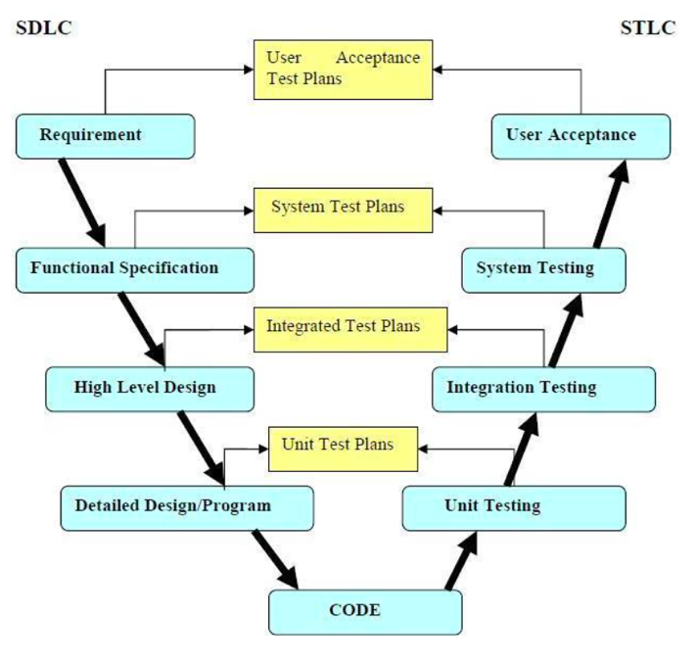
    - Testing lifecycle: V-model
Unit & Module Testing
- Static testing (no execution)
    - Desk checking
    - Structured walkthroughs
    - …
- Dynamic testing (execution with test cases)
    - Black box testing
      - Independent from code: not looking at code
      - Random testing: random selection of input variables
    - White box testing
      - Looking at module content: in depth coding knowledge required
      - Selecting input variables that cover as much as possible
Traditional white box criteria
      - Path coverage: try to test each possible path
      - Branch coverage: try to test at least each branch
      - Structured testing: boundary cases of loops
      - Special values testing: exception & limit testing

Solution Delivery
- Implementation stage: three major aspects
    - Business readiness assessment
      - Is business area of change sufficiently prepared to accept new way of working
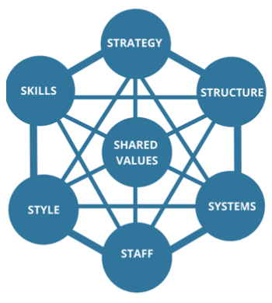
      - McKinsey 7S model to evaluate fit
    - Transition & migration
      - Data migration
      - Training sessions
      - Creation of suer guidelines, procedure descriptions…
      - Deciding on implementation strategy
    - People’s response to change
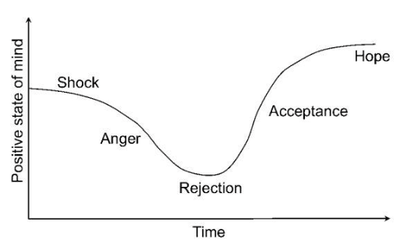
      - SARAH curve
- Realisation stage
    - Focus on how expected business benefits will be achieved
      - Benefits plan
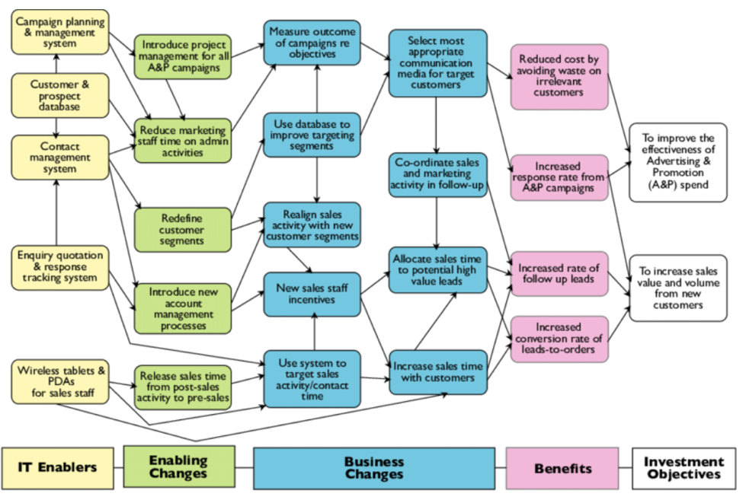
      - Benefits dependency network
      - Benefit review & business case management

Guest Lecture: Enterprise Architecting for Agility (PwC)

Watch lecture on Toledo

Process Modelling Languages

1. Introduction to Process Modelling Languages

Notations
- Many different forms
    - Petri nets
    - BPMN
    - UML
    - …
Petri nets
- Why?
    - Mathematically founded language
    - Graphical notation
    - Very compact
    - Concurrency, locality
    - Analysis techniques
    - Tool support
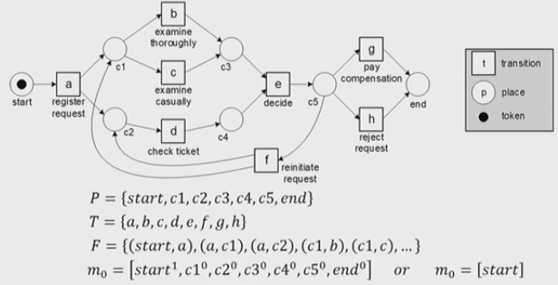
- Example of a petri net
    - Places are set
    - Transitions represent activities in the process
    - Flows connect places to transitions or the other way around
    - Tokens represent the state of the model ex. one token at start
    - Transition fires when it contains at least one token in each of its input places
      - It consumes one token from each input
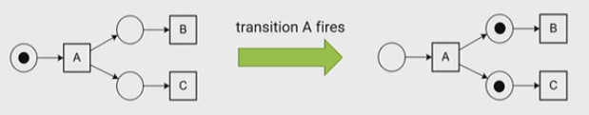
      - It generates one token in each output

- Workflow nets: subclass of petri nets, used for modelling processes
    - Has only one input and output place
    - Net must be strongly connected: directed path between any pair of nodes

2. Business Process Modelling Notation (BPMN)

Basics of BPMN
- Supported by most tools, OMG standard
- Elements
    - Events (≠ events in petri nets!)
    - Tasks
    - Flow
    - Gateway
- Routing patterns
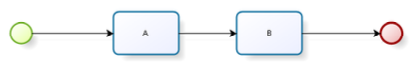
    - Sequential: first A, then B
    - Parallel: at the same time or in any order
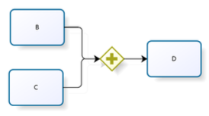
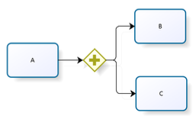
      - AND-split: after A both B & C
      - AND-join: D follows after both B & C have ended
    - Choice
      - OR-split: one or more (avoid to use it)
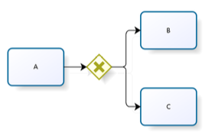
      - XOR-split: after A either B or C
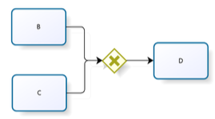
      - XOR-join: D after either B or C

    - Iteration: multiple B’s (loop)

- Process decomposition
    - Activity in a process can invoke a separate subprocess
    - Used to break down large models into smaller ones
    - Share common fragments across multiple processes
    - Identify parts of a process that should be
      - Repeated
      - Executed multiple times in parallel
      - Cancelled
    - Process hierarchies
- Modelling guidelines
    - Good practice: top level process (parent-process) should be simple and only show main processes
    - Rule of thumb: no more than 30-50 control-flow objects
If too large: decompose
- Call activities
    - Activities that have a subprocess embedded inside
    - Makes reuse easier
- Syntactical for subprocesses
    - Start/finish with at least one start/end event
    - Sequence flows cannot cross subprocess boundaries
    - Message flows can cross subprocess boundaries

Loops in BPMN
- Activity loops
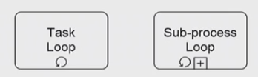
    - Can be unstructured or structured

- Parallel loops
    - Multi instance activity: multiple loops running at same time
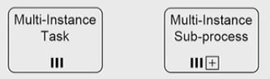
    - Can also be structured or unstructured

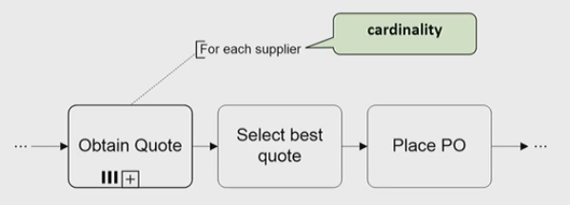
    - Cardinality needed sometimes

- Uncontrolled repetition
    - Ad-hoc subprocesses: activities to be executed in arbitrary order and time
    - Can be done multiple times or not executed at all
    - Most flexible element
    - Can constrain it a bit by adding flow
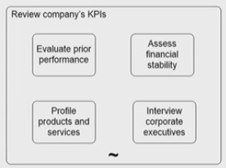
    - Denoted with a tilde marker (~)

Events in BPMN
- Difference between task & event:
    - Instantaneous: event (ex. receive an invoice)
    - Takes some time or uses resources: task (ex. open mail)
- Event types
    - Start vs. intermediate vs. end
    - Typed vs. untyped
    - Throwing vs. catching
    - Interrupting vs. non-interrupting
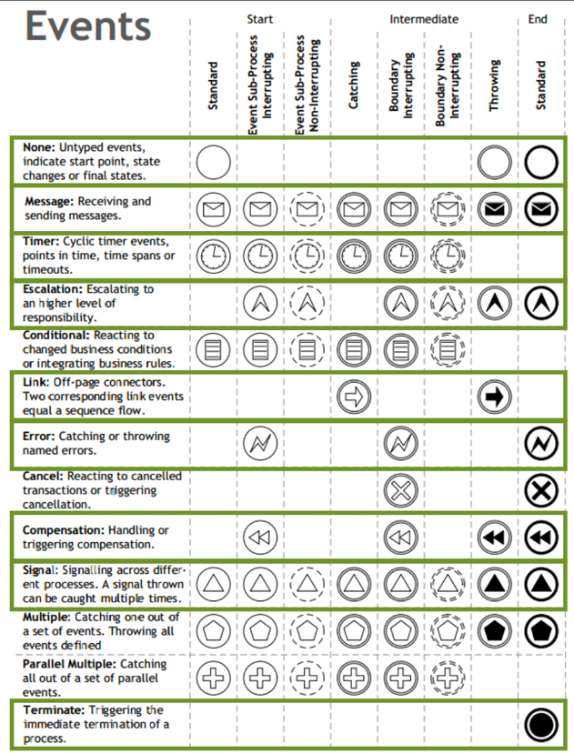
In green the ones you must know:

- Link event
    - Purely practical: to link models to each other
    - Often abused for ‘snake modelling’
    - Used to model ‘impossible’ control flows
- Event-based decisions
    - XOR-split gateway: branch chosen depending on incoming data
      - Can be made on token arrival
      - Can be delayed until an event happens
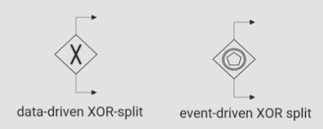
Difference data-driven & event-driven XOR-split

- Boundary events
    - During a sub-process execution, an event can happen that needs action
Placed at the boundary of the sub-process (‘boundary events’)
    - Two types
      - Interrupting: in parallel with sub-process (full line around event)
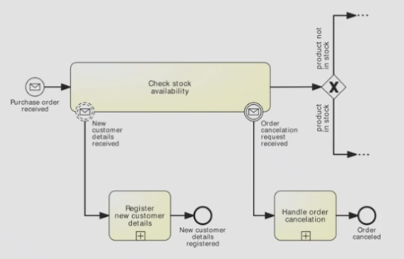
      - Non-interrupting: interrupts sub-process (dashed line around event)

Exceptions in BPMN
- Terminate event
    - Exceptions are events that deviate from the normal flow
    - Simplest form of exception: termination of the process because of positive or negative outcome
    - ‘Wipes off’ all tokens left behind
    - Only works downwards in the process hierarchy: a terminate event in a subprocess only stops the subprocess, not the parent process
- Interrupting boundary events
    - Timeout: activity takes too long, use timer event
    - External: something goes wrong outside of process, use message event

    - Internal: something goes wrong inside activity, use error event
      - End error event: stops enclosing subprocess execution
      - Intermediate error event: where process execution will continue after the error
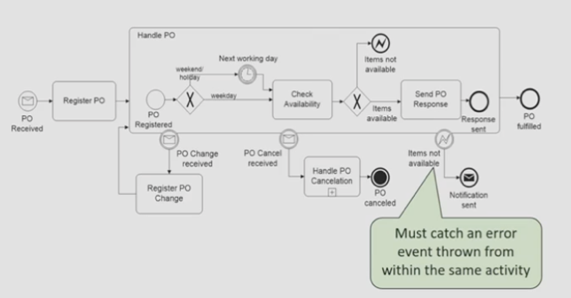
- Compensation handling
    - Rollback of completed process activities
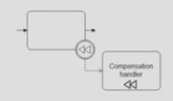
    - A compensate throwing event in a process flow is caught by boundary compensation catching event, which is linked to the compensation handler

Resource Modelling
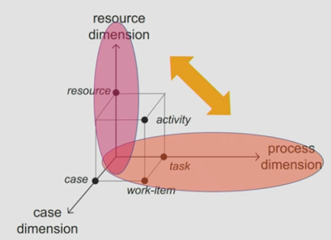
- Dimensions
    - Resource dimension
      - What resource do you need
    - Process dimension
      - Which process is it for
    - Case dimension
      - What is the case
- Abstractions
    - Resource: something that is required to perform the activity
    - Resource class: set of resources with shared characteristics
      - Role (skill competence, qualification)
      - Group (department, team, office…)
- Resource modelling: capture resource classes
    - Pools: independent entities (ex. customer, supplier, KU Leuven…)
Every pool is a separate process!
    - Lanes: resource classes in same organization, sharing common systems

Data Modelling
- Data objects: shows how data is required or produced by activities
- Data stores: containers of data objects that need to be saved after the process instance
- Associations: used to link artifacts such as data objects/stores with flow objects
- Use sparsely, doesn’t really add value to model
Only use elements if they are unusual or unexpected

Business Process Management

1. Introduction to Business Process Management

What is BPM
- Body of principles, methods and tools to design, analyse, execute and monitor processes
- How to engage BPM
    - Continuous process improvement (CPI)
      - Does not question the current process structure
      - Identifies issues & resolve them incrementally one step at a time
    - Business process re-engineering (BPR)
      - Puts whole process into question
      - Breakthrough by re-inventing the process
- Every process leads to one or more outcomes, positive or negative

Business Process Elements
- Activities
    - Active elements (ex. enter a sales order)
    - State changing, time-consuming and resource demanding
- Events
    - Passive elements (ex. receive a notification of an order)
    - Represents a condition or circumstance
    - Atomic, instantaneous
- Business objects
    - Organizational artifacts that undergo state changes
    - Physical or electronic info (ex. sales order)
- Actors (resources)
    - Entities performing process activities and generating events
    - Ex. humans, systems…
All combined in business process model
    - What needs to be done & when: control flow
    - What do we need to work on: data
    - Who’s doing the work: resources

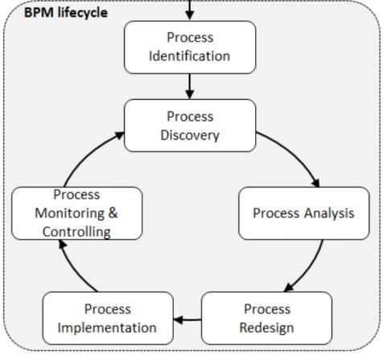
2. BPM Lifecycle
Process Identification
- Designation phase (process architecture)
- Enumerate main processes (ex. create sell deliver)
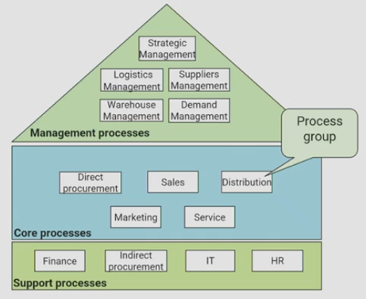
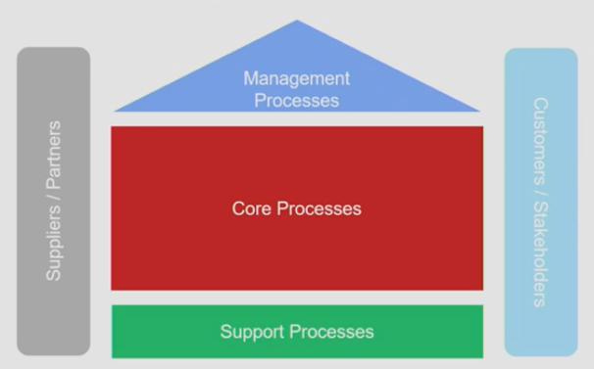
    - Types of processes as defined by Porter and an example
- Determine process scope
    - Processes are interdependent; insights into interrelations required
      - Specialization: general – special product/service
      - Horizontal: upstream – downstream processes and value chains
      - Vertical: main processes – sub-processes
    - Artifacts of vertical scoping
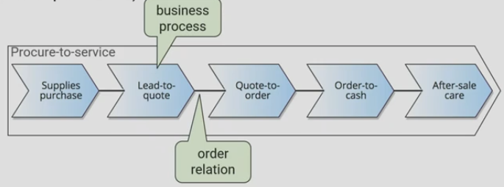
      - Value chains: high level chain
      - Root processes: object in a value chain, abstract
      - Subprocesses: detailed version of a main process
      - Process tasks: tasks within a subprocess
    - Usually reference models used to set up architecture, one example: PCF
      - APQC Process Classification Framework
      - Industry neutral reference framework, open standard
      - Four levels: categories, process groups, processes & activities
- Evaluation phase (prioritized process portfolio)
- Which process should be improved?
- Prioritize processes based on
    - Importance: how strategically important is the process
    - Health: which is in deepest trouble, which can be most improved
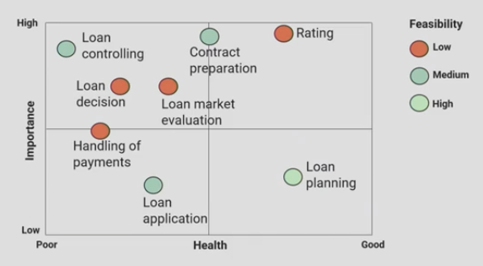
    - Feasibility: how easy it is to improve
Process Discovery (as-is process modelling)
- Define the setting: assemble team to tackle process
    - Domain experts & process analysts
- Gather information: build understanding of the process
    - Issues with information gathering
      - P1: fragmented process knowledge
      - P2: domain experts think on instance level
      - P3: knowledge about process modelling is rare
    - Information gathering techniques
      - Document analysis:
          - forms, work instructions…
          - Objective
          - Can become outdated
          - Employees might not follow these exactly
      - Observation:
          - The working environment, machines, people
          - Observational bias
          - Time consuming
      - Process mining:
          - Automated process discovery
          - Very objective
          - Hard to interpret, not much context
      - Interviews:
          - Structured or unstructured
          - Direct interaction
          - People can lie and are biased
          - Time consuming
      - Workshops:
          - Create shared understanding
          - Hard to plan
          - Time consuming
    - Conduct the modelling task: model the process, plan and map it out
    - Assure process model quality: guarantee that model meets quality criteria
- Setup the control flow model
See process modelling summary
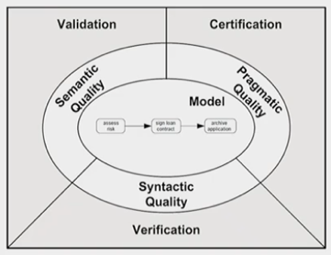
- Process model quality insurance
- Three quality measurements
    - Verification: syntactic quality
    - Validation: semantic quality
    - Certification: pragmatic quality
- Syntactic quality
    - Are rules of modelling language followed
    - ‘Technical check’, no expert needed
    - Types of problems
      - Behavioural problems: relate to how control flow constructs are inappropriately combined
      - Structural problems: direct mistakes against the modelling language’s structure rules (incorrect use of elements)
    - Lack of synchronization: token left in the model after reaching the end
    - Livelock: token keeps going in a loop
    - Deadlock: token gets stuck

    - Soundness of workflow models
      - Option to complete: for each case it’s possible to reach an end state
      - Proper completion: when at the end, all other places are empty
      - No dead transitions: should be able to reach every activity
- Semantic quality
    - Checks correctness & completeness of the model
    - Domain expert needed to validate model
    - Validation techniques
      - Interviews
      - Workshops
      - Process mining
- Pragmatic quality
    - Dimensions
      - Understandability: easy to read
      - Maintainability: how easy to adapt
      - Learning: ease of understanding how to process works in practice
    - Influencing factors
      - Size
      - Structural complexity
      - Graphical layout
    - Layout best practices
      - Block structuring
      - Linear layout
      - Good labelling
          - Activities as verb-object
          - Events as object-passive-participle
          - Conditions with reference to object
    - 7 Guidelines (7PMG)
      - Use as few elements as possible
      - Minimize routing paths per element
      - Use one start and one end event
      - Model as structured as possible
      - Avoid ‘OR’ routing elements
      - Use verb-object activity labels
      - Decompose a model with more than 50 elements

Qualitative Process Analysis
- Value-added analysis
    - Decorticate the process into steps
      - Steps performed before a task
      - Task itself, possibly decomposed in smaller steps
      - Steps performed after a task, in preparation of the next
    - Classify steps into
      - Value adding (VA): produce value or satisfaction to the customer
        - Customer willing to pay for it?
        - Does customer agree that step is necessary to achieve goals
        - Would customer perceive as less valuable without this step?

      - Business value adding (BVA): necessary or useful to operate
        - Required to collect revenue/improve/grow business?
        - Would business suffer long-term without step?
        - Does it reduce risk of losses?
        - Required to comply with regulation?
      - Non-value adding (NVA): everything other than VA & BVA
- Waste analysis
    - Eliminating waste (‘muda’)
    - 6-sigma analysis, 8 sources of waste
      - Unnecessary transportation: send & receive
      - Motion: drop-off, pick-up, to go…
      - Inventory: large work-in-progress
      - Waiting: between tasks
      - Overprocessing: performing what isn’t needed
      - Overproduction: unnecessary cases
      - Defects: rework to fix defects
      - Resource underutilization: waste of intellect
- Issue documentation
    - Issue register: categorize identified issues as part of as-is process modelling
      - Usually, a table of issues with following columns
        - Issue number
        - Name
        - Description
        - Impact: qualitative & quantitative
        - Possible solution
    - Pareto analysis
      - Useful to prioritize a collection of issues or factors behind an issue
      - Bar chart where height of bar denotes impact of each issue
      - Bars sorted by impact
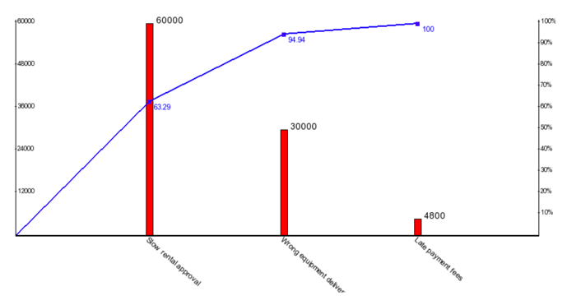
      - Superposed curve where y-axis represents cumulative impact
    - PICK chart
      - Two-dimensional prioritization
      - Payoff vs. difficulty (easy/low vs. hard/high)
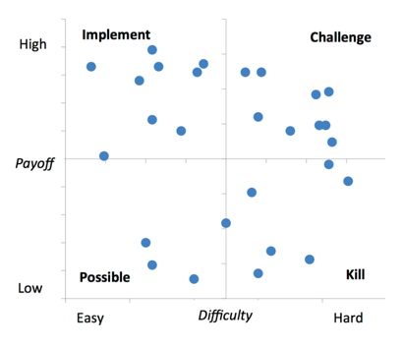

    - Root-cause analysis
      - Fishbone diagram
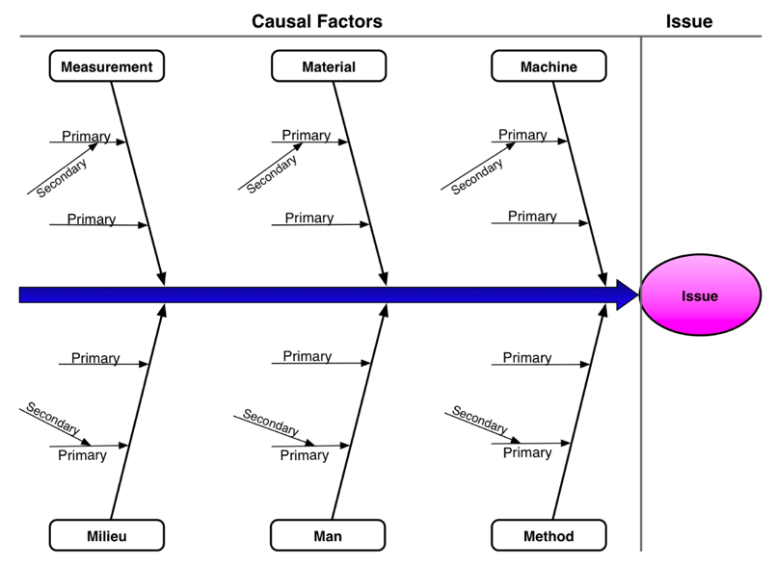
      - Asses possible root causes from 6 dimensions (6M’s): measurement, material, machine, milieu, man & method
    - Why-why diagram
      - Like fishbone, but not bound by 6M’s
      - Deeper in terms of contributing factors-structure
      - If you ask ‘why’ 5-times, you have an answer

Quantitative Process Analysis
- Process performance measures (KPI’s)
    - Cost: per execution, resource utilization, waste…
    - Time: cycle time, waiting time…
    - Quality: error rate, missed promises…
- Flow analysis
    - Cycle time analysis: avg. difference between start & end time process
    - Cycle time efficiency: theoretical cycle time / cycle time
      - Theoretical cycle time (TCT): cycle time without waiting time
    - Work-in-process: little’s law
      - WIP = (average) work-in-progress = λ * CT
      - λ = arrival rate (cases per time)
    - Limitations of flow analysis
      - Only possible on structured models
      - CT doesn’t take into account resource capacity etc.
Use queuing analysis
- Queuing analysis
    - Takes capacities into account
    - Good for queuing & waiting time analysis
    - Job interference comes from
      - Bursty interarrival intervals
      - Job size variation
      - High utilization (unstable when close to 100% utilization)
    - Basic concepts
      - λ = mean arrival rate (avg. arrivals per time unit)
      - μ = mean service rate (avg. jobs per time unit per server)
      - c = number of servers
Calculate
        - W_{q} = avg time in queue
        - W = avg time in system
        - L_{q} = avg number in queue
        - L = avg number in system
      - M/M/1 system: ρ = λ/ μ = capacity
      - M/M/c system: ρ = λ/(c*μ) = capacity
    - Limitations
      - No cost or quality metrics
      - Not for parallel activities, only for one single activity at a time
      - Assumes steady-state
- Simulation
    - Versatile quantitative analysis method
    - Run a large number of (hypothetical) process instances to gather data
    - Steps
      - Build process model
      - Enhance with simulation info
      - Run simulation
      - Analyse outputs
      - Repeat for alternative scenarios
    - Limitations
      - Numerous choices to make
      - Simplifying assumptions necessary
      - Reliability dependent on accuracy of inputs
      - Multiple validation loops necessary to verify validity
Sensitivity analysis

Process Redesign
- Purpose: identify possibilities for improving the design of a process
No silver bullet: requires creativity
- Explorative redesign (transformational)
    - Puts into question fundamental assumptions & principles of the structure
    - Aims for breakthrough innovation
- Exploitative redesign (transactional)
    - Doesn’t put into question current process structure
    - Seeks to identify problems and resolve them incrementally
- Business process re-engineering (BPR)
    - Transformational: exploitative redesign method
    - Analytical: based on set of principles that foster
      - Outcome-driven process
      - Integration of information gathering, work & decisions
    - Principles
      - Capture information once at the source
        - Shared data store: all workers access same data
        - Self-service: customers capture data & perform tasks themselves
      - Subsume info processing work into real work that produces the info
        - Evaluated receipt settlement: when receiving products, record fulfilment of purchase order, triggering payment

      - Those who use output of process, drive the process
        - Vendor-management inventory
        - Scan-based trading
        - Push work to the actor that has incentive to do it
      - Put decision point where work is performed, built-in control process
        - Empower process workers
        - Provide them info needed to make decisions themselves
        - Replace back & forth handovers with controls
      - Treat geographically dispersed resources as if they were centralized
        - Integrate work when people perform same actions in different places
        - Larger resource pool: less waiting time, high resource utilization
- Heuristic process redesign
    - Transactional: exploitative redesign
    - Inward-looking: operates within the scope of ‘as-is’
    - Analytical: based on redesign heuristics that strike trade-offs between
      - Time: service time, transport time… evaluate with avg, variance…
      - Quality: customer satisfaction (external) / work conditions (internal)
      - Cost: fixed or variable, human or system costs
      - Flexibility: resources, process, management & organisation
    - Redesign heuristics
      - Task elimination
      - Integrate (new) technology
      - Task composition: combine small or split large tasks
      - Parallelism
      - Specialist-generalist: deepen or broaden skills of resources
      - Resequencing
      - Integration: integration with workflow of a client or supplier
      - Empowering: give workers decision authority
      - Numerical involvement: minimize departments & people involved
      - Case assignment: let workers perform as many steps as possible in a single case

Process Implementation
- From conceptual ‘to be’ process models to executable process models
- Identify the automation boundaries, principle: not all processes can be automated, 3 types
    - Automated tasks
    - User tasks
    - Manual tasks
- Review manual tasks, principle: if it cannot be seen by BPMS, it doesn’t exist
Find way to support manual tasks via IT: user/automated task
- Complete process model, principles
    - Exceptions are the rule (add exception handlers)
    - No data = no decisions, no tasks handover (specify all electronic business objects)
- Adjust task granularity, principle: BPMSs add value if they coordinate handovers of work between resources
Aggregate any two consecutive tasks assigned to the same resource
Refine tasks that are too coarse-grained

- Specify execution properties
    - Process variables, messages, signals, errors…
    - Task & event variables and their mappings to process variables
    - Service details & code snippets
    - Participant assignment rules and user interface structure
    - Task, event & sequence flow expressions
    - BPMS specific: work queues, forms, connectors…

3. Declarative Process Modelling

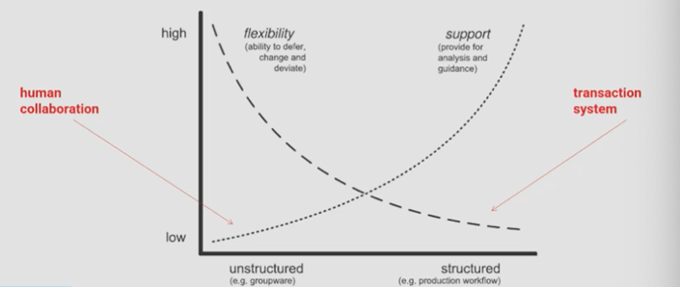
Introduction
- Objectives of BPM
    - Descriptive
    - Prescriptive
    - Explanatory
- Balance flexibility & control
    - Structured: easy to program
    - Unstructured: flexible
- Procedural approach to BPM
    - Inflexible, not maintainable (overspecification)
    - Difficult to demonstrate compliance
- Declarative approach to BPM
    - Focusses on defining regulatory or internal directives in constraints
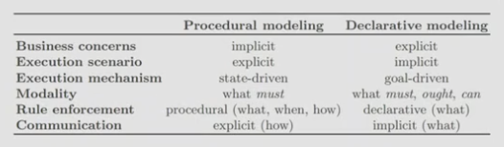
    - Minimum specification of the relevant business concerns, some freedom is left for the exact activity sequence
- Uncontrolled repetition in BPMN: ad-hoc subprocesses
    - To be executed in arbitrary order & time
    - Allows some flexibility

Declarative BPM
- Dynamic, goal-driven execution
    - Doesn’t involve pre-computation of task control flows, information flows and work allocation schemes
    - During execution, suitable execution scenario is constructed
- Process is seen as a trajectory in a state space, defined by declarative constraints
- Declarative BPM models constraints, but doesn’t specify exactly what is allowed
- Assumption bias of procedural BPM
    - Procedural process models: result of implicit precomputation of task dependencies, not guaranteed that procedural BPM don’t include overly specific assumptions
Often overly specified

- Languages
    - CMMN: Case Management Modelling Notation
    - DCR: Dynamic Condition Response Graphs
      - Scientifically developed language, extremely flexible
      - Popular in Danish government and companies
      - Used in ex. hospitals
    - Declare
      - Body of process model constraints
      - Based on logical elements
      - Model using symbolic arcs and activities

      - Captures notion of rules, can be satisfied in multiple ways
          - Satisfied
          - Temporarily violated; unfulfilled
          - Permanently violated; can never be satisfied

Declarative BPM in Declare
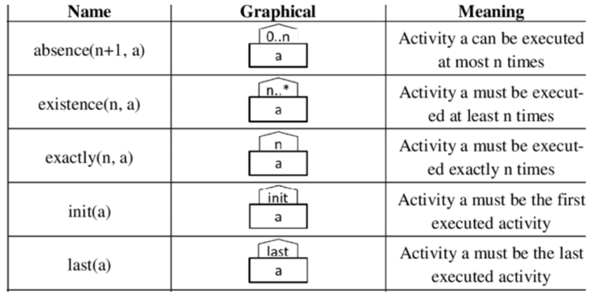
- Unary constraints
    - Ex. absence(5,a) means a can be executed 4 times (maximum cardinality)
    - Ex. existence (5,a) means a has to be executed at least 5 times (minimum cardinality)
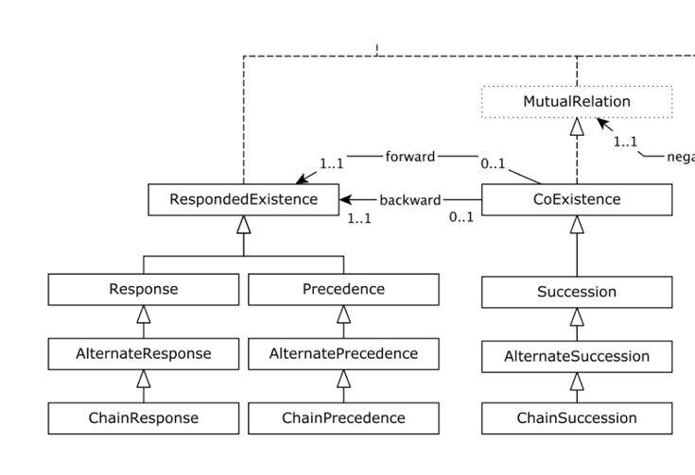
- Binary constraints
    - Simple ordered binary constraints
      - Coexistence: A & B cannot exist alone (position agnostic constraints)
        - Succession: if A happens, B will happen at some point and if B happened, it has to be preceded by A
      - Responded existence constraints:
        - Response: if A happens, B will happen at some point
        - Precedence: if B happens, it has to be preceded by A
    - Alternating ordered constraints
      - Alternate response: every A has to be followed by a new B
      - Alternate precedence: a new B can only follow after a new A
      - Alternate succession: both alternate response & precedence
    - Chain ordered: has to follow or precede instantly
      - Chain response
      - Chain precedence
      - Chain succession
- Execution process
    - Initial state
    - Non-accepting state (temporarily or permanently violated)
    - Accepting state
    - Transition

4. Decision Modelling with DMN

Process Modelling & Decisions
- To what extend can you model decision logic in BPM
- Business operation decisions more & more automated
- Process contains decisions
    - Cannot always be put in exact values: complex decision logic
Ex. when to accept/refuse a claim?
    - Strategic and tactical decisions: high level, long-term & large impact
    - Operational decisions: daily, high-volume & often structured
( Focus of the course)
- Decisions in processes
    - Inside a knowledge-intensive activity
      - Manual or automated, ex. incident categorization
    - A simple gateway
      - Based on a single question with two or more outcomes
      - Gateway is not the decision, but the question
    - Cascade of gateways
      - Multiple questions follow-up on each other
      - Decision trees should not be process-paths
Use decision tasks instead
- Decisions also need to be modelled: use of decision modelling notation (DMN)

Decision Modelling Notation
- Unifies modelling & execution
- Can be directly automated using a business rules management system (BRMS)
- Decision service
    - Encapsulation of the decision logic
    - Provisioning of an interface
- DMN levelling on 2 levels
    - Decision requirement level
      - What is required to make the decision
      - What can be the outcome
      - What are the knowledge sources

    - Decision logic level
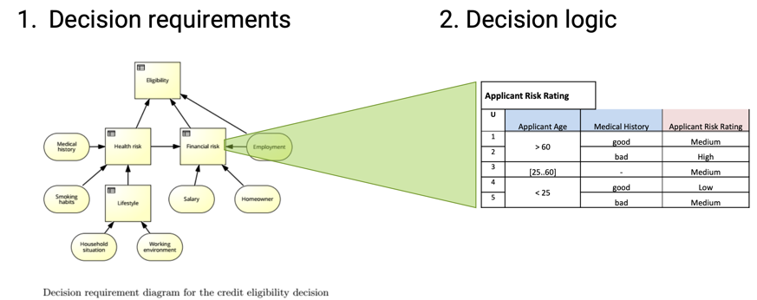
      - How is the outcome determined

- Major elements of DMN
    - Decision requirements diagram (DRD) (requirements)
    - Decision rules (logic)
    - The FEEL (Friendly Enough Expression Language)
      - How to define functions, operators & expressions

Decision Requirements Modelling
- Use of DRD
- What is required to make a decision
    - Information
    - Outcome of other decisions
    - Knowledge sources
    - Decision logic
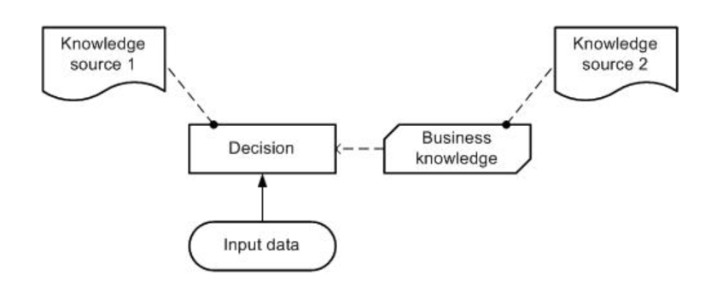
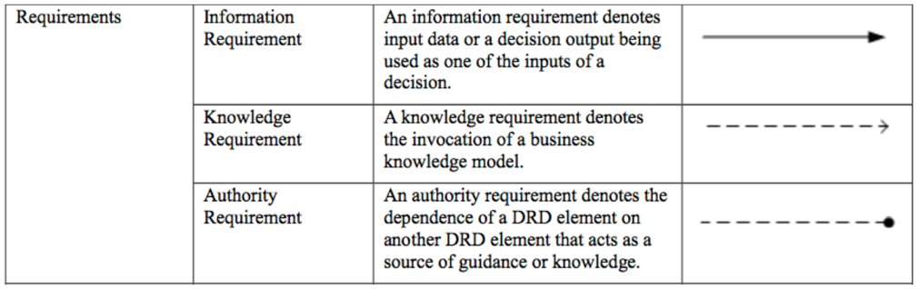
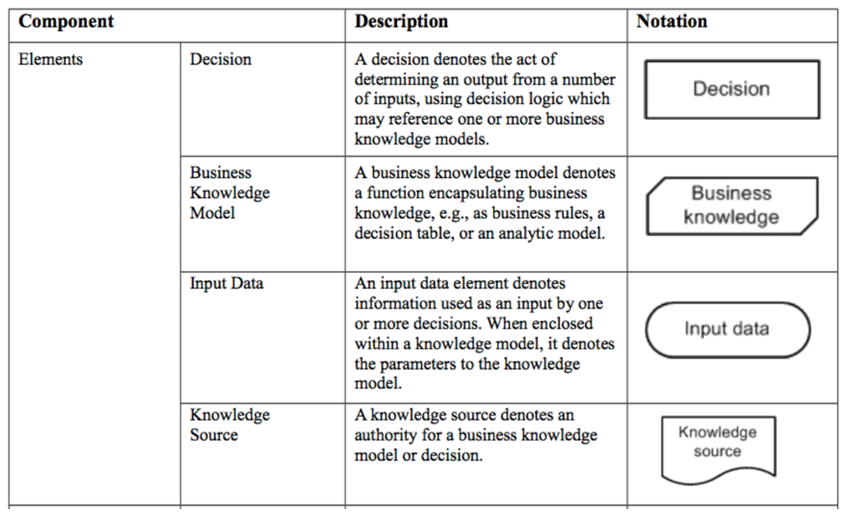
- Modelling
- Advantages of DRM
    - Focus on big picture, not details of decision rules
    - Allows to update without changing structure (maintainability)
    - Allows reuse of sub-decisions
    - Is declarative in nature

DMN Decisions Logic
- Use of value expressions to make decisions, specifies how output is determined from input
- Decision: an evaluation of the expression
- Three expression types
    - Decision tables: logic based on rules
    - Literal expressions: formulas, arithmetic functions
    - Invocations: leveraging decision logic form elsewhere (ex. BKM)
- How to make it explicit
    - Natural language: unclear, ambiguous
    - Logic: powerful, unambiguous, not for business people
    - Structured English rules: subset of natural English
    - Object constraint language: part of UML
    - Decision trees, tables, graphs & diagrams (most used)

Decision Tables
- Columns: every column is a variable
    - Inputs on the left
    - Outputs on the right
    - Relate to each other with ‘and’ (ex. US & web 8%)
- Row: makes logic explicit
    - Provides values of the inputs
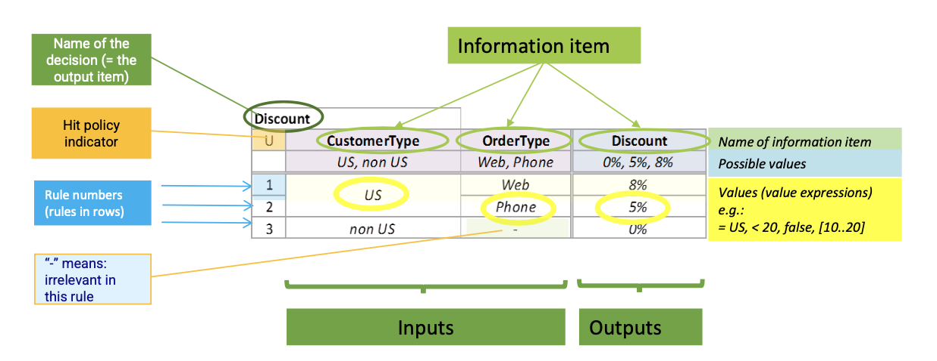
    - Provides how they relate to the outputs

- Hit policies
    - Single hit: one output
      - Unique hit policy (U): every input can only trigger one rule
      - If rules are overlapping, 1 rule has to be selected
        - Any hit policy (A): might hit multiple but output will be same
        - First hit policy (F)
        - Priority hit policy (P)
    - Multiple hit: multiple outputs are possible
- Different types of tables: guiding principles
      - Simpler (fewer rules) = better
      - Should make underlying logic understandable
- Validation of tables
    - Completeness: all inputs must have an output
    - Consistency with hit policy, no masked rules (can be triggered but always overruled by another one)
    - Avoid subsumption
      - Two or more rules shouldn’t be combined
      - Apply decision table contraction
- Expressing decision logic
    - FEEL (similar to excel functions)
    - S-FEEL (simple FEEL)
To make decision models executable
- DMN separates the decisions from the processes

5. Business Process Management Systems (BPMS)

Process Modelling Tool
- To create & modify executable process models
- To store & retrieve automation solutions from a process model repository
- May import from conceptual process modelling tools
- Execution engine
    - Instantiates executable model (case)
    - Orchestrates distribution of work items to process participants & software services in order to execute a business process from start to end
    - Logs execution data
- Worklist handler
    - Offers work to participants & allows them to commit to work items
    - Handles participants work queues and item priorities
    - May provide social network capabilities
- Push vs. pull
    - Pull control
      - Determined by people, ‘race’ among resources
      - Select to start and to allocate work item
    - Push control
      - Weighted around robin
      - Shortest queue
      - Select most appropriate (specialized) resource
- Administration & monitoring tool goals
    - To manage automation solutions
    - To configure access to system components
    - To monitor participants availability & performance of process cases
- External services
    - Expose a service interface with which the engine can interact
    - Engine provides invoked service with necessary data for specific case
- BPMS classification
    - Pure BPMN: designed from the ground up
    - Adapted BPMN: use a BPMN skin but rely on internal representation
    - Non BPMN: proprietary language and semantics

6. Process Mining: Discovery

What Is Process Mining
- At intersection of BPM and data science, 3 types
    - Discovery (see earlier)
    - Conformance
    - Extension

Process Discovery
- Quality trade-off for discovered process model
    - Fitness: model should allow for the behavior seen in the event log
    - Simplicity: model should be as simple as possible
    - Precision: discovered process model should not allow for behavior completely unrelated to what was seen in the event log
    - Generalization: model should generalize example behavior seen in the log

Alpha Algorithm
- Ordering relations
    - Direct succession: x > y
    - Causality: x y
    - Parallel: x // y
    - Unrelated: x # y
Ex. XOR split pattern: a b, a c and b // c
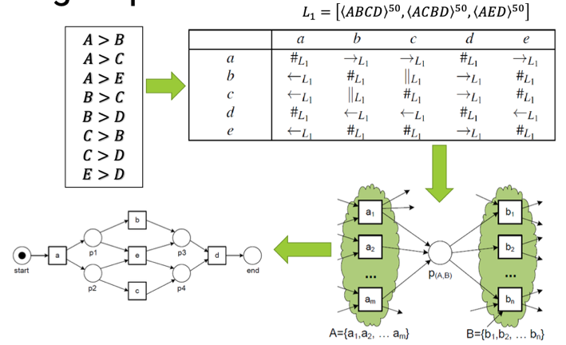
- Mining steps
- Limitations
    - Representational bias problems, no discovery of:
      - Loops of length one, B > B and not B > B implies B B (impossible)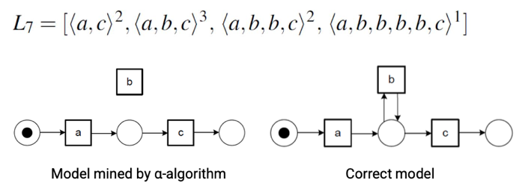
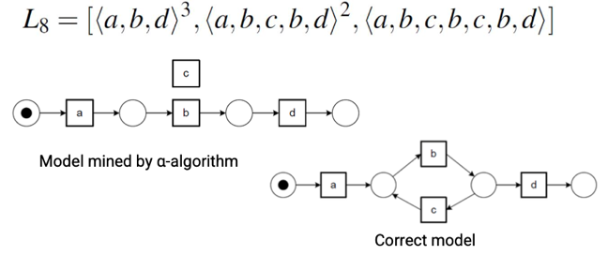
      - Loops of length two, B > C and C > B implies B // C
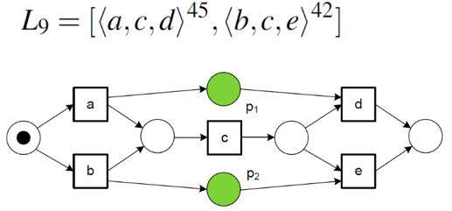
      - Non-local dependencies, green places stay undiscovered
      - Duplicate tasks
      - Silent/invisible activities
    - Noise
    - Incompleteness

Heuristic Process Discovery
- Heuristic miner
    - To deal with noise & incompleteness
    - To have better representational bias than alpha algorithm
      - Skips (invisible tasks)
      - Non-local dependencies
      - OR-splits & joins
    - Uses different process model representation
      - First version: heuristic nets
      - New version: causal nets or C-nets
      - Can be converted into Petri nets
- Dependency measure
    - Counting the number of times two activities directly follow each other
      - |a > b| number of times activity a is directly followed by b
      - |a < b| number of times activity b is directly followed by a
    - Calculate dependency measure between a & b
      - If a ≠ b: dependency measure (a, b) is $\frac{\left|a>b\right|-|b>a|}{\left|a>b\right|+\left|b>a\right|+1}$
      - If a = b: dependency measure (a, a) is $\frac{\left|a>a\right|}{\left|a>a\right|+1}$
      - Lower threshold: at least 2 direct successions + at least 0.7 dependency
      - Higher threshold: at least 5 direct successions + at least 0.9 dependency
    - Why can we now deal with noise
      - Threshold of 0.9: dependency between B & A is not part of mined model
      - Alpha algorithm would include the relation B to A
- Advantages heuristics miner
    - Robust: noise & log incompleteness
    - Computationally tractable, very fast
    - Can deal with many representational bias problems
- Disadvantages heuristics miner
    - No duplicate tasks
    - Parameter settings

Other Process Discovery Approaches
- Genetic process mining
    - Requires lot of computing power (can be distributed)
    - Can deal with noise, infrequent behaviour, duplicate tasks & invisible tasks (highly expressive discovery technique)
    - Design decisions
      - Representation of individuals
      - Initialization
      - Fitness function
      - Selections strategy (tournament or elitism)
      - Crossover
      - Mutation
- Process maps: fuzzy miner
    - Motivation: mine less structured processes
    - Simplification by abstraction + filtering (like zooming in/out on a map)
    - Advantages
      - Derives comprehensible process models from highly complex logs
      - Uses simplification techniques (filtering, abstraction)
    - Disadvantages
      - Proprietary process modelling language (fuzzy model)
      - No conversion to petri nets possible: difficult to calculate quality metrics, difficult to compare with other techniques
- Inductive miner
    - Goal: discover sound & block structured process models
    - Recursive algorithm finds next best split to divide event log
    - Allows trade-off between evaluation dimensions
    - Process tree as underlying model
- Split miner
    - BPMN model discovery tool
    - Hierarchical process discovery tool (discovery of subprocesses)
    - Default representation in BPMN

Event Data
- Event log preparation
    - Data sourcing and pre-processing is key aspect in mining projects
    - Research on data preparation is limited & fragmented
- Data attributes of event logs
    - Essential
      - Case ID
      - Activity name
      - Timestamp
    - Additional
      - Case attributes (plant, country, city…)
      - Event attributes (type of item, resource booking the invoice…)
    - Usage of attributes
      - To filter the event logs
      - To provide contextual information
- Event types: event represents transactional information of activity instances
    - Defaults for process mining
      - Atomic activities completed events
      - Activities having a duration “started” + “completed” events
- Event log sources
    - BPMS
    - Case management or ticketing systems
    - ERP/CRM
    - Operational databases, data warehouses, data lakes
    - Project management software
    - Web data (clickstream data…)
    - IoT
    - …
- Challenges when extracting logs
    - Correlation: events grouped per case, but how group exactly?
    - Timestamps: only dates, different time formatting
    - Snapshots: cases may have lifetime beyond recorded period
    - Scoping: which data & tables to include
    - Granularity: events in log are different level of granularity than ones relevant for end users
- Javascript object notation (JSON)
    - Each event is a JSON line
    - Represents real-time server-to-browser communication
    - Ideal for machine processing

7. Process Mining: Conformance Checking

Conformance
- Between process model & event log
- Deviations?
    - Is model or log wrong?
    - Desirable or undesirable deviations?
Audits to ascertain validity & reliability of information
      - Are processes performed within set boundaries?
      - Process mining to detect fraud, malpractice, risks & efficiencies
- Use of ‘replay’ to detect errors: connect events to model elements

Measuring Fitness
- Fitness: able to replay event log
- Token based fitness
    - Replay traces in discovered model
    - Fitness problem when
      - A token is missing during replay
      - A token remains after replay
$f_{trace}=\frac{1}{2}\left(1-\frac{m}{c}\right)+\frac{1}{2}\left(1-\frac{r}{p}\right)$
      - m = number of missing tokens
      - c = number of consumed tokens
      - r = number of remaining tokens
      - p = number of produced tokens
    - Fitness over entire log L: aggregate over all traces
$f_{L}=\frac{1}{2}\left(1-\frac{\sum_{σϵL}{L\left(σ\right)*m_{σ}}}{\sum_{σϵL}{L\left(σ\right)*c_{σ}}}\right)+\frac{1}{2}\left(1-\frac{\sum_{σϵL}{L\left(σ\right)*r_{σ}}}{\sum_{σϵL}{L\left(σ\right)*p_{σ}}}\right)$
with L(σ) = frequency of trace σ

- Alignment based conformance checking
    - Technique tries to find best sequence of transitions through the model matching a trace as closely as possible
      - Allow for model-only and log-only moves
      - Deviations come at a cost
      - Best solution is the one with lowest cost
    - Advantages
      - Avoids forcing transitions to fire
      - Does not introduce tokens that can skew replay
      - Nice optimization problem: tree-based algorithm to find minimum cost-path
      - User-modified cost: higher when activity is executed by wrong user
    - Disadvantages
      - Time consuming, scales badly
      - Model-only move hard to justify
      - What if optimization routes around set costs

Measuring Precision
- Advanced behavioural appropriateness: compare behaviour of model to event log behaviour
    - One of first precision metrics
    - Metric compares two types of relationships between activities
      - Follows relationship: always, sometimes or never follows
      - Precedes relationship: always, sometimes or never precedes
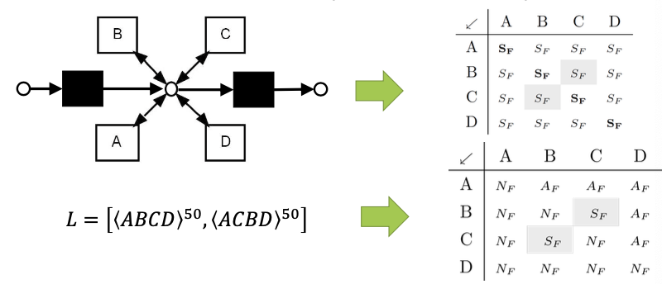
    - Ex. flower model: follows relations matrix according to model and log
      - ‘Never’ & ‘always’ are much more restrictive than ‘sometimes’
      - If much more ‘sometimes’ relations are observed in the model than the log, the model allows too much behaviour
- Artificial negative events
    - Principle: “at each positive event, it is checked whether another event appearing in the log could also occur, given its prefix. Therefore, it is tested whether in the log there is a similar prefix sequence with this other event occurring at the same position of the positive event. When this is not the case, a negative event can be injected into the log at the position of the positive event. “
    - Developed conformance checking techniques based on artificial negative events
    - Traditional classification evaluation measures can be used with the availability of negative events (activities denied to happen)
    - Availability of negative events in real-life logs is unlikely
    - Induction of artificial events into an event log

- Fitness & precision
    - Confusion matrix after log replay: metrics are not token-, but event-based
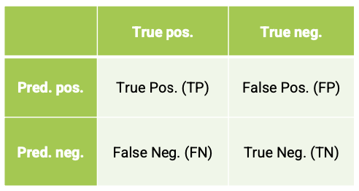
    - Recall: $r_{B}^{p}=\frac{\sum_{i=1}^{k}{n_{i}{TP}_{i}}}{\sum_{i=1}^{k}{n_{i}{TP}_{i}}+\sum_{i=1}^{k}{n_{i}{FN}_{i}}}$

    - Precision: $p_{B}=\frac{\sum_{i=1}^{k}{n_{i}{TP}_{i}}}{\sum_{i=1}^{k}{n_{i}{TP}_{i}}+\sum_{i=1}^{k}{n_{i}{FN}_{i}}}$

    - For basic algorithm & steps see slides 40 – 47, BPM 12 Process Mining – Conformance

Measuring Generalization & Simplicity
- Simplicity
    - Based on topology, layout, visual of the model
    - Average node connector degree
    - SESE-nodes (single-entry-single-exit)
    - Block structuredness
- Generalization
    - Several attempts exist
      - Cross-validation
      - Artificial generalized events
    - Unfinished research problem

8. Process Mining: Extension & Tooling

Extension
- Process consists of cases
Cases consist of events, each event belongs to a specific case and can be timestamped
Events can have attributes that describe it
- Extension techniques
    - Performance analysis
      - Use time dimension, keep track of timing info
Ex. delay times, wait times, process times
      - Goal: identify bottlenecks
    - Dotted charts
      - ‘Helicopter view’
      - Each dot is an event
      - Time can be absolute/relative and real/logical
      - Colour & shape of dots depends on their attributes
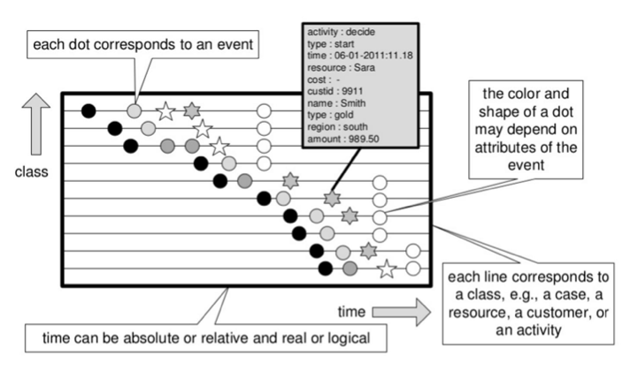
      - Each line corresponds to a class (case, resource…)
    - Decision mining
      - Goal: find rules (predictor variables) that explain routing choices in terms of characteristics of a case
      - Classification techniques like decision tree
      - Decision points are XOR-splits
    - Organisational mining
      - Event log has precise info on resources that execute activities
      - Use this info in resource-activity matrix: mean number of times a resource performs an activity per case
      - Visualize in a social network: resources that execute similar activities are related, non-related resources are very important
      - Use info in handover matrix: check interaction between resources

Predictive Process Mining
- Used to do diagnostic & descriptive analysis (after the facts)
Now focus on predictive process mining (future)
- Process discovery is unsupervised (no label)
    - Supervised applications more & more important
    - Use of event data for predictive goals
      - What is the next event
      - Remaining suffix & time
      - What will be the outcome
    - Model construction
      - Use historical event log
      - Apply prefix transformation
      - Train the model using the historical data (machine learning)
    - Model application: predictive monitoring of running business process
- Machine learning driving development
    - Decision trees
    - Recurrent neural networks (RNNs)
      - Long short-term memory neural networks (LSTMs)
      - Transformers (encoder-decoder) (like ChatGPT)
- LSTMs
    - Type of RNN with tailored design to address vanishing gradient problem
    - Classical SEP-LSTMs
      - Normal predictive analysis predicts next step, not whole sequence
      - Single event prediction
Problem of hallucination when using it in sequence
    - CRTP-LSTM: Seq2Seq model
      - Not hallucinating, state of the art
      - Predicts entire sequences
    - Seq2Seq-LSTMs
      - Motivation: processing of luggage at Brussels Airport
      - Case features: arrival & departing flights
      - Time features: time information
      - Research: develop a model that incorporates all relevant information to predict remaining suffixes and runtimes of bags processed at airport

- Learning neural network uncertainty for PPM
    - Let the machine model understand there is uncertainty in its predictions
    - Predict the uncertainty of a prediction
- Process model forecasting
    - From operational predictions to tactical & strategic insights
    - Process model discovery via forecasting
    - Predict entire new models in the future

Tool Support
- Open-source tools
    - ProM
    - Apromore
- Commercial process mining tools
    - Celonis (see guest lecture)
    - Disco

Guest Lecture: Process Mining to Business Insights (PwC)

Business Applications
- Process Intelligence (PI)
    - Combines process mining techniques and standard data analytics
    - Creates one-stop shop for process analytics
- Business value of process mining
    - In-depth process discovery including re-work & bottlenecks
    - Identification of root-causes for process inefficiencies
    - Benchmarking & definition of best practices
    - Identification of deviations and understanding the cause
    - Efficient process monitoring & steering
- Audit value of process mining
    - Effective quantification of process behaviour
    - Smart audit scoping based on observed behaviour
    - Smart sampling focussing on exceptional behaviour
    - Efficient year-to-year comparisons
    - Audit as proactive & trusted advisor

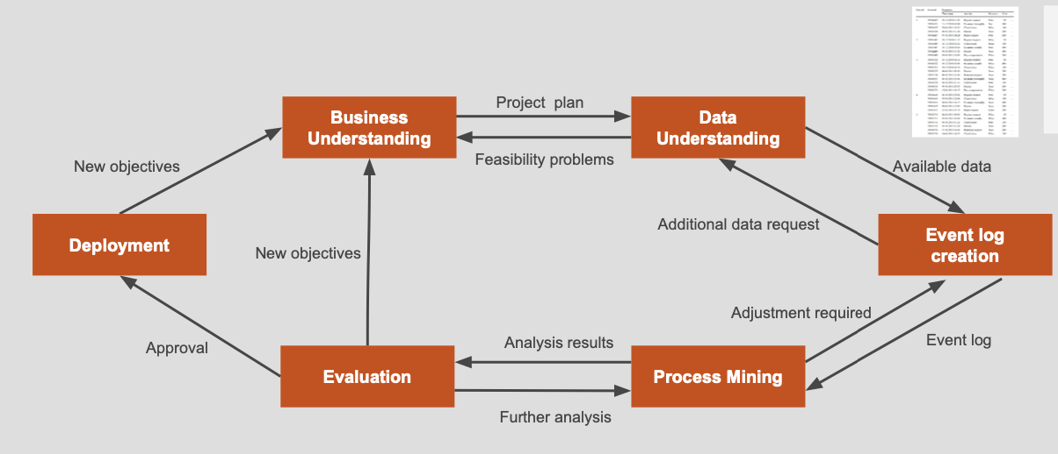
Project Lifecycle

Future Outlook
- Evolution of tool landscape
    - Market consolidation, driven by acquisitions and investment from ERP providers like Microsoft and IBM
    - BPM-focussed vs. process-mining focussed
    - Integration of AI, machine & deep learning

