Organising for Entrepreneurship
Summary of classes by Johan Bruneel & Fernanda Rios, winter semester 2023
Pictures from slides by Johan Bruneel & Fernanda Rios

1. Business Models and Their Importance

Solve a problem
- Hear a lot about success stories, but most start-ups fail in the first few years
- Start of a product/service:
    - Solve a defined problem with a defined solution
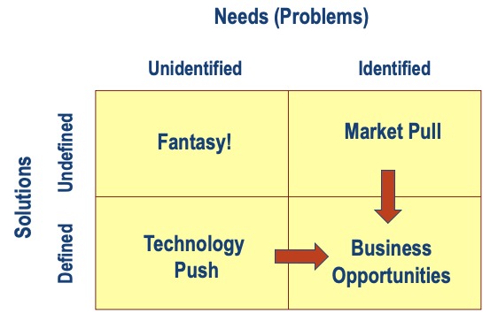
Creation of value
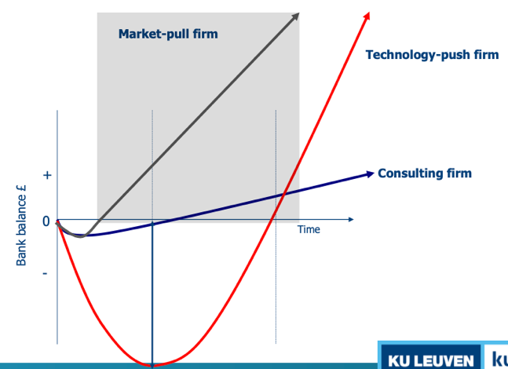
    - Different business opportunities mean different cash(flow) profiles

What is a Business Model
- Concept: a business model is the architecture of the firm’s value creation, delivery and capturing mechanisms
    - 3 components
      - Value creation: fit between the problem and the solution
      - Value delivery: what are the activities to develop and bring the solution to the customer (distribution channels etc.)
      - Value capturing: how to generate financial value for the business
    - The business in a nutshell: must be able to explain it in 50 words
- Assumptions
    - Because of assumptions, business models always work on paper
    - Wrong assumptions lead to false expectations
    - Rapidly changing business environments
      - Assumptions can change
      - Business model must be adaptable

2. The Lean Start-up Method

Where Start-ups Fail
- Key differentiator between start-ups: absorptive capacity
    - Capacity to acquire, absorb and put into practice new information
    - Information from investors, customers, suppliers…
    - Use of prototypes and beta-testers
    - Overlap between setting specifications and adjusting parameters (not sequentially, but still happens often)
- Lean start-up: 3 principles
    - Day 1: series of hypotheses & assumptions based on own world view
    - MVPs test hypotheses: learning, importance of absorptive capacity
    - Approach based on BML-cycles (build – measure – learn)
<-> stealth mode of entrepreneurs (under the radar as long as possible)

Confirming or Rejecting Hypotheses
- Analogs / antilogs: evidence of things that worked/failed elsewhere, put in another context
- Interviews:
    - Ask open-ended questions
    - Separate problem & solution interviews
    - Listen, don’t try to sell
- Experiments
    - Test minimum viable product (prototype containing minimum features of the real value proposition)
    - Test often, with different and the same testers
- Pivot: in case of failure, plans need to be adaptable
- Chasm: make-or-breaking point for new products/services
    - Hurdle between early adopters and early majority (the mainstream)
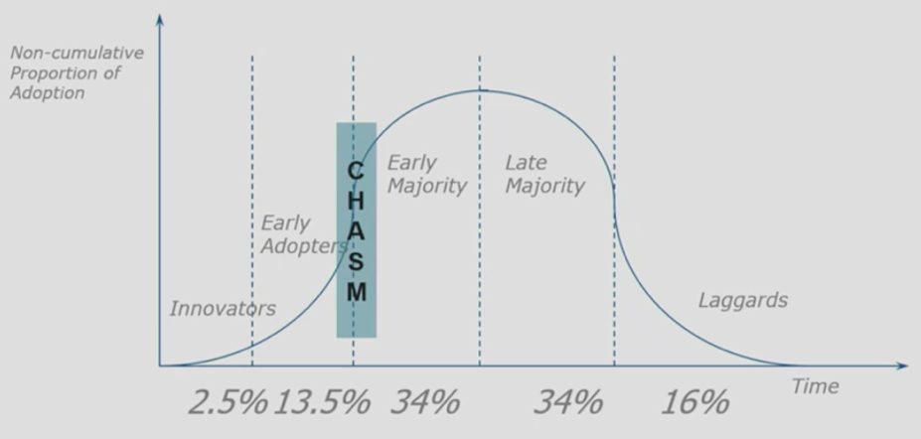
    - Innovations often don’t pass the chasm

- Every analog, experiment, interview… creates value to the firm by confirming or rejecting an earlier assumption: milestones

3. Business Model Innovation

Introduction
- Reasons against innovation
    - Cost of R&D
    - Business model not adaptable (ex. Kodak selling film)
Adaptability is key in innovation
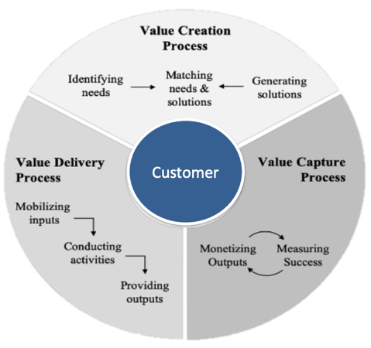
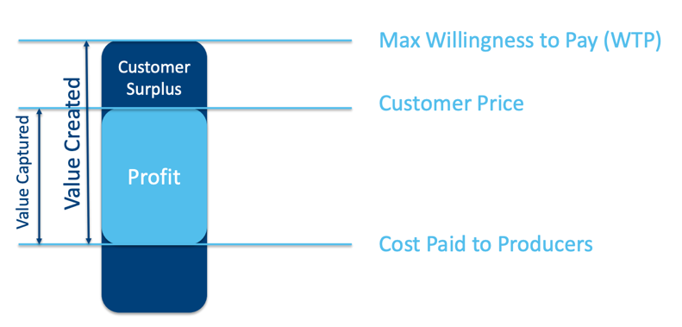
- Business Model “Magic Triangle”
Value creation: WTP – production cost
- Innovation = invention + commercialisation

Business Model Innovation Strategies
- Methods
    - Transfer: existing business model is applied to a new industry
    - Combine: transfer & combine two business models
    - Leverage: use of a successful business model for another product range
- Myths
    - Initial ascent myth: innovation needs to be entirely new
    - Think big: has to be something major
    - Technology myth: the technology needs to be new
    - Luck myth: needs to be lucky
    - Einstein myth: needs someone extraordinary
    - Size myth
    - R&D myth

Business Model Canvas
- 9 building blocks
    - Desirability: do they want it?
      - Customer segments: who am I creating value for
      - Value proposition: what value do I create for each segment
      - Channels: how is the value delivered to the customer
      - Customer relationship: how do you keep customers (interested)
    - Feasibility: can we build it?
      - Key activities: which actions do you need to perform well
      - Key resources: which key elements do you need to operate
      - Key partners: who will help you leverage the business model
    - Viability: sanity check
      - Revenue streams: how do you make money
      - Cost structures: what are the main costs of the business
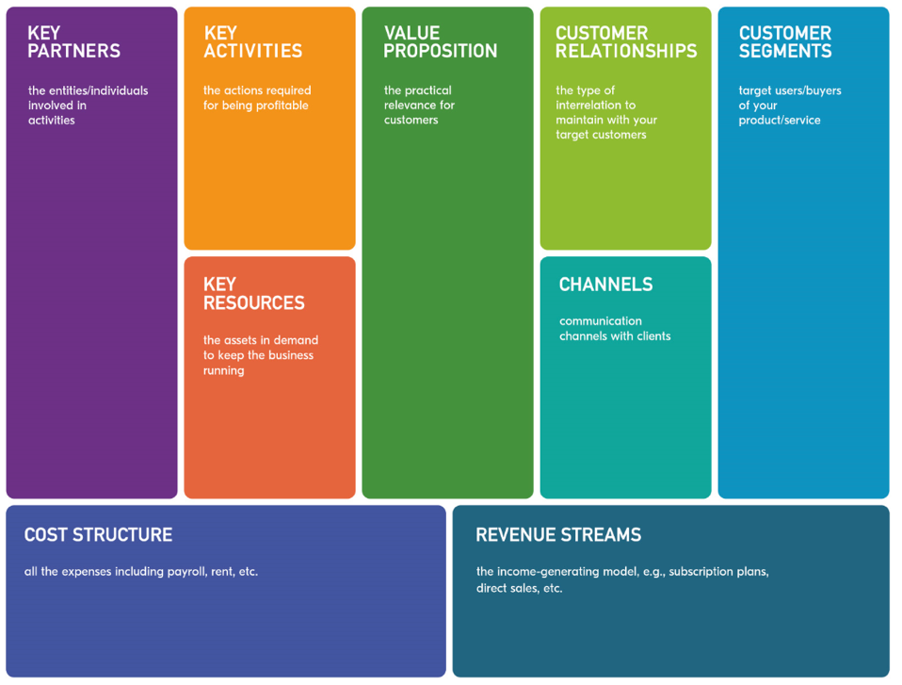

- Starting point
    - Technology push: analyse a problem
    - Market pull: find a solution
- Case: Nespresso
    - Customer segments: households
    - Value proposition: Nespresso machine and capsules
    - Channels: retail stores, own stores & own website
    - Customer relationship: acquire & lock-in, Nespresso club
    - Key activities: b2c distribution, production
    - Key resources: patents, coffee, production facilities
    - Key partners: machine manufacturers, retail stores, coffee growers
    - Revenue streams: machine & capsule sales, patent licenses
    - Cost structures: production, distribution, marketing & branding

Paper Foss & Saebi
- 4 streams of research
    - Conceptualising BMI
    - BMI as organisational change process
    - BMI as an outcome
    - Consequences of BMI
- Defining BM
    - Architecture of firm’s mechanisms for creating, delivering & capturing value
    - Components: segments, value chain, revenue capture mechanism…
    - Architecture: functional relationship between elements
- Defining BMI: designed, novel and nontrivial changes to the key elements of a firm’s BM and/or architecture linking these elements
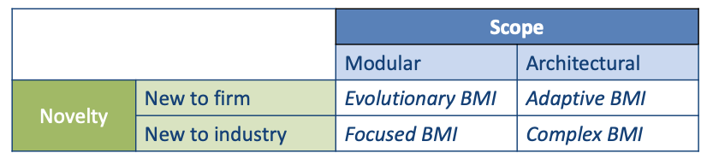
- Dimensionalisation: difference in scope & degree of novelty

4. Entrepreneurial Team

Introduction
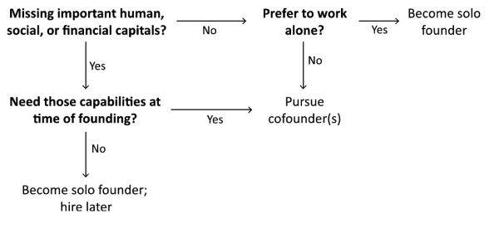
- Biggest challenge: forming an effective team
- 65% of VC backed ventures fail because of ineffective management
- Going solo
    - Need deep human, social and financial capital relevant to industry
    - Does not need validation or support
    - Small business in slow-moving industry
    - Preference for maintaining full control

Team Models
- DEFT
    - Diversity
    - Expertise
    - Fault lines within team
    - Timing of team expansion
- Diversity
    - Knowledge diversity
      - Promotes innovation & creativity
      - Flexibility and holism in thinking
    - Social diversity
      - Stereotyping can lead to conflict
      - Opportunity cost of resolving interpersonal frictions is high
- Expertise
    - Map skills required based on business concept and life stage of venture
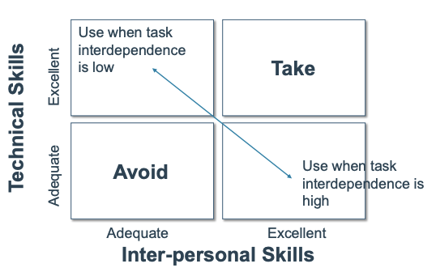
    - Identify gaps between available and needed skills
- Fault lines
    - Divide members based on attributes (ex. gender)
    - Fault lines become stronger when more attributes align in same way
- Timing of hires
    - Types of hiring
      - Hire when meeting good fit
      - Hire in anticipation of growth
      - Hire when growth expectations are confirmed

3R Model
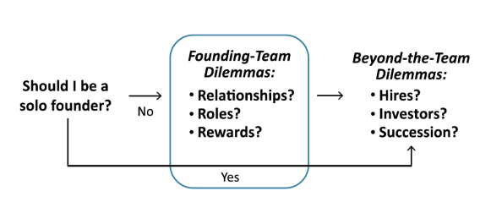
- Sequence of founding team dilemmas
- 3R model: assess founding team based on tensions
    - Relationships
      - Homogeneous vs. heterogeneous
      - With whom to found
      - Playing with fire gap
    - Roles
      - Division of labour, positions and skills
      - Decision making process
    - Rewards
      - How to split the pie
      - Compensation & bonusses

5. Organising the Start-up

Industry Value Chain
- Provides snapshot of industry structure
- Central concept: complementary assets
    - Assets needed to translate innovation into commercial returns
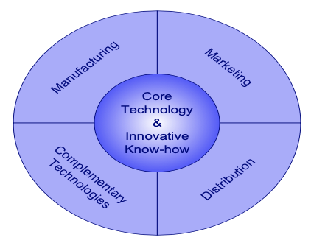
    - Resources & capabilities
      - Marketing
      - Distribution channels
      - Manufacturing capabilities
      - Complementary technologies
- Value chain analysis to discover
    - Competitive position in chain
    - Opportunities & challenges with other players
    - Probable consequences for your business model
- Plotting value chain
    - What are different steps to reach end user?
    - How many phases in the chain does your business cover?
    - Who are the other players and what is their power?

- Value network: three different elements
    - Different players
      - Company: offers product/service
      - Partners: other stakeholders (suppliers…)
      - Client: individuals (B2C) & companies (B2B)
    - Flow company client
      - Product, service, experience or reputation
    - Flow client company
      - Money, attention, exposure, data…

6. Sources of Funding

Sources
- Internal
    - Personal means
    - Cash flow
- External
    - Bank loans
    - 3F
    - Business angels
    - Venture capital
- Business angels
    - Wealthy private investors, often experienced entrepreneurs in the sector
    - Objectives: fun & return, usually wants hands-on involvement
    - Use network & experience to spot opportunities
    - Expectations
      - Return of 30-35%
      - Early stage, while VC still reluctant to invest
      - Consider themselves part of team
- Venture capital funds
    - An intermediary for investors who want to invest in starting companies
    - Investment of usually 5-10y
    - Return distributed in cash or as shares

Stages
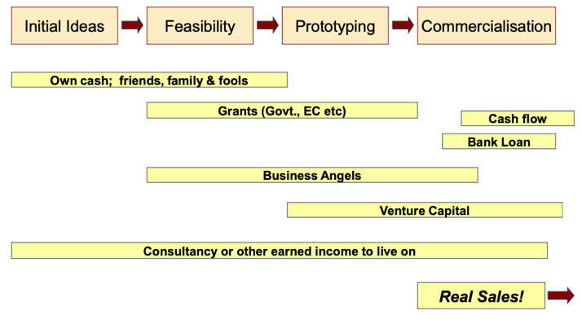
- Stages of venture development and funding
- At each new funding round, a new valuation is made
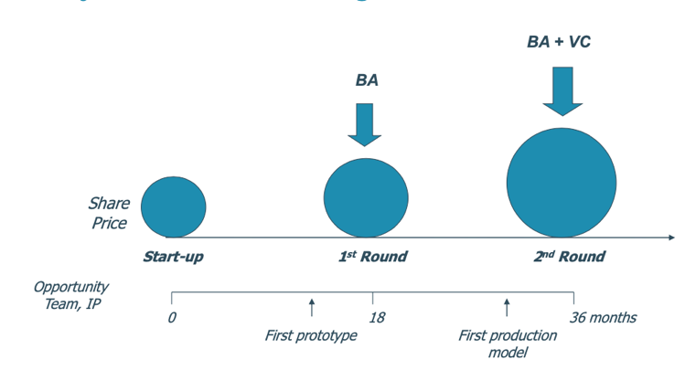
- Lifecycle & funding

Bootstrapping
- Process of finding creative ways to exploit opportunities to launch & grow businesses with limited resources available
    - Limit working capital needed, improve cashflow
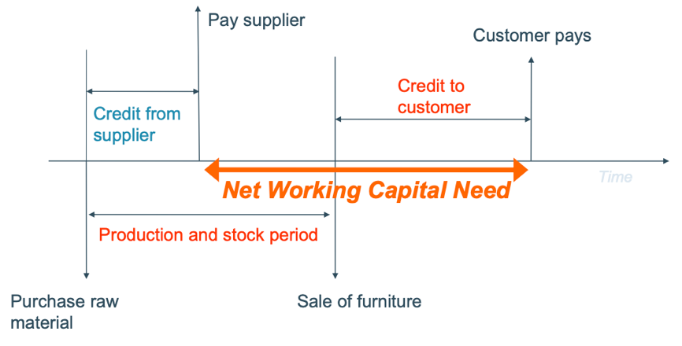
    - Follow pecking order model of finance
- 4 techniques
    - Customer related: obtain advance payments, cash discounts…
    - Delaying payments: leasing, suppliers…
    - Owner related financing & resources: no salary…
    - Joint-utilization of resources with other organisations: shared offices

- Advantages
    - Focuses on business, not raising money
    - 100% control over company
    - Learn financial discipline fast
    - Be more customer-focused
- Disadvantages
    - Much longer time to grow business
    - Not all business can be bootstrapped

Screening, Due Diligence & Funding
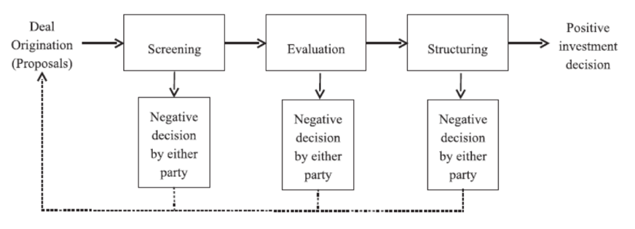
- Structure of an investment decision
- Funding gap
    - Information asymmetry
    - Policy intervention needed
      - Loan guarantee schemes
      - Support equity funding (business angels’ networks, public funds, co-investment schemes…)

7. Growth Strategies of Entrepreneurial Ventures

Growth
- Not always desirable or possible
- Problems
    - Not all businesses can grow aggressively
    - Growth can be too fast
    - Business success doesn’t always scale
Need of growth plans
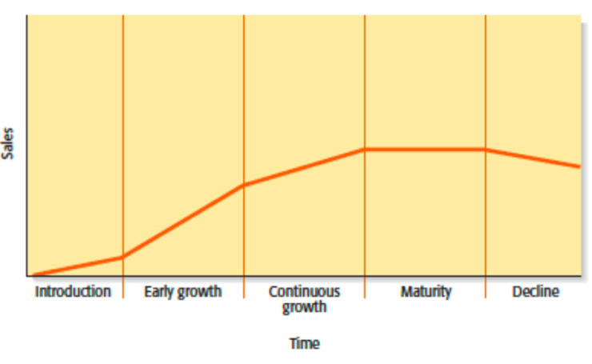
- Stages
    - Introduction to market
      - Check product – market fit
      - Discover core capabilities & strengths of the business
    - Early growth
      - Increasing sales, heightened complexity
      - Founder must work “on” the business, not “in” it
      - Need for increased formalization (procedures & policies)
    - Continuous growth
      - Increasing need for formalization
      - Expand product offering / enter new markets
      - Might be need for new TMT
    - Maturity
      - Growth slows down
      - Focus shifts towards efficiency
      - Growth via partnerships, acquisitions, licensing…
    - Decline
      - Not inevitable (ex. Nokia, Blackberry…)
      - Avoid decline by strong leadership and ability to adapt

Challenges
- Managerial capacity problem
    - Entrepreneurial services generate new market, product and service ideas
    - Managerial services administer routine functions and facilitate execution of opportunities
Cannot be increased quickly
      - Expensive
      - Takes time to adjust to new company and skillset
Bottleneck this creates = managerial capacity problem
- Adverse selection: number of employees increases: harder to find right new employees
- Moral hazard: new personnel might not be as motivated as original owners
- Day-to-day challenges
    - CF management: increasing amount of cash needed while growing
    - Capital constraints
    - Price stability: if growth comes at expense of competitor, price war ensues
    - Quality control: if firm is not able to increase resources to handle extra work

Internal Growth Strategies (IGS)
- New product development (NPD)
    - Involves creation & sale of new products to increase revenue/profitability
    - NPD is often a competitive necessity
High risk strategy, requires new business model
- Other product-related growth strategies
    - Improving existing product/service (ex. quality)
    - Increase market penetration (ex. marketing, production capacity)
    - Extending product lines (ex. additional variations)
- International expansion

Internationalisation of Start-ups
- Central concept: transaction cost, resulting from negotiation, conclusion and maintenance of a contract
- Selecting an entry mode (transfer of knowledge)
    - Complementarity between partners
    - Opportunism & control of a partner
    - Types
      - Direct export
      - Distributor
      - Sales offices
      - Subsidiary
    - Internationalisation consists of different stages of
      - Entry modes
      - Geographical expansion
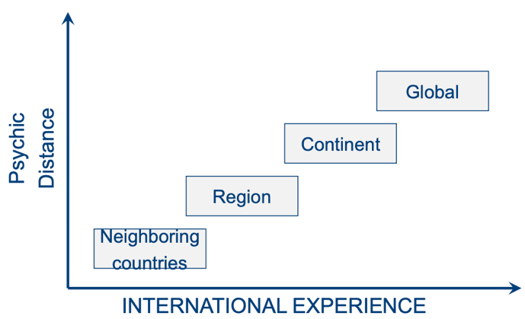
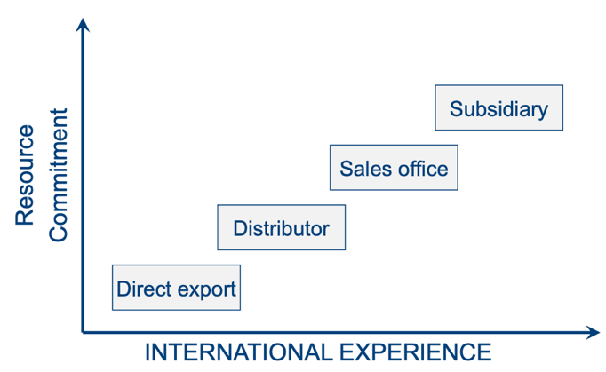

- Stage model in practice
    - 30% of HTSU (high-tech start-ups) use higher entry mode than direct export at first market entry (usually leapfrog some entry stages)
    - 55% of HTSU have export outside EU within 3y
Stage model doesn’t reflect reality
    - Born global companies
      - Focus on role of entrepreneur & management team
      - Foreign knowledge through working experience of founders
      - Congenital learning
    - Network approach
      - Focus on role of network partners
      - Foreign market knowledge through learning form network partners
      - Inter-organisational learning

External Growth Strategies (EGS)
- Mergers & acquisitions
    - Acquisition: purchase of another firm
    - Merger: pooling of interests to combine two firms into one
- Licensing
    - Granting permission to other companies to use intellectual property
    - Usually protected by a trademark, copyright or patent
- Strategic alliances: partnership between firms to achieve common goal
    - Technological alliances: cooperation in R&D, manufacturing…
    - Marketing alliances: use excess distribution capacity to sell products
- Joint venture: two or more firms pool resources to create separate, jointly owned firm

8. Exit Decisions

Exit Options
- Nobody makes real money until the exit
- Options
    - IPO
      - Growth opportunity & increased visibility
      - Greater returns
      - Costs significant time & money
      - Need of ongoing disclosure
      - Reliant on market conditions

    - Trade sale
      - Resource & capability leveraging
      - High liquidity
      - Loss of control, maybe downsizing
    - Sale to another financial investor
    - Bankruptcy / liquidation
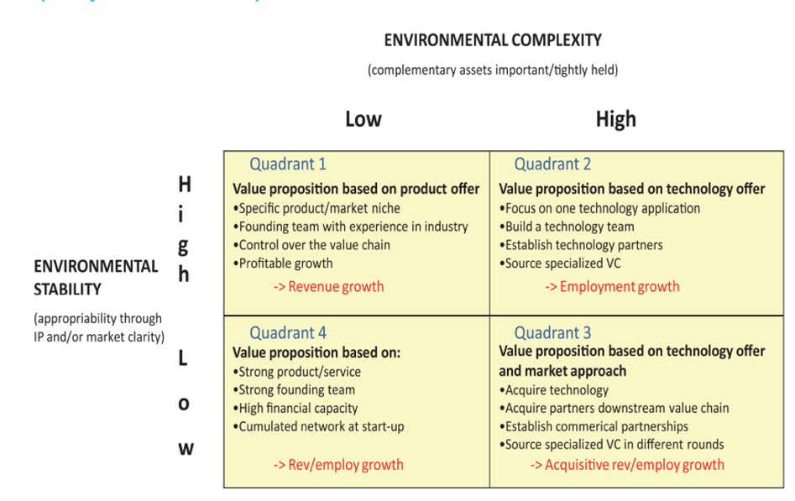
- Start-ups with exit strategy are in quadrant 2 & 3

Firm Valuation
- NPV & new venture valuation
    - Advantages
      - Unambiguous, clear & concrete
      - Considers time value of money
    - Disadvantages
      - Only as reliable as CF projections
      - Discount rate hard to estimate
      - Discriminates against high-risk LT projects
      - Strategic importance of project not captured
- Multiples valuation
    - Based on how similar assets are currently prices in the market
    - Most frequently used are P/E and P/S (for new ventures P/S)
    - Important issues
      - Find similar publicly-listed firms or recent M&A deal
      - Prices need standardisation by converting them into multiples of earnings or sales, to value on a relative basis
    - Advantages of P/S over P/S
      - No companies eliminated because of E < 0
      - Difficult to manipulate S (E is easier)
      - Less volatile than E
    - Disadvantages: company has to generate sales to have value

