Strategic Financial Management
Summary of classes by Roman Goncharenko, winter semester 2023
Pictures from slides by Roman Goncharenko

1. Introduction to M&As

Background & Historical Trends
- Market for corporate control
    - Acquirer (bidder): buyer of the firm
    - Target: seller of the firm (collection of shareholders)
- Usually in merger waves: peaks of heavy activity followed by quiet throughs of few transactions in the takeover market
- Types of mergers
    - Horizontal: target & acquirer in same industry
    - Vertical: target & acquirer used to be supplier & client
    - Conglomerate merger: target & acquirer operate in unrelated industries
- Types of payment
    - Cash: shareholders receive payment in cash for their shares
    - Stock (swap): shareholders swap old stock for new
    - Debt: shareholders get debt instruments from acquirer

Deals
- Cash deals
    - Most common & simplest
    - Comes from internal sources, SEO’s or additional debt (leveraged buyouts)
    - Corporate identity and ownership of acquirer remains unchanged
    - Acquiring firm usually much larger than target firm
    - Drawback: acquirer must compensate target shareholders the taxes they have to pay on capital gains
- Stock deals
    - Swap target stock for own stock or stock of new merged firm
    - Acquirer & target both share post M&A deal outcome (good or bad)
      - Acquirer discounts own stock to acquire company, exchange rate?
Acquirer stock value decreases because it gives target a discount
Acquirer stock value increases if acquisition is considered good
Final outcome?
- Debt deals
    - Like cash deal, but no capital gain taxes at time of acquisition
    - If acquirer goes bankrupt, shareholders are categorized like other creditors
- Acquirer has to pay premium on current market valuation of firm to convince shareholders
    - Acquisition premium: percentage between acquisition & premerger price
      - When bid announced, shareholders of target enjoy 15% gain on avg.
      - Shareholders of acquirer on avg. see 1% gain, half receive decrease

Reasons to Acquire
- Synergies
    - Cost reductions (ex. by efficiency gains)
    - Revenue enhancements (hard to predict)
- Economies of scale/scope
    - High volume can lead to lower prices
    - Combining marketing, distribution etc. from different products lowers prices

- Expertise sharing
    - Hiring experienced workers can be hard
    - More efficient buying whole firm than individual workers?
- Monopoly gains
    - Reduce competition
    - Antitrust laws limit monopoly building
- Tax savings: operating losses can lower taxes
- Risk diversification: larger portfolio firms are less exposed to market risks
- Debt capacity & borrowing costs can be optimised, larger and more diversified often means more credit credibility
- Earnings growth: earnings per share often exceed pre-merger prices, even when merger itself had no economic value (maybe in future?)
- Managerial motives to merge
    - Preferring to run a larger company: more pay and prestige
    - Hubris hypothesis

Takeover Valuation
- Key issue: quantifying & discounting the value added as a result of the merger
- Takeover synergies: additional value created by merger
- Price for a target = target pre-bid valuation + premium
Premium must be lower than takeover synergies to have a positive-NPV project
- Stock swap merger valuation
    - Is only a positive NPV project if share price of merged firm exceeds pre-merged firm stock price
    - The acquirer’s share price should increase post-merger if
      - $\frac{A+T+S}{N_{A}+x}>\frac{A}{N_{A}}=P_{A}$
        - A pre-merger value acquirer
        - T pre-merger value target
        - S value of synergies created by merger
        - N_{A} number of shares outstanding of the acquirer pre-merger
        - x number of new shares created to pay for target
        - P_{A} share price of the acquirer after the merger
    - x gives max. number of shares acquirer can offer to still have a positive NPV
      - $xP_{A}<T+S$
      - Can be expressed as an exchange ratio:
        - $\frac{x}{N_{T}}<\frac{P_{T}}{P_{A}}\left(1+\frac{S}{T}\right)$
- Merger-arbitrage
    - When offer is announced: uncertainty about takeover can add volatility
    - Risk-arbitrageurs: traders who speculate on the outcome of a takeover deal
    - Merger-arbitrage spread
      - Difference between a target stock’s price and the implied offer price
      - No real arbitrage as there is a risk the deal falls through

Takeover Issues
- Tax & accounting issues
    - Payment method affects taxes or timing of the taxes
    - Step up: an increase in book value of target’s assets to the purchase price when an acquirer purchases those assets directly instead of purchasing the target stock
    - Payment method does not affect combined firm’s financial statements for financial reporting
    - If purchase price exceeds fair market value of the identifiable assets, the remainder is recorded as goodwill and annually assessed by the accountants
      - Goodwill created can be amortized over 15y for tax purposes
- Board & shareholder approval
    - Both boards must approve the deal and put the question to a vote
    - Friendly takeover: when the target board supports a merger
    - Hostile takeover: when only (part of) the target shareholders agree and the ruling board is voted out
    - Corporate raider: the acquirer in a hostile takeover
    - Proxy fight: when in a hostile takeover, the acquirer attempts to convince shareholders to vote out the board
    - Poison pills: defence against a hostile takeover, a rights offering that gives target shareholders right to buy shares in target or acquirer at huge discount
    - Staggered board: board of directors whose three-year terms are staggered so only 1/3 of directors are up for election each year
Acquirer has to win proxy-fight 2y in a row before majority presence
    - White Knight: target looks for a friendlier company to acquire it
    - White Squire: variant of white knight, passive investor agrees to purchase substantial number of shares with special voting rights
    - Golden parachute: renumeration package that has to be paid to senior management when they are let go
    - Recapitalization: company changes capital structure to be less attractive
- Regulatory approval
    - Mergers above certain size must be approved by an institution (ex. EU)
    - Mergers can be stopped by regulators
- Free rider problem
    - If corporate raider thinks it can increase price of target from $40 to $75
    - Pays $60 per share to shareholders ($20 premium)
Shareholders might sell, unless they know it is actually worth $75
Shareholders who do not sell: free riding
To get rid of free riders, raider has to give up all of its profits, balance?
    - Overcome free rider problem: toehold & LBO
      - Initial ownership stake in target to initiate takeover
      - Don’t use own cash to pay for outstanding shares, use of a loan with the shares as collateral for the bank
      - Only needs the money if offer succeeds
      - Loan will become attached to target, not raider, so if sale goes through the raider will acquire the target. Target will have to pay off the loan.
    - Overcome free rider problem: freezeout merger
      - Raider can freeze existing shareholders out of the gains from merging, by forcing non-tendering shareholders to sell their shares for the tender offer price
Advantage over LBO: raider can use own shares to pay instead
- Large premium on mergers: because a lot of competition in takeover market

2. Valuation Technique for M&As

Comparables Approach
- Comparable firms approach
    - ‘Similar companies should sell at similar prices’
    - Widely used by investment bankers and in legal cases
    - Can be used when market value of equity is unknown (not publicly listed)
- Comparable transactions approach
    - Market value of a firm in a similar recently closed deal
- Premium paid to target and combined: following ratios
    - Premium ratio: $\frac{Total paid - market value target}{market value target}*100$
    - Premium combined ratio: $\frac{Total paid - market value target}{market value combined}*100$
- Issues with comparables
    - No definitive values
    - Comparable companies still have a lot of differences (ex. track record)
    - Hard to account for unobservable differences

Discounted Free Cash Flow (DFCF) Model
- Determine total value of firm to all investors
    - Enterprise value = market value of equity + debt - cash
    - Firm’s value is equal to present value (V₀) of all future free cashflows
$V_{0}=\sum_{t=1}^{∞}{{\left(\frac{1}{1+r}\right)}^{t}{FCF}_{t}}$
$FCF=EBIT*\left(1-τ_{c}\right)+depreciation-capex- ΔNWC$
- Future FCF’s are assumed to grow at a certain rate
    - Forecast future FCF for a number of years (N)
    - After N, assume FCF’s continue growing at long run growth rate g_{FCF}
- Weighted Average Cost of Capital (WACC)
    - $r_{wacc}=r_{D}\frac{D}{D+E+P}+r_{E}\frac{E}{D+E+P}+r_{P}\frac{P}{D+E+P}$
      - r_{D} = return on debt, take weighted avg. across different maturities of after-tax debt interests
      - r_{E} = return on equity*
      - r_{P} = return on preferred stock, given by promised divided over current market price

*$R_{i,t}-R_{f,t}=α+β\left(R_{m,t}-R_{f,t}\right)+ϵ_{i,t}$ $r_{e}=\overline{R_{f}}+β\overline{R_{m}}$

- When terminal value estimated by a rate of g_{FCF} we can calculate firm value as

$$V_{0}=\frac{{FCF}_{1}}{1+r_{wacc}}+\frac{{FCF}_{2}}{{(1+r_{wacc})}^{2}}+…+\frac{{FCF}_{N}+V_{N}}{{(1+r_{wacc})}^{N}}$$

with $V_{N}=\frac{{FCF}_{N+1}}{r_{wacc}-g_{FCF}}=\frac{1+g_{FCF}}{r_{wacc}-g_{FCF}}{FCF}_{N}$
- Estimated market value of equity E₀ = V₀ – debt + cash
- Issues with DFCF
    - Valuation depends heavily on assumptions about the future
    - Very sensitive to parameter values

3. Theories of M&As

Mergers as value decisions
- Value increasing decision
    - Economies of scale
    - More effective management
    - Knowledge sharing
    - Combination of complementary resources, no duplicates
- Value decreasing decision
    - Free cashflow problem could lead to value reducing mergers
    - Agency problem in management:
      - Separation of ownership and control
      - CEO’s interest not always aligned with shareholders
    - FCF theory: more FCF means more conflict of interest
      - More likely to initiate negative NPV projects
      - More chance of empire building by management

Impact of takeovers on management
- Managerial hubris: excess of self-confidence
    - Is the source of inefficient mergers
    - Winner’s curse in a bidding competition
Can lead to zero-value mergers, as the winner probably overpays
- Management of target
    - Might work harder due to threat of replacement by raider
    - Might induce myopic behaviour (short-terminism), with excessive risk-taking or empire building

Positive Theory of Takeovers
- Typical target has many dispersed shareholders, hard to agree on a price when bid is placed
- Grossman & Hart
    - When shareholders are atomistic (highly dispersed), takeover might not take place even when it leads to overall value increase
    - Reasoning: the value improvement of the takeover is effectively a public good (because dispersed ownership) to which no shareholder wants to contribute, but everyone hopes the others will (free-rider problem)
Explains importance of block holders, toeholds and dilution
    - Technical
      - Assume target has infinite shareholders
      - One singe bidder makes an offer
      - Shareholders individually decide whether to accept
      - If raider wins, value of target is improved to $\hat{V}>V$
(for simplicity, normalise so that $\hat{V}-V=1$)
      - Raider needs to capture a fraction of k shares to become owner
      - P is premium over V raider has to offer
Price raider wants to pay is P + V
Then we get 0 < P < 1 or the raider would turn a loss

Takeover in Formulas
- Takeover probability ($β$)
    - $β$ must be equal to premium P
    - $P+V=β+V= β\left(\hat{V}-V\right)+V=β\hat{V}+(1-β)V$

- Price shareholders want is: (probability of takeover x price if takeover takes place) + (probability of no takeover x price if it does not take place)
- Expected payoff by raider:
    - $π=k\left[β\left(\hat{V}-V\right)+V-\left(P+V\right)\right]=k[β\left(\hat{V}-V\right)-P]=k\left[β*1-P\right]=0$
Free riding by shareholders fully captures the raider’s profit
- Expected payoff for raider with private surplus ($ω$):
    - $π=k\left[β*1-P\right]+βω=Pω$
Raider prefers to bid premium of 1 to maximize private profit
- Role of toeholds
    - Assume raider already holds toehold $θ<k$
    - Assume no private benefit
    - $π=\left(k-θ\right)\left[β\left(\hat{V}-V\right)+V-\left(P+V\right)\right]+θ\left[β\left(\hat{V}-V\right)+V-\left(P+V\right)\right]=\left(k-θ\right)\left[β*1-P\right]+θP=θP$
P = 1
    - Raider fully appropriates the value added to the toehold shares
- Role of dilution
    - Suppose raider captures a fraction $ϕ∈[0,1]$of the gains made by the shareholders who have not tendered their shares
    - Partial expropriation of minority shareholders (can be illegal)
(ex. forces firm to buy supplies at inflated price from the raider’s affiliate)
    - This increases private surplus ($ω$) and decreases takeover value ($\hat{V}$)
$ω=ϕ\left(\hat{V}-V\right)=ϕ$
    - Dilution might not be feasible: controlling shareholders have fiduciary duty to minority shareholders
- Multiple bidders
    - Bidder with highest valuation will enter deal (winner’s curse)
    - Toeholds increase chance of winning

Managerial Resistance
- Management can resist hostile takeovers in multiple ways
    - Routinely advise shareholders against tendering their shares
    - Lobby ex-ante & ex-post for take-over defence
    - In response to takeover, target may
      - Threaten raider with litigation
      - Sell some of the assets desired by raider
      - Increase debt prior to bid
      - Acquire another firm to create antitrust problems
      - Agree on greenmail (repurchase raider’s current toehold, high price)
- Should target management have a say in the take-over?
    - Clear conflict of interest (might lose job)
    - Golden parachute: large compensation guaranteed to an executive if they are dismissed as a result of a merger

4. Event Study Analysis

Statistical Background
- Standard regression model:
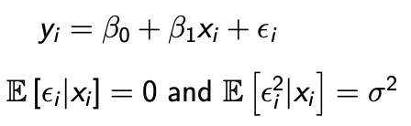

- Ordinary least squares (OLS)
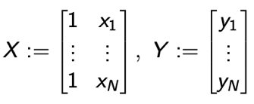
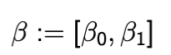
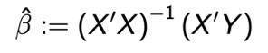
with

- Statistical inference: test if $β_{j}$ is significantly different from 0
    - Use two-sided t-test
    - H₀: $β_{j}=0$
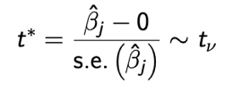
    - H₁: $β_{j}≠0$
    - Construct t-test statistic:
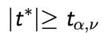
    - Choose significance level α
Reject H₀ at selected significance level if

    - How to get $β_{j}$:
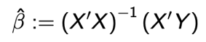
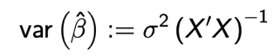
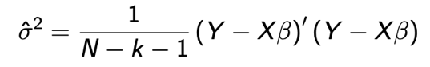

with k as number of slope coefficients

Introduction to Event Studies
- Event study
    - Standard tool in testing M&A theories
    - Statistical method to assess impact of an event on the interest variable
    - Analysis tells us if market views merger as positive
    - Implicit assumption: rational market participants act immediately on events
- Applications
    - M&A announcements
    - Equity issue announcements
    - Bank loan grant announcements
    - Earnings announcements
    - …
- Procedure
- Identify the event & variable of interest
- Identify the event window (period over which the variable is examined)
- Decide on selection criteria for firm sample & construct the event
- Choose normal performance model & estimation window
- Given the normal model, construct the measure of abnormal return
- Design testing framework
- Present empirical result & diagnostic checks
- Discuss causes of the effect or lack of effect and the possible explanations
- Conclude
(Ab)normal Returns
- Normal returns: what would have been under normal circumstances
- Abnormal returns
    - Return – normal return statistically different from 0
    - Examine effect of events in terms of abnormal return
- Constant mean return model (CMR)
    - Expected value is always the mean
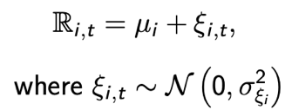
    - Mean calculated by taking sample mean
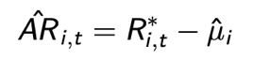
    - Estimator for abnormal returns AR
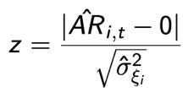
    - To test if AR is statistically different from 0 take
- Market model
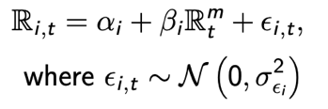
    - The regression model
where $R_{i,t}$ and $R_{t}^{m}$ are the period-t returns on security i and the market portfolio
    - We look for normal return so eliminate the error factor
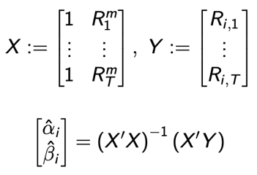
    - Estimate α_{i} & β_{i} using OLS estimator
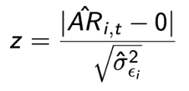
    - Compare return to normal return to get AR, take z-statistic
    - Return on market portfolio, use broad based index like S&P500 (for US) or local index
    - Specify market model in terms of excess returns rather than returns
before estimating coefficients, subtract nominal risk free rate R from R_{i,t} & R_{t}^{m}, that is your estimate the following model

Aggregation of Abnormal Returns
- Must be aggregated in order to draw overall inference for the event of the interest
- Along two dimensions: time (t) and securities/firms (i)
- Cumulative abnormal returns (CARs)
    - Aggregation over time
    - To accommodate the effect of the event based on multiple periods
    - CAR over a period [t₁, t₂] is the sum of those two
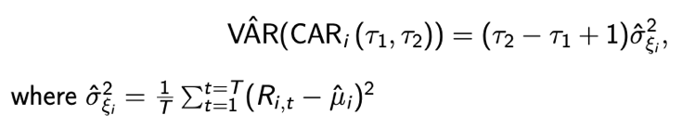
    - Calculate variance of CAR using CMR then
- Aggregation across firms
    - ‘Think about N M&A announcements and we want to know avg. effect of one on the combined value’
    - Assume no clustering of firms
    - Take avg. abnormal return over all firms
    - Take variance of avg. abnormal returns
    - Do the 0 testing
- Alternative approach
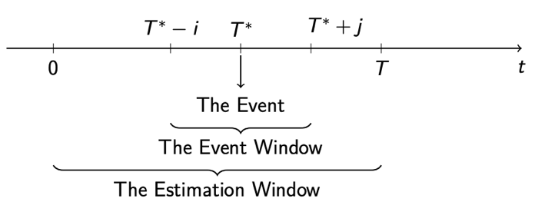
    - Take as event window a subset of the estimation window
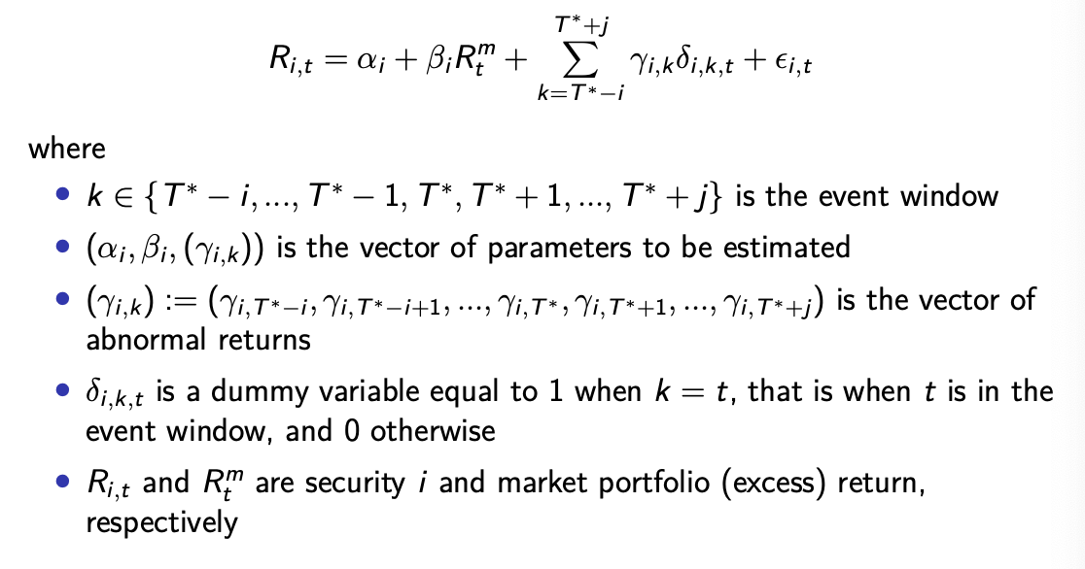
    - Take the econometric model
    - With this model we directly control for normal returns (before large sum operator) when estimating abnormal returns (after)
    - Model is estimated with the OLS using standard formula
    - Once Ars have been estimated, aggregate across time & firms
    - Perform 0 test

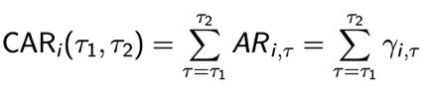
Standard Errors
- Compute standard errors for
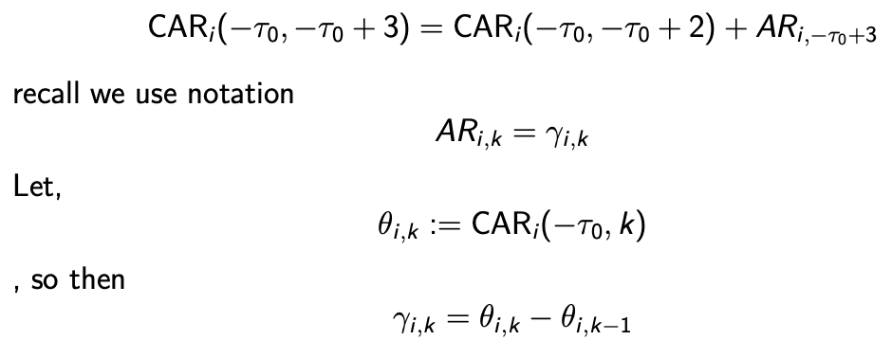
- Recursive relation of returns:
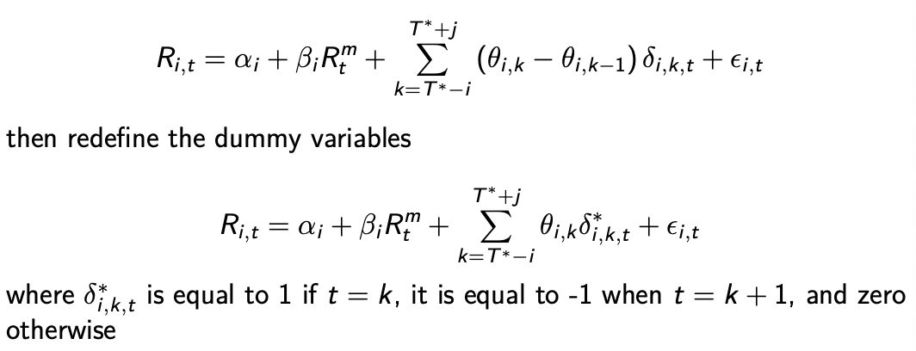
- Use this to transform the econometric model for abnormal returns to
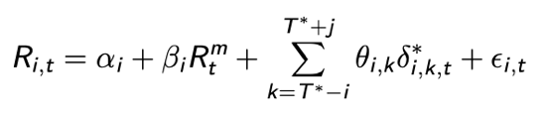
- Now you can estimate the following using the OLS

5. Empirical Evidence on M&As

Main Theories
- Mergers as value-increasing decisions: merge due to synergistic effects
    - Economies of scale
    - Effective management
    - Improved production techniques
    - Combination of complementary resources
- Mergers as value decreasing-decisions: agency cost
    - FCF problem
    - Agency problem in management derives from the separation of ownership
    - C-level executives’ interests not always aligned with shareholders’ interests
    - Principal agent problem: dispersed ownership leads to free-riding
- Mergers as value-neutral decisions: managerial hubris
    - Managers are prone to excessive self-confidence
    - Winner’s curse in a takeover bidding competition

Combined Returns
- Is a merger a positive NPV investment: is combined return of bidder & target positive
    - Combined returns estimated (C)AR from event study using weighted portfolio of bidder and target stock
    - Theories based on synergy & efficiency: return is positive
    - Theories based on agency costs of FCF: return is negative
    - Theories like Roll 1986: wealth gain represents redistribution, net gain is 0

Evidence on Combined Returns
- Bradley, Desai & Kim 1988
    - Sample of 236 offers (between ’63-’84)
    - Successful tender offers generate synergistic gains and lead to more efficient allocation of corporate resources
- Kaplan, Weisbach & Servaes 1991: estimated combined return of about 4%
- Mulherin & Boone 2000: positive combined returns, magnitude linked to size of event
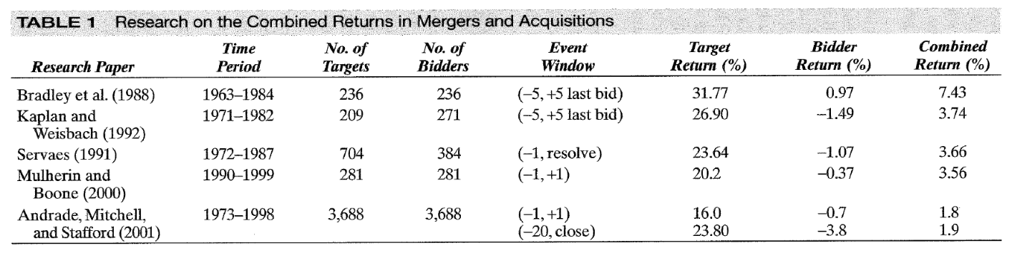
- Andrade, Mitchell & Stafford 2001: positive combined return, value on behalf of shareholder

- General conclusion
    - Positive returns
    - Mainly for shareholders of combined firm after merger
    - Evidence cannot be used to reject theory of value-decreasing mergers

Extended Analysis
- Berkovich & Narayanan 1993: test correlation between target gains & total gains
    - If synergy is driving force: correlation positive (both parties gain)
    - If hubris is at play: correlation is zero (total gain 0)
    - If agency is factor: correlation negative (target extracts rent from bidder)
Most of time synergy is primary factor (+-75%)
- Becher 2000
    - Studies shareholder wealth effect of bank mergers
    - Lots of mergers in ‘90s due to deregulation of sector
Both mergers and deregulation create value

Factors Affecting Returns
- Method of payment
    - Most influential factor on returns
    - Due to taxation and regulation
    - Cash deals create most wealth
- Number of bidders: single vs. multiple
    - Return to target increases with number of bidders
    - Takeover premium will be larger with more bidders
    - Similar results for run-up & markup price increases
      - Run-up: always similar (price increase prior to announcement)
      - Markup: larger for multiple bidders (post announcement increase)

- Target run-up
    - Papers usually document a positive target stock run-up prior to acquisition announcement
    - Keown & Pinkerton ‘81: merger announcements are poorly held secrets
    - Jarrell & Poulsen ’89: run-up related to media rumours and pre-bid share acquisition by eventual bidders
    - Sander & Zdanowicz ’92: run-up starts when transaction is initiated, this indicates that run-up is not due to speculation but tied to likelihood of deal
    - Meulbroek ’92: abnormal returns on an insider trading run-up day avg. 3%
    - Schwert ’96: no correlation between run-up and markup, meaning run-up is an added cost for the acquirer
- Takeover bidding & premiums
    - Premium in takeover bid: percentage difference between price of merger and price prior to merger offer
    - Premium usually very large (almost 50%)
    - Bidders sometimes do pre-emptive bid to deter competition

Factors Related to Bidder Returns
- Method of payment: more negative returns in stock than cash deals
- Digression: pecking order hypothesis
    - Hierarchy in sources of funds: internal sources > debt > equity
arises due to asymmetric information, internal sources have a lot of information and thus need a lower (or no) interest
    - Implication: equity issuance announcement firm’s stock price decreases
- Single vs. multiple bidders
    - Single bidder: higher bidder returns
    - Multiple bidder negative return driven by bidders who weren’t first
    - Competition among bidders reduce return for the acquirer
    - According to studies, bad bidders become targets themselves more easily

Takeover Regulation
- William Act ‘68
    - Federal constraints on tender offer process
    - Forcing greater disclosure by bidders and setting minimum bidding period
    - Combined return after the Act did not change, but distribution of profit shifted between targets & bidders
Target premiums increased and bidder returns fell
- Takeover impediments in the ‘80s
    - More antitakeover laws and poison pills followed
    - Decline in takeover market due to economic conditions, not because of laws
    - Laws affect form of takeovers (hostile/friendly), but not substance of it

Long-term Stock Price Performance
- Hard as there is no perfect model for normal returns with/without merger
- Findings that are positive/negative could rally be due to many random factors
- Average long-term price performance following merger is insignificantly different from 0
- Results based on samples such as method of payment or book-to-market ratio are very sensitive to estimation methods
- Efficiency vs. market power
    - Ellert ’79: inconsistent evidence for market power explanation/merger gains
    - Stillman & Eckbo ’83: evidence against anticompetitive effect of mergers
    - Number of studies document positive industry spill overs from mergers
    - Fan & Goyal ’02: no statistical evidence that combined returns differ between horizontal or vertical mergers

- Effects of concentration
    - Despite increased mergers, aggregate concentration has been unchanged
    - Industry concentration measures stay constant despite merger activities

6. Initial Public Offering

External Financing
- Raising external funds via
    - Debt: bank loan, bond issuance…
    - Equity: initial public offering (IPO) or seasoned equity offering (SEO)
- IPO
    - Not just about raising funds, but also going public
    - Stock can be traded publicly at an exchange
    - Strategic decision, has large impact on firms’ future

Going Public
- Reasons to go public
    - Reduce cost of capital
    - Allow insiders to cash out
    - Facilitate takeover activities: broaden ownership base
    - Other strategic reasons
      - Broaden ownership base
      - Capture first-mover advantage, increase reputation
      - Analyst recommendations biased upwards
- Other advantages
    - Improved market discipline & transparency
    - Creation of multiple financing opportunities: equity, convertible debt, cheaper bank loans etc.
    - Employee stock option compensation plans
- Disadvantages
    - Potentially large under-pricing of IPO
    - Significant (ongoing) legal, accounting & marketing costs
    - Requirement to disclose more financial & business information (might be beneficial for suppliers, customers & competitors)
    - Loss of control and stronger agency problems due to equity dilution
    - Increased risk of litigation, including private securities class actions and shareholder derivative actions
- Pecking order of financing
    - Internal equity
    - Debt financing
    - External equity
Based on asymmetric information and possible stock price misvaluation

IPO Timing
- Comes in waves (like M&As)
- Three domains to explain timing
    - Take advantage of bull markets to capture attractive stock price
      - When current overall market or industry conditions are good
      - When predicted overall market or industry conditions are good

    - Attractiveness of the IPO market
      - Great recent first-day stock performance leads to more IPOs
      - Firms prefer to go public when other good firms are issuing
    - Do IPO when reaching sufficient maturity

IPO Process
- Selection of an underwrite
    - Involves one or more investment banks as underwriters (if more: syndicate of underwriters with one lead underwriter or bookrunner)
    - Issuer enters into contract with lead underwriter to sell its shares
    - Underwriter approaches investors with offers to sell the shares
    - Upon selling, underwriters retain portion of profits as underwriting spread
    - Spread is calculated as discount from gross spread (price of shares sold)
    - Bookrunner underwrites largest proportion of the IPO and takes largest portion of the gross spread (up to 8% sometimes)
    - Following underwriter arrangements exist
      - Firm commitment: bookrunner purchases whole offer and resells to public, this way it guarantees issuing company sum of money
      - Best efforts agreement: bookrunner sells on behalf of the company without any guarantees about the money being raised
      - Syndicate of underwriters: bookrunner forms strategic alliance with other banks to spread the risk of the IPO. Each bank sells a portion.
- Due diligence and filings: an underwriter must draft following documents
    - Engagement letter, this includes
      - Gross spread / underwriting discount defined as the % difference between sale & purchase price
      - Reimbursement clause: issuing company must cover all underwriter expenses, even if the IPO is withdrawn during an early stage
    - Letter of intent: agreement between issuer and underwriter
    - Red herring document: prospectus including neither price/quantity to be sold and used in roadshows (marketing campaign leading up to IPO)
    - Underwriting agreement: replaces letter of intent after pricing of securities
    - Registration statement: includes prospectus and private filings (SEC info)
- Pricing
    - When IPO is approved by a regulatory body, effective date of IPO is decided
    - Day before effective date, issuing company and underwriter decide price and precise number of shares sold
    - When stock starts trading on secondary market, money raised through sale of shares does not go to underwriter anymore
    - Price depends on
      - Success/failure of roadshows
      - Company’s goals
      - Condition of stock market, the industry and global economy
    - IPOs often under-priced
      - To ensure issue is fully subscribed
      - Investors expecting a rise on the offer day, leads to more demand for the issue
      - To compensate the risk of investing in an IPO

- Stabilization
    - After issue is brought to market, underwriter provides
      - Analyst recommendations
      - After-market stabilization: in event of order imbalances (purchasing shares at offering price or below)
      - Creates a market for the stock issued
    - Stabilization activities can only be carried out for short period of time
      - Prohibitions against price manipulation are suspended during period
      - Underwriter has freedom to trade and influence the price
- Transition to market competition
    - Starts 25 days after IPO, once quiet period mandated by SEC ends
    - Quiet period: transition from relying on mandated disclosures and prospectus to relying on market forces for information regarding shares
    - After quiet period: underwriters may provide estimates regarding earnings and valuation of the issuing company
    - Underwriter becomes advisor and evaluator once issue has been made

Reverse Merger
- Type of merger where private company becomes public by acquiring a publicly traded firm
- Advantages
    - Saves private company from expensive and difficult IPO process
    - Lowers tax bill of private company
- Disadvantages
    - Lawsuits are common
    - Reverse stock split (reduction in number of shares held by shareholder of private firm)

Under-pricing of IPOs
- Stock was under-priced if after one day of trading, stock price has risen
    - Markets w/o price limits: under-pricing is evident by closing of offering day
    - Offer price usually set hours before offer starts, so market movements between offer price determination and opening are negligible
    - Dollar value of under-pricing: money left on the table (only if entire offering could have been sold at closing price)
    - Time variation in avg. under-pricing fluctuates between 5-20% (USA)
    - Under-pricing low in EU, high in Asia
- Because of asymmetric info
    - Between underwriter & issuer, issuer exploits superior market knowledge to
      - Under-price issues
      - Minimize marketing effort
      - Ingratiate themselves with buy-side clients
    - Between issuer & investors
      - Investor uncertainty about IPO biases offering prices lower than unknown future market price
      - Under-pricing rewards sophisticated investors for divulging accurate valuation information during book-building process
    - Between informed & uninformed investors
      - Uninformed investors must be compensated for taking risk
- Under-pricing serves as protection against possible litigation from investors

- Under-pricing as marketing function
    - Cause domino effect among investors that raises demand
    - Allows for cost savings in other areas of marketing the issue
    - Brings attention to stock on opening day
    - Increases after-issue trading volume of stock
- It broadens ownership base after IPO
    - Helps ensure wide base of owners, increases liquidity of newly public firm
    - Motivation to entrench management
    - Allows for creation of a block holder that can increase monitoring
- May facilitate questionable practices
    - Permits spinning (enriching of executives of prospective bank clients)
    - Allows practice of flipping by favoured friends
    - Enriches friends & family through directed share program
- Behavioural explanation for under-pricing an IPO
    - Issuers are pleasantly surprised with amount they can raise in IPO
    - Under prospect theory, they are not really concerned with under-pricing

Historic Trends of IPOs
- Way more IPOs in the 80s and 90s than now
- Many blame the Sarbanes-Oxley act and Global Settlement’s effects on analyst coverage
- Economy of scale hypothesis: advantages of selling out to larger firm have increased
    - Speed of product to market
    - Realization of economies of scope & scale

7. Corporate Restructuring & Divestitures

Intro to Corporate Restructuring
- Managers face dynamic, ever-changing environment
    - Variety of options to deal with these changes
    - Multiple restructuring options
    - No one-size-fits-all approach
- Restructuring and reorganization strategies
    - Reorganization of assets & ownership via divestitures (see further)
    - Reorganizing financial claims
      - Debt-equity exchange offers
      - Dual-class or leveraged recapitalization
      - Financial reorganization (bankruptcy) or liquidation
    - Other strategies
      - Alliances & joint-ventures
      - ESOPs & MLPs
      - Going private and leveraged buyouts
      - Using international markets
      - Share repurchase programs

Divestitures
- Disposing of an asset through a sale, exchange or closure
- Primary reasons
    - Can create value for companies in mergers, acquisitions or consolidations
    - Eliminate redundancies, improve efficiency and reduce costs
    - To restructure, raise cash or reduce debt

- Primary methods
    - Asset sales: sale of a division, subsidiary, product line…, usually for cash
    - Equity carve-outs (ECO): offering interest in a subsidiary to investors
    - Spin-offs: pro rata distribution of shares in a subsidiary to existing investors
    - Other variations: split-ups, tracking stocks or exchange offers
- Equity carve-outs and spin-offs create a separate publicly traded company

Equity Carve-Out (ECO)
- Company tactically separates a newly created subsidiary from its parent as standalone
- New company is complete with own board and financial statements
- Parent retains controlling interest, usually indefinitely
(data suggests most parents fail to keep control, most ECOs are acquired by a third party)
- Not about selling the business unit outright, but selling a portion of the equity stake
- Allows company to strategically diversify
- Benefits for parent and new company
    - Diversified core businesses
    - Separation of operations and streamline the focus on core operation
    - Increases value of both due to increased profitability
- Efficiency
    - Conflicts between ECO and parent often intensify as years go by
    - ECOs usually grow at higher rate, starting with initial IPO
    - Empirical evidence suggests shareholder value increases if company follows structured plan to fully separate subsidiary in future

Spin-Offs
- Create a new independent, publicly traded business out of existing subsidiary
- Parent distributes shares of subsidiary directly to current shareholders on pro-rata basis
(basically as a dividend payment)
- New entity takes assets, employees… in exchange for predetermined amount of cash
- May take on debt to provide a distribution to the parent in exchange for those assets
- Shareholders of parent firm are not required to surrender any stock of parent in exchange for the subsidiary’s stock
- Reasons for a spin-off
    - Reduce agency costs: reorganizing administrative structure to improve profitability/efficiency
    - Create tax shields
    - Enter a new industry
    - Consolidate/streamline workflow: spin off less productive divisions
    - New entity expected to be more profitable / have higher value alone
- Disadvantages
    - Share price can be more volatile (less diversified firm)
    - Experience high selling activity: shareholders of parent might not want stock of the new entity
Share price can dip short term

Variations of Primary Divestiture Methods
- Split-up
    - Separation of a company in two or more parts, often via spin-offs
    - Occurs because
      - Company wants to maximize efficiency/profitability of each line
      - Government forces split up to combat monopoly
    - After split-up is complete, shareholders can choose which shares they want
    - Strategic advantage
      - Strategically revamp operations when having multiple business lines requiring different resources
      - If combined profits of separated entities exceed those of single one

- Tracking stock
    - Create separate class of stock, based on cash flow of specific divisions
    - Sometimes part of an IPO, but doesn’t require change in business structure
    - Holders of stock hold equity in parent, not specific division
    - Salient features
      - Voting rights: holders usually have fixed or floating voting rights
      - Dividend rights: based on earnings of tracked division
      - Liquidation rights: no right to liquidation value of tracked division
      - Conversion rights: convert tracking stock to other class for premium
    - Pros
      - Give investors access to more promising divisions of a company
      - Performance comes only from tracked segment
      - Issuance provides company with extra capital
    - Cons
      - Investors can lose money if specific division performs badly
      - Usually comes with limited or no voting rights
      - Parent company goes bankrupt, creditors may have claim on assets
- Exchange offer
    - Distribution giving shareholders a choice to retain parent or exchange for shares in new subsidiary
    - Difference with spin-off: shareholders can have to opt in
    - Creates separate publicly traded company
- Spin off vs. split-up vs. carve-out
    - Spin-off: formation of new independent company from parent by distributing shares of existing company
    - Split-up: parent splits up in two or more independent companies
    - Carve-out: parent sells shares from subsidiary company to external investor

Divestitures Create Wealth
- Transaction costs: divestitures respond to changes in transactions costs
- Information/signalling: divestitures can signal information to the market
- Incentives/monitoring costs: divestitures could enhance monitoring

8. Financial Restructuring

Financial vs. Operational Restructuring
- Corporate restructuring
    - Fundamental change in a company’s business or financial structure
    - Designed to increase value to shareholders or creditors
    - Often divided in two parts: operational & financial restructuring
    - In most turnaround/bankruptcy situations: financial & operational restructuring must occur simultaneously to save business
- Operational restructuring: increase economic viability of underlying business model

- Financial restructuring
    - Improve capital structure of the firm
      - For viable firms: debt restructuring or equity-for-debt swaps
      - In bankruptcy: laid out in plans of reorganization
    - Can be done proactively, initiated by management or board, by doing share buyback and leveraged recapitalizations
    - Most of the time existing structure remains in place until crisis happens

Reasons for Financial Restructuring
- In normal times: unlocking the value in the firm
- In financial distress: increasing firm value
- How
    - Optimising leverage
    - Fine-tuning debt & equity structure
    - Financial reorganization (bankruptcy)
    - Liquidation

Trade-off Theory
- Trade-off theory of capital structure: tax-benefits of debt vs. financial distress cost
- Interest rate on debt is tax-deductible and thus generate a tax-shield per unit of debt with
    - τ = corporate tax rate
    - r = interest rate on debt
Tax shield per unit of debt = τ * r
    - Higher debt level = higher interest payments = increased default risk
    - Lower debt level = losing tax shield
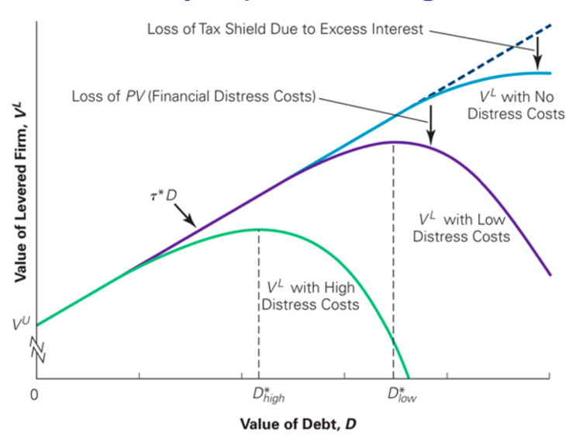
Firm value = PV (FCF) + PV (tax shields) – PV (bankruptcy cost)

Agency Costs
- Agency issues arise when conflicts of interest among stakeholders occur
    - Debt repayments have priority over dividends
    - Equity is a residual claim
    - Too much debt aggravates risk shifting and debt overhang issues
- Issues between managers and investors
    - Managerial moral hazard: private benefit extraction
    - FCF problem: too little debt leads to inefficiencies
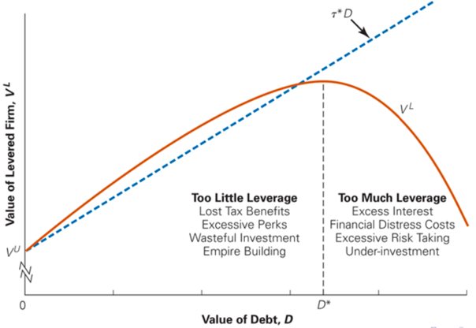
- Trade-off theory with agency costs
- Firm value
= PV (FCF)
+ PV (tax-shields)
– PV (bankruptcy cost)
– PV (agency cost)

Leveraged Recapitalization
- Type of financial restructuring
    - Company changes capitalization structure
    - Replaces majority of its equity with debt securities consisting of
      - Senior bank debt
      - Subordinated debt
Company borrows money to buy back shares
- Senior managers/employees may receive extra equity in order to align their interests
- Used to
    - Prepare a company for period of growth, as structure that leverages debt is more beneficial to a company during growth periods
    - During periods when interest rates are low
- Leveraged recapitalization advantages
    - Similarities with leveraged buyouts (LBO), but firm remains public
    - Doesn’t dilute stock value, less negative effects on shareholders
    - Used by private equity firms to exit some of their investment early
    - Can increase the value of a tax shield
    - Can decrease the likelihood of a takeover
    - Will improve incentives (no FCF problem anymore)
- Disadvantage: higher default risk and agency costs

Debt Restructuring
- Process of restructuring whole debt capital, involves reshuffling of balance sheet items
- More commonly used than equity restructuring
- Three reasons to restructure debt
    - Healthy company: restructure to replace high-cost debt with lower cost debt
    - Company with liquidity issues: reduce cost of borrowing and increase working capital position
    - Company in default (bankruptcy prospect): to improve solvency, avoid liquidation
- Often achieved through negotiation between firm and their creditors (banks etc.)
    - The principal: reduce total amount of debt company owes
    - Cost of debt: decrease interest rate it pays
    - Extend maturity: extend period of time
- Debt-equity swap: some debt is written off in exchange for an equity position in the firm
Usually, final opportunity for distressed firm to avoid bankruptcy

Bankruptcy
- Legal proceeding involving a company unable to repay its outstanding debt
- Starts with a petition filed by the debtor (common) or on behalf of creditors (less common)
- Types of bankruptcy
    - Liquidation
    - Reorganisation
    - Arrangement for debt repayment with lowered covenants or payment plans
- Liquidation & reorganisation are most popular
- Liquidation
    - A bankruptcy trustee is appointed to liquidate non-exempt assets to repay all creditors
    - Unsecured debt separated into categories of priority and paid first
    - Secured debt backed by collateral is paid second
    - Lastly the unsecured non-priority debt is paid with remaining funds from the liquidation of assets
- Reorganisation
    - Reorganise debtor’s business affairs, debts & assets
    - Entity filing for bankruptcy under reorganisation, remains in control
    - Advantages
      - Can continue operations which ensures CF to aid repayment process
      - Not required to liquidate assets
    - Disadvantage
      - Very complex and expensive process
      - Legal costs could worsen the situation
      - Plans must be approved by bankruptcy court and be manageable enough to pay off debt in reasonable amount of time
- Strategic bankruptcy
    - When it is a strategic choice, not an unavoidable condition
    - Can declare bankruptcy without being insolvent or to retain its incumbent management (in US the chapter 11 bankruptcy)
    - Advantages
      - Strategic debt cutting (possibility for debt forgiveness/restructuring)
      - Breaking outstanding contracts with unfavourable conditions
      - Same name, different company option
      - Different name, same company: rebranding
    - Chapter 11 and efficiency
      - Improves efficiency as it inhibits inefficient liquidation and provides an incentive for shareholders to seek bankruptcy instead of delaying the resolution of financial distress
      - Bankruptcy laws exacerbate the incentive to overinvest, may encourage managers to reorganize if liquidation is more efficient
    - Ex-ante incentives
      - Deviations of absolute priority of debt over equity in bankruptcy is beneficial as it helps to reduce excessive risk shifting
No gamble for resurrection from management
    - Ex-post incentives
      - Less than half of directors of distressed firms remain after reorganisation and they are less likely to serve on boards of other publicly traded firms
Board members are monitored for their performance & penalised

    - Empirical evidence
      - 40% of reorganised firms continue operating losses in the 3y after
      - Total CFs of reorganised firms over 5y after reorganisation exceed the benchmark
      - Firms that significantly restructure assets & liabilities during chapter 11 are more likely to achieve positive operating performance

Equity Restructuring
- The process of reorganising the equity capital
- Common methods
    - Repurchasing shares from shareholders for cash: helps reducing liability to shareholders resulting in a capital reduction
    - Dual class stock recapitalisations (DCRs)

- Dual class stock
    - Dual class structure: multiple classes of shares with different voting rights
    - Insiders have access to shares that provide greater control and voting rights
    - Allows LT-investors, founders… to control the company easier, because ST-investors are likely to force ST gains
    - Empirical evidence: shareholder wealth not adversely affected by DCRs
    - Paradox of entrenchment by management
      - DC stock can be used to entrench management positions
      - Voting power of managers often insufficient to explain DCR approval
      - DCRs provide higher dividends in exchange for reduced voting rights
Prisoners’ dilemma for shareholders
Maximise own profit by going for DCR, yet solution is suboptimal

Exchange Offer
- Provides classes of securities the right to exchange part of holdings for a different class
- Exchange offer is usually open for a month and then extended
- Reasons
    - Leverage in-/decrease
    - CFs are expected to in-/decrease
    - Stock is over-/undervalued
    - In-/decrease of management ownership or control over use of cash
    - Positive/negative signalling effect
- Two types
    - Debt-to-equity swaps: positive exchange offer
      - Decreased leverage
      - Imply decrease in future CFs
      - Control over cash usage by management increased
      - Loss of tax shields
    - Equity-to-debt swaps: negative exchange offer
      - Increase leverage: higher ROE
      - Imply increase in future CFs
      - Control over cash usage by management is reduced
      - Potential signalling with leverage & tax shields

- Swaps
    - Debt-to-equity swaps in order to write off money owed to creditors
    - Conducted during bankruptcies, swap ratio varies
    - In case of bankruptcy, debt holder is required to make the swap, other cases they may do so if they want
    - Difference with exchange offer
      - In an exchange: holders of entire issue of a security class are offered same opportunity to exchange them for a different class
      - In a swap: involves open market repurchase of a portion of debt/stock issuance

9. Going Private & Leveraged Buyouts (LBOs)

Going Private
- Transactions that convert a publicly traded company into a private entity
- Shareholders are no longer able to trade shares in the open market
- Types
    - Private equity (PE) buyouts
    - Management buyouts
    - Tender offers
- Company goes private when
    - Shareholders decide there are no benefits to being public anymore
    - Result of a takeover of a private company
    - For restructuring purposes when in distress
- Private equity buyout
    - PE firm buys controlling share in the company using significant debt (LBO)
    - Secures debt against assets of the company acquired
    - Interest & principal payment on debt financed by CFs of target
- Management buyout (MBO)
    - Taken private by own management
    - To streamline operations & improve profitability
    - Funding from personal resources of management, PE financiers and seller-financing (seller receives payment later from profits of the sold company)
    - Management buy-in?
      - External management team acquires firm & replaces management

Private Equity
- Alternative investment class existing of non-listed capital
- PE firms hold large portion of the market
- Composed of funds & investors directly investing in specific private companies or in public companies by delisting them
- Most PE funds come from are institutional or accredited investors who can dedicate substantial sums for extended time periods
- Usually long holding times, investing in low-growth but high FCF firms
- Advantages of PE financing
    - Access liquidity without using bank loans or an IPO
    - VC (part of PE) finances ideas & early-stage companies
    - PE financing can help delisted companies to attempt unorthodox growth strategies away from glare of public markets
    - Use of debt financing to lower tax obligations

- Disadvantages
    - Harder to liquidate holdings in PE funds
    - Pricing decided through negotiation, not market forces
    - Rights of shareholders decided case-by-case
- Public vs. private: private ownership mitigates some agency problems
    - High level of oversight by shareholders
    - Limit inefficient use of FCF, as they are used to pay off debt
    - Promotes LT decision-making as exit is only after x years
- Types of PE
    - Vulture financing (distressed funding): invest in troubled companies
    - Leveraged buyouts (LBOs): buyout using a lot of debt (often >50%)
    - Real estate PE: targets commercial real estate
    - Fund of funds: fund investing in other PE funds
    - Venture capital (VC): invests in young businesses
- Profile of LBO targets
    - LBOs are a mechanism to discipline inefficient firms
    - Solution to agency problems, prevalent in low-growth firms with high FCFs
    - Generally, firms with low capex

LBO Deals
- General partner: the PE fund that makes the acquisition
- Limited partner: invests in the PE fund and expects a return
    - Institutional investors (ex. pension funds, insurance companies, banks…)
    - Wealthy families & individuals
- Relationship between GP & LP: careful balance of caution & trust
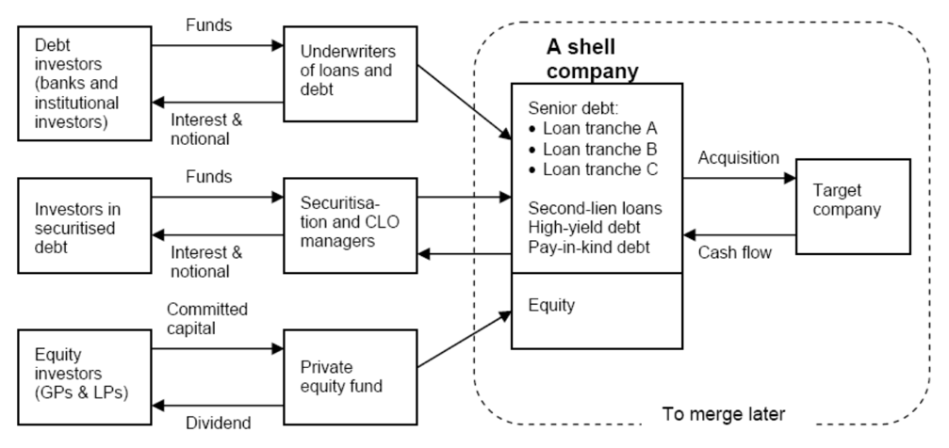
- Deal structure
- Leveraged loan: loan for firms/individuals that already have considerable amounts of debt
- Collateralized loan obligation (CLO)
    - Security backed by pool of loans
    - Part of broader class of (re)securitisation
    - Contributed to strong demand for leveraged loans
    - Has senior & mezzanine tranches
- Stages of LBO
    - Planning & fundraising
      - 10% from PE firm
      - 50-60% debt (senior & junior debt)
      - Setup of stock price incentives for management
    - Take target private
      - Via stock or asset acquisition
      - New owners sell of parts of acquired firm to reduce debt
    - CF improvement attempts
      - Cutting operational costs & spending
      - Delaying of capex
      - Trying new marketing to increase revenue
    - Take firm public again (secondary IPO or SIPO)
      - SIPO realizes avg. annual return of 260% on initial LBO investment
- Exit strategies of LBOs, usually 5y after the deal
    - (S)IPO
    - Sell company to strategic buyer
    - Secondary buyout: sale to another buyout firm
- LBO value creation
    - Tax advantages (deduct interest payments, accelerated depreciation…)
    - Management incentives & lower agency costs
      - Better interest alignment
      - Less asymmetric information and CF problems
    - Focus on LT goals
    - Wealth transfers
      - Debt (bondholders) to equity (shareholders)
      - Employees to shareholders (employment reduction?)
      - Tax payers to shareholders
      - Asymmetric information: transfer from outsiders to insiders

10. Share Repurchase

Share Repurchase Activities
- What happens in a share buyback
    - Assumptions
      - N: total shares, P: price per share
      - C: Cash reserve of firm
      - A – C: total assets, E – C: book equity
      - π: net profit next period
    - Firm can buy back n(P, C) < N, with n(P, C) = C/P
    - If firm performs buyback, earnings per share next period are $\frac{π}{\left(N-n\left(P,C\right)\right)}$
    - Without buyback, earnings per share are $\frac{π}{N}$
    - What if fraction q of reserves is used to repurchase shares and remaining cash is paid out in dividends
      - Dividend per share $\frac{\left(1-q\right)C}{(N-n(P, qC)}$
      - Dividend per share without buyback $\frac{C}{N}$
      - If P is low (company undervalued), then per share dividend after buyback can be higher than $\frac{C}{N}$
- Reasons for stock buyout
    - Signalling that stock is undervalued
    - Distribute capital to shareholders with high flexibility in amount & time
    - Take advantage of tax benefits (when capgain is taxed less than dividends)
    - Absorb increase in shares outstanding due to exercise of stock options from employees to keep optimal level of shares outstanding
    - To use as a hostile takeover defence

- Repurchase because of undervaluation
    - Share repurchases more interesting when undervaluation increases
    - Buyback at less than intrinsic share value: return on buyback higher than firm’s ROE
$Buyback return rate=\frac{cost of equity}{1 - undervaluation\%}=\frac{cost of equity}{\frac{market}{intrinsic value}}$
    - Repurchase when no superior alternative investment opportunities

Types of Share Repurchases
- Fixed-price tender offer (FPTs)
    - Includes premium relative to current spot price
    - Interested shareholders submit their number of shares for sale
    - Can be done within a short time period
    - Value after = value before – value paid out + value created
$P_{E}N_{E}=P_{0}N_{0}-P_{T}\left(N_{0}N_{E}\right)+W$
      - P = price, N = number of shares
      - _{E} = after repurchase, ₀ = before repurchase
      - P_{T} = FPT offer price, W = FPT value creation
    - Rewrite with $F_{P}= \frac{N_{0}-N_{E}}{N_{E}}$ as proportion of repurchased shares
$\frac{W}{N_{0}P_{0}}=F_{P}\frac{P_{T}-P_{0}}{P_{0}}+(1-F_{P})\frac{P_{E}-P_{0}}{P_{0}}$
Value creation is split between selling & non-selling shareholders
- Dutch auction repurchases (DARs)
    - Tender offer to buy back shares
    - Provides range of prices, minimum is above current market price
    - Shareholders make bids by specifying number of shares for sale and their minimum price
    - Company reviews bids and determines suitable price within range
    - Can be done within a short time period
    - Example, assume
      - 1000 shareholders, 1 share each
      - Current spot price is $80
      - Value function $V\left(r\right)=80+0,04r$
      - DAR conditions: 200 shares between $84 - $90
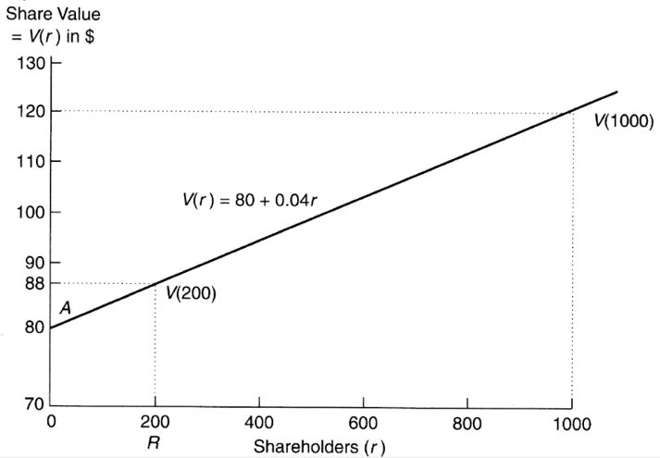
      - Profit selling shareholders: $0,5*\left(\$88-\$80\right)*200=\$800$
    - Price paid is same for all shareholders
    - Avg. premium in DAR lower than in FPT
    - Used as takeover defence, remove all shareholders that are willing to sell at a low premium
    - Value creation
      - Smaller than for FPT
      - If many shareholders take offer: small wealth effect
      - If insiders increase their stake: larger wealth effect
- Transferable put rights (TPRs)
    - Option issued by firm to shareholders to sell one share at fixed price within a stated period (time to maturity)
    - Put right can be traded in the capital market (tradeable)
    - Advantage
      - Let market identify the shareholders wanting to sell
      - Don’t have to collect offers or determine equilibrium price
      - No mismatch in supply/demand of shares
    - Example
      - TPR strike price of $96 (1 share + 1 TPR exchanged for $96 cash)
      - For shareholders with reservation price > $96, TPR is worthless
      - For shareholders with lower reservation price, value of TPR equals
$96 – reservation price = value TPR
- Open-market repurchases (OMRs)
    - Firm buys directly from market
    - Transaction executed by company’s broker
    - Happens over long period of time to not influence share price
    - No legal obligations for firm, flexible to stop buyback at any time
    - Cost-effective as buyback happens at spot price without premium
    - Is most commonly used buyback method, usually for small fractions (5%)

Employee Stock Options (ESOs)
- Type of equity compensation granted by companies to employees
- In form of regular call options, buy at specified price for finite time period
    - Vesting schedules, limits the ability to exercise
    - Taxed at exercise, stockholders taxed if they sell in open market
    - Significant time value, even with little to zero intrinsic value
    - Used as incentive for management
    - During 90s
      - Decreasing CAR (capital adequacy ratio)
      - Repurchases more used to neutralise employee stock option (ESO) plans than to signal undervaluation
      - Companies repurchase as soon as it is likely ESOs will be exercised

Buybacks vs. Dividends
- Advantages of repurchase
    - Dividend is strong signal for company’s LT profit outlook
Reducing dividend has strong negative impact on share price
    - Taxation
      - In US: 40% on dividends, 20% on capgains from repurchase
      - In Belgium: 30% on dividends, de facto 0% on capgains (for now)
      - Timing: shareholders can choose to cash in capgain by selling, dividends are not optional
      - Systematic repurchases instead of dividends are not allowed
    - Differences by type of company
      - Large mature firms use dividend payouts
      - Small growing firms prefer repurchases to offset option grants
Notes taken during classes by Roman Goncharenko, winter semester 2023
Pictures from slides by Roman Goncharenko

