International Business Finance
Summary of classes by Piet Sercu, winter semester 2023
Pictures from slides by Piet Sercu

2. Institutional Background

No direct exam questions about this chapter

Money & Banking
- 3 conditions for money to be successful as a medium
    - Storable
    - Stable purchasing power
    - Easy to handle
- Introduction of bank notes
    - Only cashed in after a certain period of time
    - Bank could create more money as long as it is not cashed in
    - Risk of confidence crisis in bank (everyone wants to cash in at same time)
    - Is now the real currency, coins are used less and less
- Modern central bank vs. private issuing bank (commercial)
    - Central bank doesn’t deal with the public (b2b only)
    - Commercial banks can borrow from central bank using commercial paper (passing on bank loans they extended to private companies)
    - Central banks don’t pay commercial banks in bank notes (only part they need for their cashflow), rest is credited to its account
- Countries monetary base or M₀: liability side of central bank
    - Bank notes of central bank
    - Commercial banks’ deposits in their account with the central banks
- Loans make deposits principle
    - Private banks can extend loans for a much larger volume than the amount of base money they keep in their vaults or with the central bank
    - Ex. I buy car with money in my account (= check), car dealer leaves the money in the bank after the transaction (money was never in cash)
- Money multiplier: ratio between total amount of money (monetary base plus checking-account money, M₁) and the monetary base (M₀)
    - Money supply = M₁ = m x M₀ = m x (D + G + RFX)
      - M₁ = money supply (money in circulation)
      - M₀ = monetary base
      - m = money multiplier
      - D = credit to domestic private sector
      - G = credit to government
      - RFX = reserves of foreign exchange (incl. gold)
- To avoid bank runs and enhance credibility
    - Banks have reserve requirements
    - Minimum fraction of customers deposits in coins, bank notes or non-interest-bearing account with central bank

Monetary policy
- Intervention in foreign exchange markets
    - Central banks control money creation process, but leave process to commercial banks
    - Control process by buying selling foreign exchange (RFX)
      - Pays for foreign exchange in notes or credits to commercial banks’ accounts with the central bank
      - Change in RFX leads to identical change in M₀
Affects amount of money private banks can create
- Open market policy
    - Central bank can influence monetary base by restricting/expanding amount of credit they give to governments or private banks
- Reserve requirement
    - CB can curb money creation by commercial banks by changing reserve requirements (= changing upper bound of m)
- Credit controls
    - Impose limits on amount private banks can lend

Crypto-currencies
- Currency not controlled by a central player (ex. government)
- Distributed ledger instead of one master file ledger that keeps track of all transactions
    - Proof-of-work method: if enough computers with each their own ledger, agree that someone has enough in their account to make a transaction, it will be authorised
    - If you want to hack the ledger, you have break into so many computers that it’s not feasible to do
    - If a ledger gets destroyed, there are enough others to authorise transaction
- Weaknesses
    - Miners need lots of power and create a lot of heat
    - Transaction costs: can cost up to 50$
    - Can only do about 7 transactions per second (while VISA 10.000s)
    - Cost of mining and and transacting engineered to become harder over time to not make the Bitcoin supply explode
- Ethereum: proof-of-stake method
    - Instead of proof of work
    - Many computers still has to authorise the transaction
    - The OK of a computer has a weight proportional to their own ETH position
    - Combined validation needs to be a substantial % of outstanding ETH before final approval
Hackers would need large ETH position, which is very expensive/detectable
    - Uses 99% less energy than proof-of-work method
- Bigger fool theory
    - Crypto has no intrinsic value like commodities or stocks (get dividend…)
    - Lots of currencies are like lotteries
    - Fine to speculate as long as there are bigger fools who want to buy
- Volatility
    - Huge bubble and bust in 2017 (1000$ - 20.000$ - 4.000$ in months)
    - Daily return has standard deviation of about 4%, extremely high
    - Volatility makes it not trustworthy as payment method

- Defaults & fraud
    - Are transactions real? A sells to B and buys it back: 2 sales recorded
    - Ponzi schemes are frequent
    - Many exchanges of crypto currencies were robbed or collapsed
    - Tax evasion prominent
    - Lots of criminal transactions because they are hard to trace

International Payment Mechanism
- Imagine a UK exporter sells goods to American importer and receives 1USD
    - The 1USD is transferred (only electronically) from a US bank to the UK bank
    - The UK company now has a 1USD claim on the UK bank
    - If it wants to withdraw this, the UK bank has to buy 1USD in the UK from someone or fly 1USD over from the US transactions costs
    - This is why exchange rate in your bank can be different, 1USD held on a non-US bank account has a different value than 1USD held on a US bank account
- Central bank as ‘bank of banks’
    - Trades currency with other central banks in name of its customers (private banks)
- Netting of payments: central banks used to ‘net’ all incoming and outgoing transactions and pay out the difference at the end of the day to the commercial banks
Banks now have larger amounts and want their money faster: Real Time Gross Settlement
    - Also provides the option of intraday borrowing (shortest period to borrow used to be one day)
- SWIFT (Society of Worldwide Interbank Financial Telecommunication)
    - Transmits messages between banks not under same clearing organisation
    - For a small fee
    - You get same-day value instead of fifth day (like in the past)
- Time deposits
    - Can deposit 1USD in a UK bank for 3 months and give them right to use it
    - Get interest in return
    - This is a eurodollar transaction (USD transaction in Europe)
- Why have USD deposits outside of the US
    - Less regulated (transaction tax, reserve requirements…)
    - For tax evasion

Balance of Payments (BOP)
- BOP account is a statistical record of the flow of all financial transactions between residents of one country and the rest of the world over a certain period (usually one year)
- Grouped in a source and use table
    - Source: plus-sign, credit; where we obtained the money of the transaction
    - Use: minus-sign, debit; what we used the money for
Signs are opposite to balance sheet signs!
- Link between BOP and exchange market weakened by international money accounts
- Accruals vs. cash accounting
    - Accountants work on accrual basis: transaction happens when invoice is sent
    - BOP is put together by central bank, who only has info from commercial banks about the actual payments (cash accounting)
- CIF vs. FOB
    - Imports are booked at their CIF value (cost, insurance & freight)
    - Exports are booked at their FOB value (free on board)
    - So, imports weight more than exports as the service component is counted
- FDI (direct investment) vs. portfolio investment
    - FDI when investor acquires a controlling share of a company
    - Portfolio investment when it is purely financial
    - Hard to guess for clerks in statistical offices, classification is made by proportion of company held by investor (10% as cutoff)
- Errors & omissions (E&O)
    - Sources and uses statement should sum up to 0
CA + KFA = 0
    - Measurement of some items can be off
      - For small payments, commercial banks don’t ask details
      - Purpose of payment sometimes misstated on purpose (tax evasion)
      - International cash payments hard to track
CA & KFA are usually estimates, add E&O factor to account for mistakes
$\hat{CA}+\hat{KFA}+E\&O=0$
    - Take the BOP with a grain of salt!
- Net International Investment (NII) Account
    - Or Net External Assets Account
    - Measures net ownership of foreign assets
    - Nets all foreign assets and liabilities of residents
    - Closely linked to BOP, as changes in BOP will affect NII, but because BOP is an estimation they will not align perfectly

Exchange Rate Regimes
- Currencies like USD used to gold backed (you could always exchange USD into gold)
    - For every X USD there is X kg gold in the bank
    - If ratio is bad, credibility off the USD will be low and chances of bank run rise
    - Triffin Dilemma: trade-off between economic growth and credibility
- Fixed exchange rate regime
    - Government guarantees a constant price for a foreign currency
    - Central bank instructed to buy/sell when rate deviates x% from it
Ex. if GPB and DEM both have a fixed rate in USD, there is also an unofficial fixed rate between GPB and DEM
    - Similar inflation rates are needed to maintain fixed rate
- Fixed exchange rate relative to a basket
    - Put most prominent export partners in basket, their currency weights relative to the amount of export revenue they generate
    - Currency rate now has to remain stable around basket price

3. The 2007 Financial Mess and its Implications

No direct exam questions about this chapter

Reading

4. Market for Spot Foreign Exchange

Exchange Rates
- Quoting conventions
    - HCperFC: home currency per foreign currency
Ex. USDperEUR 1.25 = 1 USD is 1.25 EUR
    - EUR/USD or EUR:USD or EURUSD: value of EUR in USD
Ex. EURUSD 1.25 = value of 1 EUR in USD is 1.25 (=USDperEUR 1.25)
    - Specials
      - EUR is always second, so XXXperEUR or EURXXX
      - GBP is always second, so XXXperGBP or GBPXXX

Bid & Ask Rates
- You buy at ‘ask’-rate and sell at ‘bid’-rate
- Bid-Ask spread = ask – bid >= 0
- Commission: ½ of spread
Ex. EUR:USD = USDperEUR _{1.23}45 – _{1.23}47
    - Buying at 47 is like paying midpoint 46 + cost 1
    - Selling at 45 is like getting midpoint 46 – cost 1
    - Broker gains 1 from ask and 1 from bid = 2
- Determinants of the spread
    - Retail: spread falls with order size
    - Wholesale: spread rises with risk of posting a quote
      - Poor liquidity
      - High volatility
      - Larger order size: above a convened amount
- Inverting
    - 1 / ask = bid, 1 / bid = ask
    - Mr. gives 1000JPY to bank and receives 10USD
= bank gives 10USD to Mr. and receives 1000JPY
- Rates
    - Primary rate: against world reference or base currency (USD)
    - Cross rate: between 2 non-base currencies

How Exchange Markets Work
- Not organised like NYSE or LSE
- Two tiers
    - 24h wholesale tier (informal network of banks & big corps)
      - Market makers: give 2-way quotes up to agreed limit (ex. 10milUSD)
      - Brokers: shop around to find takers for someone else’s offer
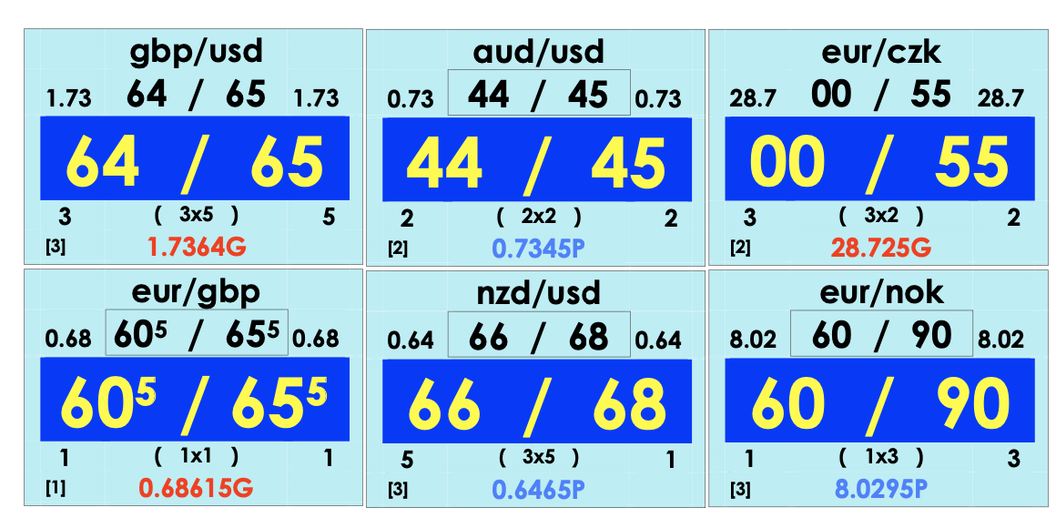
Ex. a panel of Reuters broking window
    - Retail tier
- Markets by delivery date
    - Spot market rate (S_{t}): rate for immediate payment (means 2nd working day)
    - Forward market rate (F_{t,T}): rate for payment at some future date
- Mechanisms enforcing LOP
    - Arbitrage (two-way)
      - Buy low, immediately re-sell high without risk
      - Transaction cost very important
    - Shopping around (one-way)
      - Difference of costs matter
      - Opportunities happen all the time (intended by market maker)
    - Triangular arbitrage and shopping
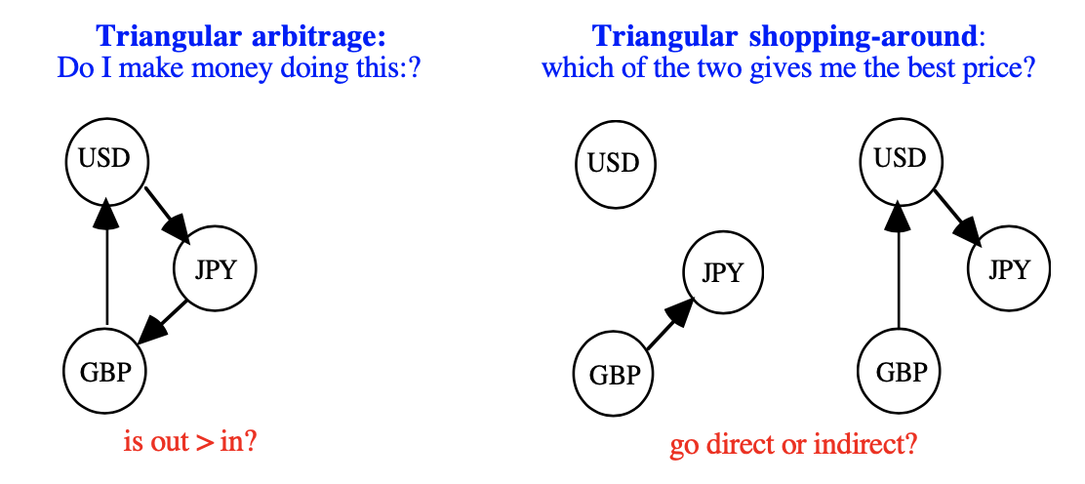
      - Need synthetic (indirect) rate JPYperGBP

- Synthetic cross-rates
    - Replication: synthetic version (replication) of a contract is
      - Combination of two or more transactions
      - Same purpose as original contract
    - Rip-off rule: rule of the worst possible combination
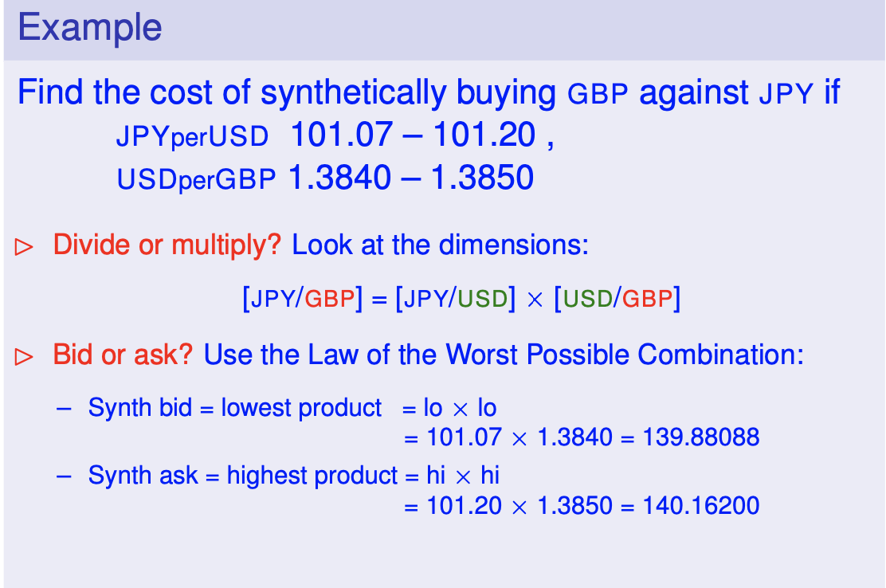
      - At every transaction you get the worst rate (hi for buy, lo for sell)
Ex. if it were GBPperUSD you’d have to divide instead (lo/high and high/lo)

PPP Exchange Rates
- PPP rate: purchasing power parity; to compare purchasing power of an amount of currency
    - Can be really far from nominal rate
- Exchange rate only tells you how much something is worth to you, PPP rate how much something is worth to someone else
- Big Mac Standard as PPP rate
- Real rate (RER) or deviation from PPP
    - Cannot trust logs!
    - Difference between actual rate and ppp rate
    - RER shows what country is more expensive and by how much
    - Real rate = S / S^{PPP}
    - RER is not constant at all throughout the years
    - Ex. YEN RPPP vs. actual
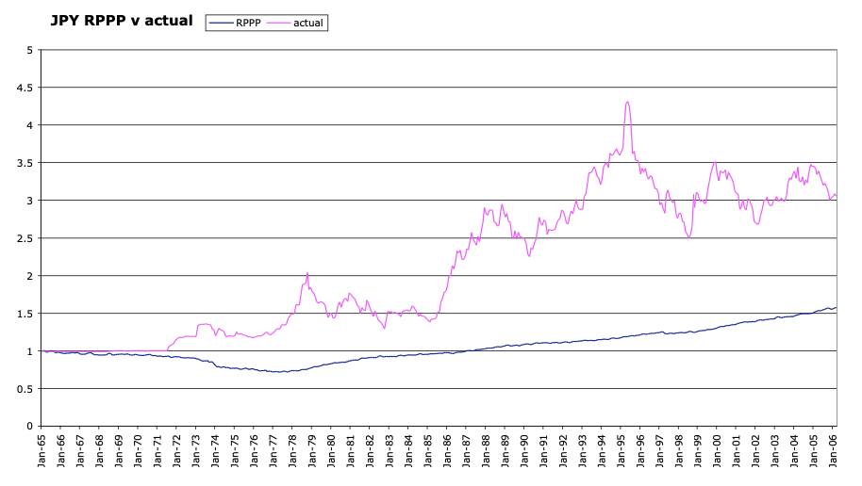
      - High inflation: YEN should be depreciated, but they didn’t
    - RER behaviour
      - Huge swings
      - High inertia in the short run: moves slow (half-life is like 5y)
      - Most variability comes from nominal rate, not PPP rate
      - S is hard to predict
- Financial policy implications
    - RER movements can force company to change its strategy
Ex. becoming multinational producer instead of exporting to profit from PPP
    - Nominal movements can also kill a company
Ex. after devaluation

How to profit?
Borrow a lot of currency X for low interest rate, convert it to currency Y. Hope currency X devalues, then pay off loan buy reconverting Y to X.

    - If rates were predictable, we could prepare for the move; but rates are unpredictable
hedging can be useful (but only when exchange rate changes can affect operations of the company)

5. Understanding Forward Rates for Foreign Exchange

Introduction to Forward Rates
- Outright rate vs. swap rate
- Swap rate
    - Difference between spot rate and forward rate
    - Aways in cents
    - More stable than outright rate because doesn’t change much when spot rate changes as it usually doesn’t change the difference
- Effective return: percentage difference between start and end value
- Interest rate: annualised version of r, but there are many conventions or systems
Ex. 3 months at 6% per annum interest
    - Simple interest: (1 + 3/12 x 6%) - 1
    - Compound interest annual (monthly…): (1 + 6%)^{3/12}
    - Continuous compound: e^{6% x 3/12}
    - Banker’s discount: (1 – 3/12 x 6%)⁻¹ – 1

Relation between Exchange & Money Markets
- Chains of transactions: intertwined markets
    - Notation
      - HC: home currency
      - FC: foreign currency
      - T: time in the future
      - t: spot time
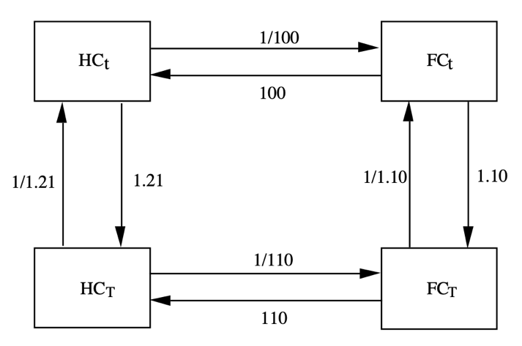
    - Matrix of transactions
Ex. Start with HC_{t} = 100.000
FC_{t} = 1.000 (buy at spot rate: x1/100)
FC_{T} = 1.100 (deposit for one year: x1.10)
HC_{T} = 121.000 (sell forward: x110)
In a perfect market, you get the same rate as depositing the HC_{t} for a year so it becomes HC_{T} (deposit: x1.21)
- So, in perfect markets, all paths are equal: covered interest parity (CIP)
    - $F_{t,T}=S_{t}\frac{1+r_{t,T}}{1+r_{t,T}^{*}}$
    - There are no arbitrage opportunities (ex. HC_{t} to HC_{t} while making profit)
    - There are no shopping-around options (all options have the same result)

- CIP doesn’t explain where the equilibrium price comes from
    - Fisher equation: interest rates reflect expected inflation and the real return investors require on their capital
    - Theory: forward rates reflect the market’s expectation about the (unknown) future spot rate
- ‘The’ bid- and ask interest rate does not exist
    - Multiple rates because of credit-risk & liquidity premiums
Arbitrage opportunities for some banks (but only a few)
CIP hold approximately for an average bank
- Forward rate premiums
    - Forward rate > spot rate
      - Currency at a premium
      - Strong currency, low interest
    - Forward rate = spot rate: currency at par
    - Forward rate < spot rate:
      - Currency at a negative premium / at a discount
      - Weak currency, high interest rates
- Taxes
    - When comparing synthetic and direct HC deposits, we ignored taxes
Works when no tax difference between capital gains and interest income
    - Pre-tax income always same if CIP hold up

Market Value of an Outstanding Forward Contract
- Time notation: t₀ < t < T
    - t₀ = initiation date of the contract
    - t = current date
    - T = maturity date of contract
- Value outstanding contract (future) before it’s maturity date: interpret as portfolio of
    - FC denominated PN with face value 1 as asset
      - Compute present value (PV) in FC (discounting by r*)
      - Translate FC in HC using current spot price S_{t}
      - (1 / (1+r*_{t0,T})) x S_{t}
    - HC denominated PN with face value F_{t0, T} as liability
      - Discount face value at risk-free rate
      - F_{t0, T} / (1 + r_{t,T})
    - Ex.
      - Current spot price S_{t} = 100
      - Historic forward price F_{t0, T} = 115
      - Rate past until end of contract r*_{t0,T} = 10%
      - Rate now until end of contract r_{t,T} = 21%
Asset – liability = $\left(\frac{1}{1+10\%}*100\right)-\frac{115}{1+21\%}= -4,132$
    - Alternative formula: ‘Take loss now and discount it by the rate of T’
      - $\frac{F_{t,T}-F_{t_{0},T}}{1+r_{t,T}}$
- Value of a future contract at expiration
    - $S_{T}-F_{t_{0},T}$ ‘Normal’ way of trading
    - How hedging works
      - Say you have to pay 1USD in the future, your HC is in EUR
      - Uncertain future spot rate of USD: ${\tilde{S}}_{T}$ (tilde to show it’s uncertain)
      - Buy a future contract on 1USD now to eliminate uncertainty

- Value of a contract at inception
    - $\frac{F_{t,T}-F_{t,T}}{1+r_{t,T}}=0$
    - Value is 0 as it can be replicated at 0 cost
- Forward rate vs. risk-adjusted expected future rate
    - Certainty equivalent operator (CEQ): risk-adjusted expected value of a future spot price
${F_{t,T}= {CEQ}_{t}(\tilde{S}}_{T})$
${F_{t,T}=E_{t}(\tilde{S}}_{T})*\frac{1+r_{t,T}}{1+r_{t,T}+{RP}_{t,T}}$
      - E_{t} = expected value
      - RP = risk premium
      - r = risk-free rate

6. Using Forward Contracts in International Financial Management

Real World Practicalities of Forward Rates
- Provisions for default
    - The set-off right
      - If one defaults, the other cannot be forces to fulfil its own part
      - If other party still sustains losses, defaulting party is liable
Worst possible impact for bank at T losing $[S_{T}-F_{t_{0},T}]$, not S_{T}
    - Vetting & security
      - Bank prefers known customers
      - If unknown: asks for security
    - Short maturities
      - Offering short term contracts and rolling them over (extending the future by selling and buying a new one)
- Could default risk screw up CIP
    - When risky: $R_{t,T}=r_{t,T}+ρ_{t,T}$
    - Cross-currency basis (CCB): spread between HC and swapped-FC returns
      - ${CCB}_{t,T}=\left(1+r_{t,T}+ρ_{t,T}\right)-\frac{F_{t,T}}{S_{t}}\left(1+r_{t,T}^{*}+ρ_{t,T}^{*}\right)=$
$$\left[\left(1+r_{t,T}\right)-\frac{F_{t,T}}{S_{t}}\left(1+r_{t,T}^{*}\right)\right]+[ρ_{t,T}--\frac{S_{t}}{F_{t,T}}ρ_{t,T}^{*}]$$
      - Deposits (shopping around): CCB becomes ambiguous
          - If HC bank is AA⁺ and FC is BB⁻, a negative CCB says little
          - If it is same bank, CCB is reliable
      - Loans (shopping around): CCB is +-OK as you’re debtor in both cases
      - Math: CCB is +- unaffected by risk if
          - CIP holds well enough with risk-free rates
          - The debtor is the same
          - ρ is translated via $\frac{ρ}{(1+r)}=\frac{ρ*}{(1+r*)}$
    - How risk premia & CIP can happily coexist
      - Banks can pay different risk spreads on HC loans, but face similar risk spreads when borrowing FC
          - One value for F/S can make banks indifferent between HC & FC borrowing
          - Avg FC & HC rates would fit CIP very well

- Could funding liquidity screw up CIP
    - Interbank unsecured term loans
      - Standard until 2007, banks ‘trusted’ each other
      - Market died after crash
    - Rolled-over one-day secured loans (via ‘repo’s’)
      - Sell bond spot and simultaneously buy it back forward n days
      - Safe & cheap, but is bounded by your eligible asset holdings
    - Commercial paper (CP)
      - Promissory notes (PN) & certificates of deposits (CD)
      - Marginal source of funds for the biggest players
      - Not as fast as interbank loans
      - Funding liquidity: premium depends on
        - CP issue
        - Bank’s visibility
        - FX market
- Could regulation screw up CIP
    - Capital adequacy ratio & supplementary leverage ratio, combined with reluctance to issue equity
      - CIP deviations peak every 3 months when banks have to file data for overseers to check their capital adequacy
      - Stricter leverage ratio leads to quoting closing to leverage limit
    - Volcker rule curtails banks’ trading for own account
    - Indirectly: reduced liquidity & widened range of liquidity premiums
- Second law of imperfect exchange markets: forward spread is always larger than spot spread, and increases with the time to maturity
    - When observing premium: add smaller of the two swap rates to the spot bid rate and larger to the spot ask rate
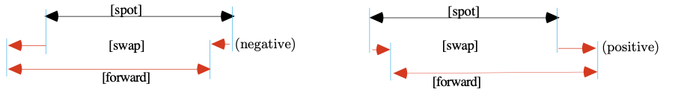
    - When observing discount: subtract the larger from the spot bid rate and smaller from the spot ask rate

Arbitrage
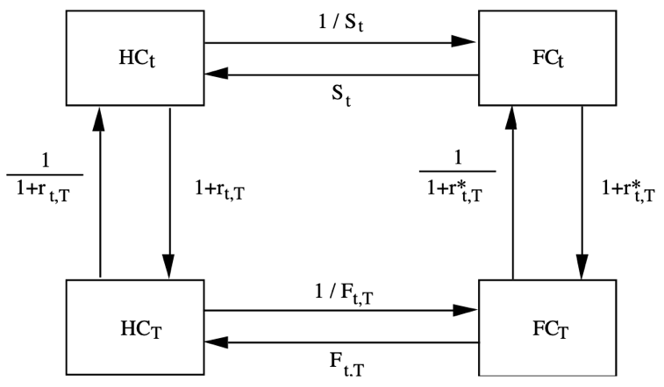
- Bid- & ask prices determined by bid & ask of all steps in the diagram
- Clockwise arbitrage: borrow HC and invest in swapped safe FC
    - ${HC}_{T}=\frac{1}{1+R_{t, T}^{a}}*\frac{1}{S_{t}^{a}}*\left(1+r_{t,T}^{b*}\right)*F_{t,T}^{b}≤1$ (no arb)

- Counter clockwise arbitrage: borrow FC and invest in swapped HC
    - ${FC}_{T}=\frac{1}{1+R_{t, T}^{a*}}*\frac{1}{F_{t,T}^{a}}*\left(1+r_{t,T}^{b}\right)*S_{t}^{b}≤1$ (no arb)
- No arbitrage bounds
    - $F_{t,T}^{b}≤S_{t}^{a}\frac{1+R_{t, T}^{a}}{1+r_{t,T}^{b*}}$ (no arb, synthetic Fª)
    - $F_{t,T}^{a}≤S_{t}^{b}\frac{ 1+r_{t,T}^{b}}{1+R_{t, T}^{a*}}$ (no arb, synthetic F^{b})
    - Can be interpreted as synthetic rates
    - No-arb bounds say that bids shouldn’t exceed asks
    - Synthetic rate corresponds to highest and lowest possible combinations of the perfect-markets formula: $S\frac{1+r}{1+r^{*}}$
    - Remark: borrowing rates are bank specific, so synthetic rates are too
    - Synthetic rates rise fast with time to maturity
- Arbitrage nowadays
    - London Interbank Offered Rate (LIBOR): interest rate avg. calculated from estimates submitted by leading banks in London
    - Overnight Indexed Swap (OIS): swap derived from overnight rate, generally fixed by local central bank, this allows LIBOR-based banks to borrow at fixed rate over the same period
    - CBB annualised and implemented as a shopping-around type application
    - No-arb conditions as conditions on F relative to bank’s synthetic rates
Synthetic rates are driven by bank’s own borrowing rate, so we can write these as CCB style conditions on the borrowing rate:
      - HC borrowing: ${CCB}_{t,T}^{a}=\left[\left(1+R_{t, T}^{a}\right)-\frac{F_{t,T}^{a}}{S_{t}^{b}}*\left(1+R_{t,T}^{*a}\right)\right]/(T-t)$
      - FC borrowing: ${CCB}_{t,T}^{*a}=\left[\left(1+R_{t, T}^{*a}\right)-\frac{S_{t}^{a}}{F_{t,T}^{b}}*\left(1+R_{t,T}^{a}\right)\right]/(T-t)$
      - R & R*: LIBOR, also OIS
      - Risk spread: LIBOR minus OIS
    - Approximate CIP for modal-liquidity banks
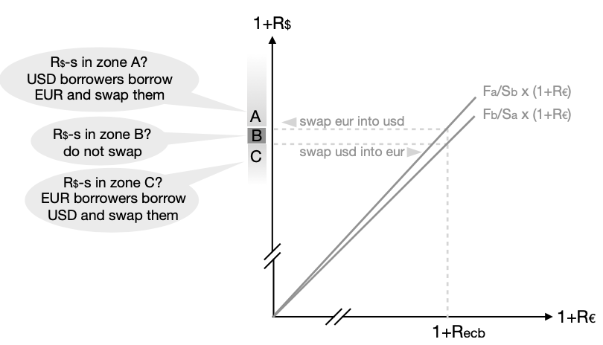
      - Set F/S so demands from groups 1 & 3 match
- Logic in CBBs, but CIP is less valid than before
    - Old days
      - CIP held for interbank relations: currency markets, lending & borrowing (at LIBOR).
      - Banks mostly cared about shopping around CCBs at ask side
      - Banks were ready to pretend they trusted each other
      - Funding liquidity was not an issue, within credit lines
      - CIP never held nearly as well for T-bills: buying is slower and short-selling is problematic
    - Nowadays: CIP holds for demand-weighted ‘average’ banks
    - Implications for CFO
      - Expect systematic opportunities for shopping around
      - If you are high grade, even pure arb-opportunities can happen
      - Zero rates are not forever

Hedging
- What is exposure
    - General: sensitivity of a financial variable V_{T} to the exchange rate S_{T}
      - Not conditional variance of S_{T}
      - A regression coefficient as in $\tilde{V_{T}}=A_{t, T}+B_{t,T}\tilde{S_{T}}+\tilde{e_{t,T}}$
      - Example: FC-denominated contract $\tilde{V_{T}}=10.000\tilde{S_{T}}$
    - Goal: cash flows offset those from contracts being hedged (reduce risk to 0)
    - Both good and bad uncertainties are gone
- Aggregating exposure
    - If flow is: +1000 on 01/01 and -800 on 02/01: much cheaper to hedge 200 than first +1000 and secondly -800
    - If time differences too big: interest risk issues
- Measuring exposure from transactions particular date
    - Exposure: number that tells us what multiple the HC value changes when the exchange rate moves by ΔS
    - Denote multiple by $B_{t,T}^{*}=\frac{Δ\tilde{V_{T}}}{Δ\tilde{S_{T}}}$
- Issue 1: are imperfect hedges worse?
    - Forward contracts, FC loans & FC deposits allow perfect hedging
    - Futures: cheaper but less flexible in amount and expiry date
    - Alternative: imperfect hedging
      - Options: imperfect, don’t eliminate uncertainty entirely (only reduce downward risk)
      - Cross-hedge: offsetting position in one currency with a position in the opposite direction in another currency that is highly correlated with the first (must accept imperfect hedging with downside risk)
- Issue 2: credit risk
    - Hedging credit creates the following dilemma
      - Leave foreign currency unhedged and debtor pays: worse off when exchange rate turns out low
      - Hedge the position, but debtor defaults: you still have to deliver foreign exchange to settle forward contract
    - Reverse risk: arises when hedged exposure disappears, you’ll have to buy a forward on FC because your debtor has defaulted
- Issue 3: different time horizons and interest risk
    - To aggregate exposure over time: use time buckets, one contract per bucket
    - Keep buckets narrow to avoid interest risk

Speculation
- Speculate when you think an asset is mispriced
- See extra positive/negative return that makes you give up diversification
- Speculating on future forward rate
    - Speculate rise of F: buy for delivery at T₂ and reverse at T₁ (lock in F₂ – F₁)
    - Speculate drop of F: sell for delivery at T₂ and reverse at T₁ (lock in F₁ – F₂)
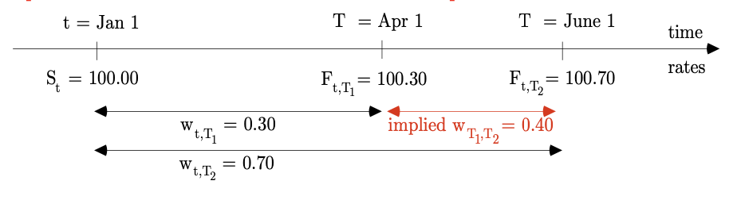
- Speculate on future swap rate
    - Compare market’s risk-adjusted expectation with ours and act when deviation seems excessive
    - We bet on changing interest differential

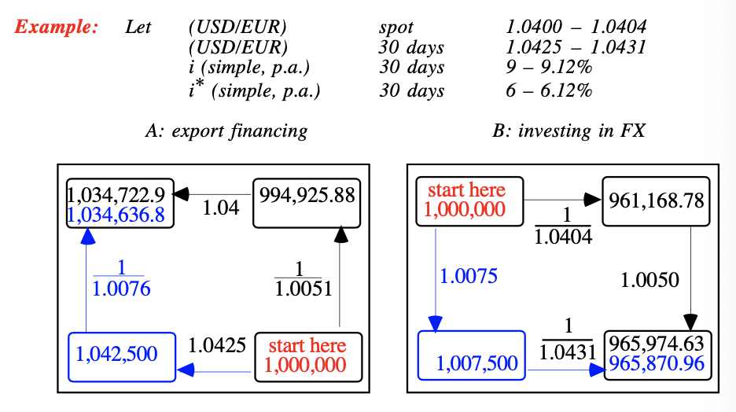
Minimizing Bid-Ask Spreads

Swapping
- For tax reasons
    - Swapped FC deposits and loans should yield same return before tax, and if the system is neutral also after tax (but in most countries, system isn’t neutral)
    - In many countries
      - Capital gains are tax exempt, interest income is taxed
      - Capital losses are not deductible
    - Swapping FC deposits in strong currency offers a tax advantage
      - Part of income is paid out as capital gain: not taxed
    - Swapping loan when capital gains are not taxed
      - Swap to higher interest currency to get more deductible interest expense in exchange for tax-free capital gains
- To avoid excess risk spreads
    - What if: you prefer to borrow FC, but HC loan has better spread
    - Why would HC-FC spread be inconsistent
      - Loans offered by different banks (ex. known or unknown customer)
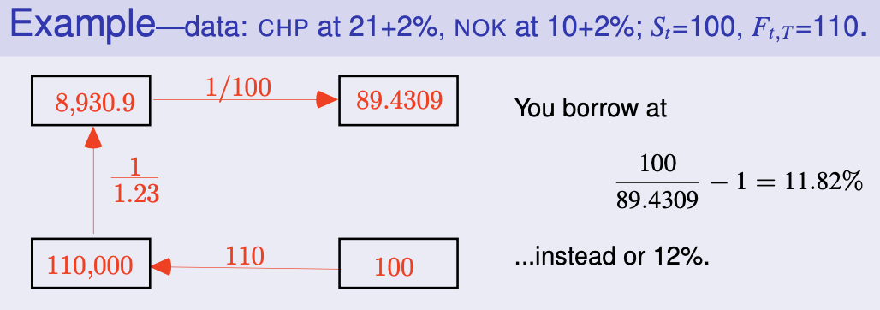
      - Loans offered by same bank (ex. sloppy homework)
    - Compare yields across currencies
      - You are indifferent if the proceeds from an FC loan are the same as those from the swapped HC loan
$$\hat{R^{*}}: \frac{1}{1+\hat{R^{*}}}=F^{b}\frac{1}{1+R}*\frac{1}{S^{a}}$$
$$→1+\hat{R^{*}}=\frac{S^{a}}{F^{b}}(1+R)$$

    - Compare spreads cross-currency under CIP
      - Rule: compare present values (at r,r*) of spreads
$$\frac{ρ}{1+r}v\frac{ρ^{*}}{1+r^{*}}$$
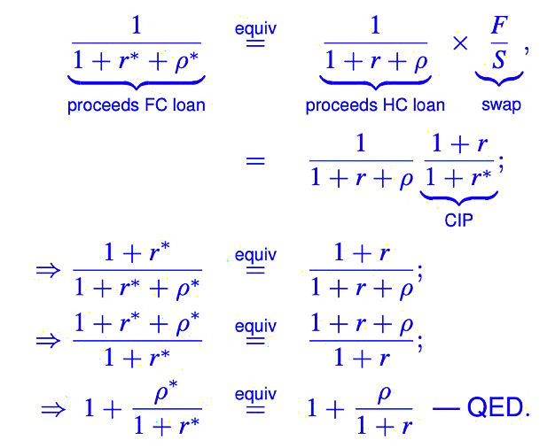
      - Proof: FC and swapped HC loans are equivalent

    - Taxes are not neutral: basic math for realised unhedged returns
      - Denote $\tilde{S_{t,T}^{b/a}}=\frac{\tilde{S_{T}^{b}}}{S_{t}^{a}}-1$ the relative capital gain when you buy now and sell later (deposit); similarly for a loan: $\tilde{S_{t,T}^{b/a}}=\frac{\tilde{S_{T}^{a}}}{S_{t}^{b}}-1$
      - Returns (or costs): per unit HC invested/borrowed abroad, the final value is $(1+r^{*})(1+s)$ so total pre-tax return makes
$$return=interest+capital gain \\ =\left(1+r^{*}\right)\left(1+s\right)-1=r^{*}\left(1+s\right)+s$$
$$after-tax return= r^{*}\left(1+s\right)(1-τ_{int})+s(1-τ_{capg})$$

    - Taxes are not neutral: evaluating loans ex ante, constant tax rates
      - Can be factored out
      - Define $f_{t,T}^{c,d}=\frac{F_{t,T}^{c}}{S_{t}^{d}}$, the CEQ of $\tilde{s^{c,d}}$ where c,d is a,b or b,a or even mid,mid as needed
$CEQ\left(cashflow\right)$
$$=\left(1+CEQ\left(s\right)\right)r^{*}\left(1-τ_{int}\right)+CEQ\left(s\right)\left(1-τ_{int}\right) \\ =(1+f)r^{*}\left(1-τ_{int}\right)+f\left(1-τ_{int}\right)$$
(Highest CEQ for deposits, lowest CEQ for loans)

    - Taxes are not neutral: evaluating loans ex ante, tax rate depends on $\tilde{s}$
      - Cannot be factored out
      - Ex. if $\tilde{s}<0$, tax rate is $τ_{-}$, otherwise $τ_{+}=T_{-}+Δτ$
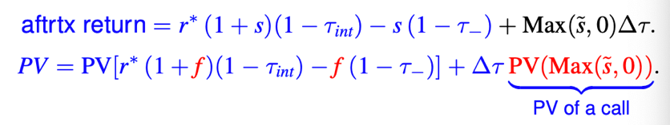
      - Subtract the ‘extra’ tax for outcomes where S_{T} is high
- Swap as disguised mutual secured loan
    - Mutual secured loan: two loans that serve as security for each other
    - Motivations for back-to-back(mutual) loans
      - Provide security to lender
      - Money laundering: customer lends to bank, which in turn uses the deposit to issue a loan to the customer
      - Avoidance of costs for moving money across borders
    - Right-of-offset clause in contract: one defaults, the other also doesn’t pay
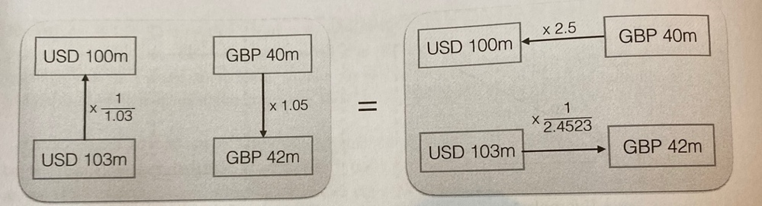
    - On the left a back-to-back loan, on the right a swap with same value
    - Using a swap is legally easier and gives
      - Same promised cashflows
      - Same protection in case of default
    - Legal differences
      - Loan: not on balance sheet, leaves assets/profits… unaffected
      - Security: not mentioned in notes to balance sheet, no need to register the security or pledge…
      - Interest: tax advantage, sometimes religious issues

Choices & Decisions
- Valuation of outstanding forward deals
    - Show market value as $N*(F_{t,T}-F_{t_{0},T})$ discounted
    - Discounting unthinkable for real accountants, but you can have own version
    - M2M (market-to-market; fair accounting) of forward increases risk of reported profits if underlying hedge is not M2M
- Valuation of FC-denominated contracts: translate A/P, A/R, at F_{t,T} and not at S_{t} (accountant default option)
- Recommendation: salesforce should use F, not S, to assess a deal’s contribution to profit
- Elements taken into account when deciding upon choice of loans
    - Risk-free rates and expected rate of ap-/depreciation
    - All costs paid on top of risk-free rate
    - Effect on risk

8. Markets for Currency Swaps

IBM WB Swap
- IBM’s plans
    - Had DEM & CHF debt outstanding
    - Latent capital gain: interest rates & USD had gone up ($V_{bonds}^{DEM-CHF}<100\%$)
    - IBM wants to lock in gain: retire the DEM & CHF debt, replace with USD debt
Costs
      - Issuance of new USD bonds
      - Conversion cost of USD to DEM & CHF to pay off debt
      - Call premium to pay off debt early
      - Capital gain tax on gains
- WB’s wants to issue DEM & CHF debt to finance its own lending
Costs: issue cost & spread new debt
- Deal
    - IBM leaves DEM & CHF debt outstanding, WB will service it
    - WB issues USD debt instead of DEM or CHF and lets IBM service it
- Initial equivalence: fairness at t₀, PV (DEM & CHF flows) = PV (USD flows)
- Gains
    - Cost of IBM retiring bonds avoided, cost of WB issuing bonds avoided
    - WB can borrow USD at lower risk spread than IBM
    - IBM capital gain is postponed: tax advantage
- Standardisation
    - Idea applied to interest swaps
      - Loans differ in type of interest (ex. fixed vs. floating), not currency
      - Take one side of swap, hedge it until customer wants other side
      - Swaps became commoditized
- Addition: reverse spot exchange
    - Reason 1
      - Suppose you want to borrow GBP, but you borrow USD and swap it
      - Future outflows will now be in GBP
      - But current inflow is in USD: use spot exchange to convert into GBP
    - Reason 2
      - Suppose a USD and an EUR company do a swap
      - Bullet loan of 50m USD, 4% payable annually, bond yield 4%
PV USD loan 50m
      - Say current spot exchange rate is USDperEUR 1.25
Bullet loan of 40m EUR, 4,5% payable annually, bond yield 4,5%
Contract has net value of 0
      - If spot rate changes, calculations have to be revised, unless there is an initial exchange of 50m USD for 40m EUR

Non-Bullet Loans
- If loans are not of bullet type, ex. constant annuities
Construct this out of different bullet loans
    - Assume swap rates for 1, 2 & 3 years are 5, 6 & 7% respectively
    - Each year an annuity of 1000 must be paid
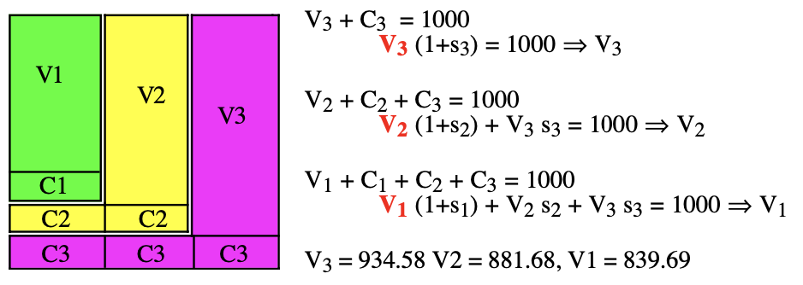
    - Tools: 3 bullet loans (1, 2 & 3y duration)
    - Year 3: pay off bullet V₃ and interest on bullet V₃
    - Year 2: pay off bullet V₂ and interest on bullets V₃ & V₂
    - Year 1: pay off bullet V₁ and interest on bullets V_{3,} V₂ & V₁
    - Present values of bullets = value V_{x}
Total PV = V₃ + V₂ + V₁ = 2.655,95
IRR = 6,35% = swap rate for 3-year constant annuity loan
(2.655,95 x 6,35%² = 3000)

Why Currency Swaps
- Rule: is risk spread favours currency A, but you prefer to have currency B
Cheaply borrow A and swap
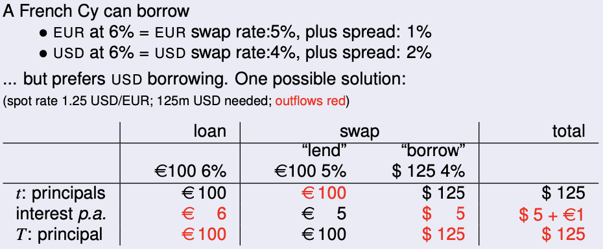
Example
    - Take a loan of €100 at 6%
    - Swap it
      - Lend the €100 at 5%
      - Borrow in exchange $125 at 4%
    - Now you
      - Have $125
      - Need to pay off the swapped USD loan ($125 + $5/year)
      - Need to pay off €1/year
    - Interest is partly in EUR, eliminate by
      - Upfront payment: calculate PV of all interest in EUR and pay upfront
€1 x a_{(7y, 5%)} = 5,786…
      - USD annuity
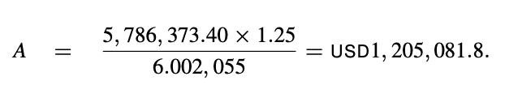
A x a_{(7y, 5%)} = 5,786… x 1,25
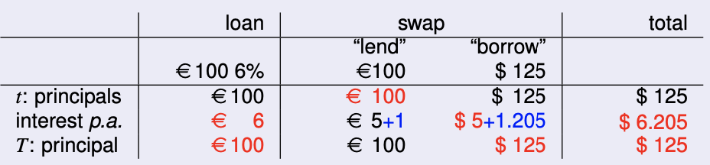
1,205 = 0,964% of 125 (below 1% EUR spread)
      - Technically, we ask our swap dealer to pay our loan interest rate instead of the swap interest rate, in return we pay their borrowing interest rate instead of their swap interest rate

- When is swapping useful
    - If French Cy can borrow USD at 4+0,964% swapping wouldn’t matter
    - Check if $0,964\%=1\%*\frac{5,786}{6,002}=ρ\%*\frac{a_{(n, s)}}{a_{(n,s^{*})}}$
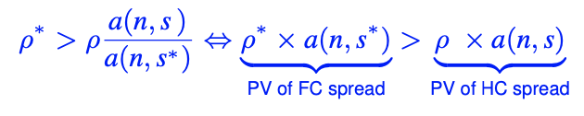
Rule: swap if
- Bank’s translation rule for risk spreads: change > by = in formula above

Other Reasons for Swapping
- Getting access to a closed market: use local strawman
- Avoiding transaction costs of reissuing/withdrawing debt: in general, synthetic alternative involves 3 transactions
    - Borrow currency 1
    - Convert
    - Reinvest currency 2
- Possible advantages of off-balance-sheet reporting
    - Ratios
    - Reduce Basel-1 capital requirement
- Favourable tax treatment: postpone capital gain (so postpone taxes)

9. Currency Options

Options
- Holder has right to buy/sell a quantity of a specified underlying asset at an agreed strike or exercise price from/to the writer of the option
    - Buy: call option
    - Sell: put option
    - At agreed expiry moment T: European style option
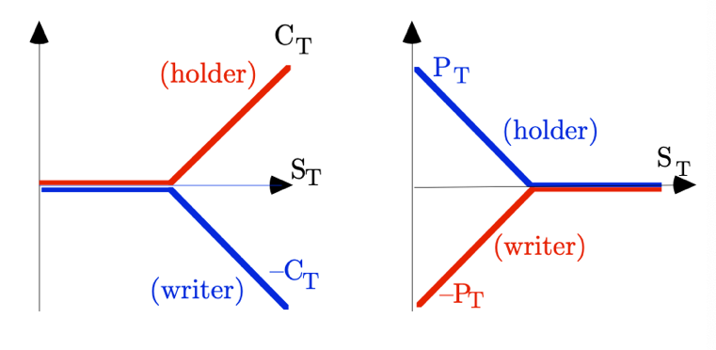
    - Until agreed expiry moment T: American style option
- Exercising (killing) the option: using the right
- Premium: price paid for the option, irrespective of exercising
    - Paid upfront
    - Paid at T: forward style
    - Paid partly via M2M and partly final: futures style
- Intrinsic value or value dead: value of option if it was exercised now
- Initial price of the option can be in/at/out of the money (ITM, ATM, OTM)
- Time value = premium – intrinsic value

Institutional Aspects
- Traded vs. OTC
    - Traded: exchanges copied after futures, margin (for writer), clearing
    - OTC: professionals
- Options on futures contract
    - Call: if you exercise, you become long side of a contract with historic price X, never M2M
    - Triggers M2M flow of f_{t,Tf} – X

Futures-style options on Futures
- Options on currency futures
    - Call on currency futures contract with strike price X:
      - Holder has right to establish long position, can buy future at price X
      - Writer has short side of futures contract
      - New futures contract is M2M at the end of each day (like every fut)
      - Difference with normal option: expiry value equals difference between strike and futures price that prevails at time of exercise
      - If European option expires at same day as future: same price as just being option on the spot price, if expiry date is different there will be a difference
- Forward-style options
    - Option contract is made at time 0
    - Option can be exercised at time T (European)
    - Premium is paid at expiry date (time T), if option is exercised or not
    - Forward-style options = cash option prices increased by r_{r,T}% time value
- Futures-style options
    - Futures contract where underlying asset is an option
    - Pay an initial margin at time 0
    - Daily marking to market: pay/receive difference if price goes down/up
    - At expiry: pay balance
    - Goal: reduce risk of default
- Futures-style option on a futures contract
    - Futures contract where underlying asset is an option on a futures
    - Steps: when exercised
      - Option creates long position in futures contract with price X, which triggers immediate marked-to-market cashflow
      - Agreed upon premium is paid through marking to market and partly at T through final option purchase
    - Combines advantages of options on futures & futures-style options
    - Little capital is needed to open position

Use of Options in Arbitrage
- Basic assumptions
    - $C_{t}^{Am} \&{ P}_{t}^{Am}$: American style call and put
    - $C_{t} \& P_{t}$: European style call and put
    - $C_{t}^{f} \&{ P}_{t}^{f}$: futures-style call and put
    - Comparable forward contract: contract with same expiry day & strike price
    - Every arbitrage opportunity should be jumped at, they disappear quickly

- Because of arbitrage, these ‘rules’ can be stated
- Option premiums are non-negative
    - Final payoff is at worst 0
    - If there is a positive chance of ending ITM, option price should be too
    - Holds for Am & Eu puts and calls
$C_{t}^{(Am)}>0 \& P_{t}^{(Am)}>0$
- American style options are worth no less than European ones
    - Provide all the rights a European one has, plus right of early exercise
$C_{t}^{Am}≥C_{t}>0 \& { P}_{t}^{Am}≥P_{t}>0$
- European-style call worth more than comparable forward purchase
    - Possible negative payoff from forward purchase is missing
    - Right to walk away from purchase never has negative implications
$C_{t}^{Am}≥C_{t}>max⁡(\frac{S_{t}}{1+r_{t, T}^{*}}-\frac{X}{1+r_{t, T}}, 0)$
- European-style put is worth more than comparable forward sale
    - Right to walk away from option can never pay off negative amounts
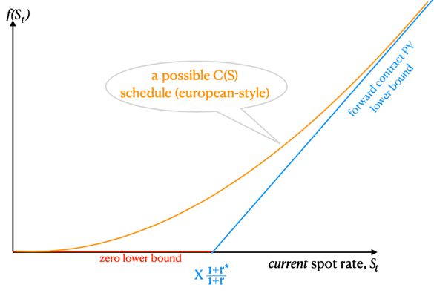
$P_{t}^{Am}≥P_{t}>max⁡(\frac{X}{1+r_{t, T}}-\frac{S_{t}}{1+r_{t, T}^{*}}, 0)$

- American call is at least worth its intrinsic value
    - Otherwise, you could buy and immediately exercise
$C_{t}^{Am}≥\max\left(S_{t}-X,0\right)=intrinsic value$
    - If intrinsic value positive, it is below value of comparable forward
    - When domestic r is positive, value of American call on zero-r currency can never fall as low as the intrinsic value
    - There is always time value! (except at T, effective domestic rate r_{t,t} = 0 too)
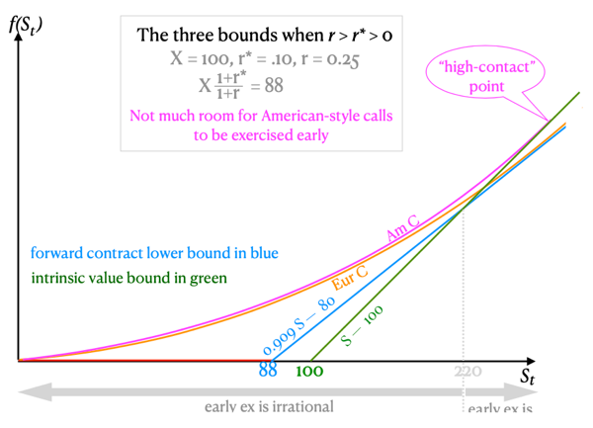
Call never exercised early and US call is prices same as Eu call
- American put is worth at least its intrinsic value
    - Otherwise, you could buy and immediately exercise
$P_{t}^{Am}≥\max\left(X-P_{t},0\right)=intrinsic value$
    - When FC’s time value is positive and HC is
      - Higher we might exercise early
      - Lower we would rarely exercise early
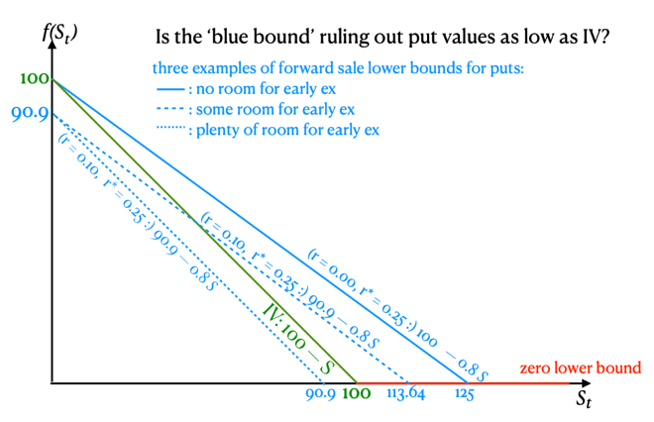
      - Zero we would never exercise early
- Put-call parity for European-style options
    - Can create synthetic puts from combining calls & forwards
    - Can create synthetic calls from combining puts & forwards
Prices of synthetic options should be positive (see earlier)
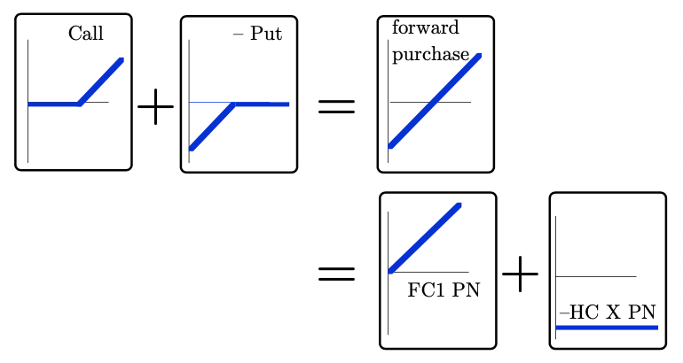
Prices of synthetic options should also equal direct options
    - Call – put = forward
    - Generally, from the set of {puts, calls, FC PNs & HC PNs}, each subset of 3 instruments can replicate the 4th
Put call parity for Eu options: $C_{t}-P_{t}=\frac{S_{t}}{1+r_{t, T}^{*}}-\frac{X}{1+r_{t, T}}$
- Put-call parity for futures-style options on futures
    - $C_{t}^{f}=C_{t}*(1+r_{t,T})$
    - $P_{t}^{f}=P_{t}*(1+r_{t,T})$
    - Use in put-call parity formula to get relation between futures-style option premiums, current futures price and the strike
$(C_{t}-P_{t})(1+r_{t,T})=S_{t}\frac{(1+r_{t,T})}{1+r_{t, T}^{*}}-X$
${C_{t}^{f}-P}_{t}^{f}=f_{t,T}-X$

Hedging
- Hedging risk of loss without eliminating possible gain
    - Use of options to hedge long or short positions in FC
      - Downside risk of an FC outflow can be hedged by a call
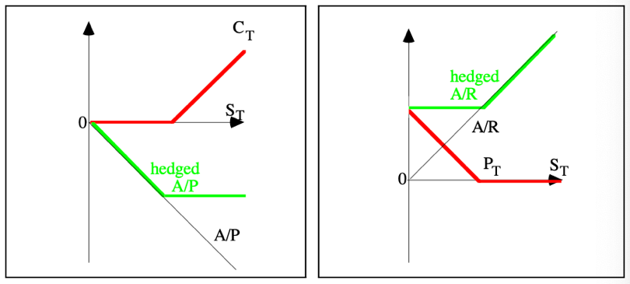
      - Downside risk of an FC inflow can be hedged by a put
    - Hedging a risk-free asset or liability in FC with options

- Hedging positions with quantity risk
    - Examples of where CFs in FC can be uncertain
      - International tenders: bidder may lose
      - FC A/R with substantial default risk: debtor might default
      - International deductible reinsurance: all damage above certain threshold is covered by foreign insurer
      - Risky portfolio investment
In these cases, options are more flexible than forwards or futures
    - Options don’t hedge perfectly: value of option depends on exchange rate, while FC CF depends on a possible event
- Hedging non-linear exposure
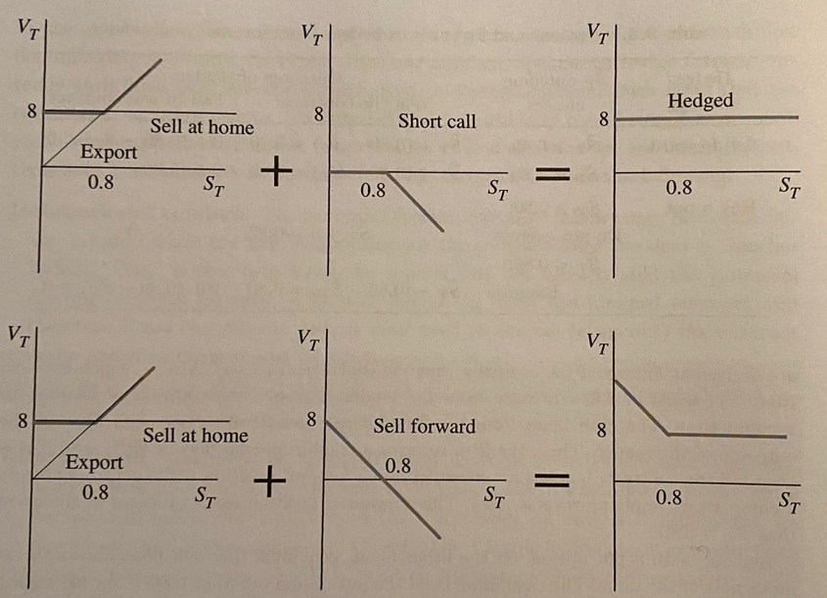
    - Options useful to hedge non-linear exposure because of asymmetric payoff
    - Firm’s option to export is similar to call
    - Writing call against potential export revenue means we sell the uncertain future gains for immediate cash
    - Analogy: customer’s option to buy imported goods: like being writer of a put

Speculation
- Speculation on S (direction of changes)
    - Bulls buy calls or sell puts
    - Bears buy puts or sell calls
    - Why not speculate spot or forward
      - Leverage effect: need less cash than in a spot position but more than in a forward position
      - Buying options: speculation with limited downside risk to premium
      - Selling options is risky: upside is limited to premium
- Speculate on volatility σ_{s}
    - Options deliver non-linear payoff in S_{T}: convex (holder) or concave (writer)
    - Speculate on volatility by going long on both call & put
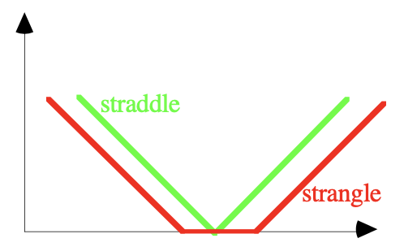
      - Straddle: call & put have same strike
      - Strangle: call’s strike is above put’s
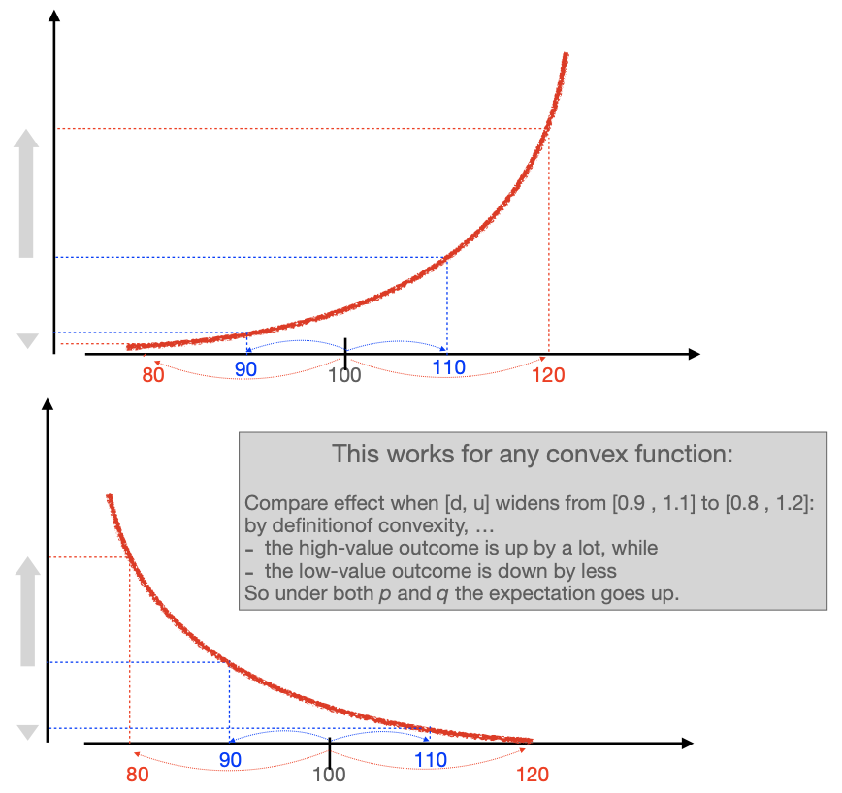
    - Jensen’s inequality: option values rise when volatility rises

10. Currency Options: Hedging & Valuation

Binomial Pricing: One Period Problem
- Given S_{t}, the only possible values for S_{t+1} are either up or down
- Restrictive, but after many of these changes
    - Distribution becomes bell-shaped
    - Binomial price converges to Black-Merton-Scholes (BMS) price
    - More accessible than BMS math
    - Can be used to approximate complex derivatives
- Data
    - S₀ = 100, r = 5%, r* = 3,96%
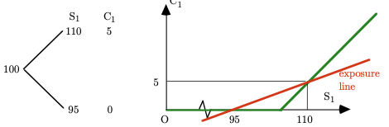
$F_{0,1}=S_{0}\frac{1+r_{0,1}}{1+r_{0,1}^{*}}=100*\frac{1,05}{1,0396}=101$

    - Option will be exercised if price goes to 110 (gain of 5)
    - Option won’t be exercised if price falls to 95 (gain of 0)
    - Slope of exposure line: $\frac{5-0}{110-95}=1/3$
- Replicate this call to find option price
    - Use combination of a forward and a risk-free deposit
    - Buy 1/3 of a forward at 101
      - If price goes down to 95: -6/3 = -2
      - If price goes up to 110: 9/3 = 3
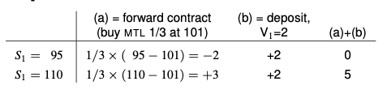
    - Risk-free deposit with a return of +2 at end of period 1
    - Time 0 cost of replicating portfolio
      - Forwards are free
      - Deposit will cost 2/1,05 = 1,905
    - Law of one price: option price = value portfolio = 1,905
- Hedge the call to find option price
    - Sell 1/3 of a forward at 101
      - If price goes down to 95: 6/3 = 2
      - If price goes up to 110: -9/3 = -3
    - Buy a call option
      - If price goes down to 95: don’t execute, +0
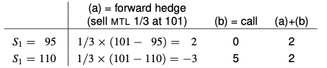
      - If price goes up to 110: execute, +5

    - Time 0 cost of replicating portfolio
      - Value = 2/1,905
    - Law of one price: option price = value portfolio = 1,905
Replication: call = forward + risk free deposit
Hedging: call – forward = risk free deposit
- Price of a call is subject to risk: risk-adjusted probabilities
    - Expectation: $E_{0}\left({\tilde{S}}_{1}\right)=p*110+\left(1-p\right)*95$
    - Risk-adjusted: ${CEQ}_{0}\left({\tilde{S}}_{1}\right)=q*110+\left(1-q\right)*95$
${CEQ}_{0}\left({\tilde{S}}_{1}\right)=\left(110-95\right)q+95$
    - q is revealed by market expectation of F_{0,1} = 101
$101=\left(110-95\right)q+95$
$q=\frac{101-95}{110-95}=0,4$
    - Discounted CEQ of call’s payoff
$\frac{{CEQ}_{0}\left({\tilde{C}}_{1}\right)}{1+r_{0,1}}=\frac{0,4*5+\left(1-0,4\right)*0}{1+0,05}=\frac{2}{1,05}=1,905$
- What if option is American?
    - There are only 2 possibilities, exercise now or at T₁
    - Value dead: exercise now, we get intrinsic value which is 0
    - Value alive: the present value of later exercise, which is 1,905
Same as European option, choose to wait

Binomial Pricing: Multiple Period Problem
- Notation
    - n: how many jumps made since T₀
    - j: how many of those jumps went up
    - $C_{t,j}=\frac{C_{t+1,j+1}*q_{t,j}+C_{t+1,j}*(1-q_{t,j})}{1+C_{t,t+1,j}}$
- Assumptions
    - Risk free return rates are constant (r & r*)
    - Multiplicative change factors (u & d) are constant over periods
- Implication
    - q_{t} is constant
    - q is between 0 and 1 (because we must have $S_{1,down}<F_{0,1}<S_{1,up}$)
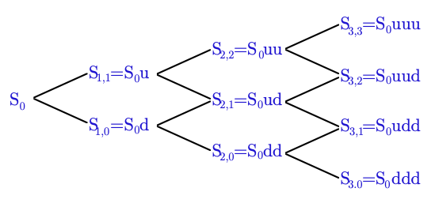
- Tree of possibilities after 3 jumps
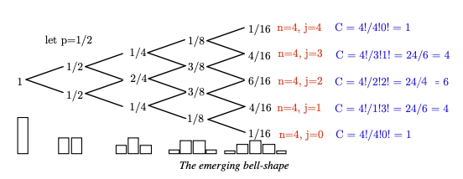
    - If chances of going up or down are equal (50%)
    - Additive model
      - + or – 10 every step
      - Leads to normality in infinity
    - Multiplicative model
      - + or – 10% every step
      - Can never reach 0
      - If we take the log, it leads to normality (= lognormality)

Stepwise Multiperiod Binomial Option Pricing
- N-period European call
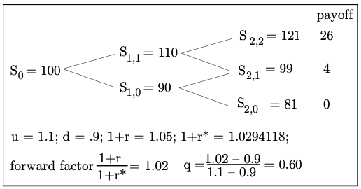
    - At any moment, investor can adjust its portfolio
    - Chance of going up is q = 0,6, going down 1-q = 0,4
- Price of the call: go backwards from S₂ step by step
    - In period S₁
      - S_{1,1}: $C_{1,1}=\frac{26*0, 6+4*0,4}{1,05}=16,38$
      - S_{1,0}: $C_{1,0}=\frac{4*0, 6+0*0,4}{1,05}=2,29$
    - In period S₀
      - S₀: $C_{0}=\frac{16,38*0, 6+2,29*0,4}{1,05}=10,23$
- How much do we sell forward to hedge our exposure
    - In period S₁
      - S_{1,1}: $b_{1,1}=\frac{26-4}{121-99}=1$
      - S_{1,0}: $b_{1,0}=\frac{4-0}{99-81}=0,222$
    - In period S₀
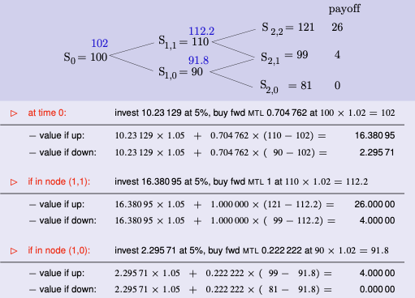
      - S₀: $b_{0}=\frac{16,38-2,29}{110-90}=0,704$
What Can Go Wrong
- If there is volatility in the volatility: what if u & d change after 1 period
    - Recompute q
    - Hedge setup at T₁ will change
    - Meaning our hedge at T₀ (which was based on price in T₁) is wrong
    - Impossible to calculate right hedge at T₀, need of extra hedge for that uncertainty

American Style Options
- Price of a put: go backwards from S₂ step by step
    - In node S_{1,1}
      - PV of later exercise (0 or 1): … = 0,381
      - PV of exercising now: 0
Wait
    - In node S_{1,0}
      - PV of later exercise (0 or 19): … = 7,81
      - PV of exercising now: 10
Exercise
    - In node S₀
      - PV of later exercise (0 or 1 at time 2, or 10 at time 1)
$$P_{0}^{alive}=\frac{0,381*0,6+10*0,4}{1,05}=4,03$$
      - PV of exercising now: 0
Wait

Towards Black-Merton-Scholes
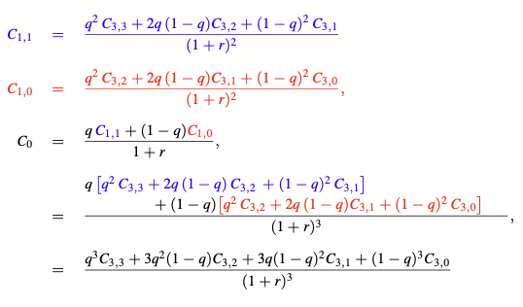
- Straight-through-pricing of European options for 2-periods
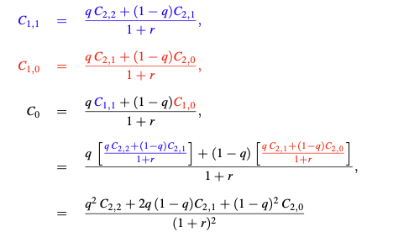
- Straight-through-pricing of European options for 3-periods
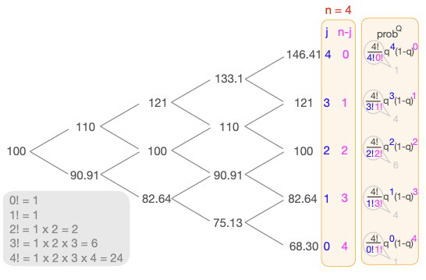
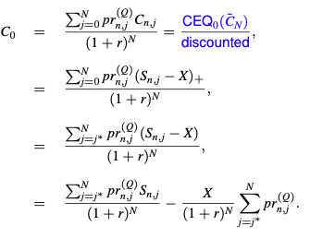
- General formula
    - Second part of equation is discounted strike price X (= HC PN value), multiplied by chance that S_{n} will end above X
    - All probabilities are risk adjusted
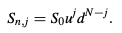
    - We can factor out S₀ in the first term, using
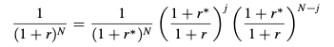
    - Rewrite foreign interest rate
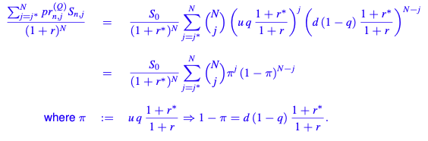
    - We can now rewrite the first term of our general equation as
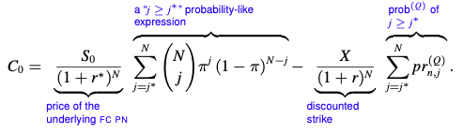
    - If CIP holds, we can write C₀ as
(otherwise, the formula is the same, just replace S₀ by F_{0, T})
    - In the limit for n infinity
      - j/n becomes Gaussian (Gaussian probabilities)
      - Denote first probability with N(d₁) and second with N(d₂)

- Delta of an option
    - Replication: in BMS, option formula is still based on portfolio replicating an option over the short time dt
      - A fraction N(d₁) of an FC PN with face value unity
      - A fraction N(d₂) of a HC PN with face value X
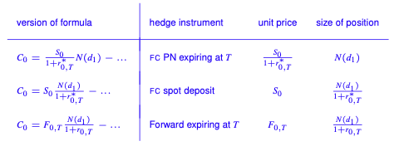
    - Hedge: is replication in reverse, use formula

13. Should a Firm Hedge Its Exchange Risk

Main Issue
- How can a zero-value contract add value?
    - Modigliani-Miller (MM) style point of view: financial decisions should be rated on basis of their impact on the company’s market value
    - Initial value of a forward (${\tilde{S}}_{T}-F_{t,T}$) is zero
    - Hedge’s pay-off may interact with other cash flows in the firm
(ex. reduce chance of financial distress)
If change is beneficial, interaction caused by hedging adds value

Hedging Interacts with Cash Flow
- Hedging can reduce financial distress, which can cause multiple costs
    - Direct costs
      - Receivers, lawyers, assessors & courts
      - Destruction of firm’s clientele and reputation
    - Indirect costs
      - Sales can fall when after-sales and warranties matter
      - Employees quit (the best first)
      - Credit lines can get cancelled, loan covenants triggered
      - Suppliers cancel credit, demand cash payment in advance
    - Liquidation can cost a lot of money to shareholders
    - Even risk of financial distress can trigger these costs
- Hedging may reduce agency costs
    - Agency costs: conflicts of interest between shareholders & management
    - Hedging reduces volatility in cashflows
      - Reduces cost of capital
      - Reduces conflict between different claimants
      - Increases debt capacity
    - Shareholders vs. bondholders’ problem:
      - When close to bankruptcy, shareholders might take decisions that reduce firm value but make them better off
      - Undertake negative-NPV risk-increasing projects (gambling)
      - Refuse positive-NPV but risk-reducing projects
Cure? Impose restrictions, covenants…
    - Managers vs. owners
      - Managers’ wealth is exposed to firm’s risks (paid in options)
      - Absence of hedging: may seek risk-reduction by refusing positive NPV but risky projects
      - Hedging may reduce the conflict of interest
- Hedging may reduce expected taxes
    - If taxes are progressive (convex, non-linear), smoothing the income stream will imply a lower tax burden
    - Corporate taxes are usually near flat (linear), with subtle convexity
Subtle convex because
      - When profits negative, taxes not proportionally negative
      - Carry-back: tax amount refunded is limited to tax paid in recent past
      - Carry-forward: can deduct this year’s losses from future profits
    - So, hedging has little effect on tax

Hedging Provides Better Information
- Report profits with less noise due to hedging: better internal decisions
- Clearer picture signalled to outsiders
- Alternatives to hedging
    - Report profits internally on an as-if-hedged basis
    - Shift exchange risk towards reinvoicing centre: other advantages of this
      - Reduce hedging transactions through netting
      - Economies of scale in costs
      - Tax havens or special tax status advantages
- Homemade hedging won’t do as well as corporate hedging, even if hedging were purely additive on top of corporate hedging
    - Shareholders have imprecise knowledge about exposures: less effective
    - Scale economies make corporate hedging cheaper (transaction costs)
    - Short-selling forex hard for small players (too little investment

Currency of Invoicing Issue
- Traditionalists: someone must bear exchange risk, either buyer or seller
- Radical young Turks: due to existence of forward market, this is not the case anymore
- Currency of invoicing doesn’t matter if
    - No delay between price quote & decision to buy
    - Both sides have same rates

True Cost of Hedging
- It reduces risk, also flattens out upward trend that is possible
- ‘If you had not hedged, you would have had more money’
    - Ex-post sum can be lower than the unhedged sum
    - Not a cost, just less profit in exchange for less risk
    - Ex-post value is pure luck, irrelevant for decision making
- Using spot rates to convert FC A/Rs or A/Ps to HC
    - Misleading practice by accountants
    - Accounts show an ex-ante cost
    - If one hedges, actual CF differs from book value
Accountants call this difference the cost of hedging (false)
    - If at moment of booking invoice, translation was done at forward rate, hedging wouldn’t have entailed accounting cost or gain
- Hedging is free, so booking forward premium as cost/gain is misleading, accounting principle is a pure construct
- There can be a small cost to hedging (transaction cost)
    - Upfront commission for entity that makes the hedge possible
    - Bid-ask spread of forward a bit wider than spot spread

- Hedging & tax shields: if taxes are neutral, capgain & interest differential wash out ex-ante

14. Measuring Exposure to Exchange Rates

Concept Risk & Exposure
- Forex risk: measure of uncertainty, like variance of ${\tilde{S}}_{T}$
- Forex exposure
    - Numerical measure of how sensitive financial positive position is to changes in the exchange rate
      - $B_{t,T}=\frac{Δ{\tilde{V}}_{T}}{Δ{\tilde{S}}_{T}}$
    - The changes Δ are at T: comparing two or more future time-T outcomes, not changes over time
      - A partial derivative $\frac{δ{\tilde{V}}_{T}}{δ{\tilde{S}}_{T}}$
      - Exposure of an option in a binomial model
      - Regression coefficient of ${\tilde{V}}_{T}$ on ${\tilde{S}}_{T}$ across scenarios
- What is affected by ${ΔS}_{T}$
    - Contractual exposure (~)
      - ${\tilde{V}}_{T}$ is defined as HC value at maturity of a net contractual CF denominated in an FC that matures on that date
      - It includes all A/R, A/P, deposits and loans denominated in given FC and contracts to buy or sell goods in future at known FC prices
      - Exposure B is then the FC value, which is assumed to be risk-free
    - Operating exposure (~)
      - Don’t look at firm as portfolio of FC contracts signed in past, generating CFs in the future
      - Look at firm as set of activities that require constant decisions
      - Future decisions depend on future exchange rates, CFs are subject to FC and HC terms
      - ${\tilde{V}}_{T}$ is defined as CF from future operations
      - The FC CF, C*, is not a constant but depends on future spot rate ${\tilde{S}}_{T}$
    - Translation exposure (accounting exposure) (~)
      - Arises when company has to consolidate financial statements
      - Balance sheets of subsidiaries must be translated into HC at exchange rate of the reporting date
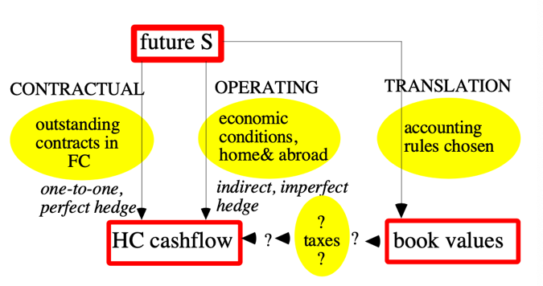
      - Based on book values, not cash flows
Contractual Exposure
- Exporter in EU wants to hedge exposure from monthly sales
    - Constant USD price, hedge every invoice
      - Sales volume in USD remains constant
      - Conditional variance falls, every hedge replaces ${\tilde{S}}_{T}$
      - Unconditional risk unaffected: long run time series of hedged incomes remains as variable as unhedged one due to variance in forward rates
    - Constant EUR price
      - No exposure to forex
      - USD cost of wine fluctuates, causing fluctuations in sales volume
Both cases have operating exposure
Just hedging contractual exposure is not enough
- Where does risk-free stop
    - Cancellation clauses, default risk: no contract is 100% certain
    - Is a memorandum of understanding or an orally expressed intent a contract
- Hedging of expected future sales has two issues
    - Non-linearity: use nonlinear hedge or approximate with a linear hedge?
    - Noise: other variables upsetting effect of S_{T} causing imperfect hedges
- Hedging of CFs vs. hedging of PVs
    - Choose one, don’t do both
    - Issue 1: how to estimate value changes of assets & liabilities
    - Issue 2: risk arising from time mismatches between hedged CF and asset
    - Hedging an unlisted company has same issues but worse

Operations Exposure
- Sources
    - Exporting & importing firms: invoicing in HC or not
    - Domestic firms with (potential) foreign competitors
    - Closed-industry firms via general economic activity
- Typical issues
    - Difficulty to identify relationship between CFs and ${\tilde{S}}_{T}$
    - Conclusions often surprising and counter-intuitive
    - How to handle non-linearity and noise
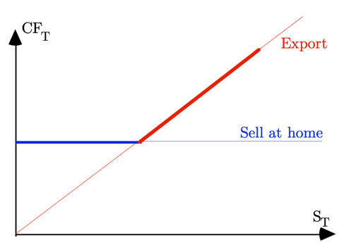
- A non-linearity: effect of the option to export on CF
- General linear hedge: Dumas’ regression approach
- Come up with table containing
    - Column representative possible ${\tilde{S}}_{T}$
    - Column showing their probabilities
    - Column showing expected CF in HC for each

- Decompose HC CFs into
    - Part perfectly correlated with ${\tilde{S}}_{T}$
    - Part uncorrelated with ${\tilde{S}}_{T}$
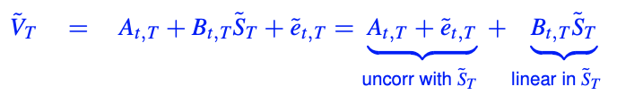
    - Done via regression across possible time-T scenarios
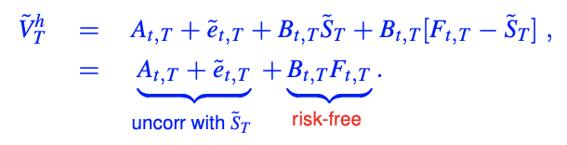
- Sell forward FC B (buy -B if B<0)
    - Comments on this approach
      - Minimizes remaining variance: remaining risk uncorrelated with ${\tilde{S}}_{T}$ so cannot be picked up by a forward contract
      - In pure binomial case: regression coefficient collapses to the familiar two-point exposure
      - In binomial case with noise: collapses to a two-point exposure, using conditional expected CFs
      - In general: provides linear projection of expected CFs onto ${\tilde{S}}_{T}$
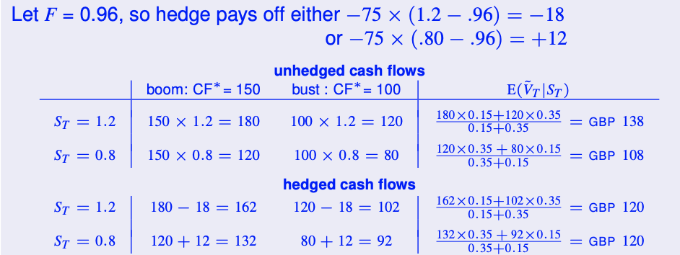
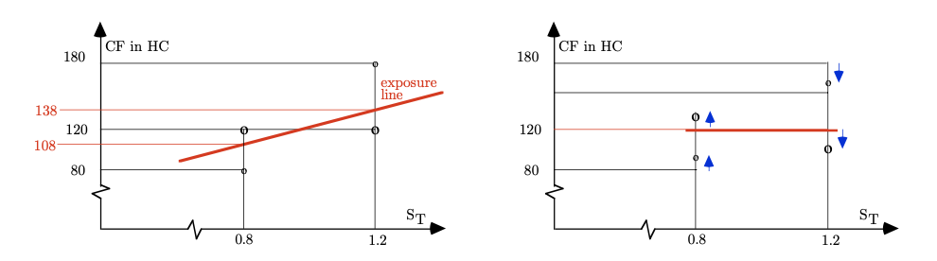
      - Example

- Issues in linear cross-hedging
    - Getting data
      - Past data on stock returns not recommended (representative?)
      - Alternative scenarios for future CFs (risky)
    - Identifying distribution of ${\tilde{S}}_{T}$
      - Not random sample, constructed population
      - Not an issue when distribution is binomial or relation is linear
      - How to set parameters: get $E(\tilde{S})$ from F and σ from ISD
    - Linear or non-linear hedges
      - Linear: OK when non-linearity not strong
      - Non-linear (portfolio of options or dynamic replication): construct linear approximation, note changes of slopes
    - Hedging other risks
      - Add commodity futures
      - Need to run multiple regression of V, S & the other variables
      - Hard to build multidimensional scenarios

Translation Exposure
- Translating individual FC items: keep historic value or use M2M value?
    - A/R, A/P, deposits, loans in FC: M2M recommended (USGAAP, IFRS)
    - Futures
      - M2M flows from clearing corporation as bank account (A) & gains (L)
      - Unrealised: M2M hard to defend
      - FASB & IASC: all gains & losses have to be shown, realised or not
      - Exception: future to hedge against other position that is not M2M
    - Forwards
      - Has no cash movement prior to expiry
      - Use revaluation of asset with initial book value set to 0 or use upward adjustment in shareholders’ funds
      - M2M using F, so only report $F_{t,T}-F_{t_{0},T}$ (probably undiscounted)

Translating Foreign Financials
- Why?
    - Taxation of foreign income
    - Consolidated financial statements & performance of subsidiaries
    - Valuations
    - Bonuses
- How?
    - Current or non-current
    - Temporal
    - Monetary or non-monetary
    - Current rate
- Foreign equity stakes shown as 2 parts
    - Original HC book value
    - M2M (called equity adjustments*)
- Determine what needs to be translated to original/new rate
- Compute new worth from translated A&L
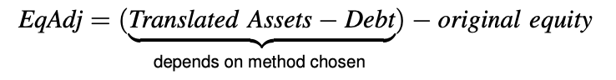
- Equity adjustment: Δ net worth of translated items and original one
- Current / non-current method
    - When FC devalues, losses on ST assets are likely but on LT uncertain
    - Deem LT A&L to be unexposed, keep historic value
Exposure = ST assets – ST liabilities = net working capital
    - Evaluation: exposure usually positive, mixture of historic values and current ones is confusing
- Monetary / non-monetary method
    - PPP: real items are unexposed
    - Recognise only gains/losses on monetary items
Exposure = financial assets – debt
    - Evaluation: exposure usually negative, mixture of historic values and current ones is confusing (PPP is a joke anyway)
- Current-rate method
    - Intent: max consistency with conventional accounting and max consistency of consolidated balance sheet with parent’s and subsidiaries’ accounts
    - Translate all assets & debts at current rate
Exposure = net worth in FC
    - Evaluation: exposure usually positive
- What method to choose?
    - Many regulating bodies prefer current rate method (FASB & IASC)
    - Doesn’t affect any real CFs, except for taxes

15. International Fixed-Income Markets

Deposits & Loans
- International or ‘euro-’ bonds: deposits, loans… in a non-local currency
- Historical use of term ‘euro’, not referring to the €
- Causes of growth of international bond market
    - Liberalisation of trade & exchange after WWII made it easier, less regulation
    - Political risks for socialist governments: socialist regimes wanting to hold USD, did so with non-US banks (ex. Paris) so the US government can’t seize it
    - UK capital controls & restrictions
      - GBP was overvalued after WWII
      - UK limited foreign borrowing in GBP to battle this
      - Result: UK banks borrowed USD
    - US capital controls & restrictions
      - US interest rates pushed up because of overvaluation of USD
      - Interest equalisation tax on foreign borrowing in US to keep internal interest rates below USD interest rates offered in Europe
      - Foreign credit restraints that hinder borrowing by foreigners in US
      - Regulation Q imposed interest ceilings on domestic USD deposits with US commercial banks
Combined effect: investors prefer to hold USD deposits in Europe
Most measures are now abolished, but eurobond market isn’t
- Main advantage: lower bid-offer spread (spread between interest on loans & deposits)
    - Lean & mean machine
      - International market is essentially a wholesale market
      - High volume allows narrow spreads
    - Low legal costs
      - Most borrowers are sovereign states or high-grade corporations
      - Hardly any credit evaluation, bonding or monitoring needed
    - Lighter regulation
      - No compulsory deposit insurance or reserve requirements
      - Local monetary authorities provide more lenient credit restraints when borrowing in a FC
    - Universal banking
      - US law separated commercial & investment banking, not in Europe
      - US law prohibited interstate banking
    - Lower taxes
      - Eurobanks often found in tax havens
      - International transactions often receive beneficial tax treatment
- International bond market now: playing field more level, most advantages have eroded
Deposits
- Types
    - Time deposits: non-negotiable registered instrument with fixed life
    - Certificate of deposit (CD): tradable security version of time deposit, negotiable and can be sold to another investor at any time
- Fixed or floating rate
    - Fixed: interest rate does not change
    - Floating: interest rate divided into fixed part and floating part that follows risk-free rate and resets every coupon period
- Term of deposit
    - If short term: interest & principal paid back at end
    - If long term: interest paid in coupons (quarterly, yearly…)
- Time duration can range from 1 week up to 7 years

Loans
- Often extended by group (consortia, syndicate) of international banks
- Consortia
    - Mandated arranger (lead bank) led by book runner
      - Negotiates terms with borrower
      - If multiple mandated arrangers, lead one is ‘book runner’
    - Participating banks: all banks that provide actual funding
    - Underwriters (co-managers, co-leads): guarantee loan if there is shortage
    - Paying/facility agent: bank that receives the payments from borrower
    - Why
      - Spread objective risks
      - Avoid moral hazard that borrower just pays off larger banks
- Revolving or floating-rate loans
    - Reduce banks interest risk
    - Resets every n-months on basis of (L)IBOR
    - Capped rate and floor: boundaries for the interest rate
      - Capped rate: equivalent to giving borrower a put option
      - Rate with floor: equivalent to giving lender a call option
- Costs of a loan
    - Fees for intermediaries
      - Management fee & participation fee between 0,25 - 1,00%
      - Paying agent’s fee (few basis points)
    - Risk compensation: risk-spread above risk-free rate, depends on
      - Quality of borrower or political risk of its country
      - Maturity and grace period
      - Up-front fee
      - Market situation
    - To make reliable comparison
      - Translate fees & risk compensation into an equivalent spread
      - If floating rate, translate upfront fees in equivalent annuity
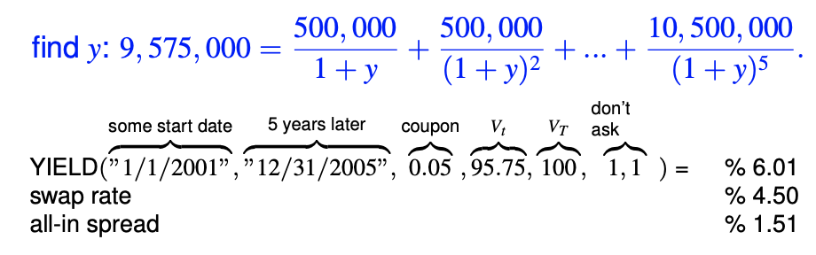
Ex. 5y bullet loan of 10m with 5% annual (inc. 0,5* spread) with 0.452m upfront fee

(shortcut for annuity calculations: $\frac{1}{1+y}+\frac{1}{{(1+y)}^{2}}+…+\frac{1}{{\left(1+y\right)}^{n}}= \frac{1-{\left(1+y\right)}^{-n}}{y}$)

- Credit
    - Credit line
      - Gives beneficiary right to borrow up to X at prevailing interest rate plus a spread
      - Usually only for a short time period
      - Can be revoked if situation changes
    - Revolving commitment
      - Same as credit line but for longer time period
      - Cannot be revoked by the bank

Bonds
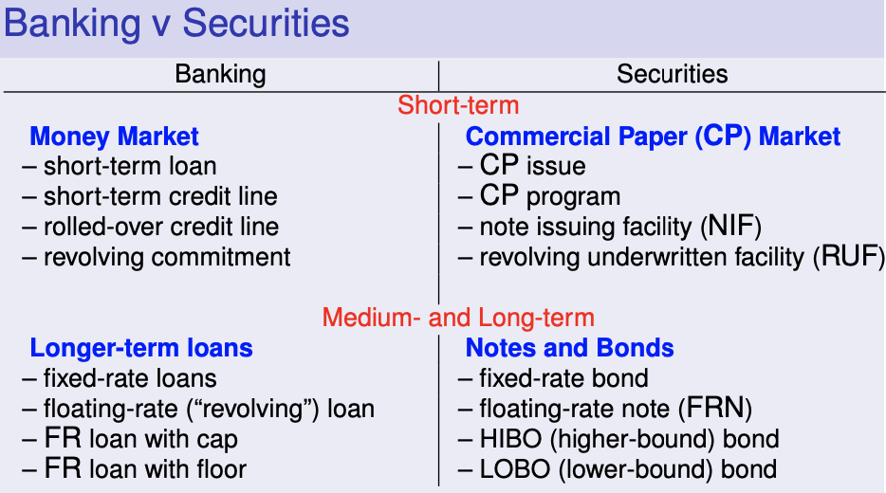
- Overview of tradeable security versions of banking products
- Advantages of these markets
    - Lighter regulation than local country bond issues
    - Swift & efficient private replacement
    - Simple contracts because of well-known borrowers
    - Tax games: anonymous bearer bonds, easy to evade income tax
    - Large issues cause low issuing costs
    - Disintermediation
      - Banks lost first-rate creditworthiness (during crisis): top borrowers can borrow at lower cost than some banks by borrowing directly
      - Lower lending/borrowing profits led to banks preferring immediate fee income

- Terms & conditions
    - Bearer securities
      - Issuer does not know buyers, does not keep a register
      - Don’t have to give up identity when cashing coupons
    - Interest payments
      - Fixed or floating
      - Can have a cap or floor
    - Amortisation, 3 types
      - Bullet bond: amortisation of bond’s principal happens at maturity
      - Purchase-/sinking- fund provision: borrower has to buy back predetermined amounts of bonds each year
      - Variant provision: borrower has right to buy back predetermined amounts
    - Currency of denomination
      - Single currency
      - Basket of currencies
      - Dual currency bond (coupons in another currency than principal)
    - Stripped bonds
      - Sell coupons and principal separately
      - Principal becomes zero-coupon bond
      - Simplifies asset/liability management
      - Zero-coupon bonds get favourable tax treatment in some countries

- Traditional issuing procedure
    - Placement done through a syndicate of banks (consortium), ex.
    - Terms & conditions can be found in the prospectus
      - Preliminary prospectus is often circulating, called red herring
      - To check how interested the market is in the issue
    - Once prospectus is official, investors can buy forward the issue before actual issuing period starts (grey-market period)
- Alternative (faster) issuing procedures
    - Bought deal
      - One bank buys entire issue
      - Before finding co-underwriters or building a book
      - Riskier, so higher underwriting fee or smaller issue
    - Fixed-price reoffer
      - No underwriters
      - Price paid by public is set
      - Sellers get commission if and when they place a paper, ex. 0,15%
      - Borrower bears risk that the issue flops
    - Yield pricing
      - No underwriters
      - Last-minute pricing via market yield of comparable bonds
      - Less risk compared to fixed-offer, where yield is decided in advance

    - On tap (au Robinet) or medium-term note (MTN) style issue
      - No underwriters, no placing, no prospectus
      - Very loose terms are set, then wait for takers with excess liquidity
      - Issuer has no idea how many takers there will be, if any

Commercial Paper
- Disintermediated counterpart of ST bank loans
    - ST securities issued by private companies
- Types
    - Purchase notes (PN)
      - 7 to 365 days
      - Discount issues
    - Notes
      - 1 to 7 years
      - Fixed or floating rate
    - Certificate of deposit (CD): PNs or notes issued by banks
- Issue procedures
    - One-shot issue
    - ECP program
      - Note issuing facility (NIF): underwritten, fixed spread
      - Revolving underwritten facility (RUF): underwritten, capped spread
RUF avoids renegotiating when required spread goes down

Comparing Offers
- In the same currency
    - Given offers
      - Trustee: 7y 2% p.a. 0.5% upfront
      - Midland: 7y 1,9% p.a. 1,1% upfront
      - IOS rate is 1,4%
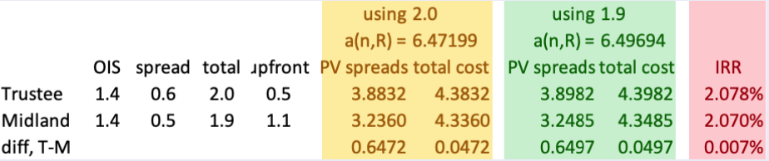
    - Calculate difference in value instead of true value, insensitive to choice of R
    - Always compare cost aggregates using same discount rate if you want to see effect of gaps in spreads an upfront cost
    - Compare PV spreads: difference almost insensitive to rate
    - Compare total costs: difference almost insensitive to rate
    - (Compare IRR: also gives right answer, but only small difference)
- In different currencies
    - Step 1: take best HC loan, swapped into FC
      - AUD swap rate is 5%
      - JPY swap rate is 2%
      - AUD loan with 1,5% spread and 1% upfront
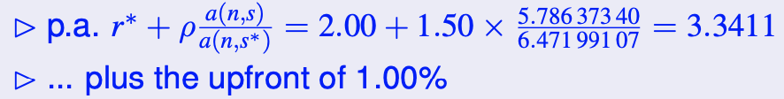
      - You can borrow AUD swapped JPY at

    - Step 2a: use swapped loan rate as discount rate for total costing
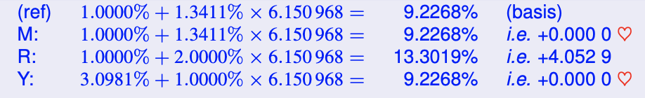
      - Discounted at 3,3411%
      - Good way of comparing loans
    - (Step 2b: use of IRR to compare loans)
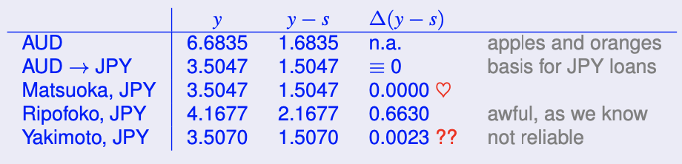
      - Use swap rates 5% & 2%
      - Bad way of comparing, misleading when using across currencies
- What if a market benchmark is missing (no swap market or interest rates set)
    - Risk neutral agent is indifferent if payoffs are the same between FC 1 & HC S_{t}
      - Borrow FC 1 and convert to HC S_{t}: pay back $\left(1+R_{t,T}^{*}\right)*E\left({\tilde{S}}_{t}\right)$
      - Borrow S_{t} of HC: pay back $\left(1+R_{t,T}\right)*S_{t}$
Prefer HC if $\frac{\left(1+R_{t,T}\right)}{\left(1+R_{t,T}^{*}\right)}>\frac{E\left({\tilde{S}}_{t}\right)}{S_{t}}$
    - What if multi-coupon, multiperiod expectations?
    - Correct for risks?
Decision not reliably measurable

19. International Taxation of Foreign Investments

Only 19.1 & 19.2 for exam 2023

Forms of Foreign Activity
- Inherent foreigners handicap: start off without network
Need competitive edge to overcome handicap

Foreign Activity: Managerial Perspective
- Inherent foreigners handicap: start off without network
Need competitive edge to overcome handicap
- Pure exports: everything done in home country, then sold abroad
- International product marketing: marketing, production... can be abroad
- Licensing: transfer intellectual property abroad without producing/selling
- Franchising: transfer marketing know-how or part of it
- Management contracts: transfer general organisational or management skill
Strategies often mixed

Foreign Activity: Legal Perspective
- Exports
    - Independent agents: unrelated company selling products abroad
    - Dependent agents: related company selling products abroad
- Foreign branch: does not have separate accounts, is part of same company
- Subsidiary
    - Separate company that is partially or fully owned by mother
    - Can pay out dividends, interest, royalties or take loans (foreign branch can’t)

Foreign Activity: Fiscal Perspective
- Laws provide the right to countries to tax
    - Residence principle: all residents can be taxed on worldwide income
    - Nationality criterion: all people with the countries’ nationality and all companies set up under the country’s law, are taxable
    - Source principle: all income earned inside the country is taxable
- Direct export
    - All transactions are made in home country
    - Pure exporter does not deal in foreign country, isn’t resident there
Taxed in domestic country only
- Foreign subsidiary
    - Wholly owned subsidiary (WOS) or joint venture (JV)
    - Is resident of in foreign country, has to pay taxes like domestic firms there
    - Parent is subject to taxes on dividends, interest, license income etc. in both countries
      - Host country: parent earns income there, source principle
      - Home country: where parent resides, residence principle
- Permanent establishment (PE)
    - Legal point of view: foreign presence if firm opens up branch
    - Fiscal point of view: host can invoke source principle if activity takes place
Conditions of having a permanent establishment
      - There is a permanent physical presence (warehouse, office…)
      - Some vital entrepreneurial activity takes place (more than rendering services like storing goods, advertising or centralising orders)
    - Issues with PE
      - Can cause double taxation
      - Companies can do substantial business without ever setting up PE’s (ex. internet companies)
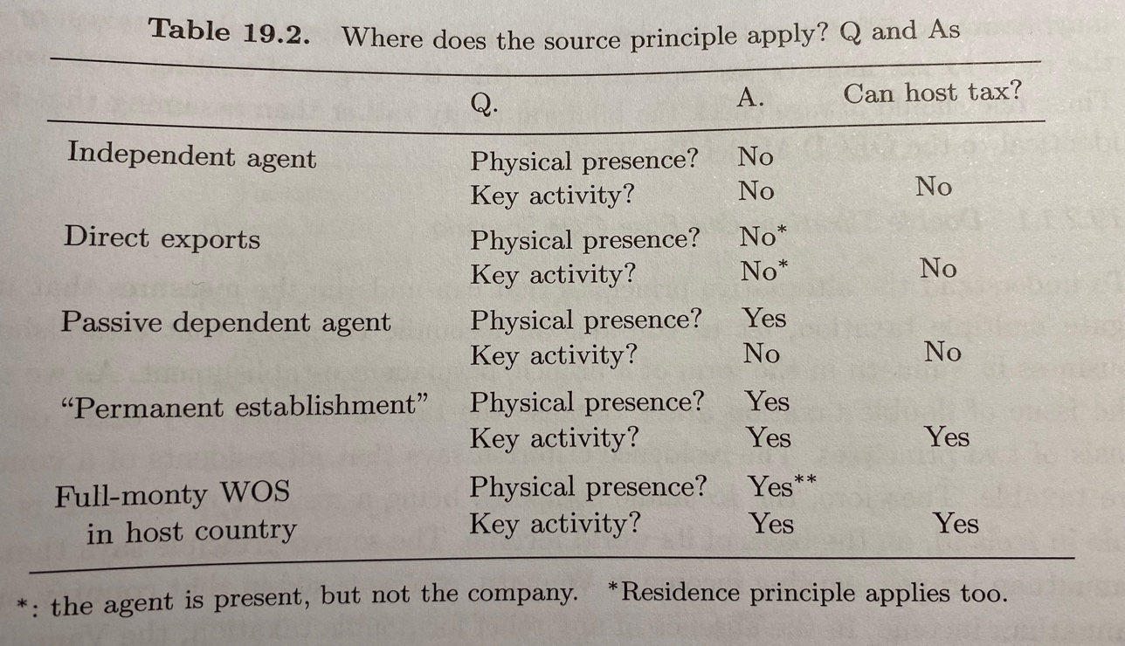
      - Current accounting system is based on PE’s, making tax avoidance & evasion easy; better system would be to assign profits to countries proportionally to for example sales
Tax Neutrality & Multiple taxation
- Relief from multiple taxation by
    - Unilateral measures built-in standard tax rules of host
    - Bilateral tax treaties (supersede national tax rules)
      - Often based on OECD Model Tax Treaty
      - Can differ in tax percentages or rights to tax more/less
- Tax neutrality can be achieved by
    - Capital import neutrality & exclusion system
    - Capital export neutrality & credit system
- Capital import neutrality
    - Based on idea: should be no (dis)advantage to being foreign owned
    - Foreign & local entities should be allowed to compete on equal basis
    - Branch only pays tax to host country, not to country of parent
Exclusion system
- Capital export neutrality
    - Goal: home country doesn’t want to incentivise moving to tax havens
    - Overall tax should be same as if branch operated inside home country
    - Apply home tax laws to foreign income, but deduct taxes already paid in foreign country
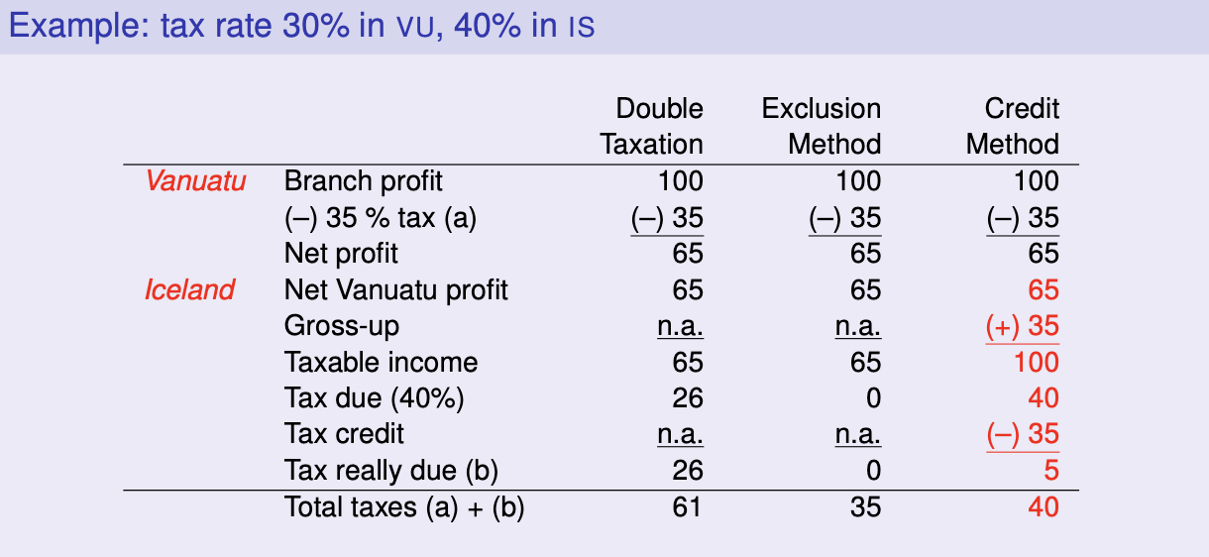
Credit system

- Tax neutrality
    - Will never be truly neutral
    - Tax basis & taxable income definitions depend on country

Until here for exam 2023, 19.3 and onwards not discussed

20. International Capital Budgeting

Domestic Capital Budgeting
- Discounted cashflows
    - Use of CFs instead of profits because timing is different
      - Depreciation & amortisation should be added back
      - Provisions must be accounted for on the date they really occur
      - Correct leads & lags in sales income
    - Discount in accordance to
      - Fact that they are spread out over several years
      - Risk-adjusted cost of capital (risk free rate + a premium)

- Net working capital requirements (NWC)
    - To account for lags & leads in CFs
    - Calculate capital needed to function
    - Method 1
      - Estimate NWC as a % of sales
      - Constant ratio of costs & sales throughout year
      - Constant NWC level needed, had if profit margins change over time
    - Method 2
      - Shift parts of costs into preceding year
      - Shift parts of revenues into next year
    - Method 3
      - Fractional discounting
      - Recognising shifts forward & backward
      - Doesn’t estimate NWC itself, only their PV

Example: calculate PV of cashflows after year 1
    - Data
      - r = 10%
      - Sales: 180 (15 per month)
      - Costs: 120 (10 per month)
      - A/R: cashed 30 days after sale
      - A/P: paid 30 days before sale
    - In steady state NWC = A/R + INV – A/P = 15 + 10 = 25
    - Method 1
      - Invest 25 NWC in year one and recuperate it in year 2
      - $PV= \frac{(180-120)-25}{1,10}+\frac{25}{{1,10}^{2}}=52,48$
    - Method 2
      - Push payment into previous year and pull receipts to current year
      - $PV= \frac{-10}{{1,10}^{0}}+\frac{\left(180-15\right)-(120-10)}{{1,10}^{1}}=52,40$
    - Method 3
      - Recognize lag & lead in discounting operation
      - $PV= \frac{180}{{1,10}^{1+\frac{1}{12}}}+\frac{120}{{1,10}^{1-\frac{1}{12}}}=52,38$
- Incremental cashflows
    - CFs used in analysis must be the incremental cashflows
    - Increased CF of one business unit doesn’t mean increased CFs for entire firm, CFs might have replaced those of other business unit or might be generated by intra company money streams
- Sensitivity analysis
    - Try out different input values and measure effect on output
    - See effect of wrong input estimates
- Adjusted net present value (ANPV)
    - NPV calculation: based on inherent economic value of project
    - ANPV calculation: take into account financing aspect
      - Cost of issuing new bonds or equity etc.
      - Take into account (tax) subsidies
- Interest tax shield concerns
    - Not all tax shields can be used if earnings before interest are too low
    - Tax shields carried forward have loss in time value
    - Paying interest more attractive than dividends
      - Depends on bond- & shareholders’ personal taxes
      - Which part of tax shield goes to bond- and which to shareholders?
- WACC
    - WACC: weighted average cost of capital approach
    - All cashflows discounted at rate that is weighted average of
      - The after-tax per annum cost of debt $R_{D}(1-τ)$
      - The cost of equity $E({\tilde{R}}_{EQ})$
$WACC= \frac{D}{E+D}*R_{D}\left(1-τ\right)+\frac{E}{E+D}* E({\tilde{R}}_{EQ})$
      - D: borrowings for the project
      - E: equity (total value – debt)
      - E + D = project’s gross present value (GPV)
$GPV=E+D=I_{0}+ANPV$
    - Assumes
      - All tax shields fully used
      - No reverse discrimination at personal level
      - All tax savings end up with shareholders
    - Problem
      - WACC based on market values, which we only have after valuation
      - Expected return on equity depends on leverage (defined in market value terms), which we also only have after valuation
Circularity problem; chicken or the egg?

International NPV Issues

- Non-Equity Features
- Need to choose legal form: branch, JV, WOS…
- Need to identify optimal remittance policy
- Step 1: branch stage
    - Value as if foreign branch
    - Focus on CFs from operations
    - Ignore financial arrangements between parent and daughter
    - Advantages: avoid many pitfalls such as
      - Confusing costs and left-/right pocket payments
      - Confusing tax savings/shifting
      - Inconsistent discount rates
      - Getting too absorbed by tax games
      - Thinking tax loopholes are forever
- Step 2: unbundling stage
    - Consider intra-group financial arrangements
    - Choose remittance policy
    - Analyse costs & benefits of intragroup financial arrangements
    - Foreign entity unbundles remittances into license fees, royalties, dividends & interest payments
- Step 3: external financing, consider subsidies, issue costs…
    - Who should borrow?
      - Parent, JV, WOS…
      - Look at all taxes, not just corporate tax
    - In what currency?
      - High interest currency: beneficial for tax subsidies
      - Trade-off exposure management and taxes
- Dealing With Exchange Rates
- For integrated markets
    - Valuation can be done in either currency
    - HC & FC procedures should use same market portfolio
- For segmented markets
    - No reason to believe foreign & home investors value project the same
    - Valuation must be done in HC
      - Cost of capital should be set in HC (all assets priced in that market)
    - Estimated risks & returns
      - Market: use long-term, low(ish) rates
      - Beta: use your priors too, or exclusively
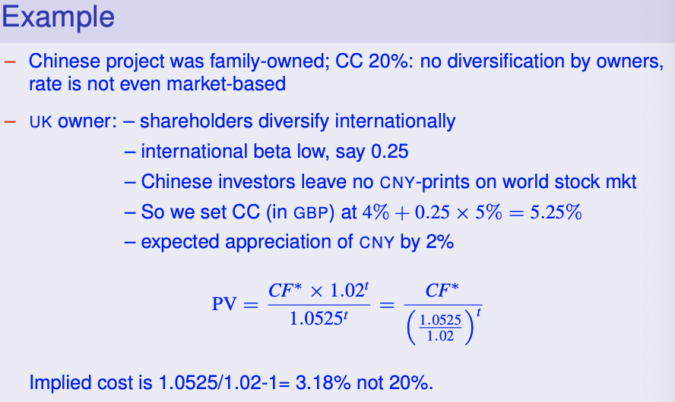
    - Setting cost of capital:

- Political Risks
- Transfer risk: risk that transfers to foreign countries are blocked or limited
- Not all types of transfers are equally exposed, some get limited faster
- Transactions on the capital account
    - Equity transfers & loans to other companies in the same group
    - If intra-group loans are limited, subsidiary can buy goods and speed up payment (leading) to get money out of the country (basically a short-term interest free loan)
- Dividends:
    - Often countries impose a dividend ceiling (ex. 5% of equity)
    - Defensive strategy can be used in this case:
      - Increase capital base to increase dividend that may be distributed
      - Bring in the parent’s government, a government agency or the International Finance Corporation as minority shareholder (they won’t block dividend payments if they are involved)
- Interest payments & license fees: defensive measure is to use bank as front in a back-to-back loan
    - Parent lends to bank, which relends to subsidiary
    - Parent’s deposit serves as guarantee for the loan
Countries won’t limit interest payments to international banks
- Payments without financial image (management fees, technical assistance…)
    - Proactive defence is to charge a lot for these services before restrictions are imposed, so it does not look suspicious
- Accounting for transfer risk: 3 options (but only 1 really)
    - Add extra risk premium: too hard to measure
    - If we now probability of blocking and the cash at risk, can take this into account: we still don’t know at which rate the CFs should be discounted
    - Insure the capital at risk: PV of insurance premiums can be used to estimate the risk-adjusted expected value of the transfer risk

- Include All Incremental Cashflows
- Risk of taking ‘project point of view’: looking at project level instead of company level
- Especially when subsidiary is own company with own accounts

Checklist
- Separation of operating & finance issues
    - Compute as if it is a foreign branch
    - Remove all intragroup payments etc.
    - Recompute taxes
- Profits vs. cashflows: use CFs to avoid timing issues
- Handle Xrates correctly: (i)CAPM, HC or FC and beta-check
- Think of political risk
- Inflation
    - Is constant rate reasonable?
    - Is it the same for all CF items?
- Terminal value
    - Use of book value: simple & conservative
    - Estimate going-concern value using relevant market multiples
    - Compute break-even liquidation value, then decide
- Perform sensitivity analysis of operational inputs
- NPV isn’t everything
    - Risk of biased & shaky inputs
    - There are non-quantifiable aspects
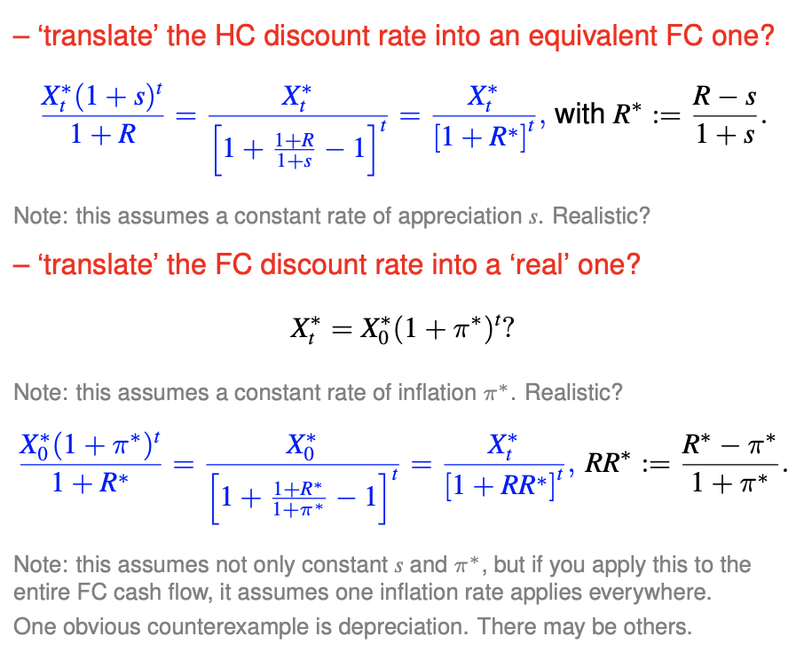
- Note on calculations

