International Auditing Standards
Summary of classes by audit partner Griet Helsen, summer semester 2024

1. Introduction

Audit Standards
- International auditing & assurance standards board (IAASB)
    - Independent standard setting body under the international federation of accountants (IFAC)
- Goals
    - Establish high quality standards for services like auditing, quality control…
    - Improve uniformity of practice by professional accountants across the globe
    - Strengthen public confidence in global auditing profession
- Overview of types of international standards (IS)
    - Reviewing financial information
      - ISA: IS on auditing (reasonable assurance)
      - ISRE: IS on review engagements (limited assurance)
    - Reviewing non-financial information
      - ISAE: IS on assurance engagements (reasonable/limited assurance)
    - Reviewing other information
      - ISQC: IS on quality control (safeguard audit quality)
      - ISRS: IS on related services (no assurance)
- ISA structure
    - ISQC 1: international standards on quality control
    - ISA 200: general principles & responsibilities
    - ISA 300-400: risk assessment & response to assessed risks
    - ISA 500: audit evidence
    - ISA 600: using work of others
    - ISA 700: audit conclusions & reporting
    - ISA 800: specialised areas

ISA 200
- Goal: explain independent auditor’s overall responsibilities when conducting an audit
    - Set out overall objectives of independent auditor
      - Obtain reasonable assurance that FS are free from material errors
      - Report on FS & communicate as required by the ISAs
    - Explain nature & scope of the audit
- While completing audit objectives, the auditor:
    - Complies with relevant ethical requirements (ISQC 1 & ISA 220: lecture 6)
    - Plans & performs an audit with professional scepticism
    - Exercises professional judgment
    - Obtains sufficient appropriate evidence to create an opinion
    - Conducts the audit in accordance with professional auditing standards
- Professional scepticism
    - Attitude that includes questioning mind & being alert
    - Critical assessment of audit evidence
    - Reduce risk of
      - Overlooking unusual circumstances
      - Generalising when drawing conclusions from observations
      - Using inappropriate assumption during audit procedures/evaluation
- Professional judgement
    - Process of reaching a conclusion when there are multiple solutions possible
    - Occurs in setting of uncertainty & risk
    - Necessary regarding decisins about
      - Assessing inherent & control risk and risk of material misstatement
      - Deciding upon nature, timing & extent of audit procedures
      - Evaluate results of these procedures
      - Assessing reasonableness of judgements & management’s estimates
    - Should be based on
      - Relevant facts and circumstances known at time of judgement
      - Made after consideration of reasonable alternatives
      - Sensitive to degree of uncertainty inherent in the judgement
      - In compliance with applicable professional standards
    - Issues
      - Overconfidence bias: tendency to overestimate own abilities
Challenge opinions/experts/underlying assumptions
      - Confirmation bias: put more weight on evidence confirming beliefs
Make opposing case, consider alternative explanations
      - Anchoring & adjustment: start from initial value, adjust along way
Solicit input from others
      - Availability heuristic: consider easy information as more relevant
Consider why something comes to mind, remain objective
- Sufficient appropriate evidence
    - Appropriateness
      - Measure of quality of audit evidence
      - Relevance & reliability in providing support for conclusions
    - Sufficiency
      - Measure of quantity of audit evidence
      - Quantity needed is affected by assessment of risks of material misstatement and by quality of such evidence

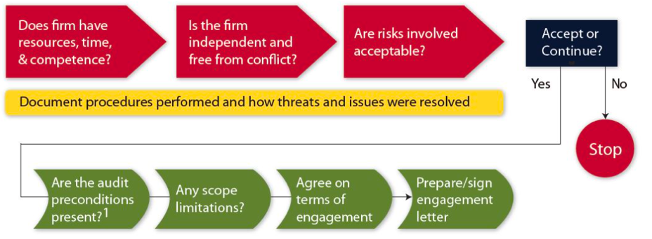
ISA 210: Acceptance & Continuance
- Preconditions of audit
    - Determine if financial reporting framework used is acceptable
    - Make sure management understands & acknowledges responsibilities
      - For preparation of FS
      - For internal controls
      - To provide unrestricted access to all information
    - If limitation of scope is imposed making proper audit impossible, the auditor shall not accept
    - New audit engagement to do’s
      - Obtain background information on new client
      - Communicate with previous auditor: why did they leave etc.
      - Evaluate risk factors associated with client
      - Obtain engagement letter
- If auditor agrees to proceed: prepare engagement letter setting out terms of engagement
    - Signed by both parties
    - Helps avoid misunderstandings
    - Includes
      - Scope & objective of audit of FS
      - Responsibilities of auditor & management
      - Identification of applicable frameworks for preparation of FS
      - Reference to expected form & content of reports issued by auditor
    - For recurring audits: auditor assesses if circumstances require terms of audit agreement to be revised

ISA 230: Audit Documentation
- Objective
    - Sufficient appropriate record of basis for auditor’s report
    - Evidence that audit planned & performed in accordance with ISAs
- Benefits
    - Facilitate supervision & review
    - Evaluation of evidence obtained & conclusions reached
    - Internal & external inspections
- Additional purposes of audit documentation
    - Assisting engagement team to
      - Plan & perform the audit
      - To be responsible for supervision (ISA 220)
      - To be accountable for its work
    - Retaining a record of matters of continuing significance to future audits
    - Enabling the conduct of quality control reviews (ISQC 1) & conducting external inspections
- Form, content & extent
    - Nature, timing & extent of the audit procedures
    - Results of audit procedures & audit evidence obtained
    - Significant matters arising during the audit
    - Conclusions reached thereon & significant professional judgments made in reaching those conclusions
- Final audit file
    - Auditor shall assemble audit documentation in an audit file
Final audit file assembled after the date of the report (ISQC 1: 60 days)
    - After final audit file has been completed, the auditor shall not delete/discard audit documentation of any nature before the end of its retention period
    - The retention period for audit engagements is at least five years (BE: 10 years) from the date of the auditor’s report

ISA 260: Communication with Governance
- Communication objectives
    - Clear communication with those charged with governance (TCWG)
      - The responsibilities of the auditor in relation to the FS audit
      - Overview of the planned scope & timing of the audit
    - Obtain from TCWG information relevant to the audit
    - Provide TCWG with timely observations arising from the audit
    - Promote effective two-way communication between the auditor & TCWG
- Audit committees
    - Specific authority and functions may differ across jurisdictions
    - Communication with committee is key element
    - Good governance principles suggest
      - Auditor invited to regularly attend meetings of the audit committee
      - Chair of the audit committee & other members of the committee will liaise with the auditor periodically
      - Committee will meet the auditor without management present at least annually
- Matters to be communicated
    - Auditor’s responsibilities: see engagement letter
    - Scope & timing of audit
    - Findings from the audit
      - Significant qualitative aspects of accounting practices
      - Significant difficulties encountered during audit
      - Significant matters discussed with management
      - Written representations sought by auditor
    - Auditor independence

2. Planning & Initial Procedures

Planning the Audit ISA 300
- Purpose
    - Helping auditor to devote appropriate attention to important areas of audit
    - Helping auditor identify & resolve potential problems on a timely basis
    - Helping auditor properly organize & manage the audit engagement so that it is performed in an effective & efficient manner
    - Assisting in the selection of engagement team members with appropriate levels of capabilities & competence to respond to anticipated risks
    - Facilitating the supervision of team members & the review of their work
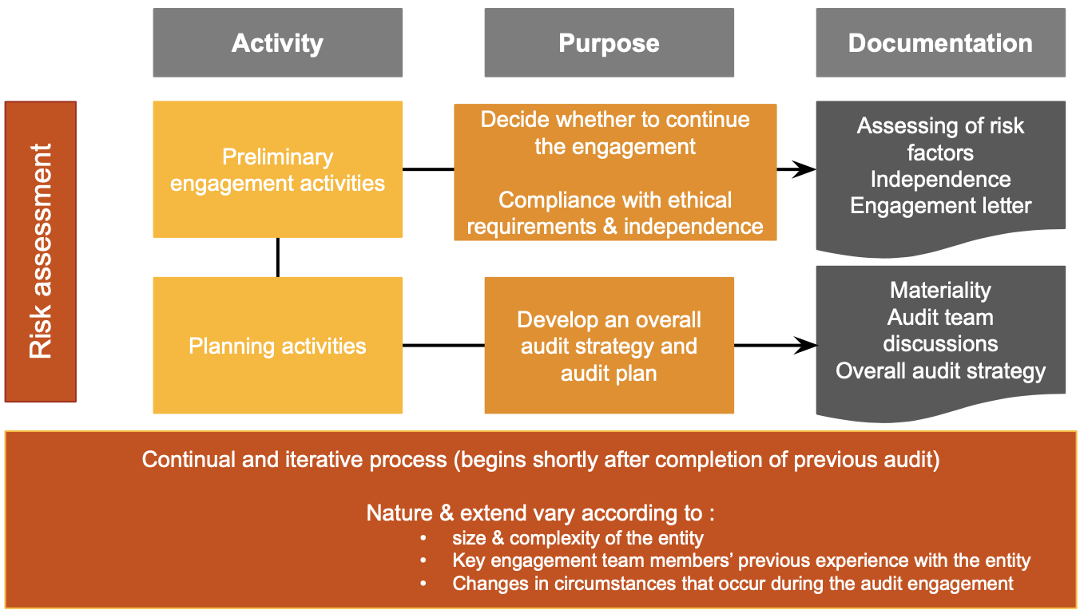
    - Assisting, in coordination of work done by auditors of components & experts
- Two stages of planning
    - Overall audit strategy
      - Engagement characteristics
      - Reporting objectives
      - Significant factors & experience (materiality, risk factors…)
      - Nature, timing & extent of resource necessary
    - Detailed audit plan
      - Nature, timing & extent of planned procedures
      - Risk assessment procedures
      - Further audit procedures
- Content of overall strategy
  - Engagement characteristics
    - Financial reporting framework used
    - Expected audit coverage, incl. number of components included
    - Consolidation setup – components audited by other auditors
    - Need for specialised expertise to address complex audit areas
    - Use of evidence obtained in previous audits
    - Availability (& reliability) of work of internal auditors
    - Use of service organisations
    - Effect of IT & availability of (client & personnel) data
  - Reporting objectives
    - Entity’s timetable for reporting
    - Timing of meetings with management to discuss audit
    - Communication with auditors of components
    - Any other expected communications with 3^{d} parties
  - Significant characteristics
    - Determination of materiality
    - Preliminary assessment of risks
      - At the overall financial statement level
      - Impact of the audit
    - Preliminary identification of
      - Material classes of transactions, account balances & disclosures
      - Areas where there might be a higher risk of material misstatement
    - Relevant results of previous audits, incl. identified control deficiencies etc.
    - Evidence of management’s attitude towards internal control
    - Volume of transactions
  - Significant changes & developments
    - Business developments affecting entity
    - Industry developments: changes in regulations etc.
    - Changes in financial reporting framework
    - Other relevant developments (ex. war, covid…)
  - Nature, timing & extent of resources required
    - Engagement team
    - Assignment of audit work to the team members
    - Engagement budgeting

Understanding the Entity & Risk Assessment ISA315 (Revised)
- ISA315R: enhanced auditing standard for identifying risks of material misstatement
- Key objectives
    - Encourage robust risk assessment, more focused responses to those identified risks
    - Modernise &update ISA for an evolving business environment
    - Promote consistency in application of procedures
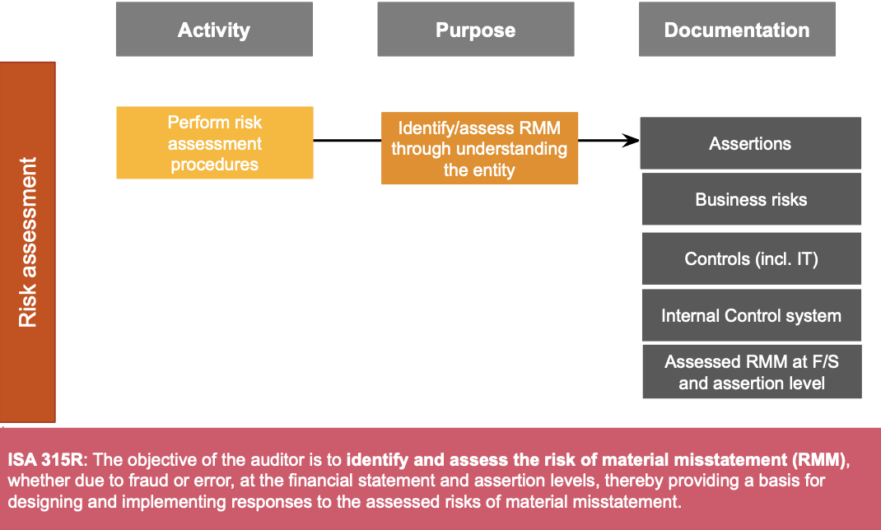
    - Make standard more usable by auditors of all entities (also if complex)
- Risk types
    - Business risk: things that could adversely affect the entity’s ability to achieve its objectives and execute its strategies
    - Fraud risk: events indicating pressure to commit fraud
    - Audit risk: risk that auditor expresses inappropriate opinion
- Risk assessment procedures
    - Inquiries
      - Management & other employees
      - Board & audit committee
      - Internal auditor
      - External parties (lawyers, banks…)
    - Observation & inspection
      - Inspect documents & records
      - Read internal & external reports
      - Visit premises & plant facilities
      - Trace transactions through the system (walkthroughs)
    - Analytical procedures: help identify inconsistencies, unusual transactions or amounts, ratios and trends
    - Unusual relationships can indicate risks of material misstatement & fraud
    - Comparing information to find unusual relationships, use
      - Information from prior periods & industry information
      - Anticipated results of the entity (budgets, forecasts…)
      - Relationships among elements of financial information
      - Relationships between financial & non-financial information
      - From client acceptance & continuance
      - Obtained from previous experience with the client
      - Discussion engagement teams
- Understand the entity
    - Organisational structure, ownership & business model
    - Industry, regulation & external factors
    - Measurement & review of financial performance
    - Applicable financial reporting frameworks & accounting policies
    - Internal controls

- Understand the internal control (IC) system
    - IC is process designed to provide reasonable assurance about achievement of entity’s objectives with regard to
      - Reliability of financial reporting
      - Effectiveness & efficiency of operations
      - Compliance with applicable laws & regulations
Look at process & controls to mitigate risks at entity & transaction level
- Entity’s risk assessment process
    - Identify business risks relevant to financial reporting objectives
      - Throughout process of obtaining understanding of entity
      - At financial statement & classes of transactions level
      - Relate risks identified to material financial statement areas
    - Assess significance of those risks, including likelihood of occurrence
      - Risk assessment based on likelihood & magnitude of risks
    - Address those risks
- Factors that may indicate significant risk s
    - Risk of fraud
    - Risk relating to recent significant developments
    - Complexity of transactions
    - Significant transactions with related parties or outside normal business
    - Degree of subjectivity in measurement of financial information
- Areas always at risk
    - Fraud in revenue recognition
    - Management override of controls

Audit Materiality ISA 320
- Material if omission/misstatement could influence decisions taken on basis of the FS
- Materiality depends on size of item or error judged
- Objective of audit: express opinion whether FS are not materially misstated
- Materiality vs. audit risk
    - Auditor decides what & how to investigate based on materiality
Try to reduce audit risk to acceptably low level
    - Inverse relationship between materiality & audit risk
    - Auditor’s assessment of materiality can change throughout audit process
- Professional judgement
    - Auditor decides on materiality related to transactions, account balances…
Matter of professional judgement
    - Starting point: apply percentages to chosen benchmark
    - Factors affecting benchmark selection
      - Which elements are presented in the financial statements
      - On which items does the user focus most
      - Internal & external environment of entity & its ownership structure
      - Relative volatility of the benchmark
- Evaluating effect of misstatements
    - Is aggregate of identified uncorrected misstatements material?
    - Management refuses to adjust & misstatements are material: audit report must be adjusted in accordance with ISA701
    - Aggregate of misstatements approaches materiality level: additional audit procedures should be conducted
- If there is material misstatement resulting from error, auditor should communicate this to appropriate management and consider reporting it to those charged with governance
Responsive Audit Plan
- Risk response: obtain sufficient audit evidence through implementing responses to risks
- Develop responsive audit plan
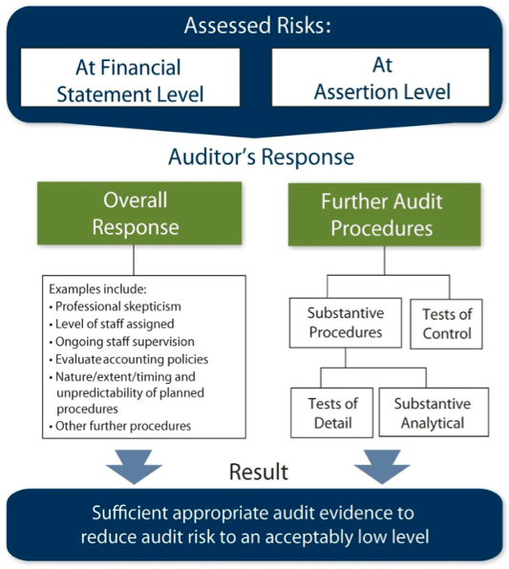
  - Respond to risks as F/S level
  - Respond to risks at assertion level
    - Are internal controls reliable? If so, test them (test of controls)
    - If n° transaction is very small, use substantive procedures (more efficient)
    - If some assertions cannot be verified by substantive testing, use internal test of controls
- Test of controls: obtain evidence about operating effectiveness of controls
    - How are they applied
    - Consistency with which they are applied
    - By who or by what means are they applied
    - Testing needs to be done throughout period
- Substantive procedures
    - Auditor performs substantive tests for each material class of transactions, account balance & disclosure
    - Performed irrespective of assessed risks
    - Tailored to specific risks of MM, avoid defaulting to standard procedures
    - Related to financial statement closing process, it’s required to
      - Agree or reconcile FS with underlying accounting records
      - Examine material journal entries & other adjustments made

Using Work of Internal Auditors ISA610
- Internal audit department in large entities to assess effectiveness of internal controls
- Scope of internal audit activities
    - Monitoring certain elements of internal control
    - Examination of financial & operational information
    - Review of operating activities
    - Review of compliance with laws & regulations
    - Risk management and/or governance
- ISA610 deals with external auditor’s responsibilities when using work of internal auditors
    - External auditor not obliged to use their work
    - Whether & to what extend can internal work be used
    - Whether the internal work is adequate for an external auditor
- External auditor performs audit procedures on internal audit department to assess adequacy
- External auditor has sole responsibility, cannot reference internal audit work in opinion
Using Work of an Expert ISA620
- Who is an auditor’s expert
    - Individual or organisation
    - Expertise other than accounting & auditing
    - Internal or external to firm
    - Assists auditor in obtaining sufficient appropriate audit evidence
- Objectives of ISA620
    - Determine whether to use work of auditor’s expert
    - Determine whether work is adequate for audit purposes
- Standard requires overriding question: is auditor’s expert needed for this engagement
    - Nature, significance & complexity of the matter
    - Has management used an expert
    - What are related risks of material misstatement
    - What sort of procedures are likely to be necessary
- Expert should be thoroughly evaluated by auditor
    - Competence & capabilities
    - Objectivity towards firm
- Expert agreement
    - Nature, scope & objectives of expert’s work
    - Respective roles & responsibilities of auditor & expert
    - Communication between both
    - Need for expert to observe confidentiality requirements
- Reporting implications
    - No reference to expert in unmodified report
      - Unless required by law, then indicate reference does not reduce auditor’s responsibility

3. Fraud ISA240

Fraud Principles
- Purpose of audit regarding fraud
    - Not responsibility to detect (all) fraud
    - Responsibility to detect material misstatements resulting from fraud
- Fraud ≠ error (intentional vs. unintentional)
- Two types of intentional misstatement
    - Misappropriation of assets
    - Fraudulent financial reporting

Characteristics of Fraud
- fraud triangle
- Rationalisation: justification of fraud
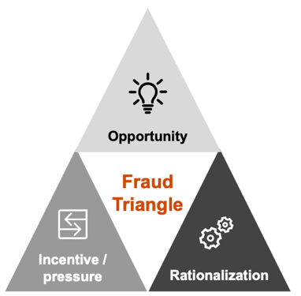
    - ‘They owe me’ / ‘I earned it’
    - ‘I need it more than they do’ / ‘I’m only borrowing’
    - Low morale among senior management
- Incentive & pressure
    - High degree of competition
    - Pressure to achieve targets (high bonusses)
    - Operating losses, negative CFO
    - Need to obtain additional financing

- Opportunity
    - Ineffective monitoring of management
    - Complex or unstable organisational structure
    - Deficiencies in internal controls

Prevention & Detection
- Management has primary responsibility
    - Adopt & implement internal control policies
    - Establish a control environment & activities to address risks
    - Assess & analyse risks
    - Monitoring activities
- Responsibility of auditor
    - Conduct audit by obtaining reasonable assurance that FS are free from material misstatements caused by fraud or error
    - Risk of not detecting material misstatement from fraud is higher than from error, because fraud may involve complicated schemes
    - Responsible for maintaining professional scepticism during audit
- Risk assessment procedures
    - During management inquiry
      - Assessment of material misstatement (MM) due to fraud
      - Process of identifying & responding to the risk of fraud
      - Communication with TCWG regarding the above
      - Communication to employees regarding ethical behaviour
    - Those charged with governance (TCWG): actual/suspect of fraud
    - Obtain understanding of how TCWG exercises oversight
    - Evaluate unusual relationships identified in analytical procedures
    - Evaluate fraud risk factors
- Presumed significant risk of fraud
    - Management override of controls
      - Analytical review
      - Inquiry of management
      - Review accounting estimates for biases
      - Testing of manual journal entries
      - Unpredictability
    - Revenue recognition as a result of fraud
      - Analytical review
      - Confirming balances with customers, observe inventory
      - Cut-off testing, non-statistical sampling of revenue
      - Testing of manual journal entries in revenue

Evaluation of Evidence
- Perform overall analytical review at or near end of audit
- Consider whether misstatements are indicative of fraud
- Requirement to consider implication for audit where fraud exists
    - Reliability of other management representations
    - Reliability of evidence previously obtained
- Auditor unable to continue due to fraud
    - Exceptional circumstances can question auditor’s ability to continue
      - Entity does not take appropriate actions
      - Significant risk of material & pervasive fraud
      - Concerns about integrity or competence of management & TCWG
- Determine legal & professional responsibilities
    - Report to persons who made appointment or regulatory authorities
    - Consider appropriateness to withdraw

Communication about Fraud
- What the management representation letter says about fraud
    - Effective fulfilment of responsibility to implement IC to prevent fraud
    - Effective fulfilment of responsibility to prepare the financial statements
    - Disclosure of results of management's assessment of risk that FS may be misstated due to fraud
    - Disclosure of their knowledge of actual, suspected or alleged fraud
- If auditor has identified suspects of fraud
    - Communicate this on a timely basis to the appropriate level of management
    - If management or employees with significant roles in IC are involved
Communicate to TCWG on a timely basis
    - Consider whether this needs to be reported in auditor's report
    - Consider whether the auditor has a legal responsibility to report to a party outside the entity

Effect on Opinion
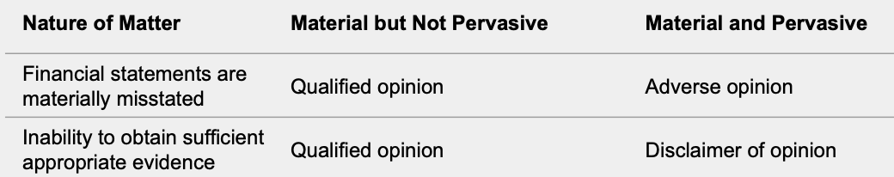
- Auditor’s judgement regarding pervasiveness of the matter
- Emphasis of matter paragraph
    - Matter does not cause opinion to be modified
    - Matter needs to be disclosed appropriately
    - Paragraph needs to refer to this disclosure
    - Only used if matter deemed to be fundamental for FS understanding

4. Financial Service Entities

Belgian Financial Service Market
- Banks: BNP > KBC > Belfius > ING…
- Insurances: AG > AXA > KBC > Ethias > Belfius…
- New players: Adyen, Keyrock, Unified Post…

Banking
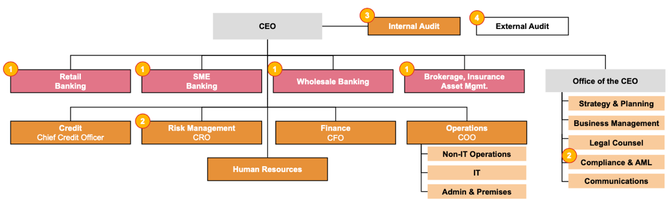
- Bank authorised by government to collect deposits, pay/receive interest, make loans…
Insurance
- Terms
    - Policyholder: pays for right to claim damages in case of uncertain event
    - Premium: amount paid by policyholder to be covered for a risk
    - Insurer: obligation to pay back policyholder in case of uncertain event
    - Provision: set aside to cover potential future payment to policyholder
- Received premiums: invested while awaiting possible claims
- Reinsuring
    - Insurer pays premium to reinsurer to insure potential losses on one or more contracts it has issued
    - Gives financial protection to insurer
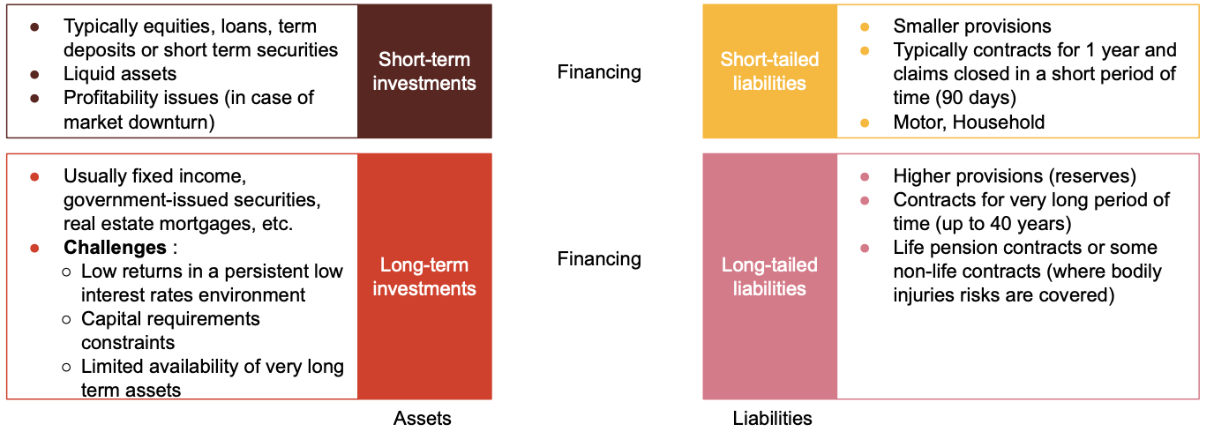
- Asset & liability management
Auditing Financial service Entities
- Working together with multiple experts
    - Market risk: valuation of derivatives & complex financial instruments
    - Credit risk: assessing credit risk models
    - Forensic: assistance for the risk of fraud
    - Valuation: valuation of (un)quoted (equity) investments
    - Actuaries: review of technical provisions
    - Tax: review of tax declarations & calculations
- Reporting responsibility towards supervisors
    - National bank of Belgium (NBB) and/or European central bank (ECB)
    - Financial services & markets authority (SMA)
- How financial institutions address fraud in their organisation
    - 3-lines of defence model
      - Strong governance
      - High level of maturity in internal controls (yearly assessment)
      - Regulatory expectations
    - Increasing importance of non-financial risks in risk management
    - Specific measures: anti-fraud committee, forensic audits…
    - Capital buffers to cover operational risks (incl. fraud risk)
- How auditors address fraud in financial institutions
    - Overall assessment of the risk of material misstatement due to fraud;
    - Understanding environment
      - Management objectives & incentives
      - Governance
      - Maturity of the control environment
      - 3 lines of defence
      - Entity level controls
    - Review of key controls in sensitive processes;
    - External confirmations (bank, dormant accounts, derivatives...)
    - Complaints review
    - Manual journal entry review
    - Inquiries with different committees and independent control functions, reading minutes of meetings
    - Professional scepticism during all audit procedures.

5. Audit Evidence ISA500

Audit Evidence
- Audit evidence to draw reasonable conclusions on which to base the opinion is obtained by
    - Risk assessment procedures
    - Further audit procedures
      - Test of controls
      - Test of details & substantive analytical procedures
- Rate evidence based on
    - Completeness: all transactions should be recorded
    - Accuracy: amounts are recorded accurately
    - Cut-off: transactions & events recorded in correct period
    - Existence/occurrence: transactions occurred and belong to entity
    - Classification & understandability: all appropriately presented & described
    - Rights & obligations: controls rights to assets & liabilities
    - Valuation & allocation: all is appropriately recorded & valued

Substantive Audit Procedures
- Collect audit evidence to investigate to which extent transactions were properly recorded & balances have a correct view
- Nature & extent of substantive procedures depend on audit planning & IC
- Substantive procedures exist of
    - Substantive analytical procedures
    - Test of details of accounts
- Substantive audit procedures need to be exercised in these areas
    - Inventories (physical observation)
    - Manual entries & other adjustments
    - Significant accounting estimates & assumptions
    - Significant unusual transactions
    - Reconciliation between FS and underlying accounts
- Factors to consider suitability of substantive analytical procedures
    - The assertions
    - The assessed risk of material misstatement
    - The tests of details
    - The level of evidence required
    - Disaggregation
    - Data reliability
    - Predictability
    - Type of analytical procedure
    - The use of entity's procedures
    - …

Test of Details
- Part of substantive audit procedures
- Performed when
    - Not enough evidence can be gained from test of controls and substantive analytical procedures
    - ISA requires to do so (ex. significant journal entries)
    - When it is more efficient than other ways of collecting evidence
- Types of tests
    - Observation, ex. examine whether inventory exists
    - Inquiry, ex. as personnel to explain
    - Recalculation, ex. check mathematic accuracy of a report
    - Reconciliation, ex. reconcile subsidiary account to general ledger
    - Confirmation, ex. confirm account balances with 3^{d} parties
    - Reperformance, ex. reconciliation of bank with general ledger
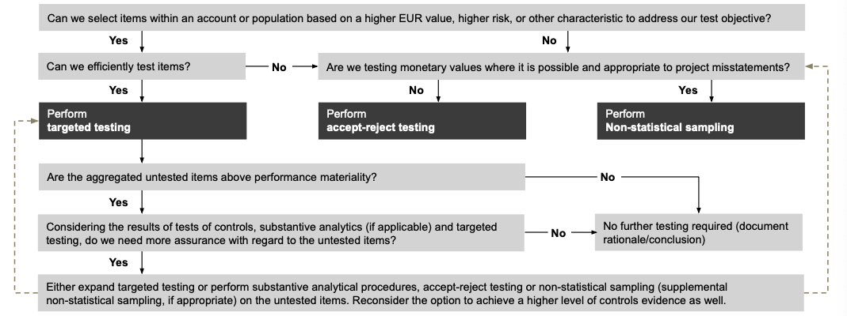
    - Inspection tests, ex. test cut-off date

- Test selection procedures: which items to apply test of details to?
    - Targeted testing: select items to test based on some characteristics
      - Applied to specific part or whole account
      - Results are not projected to untested items in population
    - Accept-reject testing: interested in one specific metric or attribute
      - Used when not testing monetary values
      - Do not project misstatement for the entire population
    - Audit sampling
      - Application of audit procedures to a representative group of items
      - To evaluate some characteristic of entire population
      - Performed when: not enough evidence from tests of controls, substantive analytical procedures, targeted testing and when accept-reject testing is not appropriate

Covid 19 Impact
- Concerns
    - Liquidity: potential short-term going concern issues
    - Disruptions of supply chain: could impact sourcing costs of materials
    - Reduction in revenues: declining demand
    - Provisions in critical customer/supply agreements could be triggered
    - Potential (non-)financial covenant defaults
    - Credit downgrades: obstruct ability to access adequate financing
    - Potential changes in internal controls due to telework etc.
- Risk assessment needs to be continuously updated
- Some areas where risks should be closely monitored: going-concern issues, goodwill, deferred tax assets, impairment losses, hedging exposure…
- Additional audit procedures needed, like
    - Review & validate stress tests on ability to generate cash, access to financing
    - Review of updated impairment analyses
    - Review of valuation of accounts receivable & financial instruments
    - Review on deferred tax assets
    - Review of reduced movement in inventories
    - …
- Going concern assumptions? (see later)

6. Accounting Estimates ISA540 (Revised)

Risk Assessment
- To obtain sufficient appropriate audit evidence about whether
    - Accounting estimates, incl. fair value accounting estimates, are reasonable
    - Related disclosures are adequate
- Understanding how management makes accounting estimates, and of underlying data
    - Relevant controls
    - Whether an expert has been used
    - The underlying assumptions
    - How management has assessed the effects of estimation uncertainty
    - Method used & changes in the method from the prior period.

Methods
- Using information on the subsequent events of the reporting period
- Validate how estimates have been made, reasonableness of the assumptions made
- Testing the effectiveness of internal controls over the estimation method (test of control)
- Develop an estimate interval

7. Subsequent Events ISA560
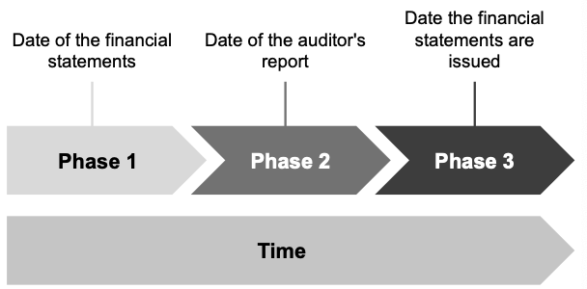
Phases
- Subsequent events
    - Events occurring between the date of the FS and the date of the report
    - Facts that become known to the auditor after the date of its report
- Types of events
    - Adjusting events: needs to be adjusted, ex. bankruptcy of important client
    - Non-adjusting events: does not need adjustment, ex. decline in market value of investments after year-end
    - Disclosure events: needs to be disclosed, ex. fire destroying a factory

War in Ukraine
- Economic sanctions: examples of sanctions that may directly affect an entity's operations
    - Prohibitions of transactions with certain individuals and financial institutions
    - Export controls & territory embargoes
    - Blockage of access to the SWIFT system for specific Russian banks
- Financial reporting considerations
    - Reporting periods ending on or before 31 January 2022
      - Non-adjusting event, but event is to be considered in the entity’s assessment of their ability to continue as a going concern
    - Reporting periods ending after 31 January 2022
      - Evaluate management’s assessment of impact of conflict on the financial statements as of the reporting date
    - All reporting dates
      - Significant risks and uncertainties relevant to business viability
      - New legal & regulatory compliance matters
      - Business interruptions & uncertainties due to sanctions
      - Impacts on asset valuations, including credit & market risks
      - Cybersecurity risks relevant to the entity
      - Other changes in the entity’s business environment
- Going-concern considerations
    - Changes in management's expected operating results & cash flows
    - Changes in management's assessment of its liquidity
      - Likelihood of non-compliance with debt covenants
      - Impact of material adverse change clauses in contracts
      - Inability to raise new capital due to market volatility
      - Adequacy of the disclosure about the material uncertainty
- Material misstatements
    - Supply chain disruptions
Higher valuation risk for some long-lived assets or goodwill
    - Operational disruptions: profitability & cash flows
May lead to short and/or long-term liquidity challenges
    - Payment and inter-entity transfer disruptions
    - Ownership changes and business discontinuance
    - Investment risks
    - Accounting estimates: impairment risks
    - Legal and regulatory compliance
- Group audit considerations
- Audit reporting considerations
    - Modifications to the auditor's opinion due to material misstatements or inability to obtain sufficient appropriate audit evidence
    - Inclusion of key audit matters
    - Addition of an emphasis of matter paragraph
    - Inclusion of going-concern material uncertainty section

8. Evaluating Misstatements ISA450

ISA450 Objectives
- Evaluate
    - Effect of identified misstatement on the audit
    - Effect of uncorrected misstatement on the FS
- Definition of misstatement: difference between what is reported & what is expected or needed for true and fair view/fair presentation
    - Factual misstatements
    - Judgmental misstatements
    - Projected misstatements
- Misstatements should be evaluated in light of the misstatement itself and of IC weaknesses

Communication of Misstatements
- Communicate misstatements accumulated during the audit on a timely basis
- Discuss with management to correct them
- Obtain reasons for any misstatement not corrected
- Take it into account when evaluating whether FS are free from material misstatement
- Communicate (involvement audit committee) uncorrected misstatements & their effect on auditor’s opinion

Evaluation of Uncorrected Misstatements
- Before evaluation: reassess materiality levels for FS as a whole and specific amounts
- Evaluate effects of uncorrected misstatements on FS, both individually & in aggregate
    - Quantitative criteria
      - Size & nature of misstatements
      - Effect of uncorrected misstatements related to prior periods
    - Qualitative criteria
      - Effect on compliance with regulatory requirements, debt covenants
      - Mask change in earnings or other trends
      - Increase management compensation
      - Likelihood of having a material effect on future periods F/S
      - Effect on company financial ratios
9. Reporting on FS ISA700

ISA700 Objectives
- Auditor objectives
    - Form opinion on FS based on evaluation drawn from evidence obtained
    - Express opinion clearly through written report
- Forming an opinion
    - Report should contain a clear expression of opinion on the FS
    - Opinion on a complete set of general-purpose FS prepared in accordance with a reporting framework, designed to achieve fair presentation
      - Whether the FS give a true and fair view
      - Whether FS are presented fairly, in all material respect
    - Auditor evaluates conclusions drawn from the audit evidence obtained
- To form opinion: auditor must obtain reasonable assurance about whether FS are free from material misstatement, whether due to fraud or error
- Auditor’s conclusion takes into account
    - In accordance with ISA 330, whether sufficient audit evidence is obtained
    - In accordance with ISA 450, whether uncorrected misstatements are material, individually or in aggregate
    - Accounting policies applied are consistent & appropriate
    - Accounting estimates made by management are reasonable
    - Information presented is relevant, reliable, comparable & understandable
    - FS provide sufficient disclosures to enable users to understand the effect of material transactions and events on the information conveyed in the FS
Elements of the Report
- Title
- Addressee
- Auditor’s opinion
    - Identify the entity whose FS have been audited
    - Identify the title of each of the FS
    - Refer to the summary of significant accounting policies
    - Specify the date and period covered by the FS.
    - States whether the FS "give a true and fair view"
- Basis for opinion
    - States that the audit was conducted in accordance with ISA
    - Refers to section of report with auditor responsibilities
    - States that the auditor has fulfilled ethical responsibilities
    - Audit evidence is sufficient & appropriate to provide a basis for the opinion
- Going-concern (if applicable, ISA 570)
- Key audit matters (for listed entities, ISA 701)
- Responsibilities of management for the financial statements
    - Describe management’s responsibility for:
      - Preparing the FS in accordance with the applicable framework
      - Internal control as management determines is necessary
- Auditor’s responsibility
    - State that the objectives of the auditor are to:
      - Obtain assurance about whether the FS are right
      - Issue an auditor’s report that includes the auditor’s opinion
    - State that reasonable assurance = high level assurance, but not a guarantee

    - State that misstatements can arise from fraud or error, and either:
      - Describe when they are considered material
      - Provide a definition or description of materiality
    - State that the auditor exercises professional judgment and maintains professional scepticism throughout the audit
    - Describe an audit by stating that the auditor's responsibilities are:
      - Identify & assess risks of material misstatement
      - Design & perform audit procedures; obtain audit evidence
      - To obtain an understanding of IC
      - Evaluate appropriateness of accounting policies used
      - Evaluate reasonableness of accounting estimates
      - Conclude on management's use of the going concern basis and whether a material uncertainty exists.
    - State that auditor communicates with TCWG regarding the scope & timing
    - For listed entities, state that the auditor provides TCWG with a statement that the auditor has complied with independence requirements
    - If KAM are communicated, state that, the auditor determines those matters that were of most significance in the audit of the FS
- Other reporting responsibilities (incl. non-financial information)
- Statements regarding independence
- Name of the engagement partner
- Auditor's signature
- Auditor's address
- Date of the report

Key Audit Matters (KAMs)
- Matters of most significance in the audit (selected by professional judgement)
- Selected from matters communicated to TCWG, based on
    - Areas of higher assessed risks of material misstatement
    - Significant management judgement (ex. estimates of high uncertainty)
    - Effect on audit judgement
- ISA requirements
    - Why is matter considered of high significance
    - How is matter addressed in the audit
    - Describe most relevant aspects & brief overview of procedures performed
    - May include indication of outcome of procedures or key observations
    - Reference to related disclosures

Types of Audit Opinions ISA705-706
- ‘Clean opinion’: Unqualified audit opinion
    - FS give true & fair view in all material aspects
    - Emphasis of a matter paragraph can be included: paragraph explaining matters that do not affect opinion, but should be emphasized to users
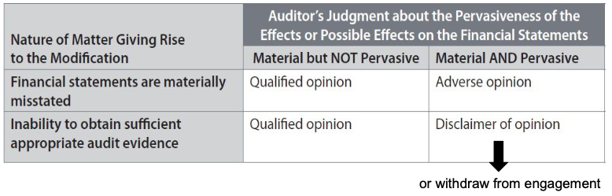
- ‘Modified’ opinion: qualified/ adverse opinion or disclaimer of opinion
- Pervasive effects on FS are those that:
    - Are not confined to specific elements; accounts or items of the FS
    - If so confined, (could) represent a substantial portion of the FS
    - In relation to disclosures, are fundamental to user’s understanding of FS

10. Going Concern ISA570

ISA570 Objectives
- Auditor objectives
    - Obtain sufficient appropriate audit evidence regarding management's use of the going concern assumption in the preparation of FS
    - Conclude whether uncertainty exists about continuing as a going concern
    - To determine the implications for the auditor's report
- Going-concern assumption: entity viewed as continuing for the foreseeable future
- TCWG must determine if application of going concern assumption is appropriate
Management has prime responsibility
- Auditors’ responsibility: be satisfied that going concern basis is appropriate
- Clean audit opinion doesn’t guarantee company remains going-concern until next period
Judgement only valid at date of report, taking into account all facts known up until then
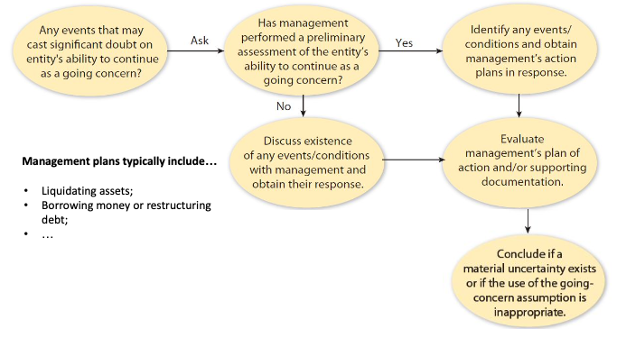
Reporting
- Emphasis of matter paragraph: no uncertainty about going-concern
- Emphasis of matter paragraph on going concern
    - Significant uncertainty on going concern exists
    - Auditor agrees with continuity
    - Appropriate disclosure exists
- Emphasis of matter paragraph on a letter of financial support
    - Absence of uncertainty is based on a letter of financial support
    - Auditor agrees with the continuity
    - Appropriate disclosure exists
    - Auditor believes that this information is fundamental for the users of the financial statements.
- Disclaimer of opinion
    - Material uncertainty on going concern exists, but auditor is not in a position to conclude (scope limitation)
    - Management has not yet made its assessment about going-concern
- Qualified audit report
    - Significant uncertainty on going concern exists,
    - Auditor agrees with the continuity, but disclosure is incomplete
- Negative audit report
    - Significant uncertainty on going concern exists
    - Either
      - Auditor doesn’t agree with application of continuity valuation rules
      - Auditor agrees with the continuity, but disclosure does not exist
- Close call situations
    - Condition identified that may cast significant doubt on going-concern ability
    - There is a plan to deal with this, concluding there is no material uncertainty

11. Quality Control

ISQC1 vs. ISA220 (Revised)
- Safeguards to audit quality: auditor conduct
    - Auditing standards
    - Code of ethics
    - Continuing education & CPA exams / internships
    - EU & national regulation
    - Quality control
- ISCQ1: quality control at level of audit firm
- ISA 220R: quality control for engagement team, applicable to individual audit engagement
- Elements of quality control system
  - ISQC1
    - Leadership responsibilities for quality within the firm
    - Relevant ethical requirements
    - Acceptance & continuance of client relationships & specific engagements
    - Human resources
    - Engagement performance
    - Monitoring
  - ISA 220R
    - Leadership responsibilities for quality on audits
    - Relevant ethical requirements
    - Acceptance & continuance of client relationships & audit engagements
    - Assignment of engagement teams
    - Engagement performance
    - Monitoring

Leadership Responsibilities
- ISQC1
    - CEO of audit firm is responsible
    - Culture of quality from top-down: ultimate responsibility with board
    - Operational responsibilities for quality control
      - Engagement quality control reviews
      - Setting QC policies & procedures
      - Monitoring
    - Commercial considerations shouldn’t override management responsibilities
    - Provision of sufficient resources for quality control policies & procedures
- ISA 220R
    - Engaging partner of audit firm is responsible
    - Perform work that complies with standards & legal requirements
    - Complying with firm's quality control policies & procedures as applicable
    - Issuing auditor's reports that are appropriate in the circumstances
    - Engagement team's ability to raise concerns without fear

Ethical Requirements
- ISQC1: procedures that provide reasonable assurance of compliance to ethical rules
- ISA 220R: engagement partner remains alert for evidence of non-compliance
- Fundamental ethics principles
    - Integrity
    - Objectivity
    - Professional competence & due care
    - Confidentiality
    - Professional behaviour
Independence
- In fact: objective & unbiased in their actions
- In appearance: perceived by knowledgeable users of FS as independent
- Types of independence
    - Planning independence
      - Auditors have freedom to develop own program
      - Program must be within bounds of engagement

    - Investigative independence
      - No legitimate source of information is closed to auditors
      - Requires that auditors have freedom to examine information that auditors themselves deem to be relevant
    - Reporting independence: report content determined by scope examination
- Safeguards
    - Professional practice
      - Education, training, practical experience requirements
    - Audit firm safeguards
      - Adherence to standards governing quality (ISQC 1 and ISA 220R)
      - Internal quality review
      - Mandatory rotation of audit engagement personnel
      - Annual declaration of independence
    - Client safeguards
      - Approval of non-audit services by audit committee
      - Presence of competent management who are financially literate
    - Other safeguards provided by Belgian law
      - Audit firm rotation for PIEs after 9 years
      - Forbidden non-audit services
      - Cooling-off period of 2 years
      - One to one rule for non-PIEs, 70% rule for PIEs
      - No contingent fees
      - No personal or business / financial relationship with client
- ISQC1
    - Relevant policies and procedures to assure independence are:
      - Setting out criteria for determining the need for safeguards to reduce the familiarity threat to an acceptable level
      - Requiring rotation of the engagement partner & individuals responsible for engagement quality control review
    - These policies enable firm to
      - Communicate its independence requirements to its personnel
      - Identify & evaluate situations that create threats to independence and to take appropriate action
    - These policies require
      - Engagement partners to provide the firm with relevant information about client engagements
      - Personnel to notify firm of situation that is a threat to independence
    - Firm obtains written confirmation of compliance with its policies on independence from all firm personnel at least yearly
- ISA 220R
    - Engagement partner has to
      - Obtain relevant information from the firm to identify situations that create threats to independence;
      - Evaluate information on identified breaches of the firm's independence policy & procedures
      - Take appropriate action to eliminate threats or reduce them to an acceptable level by applying safeguards
    - Engagement leader shall report to the firm any inability to resolve the matter for appropriate action
Client Relationships
- ISQC1
    - Firms need policies for acceptance & continuance of clients
    - Must assure
      - Competent to perform the engagement
      - Can comply with relevant ethical requirements
      - Has considered integrity of the client
    - Policies for continuance of the engagement
      - Professional & legal responsibilities applying to the situation
      - Possibility of withdrawing from the engagement
- ISA 220R
    - Engagement partner has to
      - Assure procedures regarding acceptance & continuance of client relationship have been followed
      - Determine that conclusions reached in this regard are appropriate
    - Engagement firm should report information about breaches to audit firm
- Human resources
    - Make sure there is sufficient & capable personnel to perform audit
    - Engagement team needs appropriate competences
      - Understanding of audit engagements of a similar nature
      - Understanding of professional standards & legal requirements
      - Technical expertise
      - Knowledge of relevant industries in which the client operates
      - Ability to apply professional judgement
      - Understanding of the firm's quality control policies and procedures

Engagement Performance
- Needs to be up to professional standard
- Policies & procedures of audit firm have to assure that
    - Appropriate consultation takes place on difficult or contentious matters
    - Sufficient resources are available to enable appropriate consultation to take place
    - Nature & scope of consultations are documented & are agreed by both the individual seeking consultation and the individual consulted
    - Conclusions resulting from consultations are implemented
- Engagement quality control review is needed and should include
    - Discussion of significant matters
    - Financial statements
    - Selected working papers and documentation
    - Appropriateness of report and underlying conclusions
- ISA 220R: engagement partner takes responsibility for
    - Reviews being performed in accordance with the firm's review policies
    - Engagement team undertaking appropriate consultation on difficult matters
    - Not dating the auditor's report until the completion of quality control review
    - Following the firm's policies for dealing with differences of opinion within the engagement team

Monitoring
- ISQC1: monitoring process needed that
    - Includes ongoing evaluation of the firm's system of quality control
    - Requires responsibility for the monitoring process to be assigned to a partner
    - Requires that those performing the engagement or the engagement quality control review are not involved in inspecting the engagements
    - Goals of monitoring
      - Evaluate the effect of deficiencies noted
      - Communicate deficiencies noted to relevant engagement partners
      - Undertake appropriate remedial actions
      - Communicate annually results to engagement partners
- ISA 220R
    - Engagement partner must consider
      - Results of firm's monitoring process as evidenced in the latest information circulated by the firm
      - If deficiencies noted in information may affect audit engagement
    - Deficiency in firm's system of quality control doesn’t indicate that audit engagement wasn’t performed in accordance with professional standards

Transparency Reports
- Annual reports on audit transparency disclose
    - Legal structure, ownership & governance structure
    - Internal quality control system & quality assurance review
    - Education & independence practices
    - Partner remuneration
    - Financial transformation
- Do transparency reports reveal audit quality
    - Yes
      - Useful signalling tool to signal quality investors
      - Positive influence on auditor appointment decisions
    - No
      - Audit firms may not agree that info is meaningful for public
      - Disclosure = merely marketing of audit firms?
      - No monitoring of reliability of this information
      - Disclosure may consist of boilerplate statements
- Research based on auditor continuous education, independence, internal quality control
    - There is variation in extent & type of disclosures across audit firms
Suggests transparency report is not just fulfilment of legal requirements
    - No evidence that disclosure is associated with actual audit quality

