Introduction to Auditing
Summary of classes by dr. Ditmir Sufaj, summer semester 2024

1. Introduction

What is an Audit
- “An economically motivated professional service designed to reduce information risk that relies on the knowledge and skills of experts used in a systematic process that considers the idiosyncratic needs of a client where the outcome is unobservable and subject to market forces and regulatory constraints.”
- Focus in this course: financial audit
- Audit quality
    - Probability that auditor detects & reports fraud/errors in financial statement
    - Detect: expertise in the profession (professional scepticism)
    - Report: independence from the client, integrity
    - Always some audit risk left, no matter how good auditor is
Auditors sell an opinion
- Audit service has attributes of both experience goods & credence goods
    - Experience goods: only know quality after use (ex. restaurant)
    - Credence goods: difficult to determine quality even after use
Auditor reputation is crucial for the audit to be valuable
      - Higher reputation: can charge higher fees
      - Reputation damage can negatively impact audit firm’s clients
(ex. Arthur Andersen surrendered license after Enron scandal)

Why Auditing
- Mandatory for many companies, depending on local regulation
- Valuable for stake-/shareholders: costs of audit < benefits of audit
- Reasons for voluntary audit demand
  - Information demand
    - Stakeholders want to make rational investment decisions
    - Financial reporting has role in efficient allocation of savings to investments
    - Allocation not trivial due to
      - Information asymmetry
      - Moral hazard problem
Consequence: investors need credible information intermediaries
  - Agency or contracting demand
    - Monitoring role of auditing
    - If ownership & control are separated, managers can act out of own interest
    - Agency rationale for audit demand: prove of performance to shareholders
    - Contract monitoring role: audits can improve contract efficiency (ex. higher quality audit report can lead to lower cost of debt)
  - Insurance or deep pocket demand
    - Audit demand derived from exposure for losses attributable to defective financial statements
    - Auditor’s professional liability exposure creates incentive to insure themselves against bankruptcy risk via auditor’s participation
    - Auditors have liability burden, shifting some bankruptcy risk to them
    - Depth of audit pocket
      - Wealth audit firm has at start of the year
      - Deeper pockets = more wealth at risk from litigation & sanctions
Audit Supply & Production
- Supply & production
    - By certified auditors & their audit teams
    - Audit supply & production are regulated (ex. IBR in Belgium)
    - Production is labour intensive (main focus of course)
- Tiers of audit firms
    - The big N firms
      - Price Waterhouse Coopers (PwC)
      - Deloitte & Touche
      - Ernst & Young (EY)
      - KPMG

Audit Markets
- Two effects & streams of evidence about competing audit firms
    - Differentiation strategy: higher quality leads to higher fees & market share
Industry specialisation can also be a differentiation strategy
    - Cost leadership strategy: efficiency leads to lower fees & more market share
- Market characteristics
    - High market concentration (oligopoly), no perfect competition
      - Each firm can impact market conditions
      - Competitive actions are interdependent
      - Costs & benefits to competition
      - Firms don’t necessarily actively collude
    - Concentration doesn’t seem to affect audit quality
    - Different market segments can have different type of competition
    - Product differentiation in audit market: large vs. small auditors, industry specialist vs. non-specialist auditors…
- Empirical evidence that product differentiation is associated with higher quality & price
    - Big 4 & industry specialist premiums: positive association between concentration and fees, but no quality effects
    - Price premiums in private client segments when market share distance to closest competitor is larger
    - Big 4 expand market share by offering discounts to non-big 4 clients
    - Production efficiencies for industry specialists, passed on to clients (lower fees) unless there is market power
- Growing concern about whether there is sufficient competition in audit market
    - There is a given demand
    - High entry barriers
    - High market concentration
      - Lack of choice for large public firms
      - Resulting in price & quality effects

2. Audit Regulation

Audit Regulation
- Auditor independence & quality concerns
    - Regulations often introduced after financial scandals like Enron & Wirecard
    - Conflict of interest
      - Auditors paid by client to give an opinion
      - Auditors provide many non-audit services to client (more profitable)
      - Significant revenue by client can jeopardize auditor independence
- Concerns about lack of competition (or auditor choice)
    - Only few firms can satisfy the need of large publicly listed companies
    - Fear that market will become more concentrated if one of Big 4 collapses
- Welfare economics arguments for regulation
    - When there is market failure: caused by lack of information, competition…
    - When quantity or quality of good differs from socially efficient outcome
- Regulation types
    - Ex ante policy instruments
      - Modify behaviour in immediate way through requirements
      - Rules can be pronounced directly by states or another body
    - Ex post liability
      - Works through deterrent effect of damage actions that may be brought after harm has occurred
      - Threat of punishment / law suit causes potential injurer to internalise expected social harm and take optimal precautions
- Audit regulation in place
    - Ex ante audit demand regulation: mandatory audit requirements
    - Ex ante product quality regulation: auditing standards, independence rules…
    - Ex post product quality regulation
      - Threat of litigation affects audit production behaviour
      - Different liability regimes affect behaviours in differently (EU vs. US)

Audit Regulation in the US
- Sarbanes-Oxley Act (2002)
    - Establishes ‘Public Company Accounting Oversight Board’ (PCAOB)
      - Replaces professional bodies (peer review inspections)
      - Independent from the audit profession (external inspections)
      - Registration is mandatory for auditors of publicly listed firms
      - Role: issue auditing standards & inspect audit firms
    - Impose non-audit service restrictions
      - Forbidden non-audit services for incumbent auditors (ex. bookkeeping, valuation, internal audit…)
      - To improve auditor independence
    - Impose partner rotation (5y)
      - Reduce familiarity between partner & client
      - In US only partner rotation, not audit firm rotation!
    - Publicly listed companies have to introduce audit committees
      - Responsible for overseeing internal preparation of FS and the hiring & communication with the auditor
      - Committee is independent from executives
      - Contains at least 1 financial expert
    - CEO & CFO have to sign quarterly financial statements
      - Makes executives more accountable
      - Significant penalties in case of fraudulent activities
    - Integrated audit report (financial statements + internal controls)
      - Before Act, they only provided opinion on financial statements

Audit Regulation in the EU
- Audit Directive (2006)
    - Stronger public oversight, overseeing auditor inspections
    - Disciplinary commission composed of a majority of non-auditors
    - Public disclosure of audit fees & non-audit fees
    - Audit partner rotation for PIEs (Public Interest Entities) every 7y
    - Transparency report by audit firms which have PIEs in client portfolio
      - Governance of audit firms (network & legal organisation)
      - How is audit quality / independence assured & monitored
      - Names of PIEs the audit firm audits
- EU Green Paper (2010) EU Regulation & Directive (2014)
    - Major aim: strengthen confidence of reported FS & improve quality
    - Main objectives of audit reform
      - Reinforce auditor independence & professional scepticism
      - Make top end of audit market more dynamic
      - Reduce unnecessary burdens on SMEs
      - Improve auditor supervision
      - Ensure higher level of transparency in companies’ reported FS
- Audit Reform (2014)
  - Stricter independence rules
    - PIEs: mandatory audit firm or ‘external’ rotation at least every 10y (MAFR)
      - Different implementations across EU
      - Possibility to extent until 20y after required public tendering process
      - Even extension to 24y possible in case of joint audits
    - In Belgium
      - Mandatory rotation every 9y for PIEs
      - Possibility to extent until 18y after required public tendering process
      - Even extension to 24y possible in case of joint audits
  - Stricter independence rules; forbidden non-audit services (NAS)
    - 70% rule for PIEs: NAS fees cannot be higher than 70% of audit fees
    - For all NAS: supply of service can’t compromise auditor independence
    - Six forbidden NAS for PIEs
      - Certain tax services
      - Payroll services
      - Legal services: general counsel, negotiations & advocacy roles in resolution of litigation
      - Services linked to financing, capital structure/allocation & investment strategies
      - Underwriting, promoting or dealing in shares of audited entity
      - HR services: structuring of organisation design & cost controls
  - Expanded audit reports
    - Expanded report to reduce information asymmetry
      - Introduction of key audit matters (KAMs) in the report
      - Risk description & response by auditors
      - Disclosure of materiality level & base
  - Increased public oversight
    - Professional bodies coming from auditing profession (peer reviews)
    - Public oversight bodies: external (independent) from audit profession
    - Main tasks are quality control & system of oversight (inspections)
      - At least every 3 years for PIE auditors, 6y for non-PIE auditors
    - Quality control responsibility in Belgium
      - First, Kamer van Verwijzing en Instaatstelling (KVI)
      - Now shifting to College van Toezicht op de Bedrijfsrevisoren

Audit Regulation in Belgium
- History
    - 1953: creation of Instituut van Bedrijfsrevisoren (IBR)
No legal framework at the time
    - 1975: first accounting regulations & laws
    - 1985: recognition of accounting profession & mandatory audit requirements
- Company Act
    - Control of annual accounts, statutes… allocated to ‘commissarissen’
    - Commissaris: statutory auditor
    - Only registered auditors can act as ‘commissaris’
Strict monopoly for registered auditors (by IBR)
- Mandatory audit & appointment of ‘commissaris’ if firm exceeds 2 of these thresholds
    - Avg. employees > 50
    - Total turnover excl. VAT €9.000.000
    - Total assets €4.500.000
- Commissaris
    - Registered auditor (private individual)
    - Associated to an audit firm (mostly as partner, not employee)
    - Charged with execution of assignment on behalf of audit firm
    - Exclusive signature authority on behalf of audit firm
    - Signs audit report as representative of audit firm
- Law on corporate governance (2002)
    - Stricter independence rules
      - Cooling off period for auditors to get an executive function in client
      - Forbidden non-audit services for auditors & their network
      - One-to-one rule: auditor & network cannot earn more in non-audit fees than the amount they earned from audit fees
    - Advies & controle comit& (ACCOM)
      - Check if independence rules are followed
      - Decide on expmptions
      - ACCOM abolished later

3. Audit Objectives & Evidence

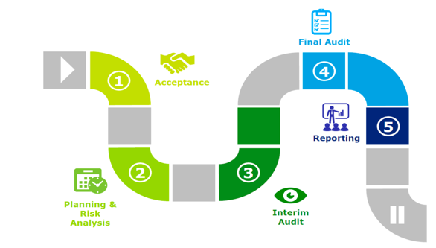
Audit Process
- Control risk: screening & acceptance of clients
    - Know your client to protect reputation
    - Elements to take into account
      - Reputation of client & industry
      - Who are the stakeholders & members on the board
      - Integrity & reputation of the management
      - Why did the firm change auditors?
    - Important factor for acceptance is independence
- Audit objectives & evidence are key components of audit process
    - Objectives: goals or purposes of audit engagement on different levels
    - Evidence: info collected by auditor to support their opinion on the FS
    - Both are closely related because evidence needed to reach goals

Audit Objectives
- Level 1: financial statements
    - Obtain reasonable assurance about the FS being free from errors & fraud
    - Enable auditor to express an opinion on whether the FS are prepared in accordance with the applicable framework
    - To report on the FS and communicate in accordance with auditor’s findings
- Level 2: financial statement cycles
    - Keep closely related account transactions together
    - Separating them into cycles: more effective audit
    - Audit objectives focus on specific business cycles or processes that are important to the organisation’s financial reporting
    - Evaluate specific cycles and ensure they are in compliance with regulations
    - Make sure all FS components are tested
    - All cycles
      - Sales & collection cycle
      - Payment & acquisition cycle
      - Payroll & personnel cycle
      - Inventory cycle
      - Investment & financing cycle
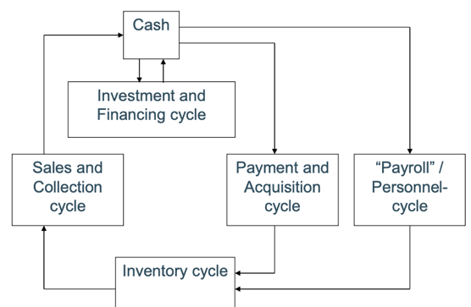
    - Relationships between cycles
- Level 3: Management assertions
    - Auditors are required to obtain sufficient & appropriate audit evidence in respect of all material financial statement assertions
Use of assertions are important in various audit stages
    - Management assertions = claims by client management about certain aspects of the business
      - Existence: all assets, liabilities… are valid and appropriately recorded
      - Completeness: all transactions have been recorded
      - Accuracy: all balances are appropriately valued
      - Rights & obligations: entity legally controls rights to its assets and its liabilities faithfully represents its obligations
      - Disclosure: transactions & balances are properly classified, all required disclosures are in the FS
- Level 4: General audit objectives for accounts
    - Selecting samples of information to ensure the info is fair
    - Transaction approach: select individual transactions in FS
    - Balance approach: select specific account balances in FS
- Level 5: Specific audit objectives for accounts
    - General audit objectives
      - An overall framework for an audit
      - Common to all audit engagement and FS items
    - Specific audit objectives
      - Detailed goals, designed to achieve general objectives
      - Provide detailed guidance about auditor’s work
Need specific objectives for all parts of FS

Audit Evidence Decisions
- Which procedures to use
    - ISA 500: objective is to design & perform audit procedures so auditor can gather appropriate evidence to draw conclusions based on its opinion
    - Audit programme: collection of all audit procedures performed
- Sample size & method
    - Cost of audit would exceed benefit if all transactions are audited
    - Sample definitions
      - Population: entire set of data
      - Sampling risk: risk that conclusion sample ≠ conclusion population
      - Non-sampling risk: other risks (mistakes etc.)
    - Two sample selection methods
      - Statistical: random selection or use of probability theory
      - Non-statistical: other type of samples
- Timing
    - When is the audit procedure performed
    - Which period is investigated

- Persuasiveness of Audit Evidence
  - Relevance
    - Audit procedures provide evidence relevant to certain assertions
    - Different procedures are relevant to check different assertions
  - Reliability is high when
    - Independent sources
    - Effective internal control mechanisms
    - Evidence obtained directly by auditor
    - Form of evidence important: original documents, oral…
    - Qualification of the source
    - Objectivity
  - Completeness
    - Sample size large enough
    - Need accurate and complete information (prices, volumes…)
  - Timeliness
    - Balance sheet items: as close as possible to balance sheet date
    - P&L account: testing & sampling over entire period
- Trade-off: persuasiveness vs. cost
    - Increasing persuasiveness increases costs significantly
    - Some minimum level needed
    - Auditor decides trade-off

Types of Evidence
- Physical examination (high reliability)
    - Inspection or count by auditor
    - Tangible assets (inventory, cash…)
    - Proof of existence but not ownership
- External confirmation (high reliability)
    - Written or oral response from third party
    - Examples where external confirmation is appropriate
      - Suppliers
      - Accounts receivable (customers)
      - Confirmation by banks
- Documentation & inspection
    - Cheap
    - Varying degrees of reliability
      - Internal or external source
      - Effectiveness of internal controls
- Observation
    - Insufficient by itself
    - Own judgement, look at procedures being performed
- Inquiry
    - Insufficient by itself
    - Seeking information of knowledgeable persons within entity
    - Extensively used throughout audit
    - Corroboration of evidence obtained through inquiry necessary
- Recalculation
    - Checking mathematical accuracy of documents or records
    - Manually or electronically
- Analytical procedures
    - Analysis of plausible relationships between financial & non-financial data
Comparisons over time, within industry…
    - Check if outcomes are in line with expectations

4. Audit Objectives & Evidence

Audit Planning
- Planning the audit
    - Establish the overall audit strategy
    - Devote appropriate attention to important areas of the audit
    - Identify & resolve potential issues on timely basis
    - Properly organise & manage audit engagement
    - Selection of team members with appropriate capabilities to respond to risks
    - Proper assignment of work to team members
    - Facilitating supervision & review of team members
    - Coordination of work done by experts
- Steps
  - Understand the business & industry of the client
  - Risk analysis
  - Determine materiality
  - Understand internal control system
  - Develop the audit plan

Understand Business & Industry
- Understand the industry
      - Risks associated with certain industries
      - Specific accounting practices
      - Similar risks for all clients in the industry
- Understand the processes
      - Most important sources of profit/sales
      - Most important clients & suppliers
      - External financing sources
      - Information about related parties
      - Capabilities to receive external financing
- Understand the management & governance
      - Management determines strategy
      - Governance entails organisation structure, board & committee
      - Ambitious targets? Rapid growth = more fraud concerns
- Understand the goals & strategies
    - Strategy: methods used to achieve goals
    - Understand strategies & goals related to
      - Reliability of financial statements
      - Effectivity & efficiency of operations
      - Compliance with laws & regulations
- Assessment of performance
    - Based on KPIs
      - Market share, sales growth…
      - Sales per outlet, per employee, per m²…
      - Number of clients
    - Financial ratios
    - Benchmarking vis-à-vis competitors

Risk Analysis
- Core audit norms are risk, evidence & materiality (REM)
- Business risk (of client) results from significant conditions, events, circumstances… that could adversely affect entity’s ability to achieve its objectives
- Main audit concerns
    - Material errors in FS as result fo this risk
    - Not responsible for identifying all business risks
    - Some have financial consequences
- Engagement risk of auditor
    - Litigation: extent to which audit firm may be subjects to lawsuits arising from their involvement with client
    - Regulatory penalties: imposed by government bodies
    - Loss of reputation
    - Lack of profitability: risk that fees don’t yield adequate profit margin
- Audit risk definitions
    - Audit risk: the likelihood that an auditor will conclude that a set of assertions is free of material misstatement when that is not the case
      - α-risk: auditor says FS are not free of misstatements, while they are
      - β-risk: auditor says FS are free of misstatements, while they are not
    - Risk of material misstatement: the risk that financial statements are misstated (inherent risk) prior to conduct of the audit (control risk).
    - Detection risk: risk that an auditor does not detect an existing misstatement
- Audit risk model (ARM)
    - Audit risk = risk of material misstatement x detection risk
      - Risk of material misstatement: risk assessment & results of knowledge acquisition
      - Detection risk: focus of substantive testing
    - Inherent risk: susceptibility that misstatement in assertion could be material
    - Control risk: risk that misstatement that could occur and that could be material, will not be prevented or detected & corrected
    - Detection risk: risk that procedures performed by auditor to reduce audit risk, will not detect a misstatement that could be material
- Acceptable audit risk
    - Risk auditor is willing to take of giving an unqualified opinion when FS are materially misstated
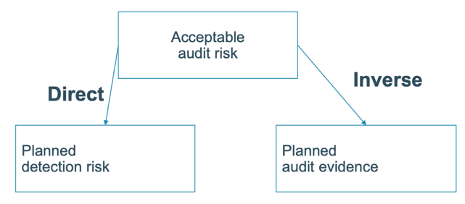
    - As acceptable audit risk increases, auditor is willing to collect less evidence (inverse) and therefore accept a higher detection risk (direct)
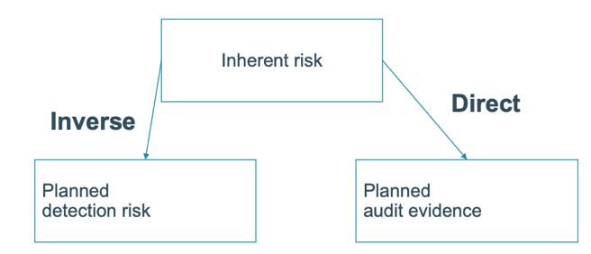
    - If inherent risk (or control risk) increases, auditor must reduce detection risk (inverse) by collecting more evidence (direct)
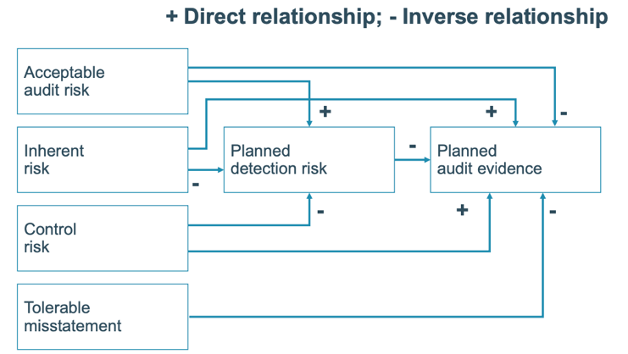
- ARM & audit planning

Determine Materiality
- Definition: information is material if its omission/misstatement could influence the decisions taken on the basis of the FS. Materiality depends on the size of the item or error judged in the particular circumstances of its omission or misstatement.
- Timing
    - Start of audit: planning of materiality
Which level of materiality would be appropriate for which accounts
    - End of audit: evaluation of materiality
- Quantitative aspects: define materiality as a percentage of a certain account, ex.
    - 5% - 10% of profit
    - 3% - 6% of total assets
    - 1% of sales
    - 1% of equity
- Qualitative aspects: when misstatement changes ex.
    - Profit becomes loss
    - Influences contractual obligations
    - Reverses trend of the results
- Allocation of materiality
    - Materiality level is an aggregate number
    - How allocated to individual accounts and/or groups or accounts?
    - Tolerable error

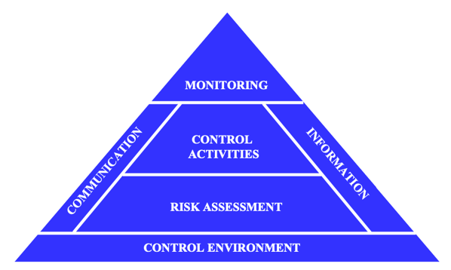
Understanding Internal Controls
- Why important to the auditor
    - Reliability of the FS
    - Focus on control of transactions
- Types of internal control activities
  - Authorisation & access controls
    - Proper authorisation of transactions should occur so only valid transactions get processed
    - Access to assets & information (accounting records) should be limited
    - Within revenue cycle, assets to protect are cash & inventories
    - Access to records such as the accounts receivable subsidiary ledger and cash journal should be restricted
  - Segregation of functions
    - Transaction authorisation should be separate from transaction processing
    - Asset custody should be separate from asset record-keeping
    - Structure organisation so fraud requires collusion between individuals
  - Supervision
    - Often used when unable to enact appropriate segregation of duties
    - Supervision of employees serves as deterrent to dishonest acts
  - Accounting records
    - With properly maintained accounting record, it’s possible to track transactions through the systems and to find where errors were made
      - Special journals
      - Subsidiary ledgers
      - General ledger
      - Files

5. Audit Testing & Reporting

Audit Test to Evaluate Control Risk
- ARM: audit risk = inherent risk x control risk x detection risk
To limit control risk: study internal control system and test the controls
- Study internal control system
    - Auditor must obtain understanding of entity and its internal controls
    - Assess design, implementation & effectiveness of client’s system
    - Determine whether internal system provides reasonable assurance about reliability of the financial reporting
- Testing controls
    - Procedures to test effectiveness of controls
    - Description phase: auditor will not have gathered enough evidence to reduce assessed control risk to a sufficiently low level
    - Test of controls support the design & operations of controls as expected: same assessed control risk as preliminary assessment
    - Want to know
      - Was internal control correctly applied?
      - Was internal control applied by authorised person
      - Has internal control been applied consistently throughout period
    - How
      - Inquiries of appropriate client personnel
      - Examine documents, records, reports…
      - Observe control related activities

Substantive Audit Testing
- ARM: audit risk = inherent risk x control risk x detection risk
To limit detection risk: substantive testing
- Substantive test: procedures designed to test monetary misstatement that directly affect correctness of FS balances
    - Substantive tests of transactions
    - Tests of detail of balances
    - Analytical procedures
- Substantive tests of transactions
    - Transaction-related audit objectives satisfied for all classes of transactions?
    - Performed together with test of controls
    - Difference
      - Substantive test mistake made: there is a material misstatement
      - Test of controls mistake: potentially a material misstatement
- Test of detail of balances
    - Satisfy all balance-related audit objectives
    - Focus on ending balances in general ledger
    - Focus mostly on balance sheet

Audit Reports
- Audit report
    - Opinion about truthfulness of FS
    - Key document, wording is essential
    - Standards
      - ISA’s: standards & guidance of the independent auditor’s report
      - Other legal frameworks (ex. US GAAS)
- Standard sections of a report
    - Report title & addressee
    - Introductory paragraph
    - Scope paragraph
    - Opinion paragraph
    - Name of firm/partner responsible for audit & report date
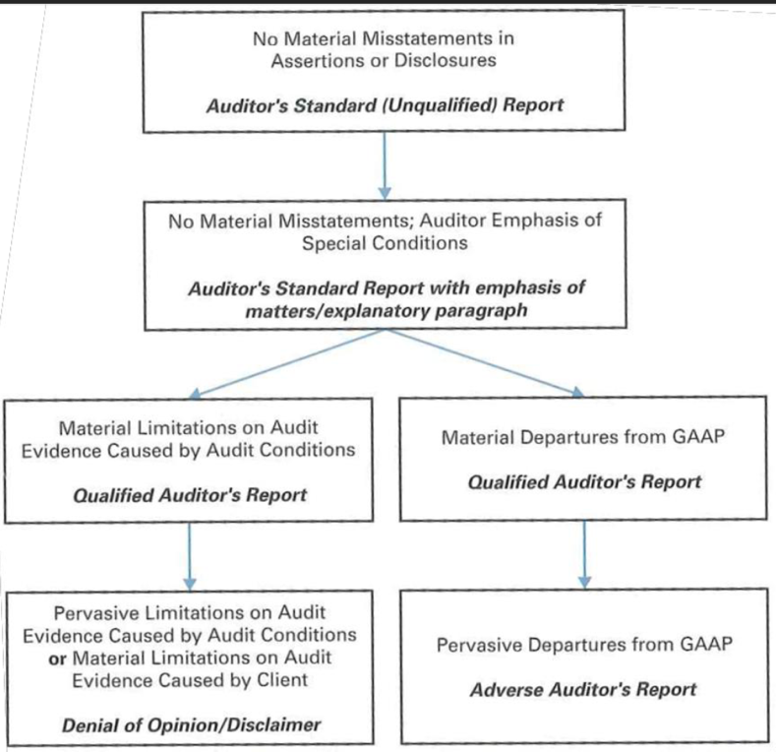
- Types of reports
  - Standard unqualified audit report
    - All conditions of standard audit have been met
      - All financial statements included
      - Sufficient evidence accumulated to conclude standards are met
      - FS presented in accordance with GAAP
      - No circumstances requiring addition of explanatory paragraph or modification of wording of the report
    - Auditors feel comfortable with rendering an unqualified opinion on the FS
  - Unqualified audit report with explanatory paragraph
    - Audit complete, auditor believes additional info is required for something
    - Auditors believe FS are fairly presented and all conditions are met
    - Explanation section follows in new paragraph after opinion
    - Conditions requiring extra explanation
      - Lack of consistency (change in accounting principles, reporting…)
      - Going concern issue
      - Auditor agrees with a departure from GAAP
      - Emphasis of certain matter
  - Qualified audit report
    - Can result from scope limitation or failure to follow GAAP
    - Examples: inappropriate accounting treatment, accounting valuation…
    - Auditors believe that overall FS are presented fairly
    - ‘Except for’ used in opinion paragraph to exclude specific information
    - Very rare, also called ‘reserved report’

  - Disclaimer of opinion report
    - Auditor cannot express opinion, does not feel confident FS are fairly stated
    - Can be result of severe scope limitation, GAAP noncompliance…
    - Differs from adverse opinion where there is knowledge of significant departure and misstatements can be identified
  - Adverse audit report
    - Auditor believes overall FS are so materially misstated/misleading that they don’t present the financial position and results fairly
    - Issued when auditor identifies significant errors/omissions that cannot be corrected on time by adjustments or disclosures
- Going Concern Assessment (ISA570)
    - Auditor must assess probability of bankruptcy within foreseeable future
    - Auditor must judge whether there is substantial doubt about ability to continue operating beyond next 12 months
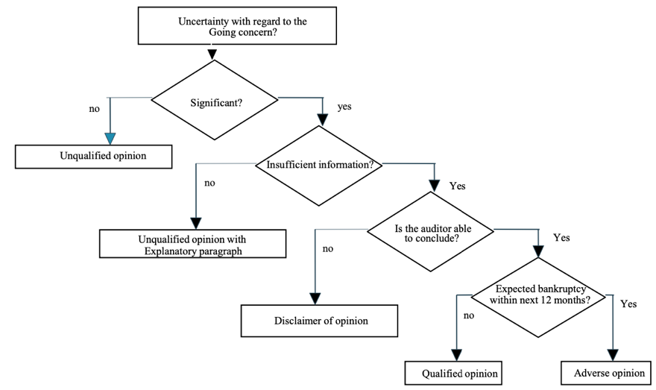
    - If doubt about going-concern, this should be disclosed in audit report in additional explanatory paragraph

Extended Audit Opinion (Key Audit Matters)
- Expansion of content
    - Opinion on whether management report is consistent with FS
    - Conclusion on management’s use of going-concern assumption in preparation of FS
- Key audit matters
    - Description of most important assessed risks of material misstatement, including assessed risk(s) of material misstatement due to fraud
    - Summary of auditor’s response to those risks
    - Key observations from that audit work

Integrated Audit
- Two types of opinions given by the auditor
- Combines the following audits
    - Audit of FS
    - Audit of management’s assessment of effectiveness of internal control
    - Audit opinion on effectiveness of these controls
- PCAOB
    - Public companies registered with SEC are required to evaluate effectiveness of internal control over FS
    - Affects 100s of public companies worldwide, not only in US

- Objectives of an integrated audit
    - Evaluate if the FS assertions are in accordance with GAAP
    - Evaluate if the internal controls over FS are operating effectively as of a particular date as described in management’s assessment of the effectiveness of internal control over FS
    - Evaluate possibility of fraud occurring within the organisation
    - Evaluate likelihood that organisation will continue as a going concern
- Auditor’s responsibilities in integrated audit
    - Responsible to express opinion on management’s reported assessment about internal controls
    - Responsible to express an opinion over design and operations of internal controls over financial reporting
    - Fundamentally, objective of the audit of internal control over financial reporting is to obtain reasonable assurance that no material weaknesses exist in the control system

6. Data-Enabled Audit (by PwC)

Financial Audit
- Statutory financial statements
    - End product of one accounting year
    - Fixed format in Belgium
    - Prepared by board of directors
    - Audited by chartered accountant
    - Approved by the shareholders
    - Published via national bank
- Statutory audit report
    - End product of auditing one accounting year
    - Fixed format in Belgium
    - Signed by chartered accountant
    - Addressed to the shareholders
    - Published via the national bank
- Types of (adjusted) audit opinion
    - Qualified
      - Sufficient & appropriate audit evidence of misstatement
      - Impact of misstatement is material but not pervasive
or
      - Inability to obtain sufficient & appropriate evidence of misstatement
      - Impact of misstatement is material but not pervasive
    - Adverse
      - Sufficient & appropriate audit evidence of misstatement
      - Impact is material & pervasive
    - Disclaimer
      - Inability to obtain sufficient & appropriate evidence of misstatement
      - Impact of misstatement is material but not pervasive
- International auditing standards
    - Goal: comparable audit quality
    - Set by International auditing & assurance standards board (IAASB)
    - Used by all statutory auditors in Belgium

- Audit cycle
  - Client acceptance: can we accept this mandate
  - Understanding relevant operational & accounting processes
  - Risk identification: what can go wrong during these processes
  - Documentation
  - Response to risks: controls testing
  - Response to risks: substantive testing
  - Reporting: formulate conclusion about true & fair view
  - Professional judgement in audit report

Audit Tools & Data
- People keep playing an essential role
    - Professional judgement is the core of an audit opinion
    - Financial auditors vs. specialists
- Efficiency & effectiveness from technology solutions mainly in
    - Understanding & risk identification phase: use process mining
    - Substantive testing: use dashboards
- Understanding & risk identification
    - Goal of these phases
      - Understand entity’s environment & subprocesses
      - Identify potential risks affecting audit risk
      - Match risks to relevant assertions and FS line items
      - Classify risks in terms of significance
      - ISA240 default risks: management override of controls, risks of fraud in revenue recognition
    - Using data-enabled techniques has the following advantages
      - Up-to-date information
      - Objective information
      - Complete information
- Response to risks
    - Responding to audit risks done through
      - Controls testing (preventive vs. detective) & substantive procedures
      - Balance between the two to obtain sufficient comfort
    - Controls testing
      - Goal: is control operating effectively & efficiently
      - What: test process behind the numbers
      - How: identify population & apply statistical selection criteria
      - Error: deficiency increasing substantive test level
      - Evidence: track record of 4 eyes principle
      - Techniques: inquiry, observation, reperformance
    - Substantive testing
      - Goal: testing assertions (ex. CAVECOD)
      - What: test actual numbers
      - How: identify population & apply materiality
      - Material error: potentially affecting audit opinion on true & fair view
      - Evidence: track record of support
      - Techniques: reconciliation to (externally generated) documents, external confirmation, recalculation…

    - Disadvantages of classical method
      - Test for only selection within population
Quality of conclusion depends on quality of selection
      - Conclusion affected by blindsiding effect
      - Difficult discussions on statistical extrapolation of error
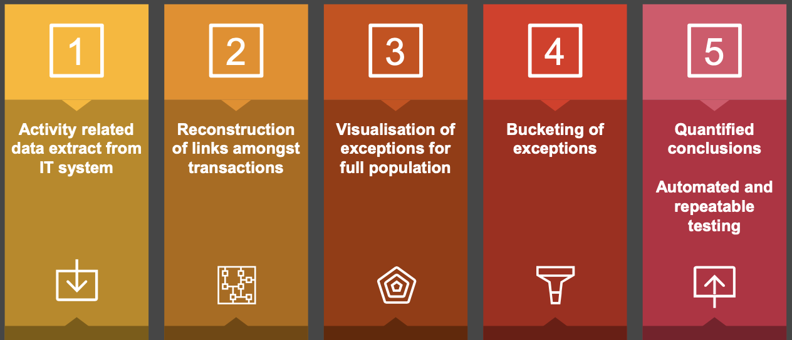
- Data-enabled auditing process

Risk of Fraud in Management Override of Controls
- Characteristics of fraud
    - Fraudulent financial reporting
      - Intentional errors
      - Through falsification, misrepresentation and misapplication of accounting principles
      - To deceive its users
      - When all elements of fraud triangle are present
    - Misappropriation of assets
      - Theft of company’s assets
      - Often accompanied by falsification of accounting records
    - Example of unusual posting: cash transactions with direct impact on P&L
Audit’s response: data analytics

Future of Audit
- Advantages
    - Up-to-date, quantified, objective & complete information
    - Strong reporting to client
    - Higher credibility
    - Long-term efficiency
- Disadvantages
    - Risk for over-auditing
    - Budget restrictions
    - Client & team investment
    - High infrastructural needs
    - Inefficient audits
    - Documentation risk
- Real-time, continuous auditing
    - Data as a skill needed for auditors
    - Much more automation & use of ai to draw conclusions
    - Improved client relationship needed

