Management Control
Summary of classes by Sabra Khajehnejad, spring semester 2024

1. Introduction to Management Control

What is Management Control
- Management control: make sure employees act in line with organisational strategy
- Objective setting: what the organisation wants to achieve
- Strategy formulation: how resources are used to meet objectives
Functions are interrelated and inform each other
- Strategy
    - Is not always planned: can emerge from interactions between actors
    - Strategy execution is the biggest challenge, because it’s about the people
- Causes of control problems
    - Lack of direction
    - Motivational problems (ex. conflict of interest)
    - Personal limitations
- Avoiding control problems
    - Activity elimination
    - Automation
    - Centralisation
    - Risk sharing

Agency Theory
- There is a principal-agent relation
- Assumptions
    - Both are motivated by self-interest, agent is work averse
    - Both have different risk perspectives
    - Information asymmetry between both
    - Principal cannot easily observe agent’s actions
- Agency problems
    - Adverse selection by information asymmetry: more info before contract
    - Moral hazard by hidden action: after contract, deviate from it
    - Empire building
    - Free-riding if no peer monitoring
    - Employee theft: employee uses firm resources for own self-interest
    - Horizon problem: leaves firm soon, focus on short-term (myopic behaviour)
- Solution: monitoring & incentive systems
- Agency costs
    - Costs of managing the relation: monitoring, incentives…
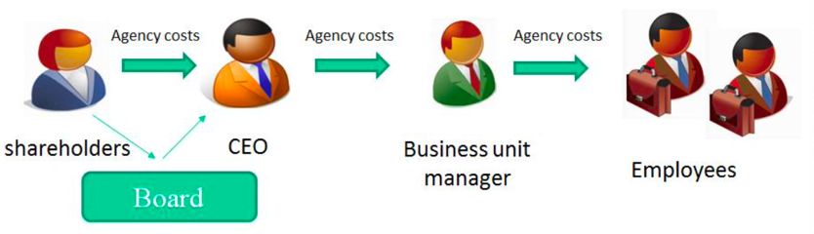
    - Cost of agent using principal’s resources in its own interest

2. Introduction to Management Accounting

What is Cost Management
- Accounting: recording, analysing, summarising & reporting business transactions
    - External reports for banks, shareholders & tax
    - Internal reports for managers (management accounting)
Different purposes = different information
- Cost management
    - Subset of management accounting
    - About estimating, allocating & controlling costs
    - Two roles
      - Decision influence: use info to motivate employees & align interests
      - Decision facilitating: reduce pre-decision uncertainty
Often a trade-off (ex. salespeople forecasting own sales)

3. Control Framework & Alternatives

Design of Management Accounting & Control Systems
- Contingency theory
    - No best way to organise an organisation
    - Systems should fit external environment & internal contextual factors
Accounting systems not isolated from other systems
      - External factors
      - Firm strategy or orientation
      - Firm characteristics
- Managers affect design of accounting & control systems (ex. leadership style)
- Sometimes inferior accounting systems in place
    - Economic Darwinism: if system survives then benefits > costs over long run
    - Better system has not yet been discovered
    - System is legitimate (reaches consensus) for different stakeholders

Control Frameworks
- Zimmerman’s control framework: three pillars
    - Decision making rights
    - Performance measurement
    - Reward systems
- Decision-making rights
    - Centralise decision rights at top management level
    - Decentralise decision rights to lower levels
      - Agents have specialised knowledge
      - Faster response to changing environment
      - Frees up cognitive resources of principals
      - Increases intrinsic motivation & trust
      - Great training opportunity
      - May increase agency costs
    - Agency costs depends on link between knowledge and decision rights
      - Linked: no increase in agency costs (ex. operator has own schedule)
      - Not linked: delegation can be costly

Results Control
- Output control, performance measurement
- Inexpensive, specific knowledge about desirable actions not available
- Provides direction & improves motivation
- Personnel limitations: helps firm attract and retain competent workers
- Conditions to use control results
    - Organisation can easily communicate desirable results
    - Employees can significantly influence their results (controllability)
    - Organisation can effectively measure results

Action Control
- Behavioural control, what employees do
    - Preventive: does not allow undesirable behaviour
    - Detective: highlights undesirable behaviour
- Control systems
    - Behavioural constraints: make undesirable actions hard/impossible
      - Physical (ex. restricting access)
      - Administrative (ex. limit on expenditure)
    - Separation of duties (ex. separation of management & control)
    - Reaction reviews: reviewing action plans & proposals
    - Action accountability: holding employees accountable
      - Defining what is (un)acceptable
      - Communication through rules, procedures, checklists…
      - Observing actions (direct monitoring)
      - Rewarding right actions & punishing wrong actions
    - Redundancy: more employees than necessary to task to ensure completion
- Conditions to use action control
    - Knowledge of (un)desirable actions
    - Ability to ensure desirable actions are taken
- Pros & cons
    - Accumulation of knowledge & learning: procedures document what works best, easy to transfer knowledge
    - May not be feasible if no routinized tasks
    - Focus on easy-to-observe actions, may ignore important actions but hard to observe (behavioural displacement)
    - May make employees sloppy or resistant to change

Personnel Control
- Input control, which people to hire
- Selection & placement: finding the right employees
    - Skills that match the job requirement
    - Values, beliefs & personality that match organizational values
- Training
    - (In)formal training through mentoring
    - Increase the likelihood that employees do a good job
- Job design & resourcing: jobs should be designed in such a way that enables success
- Workload check: not too much, achieving a good performance must be likely

Cultural Control
- Clan control, which common norms/values should be in place
- Influence culture
    - Codes of conduct
    - Events, celebrate achievements etc.
    - Social & physical arrangements (ex. office plans, dress code…)
    - Tone at the top: how top management communicates

4. Control System Costs

Types of Costs
- Direct costs
    - Monetary cost of designing & implementing monitoring
    - Time spent on monitoring by supervisors
- Indirect costs (unintended consequences/effects)
    - Behavioural displacement
      - Result controls: maximise measured performance in suboptimal way
      - Action controls: too much focus on the means, not on the ends
    - Gamesmanship (arranging slack)
      - Slack: consumption of more resources than necessary
      - Slack can reduce stress or allow for adaption, but also distort resource allocation and reduces efficiency
      - Gamesmanship: manipulating performance measures through accounting, operating means or lying (misreporting)
    - Operating delay
      - When control system causes a bottleneck (bureaucracy)
    - Negative attitudes
      - Stress, frustration & pressure have negative impact on performance
      - Control being perceived as distrust or unfairness
      - Reduce intrinsic motivation
      - Creates negative working atmosphere (ex. provoking envy)
- Adaption costs: cost to adjust control system to new situation

5. Maintaining Effective Control

Enabling Control System
- Benefits & side effects of control system depends on how people perceive it
    - Perceived as more controlling = more potential side effects
    - Key features of enabling control system
      - Internal & global transparency
      - Repair
      - Flexibility
    - Traps
      - One size fits all: reaction might be different across cultures, tasks…
      - Standpoint: designing from employer of view instead of employee
      - Easy performance measures: focus on easy to measure indicators instead of important measures
      - Focus too narrow (ex. focus on individual instead of team output)
      - Static approach: control system must evolve to avoid loopholes etc.

6. Incentive Systems

Types of Systems
- Monetary rewards: salary, bonusses, retirement benefits…
- Tangible (non-monetary) rewards: awards, privileges…
- Non-tangible rewards: power, job titles, verbal recognition…
- Negative incentives (punishments): demotion, termination…

Purpose of Systems
- Informational value (effort-directing): make clear to employees what’s important
- Motivational value (effort-inducing)
- Attraction & retention (sorting effect): attract the right employees
- Good system
    - Values motivated employees
    - Is easy to understand
    - Large enough, timely & durable rewards
    - Is cost efficient
- Different systems for different levels in an organisation
    - Top core managers
      - Equity, bonusses…
      - Compensation impacted by their power
    - Lower levels
      - Flat pay
      - Bonus pools
      - Tournament pay
- Long-term performance targets to avoid short-terminism
    - Cumulative targets
    - Equity based plans like stock options
    - Contingent stock plans

Standard Agency Theory
- Suggests (monetary) incentives should be offered to align agent’s interest with firm’s
- Crowding-out effect
    - Monetary incentives can crowd-out intrinsic motivation
    - People feel their effort is due to incentive rather than own will
Overjustification effect
    - Incentives may signal information about the task
      - Task is hard, boring, not fun…
      - Principal distrusts the agents

7. Performance Measurement

Good Measures
- Principal unable to perfectly observe actions of agents: use of performance measures
- Measures must be goal congruent
    - Firm value increases when measure performance goes up
    - Employees must be pushed towards organisational goals
- Measures must be controllable
    - Otherwise, it imposes risk on the manager
    - Measure must be sensitive to performance and precise (no noise)

    - Types of uncontrollability
      - External factors (economic, competitive…)
      - Act of nature (force majeure, ex. covid)
      - Internal factors (sequential, reciprocal or pooled interdependence)

Shortcomings
- Trade-off between controllability and congruence
    - More input measure: more controllable, less congruent
    - Capture & evaluate relevant aspects of individual performance in area
Trade-off makes every measure incomplete/imperfect
- Surrogation: shortcoming for performance measurement
    - People fail to see performance measure as imperfect proxy
    - People behave as if measure is the only construct of interest
Compensation based on single performance measure triggers surrogation
- Measures are subject to manipulation & distortion
    - Possible to ignore important parts of the job if they are not measured
    - Gaming the system: improve measured performance without creating value
      - Distributing customer satisfaction survey among happy customers
      - Teacher being evaluated on grades of students (make class easy)

Overcoming shortcomings
- Subjective performance evaluation
    - Three forms
      - No performance measures: totally based on supervisor’s discretion
      - Supervisor can adjust performance evaluation (discretionary adjustment
      - Multiple performance measures: supervisor can adjust weighing of all measures
    - Possible issues
      - Favouritism
      - Compression bias: evaluating employees’ performance similarly while there is actually a large performance difference between them
      - Centrality bias: rating everyone an average score
      - Leniency bias: giving more favourable rating the employee deserves
- Relative performance evaluation
    - To reduce noise in performance evaluation
    - Teasing out effect of common noise in performance measurement
    - Peers can be within same organisation or from other organisations
    - Possible issues
      - Destructive competition
      - Sabotage, cheating or counterproductive behaviour
      - Making people more self-oriented & less collaborative
- Multiple performance measures
    - Reduces risk on agents
    - Improves congruity of performance measures
    - Providing additional information about agent’s effort
    - Costs: losing focus on one measure & spreading attention to multiple ones
    - Key challenge: weigh different measures
- Cultural/personnel/action control
- Muting incentives

8. Financial Performance Measures

Classification of Financial Measures
- Financial measures: easy & cheap to be used for control, focus for top management
- Market measures
    - Changes in stock price or market return
    - Merits
      - Direct (imperfect) measure of firm value
      - Accurate, understandable & always (publicly) available
      - Less manipulable than other measures, cost efficient
    - Limitations
      - Not available for private firms
      - Not controllable for employees, affected by many factors
      - Does not reflect realized performance, only expectations
- Accounting measures
    - Ratios such as liquidity, solvency, profitability…
    - Merits
      - More controllable, measured on timely basis, cost efficient
      - Understandable & fairly objective
    - Limitations
      - Conservative accounting rules: slow recognition of revenues
      - Long measurement period = more congruent accounting measures
      - Ignores value that cannot be accurately measured
      - Depends on measurement methods (choices)
      - Focusses only on the past
- Disaggregatied measures: revenues & expenses
- Economic measures: residual income, economic value adde

Ratio Measures
- Assets employed = invested capital = total assets – current liabilities
- Shareholder’s equity = total assets – total liabilities
- Financial leverage = (shareholder’s equity + debt) / shareholder’s equity
- ROA = profit margin x asset turnover
    - Increase ROA by
      - High volume & low margins
      - Low volume & high margins
- ROE (Dupont Equation)
= net income / shareholder’s equity
= profit margin x asset turnover x financial leverage
= return on assets (ROA) x (total assets / shareholder’s equity)
    - ROE & ROA equal for a debt free firm
- Financial leverage
    - Interest cover = operating profit / interest payable
    - Business’ ability to pay interest
- Comparing ratios can only be done within sectors, not across
- Ratios may motivate sub-optimal behaviour ex. denominator problem (underinvestment)
- Economic value added (EVA) = NOPAT^{adjusted} – (WACC x invested capital^{adjusted})

9. Financial Responsibility Centres

Responsibility Accounting
- Dividing organisation into responsibility centres
    - Each responsible for specific aspects of organisation’s operations
    - Headed by a manager responsible for unit’s performance
    - Setting budgets & performance targets for each centre
Financial responsibility centre if unit responsible for own finances
    - Performance measurement by comparing results vs. budget, in case of gaps
      - Managers give explanation: variance analysis
      - Perform corrective actions: performance measurement & reporting
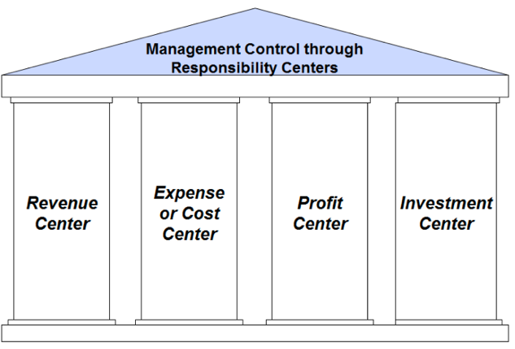
- Different types of responsibility centres
  - Expense or cost centre
    - Control costs, does not generate revenue
    - Decision rights: quantity & quality of inputs
    - Evaluation measures
      - Total cost for fixes output
      - Average production cost
      - Output for a fixed budget
    - Monitoring
      - Inventory: incentive to produce to spread fixed costs over units
      - Quality: incentive to reduce quality to adhere to budget
    - Standard cost centres
      - Relation between in- & outputs known
      - Easy to measure
    - Discretionary cost centres
      - Output difficult to measure
      - Relation in- & outputs is unknown
    - Ex. human resource department
  - Profit centre
    - Controls costs & revenues, not investments to generate the profits
    - Decision rights: choose input mix, product mix, selling prices & discounts
    - Evaluation measure: profit
    - Ex. individual fast-food restaurant in a large chain
    - Pseudo profit centre
      - Sales-focused units that are charged standard cost of product sold
      - Cost-focussed unit assigned revenue based on function of cost
    - Profit centre structure pushes managers to think about costs & revenues at same time and account for trade-offs
    - Key challenges
      - Set up appropriate transfer prices on goods & services transferred
      - How to allocate corporate overhead cost
      - Profit centres focus on own profit, ignoring rest of organisation
    - Solutions
      - Incentives paid to managers if targets are made
      - Non-financial performance measures when interdependence exists
  - Investment centre
    - Most independent form of responsibility centre
    - Responsible for
      - Some measure of profit & balance sheets items
      - Profit they generate compared to investments made
      - Ratify & monitor decisions of cost & profit centres
    - Performance measures
      - Return on investment (ROI)
      - Return on capital employed (ROCE)
      - Residual income (RI)
      - Economic value added (EVA)
    - Ex. theme park

10. Balanced Scorecard (BSC)

Characteristics
- Revolution in performance measurement
    - Dashboard of performance, proposed nu Kaplan & Norton
    - BSC later developed to be a strategy implementation tool
      - Helps communicate strategy to all members
      - Translates strategy into coherent set of performance measures
    - Widely used but not necessarily in a classical way
- Addresses following limitations of performance measures
    - Financial measures are backward-looking, reflect the past
    - Short-termism
    - Dysfunctional behaviours such as gaming
    - Lack of emphasis on intangible assets
    - Failure to track sources of competitive advantage
    - Lack of explicit connection between strategy & performance measurement
- What’s new
    - Balanced performance measurement: leading indicators (nonfinancial) & lagging indicators (financial)
    - Focus on critical success factors: measure & manage intangible assets to be successful in long-term
    - Strategy oriented: strategy map, framework to turn strategy into actions
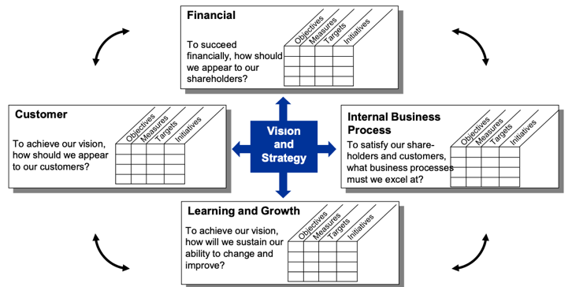
    - Shopping list: reminder of strategic objectives for each perspective

- Different uses
    - Articulation of strategy into a set of financial & non-financial measures
    - Cascade strategy throughout hierarchy, communicate it to units
    - Monitor unit’s strategy & performance
    - Take corrective actions or adapting strategy
    - Managers’ & employees’ performance evaluation tool
- Weight of different measures
    - Economic-based prediction: weight = f(precision, sensitivity, controllability)
    - Psychology-based prediction: weight = can be influenced by cognitive processing limitations

Cautions
- Validation is important
    - Firms not validating links perform worse
    - Use employee retention in learning & growth
      - No better results
      - Supervisor retention more crucial than overall employment rates
- U-shaped relations
    - Improvement in customer satisfaction pays off to certain point
    - 100% satisfied customers too expensive
- Focus on wrong measures dangerous ex. number of patents can be misleading if unused
- Biases
    - Common measure bias
      - Evaluate business unit by using common measures across units
      - Often don’t capture specifics of business unit
      - Unique measures needed, especially if third party reassurance
      - Links need to be provided between unique measures and strategy
    - Outcome bias
      - Evaluators prefer outcome measures over driver measures
      - Driver measures are often leading indicators of performance
    - Bias towards financial measures
      - Often get too much weight in evaluations
      - Make causal linkages visible in analysis
      - Signal importance of non-financial measures with trend indicators

11. Introduction to Budgeting

Characteristics
- Budget
    - Forecast of revenues, expenses or profits for future time period
    - Prepared at different levels & across different functions
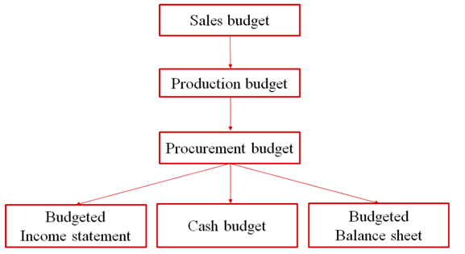
    - Central planning tool: master budget (aggregation for different functions)
- Budgeting helps organisations in several ways
  - Planning (three cycles)
    - Advantages
      - Promotes forward thinking
      - Controlling cashflow & identify financial needs
    - Strategic planning: long range, vision, mission, objective & strategies
    - Capital budgeting (programming): middle range, resource allocation
    - Operational budgeting: annual, short term financial plan (budget)
  - Communication & coordination
    - Knowledge transfers
      - Vertical transfers from lower to higher levels of organisation
      - Horizontal transfers, marketing to manufacturing
Identify potential bottlenecks in production
    - Ensure that expectations & assumptions are consistent throughout the firm
    - Clarify key planning assumptions: unit placement, prices, purchasing needs…
  - Motivation
    - Budget acts as a target
    - Can be linked to performance measurements
    - Goal setting theory suggests setting clear, simple, challenging but attainable targets is more motivating than saying ‘do your best’
  - Contracting
    - Control tool for top management
    - Management negotiates budgets, reaches agreements & commits to it
    - Management by exception
      - Management informed about problems
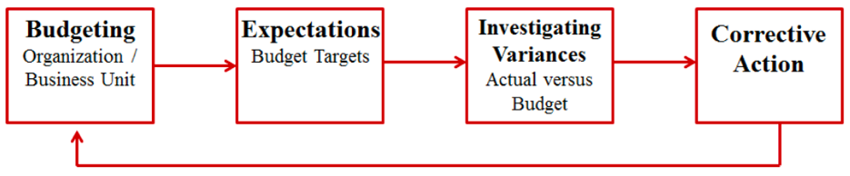
      - Investigates corrective sanctions: adjust strategies?

Compensation Systems
- Traditional compensation system
    - Kinks in traditional system create strong incentive to game
    - Satisficing behaviour
      - Move sales to this period when close to target
      - Move sales to next period if target is achieved or missed
- Linear compensation system
    - Get kinks out: remove incentives to game the system
    - Dishonest managers lie about performance to increase bonus
    - Non-monetary rewards have to be independent of budget targets
- Curvilinear compensation system
    - Again, gaming incentives?
    - Encourages managers to increase variability
- Stair-step incentive plan at Chrysler
    - Specified monthly sales target at each dealer, bonus for fulfilling different percentages of the sales target
    - If dealers didn’t reach monthly goal: push sales to next month
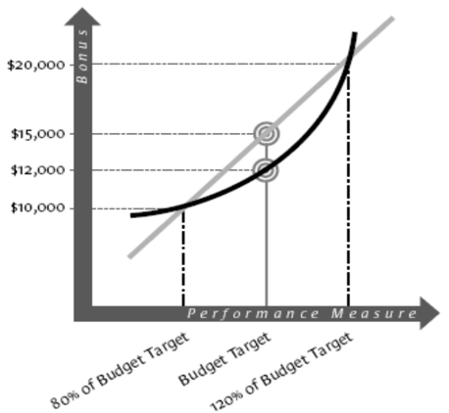
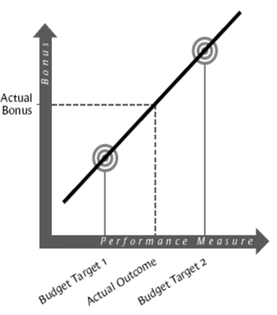
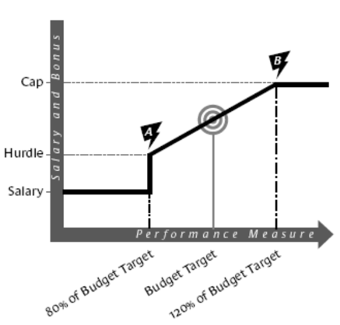
Abandoning Budgeting?
- Ex. Svenska Handelsbanken: budgeting is inherently problematic and should be abandoned
Instead, use
    - Simple structures, emphasis on lateral communication (share best practices)
    - No fixed targets for negotiation (relative target setting)
    - Resource allocation based on events
- Budgeting is not dysfunctional per se, but problem lies on how systems are designed & used
    - Significant variations in how budgeting is done in practice
    - Trade-offs in design & use of budgeting systems
Should be customised to context

12. Characteristics of Budgeting Systems

Setting of Budget
- Top-down budgeting
    - Top management makes forecast
    - Begin with aggregated forecast, break down to lower levels
More control but less informative & accurate for decision making
- Bottom-up budgeting
    - Low level sets own budgets & are held responsible for meeting them
    - Managers more committed to meet the budgets when they set them
    - Lower level: more specific knowledge, can set budget more accurately
Risk of setting easy targets to secure bonus
Providing less control but more informative for decision making
- Budget for performance evaluation & rewards
    - Optimal decision making requires managers to fully reveal private knowledge about production & market conditions during negotiations
    - When budgets are used for performance evaluation, managers make biased budget forecast so actuals look good relative to budget

Targets & Goals
- Specific, measurable, attainable, realistic & timely (SMART)
    - Learning from psychology of goal setting
    - Targets should be challenging but attainable by effort
- Target types
    - Fixed targets
      - May be unfair in case of uncontrollable events
      - Creates narrow focus, less attention to long-term opportunities

    - Flexible targets
      - May not be taken seriously when often adjusted
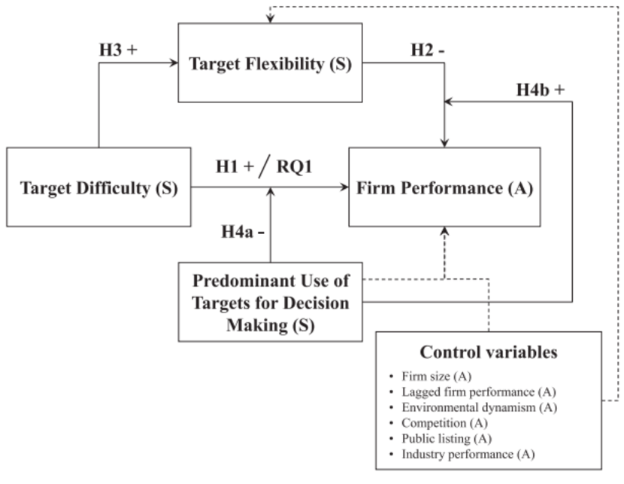
      - Employees may spend time to convince superior to adjust targets
- Targets based on previous performance
    - Ratchet effect: tendency to set next year target based on past performance
    - Performance target adjusted upward more if past performance is good
Employee may reduce current effort to avoid target increase next period
    - Free Record Shop ex.: store managers reduce sales in final quarter to make next-year target more achievable
    - Reduce target ratcheting by
      - Eliminating budget targets
      - Zero-based budgeting
      - Job rotation
      - Relative targets

Budget Types & Characteristics
- Incremental budgeting
    - Start with current year’s core budget & make incremental changes
    - Review focus on incremental changes, may ignore core budget inefficiencies
- Zero-based budgeting
    - Each year starts from scratch
    - Mandates each line item in budget to be justified every period
    - Motivates managers to eliminate inefficient expenses
    - Useful when firm is changing strategic direction or is under high uncertainty
    - Time consuming
    - Ratcheting becomes difficult
- Line-item budgeting
    - Authorise managers to only spend specified amount on each line item
    - Tight control: reduce chance of managers acting inconsistent with firm goals
Lower agency costs
    - Inflexible in responding to unanticipated needs
    - Little incentive to save costs
- Rolling budgeting
    - Continuous updating of budgeting by extending budget horizon when current period concludes
    - Forecast period: 5-6 quarters ahead
    - Advantages
      - More accurate & realistic budgets
      - More flexibility in case of unexpected events
      - More adaptive to changing market circumstances
    - Disadvantages
      - Time consuming
      - Might lead to relocation of resources too often
- Budget lapsing
    - Funds for particular year cannot be carried over to following year
    - Tight control compared to settings where budgets do not lapse
    - Prevents risk-averse managers from accumulating funds
    - Encourages wasteful spending near end of fiscal year
Consume leftover budget to avoid getting less next year

- Example
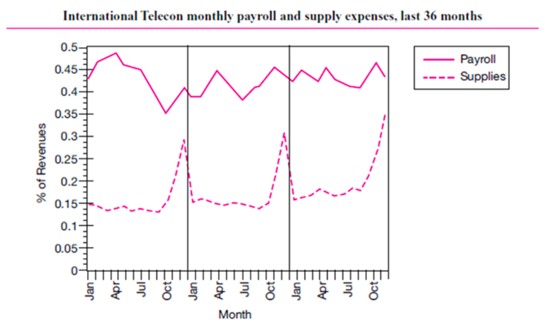
    - Payroll: no seasonal patterns
    - Supplies seasonal pattern
      - Unlikely that telecom has seasonal component
      - Pattern consistent with risk-averse managers in budget lapsing firm holding back budget until end of year
    - Corrective actions
      - Change manager’s performance evaluation
      - More emphasis on showing favourable budget variances
      - Tighter control on spending of budget (line-item budgeting)
      - Allow carry over small amounts of budget
- Flexible vs. static budgets
    - Static: does not vary with volume, prepared for one level of activity (volume)
Volume is not always controllable by manager
    - Flexible: stated as function of some volume measure, adjusted accordingly

Cost Management

1. Cost Terminology

Key Terms
- Cost: resource given up to achieve specific objective
- Cost object: anything for which a measurement of its cost is desired (brand, product line…)
- Cost driver: factor causing change in cost of an object
- Sunk cost: cost incurred that cannot be recovered
Sunken cost fallacy
- Opportunity cost: benefits given up by choosing one course of action, example
    - Product cannibalisation: new product affects sales of old product
    - Holding inventory or just-in-time
    - Using excess capacity is not always free
- Accounting costs
    - Are transaction based, don’t include opportunity costs
    - Are historical, recorded after decisions are made
    - Mainly helpful for controlling purposes
Accounting costs + opportunity costs = economic costs
- Relevant vs. irrelevant costs
    - Relevant: costs varying across alternative courses of action
    - Irrelevant: costs that never change (past, fixed…)

Cost Behaviour
- Cost behaviour/variation/structure: how it changes with a change in product volume level
- Types
    - Fixed: incurred even if no production (depends on time horizon)
    - Variable: changes as quantity changes
    - Total cost = fixed costs + variable costs
    - Step costs: increasing with capacity
    - Mixed: semi variable
- Costs are seldom linear in reality
    - Learning curve: cheaper over time because of accumulating experience
    - Economies of scale
    - Near capacity: costs may increase due to overtime, breakdowns etc.
- Relevant range: range of volume or activity within which a company expects to operate
    - In relevant range, we assume linear cost behaviour
      - Simple for decision making
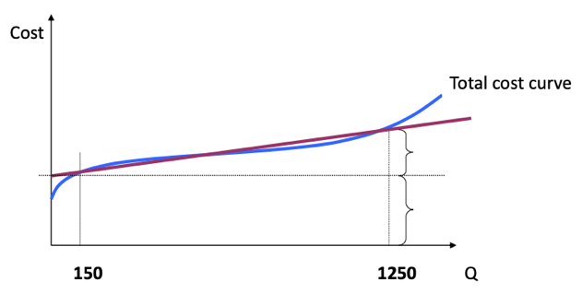
      - Practical = fixed vs. variable cost distinction
      - Cost-volume-profit = break-even

    - Average cost per unit: total cost / quantity
    - Marginal cost: cost of producing 1 extra unit
Equal to variable cost in relevant range assuming linearity
- Direct vs. indirect costs
    - Direct: easily traced to products or services
    - Indirect costs (overhead): cannot be traced to one product or service
- Product vs. period costs
    - Product costs: incurred to manufacture a product
    - Period costs: non-manufacturing costs incurred to sell a product

2. Cost-Volume-Profit Analysis (CVP)

Formulas
- CVP analysis: how total profit changes with changes in price or volume of products/services
    - Profit = revenue – total costs
    - Profit = revenue – variable costs – fixed costs
    - Profit = Q*(selling price – variable cost per unit) – fixed costs
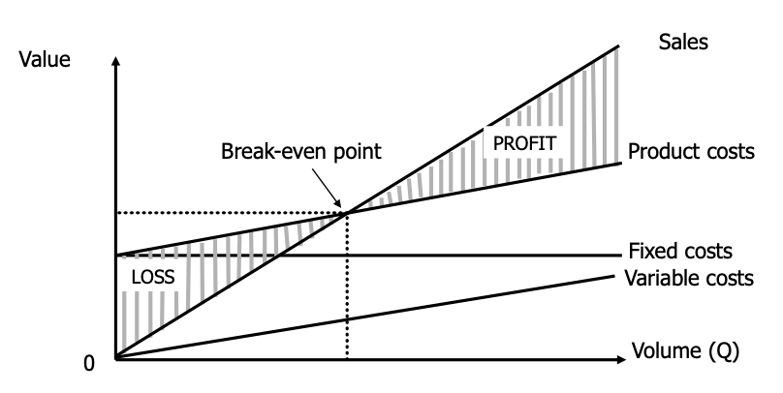
If profit is 0: break-even point = fixed costs / contribution margin
Key Assumptions
- All costs can be categorised into fixed & variable costs
- Fixed costs remain constant
- Selling price remains constant (doesn’t change with sales volume)
- Operating leverage = fixed costs / total costs
Firms with high operating leverage: low variable costs
    - High contribution margin, profit increases significantly with more sales
    - Rapid increase in profits if sales expand, but also rapid losses when they fall
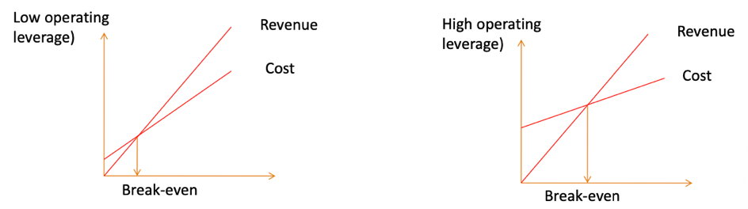
    - Longer to break-even
    - In price competitions, they can survive more price reductions
- Degree of operating leverage (DOL) = % change in EBIT / % change in sales
Analyse impact of change in sales on company’s earnings
- Scarce resource optimisation
    - Output not restricted by market demand, but input by scarce resources
    - Business at full capacity, how to optimise use of scarce resources
Optimise contribution margin per hour
3. Introduction to Transfer Pricing

Transfer Pricing Concept
- What is transfer pricing
    - Internal price charged to another unit within same corporation
    - Price at which product is transferred between responsibility centres within same firm
- Why not free
    - Centralised firm with revenue & cost functions:
      - R(Q) = Q (100-2Q)
      - C(Q) = Q² / 2
max (100Q – 2Q2) - Q² / 2
Q = 20
    - Decentralised firm with same revenue & cost functions
      - Sales: Q (100-2Q)
      - Production: Q² / 2
If sales team optimises profit, we get Q = 25
Not in line with best interest of entire company (optimal Q = 20)
- Why transfer pricing
    - Control: alignment of interests of units within decentralised firm
    - Decision making: provide relevant information for managers to make right trade-offs between costs & revenues
    - Performance evaluation: measure performance of responsibility centres
    - Internal taxation

Transfer Price Setting
- Taxes
    - Sub-units of multinational firm operate in different tax regimes
    - Transfer prices can be strategically set to avoid paying high taxes
      - Reduce taxable income: charge high on imports, low on exports
      - Increase taxable income: charge low on imports, high on exports
- Optimal transfer price
    - Its opportunity cost, value forgone by not using it in alternative way
    - Hard to estimate and use in practice
      - Information asymmetry between HQ and managers
      - Lack of information
- Other price considerations
    - Fairness
    - Simple to understand & implement
    - Not subject to distortion

4. Transfer Pricing Methods

Market Based Transfer Pricing
- Good approximation of opportunity cost because it is what company gives up by selling
- Deviations can be allowed to reflect differences between internal & external sales
    - Internal production avoids cost of writing & enforcing contracts
    - Savings in marketing, selling, packaging & collecting costs
    - Differences in quality standards, special features etc.
    - Considering interdependencies between units
- If similar goods don’t exist in market: use cost-based transfer pricing (ex. variable cost)
Cost Based Transfer Pricing
- Variable-cost based
    - Fixed costs not recovered, poor information for evaluation because
      - Selling entity appears to make a loss
      - Profits of buying entity are overstated
    - Separating variable & fixed costs
      - Creates disputes over measuring variable costs
      - Create incentives to distort variable cost upward by classifying fixed costs as variable costs
- Full-cost based
    - Very common
    - Seller does not make profit (no motivation to sell)
    - If excessive capacity: full cost is more than opportunity cost
    - Sometimes, full cost above market price, buyer no motive to buy inside
    - Production inefficiencies are transferred to buyers
      - Not so responsive to market changes
      - No incentive to improve efficiency
- Full / variable cost + mark-up transfer pricing
    - Variation on both types
    - Fixed fee on top of price to allow to recover all costs / make some profit
    - Similar issues as both earlier discussed
- Negotiated transfer pricing
    - Most efficient in many cases
    - Approximates opportunity cost because
      - Seller does not agree to sell below
      - Buyer does not pay above the product’s price elsewhere
    - Issues
      - Sensitive to bargaining power
      - Conflicts arise particularly in case of power inequality
      - Central intervention when no agreement
      - Time consuming
- Dual-rate transfer pricing
    - Resolving internal conflicts: the selling unit is credited with the outside sales price; the buying unit is charged the variable cost only. The difference is charged to the corporate account and eliminated at the time of financial statement consolidation.
Allows for the fair evaluation of managers’ performance but it is time consuming and complex. It could work in a short-term.
    - Sometimes, firms use multiple transfer prices to avoid tax

5. Death Spiral (Case Study)

Setting
- Prochim group: large firm with multiple independent production units
- Common expenses (IT, maintenance…) are directly assigned to each unit
- Information technology department (ITD)
    - Does data processing, using both
      - Specific software for firm
      - Standard software, but updated according to firm needs
    - Activities are irregular & difficult to schedule

    - KPI’s used
      - Avg. cost of processing hour
      - Avg. response time to customer’s needs
- Method of transfer pricing: actual full-cost pricing
    - Based on per processing hour
    - Calculating total volume of processing hours
    - Avg. cost of each processing hour = total expenses / total processing hours
    - Monthly bill = hours supplied to user * avg. cost per processing hour
- Issues
    - Complaints about high prices & delays
      - Fluctuations in demand = fluctuations in transfer price
      - IT couldn’t manage all processing because of irregular flow of work
    - ITD: working hard but still losing demand
      - Systematic outsourcing of some units to IBM (about 50% of activity) even though they only work at 70% capacity
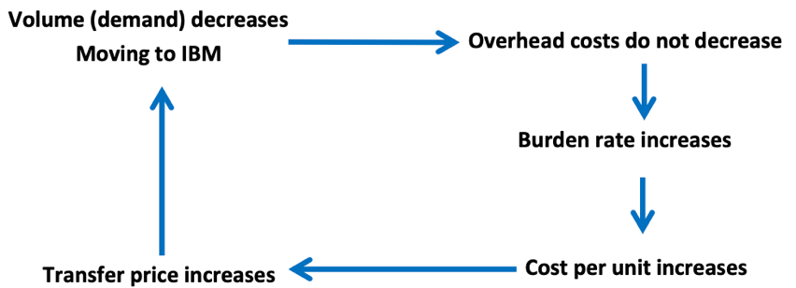
    - If no action is taken: death spiral

Solutions
- ITD is under capacity
    - Charge only for variable costs or reduce amount of fixed costs allocated
    - Excess demand then outsourced
- Use practical capacity instead of actual utilisation, ex.
    - Avg. number of processing hours in a period: replace actual by standard cost
    - Treat services differently (irregular and standard services)

6, 7 & 8. Cost Allocation

Reasons for Cost Allocation
- Cost allocation
    - Assignment of indirect (common or joint) costs to a cost object
    - Direct costs can easily be traced to the cost object
- Purpose: arrive at a full cost for the cost object
    - Allocation of costs to operating units/departments/projects
    - Allocation of costs to products/services
- Reasons for cost allocation
    - External
      - Inventory valuation & cost of goods sold for financial reporting
      - Segmental reporting: cost for different regions, products…
      - Taxation
      - Cost-based reimbursement (hospitals, universities…)
    - Internal
      - Decision making (ex. product pricing)
      - Control: control behaviour of managers with cost allocation
      - Compare internal service departments to external vendors
Check for inefficiencies when internal transfer price is higher
Cost Allocation Base
- Steps to allocate costs
  - Define cost objects: decide what and where to
  - Accumulate the common/indirect cost to be assigned
  - Allocate the accumulated cost to cost objects using an allocation base
- Allocation base relates the common cost and cost object
    - Measures how common costs are consumed by the cost object
    - Allocation base is a form of measure, ex.
      - Based on number of machine hours used
      - Based on number of employees in the unit
- Allocation base characteristics
    - Base should be driver of costs incurred by the cost object
    - Cause & effect relationship between the actual cost and allocation base
    - When difficult, can be decided upon a mutual agreement
    - There are trade-offs in choosing the base
- Internal taxation: allocation using resources is economically equivalent to taxes on resources
    - Encourages reduction of use of costly services
    - Can be used to approximate hard-to-observe externalities
    - Reveals economic demand for services

Average Cost vs. Marginal Cost

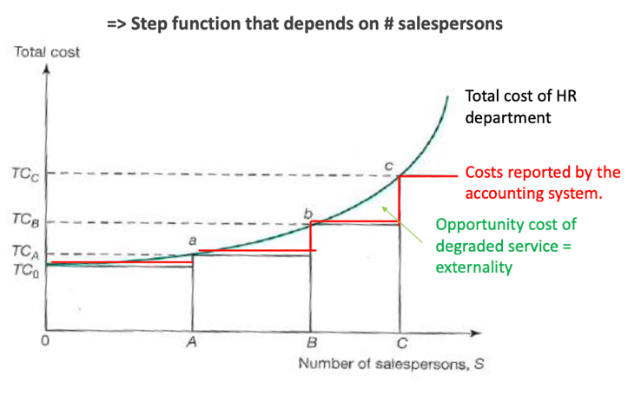

- Average HR cost per employee < MC
Allocate costs

- Average HR cost per employee = MC
Allocate costs

- Average HR cost per employee > MC
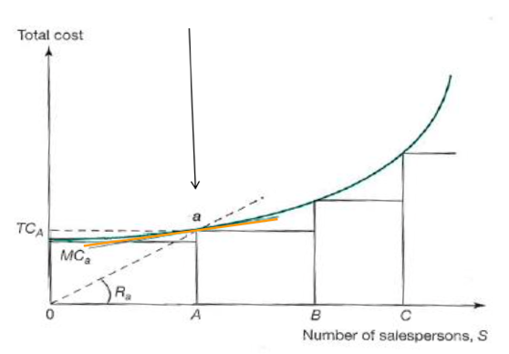
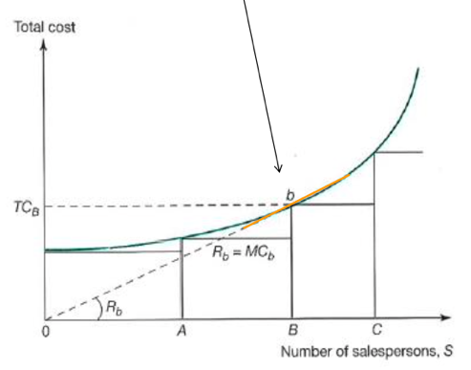
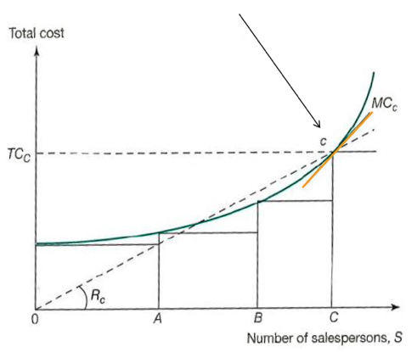
Don’t allocate, managers might decide to hire too few salespeople

Allocation Methods
- Direct cost allocation
    - Costs of service departments allocated to operational departments
    - No links between service departments
    - Ignores fact that service departments might serve each other
    - Quick & simple method, commonly used
- Step-down cost allocation
    - Hierarchy established between departments
    - Partial recognition of transfers between service departments (one way)
    - Different hierarchy means different costs, hierarchy very important
- Reciprocal cost allocation
    - Recognises mutual support services
    - First solve simultaneous equations between service departments, then allocate to operational departments
    - Not intuitive, complex solutions
    - Often difference between good step-down method and this is very small

(7) Insulating vs. Non-insulating Cost Allocation
- Insulating allocation
    - Allocation base is not related to unit’s performance
    - How well a division performs does not impact its share of common costs
    - Each division bears its own risk of events outside its control
    - One division's performance is not distorted by the performance of others
    - Performance of a division doesn’t influence performance of other divisions
- Non-insulating allocation
    - Allocation base is based on a unit’s performance
    - Costs allocated depend on the performance of the division & the others
    - Creates incentives for mutual monitoring & cooperation because one's performance & rewards depend on the performance of others
    - Sharing risks: reduce risks for the events that are outside their control
    - When one division is doing poorly, its pays less for shared costs and the other divisions which are probably doing better bear more costs
    - Minimizing performance variability among divisions
- Evaluating performance
    - Managers’ performance evaluation based on controllable segment margin or should common costs be included
    - Segment margin approach
      - Managers only responsible for costs under their control
      - Performance rewards for divisional managers based on controllable segment margin (so common costs not allocated)
    - Common cost included approach
      - Segmenting controllable & joint costs on segment margin reports won’t show how interdependent the segments are

(8) Joint Cost Allocation
- Joint cost allocation: special case of cost allocation
    - Joint cost incurred to produce two or more products from same input
    - Ex. processing of crude oil and producing multiple products
- Can be based on physical measure, ex. weight
Joint cost of chicken is sunk at time of decision to further process
- To assess profitability
    - Selling price – costs beyond split-off point = net realisable value (NRV)
    - If NRV positive, further process the product after the split-off
    - NRV depends on sales price
- Allocate costs based on NRV, ex. part 1 has 64% of net realisable value, so allocate 64% of the cost to it
- Usefulness of NRV
    - Not useful for planning, sales price more volatile than production costs
    - Not useful for pricing decisions, as it depends on price
    - Sometimes incentivizes overly large price reductions

9. Introduction to Absorption Costing

Absorption Costing Definitions
- Allocating all manufacturing costs to products
    - Direct costs (direct tracing): materials, labour…
    - Indirect costs (overhead) through allocation: variable & fixed overhead
- Reasons for absorption costing
    - Financial reporting
      - Book value of inventory (balance sheet)
      - Cost of goods manufactured (P&L account)
      - Segment reporting
    - Decision making
      - Pricing & transfer pricing
      - Product mix decisions
      - Cost reduction; activity-based management
- Two types of production, requiring different costing
    - Heterogeneous products to meet clients’ demand (job-order costing)
    - Homogenous/identical products: mass quantities (process costing)

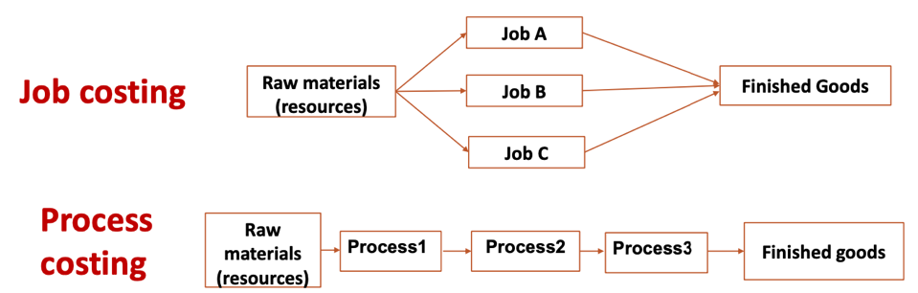
Types of Absorption Costing
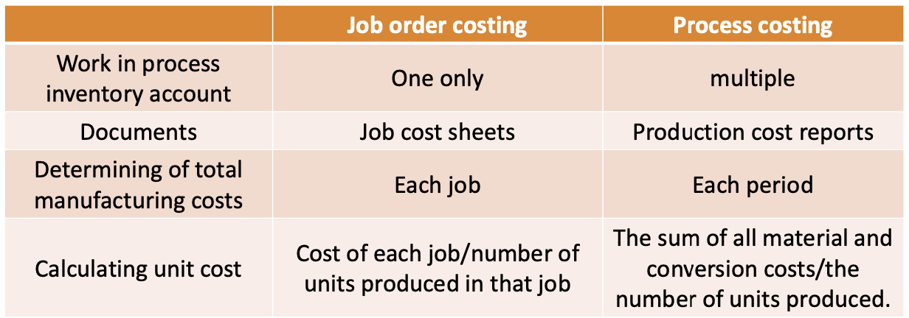

- FIFO vs. LIFO
    - LIFO
      - Better reflection of replacement value
      - Recent prices flow into COGS: better for decision making
      - If prices are rising, LIFO reports lower net income than FIFO
    - LIFO dangers
      - Year-end liquidations of old inventory: manage earnings for bonus
      - Distortion of profit to pay lower taxes
      - Lately in IFRS: LIFO forbidden

10. Job Order Costing

How To Allocate
- To allocate overhead to work-in-progress accounts, need:
    - Allocation base
    - Overhead rate
- Allocation base
    - Accuracy: choose one with high correlation to overhead: cost drivers
    - Behavioural effect: think of behavioural consequences
    - Cost allocation: internally taxing resources to affect behaviour of people
    - Use of input drivers (labour hours, machine hours, raw materials used…)
<-> output drivers (total units produced)
- Overhead rate = annual overhead costs / volume of allocation base
    - Problem: actual overhead costs & volume of allocation base available only after production process is complete (time lag)
    - We want to allocate costs to jobs as soon as they are produced
Budgeted (prospective) overhead rate
    - $Budgeted overhead rate= \frac{Budgeted annual overhead costs}{Budgeted volume of allocation base}$
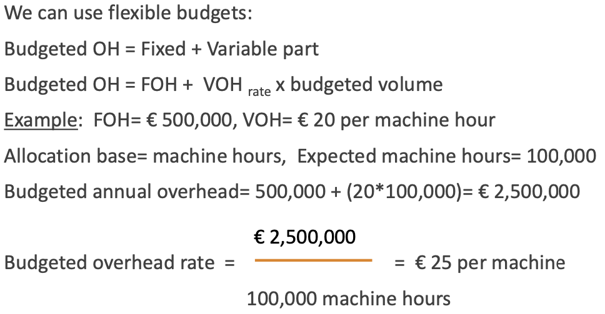
    - Example
Job Order Cost Allocation
- Trace all direct costs to jobs (WIP)
- Allocate overhead cost to jobs (WIP) via budgeted overhead rate
    - Estimate total budgeted overhead costs
    - Estimate budgeted volume over a period
Estimate budgeted overhead rate
- Allocate OH to products as soon as they are done
- Overhead is accumulated in jobs during year in T-accounts
- Actual vs. absorbed OH
    - Actual OH: amount of indirect manufacturing costs incurred
    - Absorbed OH: amount of OH applied to WIP using budgeted overhead rate and actual number of allocation base
    - Under-absorbed OH: when actual OH > absorbed OH
    - Over-absorbed OH: when actual OH < absorbed OH
    - Treating under/over-absorbed OH
      - Write-off to COGS account: product cost does not change
      - Prorate WIP account, finished goods & COGS account: product cost partially changes
      - Recalculate each job when actual OH is known: product cost changes
      - Subject to manipulation: of interest to auditors & tax authority

Alternative Cost Allocation
- Two alternatives to single overhead cost pool for entire plant
    - Multiple allocation bases & overhead rates
    - Each pool has own rates & drivers
    - Two-stage allocation of departmental overhead rates
      - Allocate OH costs to operating departments
      - Then allocate to products
- Multiple allocation bases vs. single base
    - More accurate costing because of multiple bases
    - Attention spread among several bases (weaker behavioural effects)
    - Attention to single factor: strong behavioural effects

Accuracy of Costing
- Accuracy not always needed
    - Upward-biased costs: prevent sales managers from giving discounts
    - Downward biased costs: target costs too low to stimulate product updates
    - Fewer drivers: more focus on key drivers, simplicity
Trade-off decision management vs. decision control
- Remark on budgeted volume
    - Expected volume
      - If demand falls, OH-rate using expected volume offers wrong signal
      - Volume drops accounting cost goes up, opportunity costs don’t change (may lead to death spiral)
    - Normal value
      - Stable unit cost over time: better for pricing decisions
      - Specific problem: normal volume more subjective than expected vol, large write-off needed if long-run volume inaccurate

11. Variable vs. Absorption Costing

Earnings management & absorption costing
- Absorption costing creates incentive to overproduce
    - Producing more units than can be sold, firm can transfer fixed costs from income statement to inventory on balance sheet
    - Building inventory not costless
Unit production cost ≠ marginal product cost
- Earnings management
    - Through real activity manipulation: overproduction
      - Fixed costs from income statement to inventory on balance sheet
    - Through bookkeeping choices
      - Inventory choices (FIFO, LIFO, WA…)
      - Treatment of end-of-year overhead difference
      - Normal vs. expected volume
    - More likely when
      - Managers near retirement
      - Quitting firm
      - When rewards based on current ROA or profit
      - High pressure to hit earnings benchmarks
- Solutions to mitigate overproduction
    - Penalty for overproduction (hard to set upper-bound of inventory)
    - Stock-based compensation (focus on LT-firm value)
    - Change decision rights or organisational structure (ex. produce on order)
    - Variable costing instead of absorption costing: exclude fixed costs from overhead analysis
- Variable costing vs. absorption costing
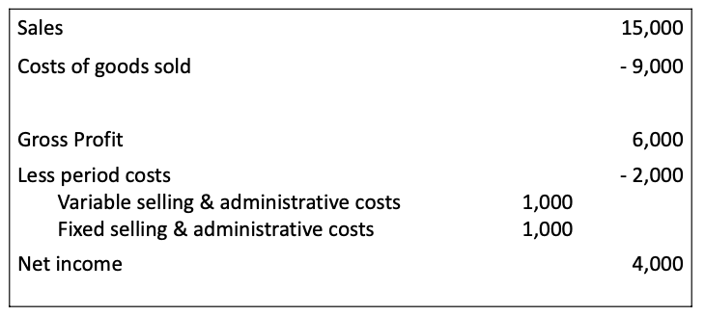
    - Income statement absorption costing
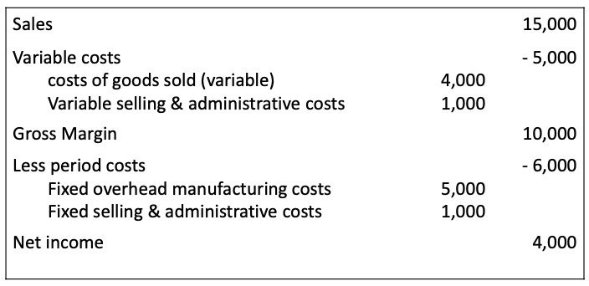
    - Income statement variable costing
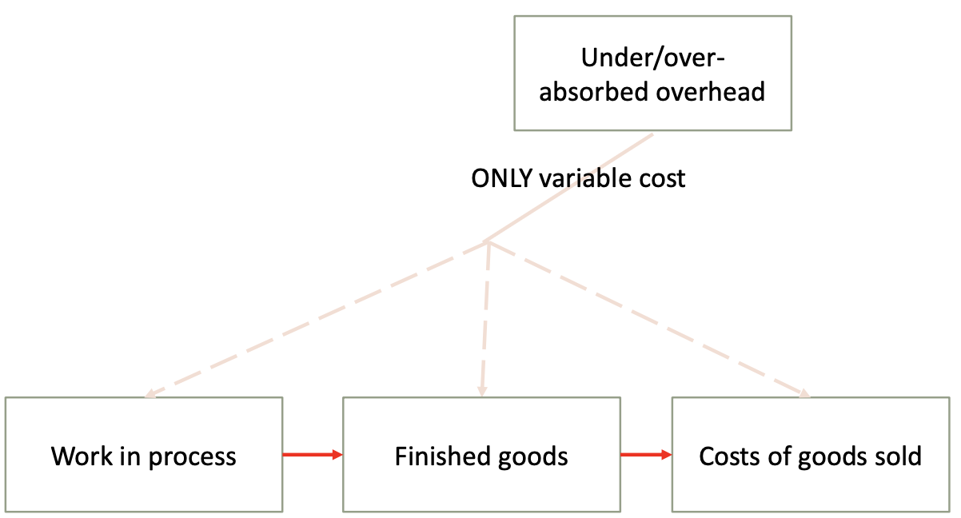
    - Treating under-/over- absorbed OH under variable costing

Limitations of Variable Costing
- In long-run, fixed costs are important
Variable costing ignores capacity costs & doesn’t show true product costs
- Subject to gaming: some OH are mixed (ex. cost of utilities)
Managers have incentives to treat some as variable or fixed to impact profit
- Variable costing doesn’t necessarily solve overproduction problem
By classifying some fixed OH as variable costs, part can be stored in inventory on BL
- When is absorption costing
    - Helpful: for long-term pricing & planning
    - Not helpful: deciding about special order, shutting down plant & outsourcing

12 & 13. Activity-Based Costing

Inaccurate Product Costing
- Absorption costing not well adapted to current production system
- Allocation bases are mainly input/output factors (volume-based costing, VBC)
Not true cost drivers
- Heterogenous processes
    - Absorption costing doesn’t clearly show how costs are influenced by diversity and complexity of production processes
    - Absorption cost systems assign too few costs to small batches & complex, special orders

Activity-Based Costing (ABC)
- Refined version of absorption costing
    - Supplement to rather than replacement for usual costing system
    - ABC accounts for the diversity & complexity of production processes
    - ABC attempts to find causal roots of cost allocation bases accordingly
- How costs are treated under ABC
    - Assigns both types of costs to products
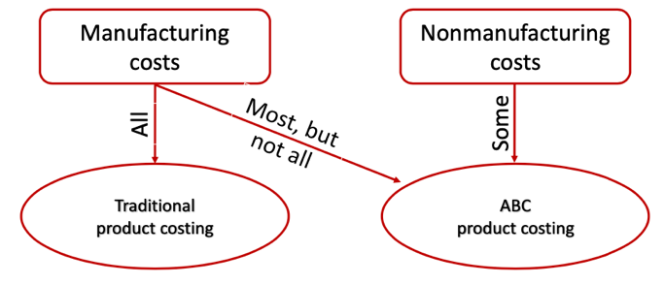
    - Does not assign all manufacturing costs to products
- Core idea: to produce products, different activities are conducted and these consume company resources

Use of ABC
- ABC raises several related logical questions
  - Why is the organisation spending money on indirect resources
Set of activities use these resources
  - Why is the organisation performing activities
Performing activities to produce for customers
  - How much is the organisation spending on these activities
Need to identify resource drivers
  - How much of each activity is required to produce each product
Need to identify cost drivers
- Two-step process
  - Resource drivers
    - Based on interviews, time studies, documents…
  - Activity drivers (multiple)
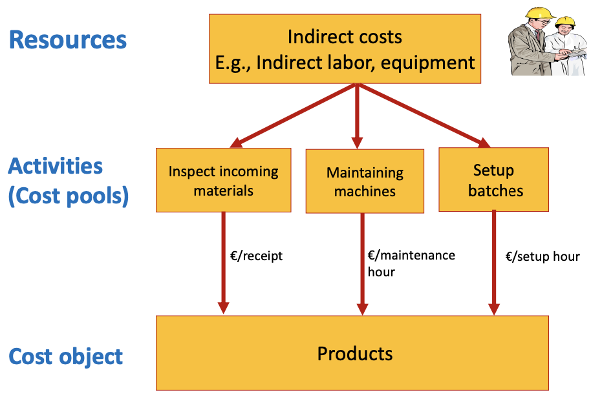
    - Availability of cost drivers, judgement of managers, ERP…
- Common types of activity drivers
    - Transaction driver: simple count of number of times activity occurs
    - Intensity driver: cost of each activity
    - Duration driver: measure of amount of time needed for an activity
- Activity levels
    - Unit-level activity: performed each time unit is produced
    - Batch-level activity: performed each time a batch is handled
    - Product-level activity: relates to specific product line
    - Organisation-sustaining activity: carried out regardless of products or units

(13) Activity-Based Management (ABM)
- ABM uses ABC information to improve performance
- Helps to manage & control costs, focuses on real drivers
- Keeping value-added activities and dropping non-value-added activities
    - Value-added cost: cannot be eliminated without affecting value to consumer
    - Non-value-added cost: can be eliminated without affecting value
- Benefits of ABC
    - More detailed analysis of OH, better operational decisions
    - Better LT pricing policies
    - Positive profitability effects: people become more cost conscious
- Costs of ABC
    - Increasing number of cost drivers increases accuracy, but also costs
    - More drivers mean more discretion (cost of misreporting)
ABC not solution for all, doesn’t reflect joint benefits of products well
- Time-driven ABC
    - Costs estimated based on the time required to perform activities
    - Managers consider practical capacity (80-85%)

Sources of Error in ABC
- Specification error: using wrong driver/link for an activity centre
- Measurement error: wrong amount/figure for driver
- Aggregation error: lumping activities in one pool and using a single driver
- Trade-off between disaggregation and specification
14. Customer Profitability Analysis (CPA)

Customer Costing
- Strategic importance of customer cost: customer specific costs are large category
    - High cost-to-serve customers
      - Low order quantities
      - Unpredictable orders
      - Special delivery & sales support
      - …
    - Low cost-to-serve customers
      - High order quantities in predictable pattern
      - Standardised products
      - …
- Traditional methods
  - Customer costs treated as period cost (no allocation)
    - General administration & selling directly expensed to profit & loss account
  - Mark-up method for customer specific costs
    - Mark-up on COGS/contribution margin
  - Single cost driver-systems for customer costs
    - Assign customer cost using one volume driver
- Some concerns regarding traditional methods
    - Allocate on ad-hoc basis, don’t differentiate across customers
Only works if customers are homogenous in ordering behaviour
    - Provide little guidance for cost management: what are our indirect service costs that our customers consume
    - Signs of shortcomings
      - General feeling of having high demanding vs; easy to serve clients
      - Attracting customers & winning bids of special orders for which other companies ask much higher prices
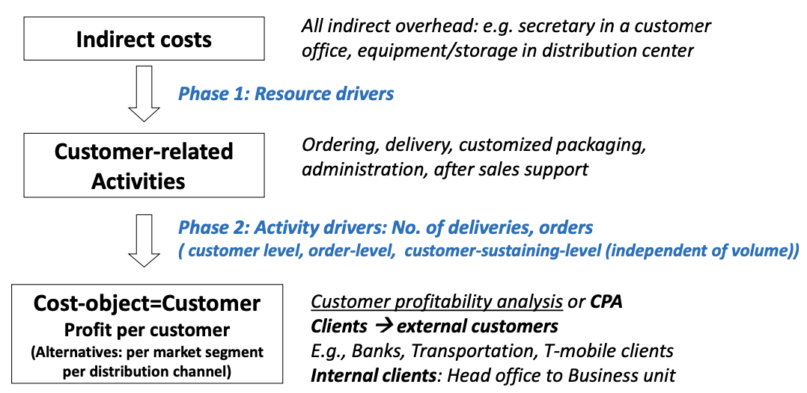
      - Lots of specific OH costs for customers

CPA as Strategic Management Tool
- CPA for price-setting
    - Companies usually ask similar prices for all customers, seldom reflect cost-to-serve (CPA cost)
    - Menu based pricing (discounting & premiums) on basis of cost behaviour
- CPA for resource allocation
    - Better understanding of how different marketing & sales activities are required to generate sales from customers
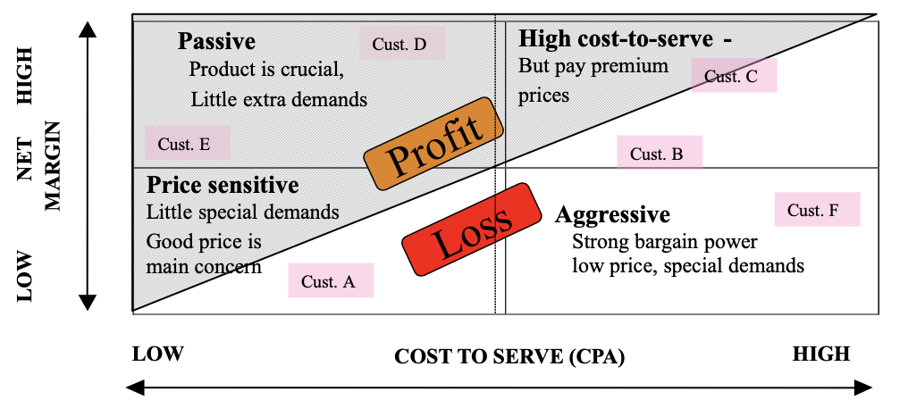
- CPA for market segmentation: new models & segments
- Dropping loss-making customers? Benefits in serving high cost-to-serve
    - Opportunities to learn
    - May be beneficial in long-run (become low-cost customers)
    - Reputation effects
- Factors to consider change when using CPA
    - Non-accounting ownership: involve non-accountants in CPA
    - Link to performance compensation: sales representative bonus…
    - Create commitment: savings might be difficult/unpopular to realise
    - System requires lot of registration: lots of data needed
- Suggestions based on findings
    - Identify characteristics of customers, use profiles to guide sales strategy
    - Motivate salespeople: reward systems based on customer profitability
    - Motivate customers: encourage predictable behaviour
      - Change options available, charge for extras
    - Outsource selling & distribution for small customers to independents

15. Standard Costing

Importance of Standard Costing
- Standard cost
    - Expected or desired cost
    - Reasonably required cost to achieve objective
    - Set at beginning of a budget period based on expectations
- Importance
    - Benchmark for decision control
      - Comparing actuals against standard costs (variance analysis)
      - Acts as control system
      - Large variances signal an out-of-control process
    - Provide more accurate information for decision making
      - Past costs are often misleading (inefficiencies)
      - Standard cost closer to opportunity cost
      - Process pricing, make/buy decisions: don’t have to wait for actuals
    - Specifying responsibilities & improving coordination among departments
      - Production guarantees manufacturing at given standard cost
      - Purchasing has clear idea of materials that should be bought
    - Performance evaluation of managers in line with controllability principle

Methods to set Standard Cost
- Past documents: bill of materials, routine sheet (historical cost + adjustment)
- Engineering method (ABC): observation of employees, measure materials
- Zero-based budgeting (each period): new assumptions to reflect reality
- Benchmarking: internal (across divisions) or external (competitors)

16. Labour & Materials Variance Analyses

Calculating Variances
- Labour variance
    - Actual cost of labour = actual wage x actual hours
    - Standard cost of labour = standard wage x standard hours
    - Direct labour variance = actual cost of labour – standard cost of labour
    - Wage variance = (actual wage – standard wage) x actual hours
    - Efficiency variance = (actual hours – standard hours) x standard wage
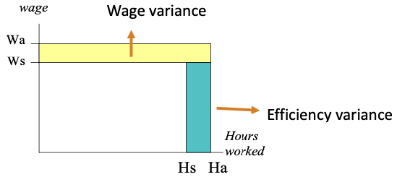
Labour variance = wage variance + efficiency variance
- Calculating materials variances (no inventory)
    - Materials variance without inventory = (Q_{a} x P_{a}) – (Q_{s} x P_{s})
    - Actual quantity (Q_{a}) = purchased quantity (Q_{b})
    - Price variance = (P_{a} - P_{s}) x Q_{a}
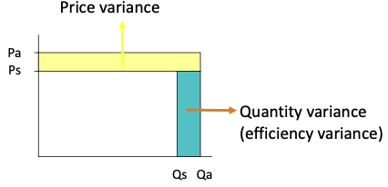
    - Efficiency variance = (Q_{a} - Q_{s}) x P_{s}
- Calculating materials variances (with inventory)
    - Materials variance = (Q_{b} x P_{a}) – (Q_{s} x P_{s})
    - Not all materials used in the process (inventory problem), solution:
      - Price variances against quantities bought (Q_{b})
      - Efficiency variance: standard used (Q_{s}) vs. actually transferred to the WIP account (Q_{a})
    - Price variance = (P_{a} - P_{s}) x Q_{b}
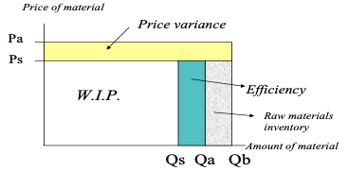
    - Efficiency variance = (Q_{a} - Q_{s}) x P
Bookkeeping with Standard Costing
- Materials recorded in raw materials inventory account at standard cost
- Price & efficiency variance recorded in separate variance accounts
Helps to assign responsibilities
    - Price = procurement (materials) & HRM (wage)
    - Efficiency = department head, production manager…
- Disposal of variances
    - COGS (P&L)
    - Pro-rate COGS (P&L), FG (balance sheet)
    - Recalculate
Firms often write off variances to COGS if they are not large because
    - Production costs & standard costs do not change
    - If volume drops (eff variance goes up) or purchasing price increases temporarily, this does not send wrong signal to managers that actual product cost has changed
- Variances
    - Favourable: actual costs < standard costs
    - Unfavourable: actual costs > standard costs

Dysfunctional Effects of Standards
- Externalities: conflicts can arise
    - Purchasing managers & HR: can impose costs on production
Low quality products & labour lead to more rework & scrap (efficiency)
    - Production can impose costs on purchasing managers & HR
Rushing, materials needed fast (purchasing can’t look for best price)
- Discourage cooperation: goal incongruence
    - Externalities can create conflict
    - Individual responsibilities for variance do not motivate cooperation
- Stock building: purchasing managers buy bulk for quantity discounts
- Micro-management & sub-optimisation
    - Price & efficiency for every material component & every labour force
    - Sub-optimisation: minimisation in one department can make another suffer
- Large variances: good or bad
    - Large favourable variance: potential negative quality effect
    - Large unfavourable variance: standards wrong
    - Still a lot of context needed
- Standards may become obsolete in automated production quickly because of frequent updates in products & processes

Minimising Negative Effects of Standards
- Maintaining standards on aggregate levels instead of for each process or material
- Mutual monitoring, group-based bonusses
- Balanced scorecard (forward looking)

17 & 18. Overhead & Marketing Variance Analyses

Budgeted Overhead
- $Budgeted OH rate= \frac{Budgeted annual OH}{Budgeted volume of cost driver (BV)}=\frac{FOH+(VOH*BV)}{BV}=\frac{FOH}{BV}+VOH$
    - Budgeted volume set at start of the year
    - $Allocated OH=budgeted OH rate*actual volume (AV)$
$Allocated OH=budgeted OH rate*standard volume (SV)$
- OH is allocated using a standard volume, not an actual volume of the driver
- Three ways to quantify volume of the cost driver
    - Budgeted volume (BV)
      - Set at start of year
      - Budgeted n° of products sold x standard n° of input needed per unit
    - Standard volume (SV)
      - Available as production is going or at end of the year
      - Actual n° units produced x standard n° of input needed per unit
    - Actual volume
      - Amount of volume measure actually used

OH Variances
- Total over/under-absorbed overhead = actual OH (AOH) – absorbed OH
- Spending variance: difference between actual OH & how much OH should have been incurred for the actual volume measure used
= actual OH – flexible budget at actual volume
= AOH – (FOH + (VOH x AV))
- Efficiency variance: captures inefficiencies in using variable OH
= flexible budget at actual volume – flexible budget at standard volume
= (FOH + (VOH x AV)) – (FOH + (VOH x SV)) = VOH x (AV – SV)
- Volume variance: captures over-/underused capacity of facility
= flexible budget at standard volume – absorbed OH
= FOH + (VOH x SV) – ((FOH/BV + VOH) x SV)
= FOH – (FOH x SV)/BV = FOH x (BV – SV)/BV

Marketing Variance
- Marketing variance = (actual price x actual quantity) - (standard price x standard quantity)
    - Price variance = (actual price – standard price) x actual quantity
    - Quantity variance = (actual quantity – standard quantity) x standard price
- Mix variance = (actual mix % - standard mix %) x actual units sold x standard price
    - Captures effect of substitution among products
- Sales variance = (actual units sold – standard units sold) × standard mix % × standard price
    - Captures effect of differences between actual & standard quantities sold
- Mix & sales variance together make the marketing variance

19. Pricing

Different Views
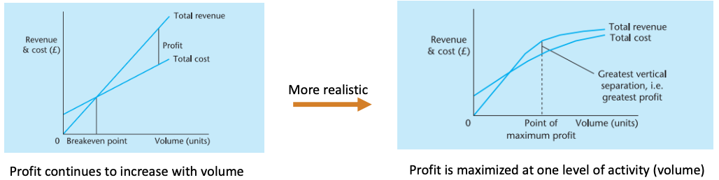
- Economist’s view

- Accountant’s view: cost-plus pricing
    - Calculate product/service cost (not straightforward)
    - Assumes product demand is price inelastic, ignores demand aspect of competitive environment
- Marketer’s view
    - Existing products: market considerations must have final say in price setting
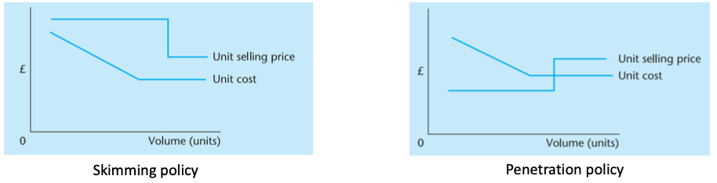
    - New products: price depends on marketing strategy
Target Costing
- Instead of bottom-up costing
- Costing starts from selling price & then desired profit (top-down costing)
- Calculated based on customer’s needs & firm’s competitive environment
    - What should selling price be to compete in the market
    - How much contribution margin do we expect
    - What is desired cost level
      - Target cost = target price – target profit
      - Target cost is given to engineers & managers to design product
- Cost control starts when design of the product starts
Many costs cannot change after product design is done
- Target costing: way of maximising product profitability, not minimising costs

