Operations Strategy in Manufacturing & Services
Summary of classes by dr. Maximiliano Udenio, winter semester 2024

1. Operations Strategy: Concepts & Frameworks

What is Operations Strategy
- Operation: an activity in which a business is involved
- Strategy: specific plan to reach a major or overall objective, a combination of ends (what) and means (how)
- NPV: present value of future cashflows, investment needed today to generate them
- Operations strategy: plan for developing resources & configuring processes such that the resulting competencies maximise the NPV of the organisation
- Strategic decision making
    - Long term perspective
    - NPV can incorporate risk & uncertainty
    - We focus on financial goals
- In this course, we want to answer the question:
“Why/how do some firms (Google, Amazon…) become really successful by improving their operations?”
    - Operations: SCM, sourcing…
    - Explore the link between strategy and operations

Framework VCAP (VCRP)
- Value = capabilities x (resources+ processes) = competencies x (assets+ processes)
    - Capabilities & competences: actual vs. desired
    - To create value, you need to understand your capabilities and focus them
    - Resources & processes flow from desired capabilities
    - In this course, look at resources in terms of capacity:
      - Size
      - Time
      - Flexibility
      - Location
    - Look at processes in terms of
      - Innovation
      - Learning
      - Revenue management (price controls etc.)
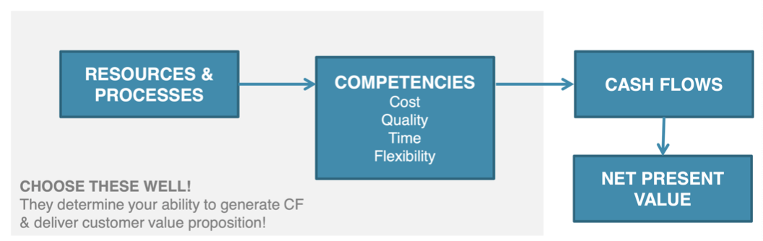
Goal: what are needed resources/processes given you capabilities

- Link with competitive strategy
    - Which needs do you want to cover
      - In line with your competencies & resources
    - What is the customer WTP
      - Niche should be worthwhile; revenue > cost
      - Must be sustainable in time
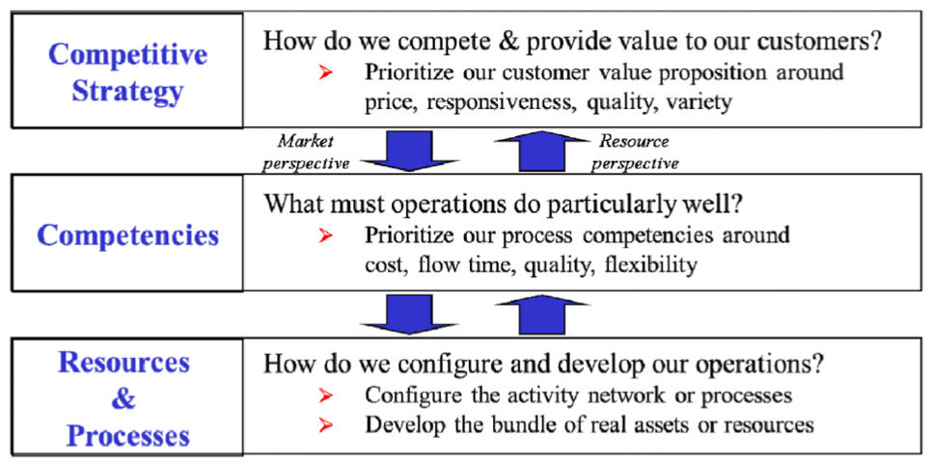
- Adopt a market or resource perspective to ensure all is aligned with the competitive strategy

    - Market perspective (structure follows strategy)
      - Top down, serve your customer
      - Customer needs dictate your actions
    - Resource perspective (strategy follows structure)
      - Bottom-up, exploit your core competencies
      - What you are good at dictates your actions
    - Dynamic environment: perspective can change

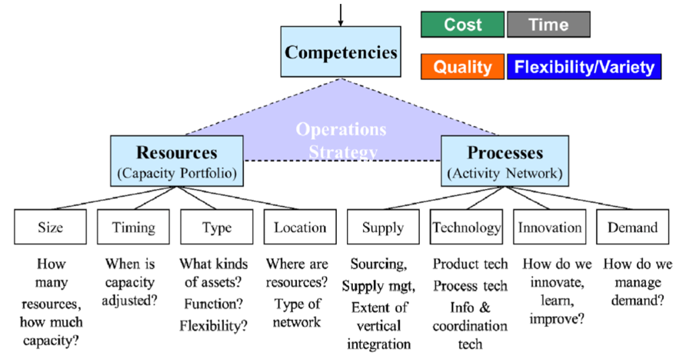
- Operations view

Align Operations Strategy with Competitive Strategy
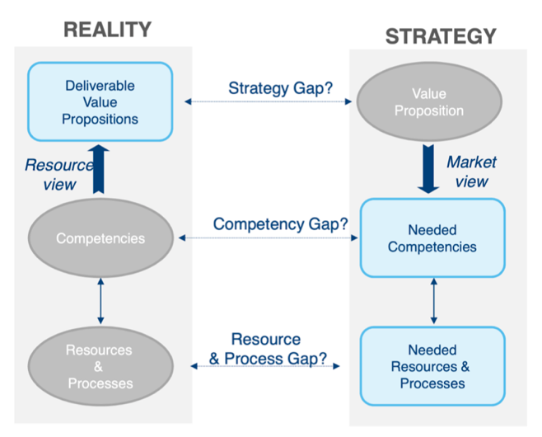
- Strategic operational audit as a tool
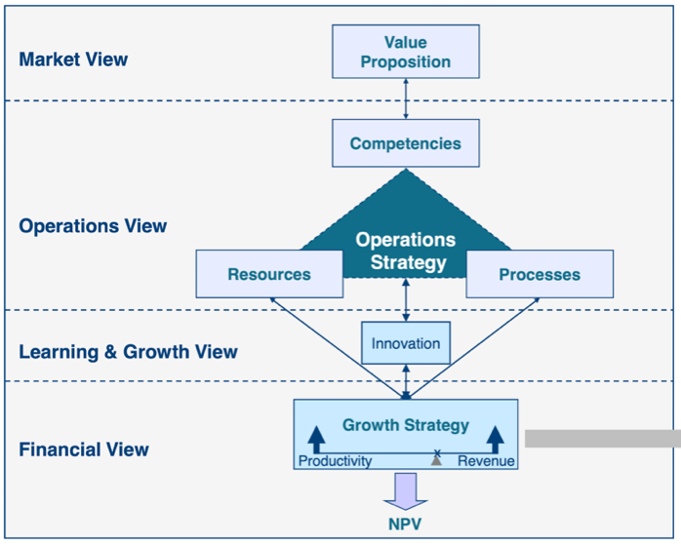
- Balanced scorecard map as a tool
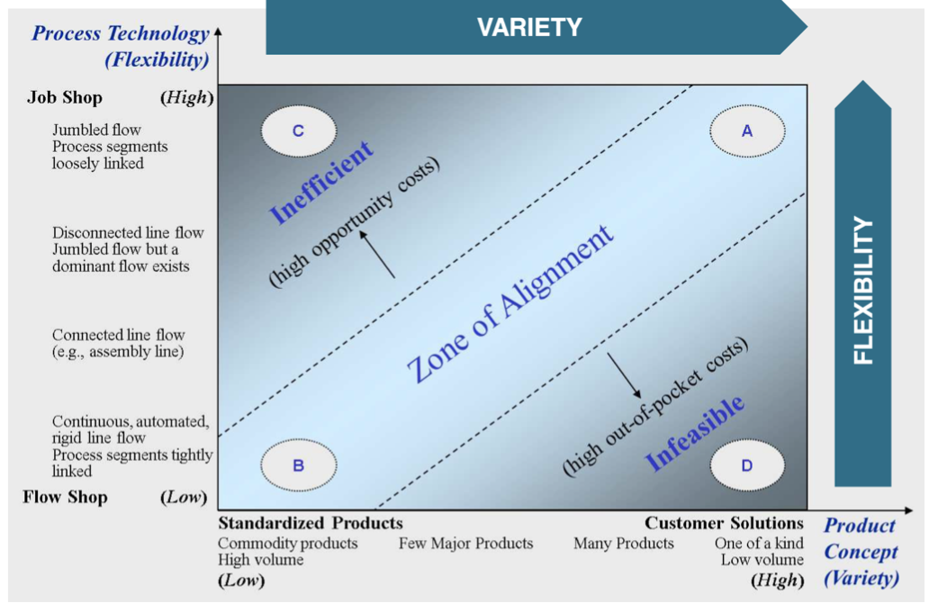
- Product-process map as a tool

2. Operations Strategy: Competition, Competencies & Operations

Cost Advantage Analytics
- Customer trade-offs vs. operational trade-offs
    - Visualise with ISO curves
    - Maximise utility (largest surface under the curve)
    - Different ISO curve per customer or producer
    - Define cost in X-axis of curve, all other competencies on Y-curve
    - Key message
      - Choose resource bundle to fix the operational trade-off curve
      - On this curve, choose point out of reach of competitors
    - Trade-off principle
      - Operational competencies are governed by trade-offs
      - No process fits all strategies
      - Operational trade-offs offer competitive protection
      - Understanding trade-off curves vital to judge competitive threats
Hard to get info about cost competitiveness of competitors
- Efficient frontier (EF)
    - Outer envelope of curve of all firms in an industry (on the edge of the area, on the curve)
    - Operationally efficient firm: on the curve
    - Sustainable position only if you are cost competitive
    - Efficient frontier is dynamic, will shift over time
- Focused operation
    - Operation whose required competencies are limited to a narrow set of competency bundles (small area in competency space)
    - Focus is not same as narrow product mix, rather a mix that requires similar competencies

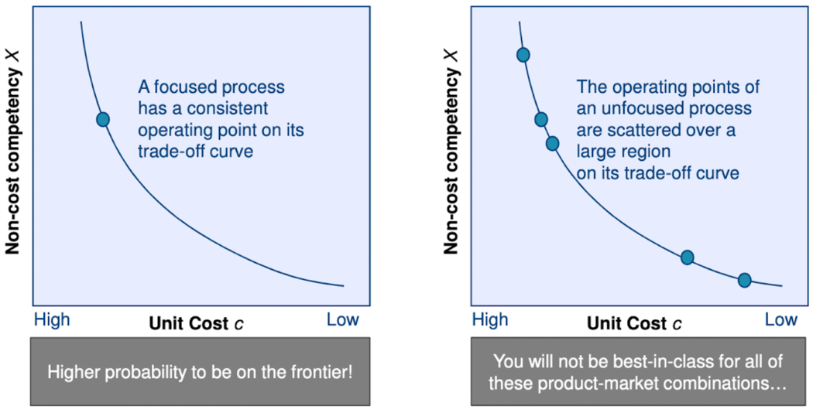
    - How to focus an operation
      - Partition products into groups with homogenous competency needs
      - For each group, separate those resources that critically support its value proposition while sharing the others
      - Ensure for each operation to retain focus over time

Analyse Competitive Threats
- Impossible to obtain perfect information, but…
    - Estimate/observe cost competences
    - Estimate/observe non-cost competencies
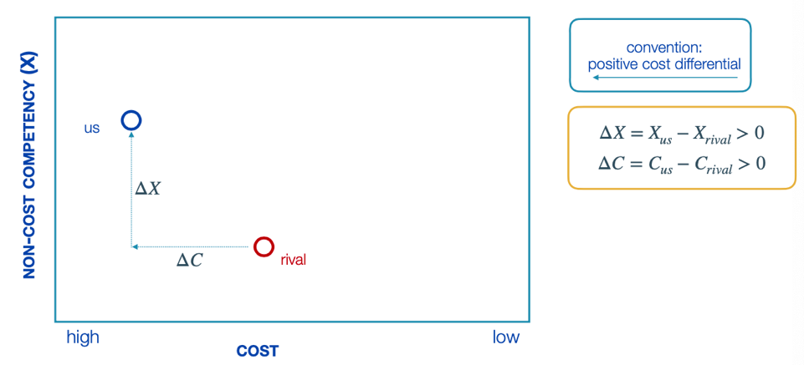
    - Analyse/estimate what our rival’s cost would be if they were to compete
- Plan cost differential
    - Observed values may not be on trade-off curve
We must account for this ‘plan cost differential)
    - Differences can be positive of negative
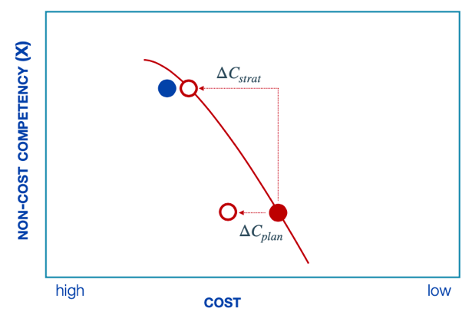
    - Typically occur when there are utilisation or sourcing issues
- What if competitor matched my non-cost competencies?
    - Step 1: correct costs for you & your competitor
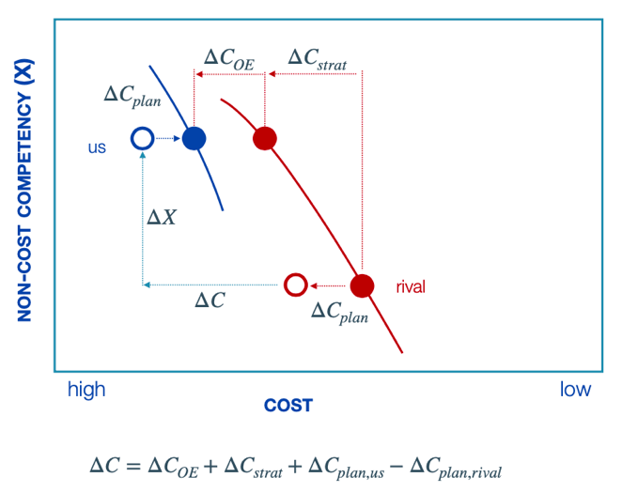
    - Step 2: adjust for differences in strategy
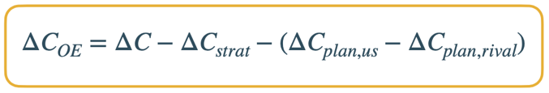
    - The larger the ${ΔC}_{OE}$, the larger the competitive threat
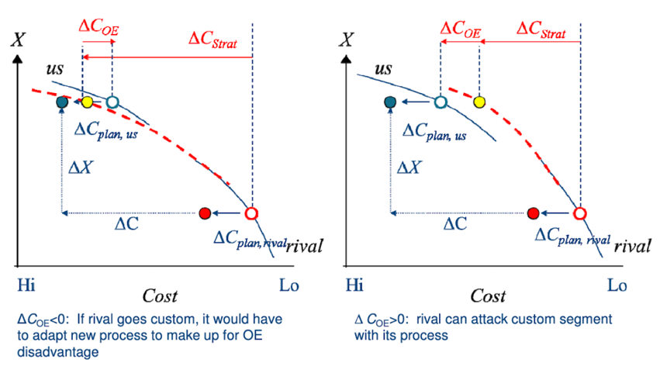
    - Outcome depends on assumptions

3. Operations Strategy: Data Envelopment Analysis (DEA)

Introduction
- DEA: method to estimate efficient frontiers from empirical data
    - Starts from data set of inputs & outputs for decision making units (DMU’s)
    - For each DMU: realised outputs & inputs used in the process
- Linear programming to calculate an efficiency score
    - Common tool for relative benchmarking
    - DMUs can be anything (hospitals, ports, firms…)
How do I perform in terms of output, given my inputs?
    - Input oriented: minimise inputs, for given output
    - Output oriented: maximise output, for given input
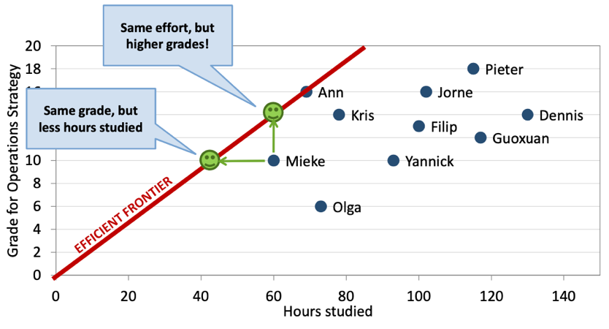
    - One input situation: steepest slope is most efficient of the set
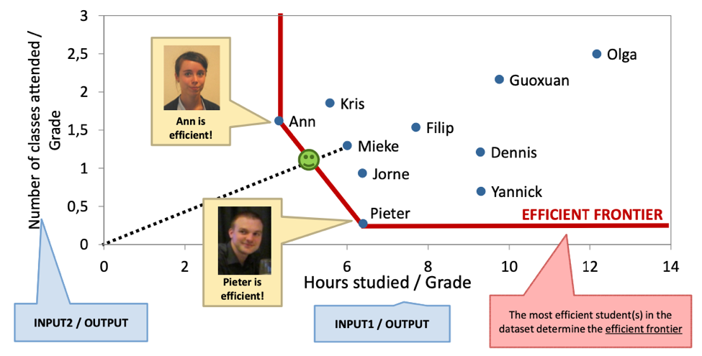
    - Two input situation:
DEA Concepts
- Key concepts
    - Set of decision-making units: the entities to be evaluated (ex. people)
    - Data: inputs & outputs, available for each DMU
    - DEA is a benchmarking method
      - Compare DMU to all others in dataset
      - Efficiency in terms of ‘best in class’
      - Notation: DMU₀ = entity under study
- For each DMU, efficiency & optimal weights are determined
    - Optimal weights represent a virtual DMU that lies on efficient frontier
    - If we can’t make a virtual company from the sample date which achieves better results than the DMU₀, then this DMU is efficient
    - How: linear programming
- DEA vs. regression vs. fixed weights
    - DEA: best performance, benchmarking
    - Regression: average performance, central tendencies
- Fixed weights: make an assumption about fixed weights
Ex. (0,1 x hours studied) + (0,25 x classes attended) = grade
(0,1 x 100) + (0,25 x 20) 15
    - If my grade is less than 15 for these same inputs, I am inefficient
    - Problem: weights can differ for all students & true inefficiencies
    - Solution: data envelopment analysis (DEA)
- Variable weights
    - Derive best weights from data
    - Maximise ratio of weighted output to weighted input
    - DEA determines best weights, inefficiencies cannot be due misspecification

Constant Returns to Scale: CCR Model
- Notation
    - Set of n DMU’s
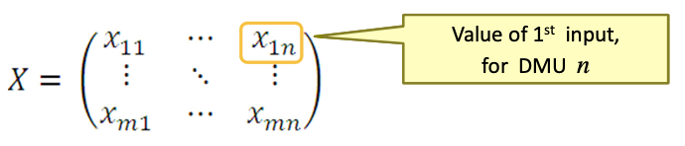
    - Each DMU has m inputs
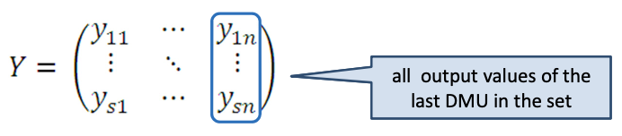
    - Each DMU has s outputs
    - Input weight vector is v = v₁, …, v_{m}
    - Output weight vector is u = u₁, …, u_{s}
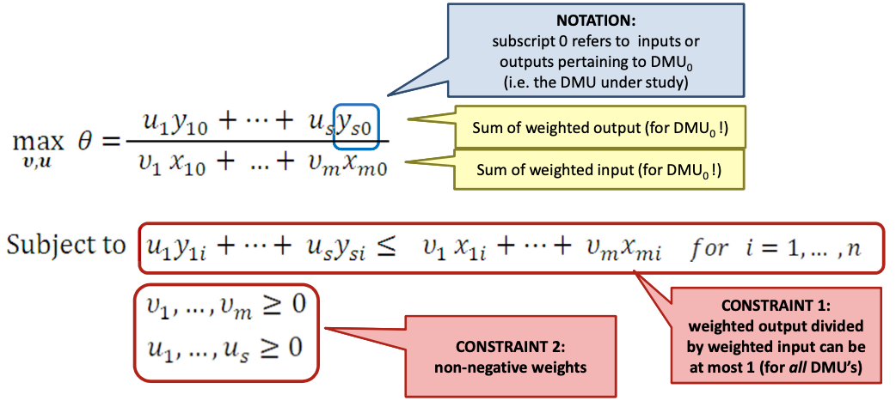
- Objective: for specific DMU, determine optimal weights u & v to maximise:
Objective function not linear: add constraint such that denominator is 1

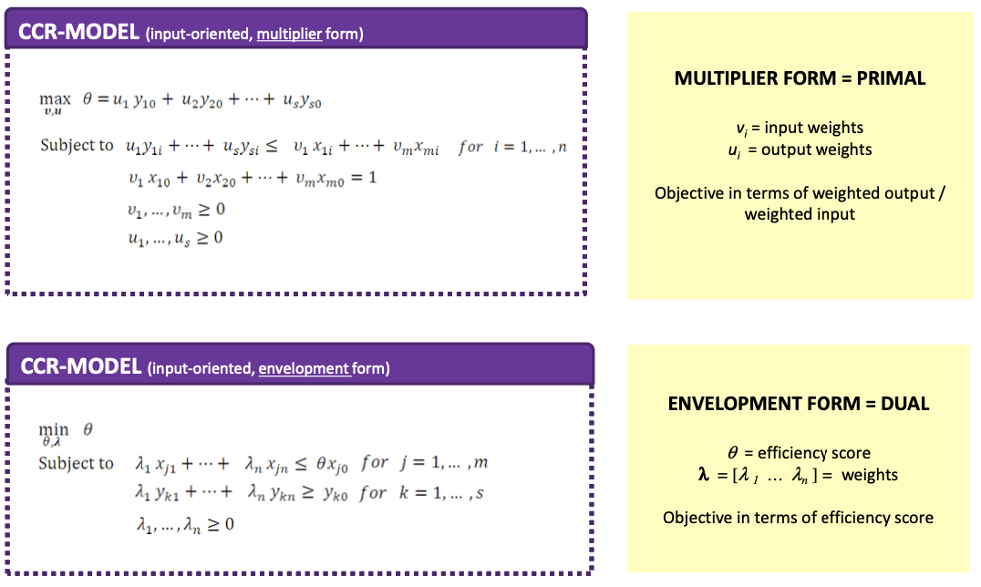
- Forms of the input-oriented model: multiplier vs. envelopment form

- Envelopment form of input-oriented model
    - The virtual DMU represents a linear combination of all the DMU’s in the dataset that lie on the efficient frontier
    - The λ’s reveal how this virtual DMU is composed
    - For every input: input of virtual DMU should be ≤ inputs of DMU₀ x θ
All inputs are multiplied with same factor θ
    - For every output: output of virtual DMU should be ≥ output of DMU₀

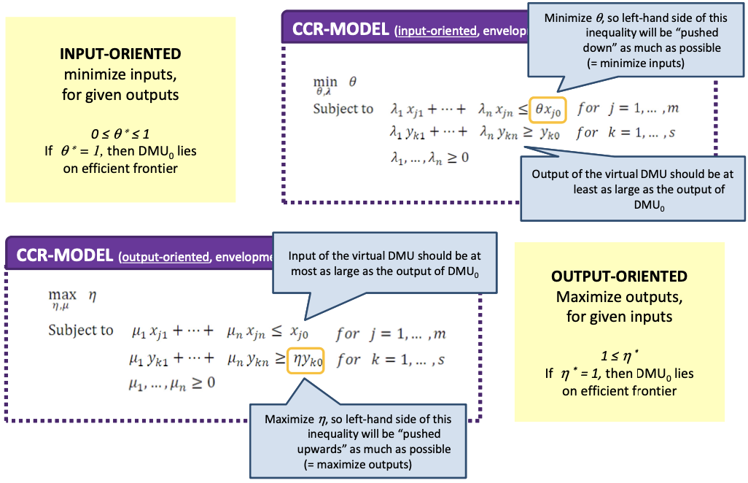
- Envelopment form: input- vs. output-oriented model

Link between input- & output-oriented formulation
    - $θ^{*}=1/η^{*}$
    - $λ^{*}=μ^{*}/η^{*}$
- Definitions & Properties of CCR
    - DMU₀ is CCR efficient if there is both
      - Technical efficiency: $θ^{*}=1$
      - Mix efficiency: all input & output slacks are 0
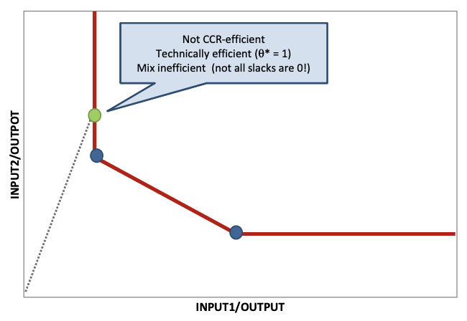
    - Corresponds to Pareto-Koopmans efficiency: DMU is fully efficient if impossible to improve any in-/output without worsening another in-/output
- See example exercise on slides 41 – 61

Variable Returns to Scale: BCC Model
- Different types of returns to scale
    - Increasing: if all inputs multiplied by k, output will change more than k
    - Constant (CCR): if all inputs multiplied by k, output will change by k
    - Decreasing: if all inputs multiplied by k, output will change less than k

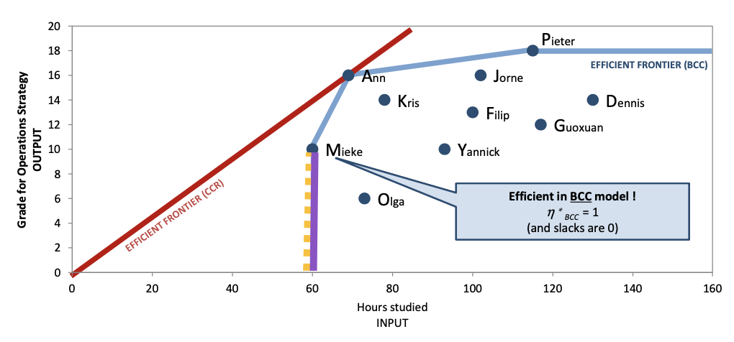
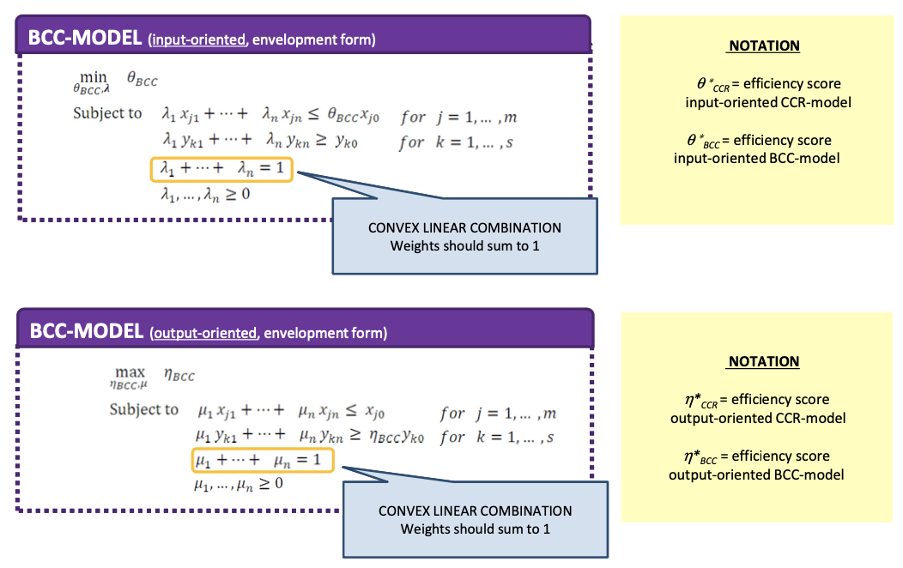
- BCC model formulations
Efficient in BCC model, but not in CCR model (has to be on the red line for this)

- Definitions of BCC
    - DMU₀ is BCC efficient if there is both
      - Technical efficiency: ${θ_{BCC}}^{*}=1$
      - Mix efficiency: all input & output slacks are 0
- Properties
  - DMU efficiency
    - DMU with minimum input value for any input, or maximum output value for any output, is BCC efficient
    - Consequence: if number of DMU’s too small compared to number of in- & ouputs, then most DMU’s will be classified as efficient
    - Rule of thumb: $\#DMUs ≥ max⁡\{ms, 3\left(m+s\right)\}$
      - m = # inputs
      - s = # outputs
  - Efficiency scores
    - ${θ_{CCR}}^{*}≤{θ_{BCC}}^{*}$
    - ${η_{BCC}}^{*}≤{η_{CCR}}^{*}$
# efficient DMU’s in CCR, never exceed # efficient DMU’s in BCC-model
  - Scale efficiency (SE)
    - $SE={θ_{CCR}}^{*}/{θ_{BCC}}^{*}$
    - CCR doesn’t account for scale effects, so efficiency might be better in BCC
  - Decomposition of technical efficiency
    - ${θ_{CCR}}^{*}={θ_{BCC}}^{*}*SE$
    - Technical efficiency = pure technical efficiency x scale efficiency

Non-Discretionary Variables
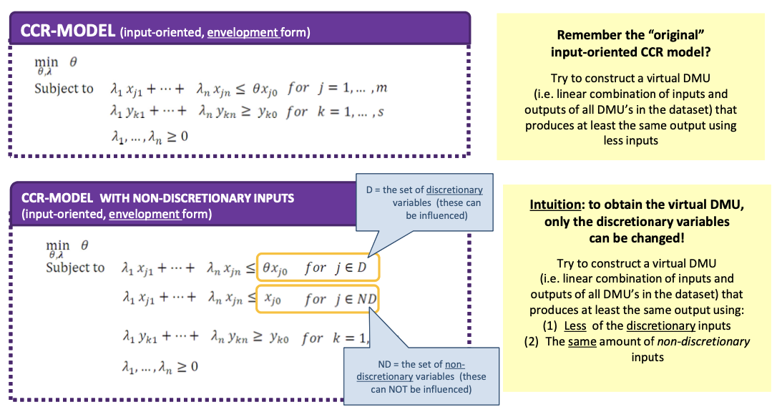
- Variables that cannot be influenced

Conclusion
- Advantages
    - Assessing multiple in- & outputs at once
    - No need to specify weights in advance
    - No need to specify functional form in advance
    - Measurement of in- & outputs does not have to be the same
- Disadvantages
    - Results depend on dataset, as the efficiency is only relative
      - Depends on sample data
      - Depends on in- & outputs taken into account
    - Many models available, ‘right’ one doesn’t exist, careful to interpret result
    - Sensitive to outliers

4. Capacity Sizing & Investment

Capacity Portfolio Strategy
- Capacity: maximum sustainable output rate of a source
- Limitations: scarcity (failures, downtimes…)
- Four metrics of capacity portfolio strategy
    - Sizing: how much capacity to invest in (this chapter)
    - Timing: when to implement capacity
    - Type: what type of capacity
    - Location: where to locate the capacity
- Impact on value of the firm (NPV)
    - Big cash outflows
    - Shape competencies
    - Determines the volume of demand that can be met
- Sizing capacity optimally
    - Need a model for capacity cost
    - Need a model for the value of capacity
    - Need to make trade-off between cost of investing too much & too little
- Economies of scale (EOS)
    - EOS: cost per unit of capacity declines as amount of installed capacity rises
      - K = size of capacity
      - C(K) = capital expenditure function, cost incurred for capacity K
      - C(K): concave & increasing function of K: C(K) < C(2K) < 2 C(K)
      - Linear capex function or power capex function
    - Causes
      - Fixed cost component: as K rises, fixed cost is spread out over larger number of capacity units (linear & power)
      - Decreasing marginal capacity cost (power)
- CapEx functions
    - Linear: $C\left(K\right)=c_{fix}+c_{K}K$
    - Power: $C\left(K\right)=c_{fix}+{(c}_{K}/α)K^{α}$ with $0<α≤1$
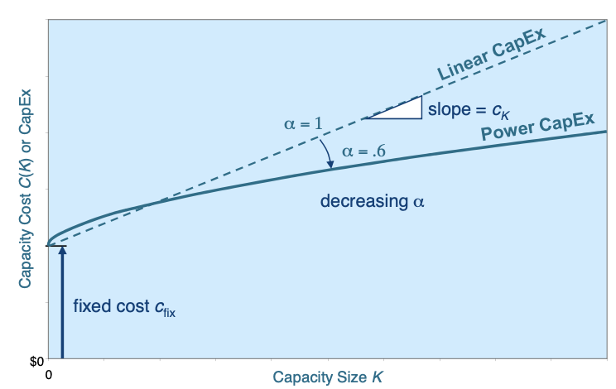
If alpha = 1, then power function = linear function

Capacity as Option
- Value of capacity = expected sales x operating profit per unit
- Operating profit per unit (M) = revenue per unit – variable cost per unit
    - Value of capacity does not increase linearly with K (due to demand link)
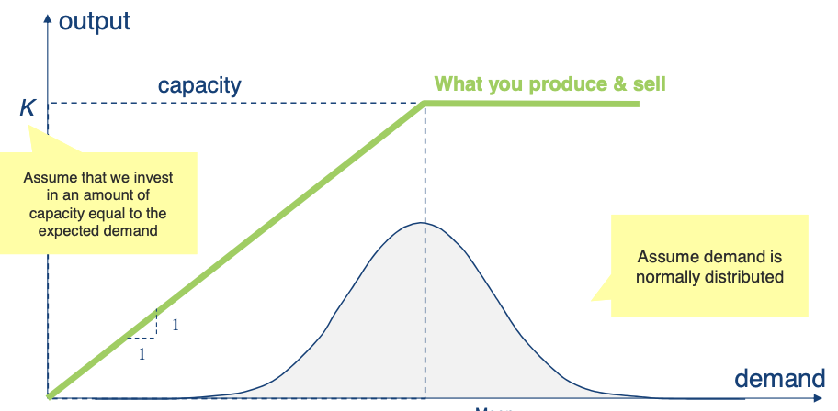
    - If capacity doubles, expected sales does not always double

- Excess demand
    - When demand > capacity = excess demand = capacity shortfall
    - Increase expected sales by limiting capacity shortfall
- Capacity is an option on a real asset, whose value decreases if volatility increases
    - Proper capacity valuation must include demand volatility & non-linearity of achievable output (cap)
    - The capacity beyond the mean demand R = safety capacity
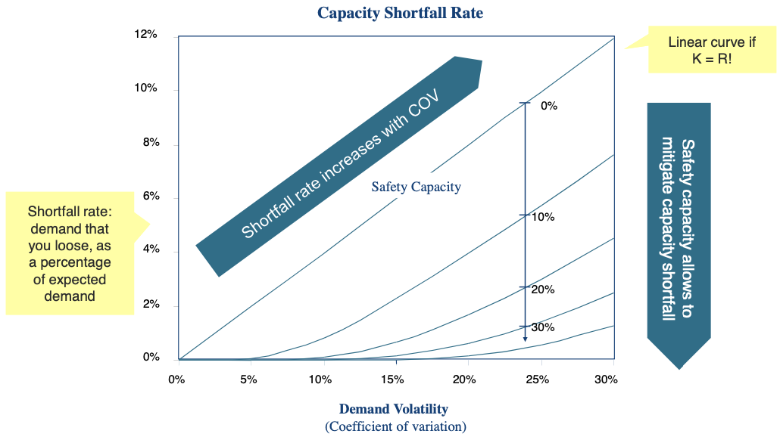
- Safety capacity for normally distributed demand

Optimal Capacity Sizing: Newsvendor Model
- Assumptions
    - Linear capacity sizing model
    - Demand is normally distributed
      - R = mean
      - σ = standard deviation
    - C_{o} = overage cost = marginal cost of excess capacity, c_{K}
    - C_{u} = underage cost = marginal cost of shortage of capacity, m + c_{p} – c_{K}
    - F = standard normal cumulative distribution
- Question: what is the optimal capacity to invest in?
Balance cost of excess capacity with cost of capacity shortfall
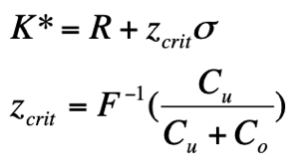
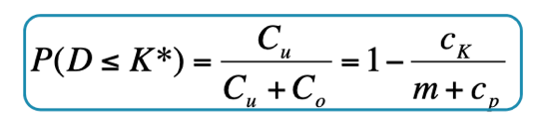
- Optimal service probability
- Suppose
  - Invest in K, demand turns out lower
    - Excess capacity
    - Determine overage cost c_{o}
    - Total cost becomes
$TC\left(K\right)=c_{fix}+c_{K}K$
  - Invest in K, demand turns out higher
    - Shortage of capacity
    - Determine underage cost c_{u}
    - Total cost becomes
$TC\left(K\right)=c_{fix}+c_{K}K+\left(m+c_{p}\right)\left(X-K\right)$
$$=c_{fix}+\left(m+c_{p}\right)X-\left(m+c_{p}-c_{K}\right)K$$

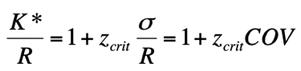
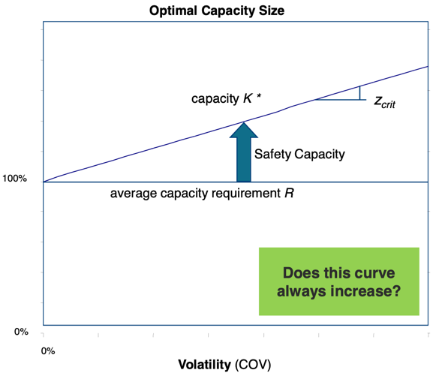
- Optimal capacity as percentage of average demand (linear in COV)
- Impact of volatility on NPV of optimal capacity
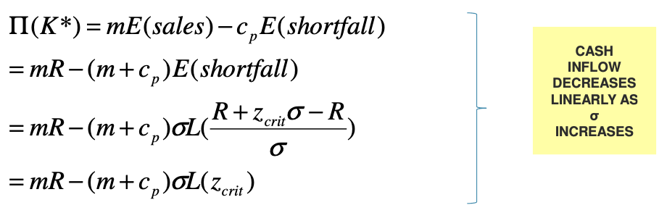
    - Expected operating profit at optimal capacity K*
    - Even if you size capacity optimally, value of optimal capacity decreases linearly as σ increases
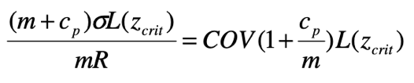
    - Degradation % in profits due to volatility = shortfall rate (if no penalty costs)
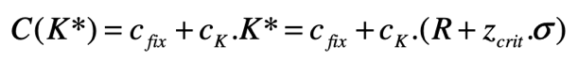
    - Expected investment at optimal capacity K*
      - Cost of optimal capacity sizing increases linearly in volatility
(increase in σ for same R)
    - Two effects of variability for optimal capacity
      - Profits go down linearly, as σ increases
      - Costs go up linearly, as σ increases
NPV of optimal capacity sizing decreases strongly in volatility

Optimal Capacity Sizing: Multiperiod Setting
- In reality, capacity lasts for more than 1 period
    - Invest once
    - Enjoy the operating profits for multiple periods in the future
Choose optimal K* to maximise NPV over multi-period horizon
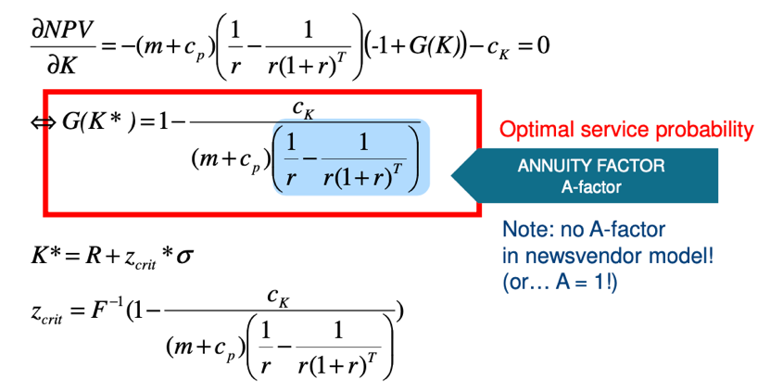
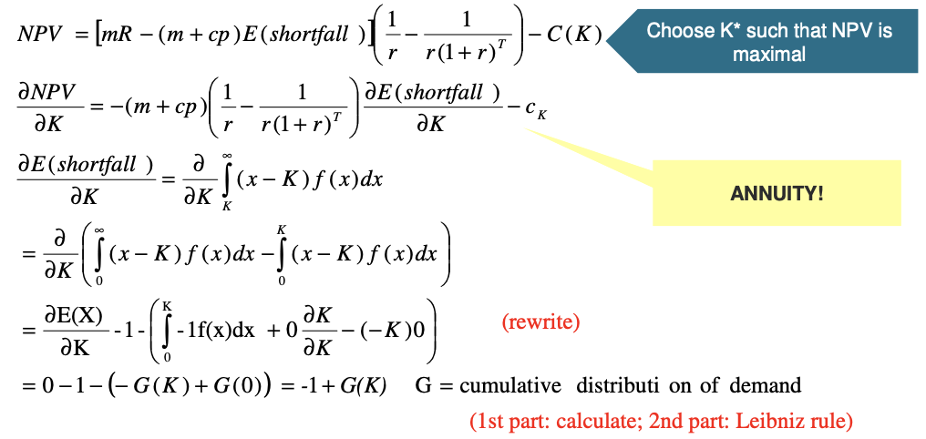
- Suppose T period horizon, then we get

- Irrespective of the value r, A is increasing in T
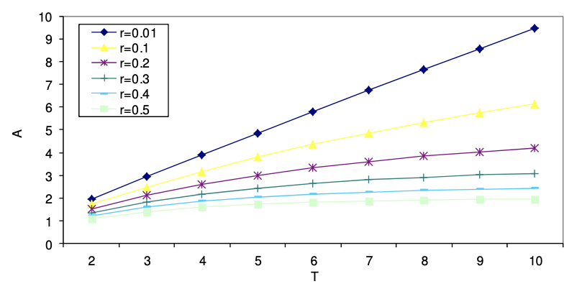
    - For typical values of r and T ≥ 2: A > 1
- Afterthoughts
    - Capacity is a soft constraint
      - Use overtime or other short-term measures to increase capacity
      - Depends on operational policies used
    - Capacity investment is subject to capacity frictions
      - Leadtime: capacity not always immediately available
      - Lumpy (indivisible, discrete) vs. incremental (divisible, continuous)
    - Capacity decisions can be political
      - Decisions influence many stakeholders
    - Measuring & valuing capacity shortfall is not obvious
      - Predicting true demand is impossible, only sales are observed
      - Reaction of customer to a shortage important
    - Capacity investment decision rely on forecasting
      - Long time horizon
      - Demand, but also supply, margins, interest rates…
      - Point estimates, but also indication of accuracy

Koss Model
- Waiting time triangle: to mitigate value degradation due to volatility, a good operations strategy uses buffers
    - Safety capacity: make resources wait
    - Safety inventory: make products wait
    - Safety time: make customers wait
Reduces mismatches between supply & demand
- Buffers
    - Cost money
    - Needs to make trade-offs between buffers
    - Examples of trade-offs
      - Seasonal products: capacity vs. inventory
      - Services: capacity vs. waiting
- Koss changed from build-to-order to inventory-building model
    - Trading off capacity with inventory
      - Chase demand (build-to-order): large investment in K required
      - Level production: inventory management required
- Assumptions
    - Half a year peak season, half low season
    - Most volatility in demand stems from seasonality
      - Peak season demand $R(1+σ)$
      - Low season demand $R(1-σ)$
      - Average demand R, $σ ϵ [0,1]$
    - Only capacity/inventory, no lost sales (so all demand is met)
    - Cycle repeats itself yearly, over infinite time horizon
    - Capacity investment costs are linear
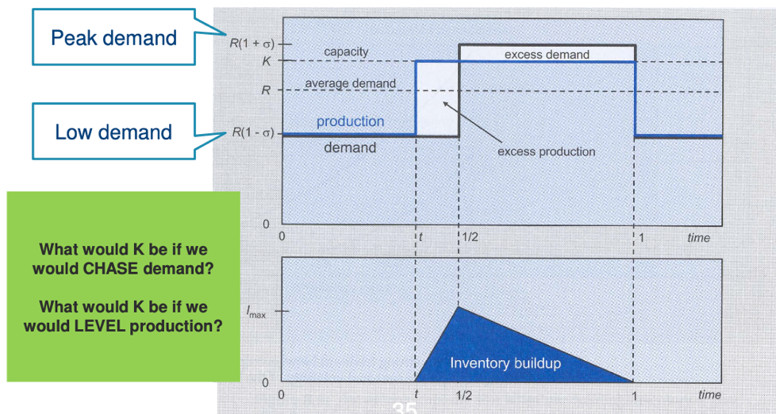
- Graphically: demand & inventory profile
- Inventory building
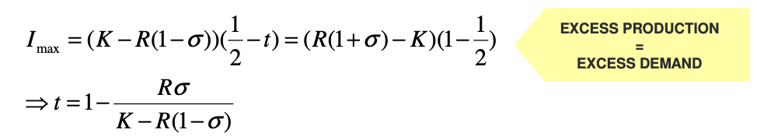
    - When to start
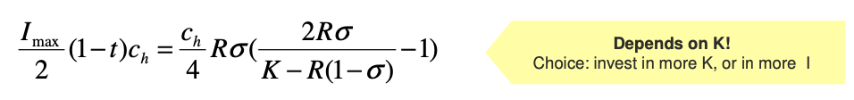
    - Annual holding cost
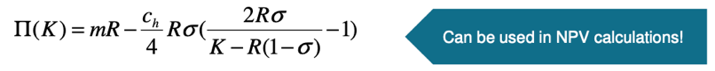
    - Annual operating profit
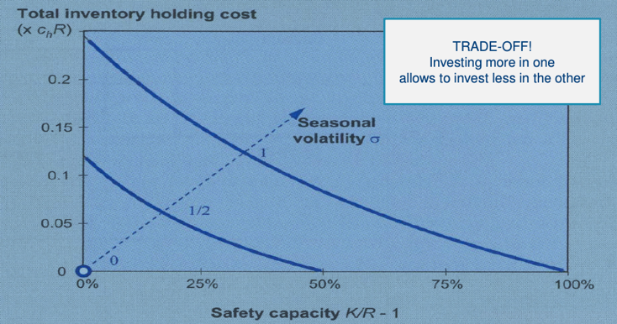
- The trade-off graphically
- NPV calculation
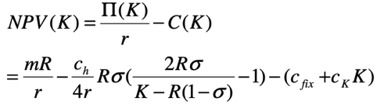
    - Over an infinite time horizon
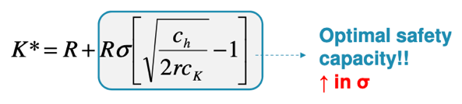
    - Finding K* = calculating NPV’(K) and setting it equal to zero
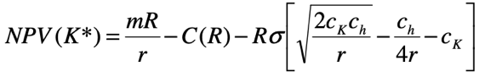
    - Corresponding NPV(K*) decreases linearly in σ
- Strategies
    - Level strategy: when will K* = R?
      - σ = 0
      - or if $\frac{c_{h}}{2rc_{k}}=1 → \frac{c_{h}}{rc_{k}}=2$
    - Chase strategy: when will K* = R (1 + σ)
      - $\sqrt{\frac{c_{h}}{2rc_{k}}}=2 → \frac{c_{h}}{rc_{k}}=8$
    - Optimal capacity depends on relation between capacity & inventory costs
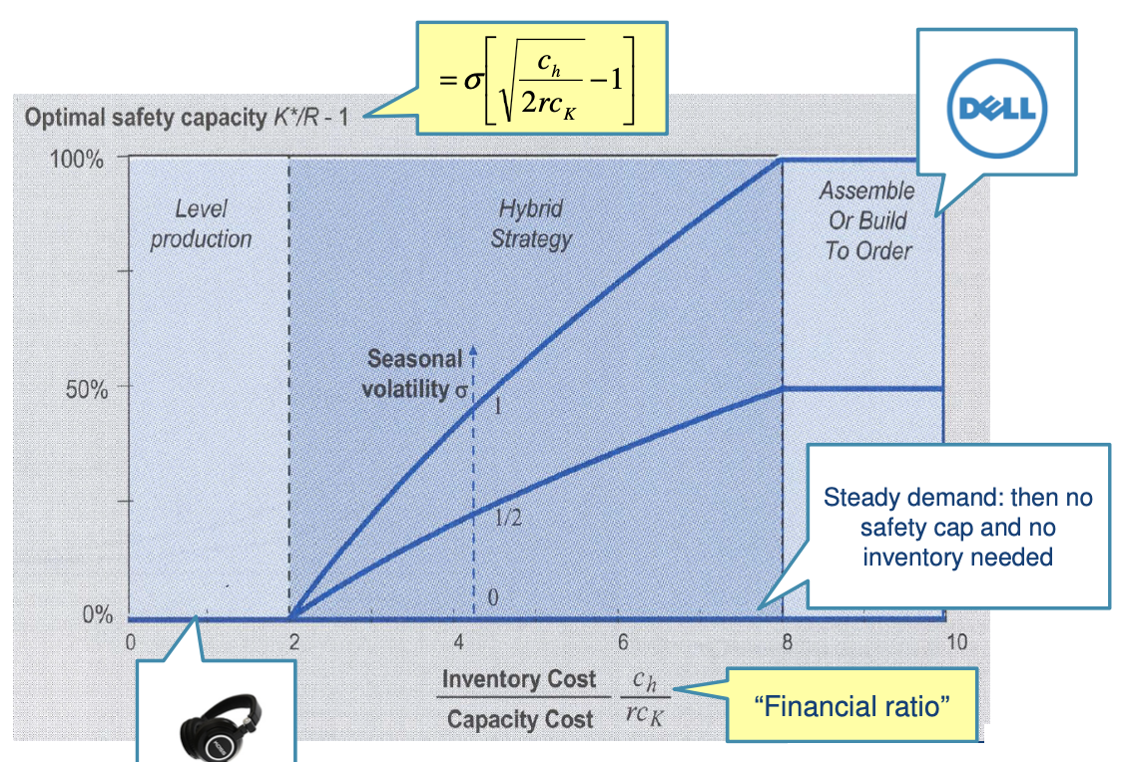
- Comparing strategies graphically
- Koss model key insights
    - K* and I_{max}* are linearly increasing in σ
      - NPV(K*) is linearly decreasing in σ
      - Avoid seasonal variation, as it hurts NPV
    - t* depends purely on financials, not on σ
    - Seasons with uneven length: same K*and same expression for t*
      - Impact on inventory holding cost reflected in NPV
      - Impact on region in which you chase
        - Low season: short, increase region in which you chase
        - Low season: long, decrease region in which you chase
Most likely a mixed strategy

Wolfgang Puck Model
- Assumptions
    - Single-server facility
    - Customers are willing to wait before being served
    - Waiting entails penalty cost c_{w} per unit time
    - Infinite time horizon, arrival & service characteristics don’t change
- Estimated waiting time for customer if capacity is K: VUT model
    - c² = squared coefficient of variation
    - ρ = utilisation, % of time service facility is occupied
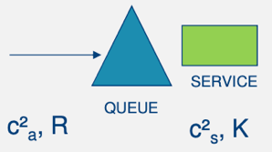
    - T_{p} = average service time

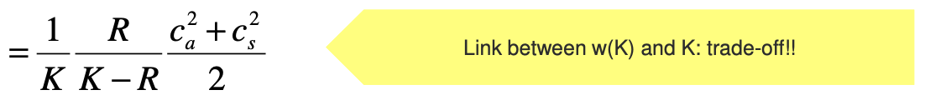
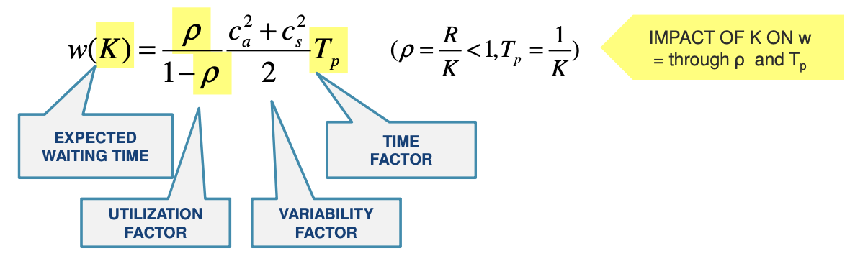
    - The model

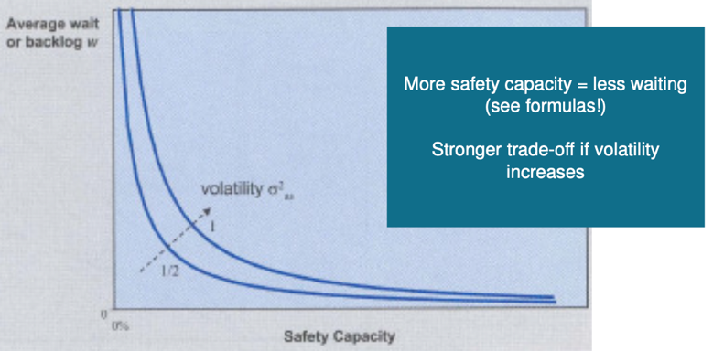
- Trade-off between safety capacity & average wait gets stronger as volatility factor increases
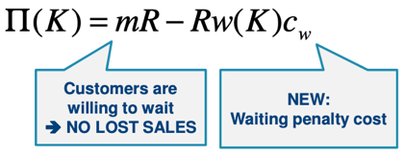
- Corresponding expected operating profit becomes
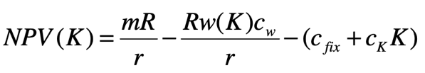
- Corresponding NPV using perpetuity formula
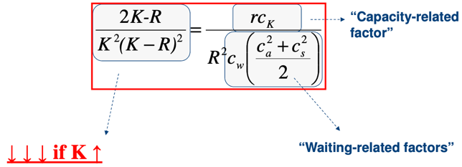
- Choose optimal K such that
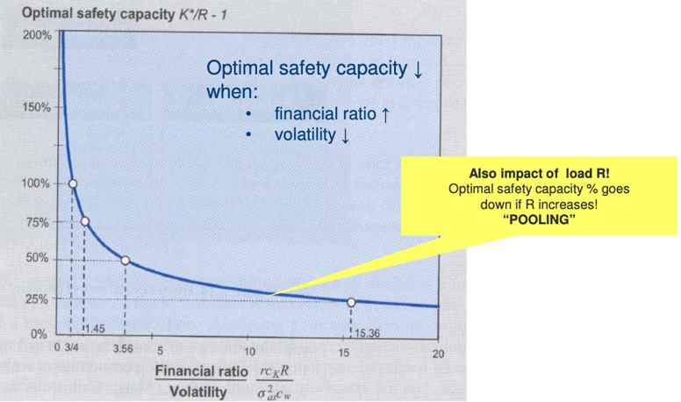
- Graphically: optimal safety capacity
- Pooling effect assumes that all factors (but R) remain the same
- Consolidation favours a lower optimal K*, not due to decreased fixed investment costs but to a better use of capacity
- Priorities and overflows: case about call centres
  - To pool or not to pool?
    - On avg. pooled system is worse because call times are not alike
  - Overflows
    - Overflow: server handles other customer type when idle
    - Use overflows between queues to avoid idle time
    - Better to have frequent short outages than infrequent long outages
    - Ex. as soon as there is 1 unit in queue & other server is idle, it can overflow
  - Overflows & priorities
    - Allow priorities: server treats customer of other type, even if there are customers of its own type in the queue
    - Introduce thresholds & use overflow as function of the status of the system
    - Ex. calls of type 1 get priority as soon as queue reaches 3 customers

5.1 Capacity Timing

Capacity Timing Strategies
- Four metrics of capacity portfolio strategy
    - Sizing (previous chapter)
    - Timing (this chapter)
    - Type
    - Location
- Tactical Timing
    - Captures key adjustment tactics over shorter time-frames (capacity inventory-waiting triangle)
    - Often ignores uncertainty
      - Capacity-inventory build-up models (ex. Koss model)
      - Capacity-waiting models (ex. Wolfgang Puck model)
      - Aggregate production planning (see SCM)
- Strategic Timing
    - Captures key capacity investment drivers (EOS & uncertainty) over longer time frames
    - Often ignores short-term operational “tricks” (ex. inventory carry-over)
    - Real options: option value of waiting

Leading, Lagging & Chasing
- Capacity investment: subject to capacity frictions
    - Lead time: capacity will not be immediately available
    - Size: lumpy (indivisible, discrete) vs. incremental (divisible, continuous)
    - Costs: fixed vs. variable, economics of scale (EOS)
    - Timeframe: typically, large and irreversible investments
- Decisions to make
    - Timing: when?
Lead vs. lag
    - Size: how much?
Many small vs. one big

- Leading strategy
    - Used for
      - New products
      - Products with short PLC
      - Time sensitive customers
    - Advantages
      - Never run short (no missed revenues)
      - Captures upward demand potential
      - Excess capacity: barrier of entry for competitors
      - Insensitive to start-up problems
    - Disadvantages: expensive & risky
- Lagging strategy
    - Used when there is a strong brand and good functionality
    - Advantages
      - Maximise utilisation of capacity
      - Protection against downturns
      - Option value of waiting
      - Less dependent on forecasting
    - Disadvantages: lost revenues, always running behind
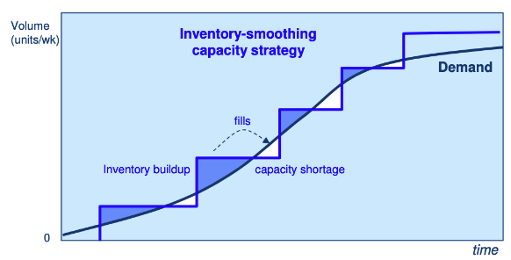
- Hybrid timing strategy: smoothing

Option Value of Waiting
- Move before you have most demand info or wait?
    - Analytical framework to compare lead and lag strategies: models
    - Value of waiting depends on amount of valuable additional information you expect to get about the demand structure
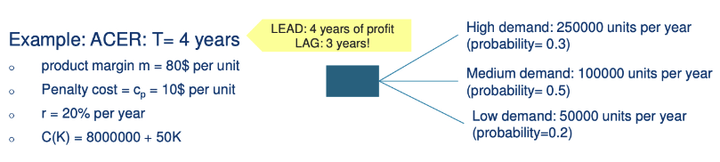
- Framework: use decision trees
- Models
  - Newsvendor model
    - Not optimal for multi-period settings
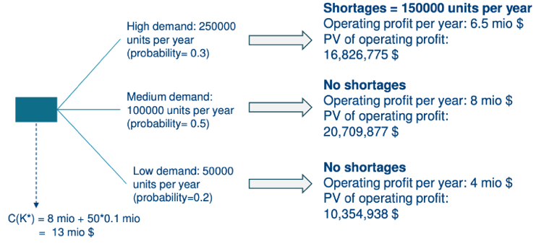
    - NPV of investing now
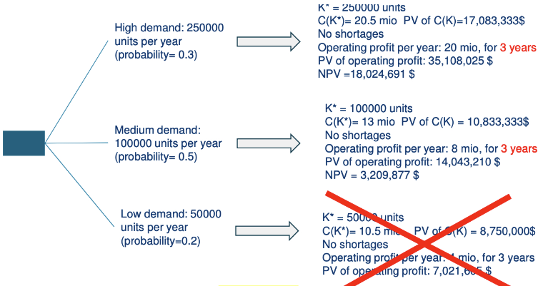
    - NPV of waiting one year
    - Waiting time depends on initial uncertainty & penalty costs
  - Multiperiod model
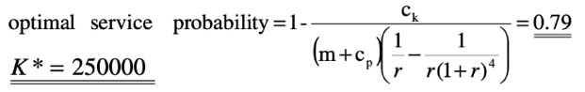
    - Optimal K for expanding now
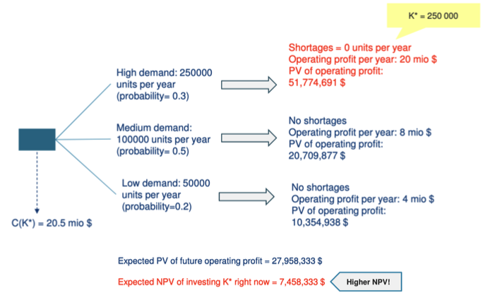
    - Impact on NPV for expanding now
    - Conclusion
      - Newsvendor model underestimates value of “moving now” option
      - Optimal K and corresponding NPV are suboptimal
      - The more you understand lifetime of a project, the more you will be tempted to wait (and vice-versa)

Capacity Frictions
- Timing problem arises due to investment frictions
No frictions = no optimisation needed
    - Streamline project management (reduce lead-times)
    - Modularise capacity & construction (reduce lumpiness)
    - Reduce irreversibility
    - Use flexible capacity (reduce impact of uncertainty)

5.2 Product & Process Flexibility

General Insights & Terminology
- Four metrics of capacity portfolio strategy
    - Sizing (previous chapters)
    - Timing (previous chapters)
    - Type (this chapter)
    - Location
- Two dimensions
    - Specialist (dedicated) vs. flexible vs. generalist (general purpose)
Depends on scope of tasks that can be performed
    - Labour vs. capital
Depending on the degree of automation
- Trade-off between flexibility and degree of automation (capital)
    - Scope
      - Breadth of activities that a resource can perform
      - Adapt to changes in demand mix
    - Agility
      - Ability to quickly change from one activity to another
      - Hand in hand with scope increase: scope flexibility assumes a minimum of agility flexibility and vice versa
    - Robustness
      - Performance doesn’t vary significantly over the range of activities
      - In cost efficiency, quality and other non-cost competencies
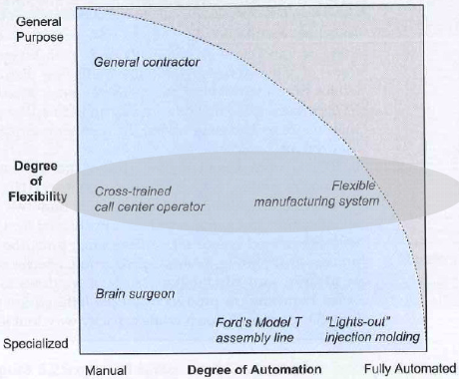
      - Remain on efficiency frontier for complete set of activities
    - But higher capital investment costs
      - Fixed costs
      - Marginal investment cost

Design for Flexibility
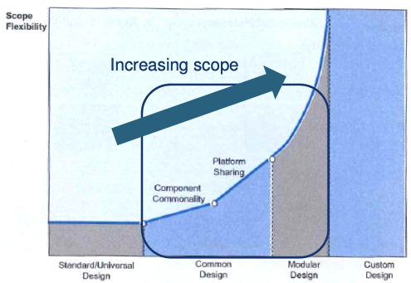
- Scope flexibility is supported by different product design strategies
- Types of design
    - Component commonality (CC): different end products share common components and are distinguished by other unique components
    - Platform sharing: similar to CC but more extreme, different end products share the same engineering structure (ex. in car industry)
    - Modular design: product is built from loosely coupled modules that can be mixed & matched
- Flexible resources are more expensive than dedicated ones, how much flexibility is needed?
    - Insights from chaining (resource sharing)
    - Insights from allocation flexibility (tailpooling)

Chaining
- Assumptions
    - Network of n plants & m product types
    - m = n = 10
    - Products have same demand probability distribution (mean = 100)
    - All plants have same capacity (100)
- Questions
    - Can significant sales & utilisation benefits be reached with anything less than full flexibility?
    - How to allocate products to plants without flexibility overinvesting
- Process
    - Start with dedicated plants (1 plant for 1 product)
    - Start adding links, so different plants can make different products
    - When to stop?
    - 95% of sales & utilisation benefits of full flexibility can be achieved by adding only 10 links, if they are chosen in the right way
    - Add links in such a way as to create fewer & longer chains
      - Not much flexibility actually needed
      - “Close the chain”, make it a cycle
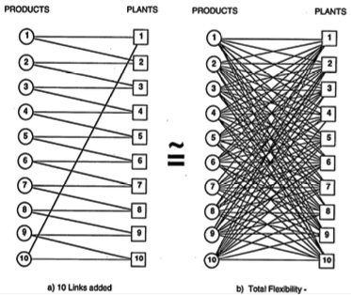
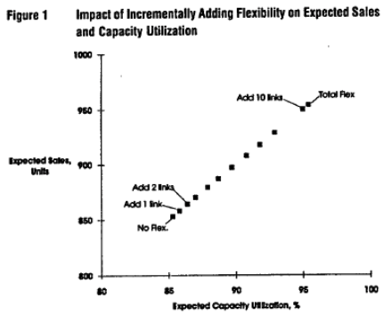
      - Balance number of plants per product and vice versa
- Intuition
    - All products in chain share all plant capacity in the chain
    - The more products & plants are encompassed by cycle, the higher the opportunities to shift demand from plants with higher-than-expected demand to plants with lower-than-expected demand
    - If product demands are negatively correlated: don’t have to be produced in same plant, but have to be in same chain
- Flexibility vs. capacity
    - Flexibility acts as substitute for adding capacity
    - Adding capacity increases expected sales, decreases utilisation
    - Adding flexibility increases both expected sales & utilisation

Allocation Flexibility
- Investing in flexible resources gives you option to switch capacity allocation to most profitable product (at expense of less profitable products)
Allows for dynamic profit maximisation
- Assume
    - 2 products types have to be assembled
    - Choose between 2 dedicated lines and 1 flexible line
    - Demands are correlated, bivariate normal distribution with corr. -0,9
- Question: determine optimal mix of capacity types and optimal allocation of demand to these types to max. NPV of the investment
    - Problem 1: inner loop optimisation
      - Determine optimal allocation of demand to capacity
      - For given capacities and demands
    - Problem 2: outer loop optimisation
      - Determine optimal capacity, given that demand is variable
      - Represent uncertainty in demand with scenarios and probabilities
      - Use simulation optimisation in Excel
    - Referred to as two-stage stochastic programming
      - Need to make a choice before you have full information (demand)
      - Decision maker acts rationally once information is available
- Solution
    - Problem 1 (rule of thumb)
      - Load dedicated lines as much as possible (otherwise lost capacity)
      - Priority on flexible line: use theory of constraints
Product with highest contribution margin per unit of time
    - Problem 2
      - Simulation based optimisation, use software
- Tail pooling
    - Dedicated assets take care of base volume of demand (low uncertainty)
    - Only upper tail volumes handled by flexible lines (high uncertainty)
    - Tail volumes are thus pooled on the flexible resource: tail pooling
    - Advantage: value creation, even if demands are positively correlated
    - Only need heterogeneity in contribution margins of different products
- Limitations
    - Assumes you first observe all demand for all product types
    - Then need to decide on how to allocate capacity to the products
    - Requires active intervention from the manager
- Optimal amount of flexibility to invest in will increase when
    - Demand volatility increases (longer tails)
    - Demands are more negatively correlated
    - Product margins are more heterogenous (switching will be more important)
    - Relative cost of flexible vs. dedicated capacity decreases

Mass Customisation
- Flexibility has high price: firms strive to product variety with essentially inflexible processes
    - Use mass production for customised products
    - Customers try to escape mass products, not mass production
    - Compromise between mass production & custom work
    - Constrain customisation: large variety of specific predetermined choices
Deliver customisation with inflexible processes

- Features of mass customisation
    - Product/service technology: modular design, CC or platform
      - Product is a menu of options combined
      - Rationalised standardisation: smart choice of options
    - Coordination & information technology
      - Allow customers to self-design products, all automatically
      - Most of the time sold over the internet
    - Process technology: resource sharing & postponement
      - At least the last step must be ATO
      - Key to have information capability to support customised last step
      - Postpone differentiation fan-out as long as possible
      - Customers must be willing to wait for the last step

Risk Management & Operational Hedging
- Risk: exposure to a chance of loss or damage, combination of both
    - Probability that an adverse event will occur (uncertainty)
    - The consequence of this event (undesirability)
- Risks in operations strategy
    - Operational risk: mismatch risk, reduces expected profit flows
    - Financial risk: profit variability risk, uncertainty in payoffs (realised)
    - Next to optimising NPV, must also limit the variability of NPV
Operational hedging to reduce risks
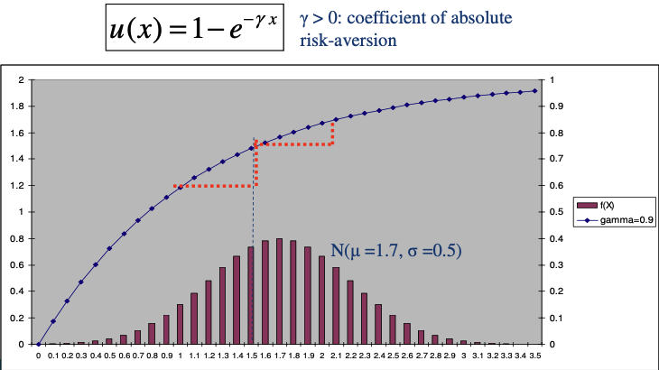
- Utility functions
    - Every uncertain outcome is translated into a utility level
    - Decision maker prefers payoff distribution that maximises expected utility
    - Expected utility depends on expected payoff and variability of the payoff
    - Maximising E[u] boils down to maximising $μ-\frac{γ}{2}σ^{2}$
    - Structure capacity portfolio such that
      - Increase expected profits
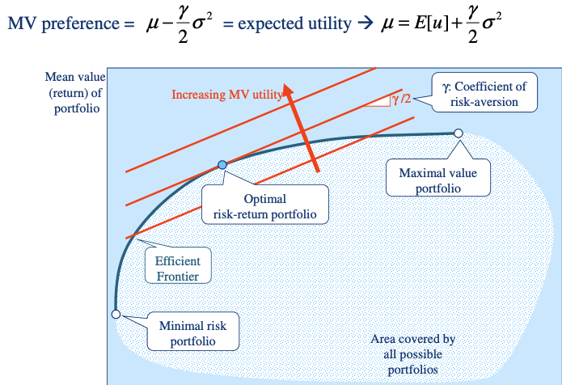
      - Profits stay robust, little variance in profits
    - Main variance curve shows how person trades off expected value to risk
      - Flat curve: risk neutral person, utility depends only on the mean
      - Not flat: people are risk averse; utility goes down as risk increases
      - Higher gamma, person is more risk-averse
- Optimal portfolio
    - Is on the efficient frontier
      - They give max. expected value for a given risk
      - Trade-off between expected value and variance is ‘fair’
      - Frontier spans a curve between min. risk and max. value portfolio
    - Gives the investor the highest utility (reflected by their preference curve)
Point at which preference curve is tangent to efficient frontier
- Operational management strategies
    - Goal: try to influence the efficient frontier
      - Make it flatter: risk reduction (at only small value loss)
      - Move it north: achieve higher expected profits with same risk
Make investor jump to higher utility curve
    - Reserves & redundancy
      - Safety capacity, inventory and time (reserves)
      - Back-up assets, suppliers, processes (redundancy)
    - Diversification & pooling
      - Pure diversification: sell different things needing different resources
      - Demand pooling: sell k products, pool demand on 1 resource
      - Allocation flexibility: sell k different products with network of dedicated and flexible resources with postponed capacity allocation
    - Risk sharing & transfer
      - Using contracts: insurance, buybacks…
    - Reducing/eliminating root causes of risk

6. Capacity Location & Sourcing Strategies

General Insights & Terminology
- Four metrics of capacity portfolio strategy
    - Sizing (previous chapters)
    - Timing (previous chapters)
    - Type (previous chapters)
    - Location (this chapter)
- Drivers for globalisation
    - Direct costs, capital costs & taxes
    - Technology & expertise
    - Market demand factors: chasing new markets, cultural globalisation
    - Macroeconomic and non-market factors: currency risk, political stability, protectionism, free-trade zones…
- Hierarchical location framework
  - Specify strategic role of location
  - Global assessment of candidate locations
  - Country segmentation (ranking according to capability)
  - Analyse total landed costs
  - Select based on 1 to 4
  - Update dynamically (and forecast)

- Strategic role of location
    - Selection by a rough, high-level assessment
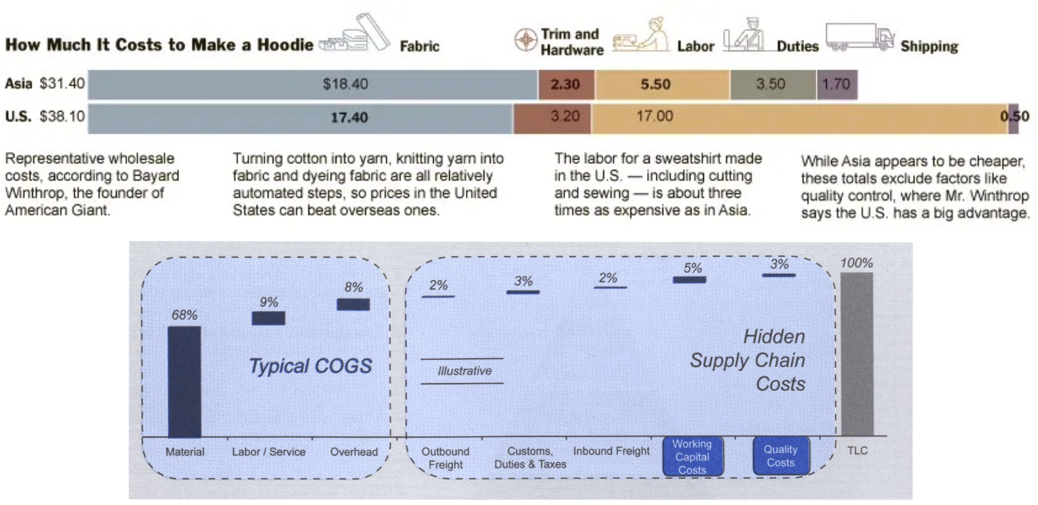
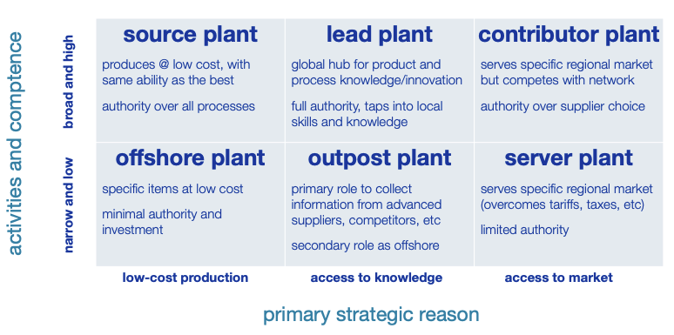
    - Ranking depends on criteria (political, technological, cost…)

    - Calculate end-to-end supply chain cost for a given service level
    - Further away manufacturing means higher lead times
Means more safety stock: higher cost
    - Hidden supply chain costs much higher when offshoring
      - Working capital costs: cycle + safety stock costs
      - Quality costs: cost of delivering lower quality (higher returns etc.)
- Supply chain management basics about lead time
    - Working capital costs: inventory perspective
      - Cycle inventory (in transit)
      - Safety stocks
    - Little’s law
      - Customers in system = arrival rate x time in system
      - Inventory = throughput (demand/period) x lead time
Larger lead times means larger inventory
    - Order size Q
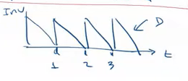
      - Avg. inventory = Q / 2
      - Optimal order size $Q^{*}=μ_{LT}+z*σ_{LT}$
        - $μ_{LT}$ = $μ*LT$ = mean demand during lead time = cycle stock
        - $σ_{LT}$ = $σ*\sqrt{LT}$ = standard dev of demand during lead time
        - $z*σ_{LT}$ = safety stock = critical z value x lead time variability
- Total landed cost analysis
    - Company located in US, demand is the same wherever it is produced
      - Demand (throughput) is 67.200 units/month, $D\sim (μ,σ^{2})$
      - ${σ^{D}}_{month}$= 20.160 units
      - Holding cost = 15%/year, tying up money in inventory costs you 15%
      - Target service level is 95%:
    - Factory in Mexico, transport with truck to US
      - ${{LT}^{M}}_{truck}$ = 8,5 days
      - ${c^{M}}_{truck}$ = 608,73$/u
      - In transit inventory = 67.200 u/m x 8,5 days = 19.040 units
      - Safety stock = $1,65*\sqrt{\frac{8,5}{30}}*20.160$ = 17.651 units
      - Total landed cost per month
$608,73*\left[67200+\left(19040+17651\right)*\frac{15\%}{12}\right]=4.118.600\$/m$
    - Factory in China, transport by sea to US
      - ${{LT}^{C}}_{sea}$ = 35 days
      - ${c^{C}}_{sea}$ = 601,9$/u
      - Same calculation above with different lead times
    - Factory in China, transport by air to US
      - ${{LT}^{C}}_{air}$ = 5 days
      - ${c^{C}}_{air}$ = 615,25$/u
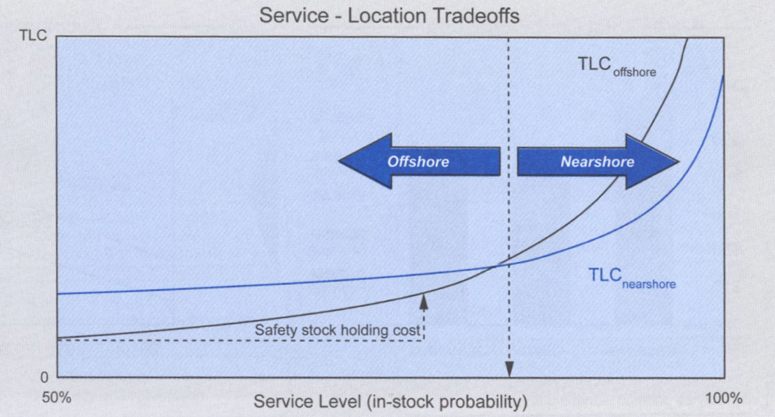
      - Same calculation above with different lead times

- Strategic location framework starts with desired role and capabilities of a location
    - Qualitative & quantitative (TLC) analysis of locations are crucial
    - Locations must be aligned with other elements of operations strategy
    - TLC analysed for given service level, must contain hidden supply chain costs

Global Network Choices
- Location choice interacts with flexibility: six standard options
    - Coloured square: location used
    - Circle: flexibility
      - White: dedicated capacity
      - Grey: flexible capacity line
    - A: dedicated capacities in home market; produce first, then observe demand
    - B: dedicated capacities in home market; observe demand then produce
    - C: same as B, but one flexible line
    - D: treat markets independently, good hedge against currency risk
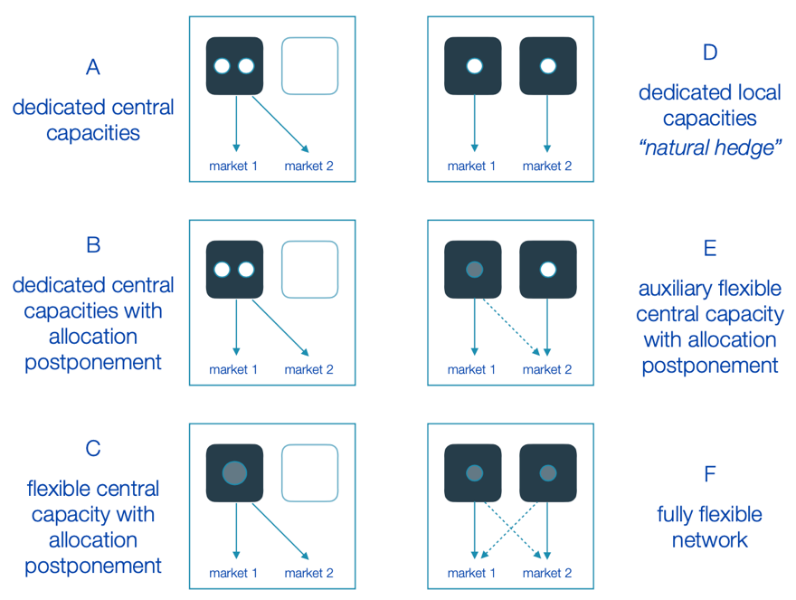
    - E & F: very flexible, great for risk hedging, but often expensive

- Global network example
    - Assume logistics cost: cost to transfer a unit from US to EU or reverse
    - 100% service level: all demand must always be met
    - Which network model is most advantageous?
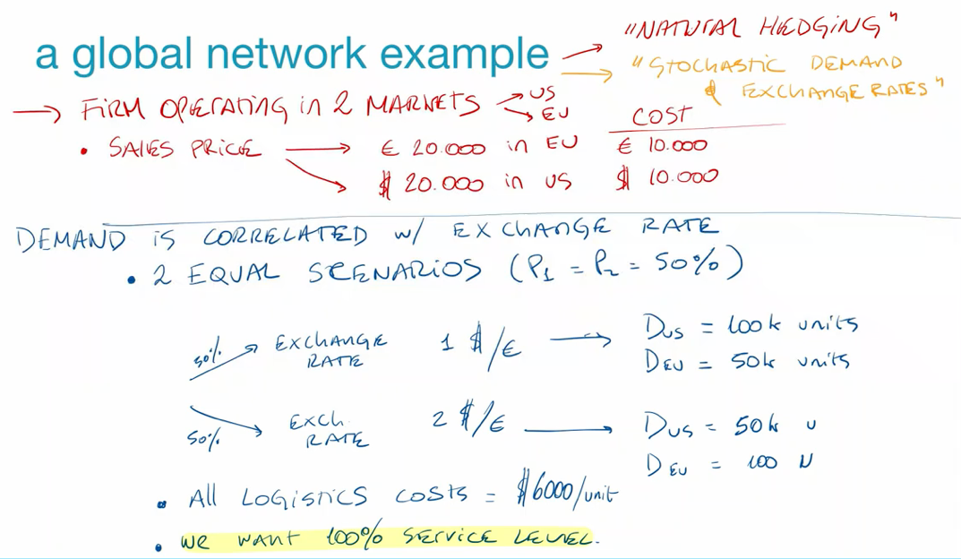
    - Assumptions

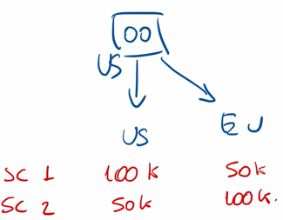
    - Option A: dedicated central capacity in the US, no postponement
      - Need to make production decision before demand is observed
      - Production 100k for US and 100k for EU because service level 100% and no postponement possible
      - Cost of all production in US + cost of shipping to EU
$200k*\$10k+100k+\$6k=\$2.6b$
      - Revenue
S1: $100k*\$20k\left[US\right]+50k*€20k*1\$/€\left[EU\right]=\$3b$
S2: $50k*\$20k\left[US\right]+100k*€20k*2\$/€\left[EU\right]=\$5b$
Expected profit = ${\$5b}/2+{\$3b}/2-\$2.6b=\$1.4b$
      - Disadvantage: have to overcommit in production
    - Option C: single flexible capacity in the US, with postponement
      - First observe, then produce: need to produce fewer units
      - Only have to produce 150k units, whatever scenario
      - Costs
S1: $150k*\$10k+50k*\$6k=\$1.8b$
S2: $150k*\$10k+100k*\$6k=\$2.1b$
      - Revenue: see above
      - Expected profit: $\left[{\$5b}/2+{\$3b}/2\right]-\left[{\$1.8b}/2+{\$2.1b}/2\right]=\$2.05b$
      - Disadvantage: costs are variable
    - Option D
      - Variable profit, but stable costs
      - Lower expected profit as in C, but only buy a little bit
      - Preferred way of working due to lower risk and variability
- Conclusions
    - Value of flexible network is higher when
      - Revenues & costs are variable
      - Exchange rates & demand volatilities are high
    - Optimal network: cheap location has excess capacity to buffer volatility
    - Value of excess capacity increases when margins are high compared to capacity costs
    - Reasons for offshoring/reshoring
      - Cost reduction is number one reason
      - Strategy, competition, access to personnel… also really important
    - Strategy
      - Use cheap offshore labour to deal with bulk of production
      - Use expensive (fast & reliable) onshore labour to deal with volatility

Offshoring Risks
- Operational risks
    - Labour costs & availability
      - More offshoring means more labour competition in offshore market
      - Gets more expensive quickly, is not a good reason in the long-term
    - Logistics costs and lead time variability (see Mexico – China example)
    - Quality concerns (defective products, worse customer experience…)
    - Service risk (ex. worse service by call centre)
- Macro & non-market risks
    - Competitive risks:
    - Currency risk
    - Political risks
    - IP risks: imitation, information theft…
    - Health, environmental & CSR risks
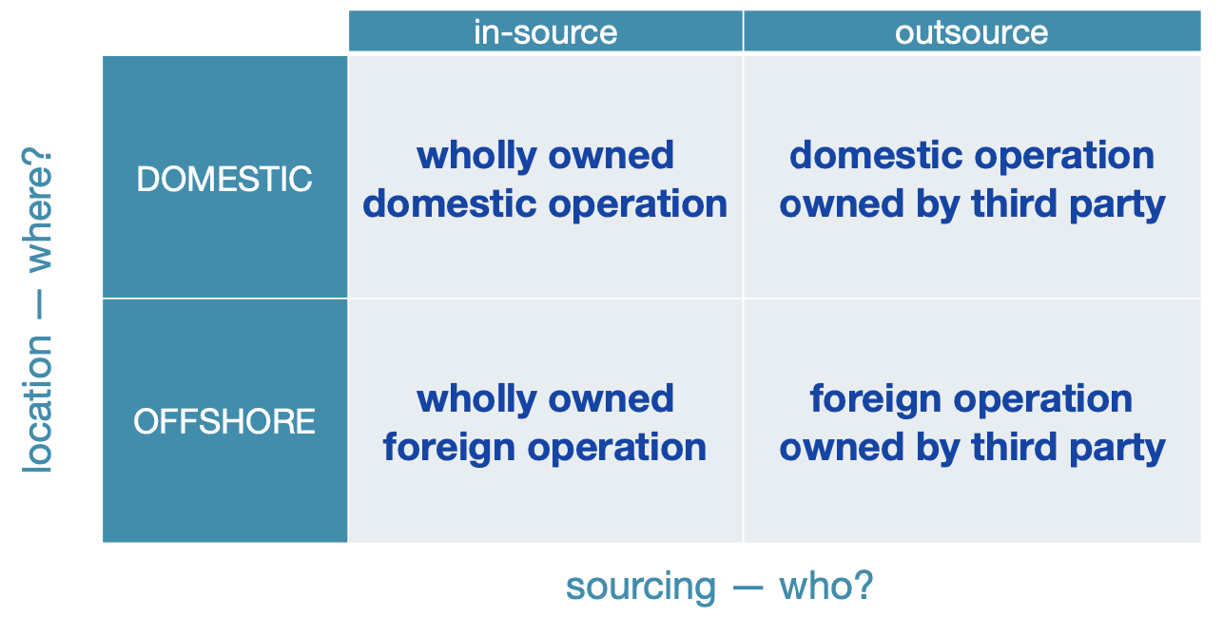
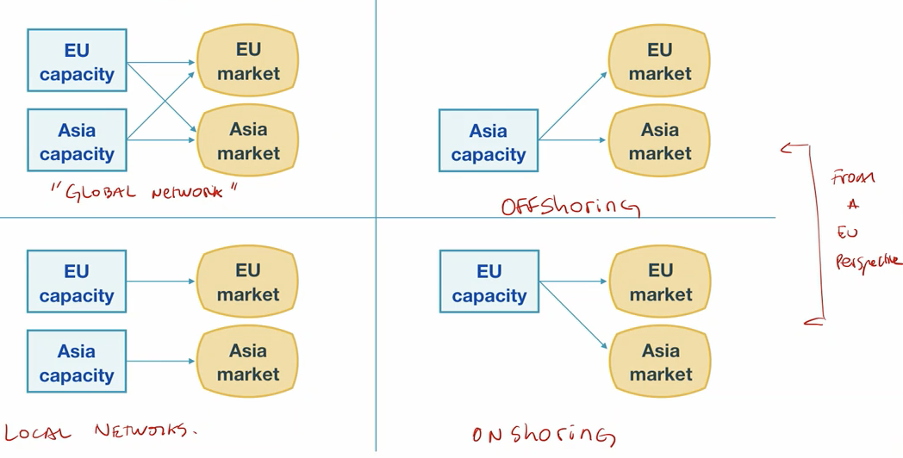
- Towards global networks

7. Improvement & Innovation

Introduction
- Difference between improvement and innovation
  - Graphically
    - Cost from high to low on x axis
    - Non-cost competencies on y axis
    - If costs decrease, non-cost competencies also decrease
    - Firms want to be on the efficient frontier (EF) (red line)
    - How to move towards EF like firm 1: innovation needed (big jump)
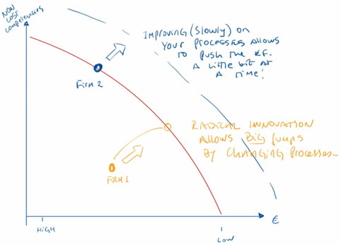
    - How to improve when on the EF like firm 2: improvement needed
  - In words
    - Improvement: small steps
      - Using the same process more efficiently
      - New version of the same product
    - Innovation: large steps, radical change
      - New process invented
      - New product category invented

Improvement
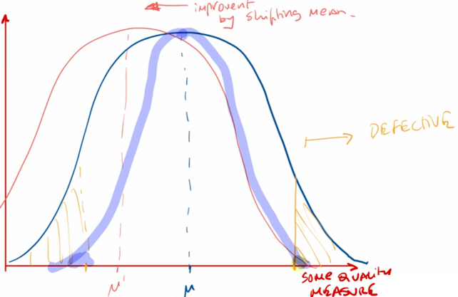
- Improvement through variability reduction
  - Can improve by shifting the mean (pink)
    - If both sides of curve are undesirable, then this is no solution
    - Shifting the mean usually very expensive process
  - Can improve through variability reduction (thick blue line)
- Continuous improvement
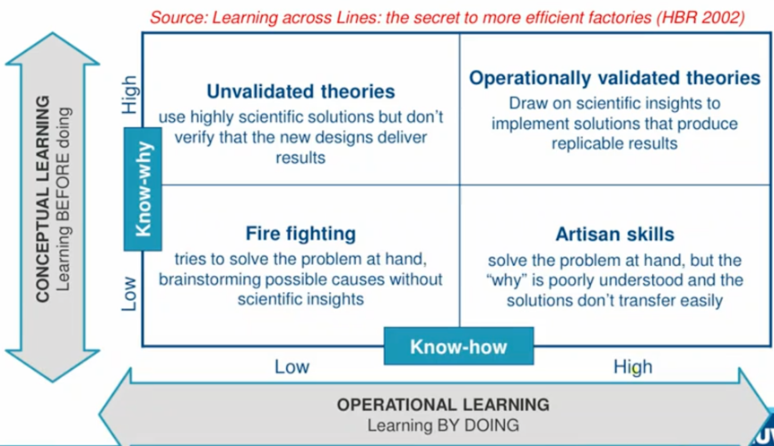
  - Learning matrix: continuous improvement mostly through learning-by-doing

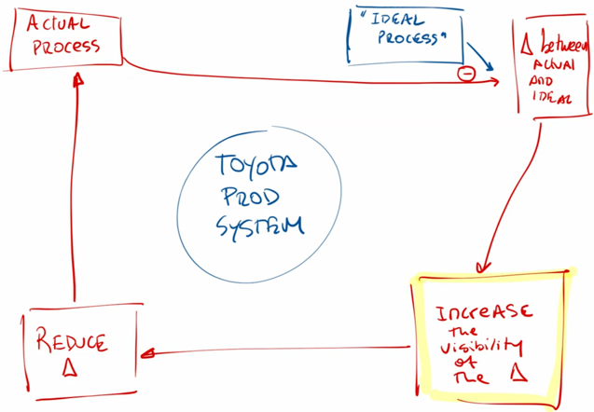
  - Example of cycle from Toyota
- Learning curve: shows how learning by doing translates into improvement
  - Experience: measured by cumulative units produced
  - Improvement measured by decrease in marginal cost per unit
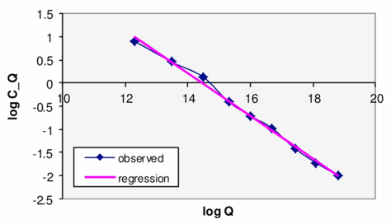
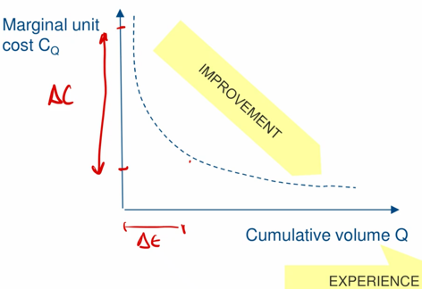
  - Usually linear in the logarithm (decreases exponentially)
  - The learning curve mathematically: $\log\left(C_{Q}\right)=\log\left(C_{1}\right)-λ\log\left(Q\right)$
    - C₁ is the cost of first unit, C_{Q} of the last unit
    - Q is the number of units produced this far, $λ$ is slope of the logarithm
    - We can rewrite this using the following equalities
      - $A\log\left(B\right)=\log\left(B^{A}\right)$
      - $\log\left(A\right)+\log\left(B\right)=\log\left(AB\right)$
    - We rewrite the learning curve: $\log\left(C_{Q}\right)=\log\left(C_{1}*Q^{-λ}\right)$
Take away the logs to get: $C_{Q}=C_{1}*Q^{-λ}$
    - If production is doubled, what happens to cost of unit Q?
      - $C_{2Q}=C_{1}*{\left(2Q\right)}^{-λ}={2^{-λ}*C}_{1}Q^{-λ}=2^{-λ}*C_{Q}$
      - This means that $\frac{C_{2Q}}{C_{Q}}=2^{-λ}=constant‼!$
If production is doubled, cost falls by same amount each time
    - Cost difference in % when doubling production
      - $C_{Q}-C_{2Q}=C_{Q}-2^{-λ}C_{Q} → \frac{C_{Q}-C_{2Q}}{C_{Q}}=1-2^{-λ}$
      - So, decrease in costs is constant
      - The learning rate $L=1-2^{-λ}$
  - Learning curve shows how good you translate experience into improvement
    - Learning by doing is predictable (but based on empirical observations)
    - Can be used to forecast future costs
    - Can be used to see how well processes are evolving

- Learning curve and economies of scale (EOS)
  - Similarities
    - Both are non-linear, have same down sloping shape
    - Both are a relation between production and costs
      - Learning curve: marginal unit cost & cumulative production
      - EOS: average unit cost & production per period
  - Differences
    - Cumulative production can only increase (cannot produce negative number)
    - Production per period can both increase and decrease
  - Interaction between both
    - Learning can move EOS curve downwards
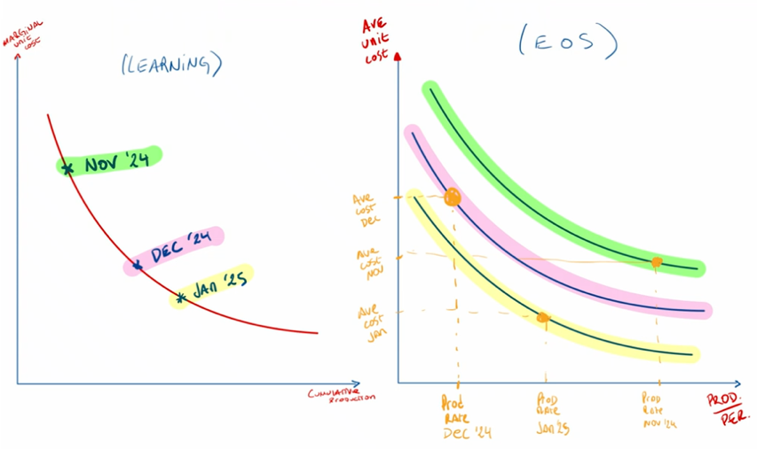
    - Does not mean average cost per period is always lower later in time

Innovation & Unforeseeable Uncertainty
- Innovation: radical change in the product or process
  - Difficult to manage
  - High unforeseeable uncertainty: decisionmaker is unaware the uncertainty exists
  - You cannot know what the next innovation is going to be, cannot predict it
How can you systematise this uncertainty?
    - Trial-and-error approach: serial
    - Selectionist approach: parallel
- Trial-and-error approach
  - Iterate-and-learn or serial approach
  - Adjust activities & targets as soon as new information becomes available
    - Start with given target or plan
    - Sequentially adjust for new information
    - May take a long time (sequential process)
  - Example: prototyping
    - Bring product to a small test market
    - Gather feedback and learn about the market
    - Improve product to fit better
    - Etc.
- Selectionist approach
  - Parallel approach
  - ‘Try everything at once and see what sticks’ (ex post)
  - Seems inefficient & expensive but can be faster
  - Example: Google l
    - Let employees use 20% of their time for personal ‘pet’ projects
    - If it sticks, they keep it, if not they take it out of the market
- Which approach to use
  - Know what you are looking for?
    - If many unknown unknowns (complex setting): parallel
    - If only few unknown unknowns: serial
  - Time-money trade-off
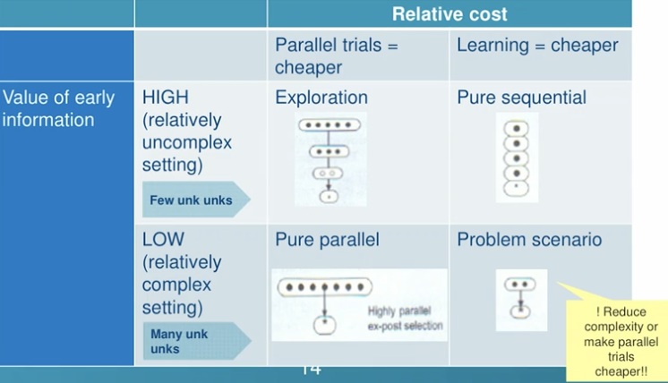
    - Parallel: more costly, less time
    - Sequential: less costly, more time

Innovation & Encroachment
- Two types in disruption theory
  - High-end encroachment: superior innovation
    - New product encroaches on the high end of the old product market
    - Does things differently and improves on key aspects of the product
    - Product & features then progress down the market
    - Tends to come from big players already in the market
    - High price & high quality, cost decreases over time
  - Low-end encroachment: inferior innovation
    - New product encroaches on the low end of the old product market
    - Does things differently but does not improve on key aspects of the product
    - Product & features then progress up the market
    - Tends to come from new entrants
    - Lower quality but can get better very quickly, disruptive technology
    - Ex. electric cars were way worse than combustion cars
- Fundamental assumptions for the models
  - Consumers are rational and maximise their utility
  - All products are from the same firm and have the same potential market
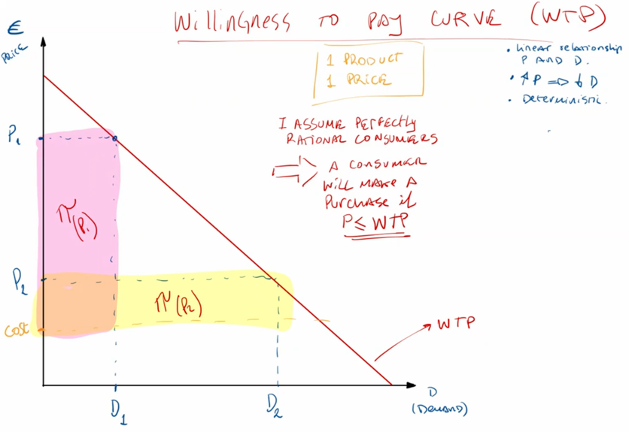
- Willingness to pay (WTP) curve
  - Customer buys product with highest utility (not lowest price or highest quality)
  - WTP curve indicates potential demand: what would demand be at this price
    - Top (small) triangle: money left on the table
    - Large triangle (D₁ D): passed up revenue
  - Maximum WTP of a customer: reservation price

High-end Encroachment Analysis
- Two products from the same firm with different prices and different WTPs
  - One is a superior innovation
  - D_{max} is the size of the market
    - At price 0 everyone in the market would get this
    - Market size for both is the same: fulfils the same needs
  - Customers will choose product with highest utility for them (WTP – P)
- The market split: place on the curve where one is indifferent between both products
  - Demand product 2: $\overline{x}$
  - Demand product 1: $D_{1}-\overline{x}$
- Having multiple products with different WTP curves, minimises both
  - Passed-up revenue
  - Money left on the table
- Optimise profit under these two products
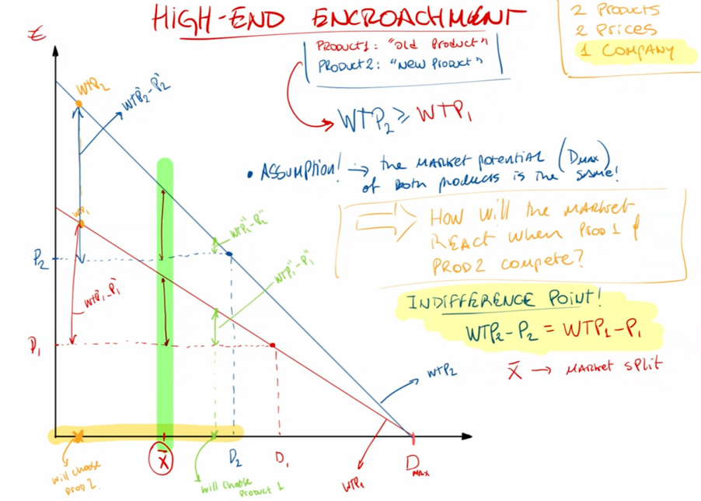
$π_{tot}=π_{1}+π_{2}=\left(P_{2}-C_{2}\right){\overline{D}}_{2}+(P_{1}-C_{1}){\overline{D}}_{1}$
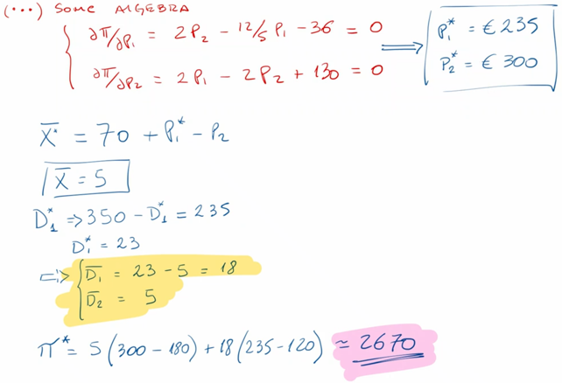
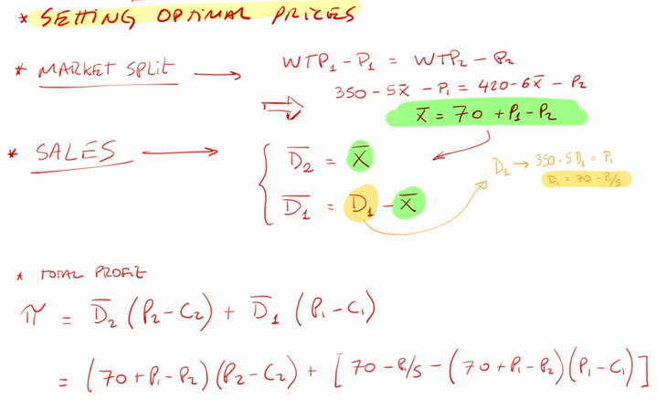
- Example
- Optimal price does not capture entire market
Market dominance ≠ profit dominance
- Cost structure because of learning curve between new and old product
  - Price of new product comes down fast while old product barely moves
  - Always introduce new product to target high end of the market
  - When old is obsolete, you learned how to make new one efficiently
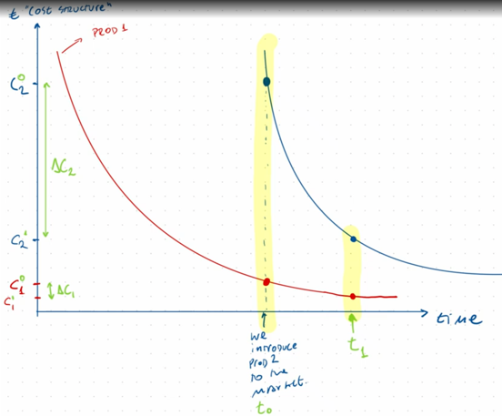
  - Ex. Apple introduces new iPhone every year
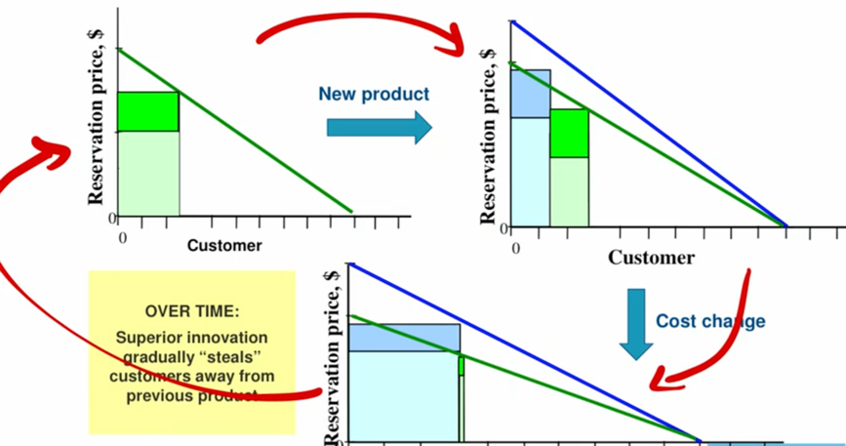
- Incorporate learning in model: diffusion of innovation

Low-end Encroachment Analysis
- Key assumptions
  - Two different companies: incumbent and new entrant
  - Firm sets own price in response to the other firm
  - Intersection of WTP with x-axis is not the same
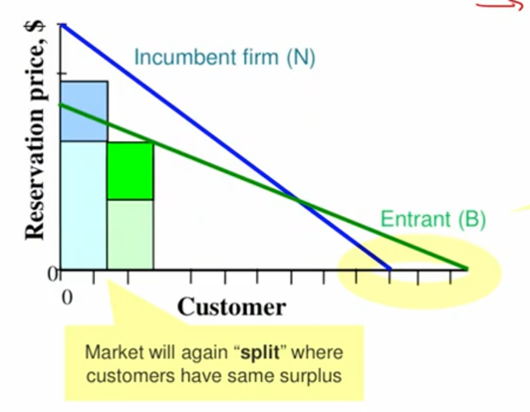
By being much different (worse) in an aspect, the market is expanded
  - Principle of Cournot duopoly, firms maximise profits with each other in mind

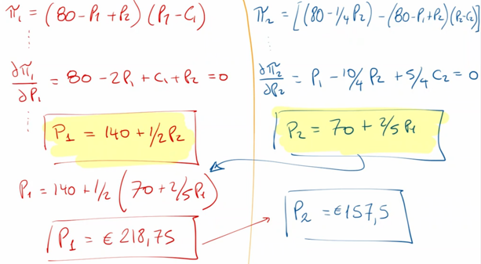
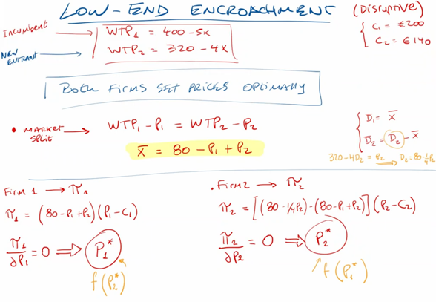
- Mathematical example with Nash equilibrium

Bass Diffusion Model
- Bass diffusion model: framework on how products progress through time
  - Goal: predict how many people will adopt a product in a given period
  - Marketing model, creates buckets of adopters
  - Factors
    - Communication
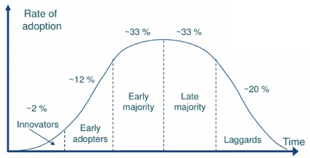
    - Innovation aspect
- Bass model, $n_{t}={AP}_{t}*{UM}_{t}$
  - $n_{t}$: number of people adopting the product
  - $\overline{N}$: size of adopting market segment
  - $N_{t-1}$: cumulative number of customers that have adopted before period t
  - $p$: coefficient of innovation, external influence, intrinsic tendency to adopt
  - $q$: coefficient of imitation, internal word-of-mouth influence, social contagion effect
  - ${AP}_{t}= p+q\frac{N_{t-1}}{\overline{N}}$
    - Adoption probability, given that customer has not yet adopted product
    - Increases if imitation coefficient is higher and if more customers adopted
  - ${UM}_{t}=\overline{N}-N_{t-1}$
    - Untapped market, number of people in untapped market of the product
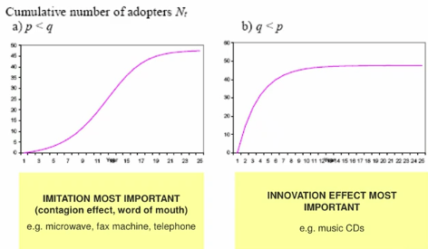
    - Gets smaller as untapped market decreases in size

8. Demand & Revenue Management

Introduction
- Match supply with demand
  - Adjust capacity, production & inventory
  - Use overtime etc.
  - Used if demand is difficult to influence or if supply can easily be adjusted
- Match demand with supply
  - Revenue management
  - Use different prices, spur demand using marketing campaigns, offer discounts…
  - If demand is easy to influence or if capacity is inflexible (ex. hotels, airlines…)
Demand needs to be price elastic
- Revenue management (revenue = price x quantity)
  - Demand management practices aiming to maximise revenue of given supply
  - Price controls
    - Price customisation
    - Dynamic pricing
  - Capacity controls
    - Yield management
    - Service customisation

Price Controls
- Price discrimination & customisation
  - Adjust prices to groups with different willingness to pay to extract maximum value
  - Two types
    - Perfect price discrimination
      - Charge exact WTP of each customer (reservation price)
      - Almost impossible to figure out, as it requires perfect information
    - Second degree price discrimination
      - Design differentiated products according to set of features
        - Features act as fences or sorting mechanisms
        - Disable ‘buy-downs’, people with high WTP will not profit from lower prices
        - Effective if correlated with WTP
      - Let customers choose, partially revealing their WTP (self-selection)
- Optimal pricing case 1
  - There is one product from one firm
  - Assume no price discrimination
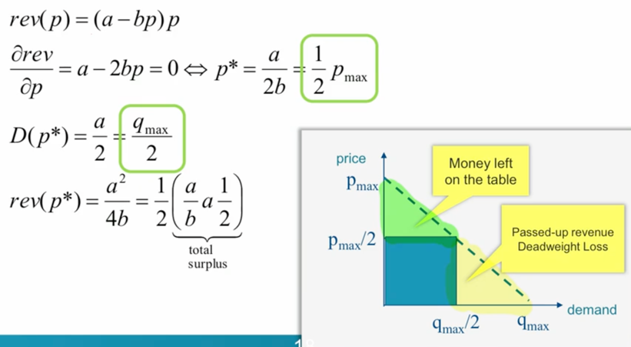
  - optimal price and quantity half of the maximum
- Optimal pricing case 2
  - Assume
    - There is one product from one firm
    - Price discrimination between 2 groups
    - No leakage: everybody with high WTP buys expensive product & vice versa
  - Prices & demand
    - $p_{1}$: regular purchase price, demand at this price $D\left(p_{1}\right)={\overline{D}}_{1}$
    - $p_{2}$: discount price ($p_{1}>p_{2}$), demand at this price $D\left(p_{2}\right)-D\left(p_{1}\right)={\overline{D}}_{2}$
    - $revenue=p_{1}{\overline{D}}_{1}+p_{2}{\overline{D}}_{2}$
    - Solve $p_{1}$ & $p_{2}$ simultaneously
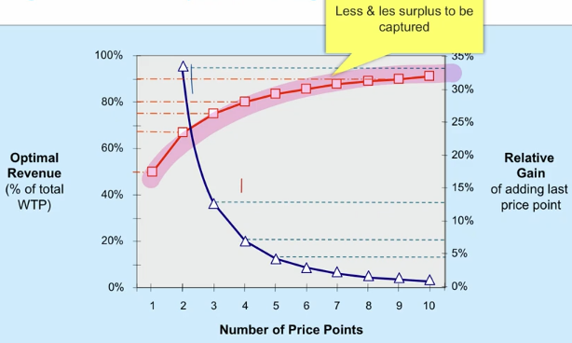
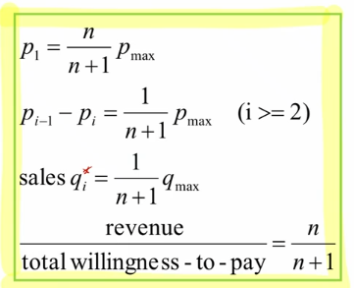
  - Solution of model
  - Adding price points
    - If n increases, revenue increases (but less and less)
    - If total WTP increases for given number of segments, revenue will increase
    - Amount gained by adding an extra price point decreases exponentially (blue)
    - With each added price point, less surplus can be captured (red)
    - With 3 price points, you can capture already 75% of total demand
    - Implementation becomes more & more difficult
    - Leakage costs increase
    - Reduces customers per segment, reducing accuracy of forecasting
- Optimal pricing case 3
  - Assume
    - Same as case 2
    - There is now a binding capacity constraint
  - Solve
    - Check if capacity constraint is binding in optimality (as if there is none)
    - If optimal demand > capacity, set prices such that: total demand = capacity
      - Set cheap price such that demand for it equals capacity
      - Now can solve for second price point
      - Set derivative of revenue function to zero using p₂ to get p₁
- General solution steps
  - Solve unconstrained problem
    - $P_{1}^{*}→D\left(p_{1}\right)={\overline{D}}_{1}$
    - $P_{2}^{*}→D\left(p_{2}\right)-D\left(p_{1}\right)={\overline{D}}_{2}$
  - Check if capacity is binding constraint
    - If no, solution already at hand
    - If yes, set $D\left({p_{2}}^{'}\right)$ = capacity and recalculate prices and demands

- Dynamic pricing: varying price over time to reflect changes in demand AND supply
  - Willingness to pay curve changes
  - New functions, new optimal prices, demands and revenues
  - Recalculate everything
- Seasonal & peak load pricing: adjust prices to changes in demand when supply is constant
- When to use segmentation and differential pricing
  - Valuation varies considerably over customer base
  - Sorting variables to segment customers in groups available
  - Can forecast valuation of each segment
    - Must estimate demand curves
    - Requires huge datasets about customer behaviour
- Issues with revenue management models
  - Do not account for uncertainties
    - Cancellations & no shows
    - Demand is a forecast (expected, not true)
  - Use yield management (capacity controls) to deal with (part of) the uncertainties
    - Overbooking: account for no shows & cancellations
    - Capacity allocation: account for forecast uncertainty

Capacity Controls: Overbooking
- Overbooking: solution to no shows and cancellations
  - Serve more demand than there is production
Some customers might be denied the product even after reservation
  - Penalty for overbooking: risk of bumping or ‘bumping cost’
- Two step heuristic: overbooking model
  - Step 1: Calculate how much to overbook
    - Make an aggregate analysis of demand
    - Use aggregate price, the avg. over the two products
  - Step 2: allocate capacity given overbooking level
    - Segment the market
- Assumptions for overbooking
  - $C_{B}$: penalty for overbooking too much (bumping cost)
  - Make an aggregate analysis of demand
  - Use aggregate price, the avg. over the two products
  - Cancellations are stochastically distributed
  - Random cancellation variable is opposite of demand
  - Decision variable q: how many rooms to overbook
- Calculate how many rooms should be overbooked (newsvendor model)
  - We expect revenue reduction through either bumping cost or cancellations
  - Minimise this revenue reduction
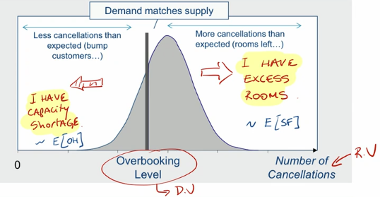
$E\left(rev\right)={rev}_{max}-P*E\left(cancellations\right)-C_{B}*E\left(shortage\right)$
  - Conceptually inverse of newsvendor model
    - Capacity shortage = expected on hand (OH)
$C_{O}=C_{B}$: cost of overage, not enough rooms (bumping cost)
    - Excess rooms = expected shortfall (SF)
$C_{U}$: cost of underage, excess rooms (missed revenue)
  - Calculate critical ratio (CR)
    - $CR=\frac{C_{U}}{C_{U}+C_{O}}$
    - Optimal overbooking $q^{*}$: $\operatorname{Pr}\left(x≤q^{*}\right)=CR$
  - Solve as any newsvendor model
    - X (normal): tables, $q^{*}=μ+σz_{CR}$
    - X (Poisson): tables, direct
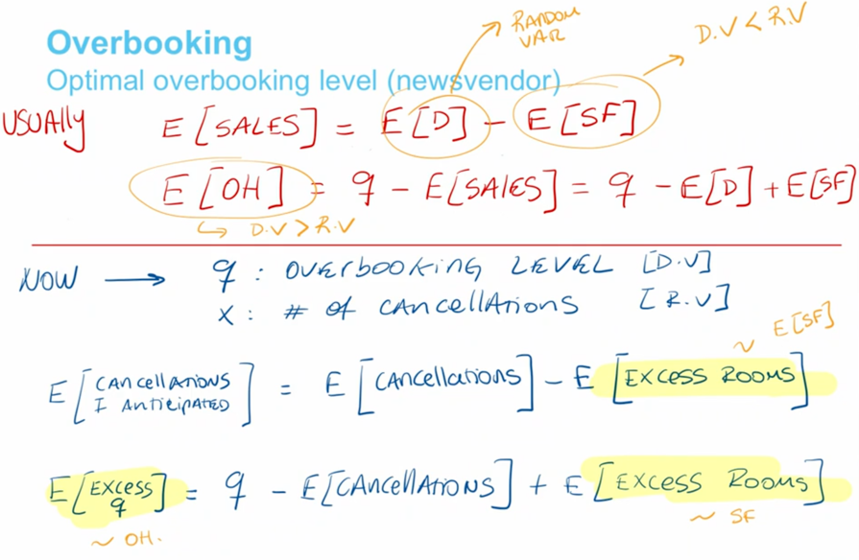
    - X (discrete): solve directly
- Remarks on overbooking
  - Bumping cost assumed constant: in reality this increases in amount
  - Ideally: no cancellations & no-shows (no reason to overbook, no mismatch of costs)
    - Ask for deposits
    - Use non-refundable tickets or ask premium for it
  - Reduce costs of
    - Excess capacity: last minute cheap tickets, discounts…
    - Bumping: backups, trading-up…
  - Increase flexibility
    - Resource pooling: being able to move customers over various assets (ex. flight tickets to unknown destination)
    - Demand induction: flexible products are inferior, can be priced below low-fare products without cannibalisation
  - Most important: protect high-price segment!

Capacity Controls: Capacity Allocation
- Assume
  - Demand at expensive price is stochastic
  - Demand at promo price is deterministic: will always sell out as demand is higher
  - Always keep enough space for expensive price segment to not lose out on revenue
- Control capacity by (these two parameters are actually the same)
  - Booking limit: what you reserve for low-price segment
  - Protection level: what you protect for high-price segment
  - Advance booking limit + regular protection level = total bookings
- Littlewood’s rule: accept advance reservations as long as their profit exceeds the expected profit of a regular reservation
  - Accept if ${price}_{low}≥{price}_{high}*p$
  - $p$: probability you will have shortage of high price rooms
    - Goes up if advance booking limit increases
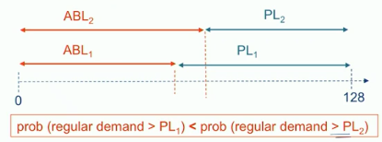
    - Because protection level decreases
  - Indifference point: when actual revenue equals expected revenue in future
Use newsvendor model
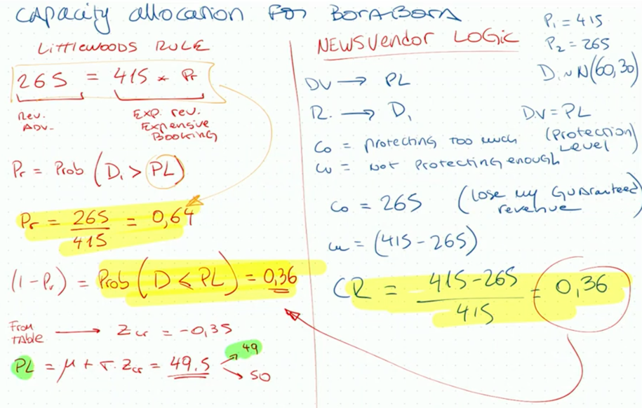
  - Both Littlewood’s rule and newsvendor model yield same result, see example:
- Revenue management
  - Demand management practices aiming to maximise revenue of available supply
  - Techniques
    - Price controls
    - Capacity controls
  - Forecasts are essential for these controls

